**Quarterly Report – Complaints, Misconduct and Other Matters**

**Contact – D/Supt Scott Cannon**

**Purpose of Report**

This report outlines the data and performance of Complaints, Misconduct and other matters that have been processed up to 31st December 2023 (Q3) by the Professional Standards Department (PSD).

**Recommendations**

That the Commissioner considers the report and raises any queries though the quarterly meeting with the Deputy Chief Constable.

**Introduction**

The Complaint and Misconduct data used for this report is generally per strand in a case, except for where otherwise stated. It does not cover each officer allegation within a complaint.

For example, an overall complaint or misconduct case number is likely to include more than one complaint/misconduct strand or category – the data used reflects the separate strands. There will often be multiple officers subject to a complaint strand. The latter is at times reflected in this data, where it is noted as such.

Caveats:

Complaints and Misconduct data includes those that were de-recorded/withdrawn.

Data is dependent on certain fields being accurate – for example, when considering Commands/Area Responsible – due to changes in structures within the force, and due to changes within commands, numbers may be skewed compared to other reporting.

This data uses the Area Responsible as recorded initially for Cases; this will not reflect the individual complaint strands and officer allegations which will often be across different commands and areas.

Commands:

The table details the Commands across Essex Police and the abbreviations that will be used to refer to them throughout the report.



**Public Complaints**

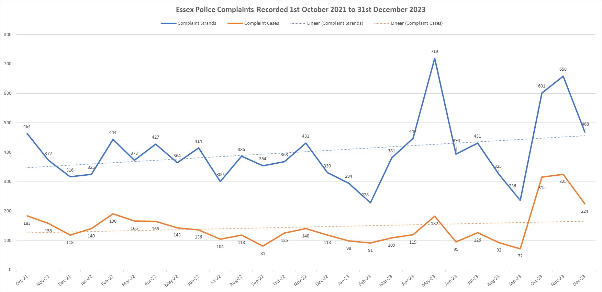

Q3 shows a significant increase in complaint cases and strands recorded. This is due to the change in NS3 process implemented on 1st October 2023 where all dissatisfactions are now recorded on Centurion with a “C” ref. This is in line with IOPC advice due to issues with data extraction and accurate reporting.

Previous reports have not included dissatisfactions in this chart. Moving forward this information will remain presented in this format to allow a reflection of overall volume.

This chart shows the total number of formal complaints and dissatisfactions combined for the calendar year of 2023. The difference in May is due to staffing difficulties, where a backlog of formally recorded complaints was a focus. However, it is apparent that more dissatisfactions are being managed outside of schedule 3 which provides a better service to the public with a quicker resolution.

*Timeliness of Complaints*

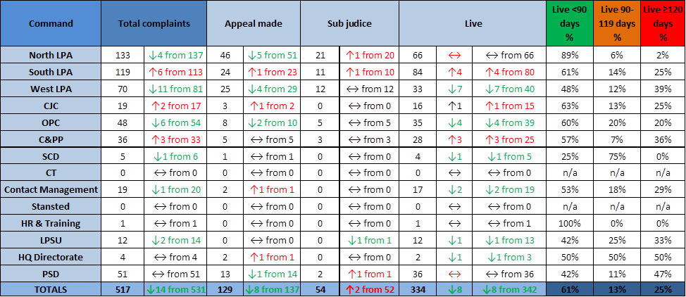

There is a continued focus on timeliness for complaints handling for the force with oversight at the Professionalism Board. The North LPA remains consistent with a low percentage of complaints under 120 days. The West LPA shows a higher percentage; however the numbers of complaints are smaller.

*Command Breakdown of Complaints:*

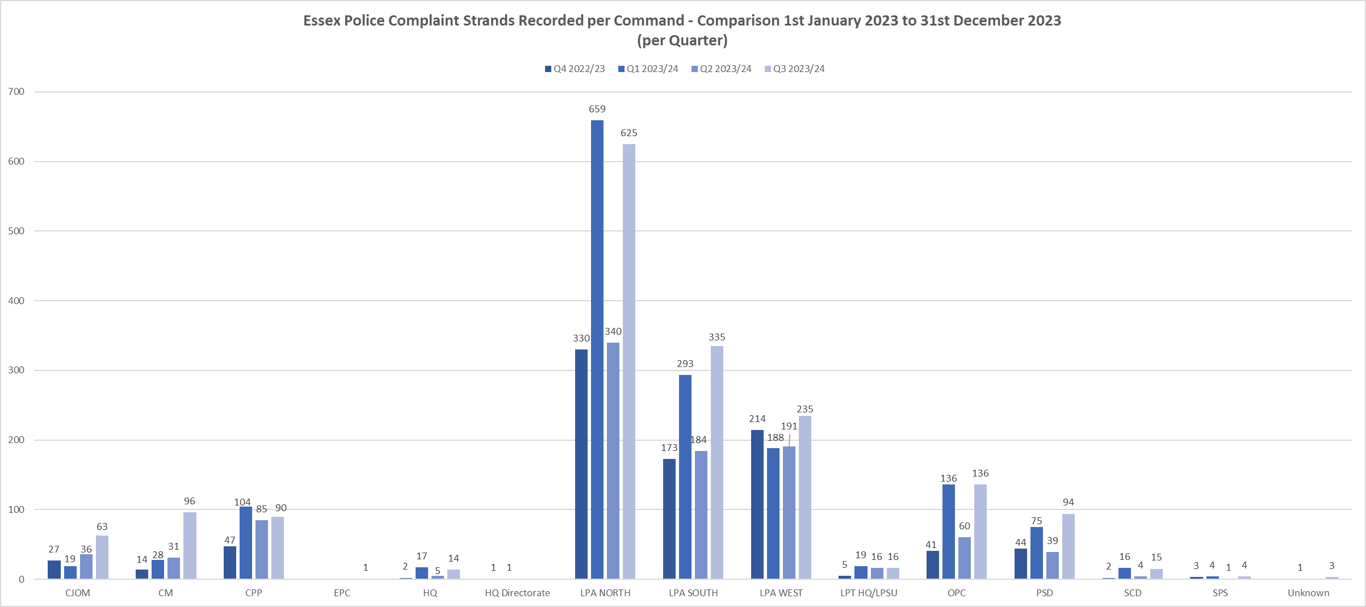

The increase shown in Q3 for strands across commands is partly due to the change in process for recording NS3s, however it is more prominent in the North LPA. The North have recently had two new complainants who are sending in a large quantity of information. They are being assessed by PSD as to if the persistent complainant strategy will need to be implemented. To date one of these complainants has a complaint consisting of 42 strands, as well as other unrelated complaints.

*Ethnicity of Complainants*

*Census Data*

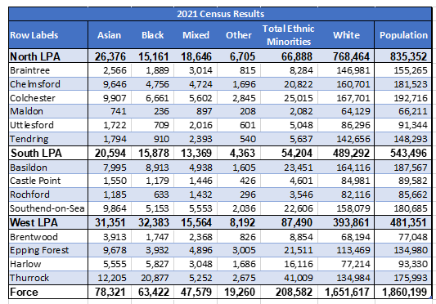

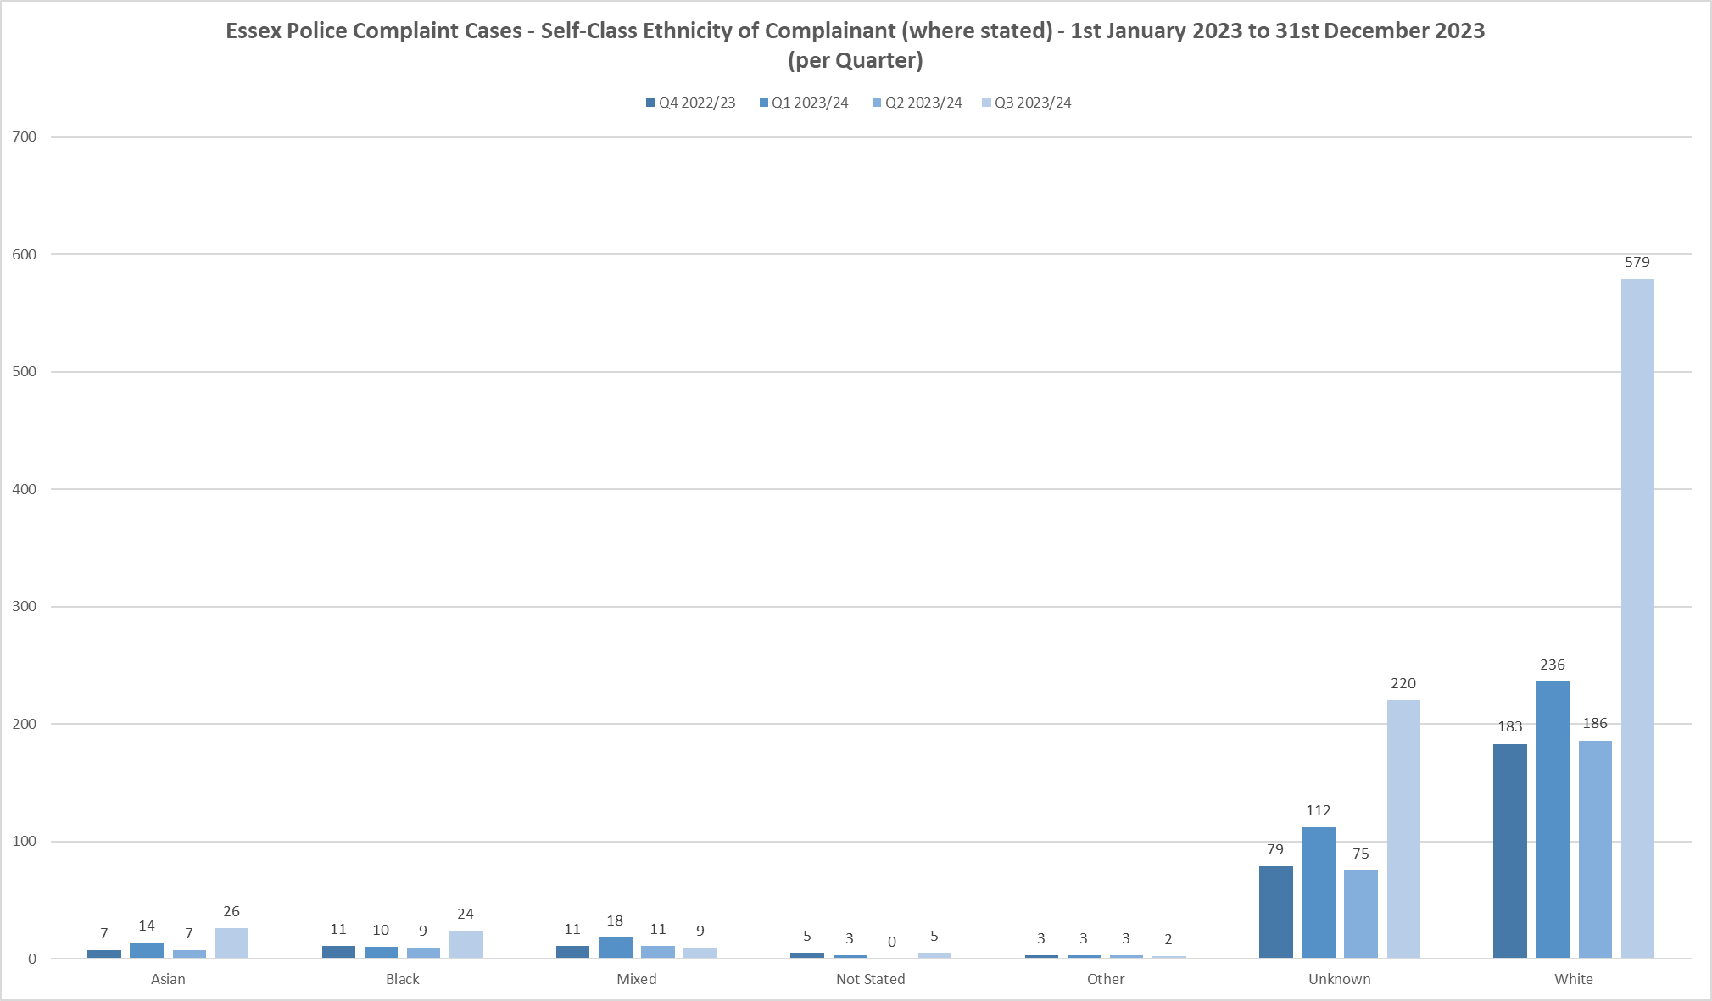

The increase in white complainants is believed to be attributed to the inclusion of NS3 data within this chart. As can be seen from the Census data, a large percentage of residents within Essex are from a white background. The increase in this area and the unknown category would correlate with the increase in numbers recorded. The implementation of the new Single Online Home form allows a more accurate data capture in this area as this field is now mandatory. However, several complainants are choosing “prefer not to say” when completing the form. PSD continue to work with the external IAG to improve public confidence in this area.

*Ethnicity of Complainants*

|  |  |  |  |  |  |  |  |  |  |  |
| --- | --- | --- | --- | --- | --- | --- | --- | --- | --- | --- |
|  | **Black Ethnicity Complaint Strands** | | | | | | | | | |
| **Category** | **Q4** | **%** | **Q1** | **%** | **Q2** | **%** | **Q3** | **%** | **Total** | **%** |
| A – Delivery of service | 15 | 37% | 14 | 48% | 6 | 26% | 13 | 32% | 48 | 36% |
| B – Police Powers, Policy and Procedures | 11 | 27% | 10 | 34% | 8 | 35% | 12 | 30% | 41 | 31% |
| C – Handling of, or Damage to property/premises | 1 | 2% | 2 | 7% | 1 | 4% | 2 | 5% | 6 | 4% |
| D – Access and/or disclosure of information | 0 | 0% | 1 | 3% | 0 | 0% | 0 | 0% | 1 | 1% |
| E – Use of Police Vehicles | 3 | 7% | 3 | 10% | 3 | 13% | 5 | 12% | 14 | 10% |
| F – Discriminatory Behaviour | 11 | 27% | 0 | 0% | 4 | 17% | 8 | 19% | 23 | 17% |
| G – Abuse of Position/Corruption | 0 | 0% | 0 | 0% | 0 | 0% | 0 | 0% | 0 | 0% |
| H – Individual Behaviours | 0 | 0% | 0 | 0% | 0 | 0% | 1 | 2% | 1 | 1% |
| L – Other | 0 | 0% | 0 | 0% | 0 | 0% | 0 | 0% | 0 | 0% |
| **Ethnicity Total** | **41** | **100%** | **29** | **100%** | **23** | **100%** | **41** | **100%** | **134** | **100%** |

|  |  |  |  |  |  |  |  |  |  |  |
| --- | --- | --- | --- | --- | --- | --- | --- | --- | --- | --- |
|  | **Mixed Ethnicity Complaint Strands** | | | | | | | | | |
| **Category** | **Q4** | **%** | **Q1** | **%** | **Q2** | **%** | **Q3** | **%** | **Total** | **%** |
| A – Delivery of service | 19 | 45% | 34 | 45% | 11 | 34% | 8 | 35% | 72 | 49% |
| B – Police Powers, Policy and Procedures | 6 | 14% | 21 | 28% | 13 | 41% | 8 | 35% | 48 | 34% |
| C – Handling of, or Damage to property/premises | 0 | 0% | 1 | 1% | 0 | 0% | 1 | 4% | 2 | 1% |
| D – Access and/or disclosure of information | 0 | 0% | 0 | 0% | 1 | 3% | 0 | 0% | 1 | 1% |
| E – Use of Police Vehicles | 0 | 0% | 0 | 0% | 0 | 0% | 0 | 0% | 0 | 0% |
| F – Discriminatory Behaviour | 6 | 14% | 6 | 8% | 4 | 13% | 3 | 13% | 19 | 13% |
| G – Abuse of Position/Corruption | 11 | 26% | 11 | 15% | 3 | 9% | 3 | 13% | 2 | 1% |
| H – Individual Behaviours | 0 | 0% | 2 | 3% | 0 | 0% | 0 | 0% | 2 | 1% |
| L – Other | 0 | 0% | 0 | 0% | 0 | 0% | 0 | 0% | 0 | 0% |
| **Ethnicity Total** | **42** | **100%** | **75** | **100%** | **32** | **100%** | **23** | **100%** | **146** | **100%** |

|  |  |  |  |  |  |  |  |  |  |  |
| --- | --- | --- | --- | --- | --- | --- | --- | --- | --- | --- |
|  | **Asian Ethnicity Complaint Strands** | | | | | | | | | |
| **Category** | **Q4** | **%** | **Q1** | **%** | **Q2** | **%** | **Q3** | **%** | **Total** | **%** |
| A – Delivery of service | 15 | 54% | 52 | 58% | 26 | 72% | 35 | 53% | 128 | 58% |
| B – Police Powers, Policy and Procedures | 4 | 14% | 9 | 10% | 2 | 6% | 10 | 15% | 25 | 11% |
| C – Handling of, or Damage to property/premises | 1 | 4% | 1 | 1% | 1 | 3% | 2 | 3% | 5 | 2% |
| D – Access and/or disclosure of information | 0 | 0% | 0 | 0% | 0 | 0% | 0 | 0% | 0 | 0% |
| E – Use of Police Vehicles | 0 | 0% | 0 | 0% | 0 | 0% | 0 | 0% | 0 | 0% |
| F – Discriminatory Behaviour | 4 | 14% | 10 | 11% | 3 | 8% | 4 | 6% | 21 | 10% |
| G – Abuse of Position/Corruption | 0 | 0% | 1 | 1% | 0 | 0% | 0 | 0% | 1 | 0% |
| H – Individual Behaviours | 4 | 14% | 17 | 19% | 4 | 11% | 15 | 23% | 40 | 18% |
| L – Other | 0 | 0% | 0 | 0% | 0 | 0% | 0 | 0% | 0 | 0% |
| **Ethnicity Total** | **28** | **100%** | **90** | **100%** | **36** | **100%** | **66** | **100%** | **220** | **100%** |

The numbers remain low in these individual areas with Category A remaining the highest area of complaint strands. Category B complaints from black complainants have remained at a similar level to Category A over this period. This information has been fed back to the Use of Force/Stop and Search Board and a deep dive carried out. At this stage there is no known reason and PSD continue to monitor.

Black Ethnicity

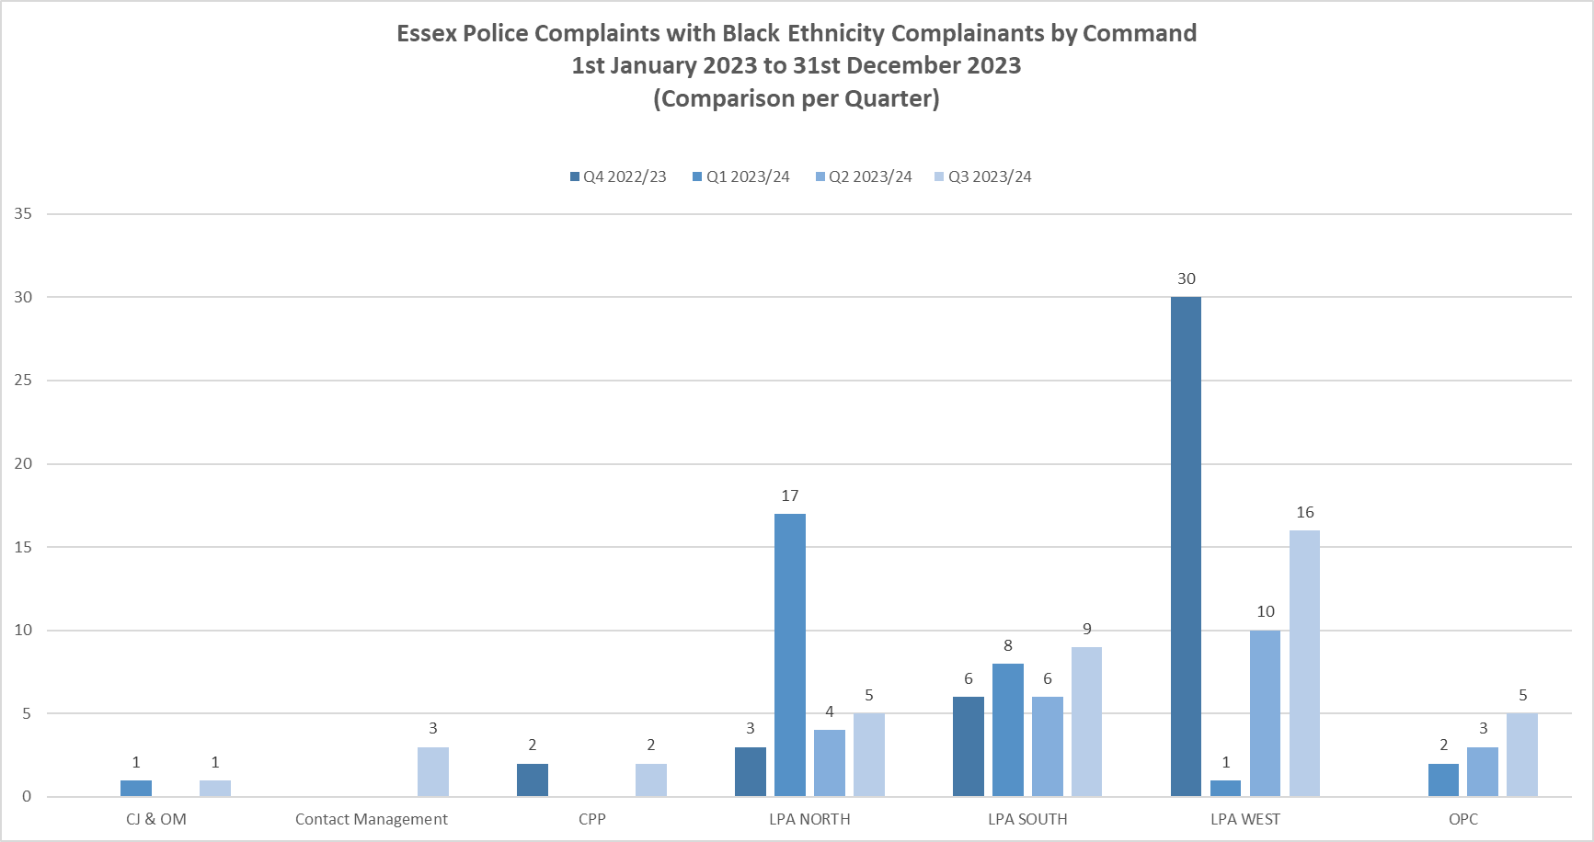

Asian Ethnicity

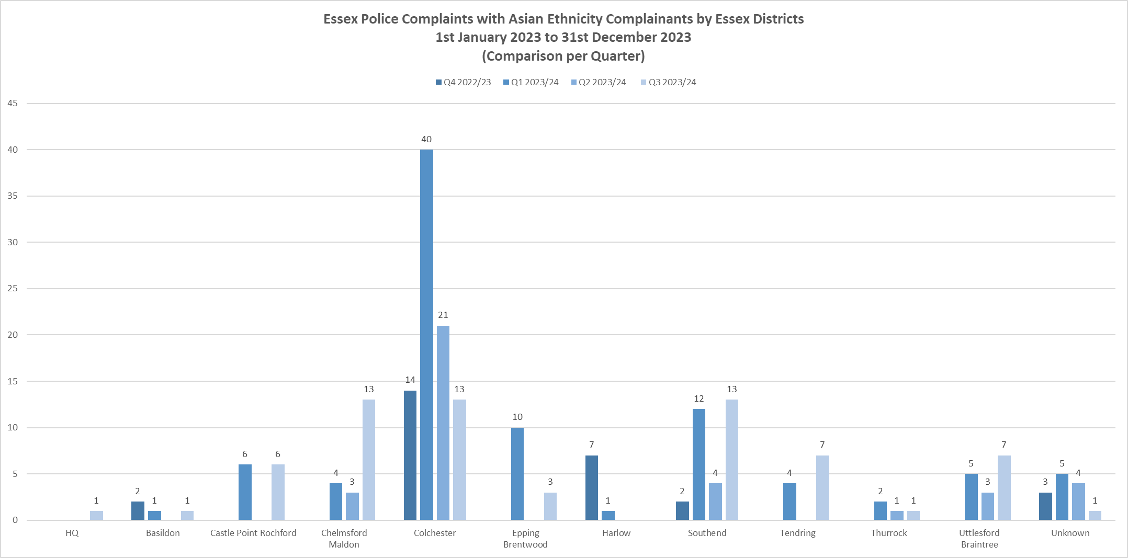

*Categories of Complaints:*



*Category A*

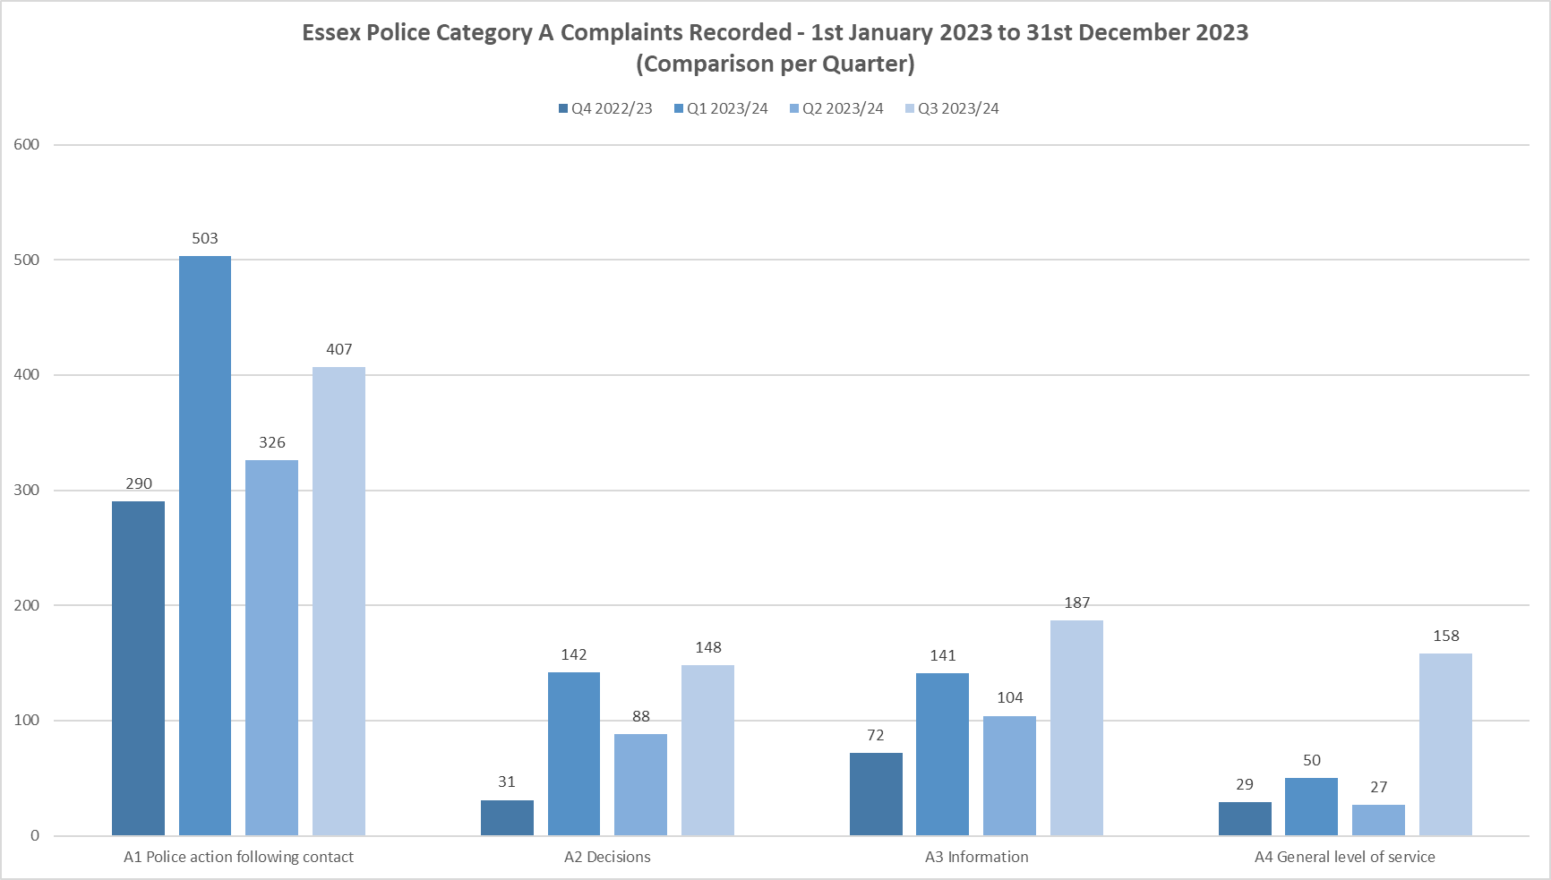

*Category B*

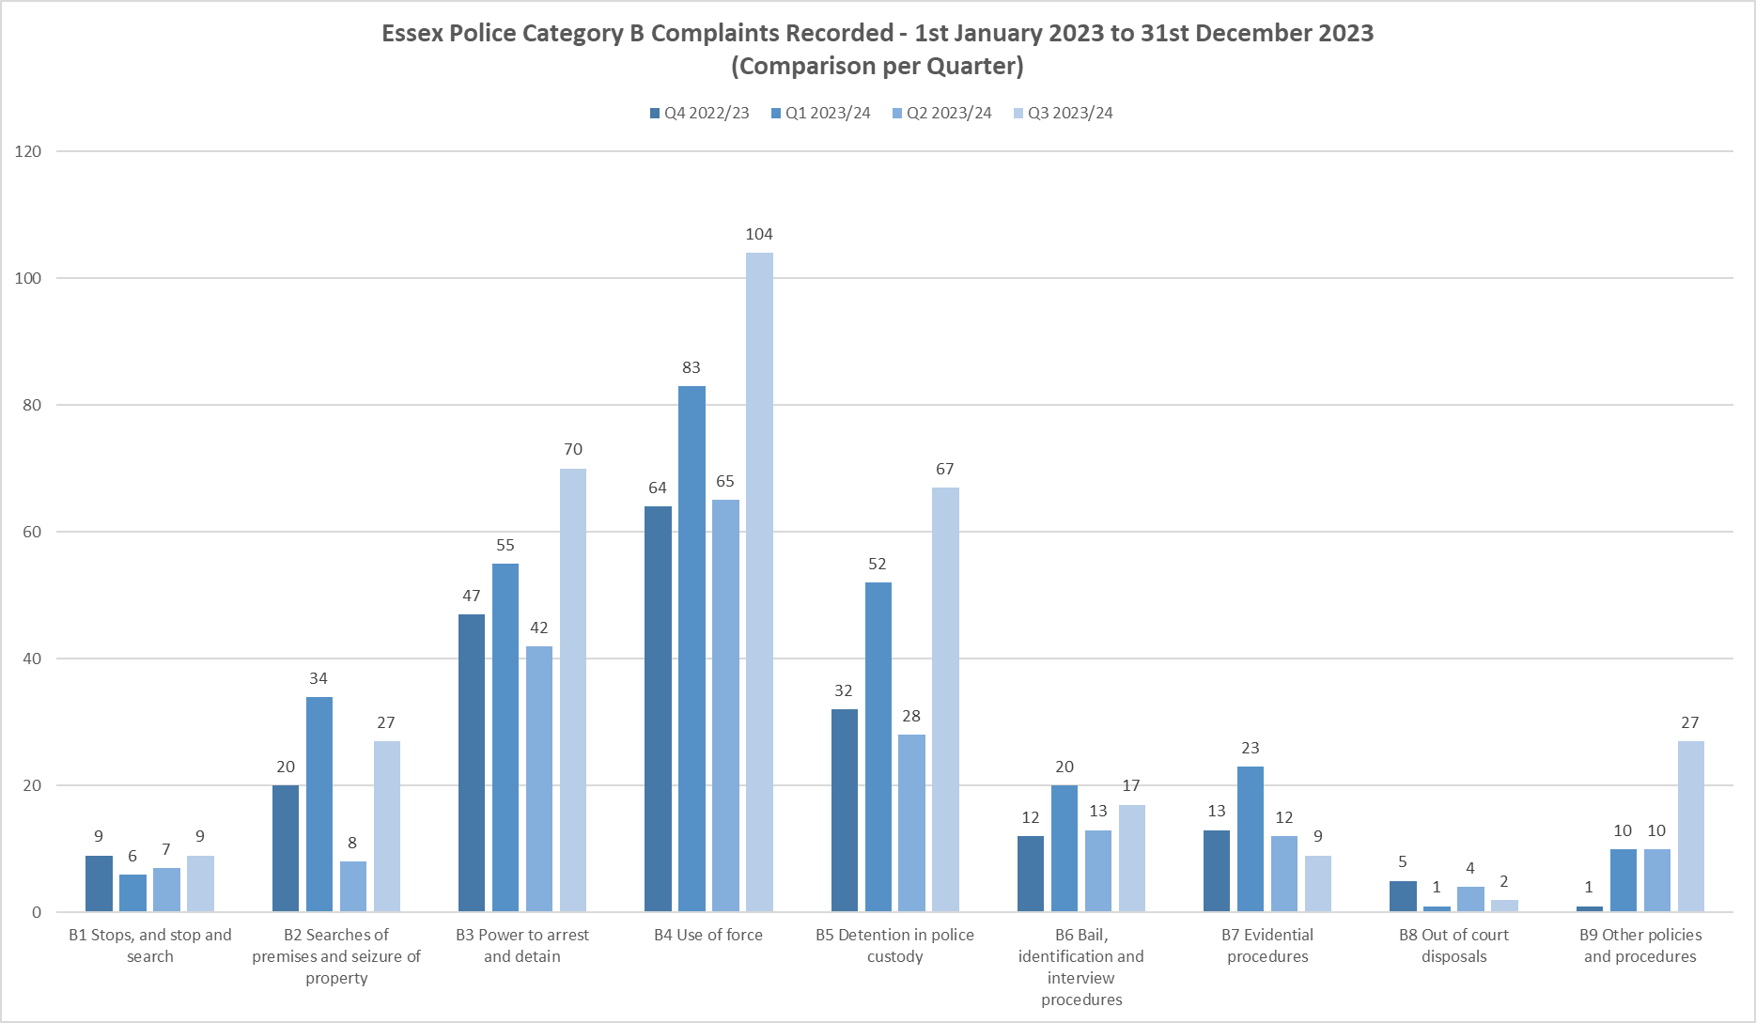

*Category H*

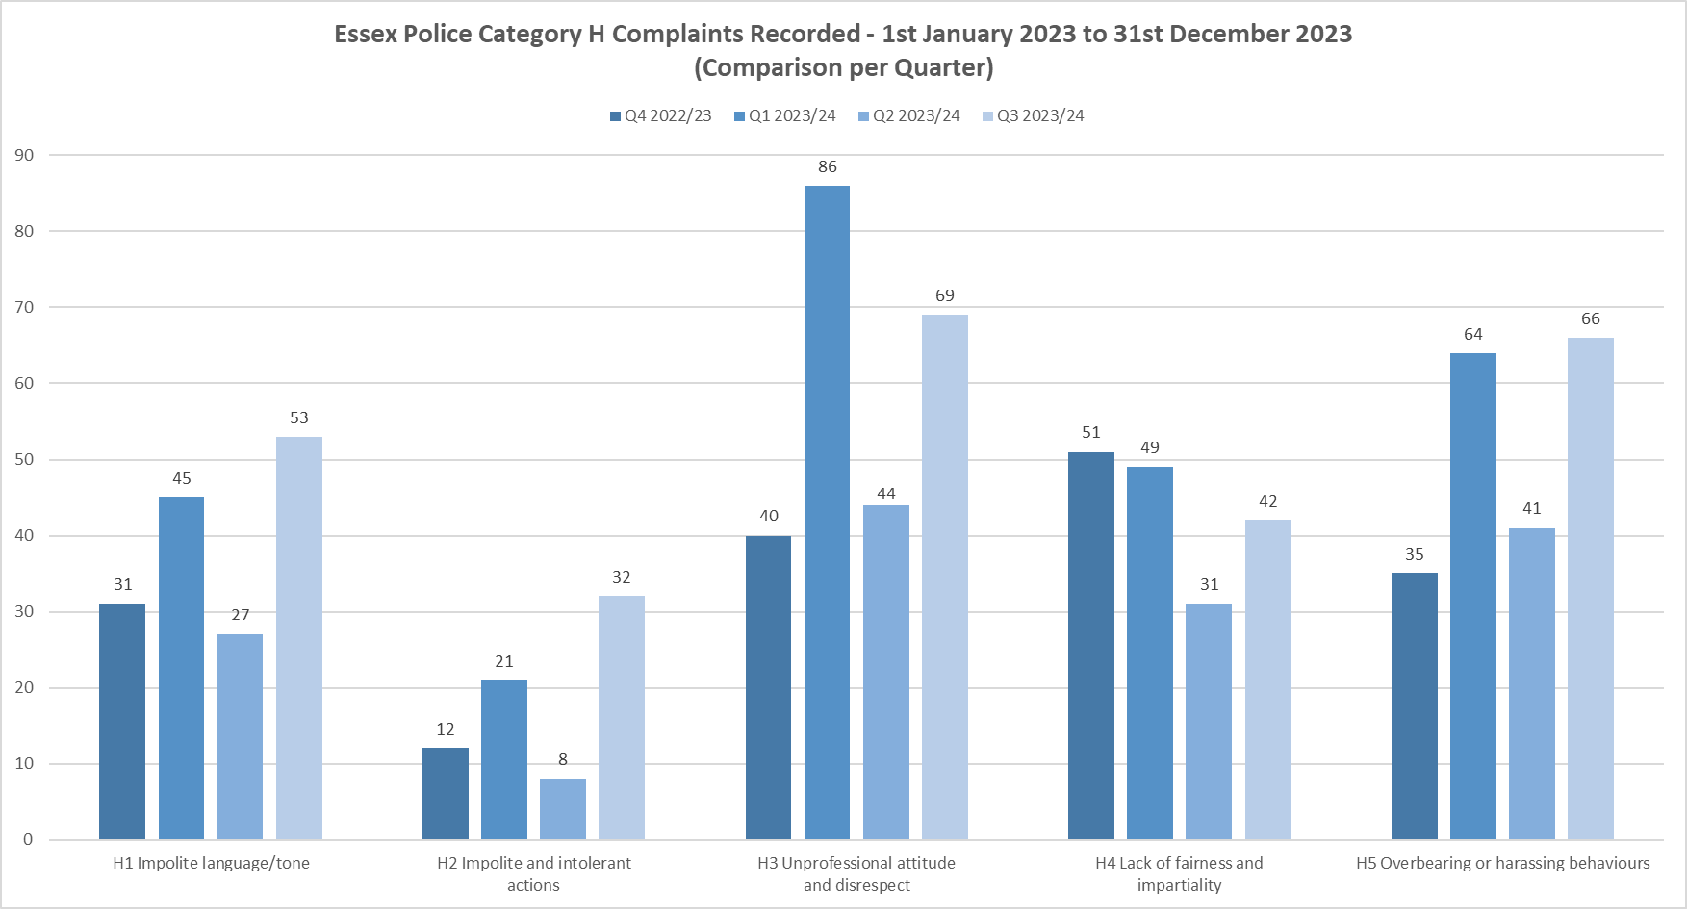

*Category F*

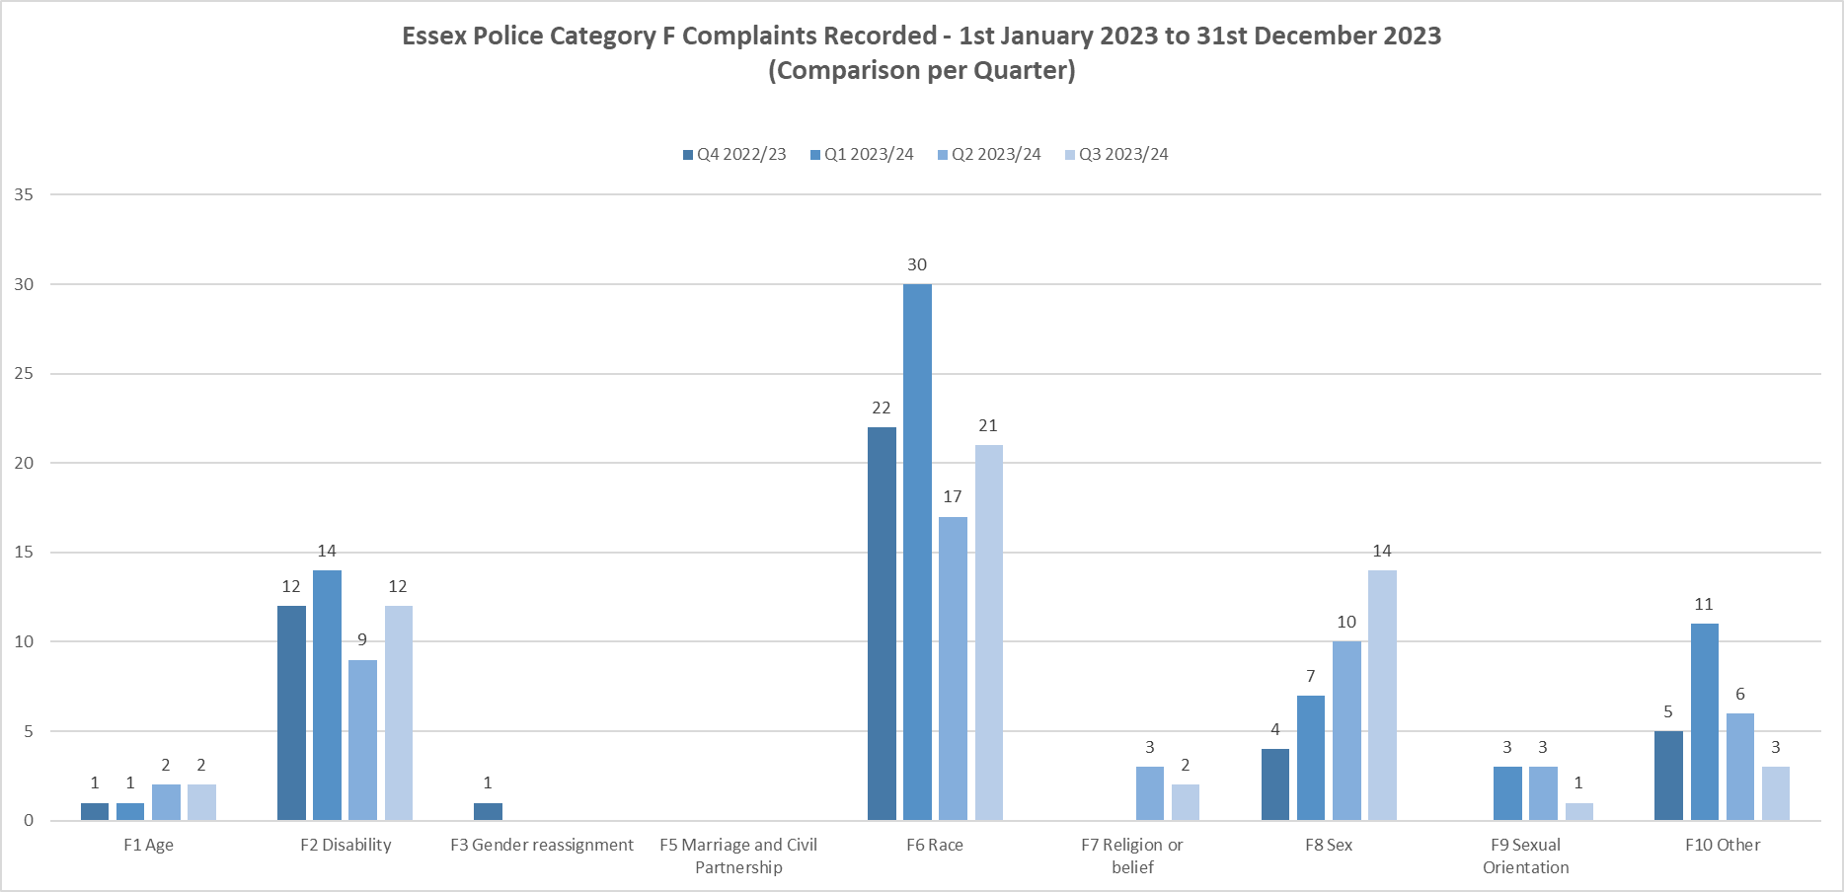

The numbers of strands have increased due to the change in recording method of dissatisfactions. Despite the increase in numbers for Q3, the percentages remain in line with the previous quarters. There is a continued focus on how complaints are stranded out to ensure consistency and correct headers are being used as per the IOPC definitions.

Category B shows an increase in Use of Force, Power to Arrest and Detain and Detention in Police Custody. These areas are usually intrinsically linked to one incident where a complainant has been subject of arrest. Due to the nature of the allegations, Category B complaints are usually formally recorded so the increase noted in Q3 is unlikely to be attributed to the change in process for dissatisfactions. There were 107 complaint cases recorded in this quarter for categories B3, B4 and B5.

Category F8 – Sex Discrimination – has continued to rise this quarter. Out of the 14 strands, 2 have been subject to no further action for being duplicate matters. 11 remain live, 1 outcome has been service level not acceptable. This strand was from a male complainant reporting a domestic abuse allegation against his female partner. It has been deemed unacceptable as the officers did not investigative his allegations proportionately. It is worthy of note that 12 out of the 14 strands are from male complainants. This is an area PSD will continue to monitor.

**Police Officer and Staff Misconduct**

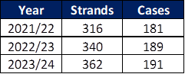

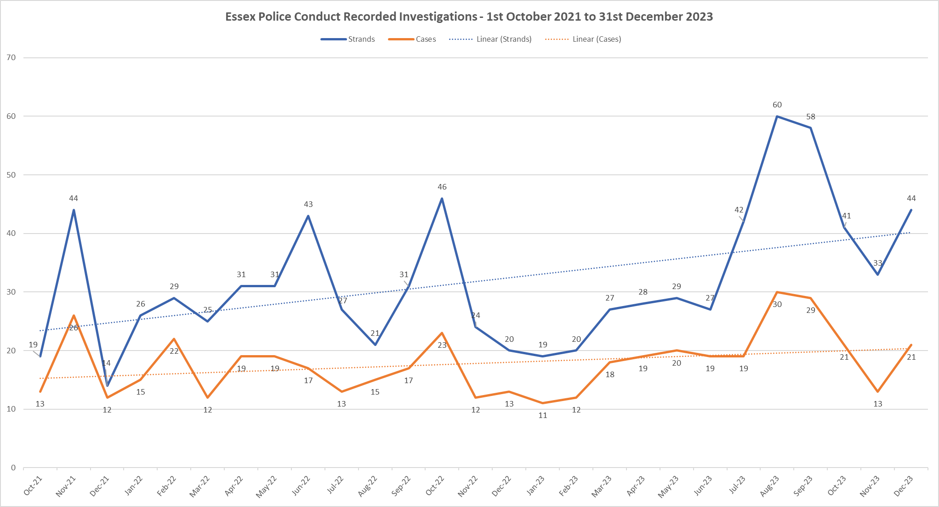

Overall, the total number of conduct strands and cases decreased in Q3 2023/2024 with 21 cases in October with 41 strands and 13 cases in November with 33 Strands and 21 case in December with 44 strands.

Reviewing the previous two years Q3 data, there is generally a dip in conduct recorded in December however there appears to be a rise in December 2023, but not significantly above the Linear trajectory and there is no particular reason for this rise.

The above graph continues to show an upward Trajectory over time.

As the new Prevention and Engagement Team continue to deliver a comprehensive programme of work to encourage reporting and wrongdoing, it is predicted that conduct levels will continue to rise for the short term. This should be seen as a positive, with more people having the confidence to report, and more examples of victims and witnesses feeling like they are believed and supported through the conduct process.

The longer-term ambition remains to see a reduction in conduct cases, with more people being ‘upstanders and not bystanders’, calling out poor behaviour before it escalates into more serious conduct and educating the workforce around the importance of adhering to the Code of Ethics and Standards of Professional Behaviour.

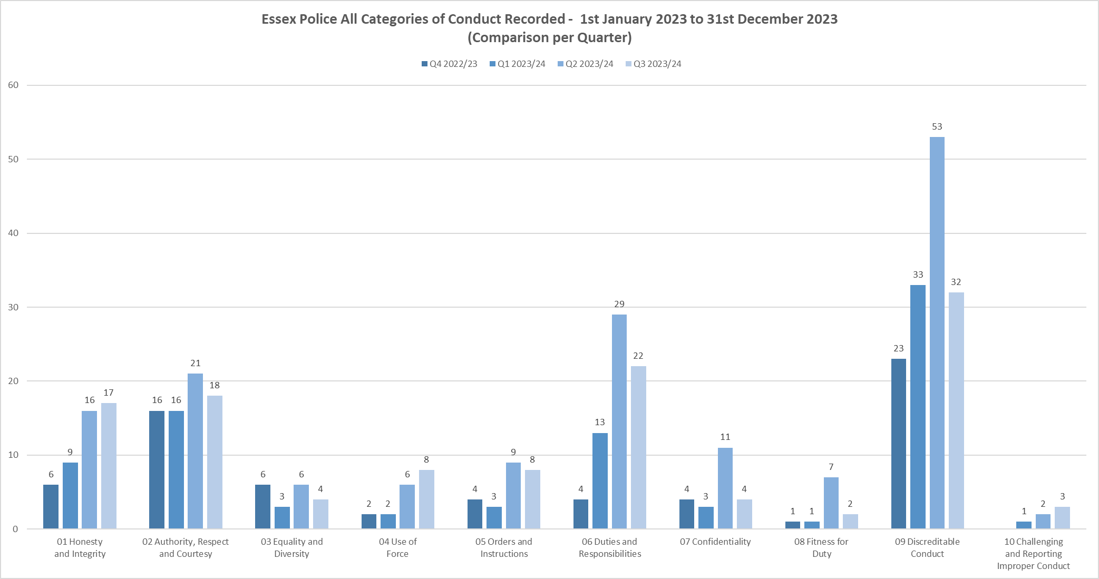

7 Categories have shown a decrease in Q3 which is to be expected given the decrease in cases in October, November and December in comparison to the previous Quarter.

There are slight increases in Honesty and Integrity (1), Use of Force (2) and Challenging and reporting Improper Conduct (1). Discreditable conduct has significantly reduced (21) however there are no clear pattern but it is indicative of the reduction in cases for the Quarter.

With regards to Duties and Responsibilities, there has been a decrease however this is not significant and remains considerably higher than Qtr 4 2022/20 and Qtr 1.

**Breakdown of types of conduct cases**

The below tables categorise the type of cases currently being investigated by PSD, the first table being ‘non VAWG related’ and the second being ‘VAWG related’.

There has been a considerable increase in driving offences and DPA Breaches in comparison to Q1.

The reason for the increase in driving related conduct cases is due to a new process, which involves the PSD DCI meeting regularly with the Driving School to discuss cases and consider which ones amount to conduct. This previously didn’t occur, and it is believed some matters were dealt with as performance and driving related as opposed to conduct.

All PSD data is shared with the Essex Police College to help inform and shape future training and education in this area.

There is no identified pattern or trend regarding DPA breaches and each case is disparate in nature.

**Non VAWG related**

|  |  |
| --- | --- |
| Non-VAWG cases type | 68 |
| Dishonesty - Operational Matter | 11 |
| Dishonesty - Non-operational Matter | 8 |
| Driving matter | 10 |
| Inappropriate comments or behaviour | 8 |
| DPA & Confidentiality related matters | 7 |
| Use of Force | 7 |
| Failure in investigation | 3 |
| Fraud | 4 |
| With Cause Drugs Test/Substance misuse concerns | 3 |
| Theft | 2 |
| Physical assault & Public Order | 2 |
| Supply of a controlled substance | 1 |
| Dangerous Dogs related offence | 1 |
| DA - Physical assaults, Harassment, Coercive & Controlling Behaviour & other offences | 1 |

**VAWG related**

|  |  |
| --- | --- |
| VAWG cases type | 69 |
| DA - Sexual offences - Sexual assault & Rape | 13 |
| DA - Physical assaults, Harassment, Coercive & Controlling Behaviour & other offences | 10 |
| Inappropriate behaviour toward other EP Personnel | 13 |
| Sexual offences - Sexual assault & Rape (Non-DA) | 15 |
| Inappropriate behaviour towards MOP | 3 |
| Misconduct in a Public Office | 5 |
| Use of Force | 3 |
| Failure to correctly investigate a DA incident/sexual offence | 3 |
| Inappropriate relationship with a Member of the Public | 2 |
| Physical assaults & Public Order (Non-DA) | 2 |
| Perverting the course of justice | 1 |

The higher number of cases shown above pertain predominantly to officers/staff accused of criminal offences and/or misconduct against an intimate partner, ex-partner or colleague. The much lower numbers depicted above predominantly pertain to allegations against members of the public.

Further analysis below has been conducted around VAWG offences and misconduct to show the age range of officers/staff accused, their geographical location, age and length of service.

The data supports that officers/staff aged between the ages of 19-39 represent a higher percentage of cases and those who are younger in service. Most cases pertain to officers based in Local Policing Areas, which is where the majority of younger and less in service officers are based.

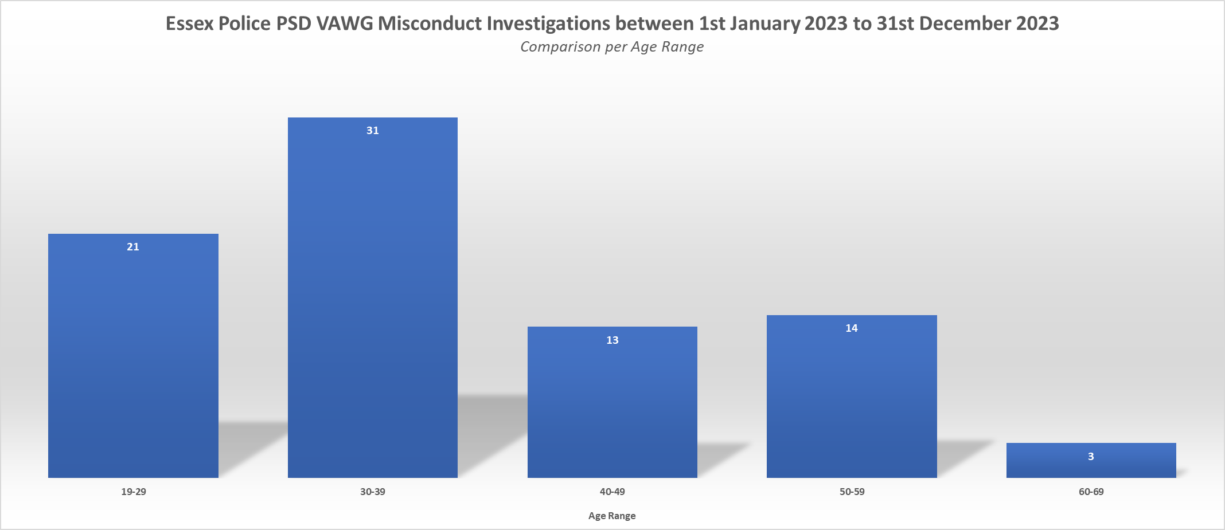

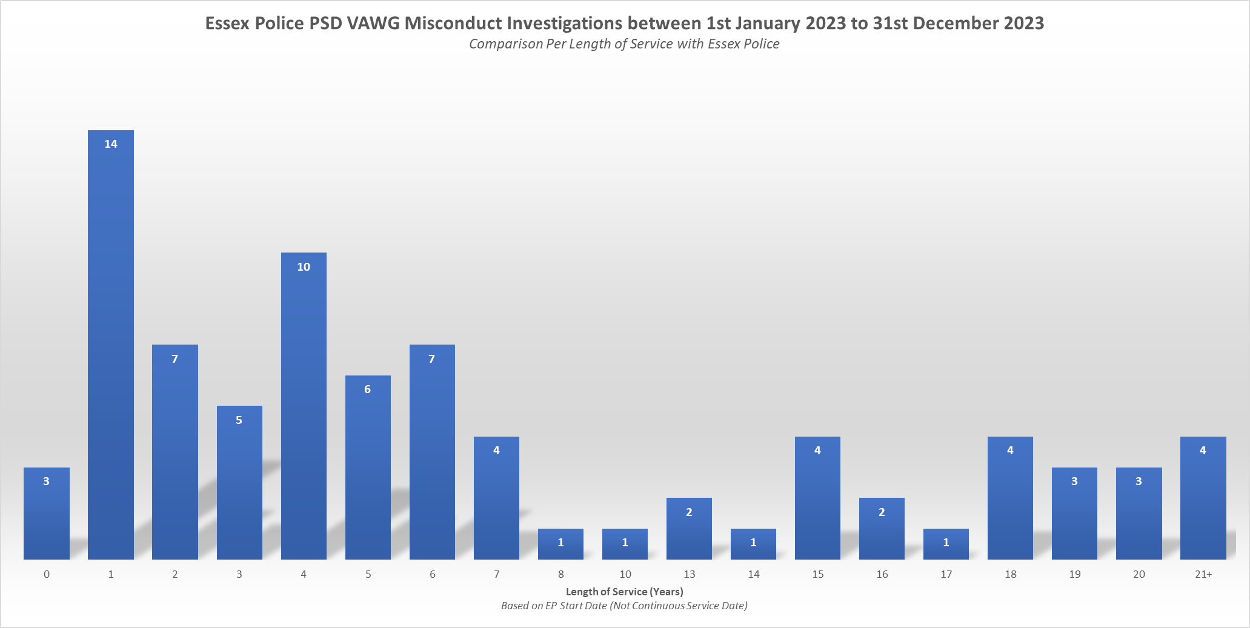

Essex Police continues to take all forms of violence and intimidation against women and girls extremely seriously and will always take positive action in support of victims and witnesses. The new Prevention and Engagement Team have a real focus on VAWG related behaviours and deliver training and education packages. Since July 2023 the team have reached over 1600 frontline officers.

.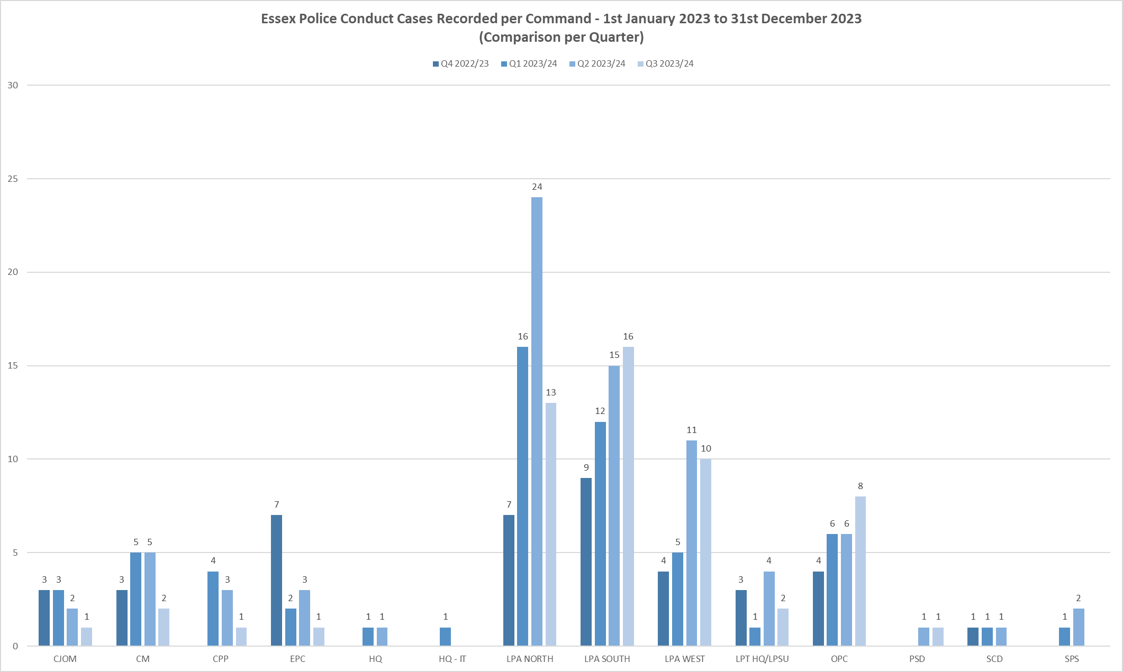



Q3 has seen a decrease in misconduct cases in the North and South and a slight increase in the West LPA of 1. Most other commands have remined stable with the exception of OPC which has seen an increase compared to previous quarters.

**Misconduct Outcomes per Case**

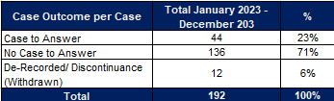

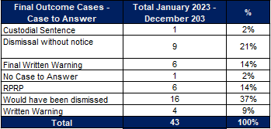

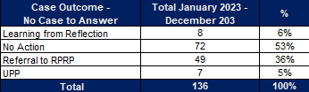

71% of cases investigated by PSD result in no case to answer. However, 47% still resulted in some form of learning or performance issues being identified. This percentage remains consistent and is largely due to the low threshold in which PSD have adhere to in accordance with the Conduct Regulations and Home Office Guidance. In short, if there is ‘an indication’ of conduct, an investigation must take place, and that indication must not soley take into account the evidence immediately available, and only the seriousness of the allegation if proven.

Where there has been a case to answer, 37% would have been dismissed if they had not already resigned. 21% were Dismissed without notice and only 2% had no case to answer suggesting that the right cases are being pursued by PSD.

**Suspensions and Restrictions**

There are currently 41 Officers / Staff Suspended and 53 Officers/Staff Restricted.

Of those suspended 37 are Officers.

Of those Restricted 10 are Staff members.

Of those Officers suspended, 8 are from the South LPA and 13 are from the North LPA.

Of those Officers restricted, 18 are from the North LPA and 10 are from the South LPA.

Of those Staff restricted, 6 are from Contact Management.

Suspensions are reviewed every month by the Deputy Chief Constable, who is provided with an investigative update and considers whether the suspension is still necessary and proportionate in order to maintain trust and confidence in policing and prevent any interference with the investigation.

The following table shows the 3 longest suspended officers -



99/20 – relates to an officer charged with a criminal offence and is awaiting trial – Trial booked for 26/02/24.

98/21 – relates to an officer whose misconduct hearing has been part heard and adjourned twice for reasons outside the control of PSD - recommences for 3/03/24.

78/21 – relates to an officer whose misconduct hearing has been adjourned due to a legal argument around expert witness evidence – recommences 20/03/24.

**IOPC/ OPFCC**

*IOPC Referrals*

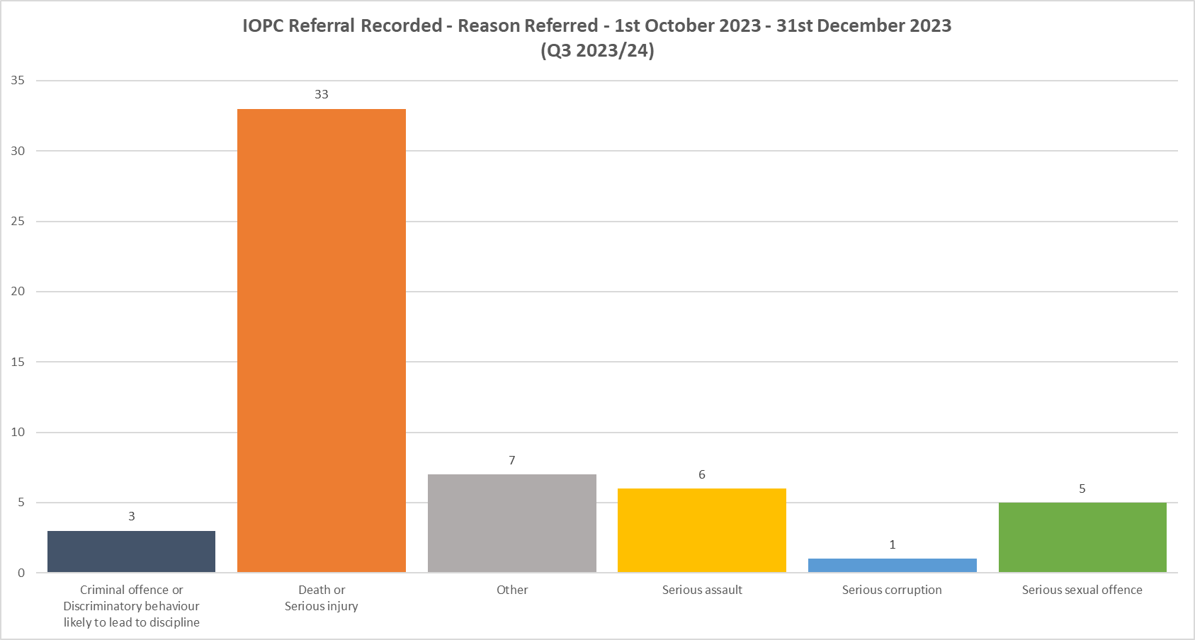

DSIs remain the highest area for referrals. This is continually reviewed to ensure they are valid, and PSD are currently working with the IOPC to standardise the referral process across the department.

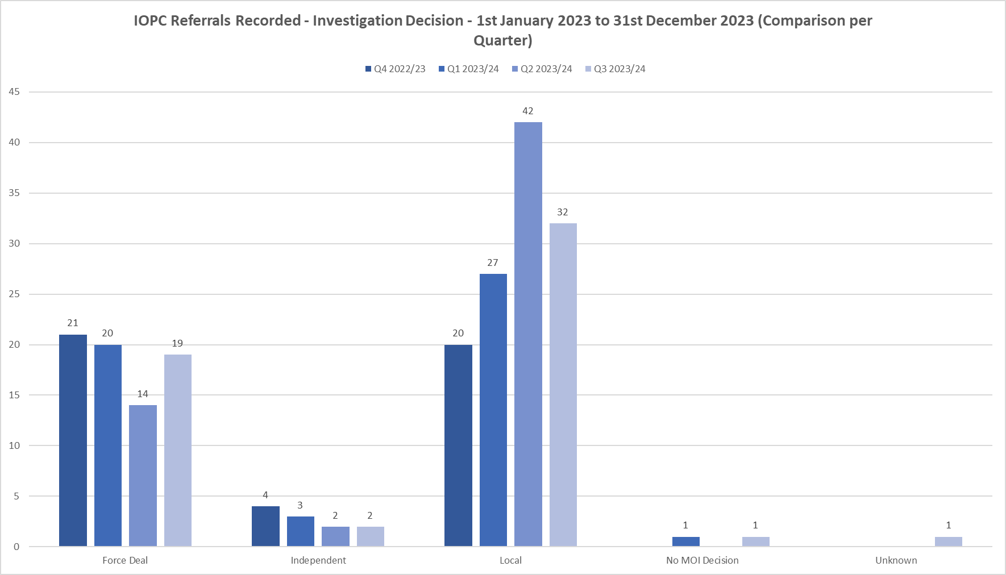

*IOPC Reviews*

|  |  |
| --- | --- |
| **Financial Year** | **IOPC Reviews** |
| 2018/2019 | 74 |
| 2019/2020 | 52 |
| 2020/2021 | 31 |
| 2021/2022 | 79 |
| 2022/2023 | 131 |
| 2023/2024 | 82 |

*Timeliness of IOPC reviews*

|  |  |
| --- | --- |
| **Quarter** | **Average days** |
| **Q4** | 182 |
| **Q1** | 167 |
| **Q2** | 155 |
| **Q3** | 160 |

*NB – this data is based on the review end date, not the date the review was received.*

|  |  |
| --- | --- |
|  |  |

*Reviews to the OPFCC*

|  |  |  |  |  |
| --- | --- | --- | --- | --- |
| **Quarter** | **Outstanding** | **Upheld** | **Not upheld** | **Invalid/Withdrawn** |
| **Q4** | 0 | 3 | 26 | 2 |
| **Q1** | 4 | 1 | 15 | 2 |
| **Q2** | 12 | 0 | 5 | 1 |
| **Q3** | 22 | 0 | 0 | 1 |

*NB – this data is based on the date the review was requested not the date the outcome was received.*

|  |  |  |  |  |  |
| --- | --- | --- | --- | --- | --- |
|  |  | **White Complainants** | **Black Complainants** | **Mixed Ethnicity** | **Asian** |
| **Quarter** | **Total OPFCC Review Cases** | **Review requests** | **Review requests** | **Review requests** | **Review requests** |
| **Q4 – 2022/23** | 29 | 62% | 3% | 3% | 3% |
| **Q1 – 2023/24** | 20 | 72% | 0% | 28% | 0% |
| **Q2 – 2023/24** | 16 | 87.5% | 0% | 0% | 6.25% |
| **Q3 – 2023/24** | 13 | 84% | 8% | 8% | 0% |

*NB – Unknown ethnicity data has not been used in these figures.*