**Quarterly Report – Complaints, Misconduct and Other Matters**

**Contact – D/Supt Scott Cannon**

**Purpose of Report**

This report outlines the data and performance of Complaints, Misconduct and other matters that have been processed up to 30th June 2023 by the Professional Standards Department (PSD).

**Recommendations**

That the Commissioner considers the report and raises any queries though the quarterly meeting with the Deputy Chief Constable.

**Introduction**

The Complaint and Misconduct data used for this report is generally per strand in a case, except for where otherwise stated. It does not cover each officer allegation within a complaint.

For example, an overall complaint or misconduct case number is likely to include more than one complaint/misconduct strand or category – the data used reflects the separate strands. There will often be multiple officers subject to a complaint strand. The latter is at times reflected in this data, where it is noted as such.

Caveats:

Complaints and Misconduct data includes those that were de-recorded/withdrawn.

Data is dependent on certain fields being accurate – for example, when considering Commands/Area Responsible – due to changes in structures within the force, and due to changes within commands, numbers may be skewed compared to other reporting.

This data uses the Area Responsible as recorded initially for Cases; this will not reflect the individual complaint strands and officer allegations which will often be across different commands and areas.

Commands:

The table details the Commands across Essex Police and the abbreviations that will be used to refer to them throughout the report.



**Public Complaints**

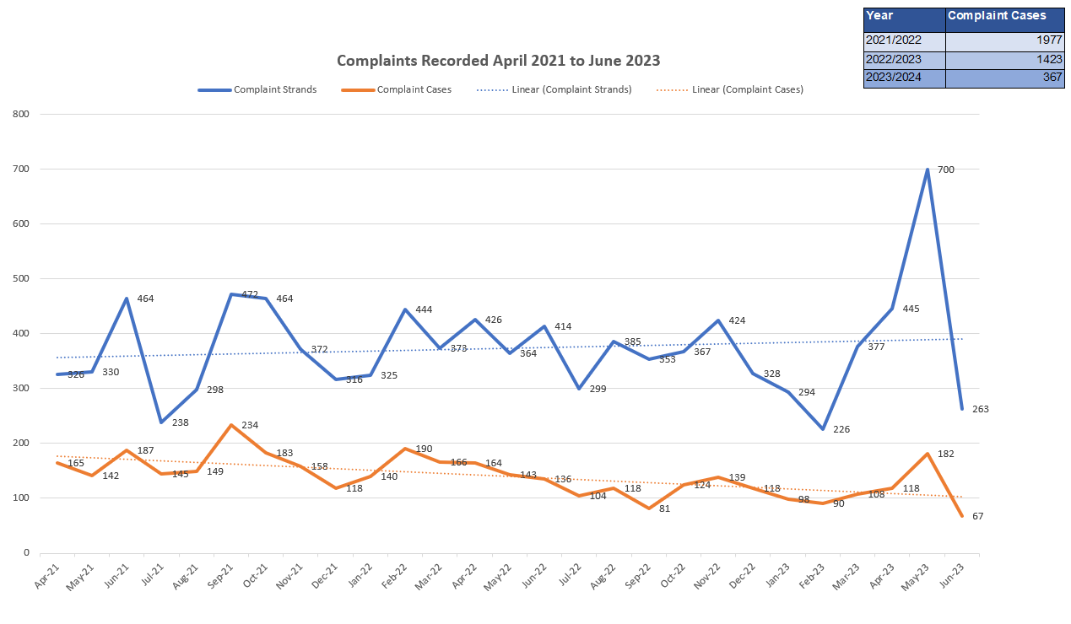

*Outcome of Complaints:*

|  |  |  |  |  |  |  |  |  |
| --- | --- | --- | --- | --- | --- | --- | --- | --- |
| Case outcome of Complaints – Finalised Cases | Q2 2022/23 | % | Q3 2022/23 | % | Q4 2022/23 | % | Q1 2023/24 | % |
| Resolved | 292 | 60% | 149 | 37% | 160 | 37% | 93 | 31% |
| The service provided was acceptable | 115 | 23% | 156 | 40% | 197 | 45% | 140 | 46% |
| The service provided was not acceptable | 36 | 8% | 36 | 9% | 38 | 9% | 36 | 12% |
| Withdrawn | 6 | 1% | 10 | 3% | 6 | 1% | 8 | 3% |
| Other | 37 | 8% | 42 | 11% | 37 | 8% | 23 | 8% |
| Total | 486 | 100% | 393 | 100% | 438 | 100% | 300 | 100% |

*Timeliness of Complaints*

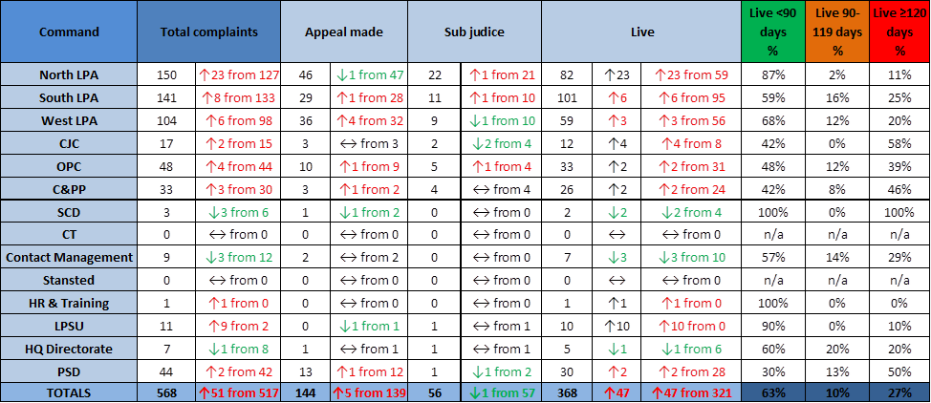

*Command Breakdown of Complaints:*

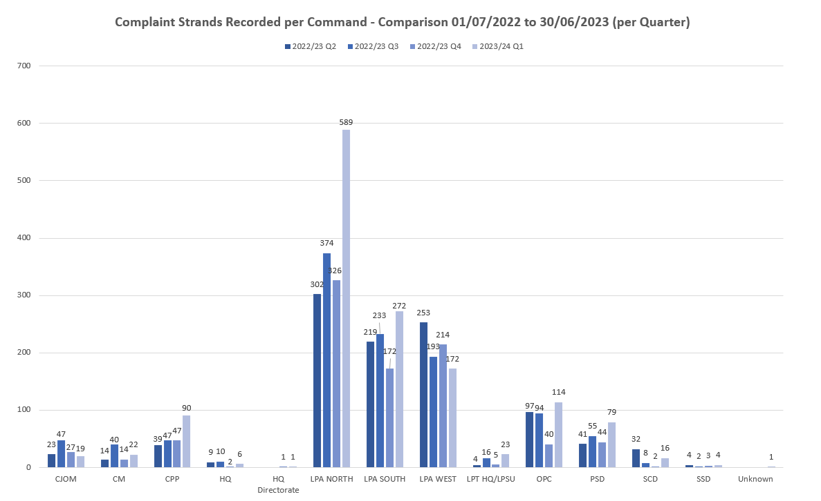

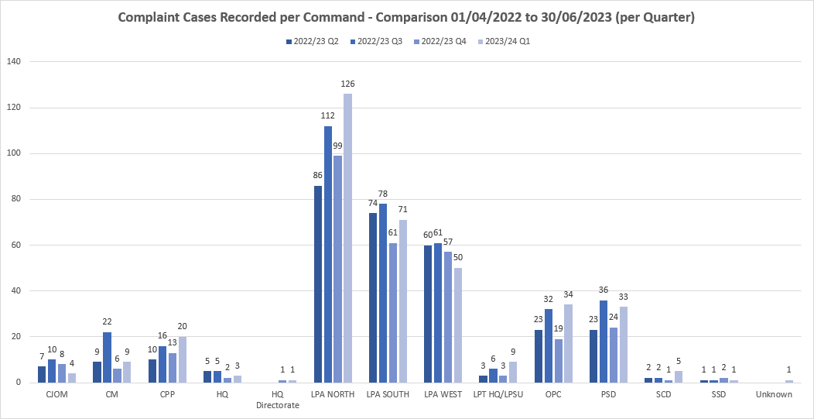

*Ethnicity of Complainants*

*Census Data*



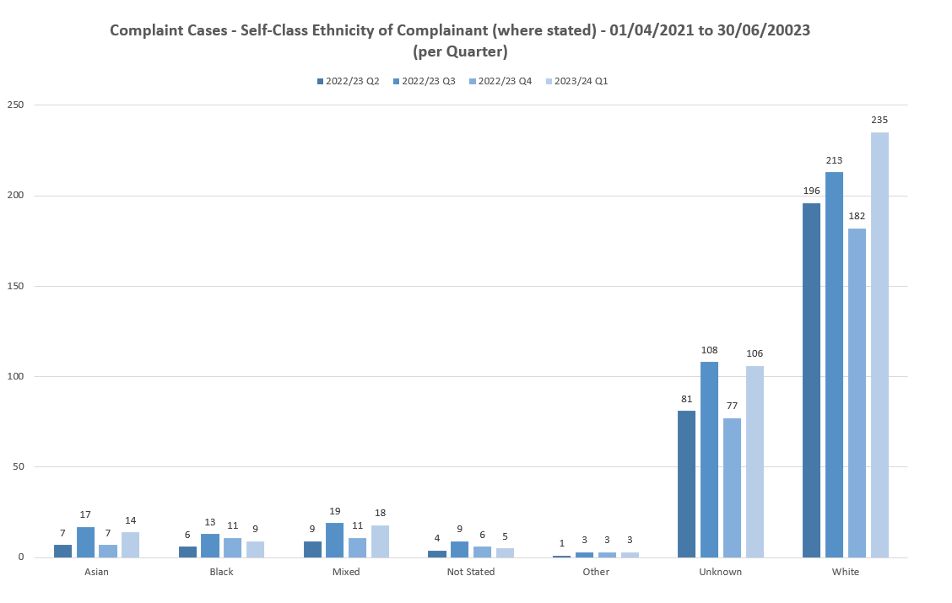

*Ethnicity of Complainants*



Black Ethnicity Group

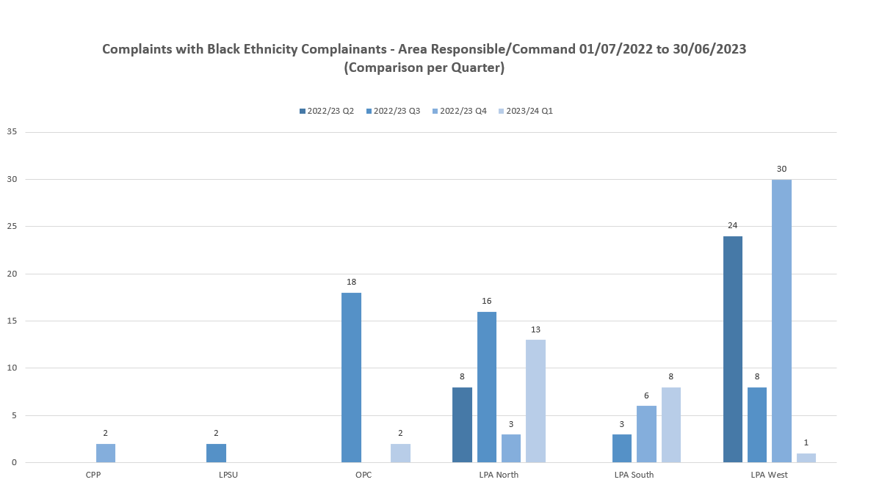

Asian Ethnicity Group

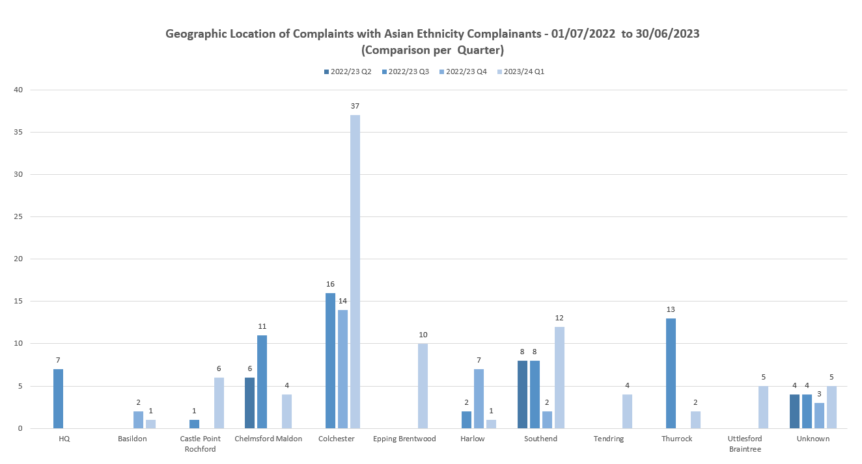

*Categories of Complaints:*



*Category A*

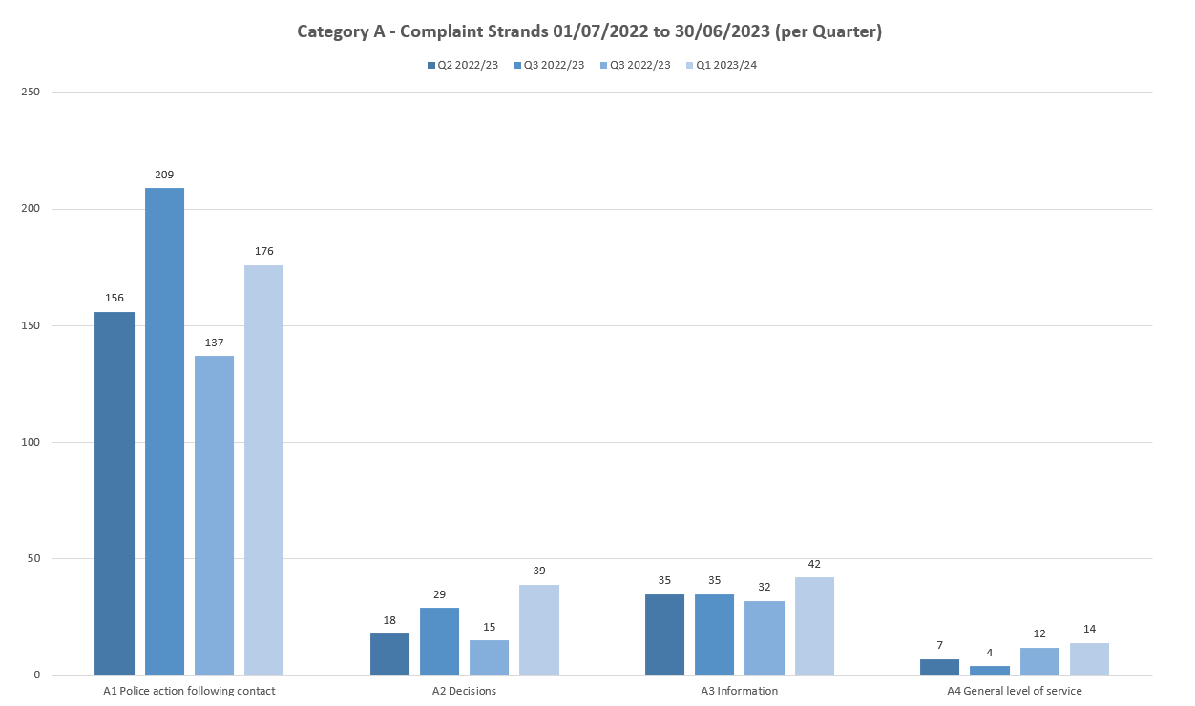

*Category B*



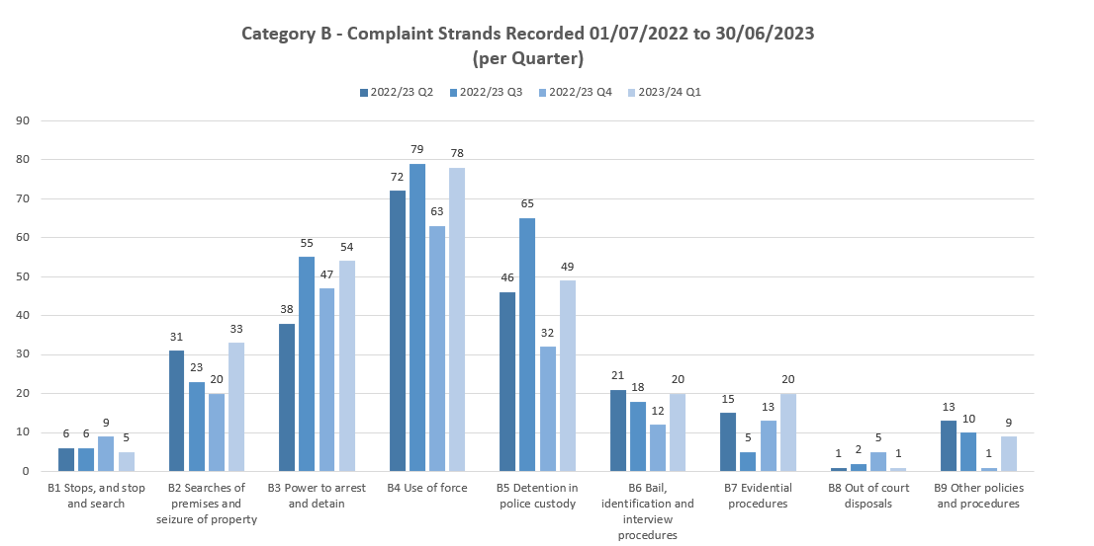

*Category H*

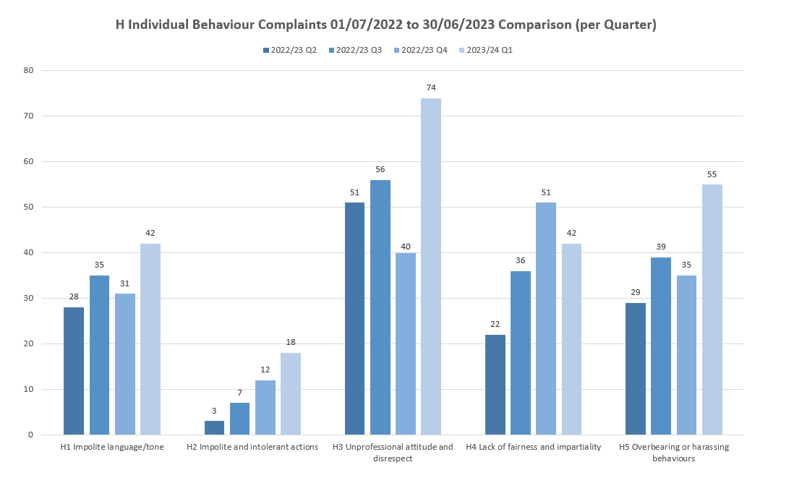

*Category F*



*Complaints – Key findings and points of note:*

* During May 2023 there was a sudden spike in recording. Due to some unforeseen sickness within a very small team, outstanding complaints awaiting assessment and recording built up, giving rise to a concerted and bespoke funded operation to get the backlog down. This resulted in a large volume of complaints being recorded within a short period of time. Backlogs are now manageable with business as usual resumed.
* The timeliness data shows an increase in live complaints due to the recording increase, however at this time it is not impacting complaints exceeding 90 and 120 days. This may show in the Q2 report as there were a large number of complaints being allocated in the same period of time.
* It is also worthy of note the IOPC backlog when it comes to appeals and the impact this has on timeliness. If the IOPC have had an appeal for a long period of time, when it is returned to force with recommendations it will show overdue.
* Ethnicity data shows similar numbers. Those with unknown ethnicity has increased, partly attributed to the increase in recording for Q1. Ongoing work continues to improve this figure including the implementation of the QR code.
* The West LPA has shown a significant decrease in complaints from Black Complainants, dropping from 30 in Q4 to 1 in Q1.**Awaits West Response**
* Data for Asian Complainants shows a peak in Colchester in Q1. This is due to a persistent complainer in this area who is Asian.
* The sexual assault category for complaints has risen from 2 in Q4 to 6 in Q1. Whilst this is still a low number, it is triple the number for previous quarters. These complaints have been reviewed. One complaint is fantastical in nature and conducive with a complainant suffering with significant mental ill health. There are 2 which are duplicates, 1 has been withdrawn as it was incorrectly recorded, 1 awaits a method of investigation decision from the IOPC. The final one has been identified as a conduct issue and is being investigated by PSD.
* Other reporting levels are in keeping with previous reports.

**Police Officer and Staff Misconduct**

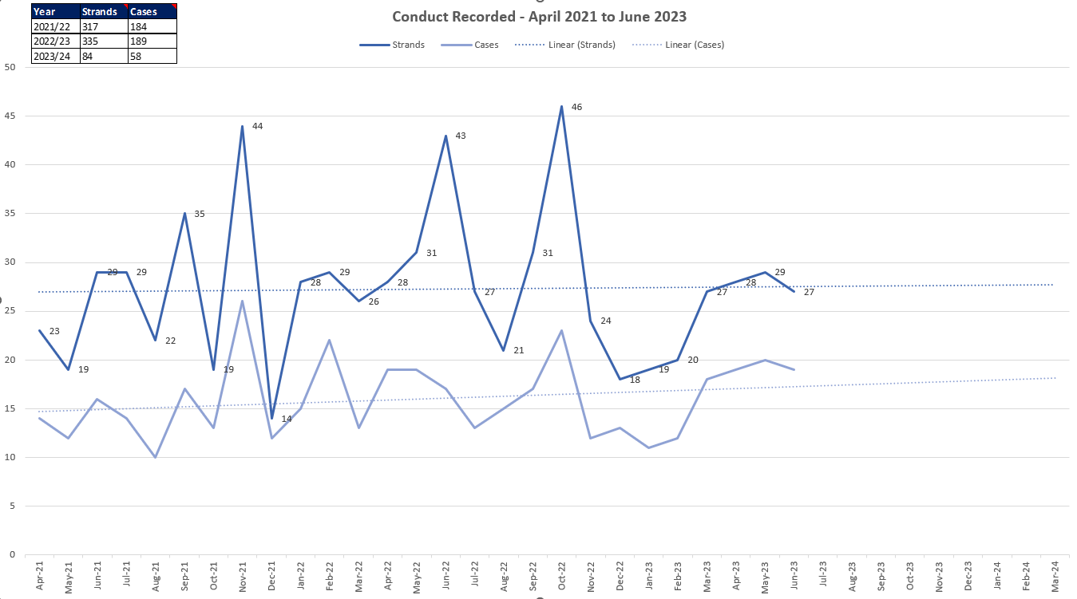

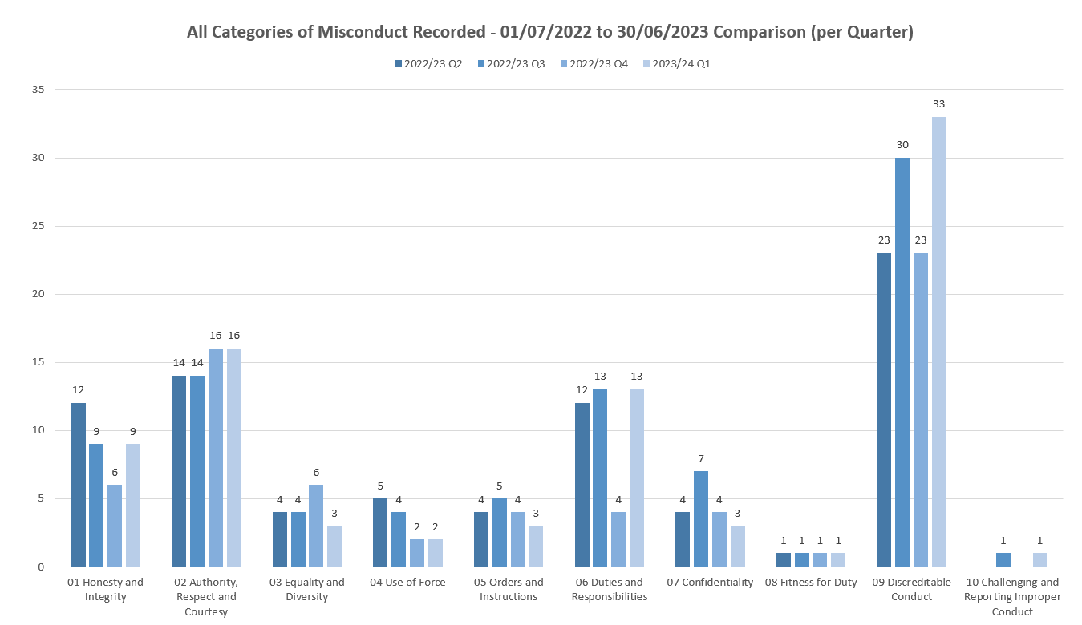

Conduct per LPA/ Command

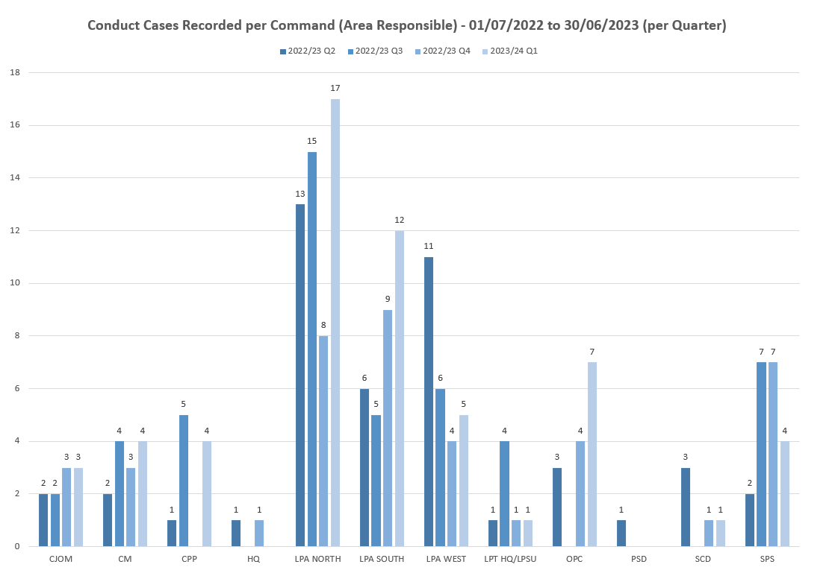



Breakdown of types of conduct cases (as of 24/07/2023)

|  |  |
| --- | --- |
| **Non VAWG** |  |
| **Non-VAWG cases type** | **Number** |
| **Total number** | **50** |
| Dishonesty - Non-operational Matter | **11** |
| Dishonesty - Operational Matter | **5** |
| Inappropriate comments or behaviour | **8** |
| DPA Breach | **5** |
| Failure in investigation | **5** |
| Driving matters | **5** |
| Drugs misuse | **3** |
| Use of Force | **2** |
| Offensive weapons | **1** |
| Criminal associations | **1** |
| Dangerous Dogs | **1** |
| Inappropriate Tattoo | **1** |
| Theft | **1** |
| Physical assault | **1** |

**VAWG**

|  |  |
| --- | --- |
| **VAWG cases type** | **Number** |
| **Total number** | **51** |
| DA - Physical assaults, Harassment, Coercive & Controlling Behaviour & other offences | **14** |
| DA - Sexual offences - Sexual assault & Rape | **7** |
| Sexual offences - Sexual assault & Rape (Non-DA) | **7** |
| Child Abuse - IIOC & grooming offences | **1** |
| Child Abuse - Physical assaults | **1** |
| Inappropriate behaviour toward other EP Personnel | **10** |
| Failure to correct investigate a DA incident | **4** |
| Misconduct in a Public Office | **3** |
| Inappropriate relationship with a Member of the Public | **2** |
| Perverting the course of justice | **1** |
| Use of Force | **1** |

Misconduct Outcomes per Case







Suspensions/ Restrictions

Suspension

|  |  |  |
| --- | --- | --- |
| Length of time | Officers | Staff |
| 0-3 months | 9 | 1 |
| 3-6 months | 4 | 1 |
| 6-9 months | 4 | 1 |
| 9-12 months | 2 | 0 |
| 12-15 months | 1 | 0 |
| 15-18 months | 4 | 0 |
| 18-21 months | 0 | 0 |
| 21-24 months | 2 | 0 |
| Over 2 years | 2 | 1 |
| Total | 28 | 4 |

Restrictions

|  |  |  |
| --- | --- | --- |
| Length of time | Officers | Staff |
| 0-3 months | 10 | 2 |
| 3-6 months | 4 | 2 |
| 6-9 months | 4 | 0 |
| 9-12 months | 3 | 1 |
| 12-15 months | 4 | 1 |
| 15-18 months | 2 | 0 |
| 18-21 months | 3 | 0 |
| 21-24 months | 1 | 0 |
| Over 2 years | 1 | 0 |
| Total | 32 | 6 |

*Misconduct – Key findings and points of note:*

* There was an increase in conduct strands of *duties and responsibilities* compared with Q4, taking us back to levels more consistent with previous quarters.
* There is a slight increase in the strand of *discreditable conduct,* with no clear pattern or trend.
* Two officers have been restricted for longer than two years and both are awaiting a criminal trial. One staff member has been restricted for longer than two years and a hearing date is set for 23rd August 2023.

**IOPC/ OPFCC**

*IOPC Referrals***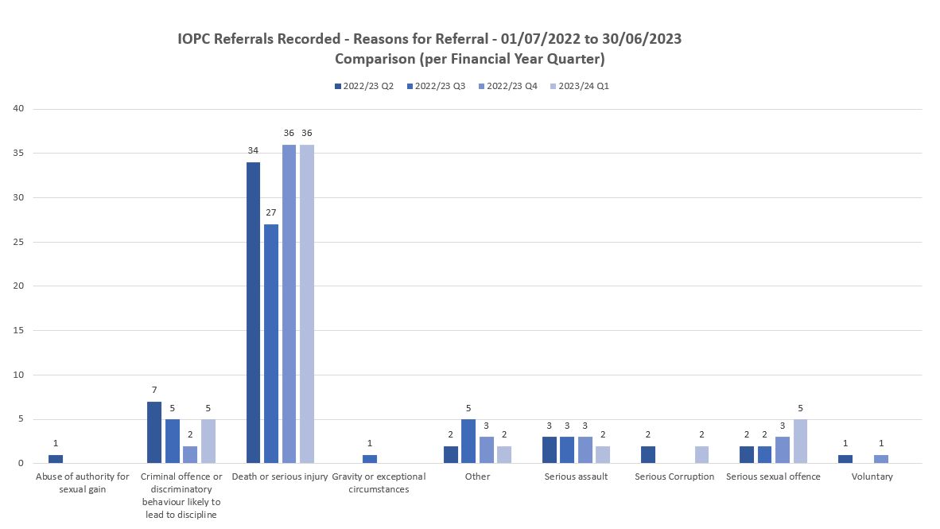**

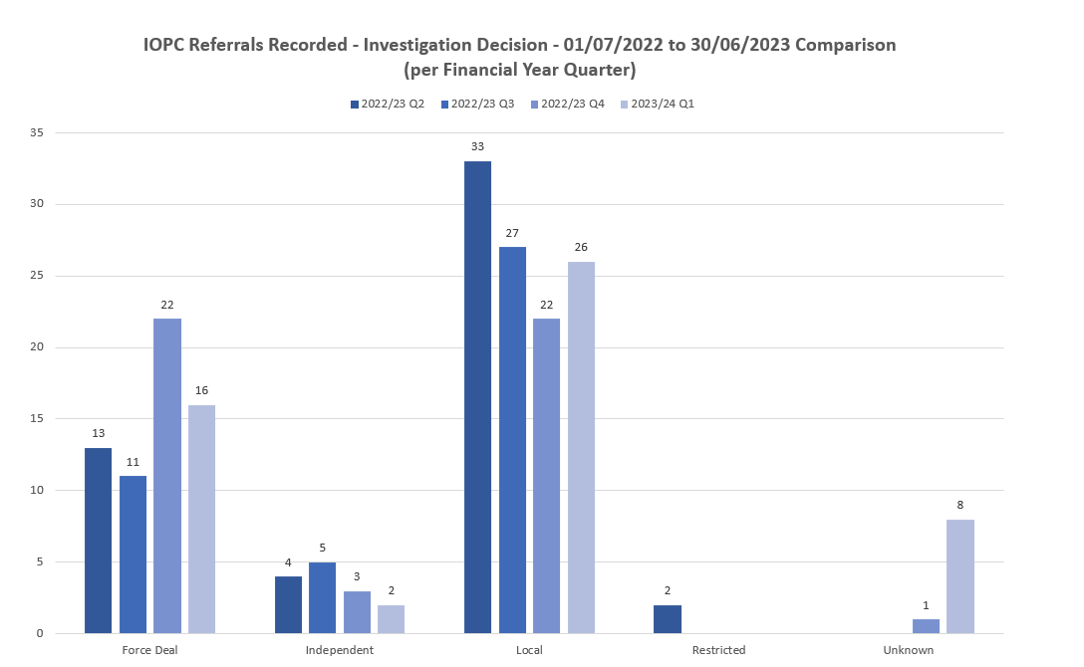

*IOPC Reviews*





*Reviews to the OPFCC*

|  |  |  |  |  |  |
| --- | --- | --- | --- | --- | --- |
|  |  | **White Complainants** | **Black Complainants** | **Mixed Ethnicity** | **Asian** |
| **Quarter** | **Total OPFCC Review Cases** | **Review requests** | **Review requests** | **Review requests** | **Review requests** |
| **Q2 - 2022/23** | 31 | 92% | 4% | 0% | 0% |
| **Q3 – 2022/23** | 46 | 69% | 0% | 7% | 7% |
| **Q4 – 2022/23** | 29 | 62% | 3% | 3% | 3% |
| **Q1 – 2023/24** | 21 | 72% | 0% | 28% | 0% |

*Note – Unknown ethnicity data has not been used in these figures.*

**National PND Requirement – Historic Data Wash**

**Statistical breakdown as of 25/07/2023**

Total amount of searches conducted during the Data Wash: **33,501**

Total traces requiring assessment by Essex Police: **5,671**

Total traces reviewed by the dedicated team, assessed by the FVM and resolved in their entirety, requiring no further action: **4,832**

Total completion rate to date: **85.2%**

Remaining traces: **839**

Remaining outstanding trace rate to date: **14.8%**

Of the **839** traces remaining

* 191 require further investigation in stage 2 to identify if they are serving police officers/staff.
* 648 have been identified as our employee and wok is ongoing to identify if the information held on PND was known to the vetting unit.