**Quarterly Report – Complaints, Misconduct and Other Matters**

**Contact – D/Supt Scott Cannon**

**Purpose of Report**

This report outlines the data and performance of Complaints, Misconduct and other matters that have been processed up to 31st March 2023 by the Professional Standards Department (PSD).

**Recommendations**

That the Commissioner considers the report and raises any queries though the quarterly meeting with the Deputy Chief Constable.

**Performance Update – Head of PSD – Key Findings**

Public complaint volumes continue to show a downward trajectory, notwithstanding a spike in complaint strands, meaning that complainants are choosing to complain about more individual matters within their overall complaint.

The reasons for this are not fully understand, although with the current national climate and challenges around public trust and confidence, it is a reasonable hypothesis that expectations on police service levels have been heightened.

**Introduction**

The Complaint and Misconduct data used for this report is generally per strand in a case, except for where otherwise stated. It does not cover each officer allegation within a complaint.

For example, an overall complaint or misconduct case number is likely to include more than one complaint/misconduct strand or category – the data used reflects the separate strands. There will often be multiple officers subject to a complaint strand. The latter is at times reflected in this data, where it is noted as such.

In Q4, 70% of complaints were deemed service level acceptable and only 14% service level not acceptable, which again could be indicative of people choosing to complain against the police due to the national climate.

The new PSD process to increase the number of dissatisfactions dealt with outside of Schedule 3 is working well, with 157 cases resolved in Q4 to the satisfaction of the person without having to record a formal complaint.

Timeliness remains a challenge, but work is ongoing in PSD to share best practice and identify ways in which the complaints handling process could be streamlined in order to reach a more timely resolution.

The majority of complaints continue to identify as white and complaints from BAME complainants are very low. The second largest category is ‘unknown’ and work is ongoing to reduce this number further as the report explains.

PSD have held a number of Focus Groups with officers and staff from an ethnically diverse background, as well as officers/staff who are part of, or allied to the LGBTQ+ community. These focus groups have been well received, with an opportunity to share feedback. Further Focus Groups are planned for different communities within the organisation to ensure a cohesive and inclusive approach to the widest audience.

The report also covers some ongoing work in relation to complaints of discrimination following IOPC guidance, with peer reviews to mitigate against any unconscious bias, look at staff/office history for any potential patterns or trends.

47.7% of complaints in Q4 related to Category A Delivery of Service, 63% of which were deemed service level acceptable and only 14% Service Level Not Acceptable. Strand A1 ‘Police action following contact’ continues to make up the vast majority of complaints.

There continues to be a slight upwards trajectory in misconduct cases, but this is predictable in light of the current national climate including recent publication of the Casey Report. With lots of proactivity ongoing around embedding the Professionalism Strategy and the new Prevention and Engagement Team, increased reporting can be expected and shows that more people are willing to come forward to report. The long term plan and ambition is to see a reduction in new conduct cases once cultural changes are embedded and low level behaviours are called out at the earliest opportunity.

A new section has been added to the report which gives a clearly breakdown of the types of misconduct cases ongoing, broken down into ‘VAWG’ and ‘Non VAWG’. The report shows that circa 50% of live conduct cases are VAWG related.

Caveats:

Complaints and Misconduct data includes those that were de-recorded/withdrawn.

Data is dependent on certain fields being accurate – for example, when considering Commands/Area Responsible – due to changes in structures within the force, and due to changes within commands, numbers may be skewed compared to other reporting.

This data uses the Area Responsible as recorded initially for Cases; this will not reflect the individual complaint strands and officer allegations which will often be across different commands and areas.

Commands:

The table details the Commands across Essex Police and the abbreviations that will be used to refer to them throughout the report.



**Public Complaints**

This table displays the levels of public complaints. The orange line indicates individual complainants and is more representative of the increase. The blue line shows complaint strands. It is not uncommon for one complaint to contain several strands.

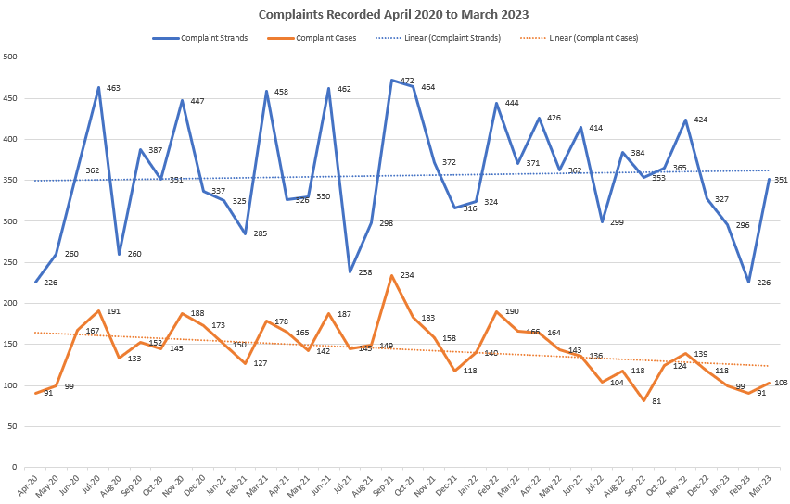

Q4 shows a significant spike in strands recorded, however a decrease in cases recorded. Further work has been carried out to identify a reason behind the spike. 56 of recorded strands have been subject to No Further Action by PSD. This may be due to them being a duplicate complaint, or there is a more appropriate avenue for the complainant to raise their concerns. As Essex Police manage a high number of persistent complainers, their complaints have been reviewed and it has been established they do not contribute to the increase. The spotlight on policing behaviours after the publication of the Casey Review in March 2023 may also contribute to the increase in complaint strands. We will continue to monitor.

Whilst complaint cases have risen in Q4, the trend line continues to be on a downward trajectory showing that formally recorded complaints are continuing to reduce in number.

This table shows how many NS3 complaints received this quarter:

|  |  |
| --- | --- |
| **Month** | **Total** |
| **January** | 75 |
| **February** | 62 |
| **March** | 80 |

These figures have risen in Q1, in line with formally recorded complaints. The most complained about areas are the quality of criminal investigations and victim updates.

*Outcome of Complaints:*

The continued reduction in the “Resolved” outcome was predicted due to NS3 complaints no longer being recorded on Centurion. This outcome is likely to be removed on future reports as the figure will be 0.

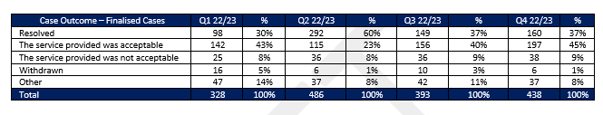

Service level acceptable has shown an increase over this period, going from 43% in Q1 gradually rising to 70% in Q4.

Service level not acceptable had increased in Q2 and remained consistent through to Q4. Whilst there has been a slight increase, 14% is not at a level of concern and highlights that we are identifying where mistakes have been made and learning has been delivered.

The following table shows the outcomes of dissatisfactions not recorded on Centurion:

|  |  |  |  |
| --- | --- | --- | --- |
| **Month** | **Resolved** | **Not Resolved** | **Live** |
| **January** | 56 | 13 | 6 |
| **February** | 48 | 7 | 7 |
| **March** | 53 | 10 | 17 |

The resolved rate for NS3s is very positive, with only a small figure remaining unresolved and progressing to a formal complaint. NS3s are being managed by the Complaints Resolution Inspectors on the LPAs with oversight from PSD, sending chasers where appropriate to ensure a good level of timeliness. The majority of live NS3s are being managed outside of the main LPAs.

*Timeliness of Complaints*



Timeliness is of paramount importance to build public confidence in the complaints system. Timeliness is scrutinised internally at the Quarterly Professionalism Board chaired by the Head of Professionalism. The regulations also require the investigating body to report any complaint (or conduct) matter which exceeds 12 months to interested parties, including the PFCC and the Independent Office of Police Conduct (IOPC). The continued ambition is for complaints to be resolved within 120 days.

Live complaints in some commands have continued to rise, which is reflected in the initial table at the beginning of the report. The South LPA has seen the largest increase, and also has the highest number of complaints over 120 days old. This shows as a smaller percentage due to other commands having smaller numbers. There is a continued focus in the South to improve complaints handling and timeliness.

PSD are supporting the commands and have recently requested a survey be undertaken by those who investigate complaints to look for ways to improve and share best practice. The results have been provided to the LPA inspectors and AAs where appropriate to address any concerns and look for ways to improve.

*Command Breakdown of Complaints:*

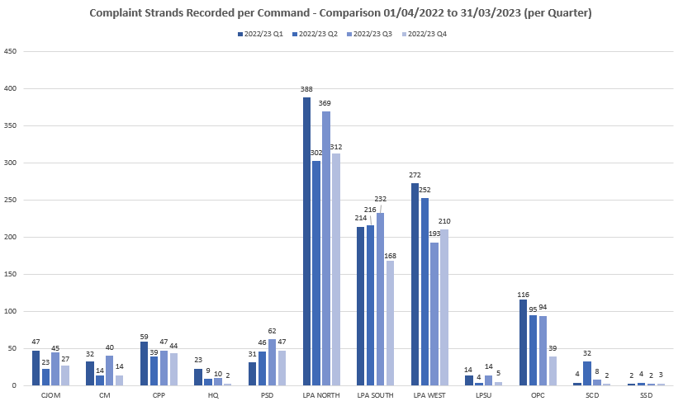

The above chart relates solely to formally recorded complaint strands. The numbers across the 12-month period in most commands remain consistent. The North LPA showed an increase in Q3 but for Q4 has reduced back in line with Q2 figures. Despite the increase in strands recorded for the force, the numbers per command overall remain lower/consistent. There are no areas of specific concern identified.

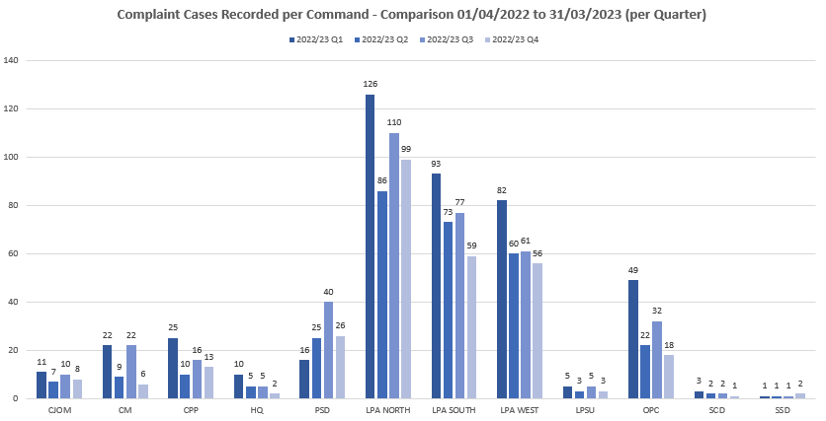Overall, most commands have shown a decrease in complaint cases recorded in Q4.

The below table shows the number of dissatisfactions recorded in Q4 per command:

|  |  |  |  |  |  |  |
| --- | --- | --- | --- | --- | --- | --- |
| **January** | | **February** | | **March** | | **Q4 Total** |
| **Command** | **Total** | **Command** | **Total** | **Command** | **Total** |  |
| North | **15** | North | **15** | North | **26** | **56** |
| South | **17** | South | **11** | South | **11** | **39** |
| West | **11** | West | **11** | West | **6** | **28** |
| C&PP | **4** | C&PP | **4** | C&PP | **1** | **9** |
| OPC | **14** | OPC | **11** | OPC | **16** | **41** |
| CMC | **7** | CMC | **6** | CMC | **12** | **24** |
| CJ | **1** | CJ | **0** | CJ | **1** | **2** |
| HQ | **4** | HQ | **4** | HQ | **5** | **9** |
| LPSU | **2** | LPSU | **0** | SCD/LPSU | **1/1** | **4** |

These figures show the LPAs receiving the highest number of dissatisfactions, however OPC has received more than the South and the West LPA. Most dissatisfactions managed by OPC relate to vehicle recovery issues. This is further explored in the Vehicle Recovery Report.

*Ethnicity of Complainants*

PSD continue to use other police systems to check for ethnicity data, ensuring this is updated and reflected on Centurion. When this information is not readily available, the IO is directed to obtain this information.

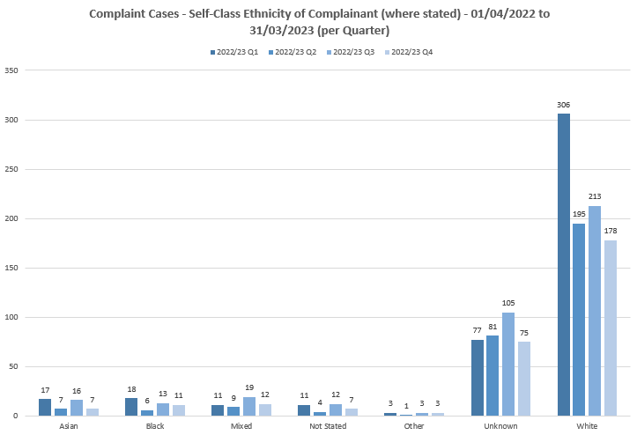

These figures show complaint cases by complainant ethnicity. The decrease in numbers from white complainants could be due to the change in the NS3 process. At present the NS3 process does not capture ethnicity data. However, from May 2023, the NS3 process will include recording dissatisfactions on Centurion using an IX reference, including ethnicity, which will improve the data quality.

Despite an increase in Q3 in the “Unknown” category, it has reduced moving into Q4. This will continue to be monitored and ongoing efforts made to reduce this figure further.

*Ethnicity of Complainants*

The below table relates to complainants who have stated their ethnicity is Black, Mixed or Asian.

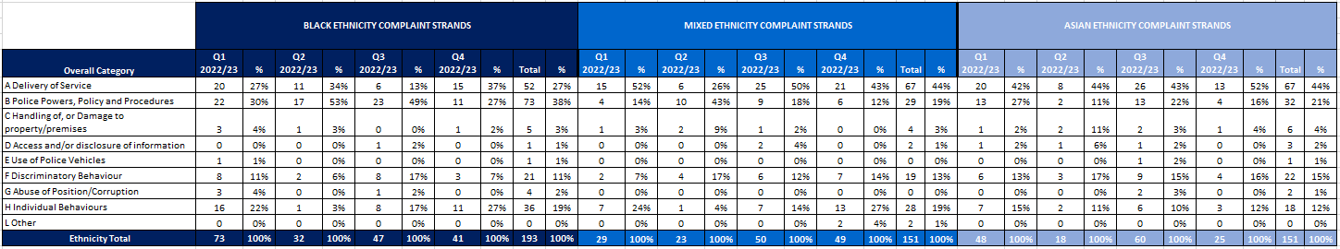

Over the past 3 quarters there has been a steady increase in complaints relating to category B from Black Complainants. This has shown a significant drop between Q3 to Q4, of 49% to 38%. Category A also has the highest number of strands in Q4 for Black Complainants which is in line with other ethnic groups. Discrimination complaints from Black Complainants have also decreased by 10%. For the Asian and Mixed Ethnicity Groups there do not appear to be any outliers.

Black Ethnicity Group

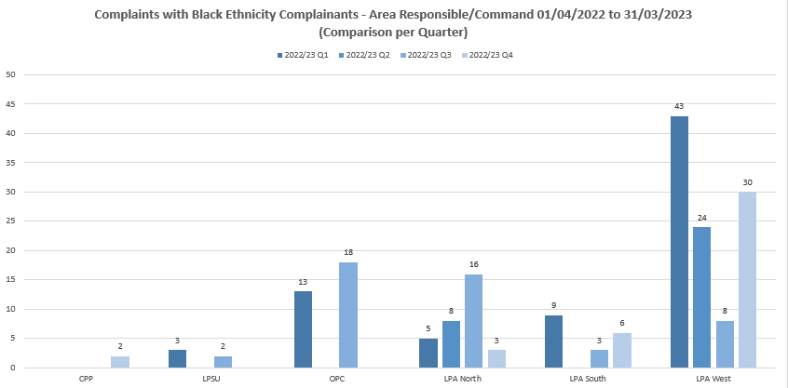

The North LPA showed a significant increase in Q3, however this has now reduced to the lowest figure for all four quarters. OPC has also shown a significant decrease. The reduction overall in complaints from Black Complainants has only fallen from 47 to 41, therefore this would not necessarily account for the reduction.

It is recognised that West LPA has the most diverse population in the force, the census data provides some key information and findings, including the breakdown of ethnicity and hate crime within each district.

West LPA has the highest rate of racial hate crime per population and the highest proportion of racial hate crime when compared to other LPA’s, however, this proportion has remained consistent, fluctuating between 70-80% of total hate crime.  Within West LPA, Harlow and Thurrock districts have the highest racial hate crime rates as well as containing the key hotspots for highest density offending.

Thurrock has seen the largest change in its ethnicity breakdown over the ten-year period. The percentage of the population who self-defined as white was 10% lower in the 2021 census compared to 2011. Those who self-defined as Asian or black increased in the ten year period by 4% and 3%, respectively.

West LPA has a 4.5% lower proportion of white populace than the force average.

Thurrock has the highest proportion of non-white populace within West LPA (23.3%)

Other factors which may have contributed to the increase in the number of reports seen within the West LPA include the continued work our Community Policing teams do with Hate Crime officers and partner agencies to raise awareness and increase confidence to report matters to the Police, not only criminal matters but also complaints.  The recent incident at the White Hart Pub which reached national news raised awareness of racial matters and hate crime which may prompt additional reporting.  Changes in the West LPA complaints processes which have seen an increase in public confidence and complaint handling satisfaction.

There is ongoing work through the Public Confidence and Use of Force Boards, which coincides with our Independent Advisory Groups to better understand the complaint matters within the West LPA, provide better transparency, and improve confidence and satisfaction in our approach and resolution processes.

A report regarding the latest census data has been shared with the papers for this board. The 2021 census data shows the following:



This data will continue to be shared in each report for comparison with figures as above.

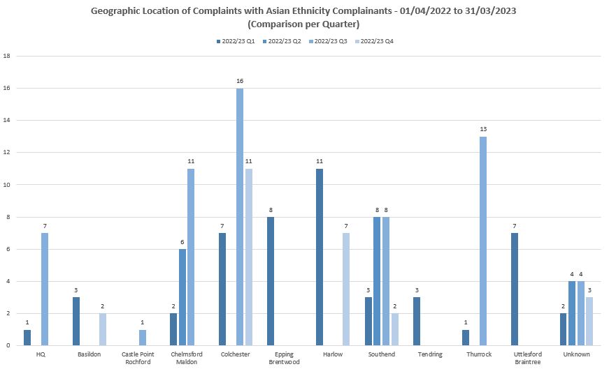

Overall Q4 has shown a reduction in complaints from Asian Complainants. Previously high numbers in Chelmsford and Colchester have reduced. It is predicted there will be an increase for Colchester in Q1 as a persistent complainer who is Asian has resumed communication this period therefore that is likely to be reflected in the figures.

Numbers of complaints from those from a Mixed Ethnicity background remain low with no areas of concern.

*Categories of Complaints:*

Delivery of service, police powers, policy and procedure and individual behaviours are the most complained about areas. This continues to be in line with previous years. It would be expected as the new NS3 process continues, there will be a decline in this category. This is due to most dissatisfactions being around delivery of service.

Governance and accountability is managed through various strategic force boards such as the Use of Force Board, Public Confidence Board and the Victim and Witness Action Board.

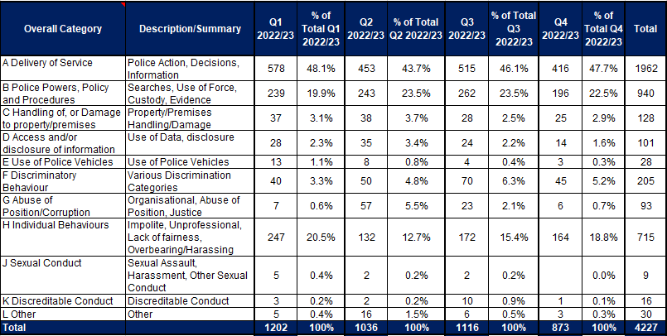

*Category A*

These primarily relate to victim contact, investigation standards and updates during investigations. PSD regularly provide complaint data to the Strategic Vulnerability Centre to update the victim’s dashboard, highlighting areas of where improvement is required.

The continued focus around accuracy of strand recording within the Service Delivery Unit is apparent with a more accurate reflection of concerns raised. Numbers in codes A2-A4 are remaining consistent. There has been a slight increase in numbers for A1, but not significant currently.

Complaints recorded in this category are largely found as service level acceptable or resolved if an NS3 complaint. Q4 shows an increase in the outcome of service level acceptable from 57% to 63%. Service level not acceptable has decreased from 17% to 14%. The number of complaints withdrawn remains steady at 4% over the last 2 quarters. There are no areas of concern identified.

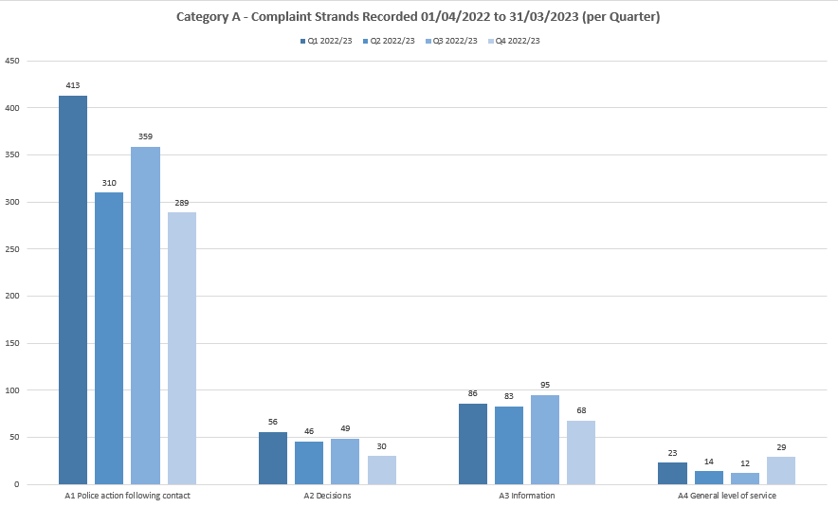

The above table evidences the ongoing work to improve stranding of complaints and accuracy. A1 has declined where A4 has increased. It would be expected to see increases in other categories due to the ongoing focus on accuracy and consistency.

*Category B*

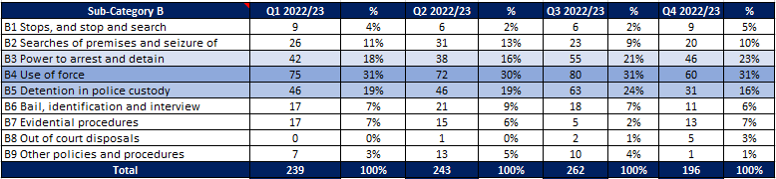This is a broad category with 9 different subcategories. Use of Force and Power to Arrest and Detain are the highest complained about areas.

Whilst the numbers have changed across the 4 quarters, there are no outliers or areas of significant concern.

PSD attend the force Stop and Search/Use of Force Board and are also represented at the Stop and Search tactical board. We continue to provide data to feed into the force dashboard reflecting the true picture of concerns raised compared against stop and search data.

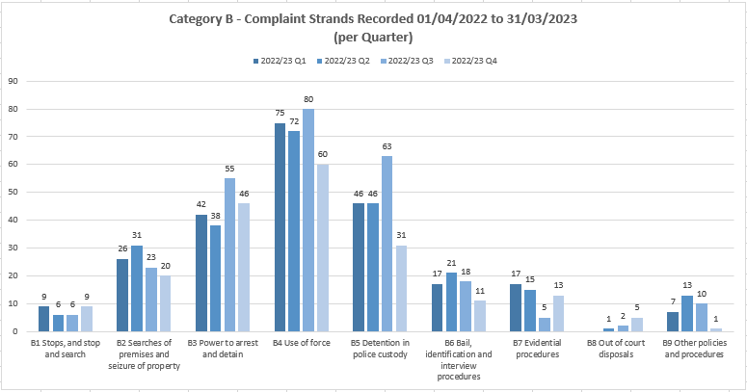

Looking at individual areas within category B, the numbers remain consistent. There has been a slight reduction in Q4 for Power to arrest and detain and Use of Force, however a reduction of almost half in Detention in police custody.

*Category H*

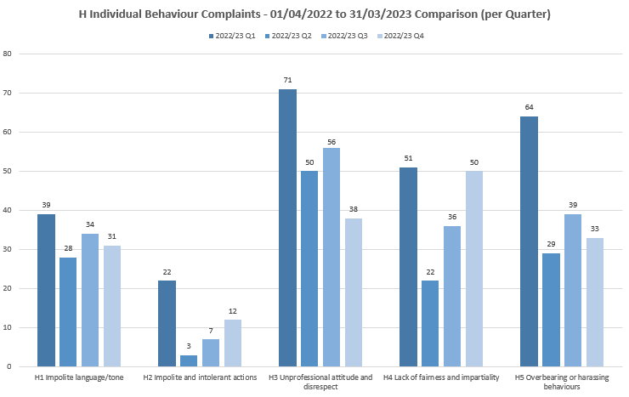

Numbers in this category remain largely consistent with no specific concerns of note. Learning is fed back to the Prevention and Engagement DI to enable use of examples of officer behaviour to be shared as part of their ongoing training and programme of work. PSD continue to work with the Head of Professionalism to share learning and any identified trends or themes.

*Category F*

As a department, PSD has an increased focus around improving public confidence and reducing disparity. There are various workstreams ongoing, including a QR code which will take complainants to a survey for feedback on their complaint handling experience. Further information on the QR code will be shared separately to this report. There are also PSD Focus groups taking place internally to learn more about different groups and communities.

To date PSD have held Focus Groups for officers/staff from an ethnically diverse background, as well as officers/staff who are part of or allied to the LGBTQ+ community. These focus groups have been well received by attendees and the opportunity provided to share feedback. Further Focus Groups are planned for different communities within the organisation to ensure it is fully inclusive and everyone has the chance to be heard.

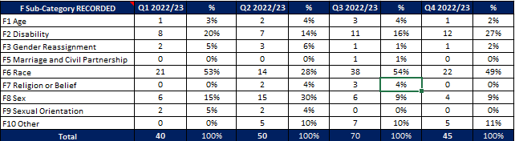

The above chart shows a peak in Q3 for race discrimination complaints, although this has reduced by 5% in Q4. This remains the highest area for discrimination related complaints.

PSD take all discrimination complaints very seriously and as such each complaint is subject of a full investigation, even if no conduct concerns are identified through initial scoping. This process was implemented after advice from the IOPC, and understanding the importance of providing a full, comprehensive update to the complainant. The report in most cases will be subject of a peer review to identify any unconscious bias from the Investigating Officer. Staff history will also be reviewed to look for any patterns of behaviour.

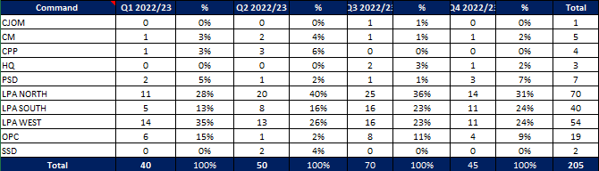The below chart shows the command breakdown for complaints. The LPAs to have the highest numbers which would be expected. Overall there is a decrease in numbers moving in to Q4 which would fall in line with the reduction in overall discrimination related complaints.

**Police Officer and Staff Misconduct**

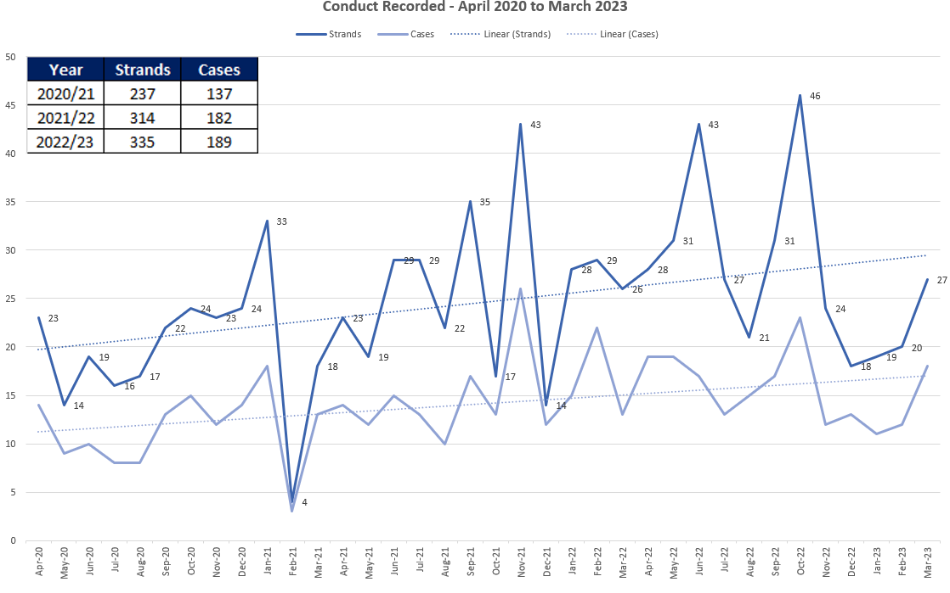

Overall, the total number of conduct strands and cases decreased in Q4 2022/2023 compared with Q3 2022/2023 with 66 strands (41 cases) in Q4 compared with 88 strands (48 cases) in Q3.

The above graph shows an upward trajectory over time but with a reduction from a peak in October 2022, although there was a slight increase in March 2023.

The below table details the 66 individual **strands** and breaks them down into the specific standards of professional behaviour that are alleged to have been breached.

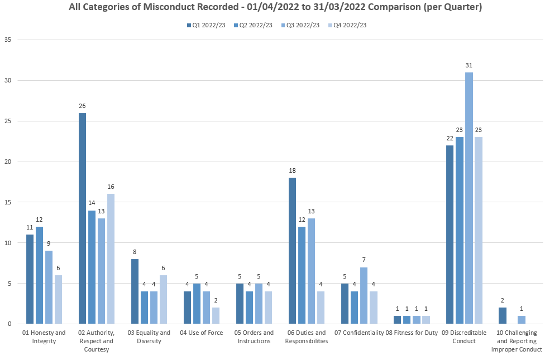

The only rises in Q4 are the rise in *authority, respect and courtesy* and *equality and diversity*.

The slight increase in *authority, respect and courtesy* does not highlight any patterns of concern and the sixteen strands are spread across the three months of Q4. There is also a fair distribution across the three LPAs, Criminal Justice, OPC and Support Services Directorate. Of the sixteen strands, five have already been concluded as no case to answer, which may also include referral to the Reflective Practice Review Process.

The six strands recorded as *equality and diversity* are recorded evenly across the three months of the quarter. Three relate to the North LPA, two to the South and one at Essex Police College.

**Breakdown of types of conduct cases**

The below tables give an indication of the type of cases that are currently live with the PSD investigations teams. A number of the investigations straddle multiple categories, so have been included in the primary category.

There is a reduction when compared with Q3. This is primarily due to improved administration and the table below only includes those which remain under active investigation.

**Non VAWG related**

|  |  |
| --- | --- |
| **Non-VAWG cases type** | **Number** |
| **Total number** | **50** |
| Inappropriate comments or behaviour | 8 |
| Use of Force | 5 |
| DPA Breach | 3 |
| Dishonesty - Non-operational Matter | 3 |
| Dishonesty - Operational Matter | 9 |
| Physical assault | 3 |
| Failure to correctly investigate an incident | 7 |
| Driving matter | 4 |
| Drugs | 3 |
| Perverting the course of justice | 3 |
| Offensive weapons | 1 |
| Criminal associations | 1 |

**VAWG related**

|  |  |
| --- | --- |
| **VAWG cases type** | **Number** |
| **Total number** | **42** |
| DA - Harassment/Coercive & Controlling Behaviour offences | 8 |
| DA - Physical assaults | 3 |
| DA - Sexual offences - Sexual assault & Rape | 3 |
| Sexual Offences – Non-DA | 9 |
| Child Abuse - IIOC & grooming offences | 4 |
| Child Abuse - Physical assaults | 2 |
| Inappropriate behaviour toward other EP Personnel | 8 |
| Misconduct in a Public Office | 1 |
| Inappropriate relationship with a Member of the Public | 3 |
| Perverting the course of justice | 1 |

Of the nine sexual assault allegations in a non-DA setting, three have police victims and occurred in the workplace, two have police victims and occurred outside of the workplace, and four have non-police victims. **Command Breakdown of Misconduct Cases**

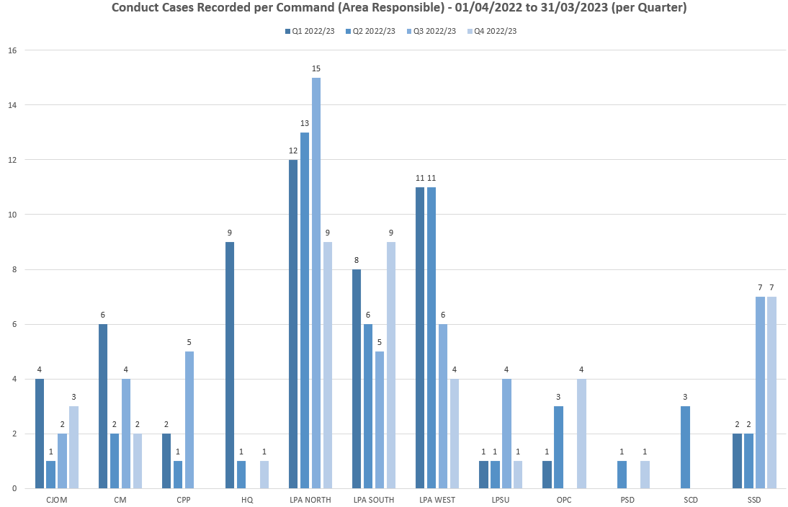

Q4 has seen a fall in recorded cases in the North and West LPAs, with a rise in the South LPA. There have also been four cases recorded for OPC.

Of the nine cases recorded in the South LPA, they were evenly spread across the three months with a range of standards breached with no clear trend or pattern.

Of the four cases recorded within OPC, three were recorded in February. Two of the four have already been finalised indicating there was no formal misconduct identified.

**Outcomes of conduct Cases – January 2022 to December 2022**

Between 1st April 2022 and 31st March 2023 there were a total of 168 conduct cases finalised. Within these there were 341 strands/ subjects, for which sanctions/ outcomes differ.

Of the 168 finalised cases, there was a case to answer in 19% of cases and no case to answer in 76% of cases. The remaining were de-recorded or withdrawn by the Appropriate Authority. In 40 cases of ‘no case to answer’, it was still found that breaches of the Standards of Professional Behaviour had occurred, but they not so serious as to justify disciplinary proceedings. These cases were dealt with through Reflective Practice.

Of those cases shown as Case to Answer, 50% resulted in a dismissal (or would have been dismissed had the officer not resigned/retired) and 34% resulted in a Written Warning or Final Written Warning. No Action was taken in 9% of cases and the remaining 7% were deemed as some form of management action/ Practice Requiring Improvement.

Where the case outcome is shown as No Case to Answer, 50% resulted in No Action and 50% were deemed to require some form of management intervention.

**Suspensions and Restrictions**

There are currently 28 officers/ staff suspended and 29 officers/ staff restricted.

Of those suspended, ten are from the South LPA and seven are from the North LPA.

Of those restricted, there is an even spread across commands.

**IOPC/ OPFCC**

*IOPC Referrals*

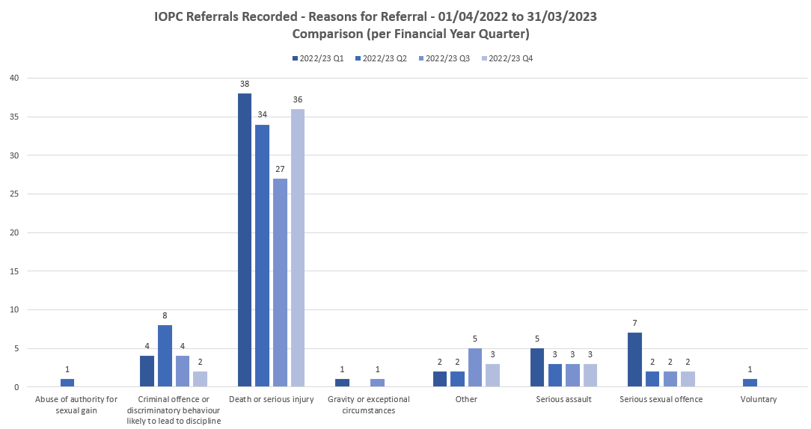

The majority of referrals from Essex Police into the IOPC are for Death or Serious Injury incidents. These include DSI incidents reported by custody and would include any loss of bodily function (including epileptic fit)

Due to a change in IOPC liaison for Essex Police a further meeting has been held with the IOPC. The amount of referrals in has again been raised and there is no cause for concern.

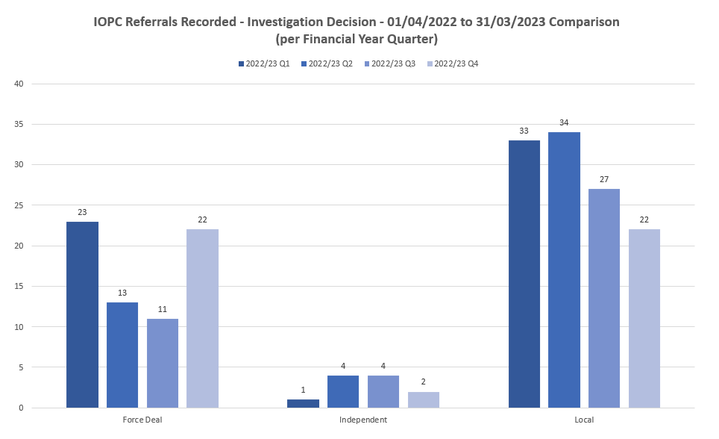

For referral decisions, there has been an increase in the “Force Deal” category. Force Deal means this is returned to the force to manage how they see fit, this may not require further investigation. An epileptic fit would be an example of where Force Deal is usually an outcome.

*IOPC Reviews*



This has been a significant increase in the number of appeals requested via the IOPC. It is believed the reason for this could be changes in the relevant review body (RRB) process, where after consultation with the OPFCC more complaints are being assigned the IOPC as the RRB at point of recording. This decision is based solely on the allegation made, it does not account for any scoping or any information to substantiate the claim.

External factors in policing have also influenced the increase in complaints, therefore it would be expected that more reviews would be requested.

The IOPC are still working through a significant backlog however there is ongoing work to reduce this.

Work has been carried out to review the outcomes of reviews made to the IOPC. The time parameters used are between 01/04/2022 – 31/03/2023.

|  |  |
| --- | --- |
| **Total number of appeals requested** | 128 |
| **Live – awaiting outcome** | 96 |
| **Upheld** | 13 |
| **Not Upheld** | 26 |

The detail for the above is provided in a separate report.

|  |  |
| --- | --- |
|  |  |

*Reviews to the OPFCC*

|  |  |  |  |  |  |
| --- | --- | --- | --- | --- | --- |
|  |  | **White Complainants** | **Black Complainants** | **Mixed Ethnicity** | **Asian** |
| **Quarter** | **Total OPFCC Review Cases** | **Review requests** | **Review requests** | **Review requests** | **Review requests** |
| **Q1 - 2022/23** | 23 | 64% | 4% | 0% | 8% |
| **Q2 - 2022/23** | 31 | 92% | 4% | 0% | 0% |
| **Q3 – 2022/23** | 46 | 69% | 0% | 7% | 7% |
| **Q4 – 2022/23** | 29 | 62% | 3% | 3% | 3% |

*Note – Unknown ethnicity data has not been used in these figures.*

Data has been obtained to compare complaints received from ethnic groups in relation to reviews received. Due to the dates in which complaints are recorded, the review period and the finalisation dates, it was not possible to provide accurate information.

PSD have recorded 29 requests for review in Q4. Out of these, 12 have been completed. None of these reviews have been upheld.

Historical Data Wash

As previously reported on, the Home Office gave a national direction for each force to conduct Police National Database (PND) checks on every single officer, member of staff and volunteer including the Chief Constable and the OFPCC (albeit this was on a voluntary basis).

The force had to submit a single return to PND containing a list of all staff and this data was centrally checked against PND using a bulk search upload process, resulting in product containing PND ID reference(s) against each person. No intelligence was reviewed centrally, and it is down to individual forces to do so.

The Essex Police return contained a list of circa 6800 people and over 7000 pieces of intelligence were identified.

Due to size, risk and complexity of this piece of work, a Gold Group has been established, chaired by the DCC and the Head of PSD has been appointed as the Senior Lead Officer.

A dedicated team was formulated, with PND trained officers and staff from across the force to deliver against this national requirement, with an ambition to minimise the impact on the Force Corporate Vetting Unit.

Through a phased approached, the intelligence has been weeded down by eliminating incorrect data or ‘false positives’. At the time of writing, there are now only 609 pieces of intelligence which genuinely relate to officers and staff, and 450 which require further investigative work as it still isn’t clear.

These pieces of intelligence are now being checked by the Corporate Vetting Unit to ascertain whether it was intelligence already known to the force and disclosed as part of the vetting process, or new and previously unknown information. It is predicted that intelligence not already known will be extremely small based on national findings from similar previous exercises.

The deadline for completion is 30th September 2023 so Essex Police are well on track.