**Quarterly Report – Complaints, Misconduct and Other Matters**

**Contact – D/Supt Scott Cannon**

**Purpose of Report**

This report outlines the data and performance of Complaints, Misconduct and other matters that have been processed up to 30th September 2022 by the Professional Standards Department (PSD).

**Recommendations**

That the Commissioner considers the report and raises any queries though the quarterly meeting with the Deputy Chief Constable.

**Performance Update – Head of PSD – Key Findings**

Essex Police continues to see a slight downward trend in the overall number of complaints as PSD continues to apply the right process of dealing with more lower level dissatisfactions outside of Schedule 3.

The report sets out another new process for complaint reporting which will go live in March 2023, effectively taking the handling of dissatisfactions outside of the Force Control Room and redirecting matters through the correct channels. This will further enhance and professionalise the way dissatisfactions are recorded and handled, whilst also reducing demand within the force’s Command and Control function.

Over half of recorded complaints were deemed service level acceptable and just 17% were deemed not acceptable, which is consist with the Q2 period.

Timeliness remains a challenge for the LPAs, who continue to receive the majority of complaints due to the front line nature of the roles, with 27% of complaints in the South and 24% in the West being over 120 days old. However, this is an improvement over Q2, whether levels were both over 30%.

The North LPAs continues to receive the highest levels of complaints, which is consistent with the geographical size and due to having the highest number of persistent complainers. There have been some increases and decreases across the Command, but nothing statistically significant.

The vast majority of complainants continue to be White British, but the second highest category is ‘unknown’. This remains a challenge despite PSD accessing other police systems to obtain this data when held, and a direction for IOs to obtain this data if the complainant hasn’t provided it. There will be a renewed focus in this area at the next Appropriate Authority Forum and Force Professionalism Board, but a number of complainants refuse to engage so this will always be a challenge.

The Head of PSD welcomes the incorporation of the 2021 Census data, which gives us a much better understanding in terms of the ethnicity breakdown of each geographical area.

The Head of PSD has also implemented a brand new internal IAG, made of different staff networks and associations, with a clear Terms of Reference and ambition to broaden the thinking and decision making in PSD, which will include both the handling of public complaints and conduct matters. This new IAG has been formed following a national review by the IOPC, who criticised forces for having too many White British decision makers. The group will receive ongoing training and guidance to help them understand the complexities of the complaints and conduct regime.

Delivery of service, police powers, policy and procedure and individual behaviours are the most complained about areas. This continues to be in line with previous years. It would be expected as the new NS3 process continues, there will be a decline in this category. This is due to most dissatisfactions being around delivery of service.

There has been a slight increase in new conduct cases in Q3 compared with Q2 and cases pertaining to violence against women and girls represent 44% of all live conduct matters.

With the former Pc Carrick case in the Metropolitan Police Service and other significant and high profile cases stemming from the Met, it is anticipated that conduct levels will continue to rise in the short term. Further growth into PSD has been approved in order to tackle the ongoing challenges and improve timeliness, whilst our extensive prevention programme of work is rolled out across the force.

As part of the Home Office response to the ongoing criticisms of policing, there is a national requirement for every officer, staff member and volunteer to be checked against the Police National Database. More details are contained at the end of this report.

**Introduction**

The Complaint and Misconduct data used for this report is generally per strand in a case, except for where otherwise stated. It does not cover each officer allegation within a complaint.

For example, an overall complaint or misconduct case number is likely to include more than one complaint/misconduct strand or category – the data used reflects the separate strands. There will often be multiple officers subject to a complaint strand. The latter is at times reflected in this data, where it is noted as such.

Caveats:

Complaints and Misconduct data includes those that were de-recorded/withdrawn.

Data is dependent on certain fields being accurate – for example, when considering Commands/Area Responsible – due to changes in structures within the force, and due to changes within commands, numbers may be skewed compared to other reporting.

This data uses the Area Responsible as recorded initially for Cases; this will not reflect the individual complaint strands and officer allegations which will often be across different commands and areas.

Commands:

The table details the Commands across Essex Police and the abbreviations that will be used to refer to them throughout the report.



**Public Complaints**

This table displays the levels of public complaints. The orange line indicates individual complainants and is more representative of the increase. The blue line shows complaint strands. It is not uncommon for one complaint to contain several strands.

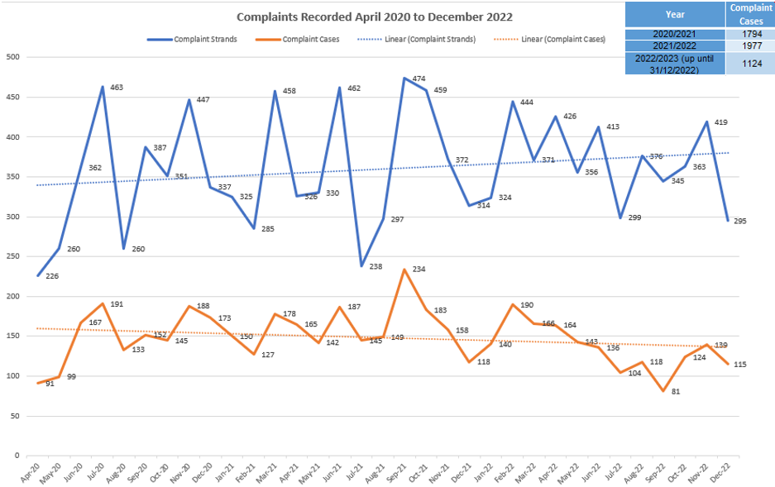

Looking at Q3 data, there has been an increase, followed by a significant decrease in strands recorded. PSD are continuing to monitor stranding to ensure it captures data required and is an accurate reflection of issues raised.

Whilst complaint cases have risen in Q3, the trend line continues to be on a downward trajectory showing that formally recorded complaints are continuing to reduce in number.

This table shows how many NS3 complaints received this quarter:

|  |  |
| --- | --- |
| **Month** | **Total** |
| **October** | 64 |
| **November** | 51 |
| **December** | 63 |

These figures support the decrease in dissatisfaction reporting, although there is a dip in November, the numbers remain mainly consistent across the period.

A new process for complaint reporting into the force will be live in March 2023. This will remove the “dissatisfaction with service” header from STORM (Command and Control System) and direct all dissatisfactions reported online directly to PSD. It is likely an increase in numbers in the PSD figures will be seen, however this would not indicate an increase in reporting overall.

The reason for the change in process is to ensure consistent decision making in complaint handling. It will also mean more accurate recording of data to identify trends and themes.

*Outcome of Complaints:*

The continued reduction in the “Resolved” outcome was predicted due to NS3 complaints no longer being recorded on Centurion. This outcome is likely to be removed on future reports as the figure will be 0.

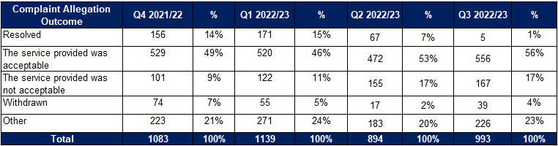

Service level acceptable remains consistent over the four quarters with the average figure of 51%

Service level not acceptable had increased in Q2 and remained the same in Q3. Whilst there has been an increase, it is not significant and will continue to be monitored to identify any potential areas of concern.

The following table shows the outcomes of dissatisfactions not recorded on Centurion:

|  |  |  |  |
| --- | --- | --- | --- |
| **Month** | **Resolved** | **Not Resolved** | **Live** |
| **October** | 53 | 5 | 4 |
| **November** | 32 | 4 | 15 |
| **December** | 39 | 6 | 18 |

The resolved rate for NS3s is very positive, with only a small figure remaining unresolved and progressing to a formal complaint. NS3s are being managed by the Complaints Resolution Inspectors on the LPAs with oversight from PSD, sending chasers where appropriate to ensure a good level of timeliness. The majority of live NS3s are being managed outside of the main LPAs.

*Timeliness of Complaints*

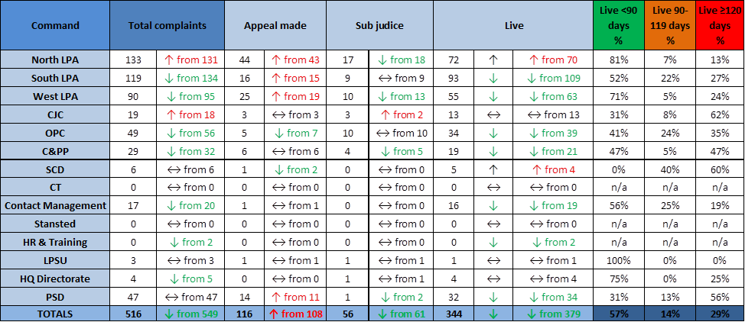

Timeliness is of paramount importance to build public confidence in the complaints system. Timeliness is scrutinised internally at the Quarterly Professionalism Board chaired by the Head of Professionalism. The regulations also require the investigating body to report any complaint (or conduct) matter which exceeds 12 months to interested parties, including the PFCC and the Independent Office of Police Conduct (IOPC). The continued ambition is for complaints to be resolved within 120 days.

Total numbers of complaints have decreased from 549 to 516 which highlights the continues focus to resolve complaints promptly and reduce the number of formal complaints received. Despite the North LPA and OPC showing an increase, this is only by 1 complaint. CJC has the highest percentage of complaints over 120 days, however they have smaller numbers in total. PSD has a continued focus on improving timeliness, however due to PSD managed complaints being more complex with a conduct element, they are more protracted investigations.

*Command Breakdown of Complaints:*

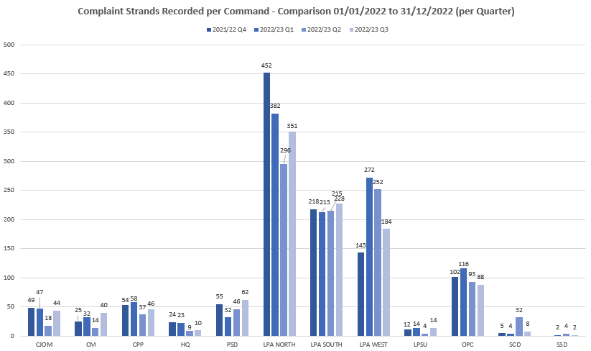

The above chart relates solely to formally recorded complaint strands. The numbers across the 12-month period in most commands remain consistent. The North LPA showed a decrease in Q2, however strands have increased in Q3 but not by a considerable amount. As previously reported, the North LPA manage the highest number of persistent complainants, who send in lengthy correspondence raising repetitive issues. This are recorded and no further action taken due to duplication. This may be a reason for the increase in Q3 but will be monitored.

SCD showed an increase in Q2, however has reduced in Q3. This is due to a high-profile complainant in Q2 that resulted in one large complaint of 30 strands. Q3 shows expected figures.

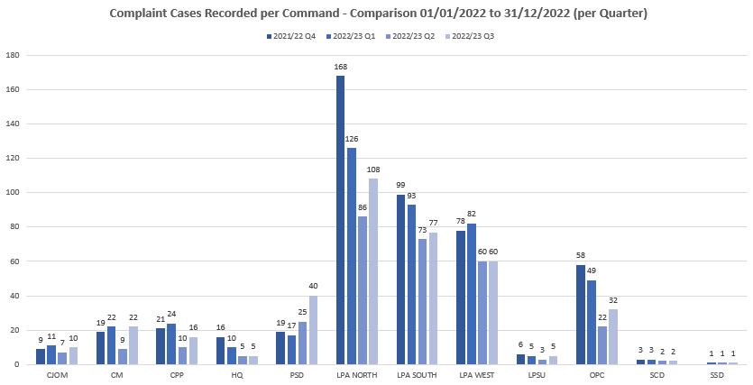

Recorded complaint cases remain consistent, with increases shown in PSD, the North LPA and OPC.

PSD is currently managing a persistent complainant who has raised issues regarding other commands, but also in relation to a current hearing process. This has contributed to the increase in Q3. Whilst there is an increase in the North LPA, it is not deemed significant and is in line with headcount percentages across the 3 LPAs. The reason for the slight increase in OPC is not known, however it will continue to be monitored to see if any trends develop.

PSD is also shown as the command managing the complaint when an NFA decision is made and it does not attribute to a specific command. Therefore this will also add to the total number.

The below table shows the number of dissatisfactions recorded in Q2 per command:

|  |  |  |  |  |  |  |
| --- | --- | --- | --- | --- | --- | --- |
| **October** | | **November** | | **December** | | **Q3 Total** |
| **Command** | **Total** | **Command** | **Total** | **Command** | **Total** |  |
| North | **19** | North | **20** | North | **12** | **51** |
| South | **20** | South | **10** | South | **16** | **46** |
| West | **7** | West | **7** | West | **5** | **19** |
| C&PP | **2** | C&PP | **0** | C&PP | **1** | **3** |
| OPC | **6** | OPC | **11** | OPC | **16** | **32** |
| CMC | **5** | CMC | **2** | CMC | **7** | **14** |
| CJ | **1** | CJ | **1** | CJ | **0** | **2** |
| HQ | **0** | HQ | **0** | HQ | **4** | **4** |
| LPSU | **1** | LPSU | **0** | SCD | **0** | **1** |

These figures show the LPAs receiving the highest amount of dissatisfactions, however OPC has received more than the West LPA. Most dissatisfactions managed by OPC relate to vehicle recovery issues.

*Ethnicity of Complainants*

PSD continue to use other police systems to check for ethnicity data, ensuring this is updated and reflected on Centurion. When this information is not readily available, the IO is directed to obtain this information.

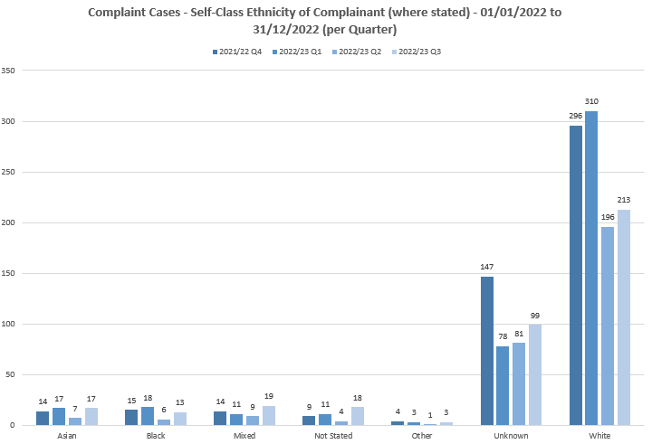

These figures show complaint cases by complainant ethnicity. The decrease in numbers from white complainants could be due to the change in the NS3 process. At present the NS3 process does not capture ethnicity data. This will be reviewed by PSD with a view of changes being made to ensure this data is being captured to provide a clear picture of the current position.

Every effort is being made to capture data; however the unknown category has shown an increase. There will be a renewed focus from PSD to ensure that investigating officers are providing this information where possible if it is not available on other police systems.

*Ethnicity of Complainants*

The below table relates to complainants who have stated their ethnicity is Black, Mixed or Asian.

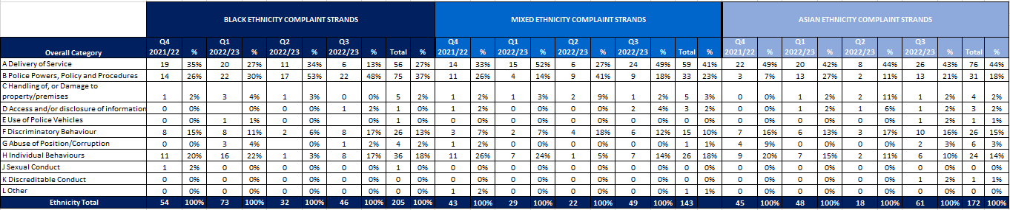

The increase in strands in the B Category for Black complainants has continued to be the highest area complained about in Q3. This increase has sustained over the last 4 quarters therefore further work will be required to ascertain why this is and the level of concern. PSD are in the process of introducing a new internal IAG where complaint/conduct reports will be sanitised and shared with the group for discussion. PSD will raise this increase with the external IAG and internal IAG.

Black Ethnicity Group

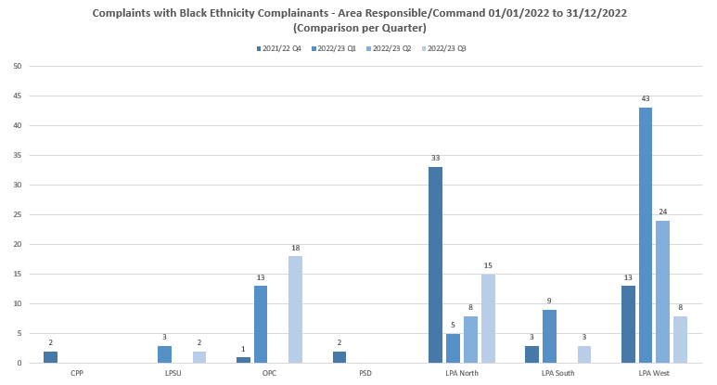

The North LPA is showing an increase of nearly double from complainants who have stated their ethnicity is black. Looking at the census figures, the North LPA has nearly half the percentage of black residents than the West LPA. This increase could be due to multiple complaints from one complainant in relation to a stop and breath test. This complaint is still live. Once finalised it will be shared with both the internal and external IAG for their views and sharing of any learning.

The West LPA peaked in Q1, however it has continued to decrease into Q3.

OPC has also shown an increase in complaints in this area. Upon review, this increase is mainly attributed to one complainant who made several complaints regarding her arrest by OSG and subsequent detention in custody.

A report regarding the latest census data has been shared with the papers for this board. The 2021 census data shows the following:



The West LPA has the highest figure of ethnic minority groups in the force. It would therefore be expected that the highest numbers of complaints from ethnic minority groups would be from this area. Apart from a few outliers across the force, this is predominantly the case over the past 4 quarters.

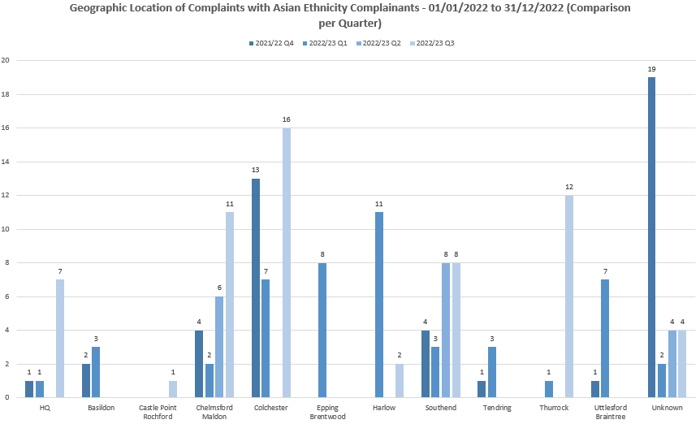

Chelmsford and Colchester have the highest population in the North LPA of those from Asian communities. This reflects in the complaint figures where they are higher than other areas. Southend has a higher population from Asian communities in the South LPA which again is reflected in complaint figures.

The complaint numbers for the mixed ethnicity groups are extremely low. They show the highest number of complaints from the West LPA with a total of 20 strands for Q3. This would be expected in line with the demographic data.

Police action following contact is the most common strand, with 19 recorded out of a total of 49. All other strands have numbers below 5, there are no areas of concern identified.

*Categories of Complaints:*

Delivery of service, police powers, policy and procedure and individual behaviours are the most complained about areas. This continues to be in line with previous years. It would be expected as the new NS3 process continues, there will be a decline in this category. This is due to most dissatisfactions being around delivery of service.

Governance and accountability is managed through various strategic force boards such as the Use of Force Board, Public Confidence Board and the Victim and Witness Action Board.

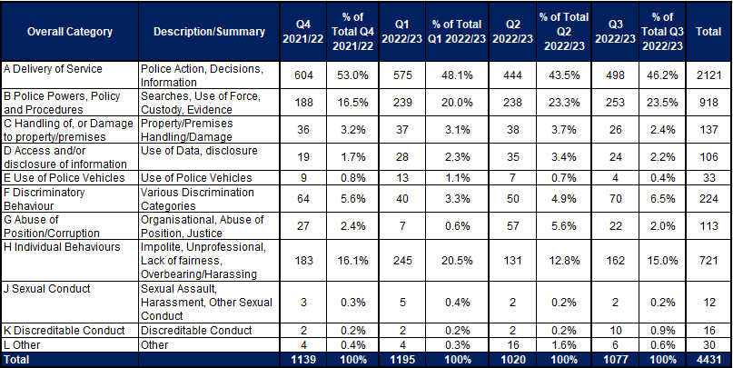

*Category A*

These primarily relate to victim contact, investigation standards and updates during investigations. PSD regularly provide complaint data to the Strategic Vulnerability Centre to update the victim’s dashboard, highlighting areas of where improvement is required.

The continued focus around accuracy of strand recording within the Service Delivery Unit is apparent with a more accurate reflection of concerns raised. Numbers in codes A2-A4 are remaining consistent. There has been a slight increase in numbers for A1, but not significant currently.

Complaints recorded in this category are largely found as service level acceptable or resolved if an NS3 complaint. This quarter has shown an increase in outcomes of service level acceptable of 14% and a decrease of service level not acceptable of 2%.

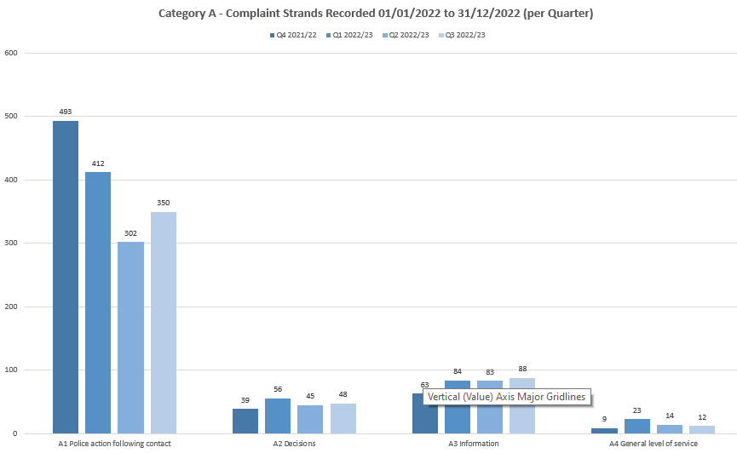

*Category B*

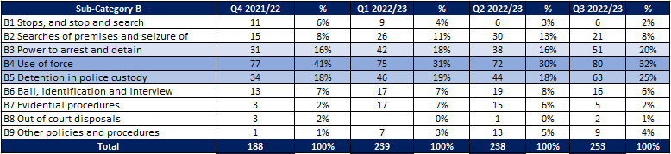This is a broad category with 9 different subcategories. Use of Force and Detention in Police Custody remain the highest.

Whilst the numbers have changed across the 4 quarters, there are no outliers or areas of significant concern.

PSD attend the force Stop and Search/Use of Force Board and are also represented at the Stop and Search tactical board. We continue to provide data to feed into the force dashboard reflecting the true picture of concerns raised compared against stop and search data.

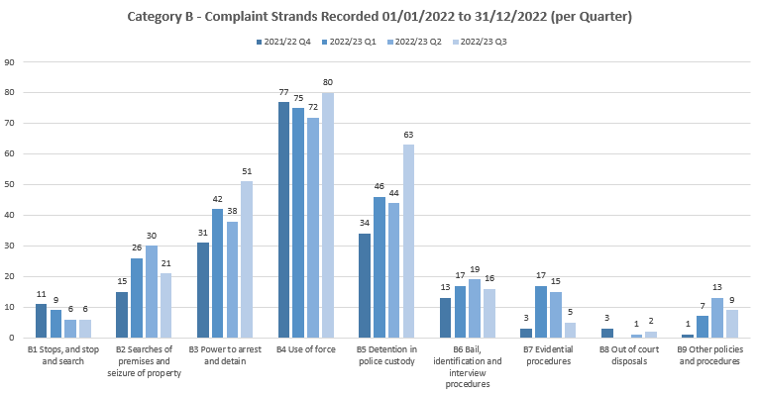

*Category H*

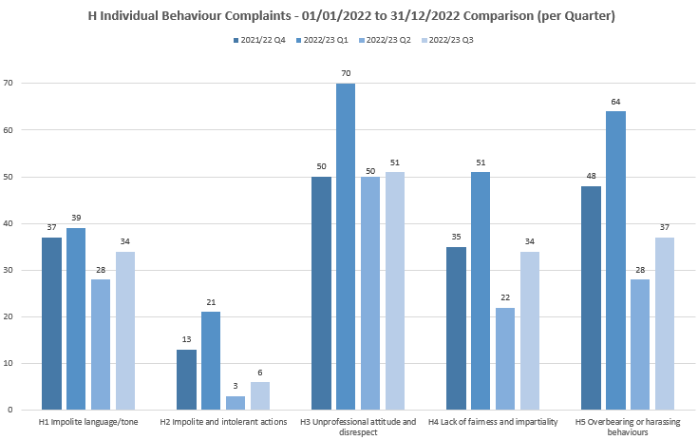

Throughout the different strands in this category, Q3 has shown a slight increase, however nothing of note at this time. PSD continue work to support the Professionalism Strategy, reporting on any trends identified and looking for areas of improve. Reports regarding use of language have been shared at the external IAG for feedback on officer actions and subsequent outcomes of complaint/conduct reports.

*Category F*

As a department, PSD has an increased focus around improving public confidence and reducing disparity. There are various workstreams ongoing, including a QR code which will take complainants to a survey for feedback on their complaint handling experience. There are also PSD Focus groups taking place internally to learn more about different groups and communities.

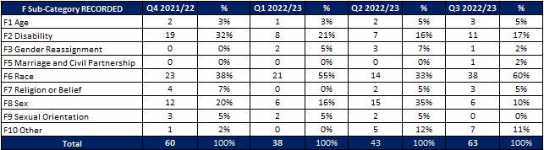

Q3 shows a significant increase in race related complaints compared to Q2, however it is worthy of note that Q1 was 55%. This will continue to be monitored and if it continues to increase or remain at a higher percentage, work will be carried out to identify any potential issues.

A review has been carried out of the discrimination strands due to the increase in Q3. Of the allegations made, 2 have been withdrawn, 12 have been finalised with service level acceptable, the rest remain live. The most common complaint made is in relation to investigation handling and potential bias shown by the officer, with the complainant as a victim or suspect. Discrimination complaints always require a local investigation to provide a meaningful response to the complainant, with officer accounts and reviews of police systems to identify any potential themes or trends.

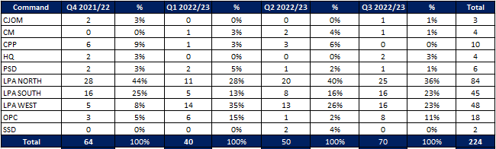

Despite the West LPA showing an increase between Q4 and Q1, it has shown a gradual decrease moving into Q3. The rest of the command areas remain consistent with no areas of concern identified.

**Police Officer and Staff Misconduct**

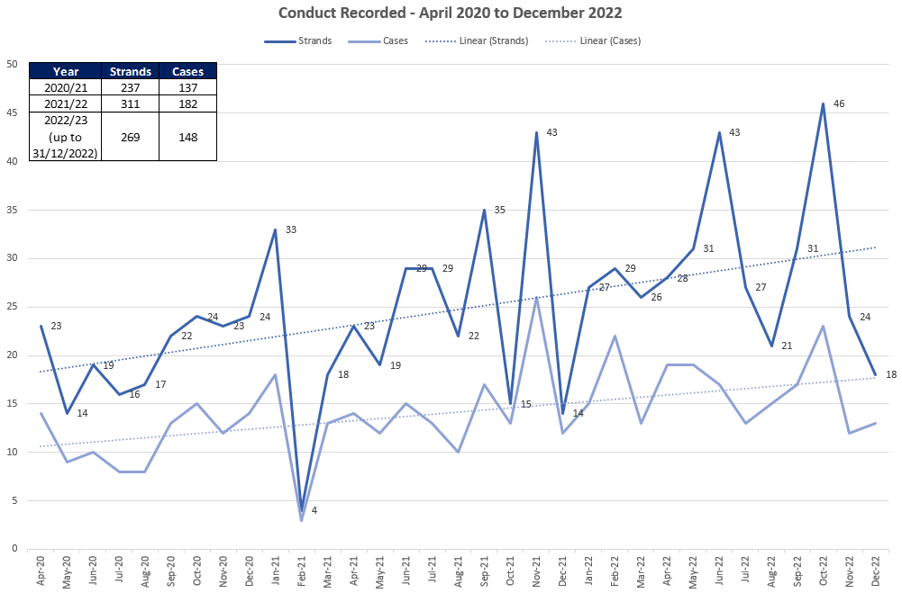

Overall, the total numbers of conduct strands and cases increased in Q3 2022/23 compared to Q2 2022/23, with 88 strands (48 cases) in Q3 and 79 strands (45 cases) in Q2.

The above graph shows the upward trajectory and a peak of strands and cases in October 2022 which will be explored in more detail below.

The below table details the 88 individual **strands** and breaks them down into the specific standards of professional behaviour that are alleged to have been breached.

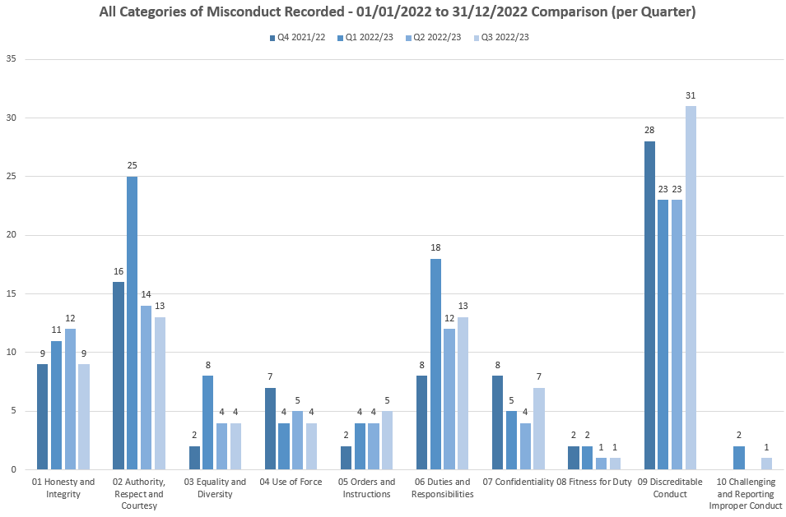

The only significant change in Q3 is the increase in *confidentiality* and *discreditable conduct*.

Of the seven strands involving *confidentiality*, there is no pattern relating to geography with cases recorded in the North, West and South LPAs, as well as Contact Management and Crime and Public Protection. Of the seven, three involve accessing police systems that do not appear to be for legitimate policing purposes, although investigation is still ongoing to determine this.

Of the thirty-one strands relating to *discreditable conduct*, there is no geographical pattern with a proportionate representation across all commands. Given that the standard of discreditable conduct is incredibly broad and includes a range of behaviours, it is unsurprising that this continues to have the highest number of breaches. However, of the thirty-one strands it is noted that fifteen were recorded in October, with only eight in each of November and December. This is a factor in the spike in cases and strands described on previous page.

Breakdown of types of conduct cases (non VAWG related

|  |  |
| --- | --- |
| **Non-VAWG cases type** | **Number** |
| **Total number** | **67** |
| Inappropriate comments or behaviour | 12 |
| Use of Force | 11 |
| DPA Breach | 10 |
| Dishonesty - Non-operational Matter | 10 |
| Dishonesty - Operational Matter | 4 |
| Physical assault | 5 |
| Failure to correctly investigate an incident | 4 |
| Driving matter | 3 |
| Drugs | 3 |
| Perverting the course of justice | 2 |
| Offensive weapons | 1 |
| Criminal associations | 1 |
| Sexual assault | 1 |

Types of conduct cases (VAWG related)

|  |  |
| --- | --- |
| **VAWG cases type** | **Number** |
| **Total number** | **52** |
| DA - Harassment/Coercive & Controlling Behaviour offences | 9 |
| DA - Physical assaults | 6 |
| DA - Sexual offences - Sexual assault & Rape | 1 |
| Child Abuse - IIOC & grooming offences | 2 |
| Child Abuse - Physical assaults | 1 |
| Inappropriate behaviour toward other EP Personnel | 11 |
| Sexual assault & Rape (non-DA cases) | 10 |
| Misconduct in a Public Office | 3 |
| Inappropriate relationship with a Member of the Public | 3 |
| Failure to correctly investigate a DA incident | 3 |
| Use of Force | 2 |
| Perverting the course of justice | 1 |

**Command Breakdown of Misconduct Cases**

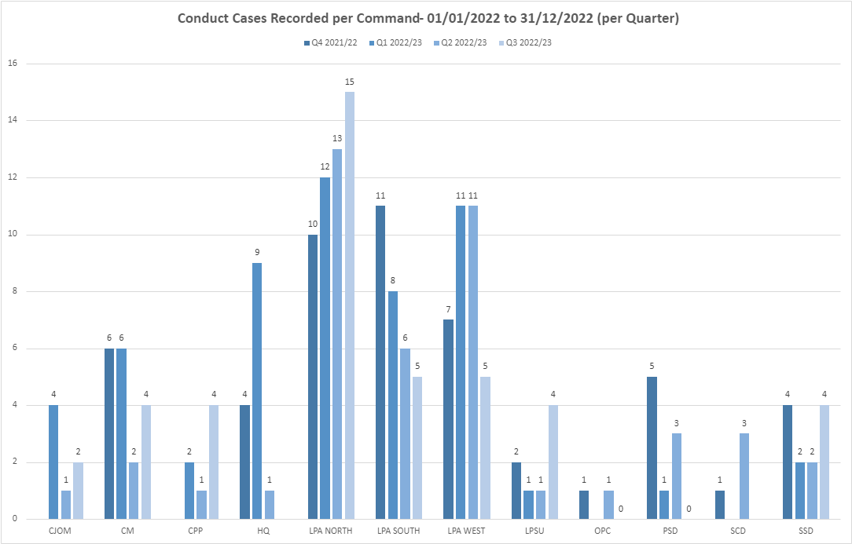

**Outcomes of conduct Cases – January 2022 to December 2022**

Between 1st January 2022 and 31st December 2022 there were 180 conduct cases finalised. Within these, there were a total of 369 strands/subjects, for which sanctions/outcomes differ.

Of the 180 finalised cases, there was a case to answer in 18% of cases and no case to answer in 74% of cases. The remaining were de-recorded or withdrawn by the Appropriate Authority.

Of those cases shown as Case to Answer, 58% resulted in a dismissal (or would have been dismissed had the officer not resigned/retired) and 30% resulted in a Written Warning or Final Written Warning. No Action was taken in 6% of cases and the remaining 6% were deemed as some form of management action/ Practice Requiring Improvement.

Where the case outcome is shown as No Case to Answer, 50% resulted in No Action and 50% were deemed to require some form of management intervention (i.e. Practice Requiring Improvement).

**Suspensions/ Restrictions**

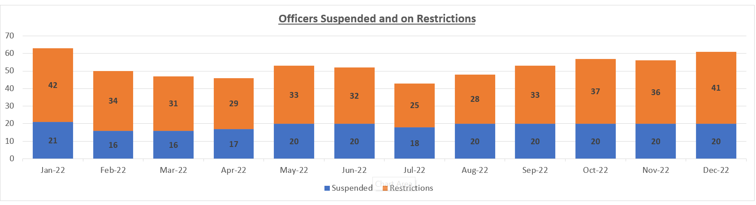

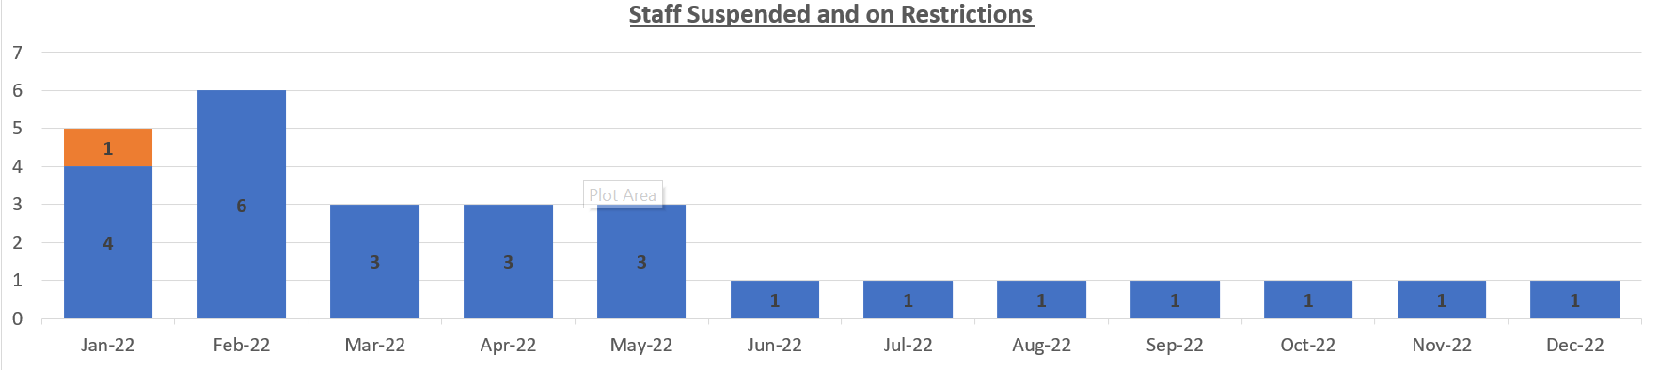

Of the 21 people suspended, 3 were suspended in Q3 2022/2023.

Of the 41 people restricted, 11 were restricted in Q3 2022/2023.

**IOPC/ OPFCC**

*IOPC Referrals*

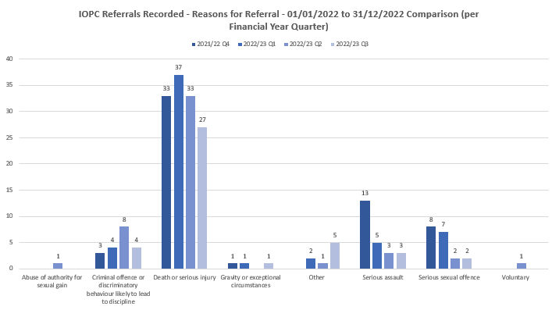

The majority of referrals from Essex Police into the IOPC are for Death or Serious Injury incidents. These include DSI incidents reported by custody and would include any loss of bodily function (including epileptic fit). The IOPC have previously been consulted with and are satisfied with the referrals through from Essex Police.

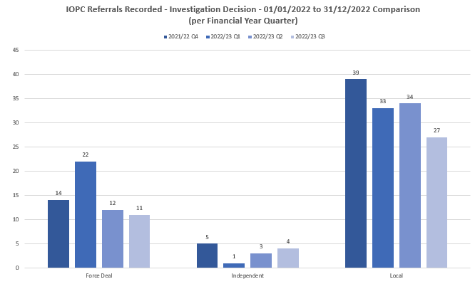

*IOPC Reviews*



IOPC review numbers have fluctuated over the past 4 years. It is expected the number will increase this year due to a recent change in process and further changing when deciding on the relevant review body. With the current number for this period being 71, this is on course to show higher numbers at the end of Q4.

There are a number of IOPC reviews awaiting decisions. It has been reported that the IOPC currently have a waiting time of approximately a year before appeals are being finalised, therefore the majority of outcomes of appeal requests are “awaiting decision”

|  |  |
| --- | --- |
|  |  |

*Reviews to the OPFCC*

|  |  |  |  |  |  |
| --- | --- | --- | --- | --- | --- |
|  |  | **White Complainants** | **Black Complainants** | **Mixed Ethnicity** | **Asian** |
| **Quarter** | **Total OPFCC Review Cases** | **Review requests** | **Review requests** | **Review requests** | **Review requests** |
| **Q4 - 2021/22** | 28 | 58% | 0% | 0% | 4% |
| **Q1 - 2022/23** | 23 | 64% | 4% | 0% | 8% |
| **Q2 - 2022/23** | 31 | 92% | 4% | 0% | 0% |
| **Q3 – 2022/23** | 46 | 69% | 0% | 7% | 7% |

*Note – Unknown ethnicity data has not been used in these figures.*

Data has been obtained in an attempt to compare complaints received from ethnic groups in relation to reviews received. Due to the dates in which complaints are recorded, the review period and the finalisation dates, it was not possible to provide accurate information.

PSD have recorded 46 requests for review in Q3. Out of these, 7 have been completed. None of these reviews have been upheld.

National PND Requirement

As part of the Home Office response to the ongoing criticisms of policing, there is a national requirement for each force to submit a return containing the name, date of birth and current home address for every police officer, staff member and volunteer.

This data will be centrally checked against PND, using a bulk search upload process and each force will receive a return by 31st March 2023, containing the PND ID reference(s) against each person. No intelligence will be reviewed centrally, and it will be down to individual forces to do so.

The Essex Police return contains a list of circa 6800 people and it is predicted that potentially over 7000 pieces of intelligence could be identified and will need to be reviewed and checked against each person’s vetting record.

Due to size, risk and complexity of this piece of work, a Gold Group has been established, chaired by the DCC and the Head of PSD has been appointed as the Senior Lead Officer.

Plans are ongoing to formulate a dedicated team, with PND trainers officers and staff from across the force in order to deliver against this national requirement, with an ambition to minimise the impact on the Force Corporate Vetting Unit.

For reassurance, every single police officer, staff member and volunteer are checked against PND as part of the initial and re-vetting process. It is therefore envisaged that the majority intelligence held on PND will already been known to the Vetting Unit, unless new intelligence has been uploaded after the initial vetting stage and before a re-vetting stage.