**Quarterly Report – Complaints, Misconduct and Other Matters**

**Contact – D/Supt Scott Cannon**

**Purpose of Report**

This report outlines the data and performance of Complaints, Misconduct and other matters that have been processed up to 30th September 2023 by the Professional Standards Department (PSD).

**Recommendations**

That the Commissioner considers the report and raises any queries though the quarterly meeting with the Deputy Chief Constable.

**Introduction**

The Complaint and Misconduct data used for this report is generally per strand in a case, except for where otherwise stated. It does not cover each officer allegation within a complaint.

For example, an overall complaint or misconduct case number is likely to include more than one complaint/misconduct strand or category – the data used reflects the separate strands. There will often be multiple officers subject to a complaint strand. The latter is at times reflected in this data, where it is noted as such.

Caveats:

Complaints and Misconduct data includes those that were de-recorded/withdrawn.

Data is dependent on certain fields being accurate – for example, when considering Commands/Area Responsible – due to changes in structures within the force, and due to changes within commands, numbers may be skewed compared to other reporting.

This data uses the Area Responsible as recorded initially for Cases; this will not reflect the individual complaint strands and officer allegations which will often be across different commands and areas.

Commands:

The table details the Commands across Essex Police and the abbreviations that will be used to refer to them throughout the report.



**Public Complaints**

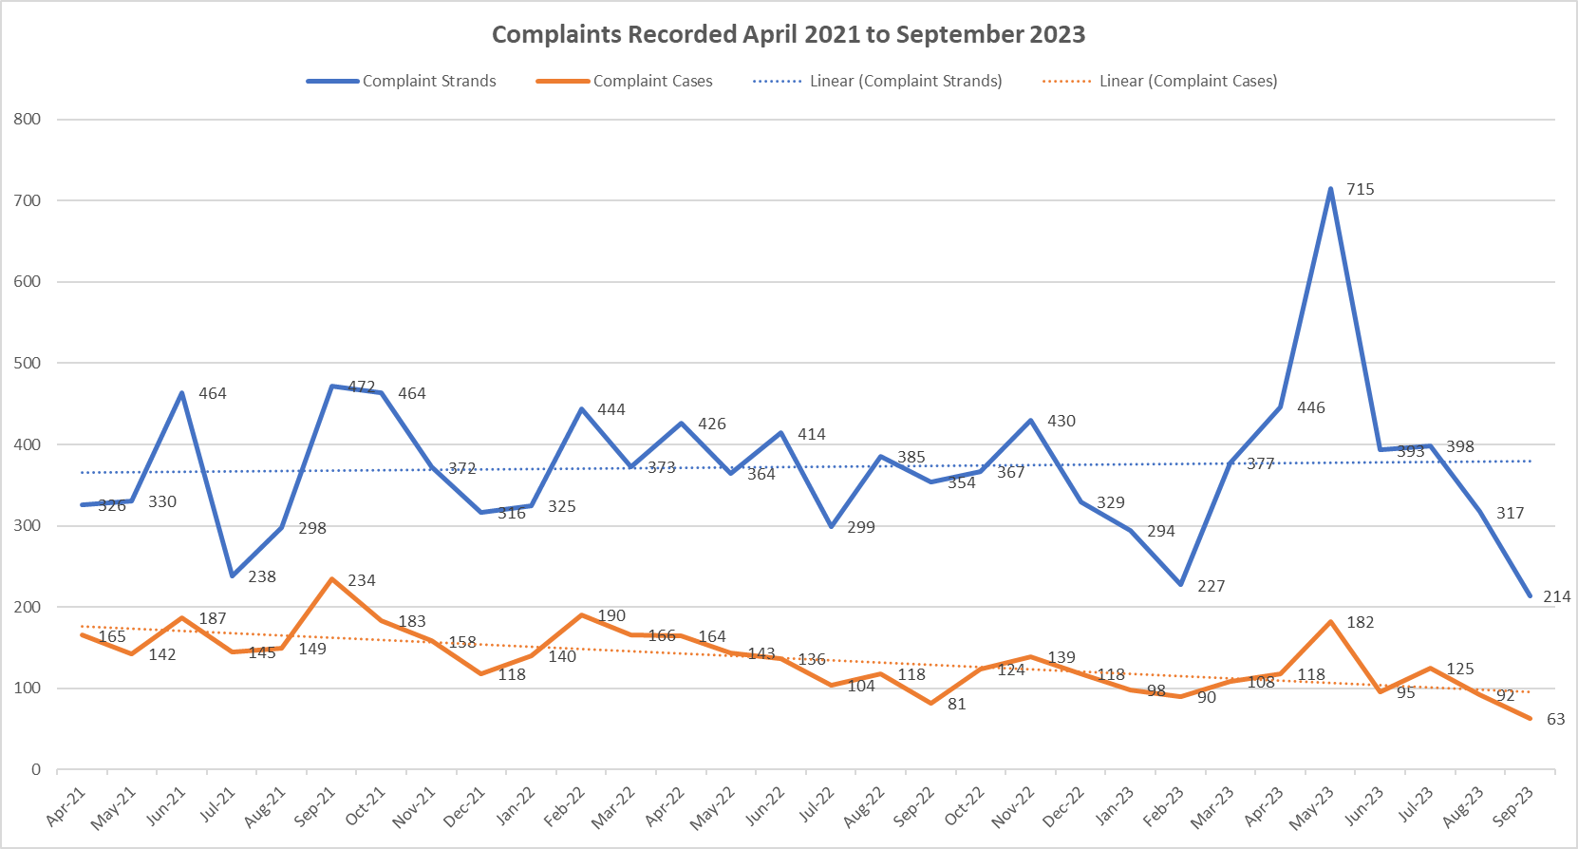

Q2 shows a significant decrease in complaint case and strands. This data is based on the date the complaint is recorded, rather than the date received by the force. Staff shortages and sickness have been a contributing factor to this decline, however it is expected this will increase into Q3 following a focus on eliminating the backlog.

*Timeliness of Complaints*

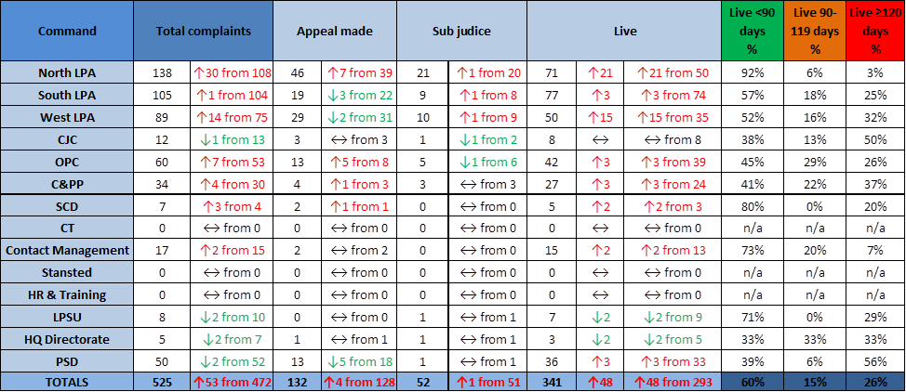

This data shows the current position of live complaints across the force. There are noted increases in the amount of complaints for the majority of commands. This is due to a focus on improved recording times, and this data now includes outside of S3 complaints.

The North LPA continues to have a lower percentage of complaints taking more than 120 days to resolve. Whilst other commands appear to have higher percentages, they are handling smaller numbers of complaints.

*Command Breakdown of Complaints:*

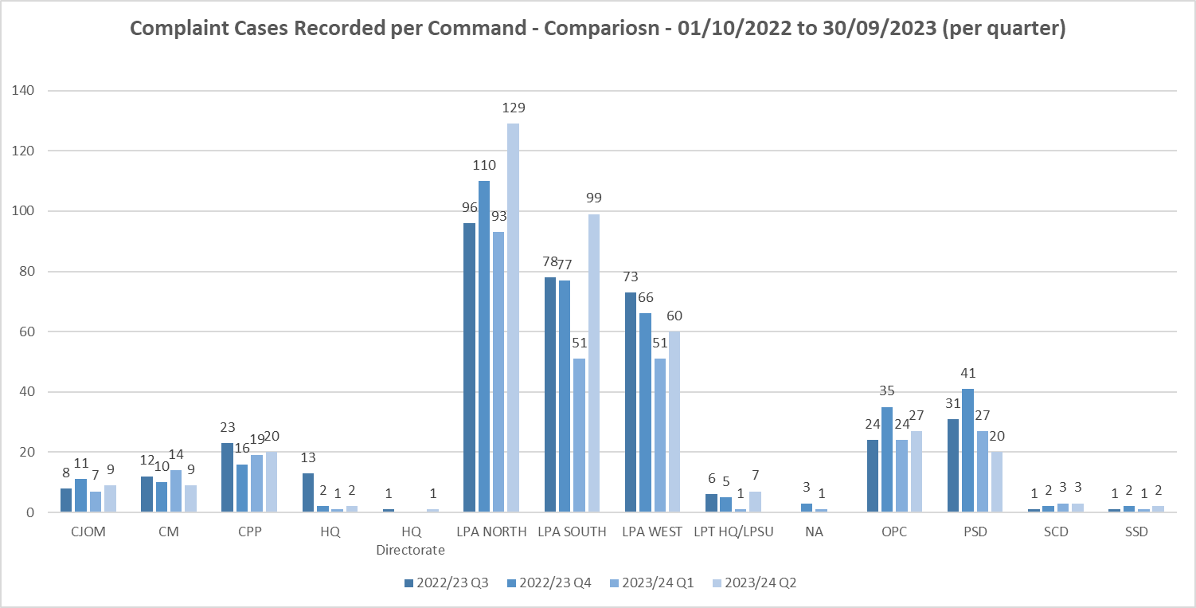

All three LPAs have shown an increase in complaints, despite overall a reduction. The North LPA appears to be most significant, however the South LPA has nearly doubled.

It is believed the increase in the South LPA may be attributed to Op Union. Op Union takes place predominantly along Southend seafront during the summer to ensure there are more officers when footfall is higher.

*Ethnicity of Complainants*

*Census Data*

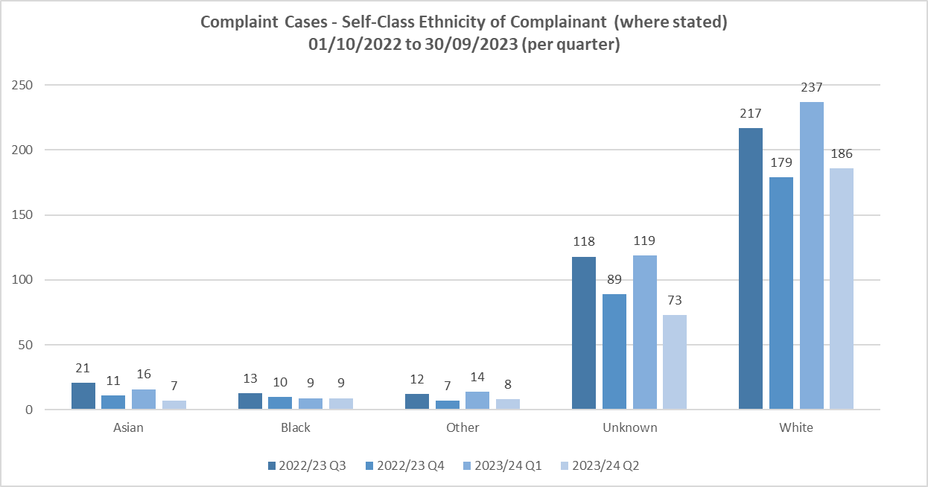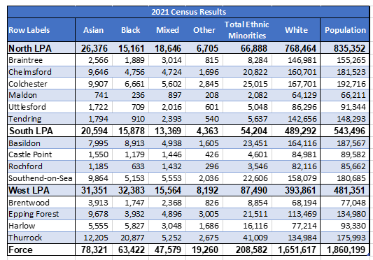

There is a noted improvement in the unknown category. This follows an increase in using other systems and further training on use of codes delivered by the IOPC.

Complaints from those from an Asian background have decreased. This is due to a persistent complainer who is currently remanded in custody.

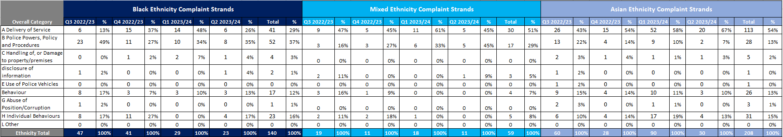*Ethnicity of Complainants*

This data shows that whilst there are some variations between the different categories there are no noted trends. Movements between quarters are not sustained over time.

Black Ethnicity

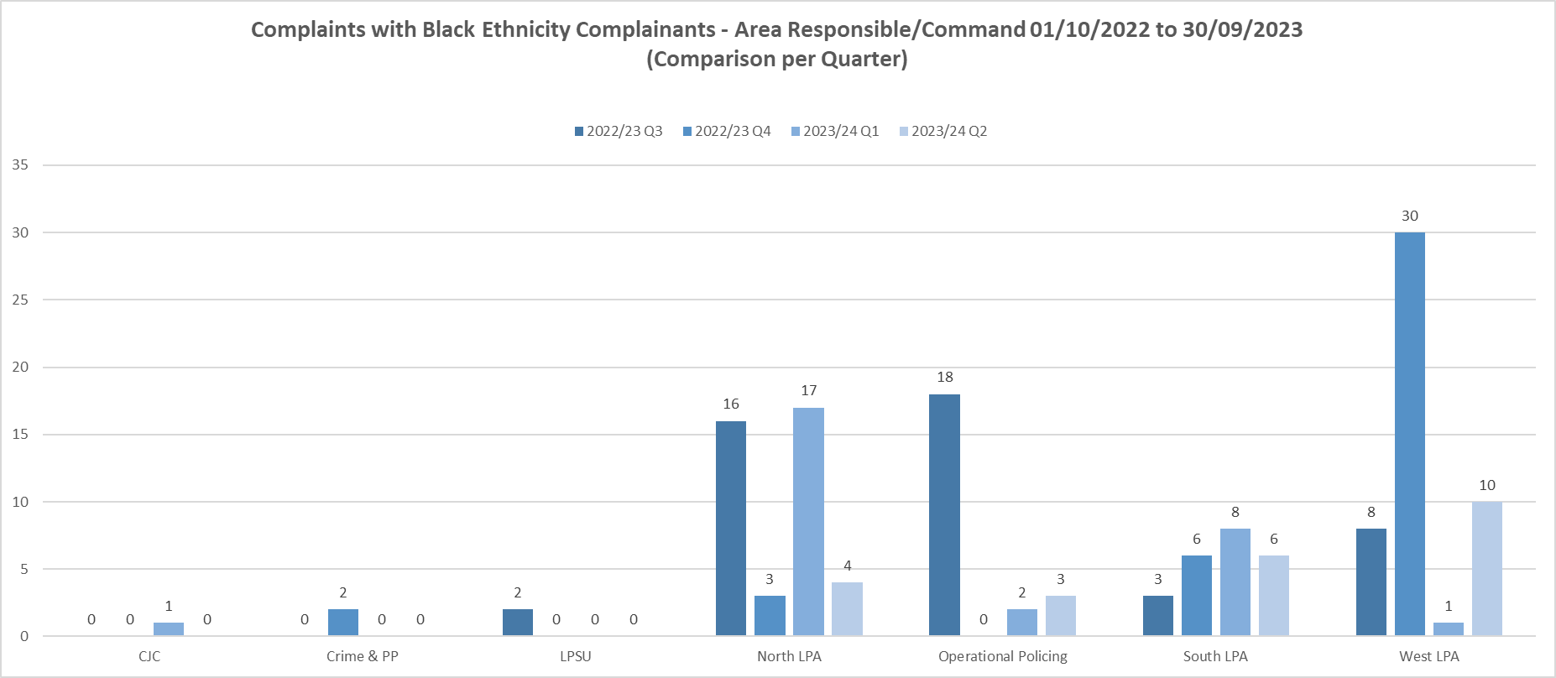

The North LPA shows fluctuation between the quarters in this period. The Complaints Inspector from the North LPA attends IAGs across the Command and delivers inputs around complaint handling. There is also an equality focus panel, where disproportionality regarding use of force and stop and search is reviewed. These could be factors which have affected the decrease in complainants of black ethnicity but it is difficult to assess on a single quarter’s data.

Asian Ethnicity

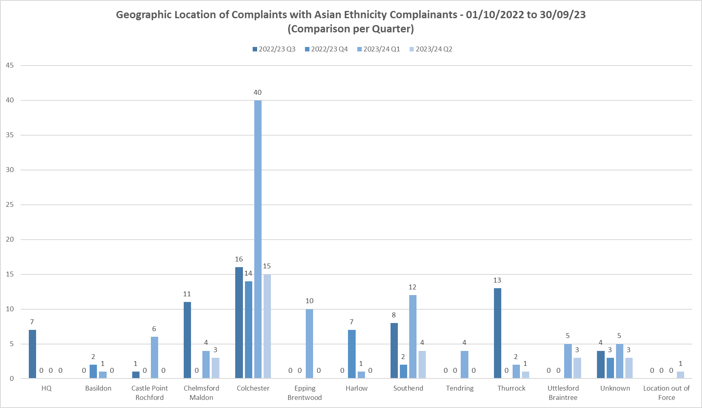

As previously mentioned, complaints from those from an Asian background have decreased. This is due to a persistent complainer from the Colchester area who is currently remanded in custody.

*Categories of Complaints:*

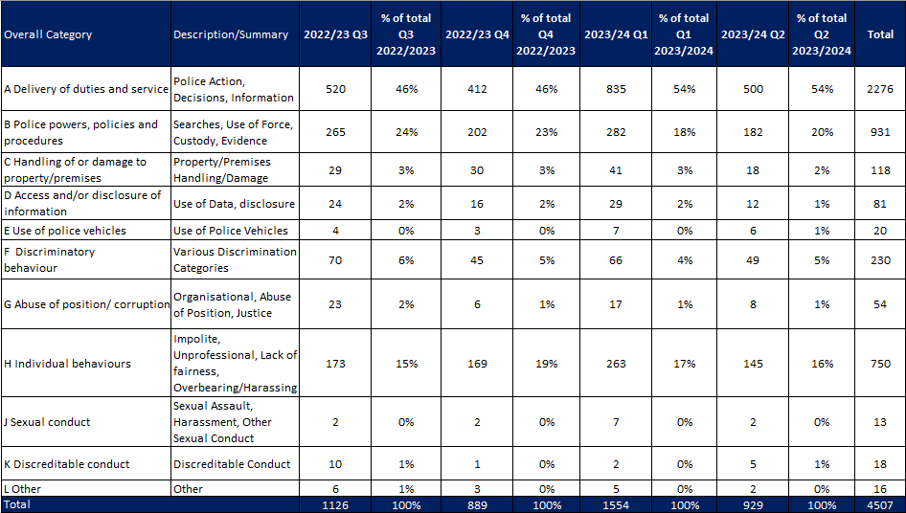

*Category A*

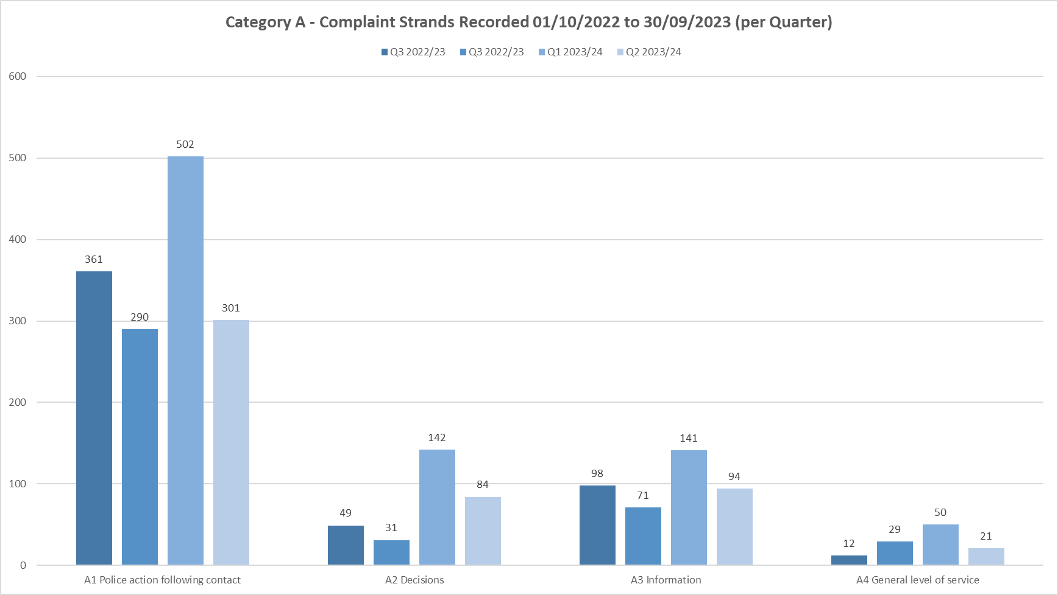

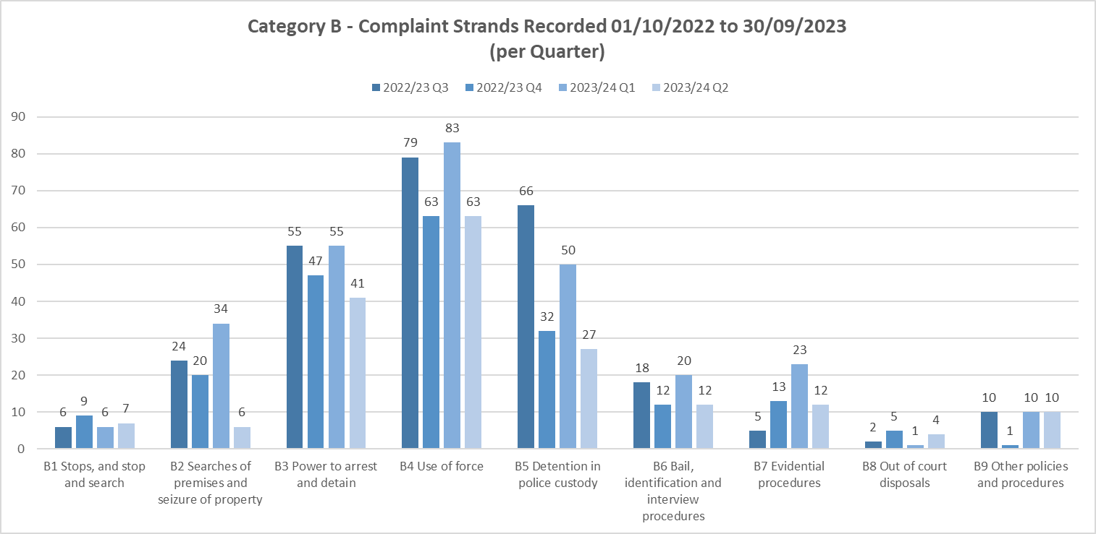*Category B*

*Category H*

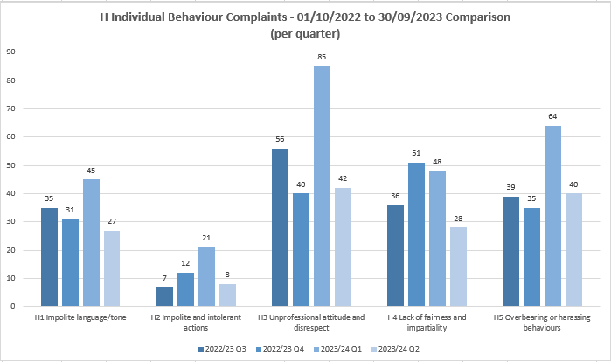

*Category F*

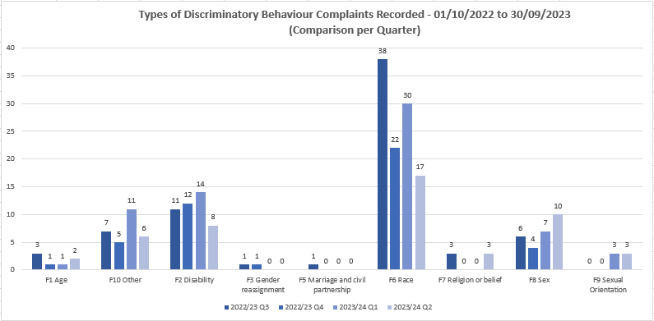

Category A, B and H have remained consistent noting that there was an increase in Q1 reflective in the overall increase in recording during that quarter.

Category F shows an increase in sex discrimination strands. There have been more complaints raised by men, stating a perception that they are not treated fairly due to their gender.

**Police Officer and Staff Misconduct**

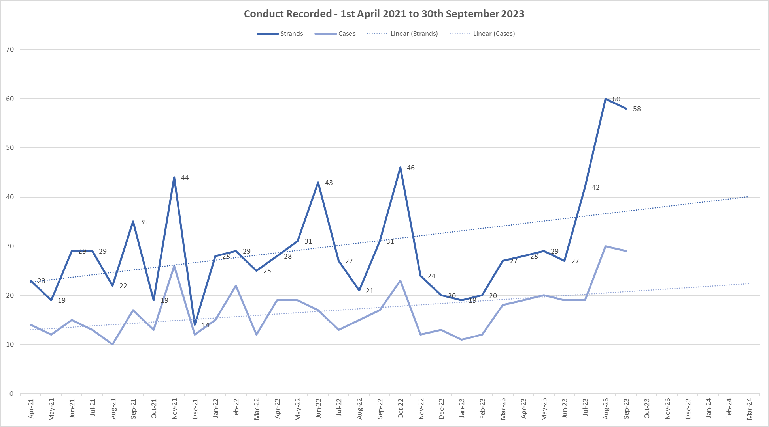

Overall, the total number of conduct strands and cases increased in Q2 2023/2024 with 30 cases in August with 60 strands and 29 cases in September with 58 Strands.

Reviewing the previous two years Q2 data, there is generally a spike in conduct recorded in August and September, albeit there is no obvious reason or explanation for this.

The above graph continues to show an upward Trajectory over time.

As the new Prevention and Engagement Team continue to deliver a comprehensive programme of work to encourage reporting and wrongdoing, it is predicted that conduct levels will continue to rise for the short term. This should be seen as a positive, with more people having the confidence to report, and more examples of victims and witnesses feeling like they are believed and supported through the conduct process.

The longer-term ambition remains to see a reduction in conduct cases, with more people being ‘upstanders and not bystanders’, calling out poor behaviour before it escalates into more serious conduct and educating the workforce around the importance of adhering to the Code of Ethics and Standards of Professional Behaviour.

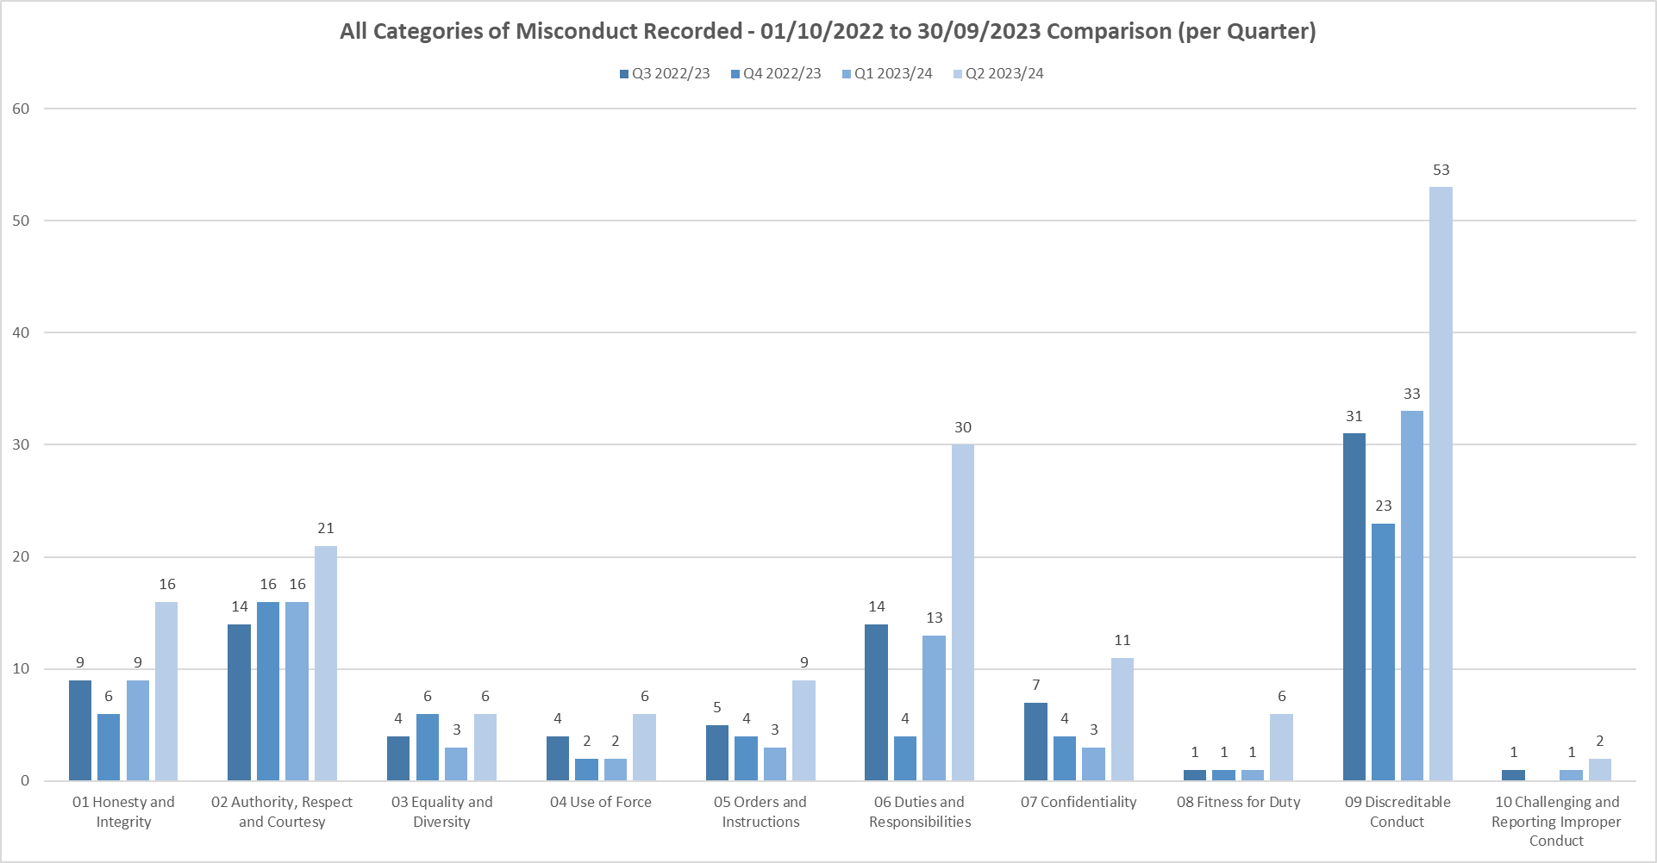

All 10 Categories have shown an increase in Q2 which is to be expected given the increase in cases in August and September.

There are significant increases in Duties and Responsibilities and Discreditable conduct however there are no clear patterns, although PSD have seen a slight increase in cases whereby officers and staff are claiming for hours they are not working and failing to investigate crimes proportionately. Such examples will be presented to the board at the next meeting.

With regards to Duties and Responsibilities, 10 of the cases are attributable to the North LPA, 7 to the South LPA and 5 to the West LPA.

With regards to Discreditable conduct, fifteen cases are attributed to the North LPA, 14 to the South LPA, 7 to the West LPA and 5 to Contact Management Command. The rest are evenly spread.

**Breakdown of types of conduct cases**

The below tables categorise the type of cases currently being investigated by PSD, the first table being ‘non VAWG related’ and the second being ‘VAWG related’.

Essex Police continues to take all forms of violence and intimidation against women and girls extremely seriously and will always take positive action in support of victims and witnesses. The new Prevention and Engagement Team have a real focus on VAWG related behaviours and deliver training and education packages.

There has been a considerable increase in driving offences and DPA Breaches in comparison to Q1.

The reason for the increase in driving related conduct cases is due to a new process, which involves the PSD DCI meeting regularly with the Driving School to discuss cases and consider which ones amount to conduct. This previously didn’t occur, and it is believed some matters were dealt with as performance and driving related as opposed to conduct.

All PSD data is shared with the Essex Police College to help inform and shape future training and education in this area.

There is no identified pattern or trend regarding DPA breaches and each case is disparate in nature.

**Non VAWG related**

|  |  |
| --- | --- |
| **Non-VAWG cases type** | **Number** |
| **Total number** | **72** |
| Inappropriate comments or behaviour | 11 |
| Use of Force | 5 |
| DPA Breach | 9 |
| Dishonesty - Non-operational Matter | 6 |
| Dishonesty - Operational Matter | 6 |
| Physical assault | 4 |
| Failure to correctly investigate an incident | 7 |
| Driving matter | 14 |
| Drugs | 6 |
| Perverting the course of justice | 2 |
| Offensive weapons | 1 |
| Criminal associations | 1 |

**VAWG related**

|  |  |
| --- | --- |
| **VAWG cases type** | **Number** |
| **Total number** | **49** |
| DA - Harassment/Coercive & Controlling Behaviour offences | 12 |
| DA - Physical assaults | 3 |
| DA - Sexual offences - Sexual assault & Rape | 8 |
| Sexual Offences – Non-DA | 8 |
| Child Abuse - IIOC & grooming offences | 2 |
| Child Abuse - Physical assaults | 1 |
| Inappropriate behaviour toward other EP Personnel | 8 |
| Misconduct in a Public Office | 2 |
| Inappropriate relationship with a Member of the Public | 3 |
| Perverting the course of justice | 2 |

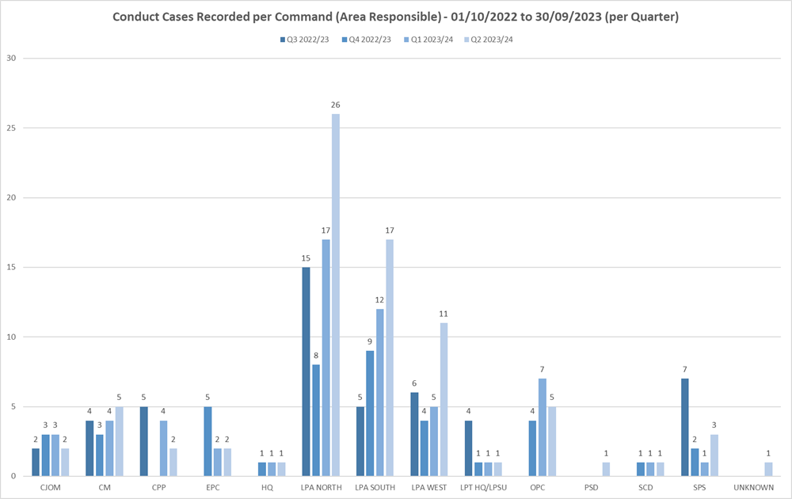



Q2 has seen an increase in misconduct cases in the North, South and West LPAS all other commands have remained stable. The majority of conduct cases still pertain to officers on Local Policing Teams, which is where the volume of officers work, and are most exposed to front line policing in all its forms.

**Misconduct Outcomes per Case**

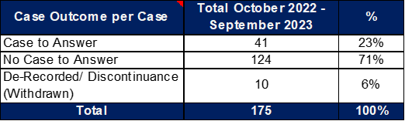

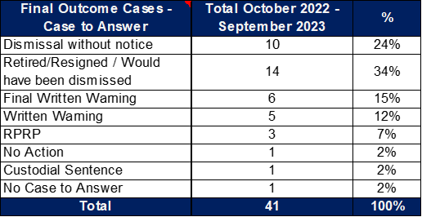

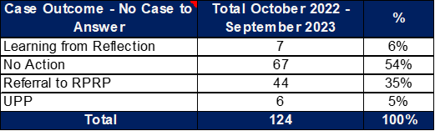

71% of cases investigated by PSD result in no case to answer. However, 46% still resulted in some form of learning or performance issues being identified. This percentage remains consistent and is largely due to the low threshold in which PSD have adhere to in accordance with the Conduct Regulations and Home Office Guidance. In short, if there is ‘an indication’ of conduct, an investigation must take place, and that indication must not soley take into account the evidence immediately available, and only the seriousness of the allegation if proven.

Where there has been a case to answer, only 2% were not proven and 2% where no action was taken. In relation to the latter, this is because officers have been found at misconduct, but have since left the police and therefore cannot be compelled to attend a misconduct meeting.

**Suspensions and Restrictions**

There are currently 33 Officers / Staff Suspended and 50 Officers/Staff Restricted.

Of those suspended, 10 are from the South LPA and 10 are from the North LPA.

Of those restricted, 13 are from the North LPA and 9 are from the West LPA.

There has been a significant rise in Police Staff who are restricted from 6 in Q1 to 15 in Q2. However, there is no clearly identified pattern or trend.

Suspensions are reviewed every month by the Deputy Chief Constable, who is provided with an investigative update and considers whether the suspension is still necessary and proportionate in order to maintain trust and confidence in policing, and prevent any interference with the investigation.

The following table shows the 3 longest suspended officers -

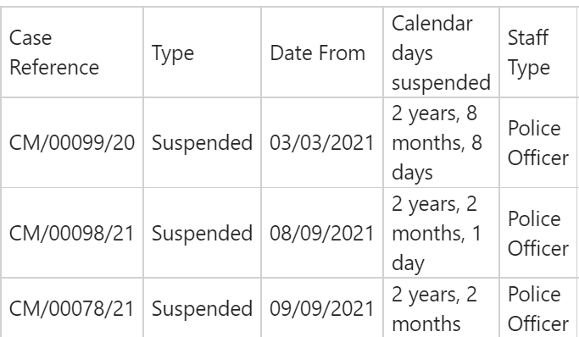

99/20 – relates to an officer charged with a criminal offence and is awaiting trial.

98/21 – relates to an officer whose misconduct hearing has been a adjourned twice for reasons outside the control of PSD

78/21 – relates to an officer whose misconduct hearing has been adjourned due to a legal argument around expert witness evidence.

**IOPC/ OPFCC**

*IOPC Referrals*

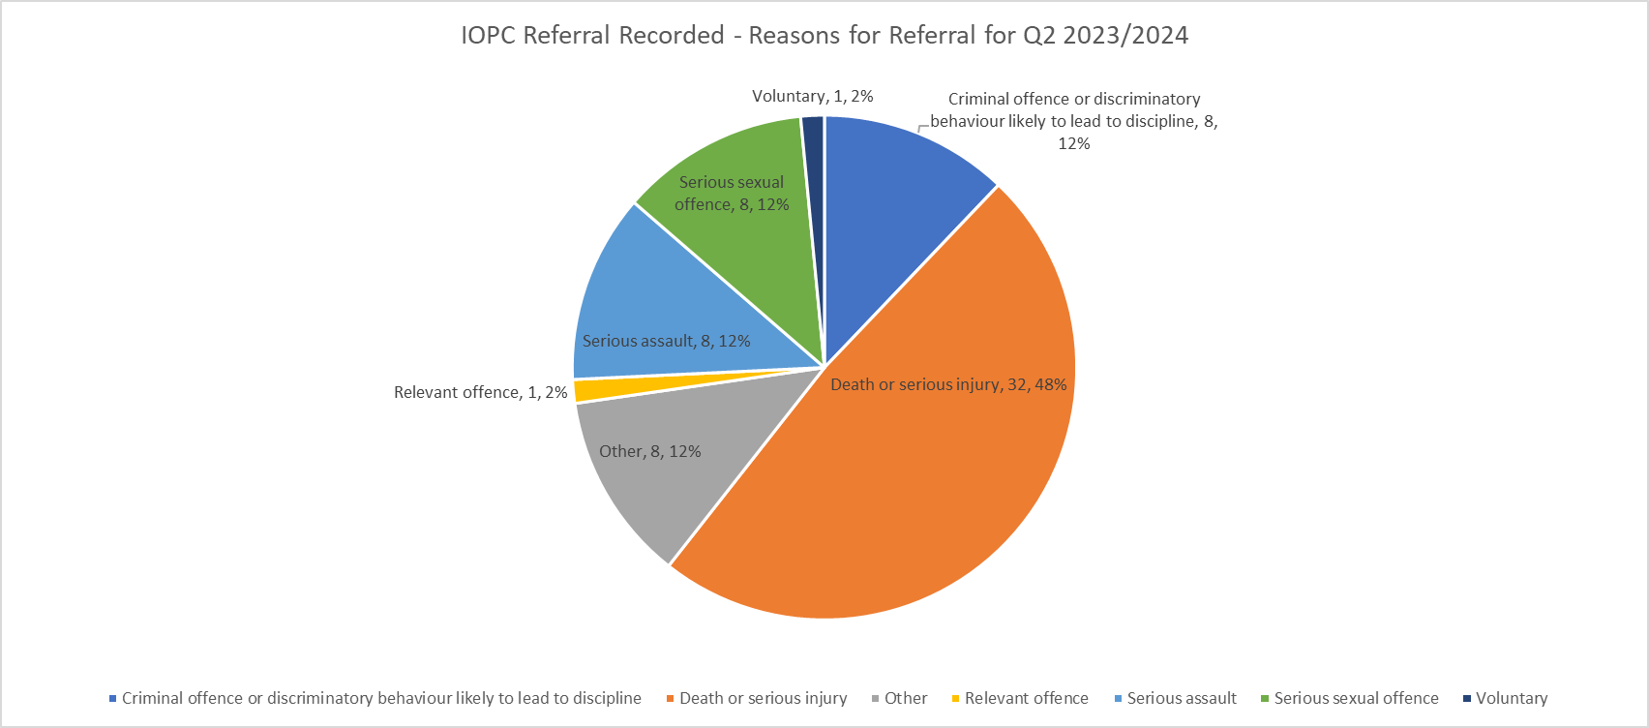

The number of referrals made by Essex Police have since been discussed at a quarterly meeting with the IOPC. There are no concerns raised regarding the number of referrals. The pattern is in line with normal peaks and lows.

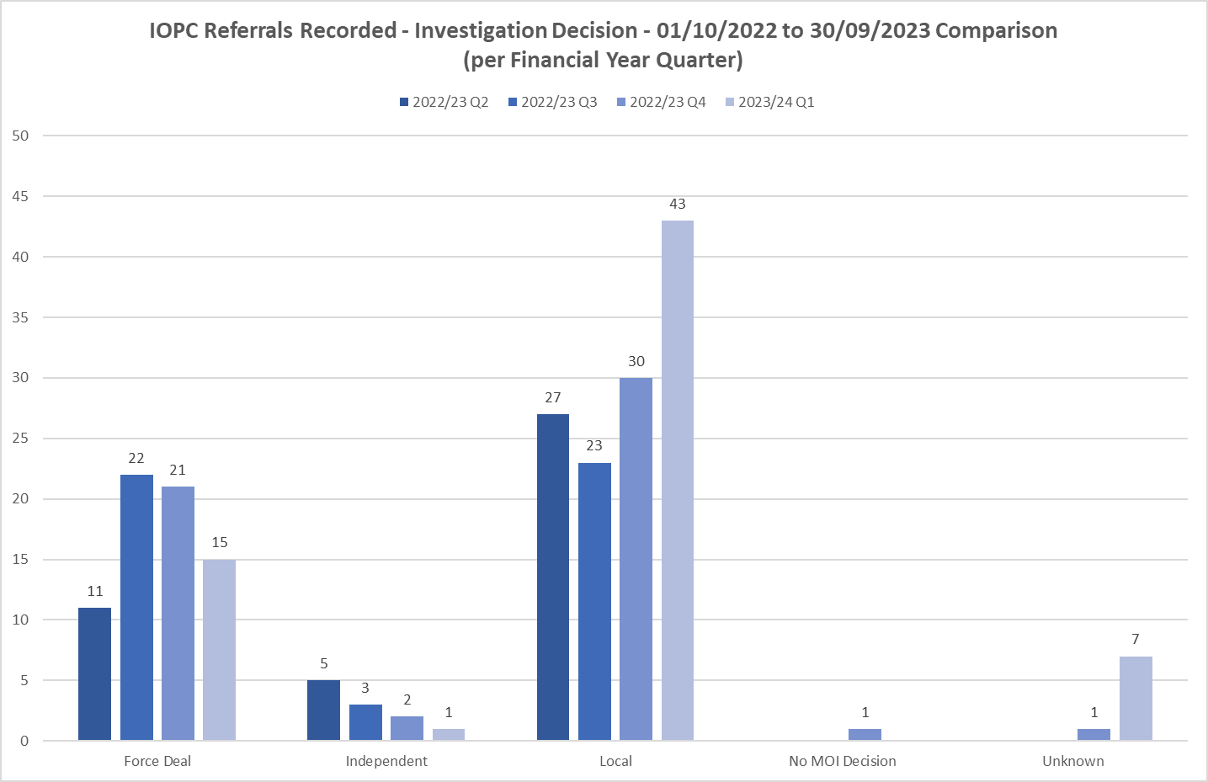

*IOPC Reviews*



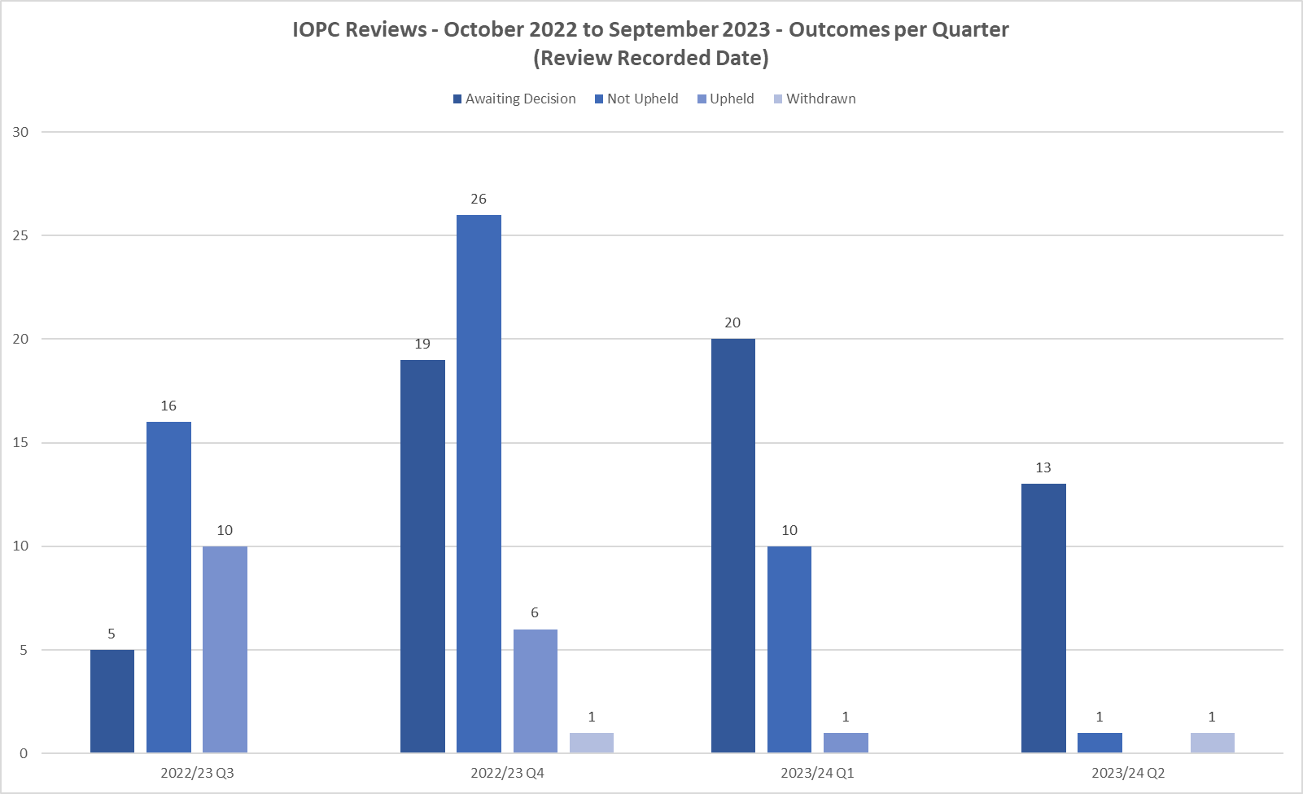

Outcomes of reviews to the IOPC were also discussed at the recent meeting. Overall, a larger number were being upheld. This is subject of review by the IOPC and they will look to identify if there are any common themes for Essex Police and if any feedback is required.

*Timeliness of IOPC reviews*

|  |  |
| --- | --- |
| **Quarter** | **Average days** |
| **Q3** | 130 |
| **Q4** | 182 |
| **Q1** | 170 |
| **Q2** | 168 |

*NB – this data is based on the review end date, not the date the review was received*

|  |  |
| --- | --- |
|  |  |

*Reviews to the OPFCC*

|  |  |  |  |  |
| --- | --- | --- | --- | --- |
| **Quarter** | **Outstanding** | **Upheld** | **Not upheld** | **Invalid** |
| **Q3** | 0 | 4 | 15 | 0 |
| **Q4** | 9 | 2 | 19 | 2 |
| **Q1** | 15 | 1 | 5 | 2 |
| **Q2** | 19 | TBC | TBC | TBC |

*NB – this data is based on the date the review was requested not the date the outcome was received.*

|  |  |  |  |  |  |
| --- | --- | --- | --- | --- | --- |
|  |  | **White Complainants** | **Black Complainants** | **Mixed Ethnicity** | **Asian** |
| **Quarter** | **Total OPFCC Review Cases** | **Review requests** | **Review requests** | **Review requests** | **Review requests** |
| **Q3 – 2022/23** | 46 | 69% | 0% | 7% | 7% |
| **Q4 – 2022/23** | 29 | 62% | 3% | 3% | 3% |
| **Q1 – 2023/24** | 21 | 72% | 0% | 28% | 0% |
| **Q2 – 2023/24** | 16 | 87.5% | 0% | 0% | 6.25% |

*NB – Unknown ethnicity data has not been used in these figures.*