**Quarterly Report – Complaints, Misconduct and Other Matters**

**Contact – D/Supt Scott Cannon**

**Purpose of Report**

This report outlines the data and performance of Complaints, Misconduct and other matters that have been recorded up to 30th September 2022 by the Professional Standards Department (PSD).

**Recommendations**

That the contents of the report are noted. There are no other recommendations at this stage.

**Performance Update – Head of PSD – Key Findings**

Recorded public complaints continue to reduce in Q2, which is positive.

A new process around dealing with minor dissatisfactions outside of Schedule 3 and managing them in a timely manner is proving to be effective, with members of public receiving early resolutions.

Essex Police were previously an outlier, but we are now in line with the national average of dealing with dissatisfactions outside of Schedule 3, which is driving efficiencies and providing a better service overall.

53% of public complaints were deemed service level acceptable at conclusion and only 17% were found to be not acceptable, which is statistically significant.

Timeliness remains a challenge for the force, compounded by many competing demands, but all 3 of the new LPA Complaints Inspectors are in post and have plans in place to improve timeliness moving forward.

The North LPA continues to perform well around complaints handling, with only 10% of live complaints being over 120 days old, compared to the South LPA at 30% and West LPA at 32%. It is believed that Operation Hazel has been a significant factor for the West LPA, supported by the South, and the North has an established dedicated Complaints Sergeant in addition to the Inspector, due to the size of the LPA.

PSD continue to use existing held ethnicity data to improve data accuracy when recording complaints whereby complainants have not stated their ethnicity.

PSD are also currently trialling Single Online Home which is a new method for the force to receive complaints, with a mandatory ethnicity field, and a ‘prefer not to say’ option for those who do not wish to state.

Category A ‘Delivery of Service’ remains the most complained area for white complainants, but there’s been a 27% reduction in this area. For black and ethnic minority complainants however, Category B is higher, which is ‘Police Powers, Policy and Procedures’.

This suggests that black and ethnic minority people are more likely to complain about the police when they are stop checked, searched or arrested and work is ongoing through the various DE&I Boards and the Stop and Search Board to improve and further professionalise how officers interact with all people when invoking such powers.

The West LPA statistically have more complaints from black people, but this report now includes the 2019 census data, which shows that Thurrock has a significantly higher population of black people than any other District.

Misconduct levels have slightly reduced in Q2 compared to Q1, with 45 new cases versus 55 respectively. 11 of the new conduct cases in Q2 pertain to violence and intimidation against women and girls, with 49 of the 102 live gross misconduct cases being VAWG related.

Out of the 102 cases, 14 are criminal, which means the conduct investigation will be subjudice pending the outcome of the criminal case. The overall volume of gross misconduct cases remains stable, but plans are in place to be more proportionate and timely in the investigative approach where possible, with prevention activity to reduce future levels of misconduct.

The force continues to drive prevention focused activity through the new Professionalism Strategy and a separate presentation will cover this topic in much greater detail.

70% of cases determined upon in Q2 resulted no case to answer, which can be explained by the initial ‘low indication’ threshold in which conduct matters must be assessed, versus the material facts upon the conclusion of an investigation. That said, where there was no case to answer, 49% were still deemed to require some form of management intervention.

Of those cases shown as Case to Answer, 53% resulted in a dismissal (or would have been dismissed had the officer not resigned/retired) and 29% resulted in a Written Warning or Final Written Warning. No Action was taken in 11% of cases and the remaining 7% were deemed as some form of management action/ reflective practice.

**Introduction**

The Complaint and Misconduct data used for this report is generally per strand in a case, except for where otherwise stated. It does not cover each officer allegation within a complaint.

For example, an overall complaint or misconduct case number is likely to include more than one complaint/misconduct strand or category – the data used reflects the separate strands. There will often be multiple officers subject to a complaint strand. The latter is at times reflected in this data, where it is noted as such.

Caveats:

Complaints and Misconduct data includes those that were de-recorded/withdrawn.

Data is dependent on certain fields being accurate – for example, when considering Commands/Area Responsible – due to changes in structures within the force, and due to changes within commands, numbers may be skewed compared to other reporting.

This data uses the Area Responsible as recorded initially for Cases; this will not reflect the individual complaint strands and officer allegations which will often be across different commands and areas.

Commands:

The table details the Commands across Essex Police and the abbreviations that will be used to refer to them throughout the report.



**Public Complaints**

Table 1 displays the levels of public complaints. The orange line indicates individual complainants and is more representative of the increase. The blue line shows complaint strands. It is not uncommon for one complaint to contain several strands.

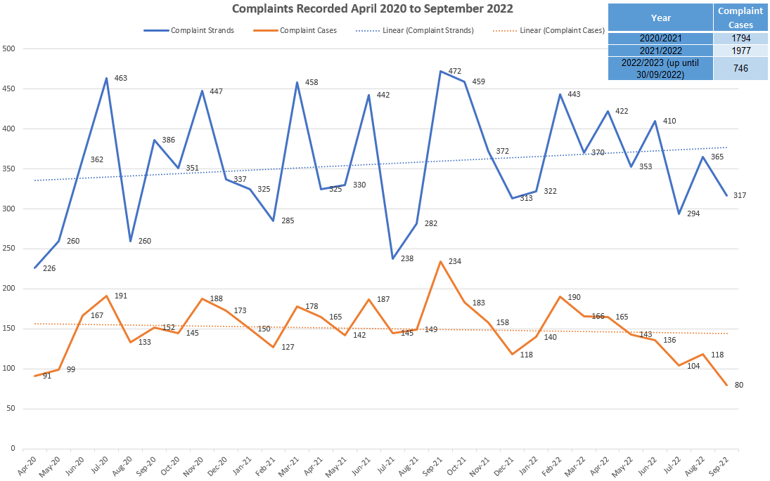

As previously mentioned, PSD commenced a new process for managing complaints suitable to be dealt with as a dissatisfaction – outside of schedule 3. This are referred to throughout this report as NS3 (Non schedule 3) complaints. As these are no longer recorded on Centurion, this chart will only show formally recorded complaints moving forward.

This table shows how many NS3 and S3 complaints received this quarter:

|  |  |  |  |
| --- | --- | --- | --- |
| **Month** | **NS3** | **S3** | **Total** |
| **July** | 114 | 104 | 218 |
| **August** | 107 | 118 | 225 |
| **September** | 66 | 80 | 146 |

This shows an increase in complaints received for the summer period, however a decrease as we move into September. The dissatisfactions that are being managed as NS3 are in line with the national average.

*Outcome of Complaints:*

Service level acceptable remains the highest outcome with Q2 showing 53%. There has been a 6% increase in complaints showing as service level not acceptable this quarter. There is no known reason for the increase and we will continue to monitor.



The resolved outcome is at 7% for Q2 which is a significant decrease. This is due to NS3 complaints no longer being recorded on Centurion. This figure will include dissatisfactions previously recorded on Centurion and finalised in Q2.

The following table shows the outcomes of dissatisfactions not recorded on Centurion:

|  |  |  |  |
| --- | --- | --- | --- |
| **Month** | **Resolved** | **Not Resolved** | **Live** |
| **July** | 84 | 20 | 10 |
| **August** | 78 | 11 | 18 |
| **September** | 33 | 5 | 30 |

This shows the majority of dissatisfactions are able to be resolved in a timely manner. Those that are unable to be resolved are then formally recorded under S3 and a decision made on how they are progressed. It is important to note that if at any stage a complainant wishes the dissatisfaction to be formally recorded this will take place.

Outcomes remain consistent over the 12-month period. The “other “allegation outcome includes unable to determine, no further action decisions and referral to proceedings.

*Timeliness of Complaints*

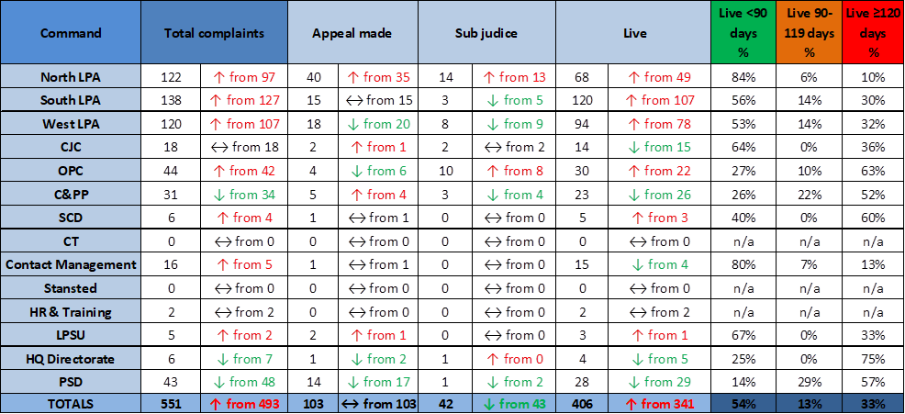

Timeliness is of paramount importance to build public confidence in the complaints system. Timeliness is scrutinised internally at the Quarterly Integrity & Counter Corruption Board chaired by the DCC. The regulations also require the investigating body to report any complaint (or conduct) matter which exceeds 12 months to interested parties, including the PFCC and the Independent Office of Police Conduct (IOPC). The continued ambition is for complaints to be resolved within 120 days

When looking at complaints over 120 days old, the North LPA has continued to reduce in this period from 15% to 10%. The North LPA has a dedicated complaints sergeant, with well established working practises followed by investigating officers. The new LPA inspectors are now in post in the North and South LPA. The West LPA have a temporary inspector in this post and are being supported by PSD to make improvements in timeliness.

There is an increase in a lot of command areas for complaints over 120 days. It is important to note that some smaller commands have a lower number of complaints, therefore the changes appear more significant. There is a slight increase in the South and West LPA.

PSD shows 57% over 120 days. These continue to be reviewed and monitored to ensure progression. The main reasons for complaints over 120 days held by PSD are due to appeals to the IOPC, linked to misconduct investigations and awaiting hearings/meetings, ongoing civil proceedings and more complex investigations. PSD managed public complaints are relatively low in number, therefore shows higher percentages.

*Command Breakdown of Complaints:*

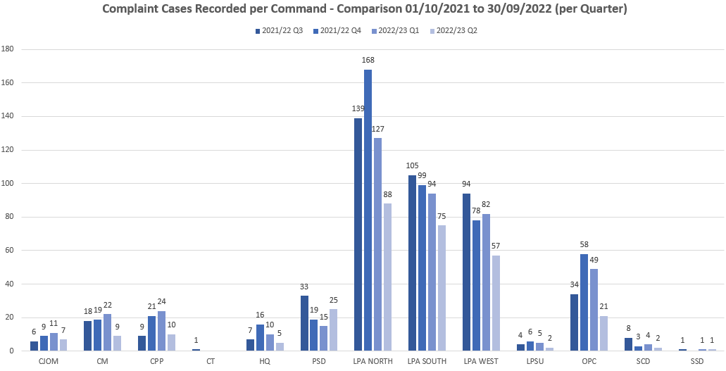

The above chart relates solely to formally recorded complaints. A decrease moving into Q2 would be expected, in line with the new NS3 process. PSD is an outlier in this area due to complaints being managed by PSD not being suitable to be deal with as a low-level dissatisfaction.

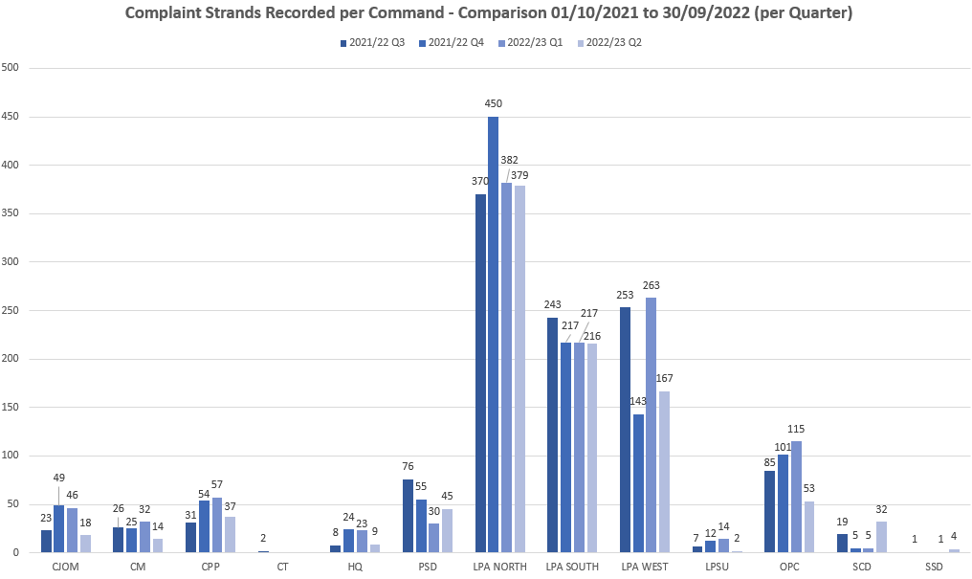

Recorded strands have decreased in Q2. This will again be due to the new process, but also in line with more scrutiny around strands and getting the right balance.

Numbers of complaint cases recorded are in line with headcount percentages. Strands recorded vary slightly showing a higher number of strands for the North LPA compared to headcount. The North LPA have had a persistent complainer who’s contact has continued to increase. A strategy has been imposed with this complainant and at the time of writing his contact has ceased, therefore it is likely we will see a reduction in strands in the North for Q3

The below table shows the number of dissatisfactions recorded in Q2 per command:

|  |  |  |  |  |  |  |
| --- | --- | --- | --- | --- | --- | --- |
| **July** | | **August** | | **September** | | **Q2 Total** |
| **Command** | **Total** | **Command** | **Total** | **Command** | **Total** |  |
| North | **39** | North | **40** | North | **26** | **105** |
| South | **33** | South | **25** | South | **15** | **73** |
| West | **17** | West | **13** | West | **5** | **35** |
| C&PP | **5** | C&PP | **3** | C&PP | **0** | **8** |
| OPC | **10** | OPC | **13** | OPC | **10** | **33** |
| CMC | **6** | CMC | **11** | CMC | **6** | **23** |
| CJ | **1** | CJ | **1** | CJ | **3** | **5** |
| HR | **1** | HR | **1** | HR | **0** | **2** |
| LPSU | **2** | LPSU | **0** | SCD | **1** | **3** |

These figures show the LPAs receiving the highest amount of dissatisfactions, closely followed by OPC. This is in line with formally recorded complaints.

*Ethnicity of Complainants*

PSD continue to use other police systems to check for ethnicity data, ensuring this is updated and reflected on Centurion. When this information is not readily available, the IO is requested in their enquiries to obtain this information.

The below figures relate to formally recorded complaints.

There has been a significant decrease (38.06%) of formal complaints from White complainants. This would indicate that just over a third of complaints from this group have been dealt with as a dissatisfaction with service. Other ethnic groups have also shown a decrease as expected, however the numbers are lower overall.

PSD are currently trialling Single Online Home which is a new method for the force for receiving complaints. This is a generated form as opposed to a PDF with no mandatory fields. This form has ethnicity has a mandatory field and “prefer not to say” as an option. The change in complaint reporting will continue to improve these figures.



Category A remains the highest area complained about across all recorded ethnicities, apart from Black and mixed ethnicity complainants where Category B is higher. This is the second consecutive quarter where Category B has remained the highest area complained about by Black complainants. We are continuing to monitor this in PSD to highlight any areas of concern.

Operational Policing Command has shown a significant decrease in complaints from Black complainants. This figure has gone from 13 in Q1, to 0 in Q2. OPC Command have been spoken to in relation to the change. There has been a restructure with complaint handling, learning provided to officers in an attempt to reduce complaints and increase public confidence.

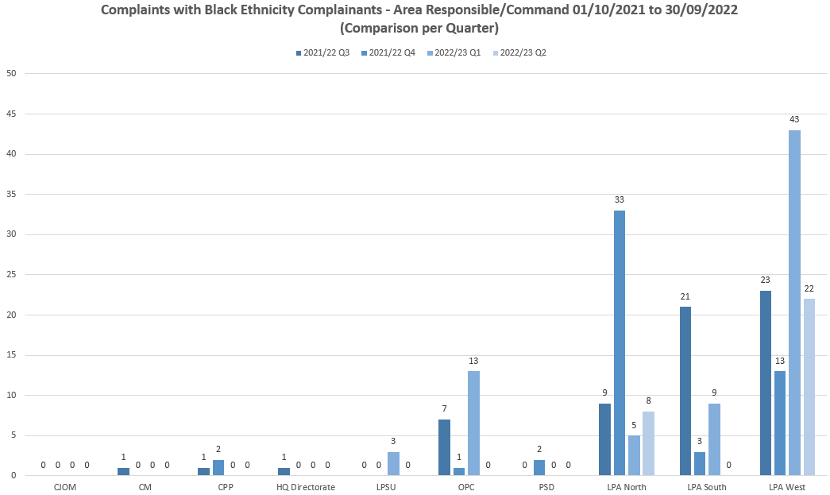

The West LPA continue to have the highest number of complaints from Black complainants. Within this LPA there is a high proportion of BAME communities. Within Thurrock there have been a number of projects to encourage engagement within various community groups, including challenge panels set up to review interactions with police regarding things such as stop and search. This has encouraged reporting of matters whereby the public feel the service is below that expected, or there are interactions which should have been handled more appropriately. This may be a contributing factor to the higher numbers and will continue to be monitored.

As the latest Census data is not yet available, 2019 mid year population estimates have been obtained. This data shows Thurrock has the highest number of members of the public who identify as Black:

|  |  |  |  |  |  |
| --- | --- | --- | --- | --- | --- |
|  | Sum of White | Sum of Other | Sum of Black | Sum of Asian | Sum of Mixed |
| Basildon | 171525 | 561 | 5535 | 5508 | 4070 |
| Braintree | 146867 | 289 | 983 | 2119 | 2346 |
| Brentwood | 71318 | 333 | 1008 | 2662 | 1700 |
| Castle Point | 87269 | 201 | 686 | 1075 | 1145 |
| Chelmsford | 166225 | 763 | 2358 | 5612 | 3430 |
| Colchester | 177616 | 2146 | 3122 | 7294 | 4528 |
| Epping Forest | 117840 | 973 | 2721 | 6686 | 3469 |
| Harlow | 76500 | 442 | 3546 | 4305 | 2274 |
| Maldon | 63536 | 62 | 163 | 552 | 612 |
| Rochford | 84559 | 144 | 496 | 960 | 1208 |
| Southend-on-Sea | 166037 | 927 | 4128 | 7180 | 4853 |
| Tendring | 142622 | 228 | 479 | 1486 | 1746 |
| Thurrock | 146343 | 1133 | 15527 | 6833 | 4505 |
| Uttlesford | 87756 | 212 | 556 | 1347 | 1413 |
| **Grand Total** | **1706014** | **8414** | **41307** | **53620** | **37300** |

From viewing the Asian and Mixed Ethnicity groups, there are no outliers in the figures or areas of concern.

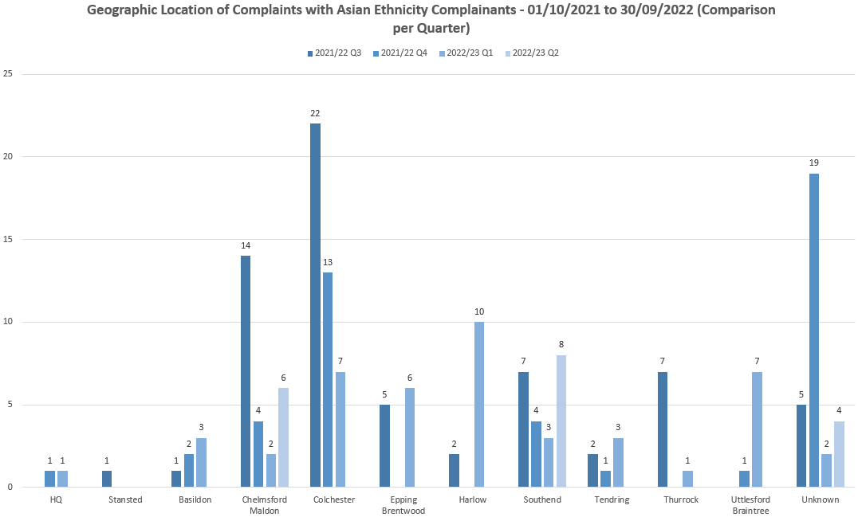

**Mixed ethnicity group:**



*Categories of Complaints:*

Delivery of service, police powers, policy and procedure and individual behaviours are the most complained about areas. This continues to be in line with previous years. It would be expected as the new NS3 process continues, there will be a decline in this category. This is due to the majority of dissatisfactions being around delivery of service.

Governance and accountability is managed through various strategic force boards such as the Use of Force Board, Public Confidence Board and the Victim and Witness Action Board.

This quarter has shown an increase in Category G complaints. These relate to “Abuse of Position/Corruption”. The reason for this increase is due to one large complaint from a high-profile complainant. Most of this complaint has been recorded and no further action taken due to it being a duplication of previously recorded matters. The second complaint that has contributed to the higher figures is from a persistent complainant who is now subject of a persistent complainer strategy. He regularly makes allegations of corruptions against higher ranking officers. The majority of his complaints are made repeatedly, therefore recorded and no further action taken. The initial allegations have been investigated and no evidence of corruption or wrongdoing.

*Category A*

There has been a 27% reduction in this category, which is positive. These primarily relate to victim contact, investigation standards and updates during investigations. PSD regularly provide complaint data to the Strategic Vulnerability Centre to update the victim’s dashboard, highlighting areas of where improvement is required.

The continued focus around accuracy of strand recording within the Service Delivery Unit is apparent, with a more accurate reflection of concerns raised. It is expected these numbers will continue to balance out, however, it is predicted that A1 will remain the highest.

Complaints recorded in this category are largely found as service level acceptable or resolved if an NS3 complaint. There is an increase however in Q2 from 13% to 23% for complaints in this area being found service level not acceptable.

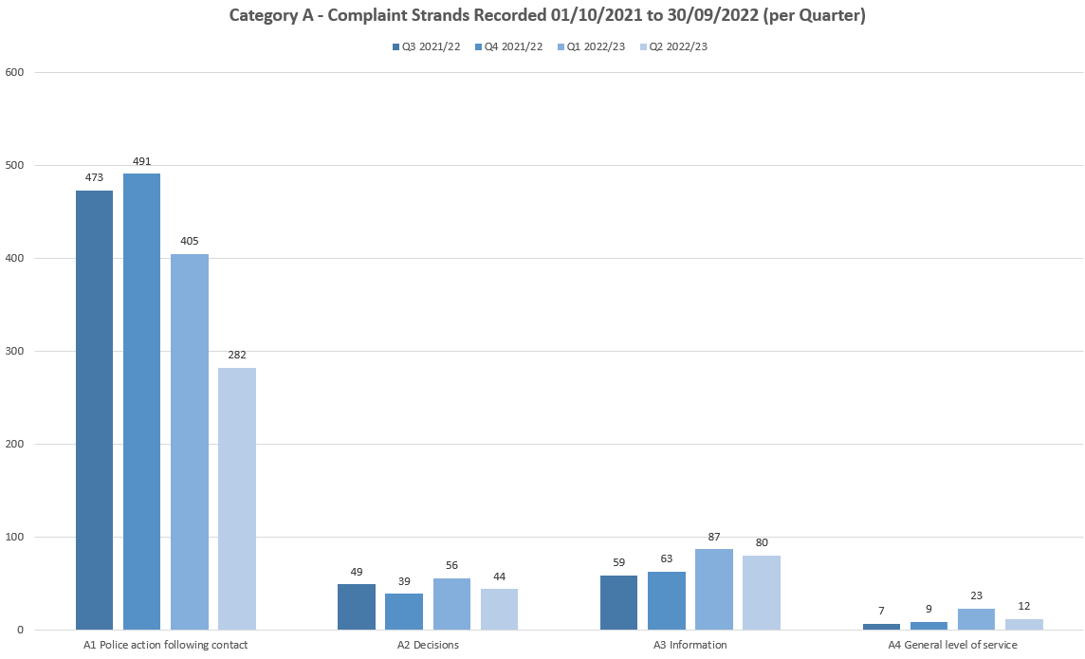

*Category B*

This is a broad category with 9 different subcategories. Use of Force and Detention in Police Custody remain the highest 2, however Use of Force has reduced over the past 3 quarters.

The West LPA have shown a decrease in category B complaints, however the North and South LPA have shown a slight increase. The increase is not significant and will continue to be monitored. Figures remain in line with the percentage headcount from the LPAs.

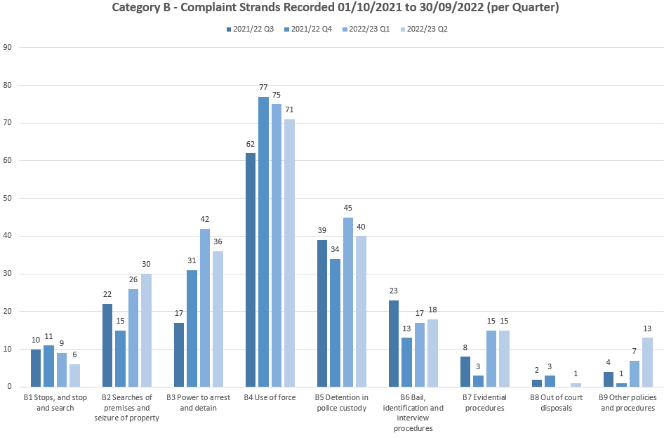

*Category H*

There has been a 48.15% decrease in this category compared to Q1. The reason for this decrease is likely to be due to the new NS3 process where some allegations are suitable to be dealt with as a dissatisfaction. A new column has been added to the NS3 log to ensure the reason for complaint is captured. This will be provided in the next quarterly report.

SDU have been re-assessing strand recording to ensure it accurately reflects the allegation made. As this new process settles, there may be differences seen between the categories.

There is no LPA that stands out as having received more complaints in this area. Complaint numbers are in line with percentage head count.

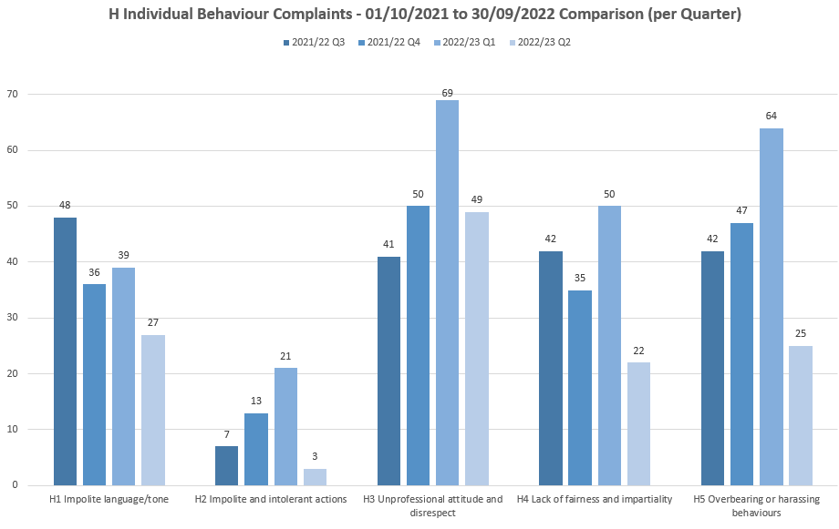

Increases of note for Q2 are as follows:

* + Uttlesford/Braintree – An increase from 10 strands in Q1 2022/23 to 17 strands in Q2 2022/23. The 17 strands represent four cases; there also were four cases recorded in Q1 2022/23.
  + Southend – An increase from 12 strands in Q1 2022/23 to 22 strands in Q2 2022/23. Also, a 66.67% increase from 9 cases in Q1 2022/23 to 15 cases in Q2 2022/23.
  + Harlow – An increase from five strands in Q1 2022/23 to nine strands in Q2 2022/23. The nine strands represent six cases; there were 4 cases recorded in Q1 2022/23.

South LPA category H complaints have been reviewed by the South Complaints Resolution Inspector. It has been established that the DAIT/CID teams in the South have received the highest number of strands. There is no known reason for this, and it will continue to be monitored. There are 10 strands which have been investigated and BWV has disproved 6, with the remaining 4 being unable to determine due to lack of evidence either way.

*Category F*

For this quarter Category F is the 5th highest category. This is due to the spike in category G from the persistent complainers, therefore it was felt relevant to highlight the strand.

Following a 37.50% decrease between Q4 2021/22 and Q1 2022/23, there was 25.00% increase in the total number of strands recorded under this category when comparing Q2 2022/23 (50) and Q1 2022/23 (40). The 50 complaint strands represent 41 complaint cases (there were 32 cases in Q1 2022/23).



North LPA had the most complaint strands recorded in Q2 2022/23 (20 equating to 40%), followed by West LPA (13 equating to 26%).

South LPA saw an increase from five complaints in Q1 2022/23 to eight complaints in Q2 2022/23 (third highest).

The second table highlights that the three LPA areas are not in line with force headcount percentages for Q2 2022/23. The lower South LPA figures and the higher West LPA figures have possibly led to a disproportionate number of complaints recorded under this category compared to headcount.



The Service provided was acceptable remains as the main outcome seen for this category, with 82% overall in Q2 2022/23.

**Police Officer and Staff Misconduct**

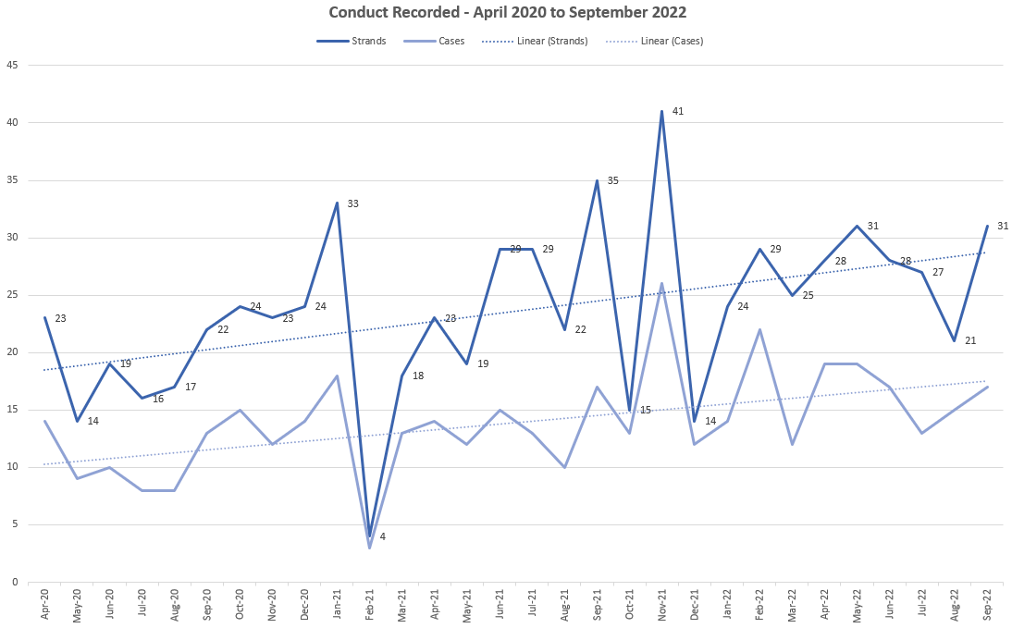

Overall, the total numbers of strands and cases decreased in Q2 2022/23 compared to in Q1 2022/23, with 79 strands (45 cases) and 87 strands (55 cases) respectively.

The below table details the 79 individual strands and breaks them down into the specific standards of professional behaviour that are alleged to have been breached.

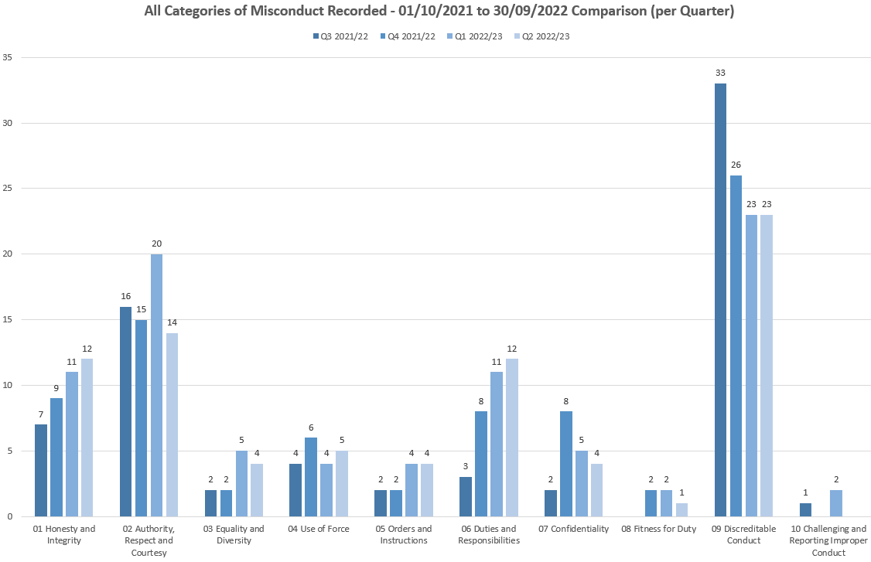

The only significant change is the fall in the strand relating to *authority, respect and courtesy* which has reduced by six in the most recent quarter. However, this reduction takes it back to levels of the previous two quarters and it can be said that the increase in the last quarter was unusual.

Of the forty-five new cases eleven related to Violence Against Women and Girls. Of these eleven, three cases have been finalised through the Reflective Practice Review Process. These three cases were complaints about how incidents were dealt with and did not relate to any violent or predatory behaviour towards women or girls.

**Command Breakdown of Misconduct Cases**

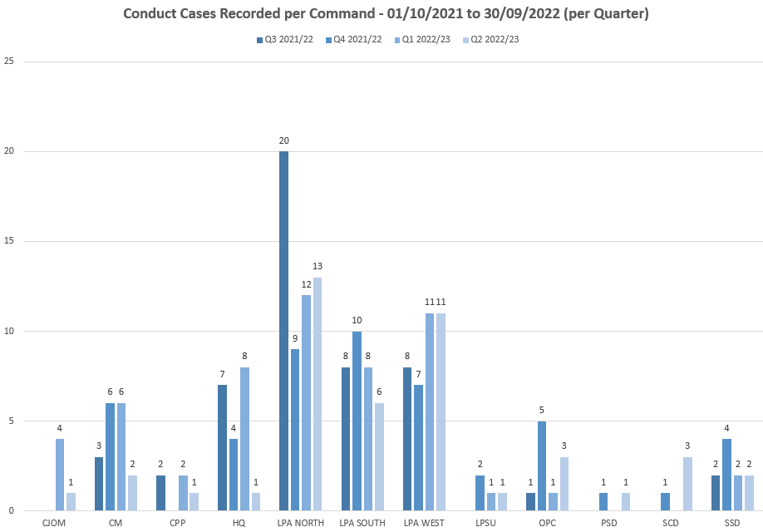

As expected, the LPA areas continued to have the highest number of cases in Q2 2022/23 (66.67%).

The table below shows that between 1st October 2021 and 30th September 2022 the number of cases recorded for each LPA has not been proportionate to force headcount percentages, with West LPA having a higher percentage compared to force headcount, and South LPA having a lower percentage compared to force headcount.



Part of this disproportionality can be explained by the fact that the West LPA has recorded 11 cases in both of the last two quarters, and both of which incorporated 18 strands. Of these 11 cases recorded in Q2, 4 have already been finalised, either as RPRP of no further action as it was deemed that there had not been a breach of the standards of professional behaviour.

**Outcomes of conduct Cases – October 2021 to September 2023**

Between 1st October 2021 and 30th September 2022 there were 189 conduct cased finalised. Within these, there were a total of 368 strands/subjects, for which sanctions/outcomes differ.

Of the 189 finalised cases, there was a case to answer in 20% of cases and no case to answer in 70% of cases. The remaining were de-recorded or withdrawn by the Appropriate Authority.

Of those cases shown as Case to Answer, 53% resulted in a dismissal (or would have been dismissed had the officer not resigned/retired) and 29% resulted in a Written Warning or Final Written Warning. No Action was taken in 11% of cases and the remaining 7% were deemed as some form of management action/ reflective practice.

Where the case outcome is shown as No Case to Answer, 51% resulted in No Action and 49% were deemed to require some form of management intervention.

**Suspensions/ Restrictions**

Of the 21 people currently suspended, 2 were suspended in Q2 2022/2023.

The three longest suspensions are 1076 days, 615 days and 571 days. The longest is an officer awaiting criminal trial, the second longest is an IOPC independent investigation and the third is an investigation that has been delayed due to the staff member’s ill health. The average length of suspension for those currently suspended is 330 days. This falls to 301 days if you remove the longest suspension which is an outlier.

Of the 33 people currently restricted, 6 were restricted in Q2 2022/2023.

**IOPC/ OPFCC**

*IOPC Referrals*

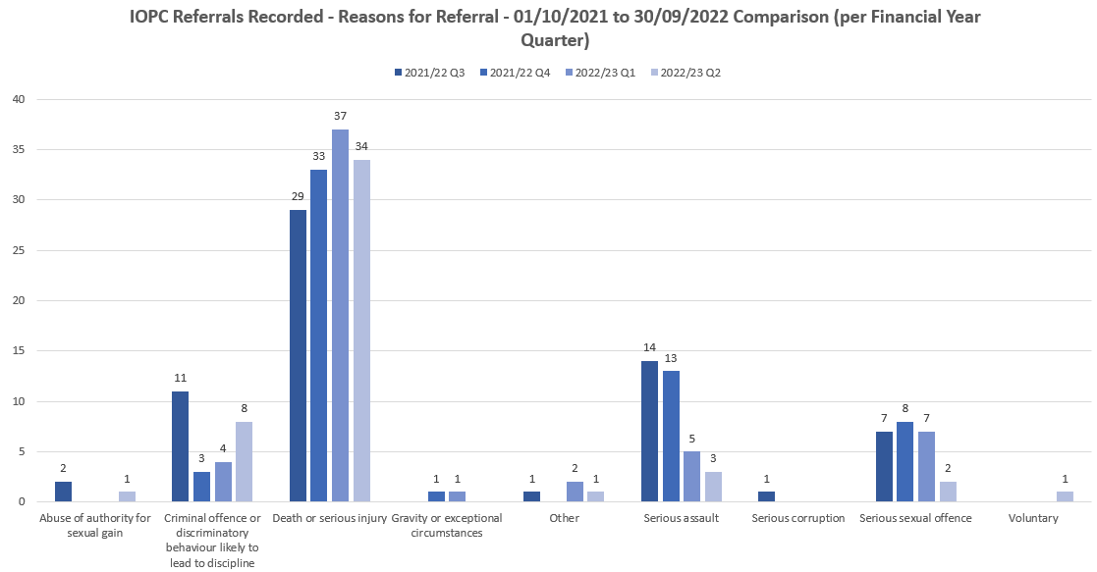

The majority referrals from Essex Police into the IOPC are for Death or Serious Injury incidents. These include DSI incidents reported by custody, and would include any loss of bodily function (including epileptic fit). The IOPC have previously been consulted with and are satisfied with the referrals through from Essex Police.

The majority, 68%, of those recorded in Q2 2022/23 have been confirmed as local investigations. Also, 26% of recorded referrals were for force to action and 6% were confirmed as independent.

*IOPC Reviews*



IOPC review numbers have fluctuated over the past 4 years. It is expected the number will increase this year due to a recent change in process and further changing when deciding on the relevant review body.

There are a number of IOPC reviews awaiting decisions.

|  |  |
| --- | --- |
|  |  |

*Reviews to the OPFCC*

|  |  |  |  |  |  |
| --- | --- | --- | --- | --- | --- |
|  |  | **White Complainants** | **Black Complainants** | **Mixed Ethnicity** | **Asian** |
| **Quarter** | **Total OPFCC Review Cases** | **Review requests** | **Review requests** | **Review requests** | **Review requests** |
| **Q3 - 2021/22** | 29 | 62% | 3% | 7% | 0% |
| **Q4 - 2021/22** | 28 | 58% | 0% | 0% | 4% |
| **Q1 - 2022/23** | 23 | 64% | 4% | 0% | 8% |
| **Q2 - 2022/23** | 31 | 92% | 4% | 0% | 0% |

*Note – Unknown ethnicity data has not been used in these figures.*

31 OPFCC Reviews recorded in Q2 2022/23 – the table above shows the number per quarter, between 01/10/2021 and 30/09/2022.

34.78% increase for the number of reviews recorded between Q1 2022/23 and Q2 2022/23.

Data has been obtained in an attempt to compare complaints received from ethnic groups in relation to reviews received. Due to the dates complaints are recorded, the review period and the finalisation dates, it was not possible to provide accurate information.

In 2021, 65% of finalised complaints were from white complainants, 3% from Asian, 1.5% from Mixed Ethnicity, 3% from Black ethnic groups.

2022 to date shows 58% from white complainants, 1% from Asian, 1% from Mixed Ethnicity, 1.5% from Black ethnic groups.