Essex County Fire and Rescue Service
Capital Strategy and MRP Policy
2023/24

Contents

1. Background 3
2. Capital Expenditure and Capitalisation Policy 5
3. Capital Strategy and Departmental Delivery Strategies 6
4. Funding 10
5. Minimum Revenue Provision (MRP) Policy and Statement 12
6. Capital Financing Requirement and MRP Forecast 13
7. Governance 14
8. Leases 14
9. Prudential Code, Affordability and Sustainability 15
10. Knowledge and Skills 15
11. Risks 15

Background
A Capital Strategy is a high-level overview of how planned capital expenditure and capital financing contribute to the Provision of Fire Services, along with an overview of how associated risk is managed and the implications for future financial sustainability.
The (CIPFA) Prudential Code for Capital Finance in Local Authorities 2017 requires local authorities to produce a Capital Strategy to support the delivery of their corporate objectives. Authorities are required by regulation to have regard to the Prudential Code.
The objectives of the Prudential Code are to ensure that capital investment plans are affordable, prudent, and sustainable.
The Capital Strategy is one of several key strategic financial documents utilised by the Authority to deliver its corporate objectives. The Capital Strategy, alongside The Medium-Term Financial Strategy, Treasury Management Strategy and Reserves Strategy underpin the Fire and Rescue Plan 2019-24.
Strategic Direction:
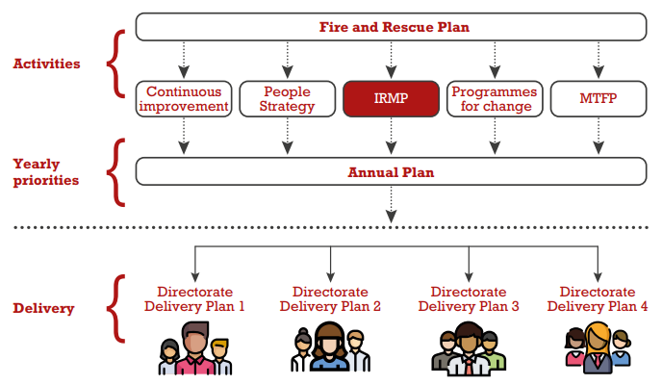
The Capital Strategy has direct links to other key departmental Strategies and Plans which include:
- Property and Estates Strategy
- Digital and Data Strategy
- Fleet and Equipment Strategy
These are referred to in further detail in Section 3.

The core principals of the Capital Strategy are:
- The Capital Strategy is affordable in line with the Medium Term Financial Strategy.
- The Capital Strategy supports the outcomes of the Fire and Rescue Plan and Annual plan.
- Value for money is achieved, while maximising the Authority’s ability to deliver against is objectives.
- Where borrowing is required, it is undertaken in line with CIPFA’s prudential code and the Service’s Treasury Management Strategy.

Non-Current Asset Base as of 31st March 2022
The Service’s non-current asset base comprises land and buildings, vehicles, plant and equipment, and assets under construction.
Land and buildings are subject to an annual valuation as part of the year end process. At 31st March 2022, the Service had 64 properties valued at more than £128m – these properties are continually maintained through revenue repairs and capital investment (see capital expenditure below). The Service also maintains a sizable fleet of operational assets and vehicles, as well as ICT assets and infrastructure. On 31st March 2022, these assets had a net book value of over £8m and £11m respectively.

Graphic 1 – Fixed Asset Base 31st March 2022:

Note – AUC refers to assets under construction, which consist of Vehicles and Capital Improvements not yet completed before the end of the year.

Capital Expenditure and Capitalisation Policy
In contrast to revenue expenditure which is spending on the day to day running costs
such as staff costs, capital expenditure seeks to provide long-term solutions to Service priorities and operational requirements.
Capital expenditure is technically described as: Expenditure on the acquisition, creation, or enhancement of ‘non-current assets’ i.e., items of land property and plant which has a useful life of more than one year. Expenditure for capital purposes therefore gives rise to new assets, increases the value or useful life of existing assets, or generates service potential for the Service.
The following costs can be capitalised:
- The costs attributable to the asset, being purchase price plus any costs directly attributable to bring it into initial use, including implementation costs.
- The de-minimus for capitalisation is £7.5k for vehicles and £10k for all other assets.
- There is no de-minimus for purchases of land and buildings.
- Consultancy support may be capitalised only where part of a major project over, where an external resource is needed and adds value to the project.
- Design and development costs may be capitalised, from the point that it is reasonably certain the project will be delivered. Research costs cannot be capitalised.
- Staff costs can be capitalised where there is sufficient evidence that the resource adds value to the project (supported by time sheets, and prior approval of the Chief Finance Officer).
- Training costs cannot be capitalised.

Capital Strategy and Departmental Delivery Strategies
The table below sets out the projected capital expenditure from 2022/23 to 2025/26. The expected funding streams are also set out with the consequent funding gap, assumed to be financed by internal borrowing (minimum revenue provision).
Budget Paper Extract
 | 2022-23 Total | 2023-24 Total | 2024-25 Total | 2025-26 Total | Total
 | £'000s | £'000s | £'000s | £'000s | £'000s
New Premises
Service Workshops | - | 500 | 1,500 | 3,000 | 5,000
Existing Premises
Asset Protection | 1,103 | 1,000 | 1,000 | 1,000 | 4,103
OCAT Project | - | 150 | - | - | 150
Asset Improvement Works
Shoeburyness | 1,172 | - | - | - | 1,172
Training works/BA Chambers | 1,136 | 822 | - | - | 1,958
Fire Training Facilities | - | 500 | 4,750 | 4,750 | 10,000
Total Property | 3,411 | 2,972 | 7,250 | 8,750 | 22,383
Equipment | 442 | 939 | 379 | 2,785 | 4,545
Information Technology
Digital & Data Strategy | 914 | 225 | 225 | 225 | 1,589
Control Project | 1,179 | 738 | - | - | 1,918
Other Projects | - | 450 | - | - | 450
Total Information Technology | 2,093 | 1,413 | 225 | 225 | 3,957
Vehicles
New Appliances | 941 | - | 2,000 | 2,000 | 4,941
Other Vehicles | 175 | 720 | 500 | 500 | 1,895
Total Vehicles | 1,116 | 720 | 2,500 | 2,500 | 6,836
Total Capital Expenditure | 7,062 | 6,044 | 10,354 | 14,260 | 37,721
Funding | Forecast 2022-23 | Forecast 2023-24 | Forecast 2024-25 | Forecast 2025-26 | Total
 | £'000s | £'000s | £'000s | £'000s | £'000s
Capital Receipts/Earmarked Reserves | (2,998) | (1,838) | (4,750) | (4,750) | (14,336)
Revenue Funding (Increase to CFR) ¹ | (4,063) | (4,206) | (5,604) | (9,510) | (23,384)
Total Funding | (7,062) | (6,044) | (10,354) | (14,260) | (37,721)

1 – Revenue funding charged through the minimum revenue provision (see section 5).

  - Property and Estates Strategy
Priorities:
The priorities of the Estates Strategy are:
- Ensure our estate allows for the best possible protection of the public.
- To create a collaboration programme with our emergency service partners.
- To provide accommodation that responds to the demands of the Service.
- To drive improvements to the economy, efficiency, effectiveness, and sustainability of our assets.
- To ensure the property portfolio is appropriate and fit for purpose.
Strategy Overview:
Investment | Overview
Services Workshops | The current Service workshops are reaching end of life. To ensure the fleet is appropriately maintained, new facilities need to be developed.
Asset Protection | The estate requires continuous investment to maintain its condition and functionality.
Asset Improvement | Specific improvement projects are required to meet the pressures of delivering the services expected by the public. This includes the redevelopment of Shoeburyness Fire Station and replacement of hot fire training facilities.

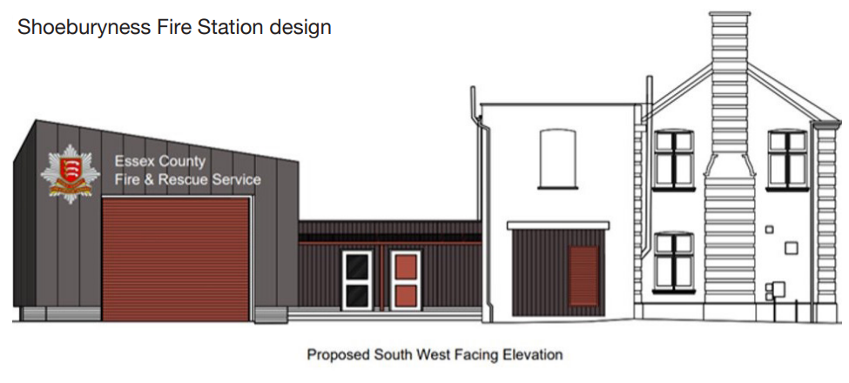

  - Digital & Data Strategy
Priorities:
The priorities of the Digital & Data Strategy are:
- Create a more agile working environment for the Authority.
- Create efficiencies through platform and infrastructure modernisation.
- Replace paper-based processing to provide improved resilience, availability, and accessibility.
- Empower users with improve digital skills to improve productivity and insight across the Service.
- Provide a foundation for future technologies which is sustainable going forward.
Strategy Overview:
Investment | Overview
Digital & Data Strategy | The Digital & Data Strategy aims to use new technology to make better use of resources in line with the Fire & Rescue Plan. The Strategy brings together multiple projects to support the workforce in flexible and remote working.
Other Projects | Other ICT projects include the Control project, which focuses on key infrastructure upgrades to the Emergency Services Network. These are vital to the delivery of services.

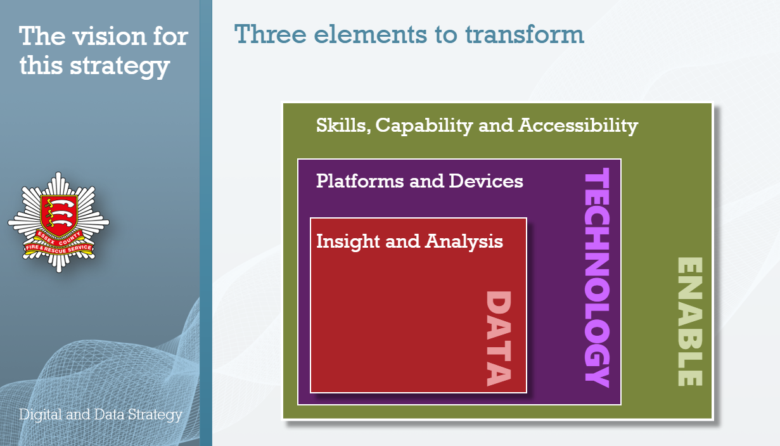
  - Fleet and Equipment Strategy
Priorities:
The priorities of the Fleet and Equipment Strategy are:
- To effectively manage the Fleet and Operational equipment of the Authority in support of the Fire and Rescue Plan.
- To ensure all vehicles and equipment are maintained to the required standards.
- To manage asset replacements and disposals when assets reach the end of their useful lives.
Strategic Overview:
Investment | Overview
Equipment | The forecast expenditure is in line with the replacement strategy for operational equipment. This expenditure is required to maintain the delivery of services in line with the Fire & Rescue Plan.
New Appliances | The forecast expenditure is in line with the replacement strategy for appliances. Appliances are maintained to a high standard – the strategy must provide a balance of regular replacement to provide the latest technology to improve the efficiency of response.
Other Vehicles | The Fleet Services team maintain a wide range of vehicles including pool cars, off road vehicles and specialist equipment. The capital strategy above sets out the requirements of the Authority over the next four years in the delivery of the Fire and Rescue Plan.

  - Environmental Strategy
Following the collaboration of Essex Police and Essex County Fire and Rescue Service,
an environmental strategy was produced to ensure that both organisations are aligned with other blue light services to reduce their carbon footprint and expenditures on budgets.
The Service must comply with the Government’s target of bringing all greenhouse gas emissions to net zero by 2050. To reach this target significant investment is required in both building and vehicle assets. New technologies will be adopted that fulfil our operational duties and are approved in an adequate timescale to fulfil the net zero target.

Funding
All Capital expenditure must be financed from either internal sources (Revenue budget via MRP or Reserves), or external sources (grants or borrowing). These sources are explained below:
4.1 Internal Funding
Capital Receipts - Capital receipts arise from the sale of surplus assets. As capital receipts are a limited source of funding, the Service should consider sustainable use for financing capital expenditure in the long term. The allocation of this funding was agreed as part of the published Reserves Strategy.

Earmarked Reserves (EMR) - The Authority has established specific reserves to manage key financial risks and to support the transformation of the Service to ensure it is fit for the future and will deliver on the priorities in the Fire and Rescue Plan.

There are clear policies in place to set out any additions to, or subsequent use of each earmarked reserve. This includes the requirement for the submission of a business case, which must be approved by the Commissioner on the advice of the Chief Finance Officer.
Each reserve is reviewed on a regular basis, at least annually. Reviews of reserves are also conducted as part of the annual budget, annual accounts, and the Medium-Term Financial Strategy.

Grant Funding - The Authority can utilise certain types of grant funding for the financing of capital expenditure.

Internal Borrowing - Remaining capital investment will be charged to the revenue account through the minimum revenue provision (see section 5).

The proposed internal funding is set out below (remainder to be funded by internal borrowing).
Proposed Funding | Forecast 2022-23 | Budget 2023-24 | Forecast 2024-25 | Forecast 2025-26
 | £'000s | £'000s | £'000s | £'000s
Shoeburyness (Capital Receipts) | 1,462 | - | - | -
ICT Strategy - Voice (Capital Receipts) | 47 | - | - | -
ICT Strategy - Infrastructure (Capital Receipts) | 600 | - | - | -
ICT Strategy – Station End Equipment (EMR) | - | 450 | - | -
OCAT (EMR) | - | 150 | - | -
ESMCP grant (Grant Funding) | 153 | - | - | -
Wethersfield replacement (Capital Receipts) | - | 500 | 4,750 | 4,750
Control system (Capital Receipts) | 736 | 738 | - | -
Total Funding | 2,998 | 1,838 | 4,750 | 4,750

4.2 External Funding

External Borrowing - In the past, the Service has financed capital expenditure through borrowing from the Public Works Loan Board (PWLB). The Service approach to external debt is set out in the Treasury Management Strategy.

The Service’s debt profile is set out below:

Debt profile as at 31st March 2022:
Total capital repayable | £Million
Repayable within 1 year | 1.0
Repayable within 2-5 years | 2.0
Repayable within 5-10 years | 15.0
Repayable within 10-15 years | 6.5
Total | 24.5

The asset base of the Authority is supported by loans of £24.5m from the Public Works Loan Board (PWLB). The Authority’s borrowing strategy is set out in the Treasury Management Strategy 2023/24.

Minimum Revenue Provision (MRP) Policy and Statement
The minimum revenue provision is charged to the revenue account each year to represent the financing of capital assets over their useful economic lives.
Regulation 28 of the Local Authorities (Capital Finance and Accounting) (England) Regulations 2003, as amended (Statutory Instrument (SI) 3146/2003) requires the Service to approve a Minimum Revenue Provision (MRP) Statement setting out the policy for making MRP and the amount of MRP to be calculated which the Service considers to be prudent.
The Service uses the depreciation method for calculating the minimum revenue provision.
Statutory Guidance under the Local Government Act 2003:
MRP is deemed to be equal to the provision required in accordance with deprecation accounting in respect of the asset on which expenditure has been financed by borrowing or credit arrangements. This should include any amount for impairment charged to the income and expenditure accounts.
For this purpose, standard depreciation accounting procedures should be followed, except in the following respects:
- MRP should continue to be made annually until the cumulative amount of provision made is equal to the expenditure originally financed by borrowing or credit arrangements. Thereafter the authority will cease to make MRP.
- On disposal of the asset, the charge should continue in accordance with the depreciation schedule as if the disposal had not taken place. This does not affect the ability to apply capital receipts or other funding sources at any time to repay all or part of the outstanding debt.
Where the percentage of the expenditure on the asset financed by borrowing or credit arrangements is less than 100%, MRP should be equal to the same percentage of the provision required under depreciation accounting.
Useful economic lives for MRP purposes are as follows:
Class of Asset | Asset life for Minimum Revenue Provision
Land and buildings | 25 years
Asset protection works | 15 - 20 years
Fire appliances | 15 years
Other vehicles | 3 - 6 years
Operational equipment | 8 - 15 years
IT equipment | 3 - 7 years

Capital Financing Requirement and MRP Forecast
The Capital Financing Requirement (CFR) measures the Authority’s underlying need to borrow for capital purposes, i.e., its borrowing requirement. The CFR is the amount of capital expenditure that has not yet been financed by capital receipts, capital grants or contributions from revenue. The projected CFR for the 4 year capital programme is shown in the graph below, and excludes future capital expenditure after this period:
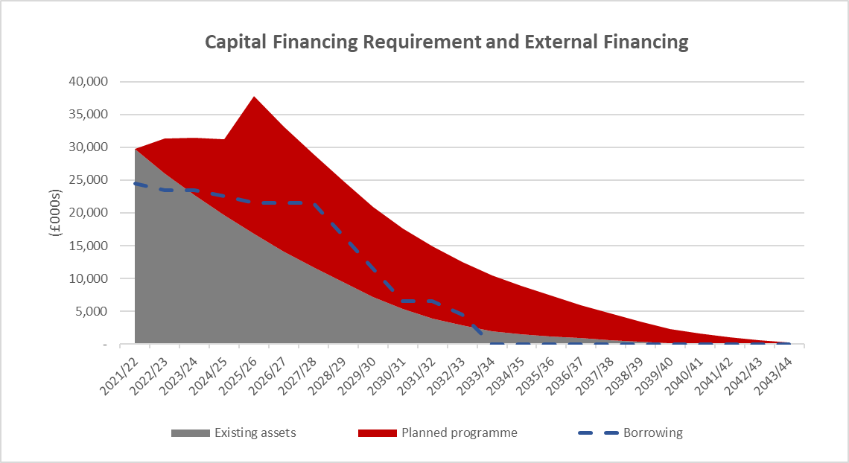
Assets Funded Over Time
4 Year Capital Programme
The table above shows the CFR increasing to over £37m in the next four years. This is supported by existing borrowing, with the remainder funded through internal borrowing – resulting in a higher minimum revenue provision charged to the revenue budget. MRP is budgeted at £4.2m for 2023/24 following savings realised in 2020/21, 2021/22 and 2022/23.
Capital Financing Requirement Forecast and MRP Forecast
Summary CFR Forecast | Actual 2021/22 | Forecast 2022/23 | Forecast 2023/24 | Forecast 2024/25 | Forecast 2025/26
 | £'000s | £'000s | £'000s | £'000s | £'000s
Opening CFR | 32,719 | 31,734 | 31,312 | 31,242 | 32,500
Capital Expenditure | 3,132 | 7,062 | 6,044 | 10,354 | 14,260
Funding Applied | (167) | (3,289) | (1,838) | (4,750) | (4,750)
MRP | (3,950) | (4,195) | (4,276) | (4,346) | (4,934)
Closing CFR | 31,734 | 31,312 | 31,242 | 32,500 | 37,076

Summary MRP Forecast | Actual 2021/22 | Forecast 2022/23 | Forecast 2023/24 | Forecast 2024/25 | Forecast 2025/26
 | £'000s | £'000s | £'000s | £'000s | £'000s
Existing assets | 4,007 | 3,739 | 3,329 | 3,010 | 2,878
Capital Programme 2022 - 2025 | - | 575 | 1,412 | 1,801 | 3,005
Less funding applied | (57) | (119) | (465) | (465) | (949)
Total MRP | 3,950 | 4,195 | 4,276 | 4,346 | 4,934
The Service includes a prudent Minimum Revenue Provision in the budget each year, which is supported by a detailed forecast. This forecast is updated regularly throughout the year with updates provided in the financial forecasts.

Governance
The Capital Programme is approved annually by the Police, Fire and Crime Commissioner for Essex, as part of the annual budget setting process. The Programme Management Board agrees in-year variations to the capital programme up to the value of £250k, with variations above £250k approved by the Police, Fire and Crime Commissioner.
The Programme Management Board provides scrutiny to projects, which require a formal business case to ensure they meet Service objectives, while achieving value for money. The role of the board is also to monitor and assess the effectiveness and delivery of the capital programme. These roles are set out in the board’s terms of reference.
Strategic Sub-Groups have been established to discuss the operational needs of the Service in the delivery of its objectives. These include:
- Digital & Data Strategy Board
- Strategic Fleet Sub-Group
- Estates Board
These boards scrutinise new proposals and provide recommendations for approval at the Programme Management Board. Furthermore, capital expenditure is reported in the monthly finance pack provided to the Service Leadership Team and the Performance & Resources Board.

Leases
Leasing obligations are similar to borrowing as they have an ongoing revenue budget commitment. Leasing will be considered following due diligence over the life of the asset, comparing the financial and non-financial benefits and risks compared to the Service owning such asset itself.
From 1 April 2024 the accounting standard which sets out the guidelines for recognising and disclosure requirements for accounting for leases changes from IAS 17 (International Accounting Standard) to IFRS 16 (International Financial Reporting Standard). This means from this date the way the Service accounts for assets it leases will change. Under these changes a right of use asset will be shown on the balance sheet except for leases of 12 months or less or if the asset is of low value. This asset will increase the capital financing requirement (see Section 6).
When the asset is recognised in the balance sheet a corresponding liability is then created, representing the obligation to make lease payments. When the Service makes a lease payment, rather than it showing as an expense against the relevant cost centre, it is split between paying off this liability and interest payments. The asset is depreciated in the same way as similar assets of that class, usually over the life of the lease unless the asset useful life is lower.
The Service has engaged with stakeholders and produced working papers in anticipation of these changes and plans to adopt IFRS 16 from 1st April 2024. Further engagement is planned with the external auditors to ensure full compliance with this standard.

Prudential Code, Affordability and Sustainability
The Chief Finance Officer should report explicitly on the affordability and risk associated with the capital strategy. The Prudential Indicators linked to affordability and sustainability are:
Borrowing as a multiplier of net revenue budget – used to assess if the level of external debt of the Service is sustainable.
Net capital finance as a % of net revenue budget – used to assess if the capital programme is affordable in comparison to the funding of the Service.
Interest cost as a % of net revenue budget – used to assess the impact of the cost to finance the Service’s external debt.
Prudential Indicators | Forecast 2022/23 | Forecast 2023/24 | Forecast 2024/25 | Forecast 2025/26
Borrowing as multiplier of revenue budget | 0.3 times | 0.3 times | 0.2 times | 0.2 times
MRP as % of net revenue budget | 5% | 5% | 5% | 5%
Interest cost as % of net revenue budget | 1% | 1% | 1% | 1%

The Treasury Management Strategy indicates that the Service may be required to borrow to fund capital expenditure in future years. Borrowing as a multiplier of net revenue budget is stable at 0.2 times, which indicates that any future borrowing would not have a significant impact on the revenue budget.
Interest cost as a percentage of net capital financing also reduces over time, which is an indication that the Service is not over-geared.
Net capital financing as percentage of net revenue budget is stable at 5%, indicating the programme is sustainable.

Knowledge and Skills
The Finance Team has responsibility for the preparation and ongoing management of the Capital Strategy. The team is staffed by professionally qualified accountants that adhere to continuing professional development as part of their accreditation. The team attends all relevant training courses and events to ensure that their knowledge and skills are up to date.
The overall responsibility for the Capital Strategy lies with the Chief Finance Officer (S.151) who is professionally qualified and suitably experienced to carry out the role.
The Service also engages with professional treasury management advisors, Arlingclose Ltd, for support in production of key strategies such as the Treasury Management Strategy.

Risks
Elements of the capital programme could impact on the strategic risks of the Service; these risks are recorded on the Strategic Risk Register. Risk is continuously monitored as part of the Service’s risk management process. Furthermore, the capital programme is authorised annually, and subject to regular review by the Police, Fire and Crime Commissioner at the Performance and Resources Board.

LOCAL GOVERNMENT (ACCESS TO INFORMATION) ACT 1985
List of background documents – none.
Proper Officer: | Chief Financial Officer (S151)
Contact Officer: | Neil Cross  Essex County Fire and Rescue Service, Kelvedon Park, London Road, Rivenhall, Witham CM8 3HB  Tel: 01376 576100

