Essex County Fire and Rescue Service

Annual Plan 2023-24

ABOUT
The Annual Plan is produced in order to set a clear direction on the Services’ strategic priorities for the year; ensuring that budgeted resources are aligned with priorities and are being utilised effectively and efficiently.

The Annual Plan also provides assurance to the PFCC Performance and Resources Board that the service is delivering against the priorities identified in the Fire and Rescue plan.

This report is structured based on priorities identified within the Fire and Rescue Plan. Each priority has several associated activities. The Plan also provides links to the Service’s Integrated Risk Management Plan (IRMP).

Introduction
Essex County Fire and Rescue Service is in the third year of its current Fire and Rescue Plan. The Plan was produced by the Police Fire and Crime Commissioner (PFCC) for Essex and sets out the strategic priorities for fire and rescue services in Essex.

These priorities are:
- Prevention, protection, and response.
- Improve safety on our roads.
- Help the vulnerable to stay safe.
- Promote a positive culture in the workplace.
- Develop and broaden the roles and range of activities undertaken by the Service.
- Be transparent, open, and accessible.
- Collaborate with our partners.
- Make best use of our resources.

The Annual Plan is an essential part of our accountability to the PFCC in providing assurance that the Service is delivering against the priorities set out in the Fire and Rescue Plan.

In addition to the Fire and Rescue Plan, the Service has several mechanisms that identify emerging activities, risks, and trends that the Service needs to prioritise to achieve continuous improvement. These include:

- Continuous Improvement (internal and external audits, Peer Reviews, HMICFRS Inspections)
- Integrated Risk Management Plan
- Digital and Data Strategy
- Medium Term Financial Plan

Traditionally, the service would have created individual action plans in response to each activity stream and reported on these separately. The Annual Plan provides a central location for prioritising and monitoring progress against all activity streams.
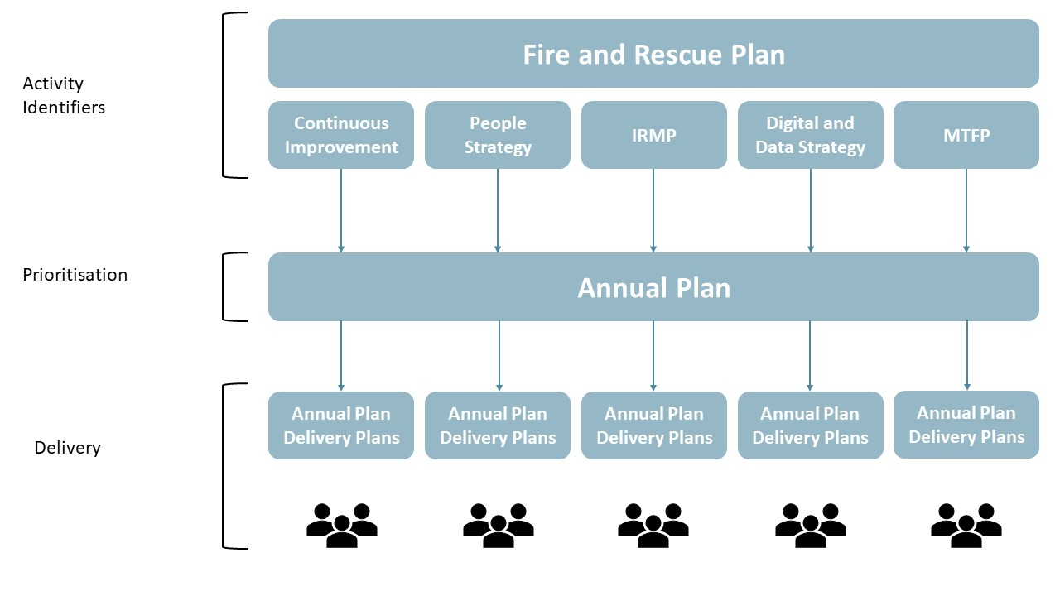

Creation of the plan
The Annual Plan is how the Service can prioritise key activities for the year. This allows the Service to commit resources, both financial and staff, for the new financial year.

The Service also runs a Change Portfolio which priorities the larger programmes and projects to deliver organisational change. Both the Change Programme and Annual Plan have separate governance models as detailed below:
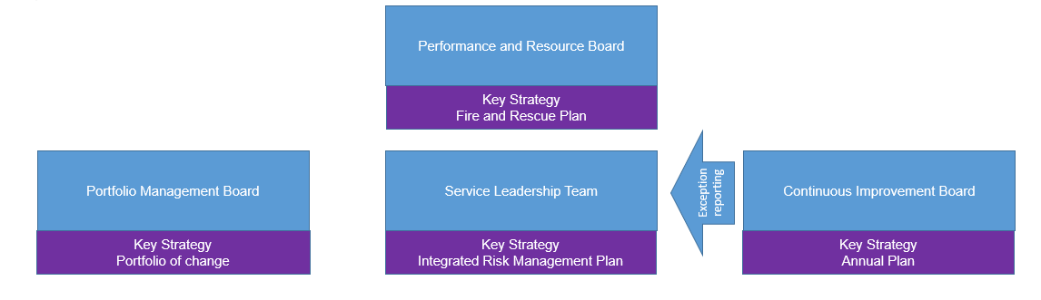

A managers briefing took place in July 2022 to capture ideas from the wider management team in Essex County Fire and Rescue Service. The output of this has been reviewed by the Extended Leadership Team (ELT) agreed the activities due to be delivered in 2023-24. The output from this session has been categorised as either “Run the Business” activity which has been included on the Annual Plan, or “Change the Business” work which falls within the Change Portfolio.

This Plan represents the output of the work identified as “Run the Business” by ELT.

The Portfolio of change can be viewed in Appendix A

Delivery and Governance of the Annual Plan
The plan will be reported quarterly.

A highlight report will be generated and issued to the Continuous Improvement Board (CIB). CIB will meet quarterly to provide challenge and review progress against the plan. CIB will also provide approval for any exception reports where a new activity has been identified, or the removal of an activity from the plan.

The highlight report will be delivered to the Police Fire Crime Commissioner via the Performance and Resource Board for assurance and scrutiny purposes.

Where appropriate, progress and completion of activities will be reality tested within the Service to ensure that staff engagement in the change has been successful.

Each cohort of our Leadership Development Programme forms an action learning set, these action learning sets are available, where appropriate, to support the ELT with delivery of the plan.
Governance

Annual Plan Summary

Activities agreed within the plan.
Task Name | Labels | Owner
ISO 17020 Fire Investigation Accreditation by October 2024.  Work with the National Fire Investigation Project Team and the Forensic Regulator to complete the 18 modules for ISO 17020 Accreditation by or before October 2024  By December 2023 we will complete the Protection restructure to provide the appropriate resource to achieve the accreditation and recruit a competent centre management team to store and quality assure data.  By April 2024 we will present the business case to SLT identifying the future requirements for Tier 2 Fire Investigation. Identify the cashable and non-cashable benefits from the change.  Definition of Done:  ECFRS is accredited to ISO 17020  Approval from SLT to implement the change and a revised strategy to deliver Fire Investigation services.  Explored working in collaboration with regional FRS to share services. |  | Area Manager - Prevention and Protection
Embed the revised RBIP.  Monitor progress against the new RBIP, ensuring we have confidence in the new data, risk profiling and resource allocation.  By 30th June 2023, we will undertake a formal review of the RBIP and present findings to SLT.  Definition of done:  The organisation has confidence that the new RBIP is targeting the appropriate risk across the county, and we are delivering consistently against set targets. | HMICFRS AI | Area Manager - Prevention and Protection
Maintenance of operational competence of day duty Grey Book staff  Identify the core skills that are required (assessable and non-assessable) to maintain key operational elements of role map relevant to individual roles.  Develop a suitable process to enable day duty grey book the ability to maintain competence (e.g. DDOR, Central training).  Definition of done:  A regular, ongoing and robust training/maintenance regime for Day Duty Grey Book Staff which minimises the impact on their primary role. |  | Area Manager - Response

Measure the productivity of Wholetime stations.  Develop a system that enables productivity of watches to be measured consistently and monitored through Continuous Improvement Board.  Ensure Whole Time stations consistently deliver against Prevention, Protection and Operational Risk targets. (Monitored Monthly through the annual plan period).  This is to support effective use of our resources and provide value for money for the public.  Definition of Done:  Whole Time Watches are consistently delivering against monthly targets and the service can demonstrate the productivity at station level and use that to drive continual improvements. |  | Area Manager - Response
Improve access to digital devices across all stations.  Improve access to digital devices across all stations whilst also ensuring that users are equipped with the digital skills to access all aspects of the services technology platforms.  Providing the right digital devices with better functionality and direct access to systems will better align the ICT experience for firefighters to that of laptop users, which should in turn improve efficiency and effectiveness.  Definition of done:  Thin client devices at ECFRS locations are replaced with devices and licences that provide a richer fit-for-purpose user experience (PCs with full Office suite installed). |  | Head of ICT
Evaluate effectiveness of Business Engagement Strategy  Undertake a review of our Business Engagement Strategy by December 2023.  To ensure that the strategy is effectively delivering engagement activities in the right areas, and these activities are actively monitored against the impact they are having in reducing risk.  Definition of Done:  Full review undertaken and any improvements that are identified are implemented. | HMICFRS AI | Area Manager - Prevention and Protection
Development of a Single Strategy for Prevention, Protection & Response.  Write a new strategy that incorporates all three areas of the operational directorate. A single strategy will ensure closer alignment of the activities that are required to deliver a successful strategy and remove the risk of silo working ensuring higher levels of efficiency and productivity.  Definition of Done:  Draft strategy developed and presented to SLT and Strategic Board for sign off by June 30th, 2023 | HMICFRS AI | Area Manager - Response
Review of core station policy effectiveness  Undertake statistical analysis to measure the effectiveness of our core stations in enabling us to meet our response standard and use that analysis to develop measures to improve performance.  We are currently failing to meet our response standard on a consistent basis, so understanding the impact our core stations are having is key to steering future improvements.  Definition of Done:  Implementation of any findings that, improve current response standards. | HMICFRS AI | Area Manager - Response
Core Code of Ethics and Values  The current Core Code of Ethics (CCofE) work will be completed in March 2023. Following this the five Fire and Rescue Service Ethical principles detailed within the CCofE will be reviewed against the current values of ECFRS. The review will include a range of stakeholders.  The outcome of the review will include a recommendation about whether the principles and values should remain separate or should be combined in some way. If the recommendation is that anything should change, an action plan will be developed detailing how change will be achieved.  This work is achievable with existing resource and can realistically be completed by 1 October 2023.  Definition of done:  The initial phase of this work will be ‘done’ when the review, recommendation and action plan are complete. Further phases of work will need to be scoped once recommendations are in place. | HMICFRS AI | Assistant Director - Human Resources
Learning and Development  We will review current training provision and recording to ensure that it enables staff to be appropriately trained for current and future roles and that we are able to provide appropriate assurance of that competence. Terms of Reference will be developed and agreed for the review.  The outcome of the review will include recommendations about current and future training provision and current and future recording of training and whether that provides sufficient and appropriate assurance of competence. An action plan will be produced which details how any recommendations could be achieved.  The review will be conducted by an independent consultant. Review, recommendations and action plan will be produced by 1 September 2023.  Definition of done:  The initial phase of this work will be done when the review, recommendation and action plan are complete. Further phases of work will need to be scoped once recommendations are in place. | HMICFRS AI | Assistant Director - Human Resources
Design and build of the Future Infrastructure Risk programme of work.  This is a statutory duty and national best practice.  Definition of done:  ECFRS will comply with the white paper reform for building safety design engagement. This will enable the Service to identify, proactively prepare for and respond to reducing future risks and capitalising on opportunities, including financing to contribute to the delivery of Service strategies. | HMICFRS AI | Area Manager - Operational Assurance
Measure collaborative activity which is outside of the PFCC Business Case  We will work with the service to ensure that all Collaborative activity is recorded. This will include what is being done, with what partners and the measurable benefits of the activity. This forms part of our statutory duty to collaborate .  Definition of done:  That ECFRS has defined list, which is dynamic, and clearly states what collaborative activity is being done - who the partners are, what the partner funding contribution is and what the benefits are; plus how those costs/benefits are attributed and apportioned across partners | HMICFRS AI | Assistant Director -  Performance and Improvement
Fire Protection Training for Operational Staff  Gain internal accreditation to enable us to deliver training to operational staff.  - Develop a role out plan for training.  - Develop a process for continued QA and CPD.  Why: A knowledge of Fire Protection is a key requirement for operational staff undertaking their roles effectively. Providing additional skills will also support delivery of our RBIP, by adding in additional capacity to complete the work.  Definition of Done:  The developed training package is delivered to all operational staff. | HMICFRS AI | Area Manager - Prevention and Protection
Developing a dashboard for the safeguarding function  Safeguarding PowerBI dashboard to be created to allow greater monitoring of safeguarding activity including no. of referrals in/out. Safeguarding Fire Standard Implementation tool complete (at approx. 95% compliance)  Definition of Done  Live Power BI dashboard capturing demand and completed safeguarding referrals | HMICFRS AI | Assistant Director -  Performance and Improvement
Develop a new three year plan for apprenticeship.  A revised three year plan for apprenticeship will be developed. This will align with career pathways and professional standards and resource effectively. The revision of the plan will begin with an independently conducted review which will consider and make observations and recommendations in five areas; productivity, effectiveness and efficiency of our current model, professional standards, areas of good practice and areas of development, stakeholder experience of current model and potential alternatives. The review will also include a recommendation about how, for firefighters we potentially streamline P2-P3 and the End Point Assessment.  The review will result in proposals in the 5 areas above. Following this, a newly formed Apprenticeship Steering Group will create a 3 year plan.  The review will be conducted by an independent consultant. The review will be conducted by 1 May 2023 with the resulting 3 year plan being developed by 1 July 2023. Initial recommendations will be completed by 1 December 2023.  Definition of done:  The initial phase of this work will be ‘done’ when the review and recommendations are complete. The second phase will be ‘done’ when the 3 year plan is complete. The third phase of this work will be done when initial recommendations (as yet unknown) have been delivered. | HMICFRS AI | Assistant Director - Human Resources
Adoption and alignment to the JESIP app and all of the JESIP templates e.g. methane, exercising  For increased interoperability, robust decision recording at the fireground and reduced costs of printing of our local templates and materials.  This work will incorporate the workplace solutions project and use current processes to ensure that we can align our work and place into the app. This will also be adopted through the JESIP working Group chaired by Essex Police.  This work is being let by Operations and with Operational Training (Incident command training) and used during annual refresher updates and IC verification.  This will also incorporate the recommendations in the Grenfell action plan and through the Prevention, Protection and Response Programme of work in the Grenfell / N.O.G workstream  Definition of Done:  We undertake an external Peer assessment to provide reassurance that objectives are embedded. |  | Area Manager - Operational and Strategic Support
Implementation of the Eastern Region Building Safety Regulator with the Protection Policy and Reform Unit to form a Regional Team.  A requirement to support the Building Safety Regulator has been placed on the organisation from the Home Office. An Officer will be recruited from Essex to support the Regional Team  A charging system will be developed and implemented by ECFRS and new working arrangements with Building Safety Regulator agreed and embedded.  Definition of Done:  ECFRS has effective systems in place to ensure efficient and effective working with Building Safety Regulator. |  | Area Manager - Prevention and Protection
Delivery of Wholetime resources supporting on call training across the service.  On call training is a priority for the service and utilising whole time staff to support (as per the pilot in the south) will ensure that there is consistency of training and enhance joint working across duty systems.  Use the learning from the Pilot in the south to understand best practice and work with all wholetime stations to support this piece of work. The on-call liaison officers to work across the service to implement and embed this work.  Definition of done:  Wholetime watches being used to set up and support some on-call training. On-call liaison officers working with both on call and wholetime stations. Increased levels of on-call training and more joint working evidenced. |  | Area Manager - Response
Develop a three year plan for PDR Pro  A three year plan for the use of our competency recording system, PDR Pro, will be produced. The plan will be created after a review; the review will provide a gap analysis detailing how we currently use the system and how we aspire to use the system to provide consistency of recording and best assurance of competence. The review will include stakeholder feedback and will utilise the expertise of the PDR Pro User Group (PUG).  The review will result in a gap analysis and recommendations which will be presented to the Learning and Development Steering Group.  The review will be conducted by an independent consultant. The review will be conducted by 1 July 2023 with the resulting 3 year plan being developed by 1 July 2023. Initial recommendations will be completed by 1 December 2023.  Definition of done  The initial phase of this work will b done when the review has been completed and presented to the Steering Group. The second phase will be done when initial recommendations (as yet unknown) have been delivered. |  | Assistant Director - Human Resources
Achieve the silver standard of recognition from Inclusion Employers  We aim to achieve the silver standard of recognition from Inclusive Employers. The application will be prepared for submission within quarter three.  Feedback from Inclusive Employers about whether we have met the standard will be received within quarter four.  The submission will be led by our Inclusion Partner and will be supported by the Inclusion and Diversity Action Group. This is likely to require the group to meet more frequently to provide the right level of scrutiny and support.  Definition of done:  The first phase of this will be done when the application is complete and submitted. The second phase will be done when feedback from Inclusive Employers has been received. |  | Assistant Director - Human Resources
Creation of single officer cars policy  Launch of a single Office Car Policy which looks to replace the current three policies into one.  Definition of done:  Service has moved to a single car policy. |  | Engineering Manager
Fully kitted spare vehicles  Changing of our current process to appliance swaps for servicing and repairs, and the purchase of the equipment to fully kit the current 6 appliance spares out.  Definition of done:  All 6 spare appliances at our fleet workshops are fully kitted out with equipment. Changed process where Fleet Workshops deliver the spare direct to station, swap, drive back to workshops. |  | Engineering Manager
Driving License Compliance - Assurance Project  Implementation of process for ensuring compliance of staff driving our vehicles.  Definition of done:  Fully coherent process for ensuring that staff are compliantly driving our service vehicles. |  | Engineering Manager
Review of working practices through transformation to establish where technological changes can support better efficiencies  Measuring improvements in effectiveness and efficiency for activities undergoing digital transformation will assure the Service that investment in technology is worthwhile.  Definition of Done:  Benchmark and improvement tests are embedded and provide metrics to stakeholders. | HMICFRS AI | Head of ICT
Data Quality and Data Sharing plan to maximise opportunity and accuracy of systems and data across the service.  Definition of done:  High level of data accuracy and quality of both data input as well as data output. Information sharing agreements allowing ease of access to partnership data sets. |  | Assistant Director -  Performance and Improvement

Rolled over activities.
Task Name | Labels | Owner
AP2022017 Network Improvements: Implement transport circuit and establish SD WAN service.  Better ICT performance across the estate and improved user experience to increase efficiency.  Definition of Done:  SD-WAN fully live across the estate 31 July 2023 for full project closure |  | Head of ICT
AP2022041 Flexible use of on-call.  Creation & implementation of more flexible approaches to utilising on-call staff, e.g. greater use of on-call to on-call ASWs & methods to utilise more dynamic use of on-call resources to maximise on-call appliance availability.  Definition of done:  On-call staff being used more flexibly with the ethos of moving people not appliances. |  | Assistant Director – Response
AP2022018 Develop an assurance process for all operational activity and risk information.  Aim to ensure that there is a framework for assurance of all operational activity.  Definition of done:  Service is working to an assurance framework and an evidence based assurance is available and auditable |  | Area Manager – Operational Assurance
AP2022020 Creation of a single crewing policy.  Definition of done: One single policy created and agreed that outlines all the ways ECFRS will crew appliances and the removal of all policies that this would supersede.  Consolidation of multiple policies that currently are used to crew appliances into a single standalone policy on crewing.  Final policy to be ready to consult through JNCC. |  | Area Manager – Response

