Formation Media Limited

Essex PFCC - https://www.essex.pfcc.police.uk/

Accessibility Correction Summary

Overview:
Below I will list the various pages tested by the government’s accessibility monitoring service and how they now score on Axe Deque (The score used by the government to test for accessibility issues):
Home Page:
Issues found -
WCAG 2.4.7 Focus Visible
- The keyboard focus becomes missing for 5 keyboard tabs after tabbing from Download Precept Leaflet
- At 200% zoom, the keyboard focus becomes lost when tabbing through the hamburger menu.
WCAG 2.4.4 Link Purpose (In Context) and WCAG 4.1.2 Name, Role, Value: Links must have discernible text.
- This refers to links in the boxes for Key resources, Community grants and Finance
To show that we have passed the automatic issues, I will include a screenshot of Axe Deque, having run a test on the page outlined above, with WCAG 2.1 AA included (The same level of accessibility the government used when testing):
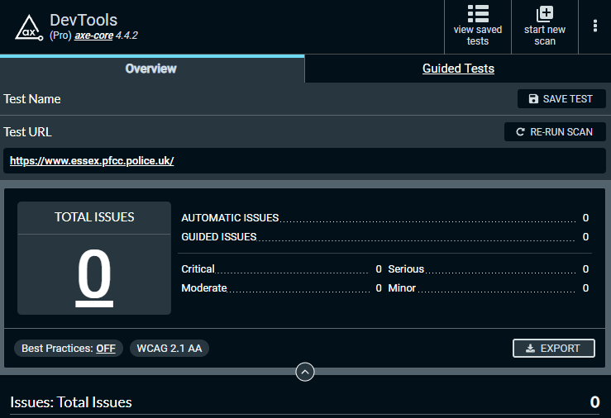
Accessibility fixes performed on the homepage included:
- Removing missing/blank links (fixing “Links must have discernible text”) and “Keyboard focus becomes missing for 5 keyboard tabs…”
- Adding outline style (Shows keyboard focus when tabbing through hamburger menu)

Contact page issues:
Issue found –
WCAG 1.4.3 Contrast (Minimum)
- There is poor colour contrast on placeholder text in Contact us using our forms boxes
WCAG 1.3.1 Info and Relationships and WCAG 4.1.2 Name, Role, Value:
- This refers to the row of text; Choose file 'No file chosen'

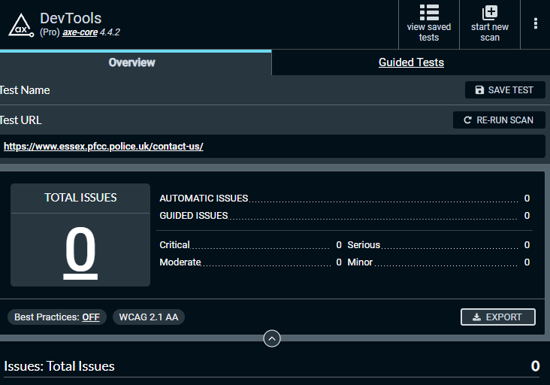

Accessibility fixes performed on the contact page included:
- Improve placeholder contrast and hyperlink hover contrast (Fixes the contrast issue)
- Wrap “Please attach any files” etc label around “Choose” file to give all form inputs labels

Accessibility statement page issues:
Issues Found –
WCAG 1.4.3 Contrast (Minimum)
- There is poor colour contrast when using the mouse to select the link for EASS.

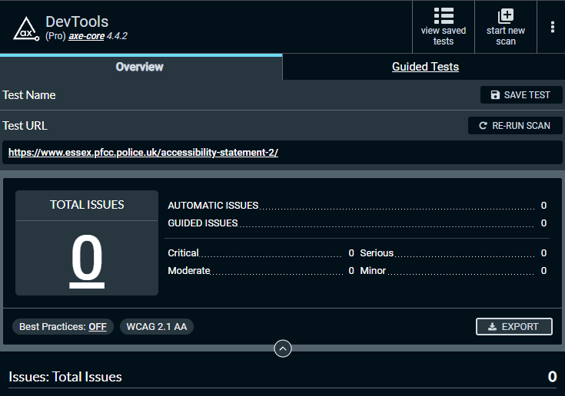

Accessibility fixes performed on the accessibility page included:
- Changing hyperlink style to simple underline to fix colour contrast issue

Procurement Dashboard July 2022 issues:

Issues Found –
WCAG 1.1.1 Non-text content
- There are multiple images without text alternative
It refers to this PDF: https://www.essex.pfcc.police.uk/wp-content/uploads/2022/09/06-Procurement-Dashboard-July-2022-.pdf
In various slides <figure> elements were used (images) but were either not marked as decoration or had missing alt text. I marked them as decoration or added alt text as necessary.
Response from Formation:
Generally, PDF accessibility is outside the scope of our services, but if once you have created an alternative PDF with text, we can replace it on the site for you. Additionally, if you can create a page with the same content as text/tables so it is accessible to screenreader users.
Additionally Essex PFCC will need to carry out an audit of all PDFs where images are used instead of text, making them inaccessible.

News page issues:
Issues Found –
WCAG 1.1.1 Non-text Content:
- This refers to information within the Facebook box. To fix this issue, you need to add an alt attribute.
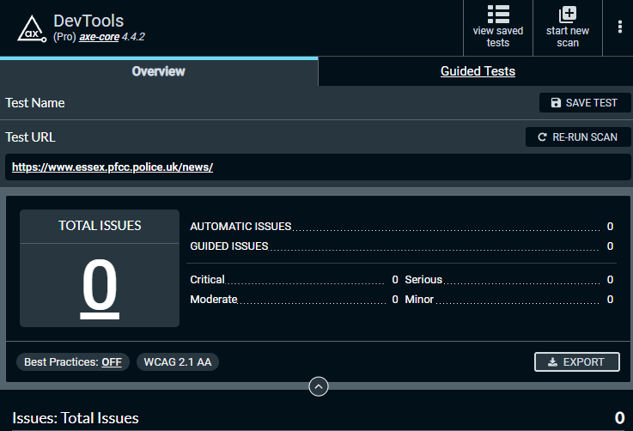
Accessibility fixes performed on this page include:
Actions on news page included:
- Added code to replace blank images with divs

Giving you a voice page issues:
Issues Found –
WCAG 2.4.4 Link Purpose (In Context) and WCAG 4.1.2 Name, Role, Value: Links must have discernible text.
- This refers to the sound icon. Element Location;.hero-link
- This refers to the paragraph of text 'Whether you live or work in Essex, or are visiting friends or family...'
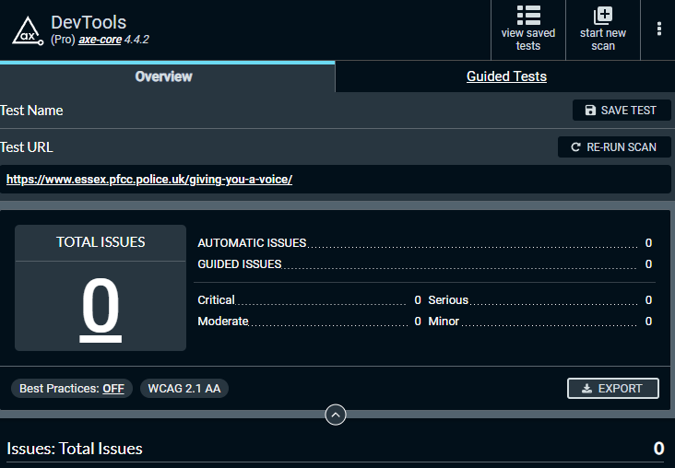

Accessibility fixes performed on this page included:
- Added text to the hero link to fix “Links must have discernible text”
- Removed link from IMG to fix issue of links without discernible text (This issue was resolved in a few places)

Essex PFCC Accessibility Statement:
Issues Found –
- accessibility issues were found during the test that were not included in the statement
- it is out of date and needs to be reviewed

Accessibility fixes performed on the accessibility statement included:
- updating date to refer to new date of testing
- adding non-compliance including PDFs without accessible text (images instead of text)
Page here: https://www.essex.pfcc.police.uk/accessibility-statement-2/

Issues Resolved Outside of Accessibility Report Scope

Overview:
Below I will list accessibility issues Formation Media solved which go beyond the issues outlined in the government report: https://reports.accessibility-monitoring.service.gov.uk/reports/8eff6a36-220d-43db-9366-25c48c43cff3#report-section-1982

WCAG 2.4.4: Link Purpose (In Context)

In various areas of the site including: https://www.essex.pfcc.police.uk/what-we-are-doing/fire-rescue-strategy/prevention-protection-and-response/
Banner was creating a blank link which would be included in tab order, I added the option to have a banner without a link in the backend of WordPress.
Additionally, I went through and fixed various areas where images were wrapped in links and the image did not have alt text, meaning it would be included in tab order without description. I did this by removing the link (alt text for images will be addressed in Essex PFCC’s accessibility plan)
For example on this page: https://www.essex.pfcc.police.uk/exploited/ I removed the blank link.
Additionally here: https://www.essex.pfcc.police.uk/precept-2023/
The image link had no alt text, which would be confusing for screenreader users. However, I added alt text “Click here to take the survey” so the link purpose is clear.
The home page also had blank links in various areas, which I simply removed.

WCAG 1.4.3: Contrast (Minimum)

On the events page: https://www.essex.pfcc.police.uk/events/
The calendar plugin added opacity on days without events, I removed the opacity in CSS to ensure it is compliant with WCAG contrast requirements.
On pages with breadcrumbs:
https://www.essex.pfcc.police.uk/what-is-a-pfcc-and-what-do-they-do/
Changed hover/focus effect for links to be a simple underline, making the purpose clear without effecting contrast.

WCAG 2.4.6: Headings and Labels

I edited the content-hero.php template so that the first slide title will be used as an h1. This resolves an issue across the site where various pages had no h1 element when using the slider template would leave the page without an H1, which is essential to help users understand the purpose and content on a page. Where necessary I manually added an H1 to ensure each page has an H1.

WCAG 1.1.1: Non-text Content
Added image alt text in various key areas of the site including: https://www.essex.pfcc.police.uk/what-is-a-pfcc-and-what-do-they-do/
To help explain the purpose of content for those using screen readers.

WCAG 1.3.1 Info and Relationships

Added aria-label to the footer <nav> element, making the purpose of the landmark clear to screenreader users.
Added aria-label to the content boxes on the homepage, so links always indicate the content they are linking to.
Made structural changes to all web pages template using ARIA landmarks to identify regions of a page. “top-bar” is now a section with an aria label, prefooter is now a section with an aria label.

I can confirm that I, Ethan Oshoko, Web Developer for Formation Media Ltd, performed a full website accessibility manual audit and corrective development on or before Monday 12 December 2022. I can confirm I have also updated the accessibility statement as required.
Contact details:
Formation Media Ltd. Unit 2, St. Georges House, Cape Road, Warwick CV34 5DJ. Tel: 01926 298777. Account Director: David Dunlop – 07772 653 463 - dave@formationmedia.co.uk

