Essex PFCC Accessibility Strategy

The Police, Fire and Crime Commissioner for Essex has engaged Formation Media to ensure that the infrastructure and content of the essex.pfcc.police.uk site is up to and exceeds Web Content Accessibility Guidelines (WCAG) 2 Level AA. Significant changes have been made to improve the accessibility of the site both prior to the legislation coming into force and once further reviewed in 2022. While the site is now largely accessible there remains a number of issues relating to the nature of the content, rather than the structure, of the website.
Image ALT text and PDFs are the two problematic issues here. We will go into more detail later, but essentially, there is a large burden of work that is required to bring these elements of the site up to standard. There is also significant volumes of content provided by third parties.

What you, the Government Digital Service have requested:
The Government Accessibility Officer, will get back in touch with you, however, you do not have to have all of these issues resolved:
From: https://reports.accessibility-monitoring.service.gov.uk/reports/more-information
After 12 weeks we will ask for:
- Issues you have fixed
- Issues you have been unable to fix
- A timeline for fixing unresolved issues
- Any other comments about the accessibility of your website
The Police, Fire and Crime Commissioner for Essex have provided the Government Digital Service with documentation which outlines:
- How we fixed the issues found in the government accessibility report
- How we went beyond that scope and performed a full manual accessibility audit
- How we then solved the issues that were found in the manual audit
- Outstanding issues we couldn’t solve
- How the accessibility statement is updated to reflect the outstanding issues
The following document covers findings from our manual audit “Essex PFCC Accessibility Summary v3.docx” This covers “Issues we have fixed” and “Issues we have been unable to fix”. Additionally, we have produced this “Accessibility Strategy” document which details a timeline and a plan for fixing unresolved issues (PDFs and Image ALT text), we will explain the issues found and outline our strategy to fix inaccessible content and a timeline.

Outstanding Accessibility Issues:

Image ALT text issue
Quite a few images on the site have descriptive alt text which is good, however there are some images without alt text which are causing issues: https://www.essex.pfcc.police.uk/news/building-lives-project-supporting-young-people-in-chelmsford/
Because the image contains a link to the image file, but no alt text, it causes the issue:
WCAG 2.4.4 Link Purpose - Links must have discernible text
We can remove the link which would solve the issue, but it’s best to make sure images have descriptive alt text where possible: https://webaim.org/techniques/alttext
We will go through the media library and go through each month starting with the most recent, making sure each image has alt text. We also have a spreadsheet to refer to that indicates all images on the website with missing ALT text.
This will allow us to break down the task down into manageable pieces.
Timeline to fix image ALT descriptions:
- We propose we will fix ALT descriptions on 30 images a month, starting from the most recently added, until all image ALT text descriptions are fixed.
- We do not have the resources to have all the images fixed in one go (disproportionate burden).
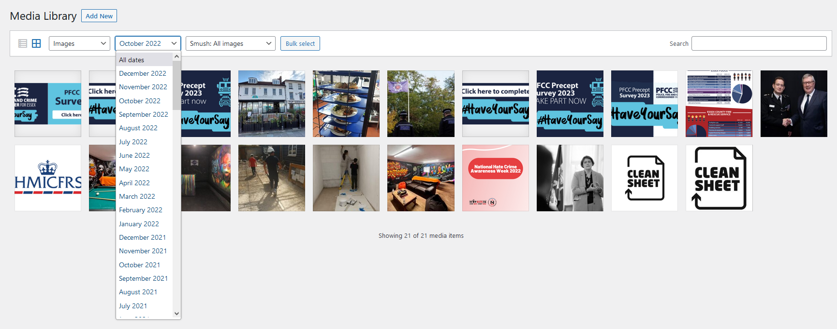
Selected Essex PFCC staff will be having a training session in January 2023 with Formation Media Ltd, on how to create and upload accessible content, with a procedure in place to check documents are accessible before being upload to the website.

PDFs issue
Another significant outstanding accessibility issue on the site is the use of PDFs, and PDFs which are inaccessible.
We have reviewed this guidance: https://www.gov.uk/guidance/publishing-accessible-documents
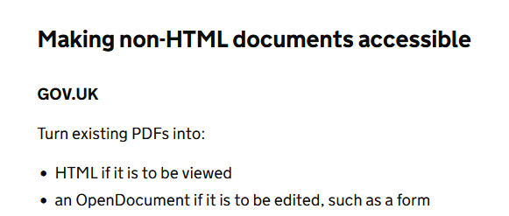
Publish in HTML format wherever possible so that your documents use your users’ custom browser settings. It can be difficult to make other formats easier to read. For example, PDF documents
Previously uploaded pdfs – post 23 September 2018
Upon review “Translating” existing previously uploaded documents from PDF format to html/web pages is not viable due to the time and resources required. That said, where possible, any NEW documents that will be uploaded we will endeavour to create them as html/web pages.
We plan to use Adobe Acrobat Pro to “fix” existing uploaded pdfs.
We will fix the top 10 viewed pdfs on the website first.
Original Word documents will have alt descriptions and accessibility considerations performed before they are converted to pdfs.
Any new pdfs that are then produced and to be uploaded will be accessibility checked through adobe acrobat pro.
- Note: When adding new pdf’s, we will endeavour to make them accessible, however some - i.e. finance pdfs are very complicated with graphics, charts and graphs, unfortunately these may not be accessible - however, a plain text version will be available on request.

Our website is due for a rebuild in 2023 and we will consider adding “page builder” template elements that will assist making added content into html/web pages as opposed to PDF’s.

Timeline to fix pdf’s:
- We will fix the top ten viewed pdfs by 24 February 2023.
- We will then fix pdfs (most recently added to the site first) at a rate of 30 per month, until the task is complete.
- We will not fix pdfs that were produced and uploaded prior to 23 September 2018.
- We will not be able to fix pdfs supplied by third parties, including those supplied by Essex Police and Essex Fire and Rescue service as we do not have access to the original documentation – therefore, deemed third party.
Disproportionate Burden Claim
As there are 4579 PDFs on the website, it is clearly going to take some time to make all accessible, we will do our very best, but some older pdfs may fall under the banner of disproportionate burden.
Note: Any PDF documents supplied with regard to Essex Police and Essex Fire and Rescue Service are deemed third-party content which Essex PFCC does not have control over.

Videos
There are some areas on the site which have videos: https://www.essex.pfcc.police.uk/news/10-years-of-making-a-difference/
Video content must include captions on the page for those who rely on sight instead of hearing if the video contains exclusive audio content:
More info: https://www.w3.org/WAI/media/av/captions/
We will ensure any new video uploaded meets standards and has captions.

Calendar and Information Request Forms
The website currently features several external “plug ins” and feeds, including the calendar and information request form, which Essex PFCC does not have control over, and therefore we deem as third party content.

