The
Assurance Strategy

About

This Strategy describes the process that Essex County Fire and Rescue Service uses to offer assurance that the services delivered are effective and efficient. It outlines roles and responsibilities, for the Chief Fire Officer (CFO) and the Strategic Leadership Team (SLT), through to managers and all personnel along with the processes that are in place to enable evidence-based assurance.
The document should be considered in conjunction with the procedures and processes that have been adopted by individual projects and Boards and is supported further by the Risk Management Strategy and Assurance Framework.
Essex County Fire and Rescue Service may be referred to as ‘the Service’ throughout this document.

Content

Purpose of this Strategy 2
Principles of Assurance 2
Assurance of activities 3
First line of defence 3
Second line of defence 4
Third line of defence 4
The key benefits to implementing an effective model 5
Assurance mapping 6
Assurance reporting and statements 6
Responsibilities: 8
Appendices 11

Purpose of this Strategy
This Strategy outlines the Service’s approach for providing assurance on its business and operational activities and sets out the monitoring and reporting responsibilities throughout the organisation.

Principles of Assurance
The following principles underpin the Service’s approach to developing and managing assurance:
Assurance by design | Assurance should not be a single exercise but a sustained activity that is a core Service priority to enable high performance and continued improvement. Planning for assurance from the outset, iterating its importance and then continuing to monitor throughout reviews makes sure that it is integrated and embedded successfully across all ‘three lines of defence’(see page 4). Undertaking assurance from the outset maximises the opportunity to learn from the approach and underpin impact and risk assessments for future delivery. In addition, the forward planning of assurance should aim for confidence in delivery rather than focusing solely on the adherence to process and methodology.
Flexible | By being pro-active and including assurance measures from the outset, the need to be reactive should be negated, however assurance should still be adaptable to allow for changes in scope, delivery or risk profile.
Risk and outcomes based | Assurance activity can inform key decisions and evidence-based risk management across the Service.  Risk impact should help provide rationale for how assurance is assessed and how much is required. Assurance should be risk-based with a clear link between the planned assurance activities and the risks, to ensure assurance activity is proportionate to risk.
Independent and impartial | Where appropriate, assurance is performed by competent people outside of the delivery team who are not unduly influenced by key stakeholders. On occasions, this may require assurance activity to be carried out by people outside of the organisation – such as technical or project management consultants, internal auditors or Her Majesty’s Inspectorate of Constabulary and Fire and Rescue Services (HMICFRS).
Accountability | Assurance roles and responsibilities at the governance level are understood, partly through, but not limited to, current Policy, Procedure and Guidance.

Assurance of activities
To ensure assurance activities are independent and objective, it is crucial to create and embed a ‘three lines of defence’ model which is essential to the overall framework of control.
This model shows how the Service’s management and assurance functions interact and in particular places accountability at a local level and ensures transparency of activity through the Service and to the public. The model is an overarching Assurance Strategy and framework, and each Directorate will design and embed their own internal first and second-line assurance arrangements through their own assurance mapping exercise. This exercise will also show the boundaries between different roles and responsibilities in the management and assurance of risks and helps to avoid duplication and gaps in risk management, performance management, governance and control arrangements
By setting out roles and responsibilities relating to risk management and assurance, the model links to an organisation’s assurance framework.

First line of defence
The first line of defence is the operational controls in place. First line of defence activities can be:

- Policy
- Procedures and guidance documents
- Performance dashboards
- Monitoring statistics
- Localised risk registers
- Routine reports
- Personal development reviews

These mechanisms provide assurance that performance is monitored, risks are identified and addressed, and objectives are being achieved at a local level.

Second line of defence
The second line of defence is the management oversight activity. This will include for example, governance arrangements, performance reporting and internal routine checks and self-assessments to ensure activity is being properly managed and delivering on its objectives. The Police Fire and Crime Commissioner (PFCC) holds the SLT to account, on behalf of the communities they represent and scrutinise how SLT manage the various systems of assurance.
This assurance provides important management insight into how well work is being carried out in line with the Integrated Risk Management Plan (Community Risk Management Plan from 2024) and Fire and Rescue Plan deliverables and our values and behaviours. It enables management to provide narrative and understanding to performance information.
Below are some examples of our second line assurance activities, but there will be more, specific to activities based on their level of risk and impact to the Service’s objectives:

• Corporate Governance
• Performance reporting
• Change Management assurance and highlight reporting.
• Operational Assurance Assessments
• Debriefs
• Staff surveys, focus groups and other internal engagement activity
• Public consultation and engagement
• Compliments, complaints and grievances.
• Evaluations and benefit reviews
• Analysis and research
• Workplace and Generic risk assessments
• Other departmental self-assessments/routine checks.

Third line of defence
The third line of defence relates to independent and more objective assurance and features mechanisms such as internal and external audit, external accreditation and inspections. This type of assurance is provided from outside of line management structures and is used to verify our performance often against an established framework.

Below are some examples of our third line assurance activities, but there may be more, specific to activities, based on their level of risk and impact to the Service’s objectives:

- HMICFRS Inspection Programme
- Home Office or National Fire Chief’s Council (NFCC) data returns (and subsequent benchmarking)
- Peer Reviews, for example via the NFCC
- ISO 27001 – Information Security Management System Certification
- Investors in People review activity
- Police Fire and Crime Panel
- Stonewall Diversity Champion activity
- Internal Audit Report
- External Audit
- Health and Safety Executive
- Consultancy

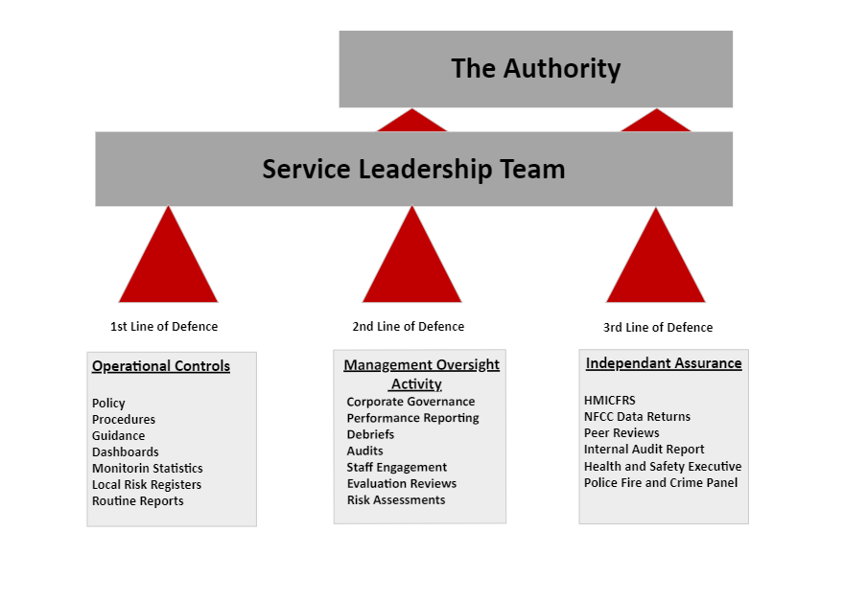

The key benefits to implementing an effective model
The implementation of this model throughout the Service will take time as it requires a change in mind set and behaviours, however the benefits are:
- Improved coverage of risks and controls by identifying and detailing where necessary the risks and controls, and appropriately allocating the ownership of these risks and controls across the ‘three lines of defence’. Consequently, any unintended risks and gaps in controls may be avoided, and unnecessary duplication of work should be avoided by removing any redundant controls.
- Improved benefits realisation and control culture across the Service by enhancing the understanding of risks and controls.
- Improved reporting to the appropriate Board through a coordinated approach to providing timely reporting avoiding potentially duplicative and irrelevant information.
- If Assurance equates to ‘the ability to evidence’, then implementing an effective model will improve the ability to demonstrate assurance upon request from external organisations e.g., HMICFRS.

Assurance mapping
Assurance mapping is a process that enables us to review the systems of control through the assessment of the three lines of defence. This exercise is dependent upon and led by the assessment of risks which in turn determines the amount of assurance required.
For example, a high-risk area such as financial management will require significant assurance to provide confidence that it is controlled effectively and is therefore subject to rigorous internal checks and external auditing. The financial implications and effort of such levels of scrutiny needs to be considered against the level of risk to the Service’s objectives before determining what assurance mechanisms need to be deployed.
The structured mapping of assurances is one of the fundamental steps in building an assurance framework, the Service’s Assurance Framework will sit outside of this strategy and will:
- Provide timely and reliable information on the effectiveness of the management of major strategic risks and significant control issues.
- Facilitate escalation of risk and control issues requiring visibility and attention by senior management, by providing a cohesive and comprehensive view of assurance across the risk environment.
- Provide an opportunity to identify gaps in assurance needs that are vital to the organisation, and to plug them (including using internal audit) in a timely, efficient and effective manner.
- Be used to raise organisational understanding of its risk profile and strengthen accountability and clarity of ownership of controls and assurance therefore, avoiding duplication or overlap.
- Provide critical supporting evidence for the production of Governance statements.
- Clarify, rationalise and consolidate multiple assurance inputs, providing greater oversight of assurance activities for the Board/Audit & Risk Assurance Committee in line with the risk appetite.
- Facilitate better use of assurance skills and resources.

Assurance reporting and statements
On an annual basis the Service is required to demonstrate and publish its overall levels of assurance in respect of specific legislation. The most significant being the Annual Statement of Assurance, which is a requirement set out in the National Framework for Fire and Rescue Services by the Home Office. This statement is designed specifically to provide assurance that we are meeting our obligations as a Fire and Rescue Service across a number of different regulations but primarily to the Fire Service Act 2004 and the Regulatory Reform (Fire Safety) Order 2005.
In addition to the Annual Statement of Assurance, there are other more specific requirements for such statements that are set out in different legislations such as the Accounts and Audit Regulations 2015, Health and Safety at Work (etc) Act 1974 and the Equalities Act 2010. These statements must be made publicly available to enable proper scrutiny so that the Service may be held accountable.
To ensure our assurance activities provide an appropriate coverage and to enable effective management of organisational risks, the Performance and Resources Board (Fire and Rescue) regularly reviews performance and assurance activities across the Service. The Board has been established to enable the PFCC in their role as the Essex Police, Fire and Crime Commissioner Fire and Rescue Authority to review the Service’s performance, ensure that budgeted resources are closely aligned with fire priorities and to ensure that resources are effectively and efficiently being utilised.
The Board will enable the Commissioner to maintain effective oversight of the Service and to hold the CFO / Chief Executive Officer to account for the delivery against the priorities in the Fire and Rescue Plan.
In addition to this, Directors are responsible for ensuring that they incorporate their own assurance mechanisms to cover their respective areas. Using these mechanisms, they are then required to provide assurance to the Portfolio Management Board (PMB) or the Continuous Improvement Board (CIB) around the performance of, and management of risk in their respective areas.
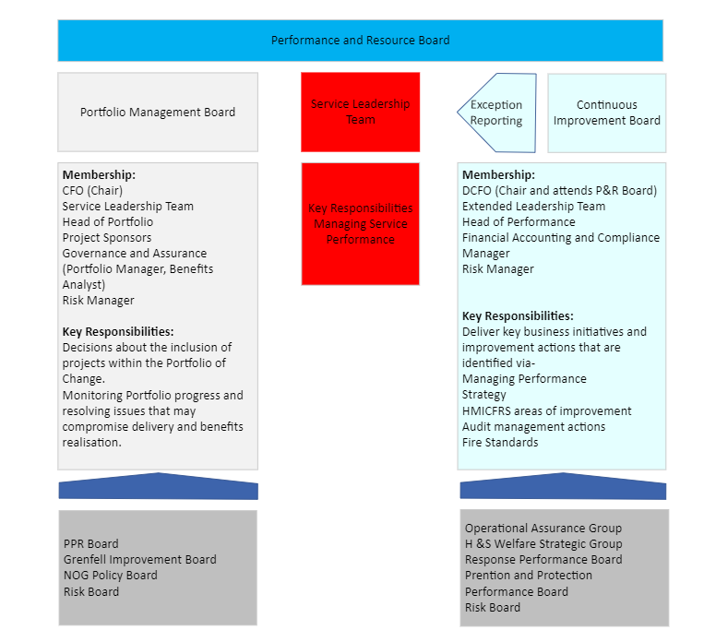

Responsibilities:
Roles and accountabilities shall be defined in the relevant Directorate, project governance and assurance framework, then assigned to people with appropriate seniority, skills and experience.
Essex Police Fire Crime Commissioner (PFCC):
The PFCC has sole responsibility for being the Fire and Rescue Authority for an area. The PFCC has a statutory duty to ensure provision of their core functions as required by the Fire and Rescue Services Act 2004. As the Authority they own and approve the Annual Statement of Assurance and receive and scrutinise regular reports on performance and assurance covering significant areas of risk to the Service.
The Police, Fire and Crime Panel (PFCP) will perform a scrutiny function, providing both support and challenge to the PFCC on the exercise of their functions and scrutiny of the Fire and Rescue Plan and Fire and Rescue Statement. The powers, responsibilities and membership requirements of PFCPs are set out in the Police Reform and Social Responsibility Act 2011.

Chief Fire Officer (CFO):
The CFO is the Annual Statement of Assurance owner and has oversight of the assurance activities and audit opinions for the Service through regular reports that are received at SLT and other executive boards. The CFO holds the other members of SLT to account on the management of strategic risks.
Deputy Chief Fire Officer (DCFO):
The DCFO is responsible for reviewing and scrutinising the Service’s performance and determining the confidence in delivering against the Fire and Rescue Plan and Annual Plan objectives.
The Service Leadership Team (SLT Directors:
SLT supports the CFO and DCFO in directing the business of the organisation in an effective and efficient way as possible, and to provide scrutiny, challenge and support, having regard to the Service’s long-term health and success. Expertise and knowledge should support the board to ensure that lessons learned from Assurance audits are acted upon and hold each other to account for the performance and assurance of their respective areas.
Extended Leadership Team (Assistant Directors (AD) / Head of Department (HD)):
Each AD / HD, supported by their respective management team, has responsibility for ensuring they have effective controls in place to provide assurance on their areas of the Service.
Each AD / HD will do this by:
- Ensuring they have considered the risks to achieving their purpose and to meet the objectives that have been set out.
- Ensuring that they have mapped out and are monitoring compliance against the effective controls across the three lines of defence.
- Routine reporting on their performance.
- Regular review of risks and the adequacy of their current controls.
Performance and Improvement:
The Assistant Director - Performance and Improvement will be responsible for providing assurance to SLT and executive boards through various systems of assurance. This includes, but not limited to:
- The facilitation of the HMICFRS inspection programme.
- The Change Management framework.
- Performance reporting, including, but not limited to, the quarterly and
end-of-year performance reports into the Performance and Resource Board.
- Organisational Performance dashboards and Deep Dive reports (within and beyond Power BI reporting).
- Wider analysis, research and evaluations.
The AD will act as the Service lead for the commissioning and scoping of activities seeking to provide assurance such as the rolling internal audit programme, HMICFRS related activities, peer reviews and other independent reviews. Following the delivery of assurance activities as described above, the AD will also ensure that through the Annual Plan, action plans resulting from reviews are tracked and improvements are fully embedded within the Service.
Operational Assurance:
Provides Operational Assurance to SLT to ensure that the Service continually learns through application of HSG65 to meet its statutory duties. This is completed by the analysis of operational information against policies, business plans, audits and key performance indicators; to evaluate and report to the Operational Assurance Group. They will ensure any learning gained from those activities is shared appropriately and timely, this includes, but is not restricted to:

- The collection, analysis and distribution of performance data.
- Provide feedback to influence organisational learning locally and nationally.
- Provide feedback to inform organisational decision-making.
- Deliver planned audit and operational monitoring activities.
- Oversee the debrief activities of the Service.
Managers:
All managers have responsibility for establishing and maintaining transparent and effective controls to ensure their business activities are delivering against the Service’s objectives.
Each manager will do this through:
- regular review of risks and performance with their respective Directorates.
- well-considered, open and honest reporting, highlighting any areas of good performance and flagging any areas of concern.
General responsibilities:
Every staff member within the Service contributes to the assurance of activities through their compliance with this Strategies, Policies, Procedures and Guidance documents and through delivering their work in line with the Service’s values and behaviours.
All staff members must provide open, honest and well-balanced feedback through a number of feedback mechanisms to highlight any areas of good performance and flag any areas of concern. These mechanisms include, but are not limited to, Personal Development Reviews (PDR), internal audits, staff surveys and other engagement activity such as dedicated user or focus groups.

Appendices
- Assurance Framework (To be developed / added)
- Assurance Delivery Plan (To be developed / added)

