Performance and Resources Scrutiny Programme 2019

Report to: the Office of the Police, Fire and Crime Commissioner for Essex

Title of Report: | Rebalanced Scorecard Gradings Cycle 2
Agenda Number: | 8.0
Chief Officer | Dr. Victoria Harrington
Date Paper was Written | 14 November 2019
Version Number | 2.2
Report from: | Essex Police
Date of Meeting: | 28 November 2019
Author on behalf of Chief Officer: | Matt Robbins, 42073495  Corporate Performance Analyst
Date of Approval:

- Purpose of Report

This paper provides an overview of the final grades for the second cycle of the “Rebalanced Scorecard” (the 15th cycle of Essex Police’s Balanced Scorecard process). This paper will also provide the rationale for the Force-level grades, as determined in the Force Performance Board, which was held on Monday 14 October 2019.

- Recommendations

There are no recommendations. This report is for the board to note.

- Executive Summary

At Force-level, two areas of the Balanced Scorecard (BSC) were graded as ‘Requires Improvement’ (RI):

- FOCUS. This area relates to our priorities, namely preventing crime, keeping our communities safe, protecting the vulnerable, violence (including Serious Organised Violence), and identifying suspects and bringing them to justice (targeting the most harmful).
- PROCESS. This area is about how efficient and effective our processes are in improving our ability to address our priorities and meet the needs of the public, specifically in relation to areas such as data quality, investigations and being within budget.

The following area was graded as ‘Good’.

- SERVICE USER. This area relates to how we are meeting the needs and expectations of the communities of Essex and our partners, specifically in relation to visibility and accessibility, public confidence, looking after our victims, and working with our partners.

No grade was given for the following area at Force level due to the lack of Redline Measures or Key Performance Indicators (KPIs) relating to Human Resources; these measures will be available for the next cycle of the BSC:

- INNOVATION. This area relates to how we are sustaining our ability to change and improve, and consequently address our priorities and meet the needs of the public, specifically in relation to subjects such as staff satisfaction and the link between organisation and procedural justice, absenteeism (police officer and staff), and recruiting and training investigators.

FOCUS was graded at RI due to the fact that three of the Redline Measures (High Harm Offences per 1,000 population v. MSG average, High Harm Solved v. MSG average and Emergency Response times v. 80% target) were not met. The Emergency Response times had also deteriorated since the last cycle.

PROCESS was downgraded to RI at Force-level (the only Force-level downgrade). This was due to the fact that the Redline Measure relating to Athena compliance for remand files (manual review conducted by CJ Command as to the number of files that were electronically transferred across with all the requisite information to prosecute offenders at court) was not met, and that the Force is forecast to overspend on both officer and police staff overtime.

SERVICE USER was graded at Good due to the fact that all Redlines – other than the Crime Survey of England and Wales (CSEW) confidence in local policing measure – were met.

Changes in grades between Cycle 1 and Cycle 2:
- Command-Level:
    - Two improvements, both in South LPA (RI to Good for FOCUS and SERVICE USER).
    - Six downgrades, four in PROCESS (due primarily to overtime overspend forecasts).
- Force-Level.
      - One change: downgrade from Good to RI for PROCESS (due to grades of individual commands and the forecast overtime overspends for police officers and staff).
      - No grade for INNOVATION due to lack of metrics (graded at Good in the last cycle).

The below table details the grades for Cycles 1 and 2 of the Rebalanced Scorecard at both Force and command-level. The ‘tube map’ detailing Force-level grades since the Balanced Scorecard was introduced at Essex Police can be found at Appendix One.

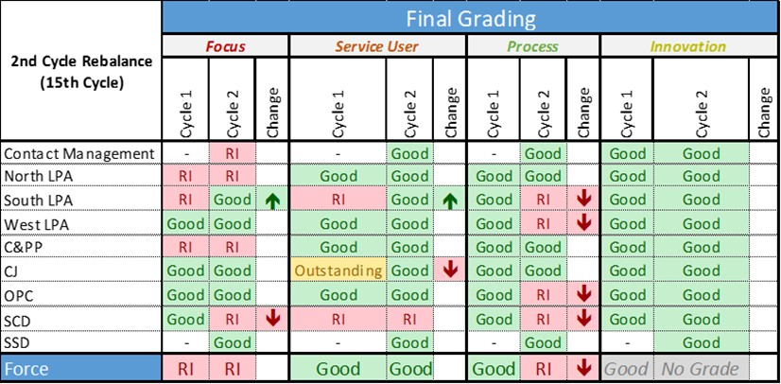

4.0 Introduction/Background
Essex Police use the “Balanced Scorecard” (BSC) strategic performance management framework to assess its own performance. Grades are provided at command and Force-level for each of the four BSC areas:

- FOCUS (formerly KEEPING PEOPLE SAFE).
- SERVICE USER (formerly COMMUNITY FOCUS).
- PROCESS (formerly EFFICIENCY).
- INNOVATION (formerly OUR PEOPLE).

The following graphic details the four quadrants of the new Rebalanced Scorecard:

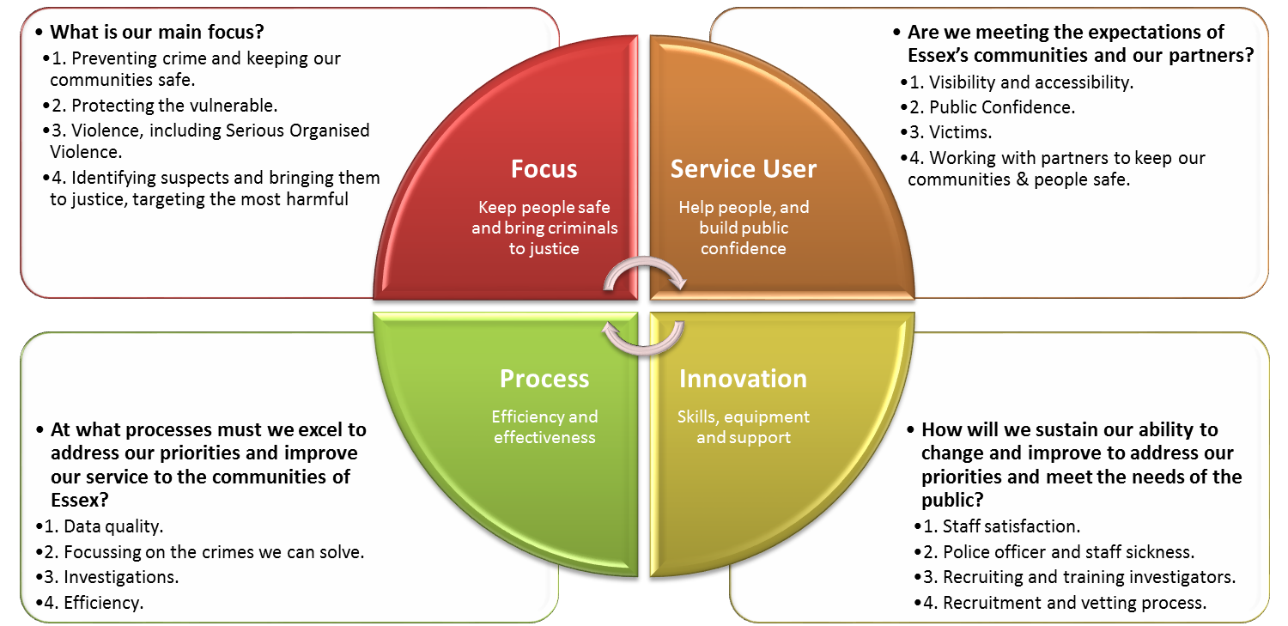

Essex Police use the grading names employed by Her Majesty's Inspectorate of Constabulary and Fire & Rescue Services (HMICFRS) in its assessments. The grades are ‘Outstanding’, ‘Good’, ‘Requires Improvement’, and ‘Inadequate’.

Where possible, Essex Police benchmarks its performance, either against other forces in its Most Similar Group (MSG) of forces, or against national or internal targets. This enables Essex Police to derive minimum standards (and consequently assess what is ‘Good’); these minimum standards are referred to as “Redline Measures”.

The BSC process is conducted on a quarterly basis. Individual commands first grade their performance for each area of the Rebalanced Scorecard, taking into account the recommended grades and analysis provided by the Performance Analysis Unit (PAU), as well as any relevant Redline Measures (minimum standards) and Key Performance Indicators (KPIs). These grades are then reviewed and moderated (where necessary) by the relevant Assistant Chief Constable/Director at Oversight Boards; Force-level grades are agreed at the Force Performance Board, which is chaired by the Deputy Chief Constable.

5.0 Current Work and Performance

At Force-level, FOCUS and PROCESS were graded as ‘Requires Improvement’. SERVICE USER was graded as ‘Good’. INNOVATION was not given a grade at Force-level due to the lack of HR Redline Measures and Key Performance Indicators (KPIs).

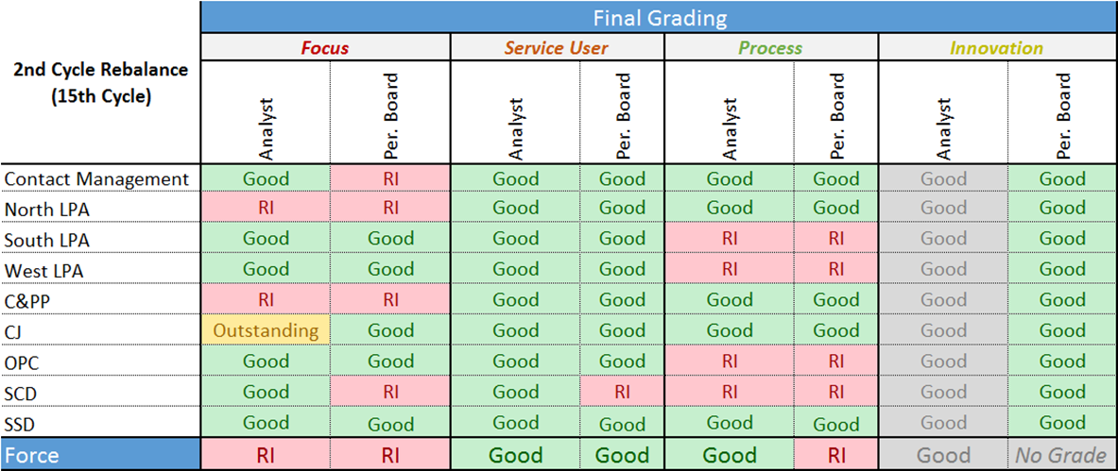

The rationale for these final grades is detailed below. Please note that data for Cycle Two are to July 2019.

FOCUS – Requires Improvement

Redlines
- High Harm Offences per 1,000 – Not Met. No overall change since last Force Performance Board in April, but slight deterioration in VWI (+0.1), and improvement (-0.1) in Burglary Residential.
- High Harm Solved Rate – Not Met. Below MSG average for all offence categories other than Burglary Residential (equal to MSG average). Key drivers: Sexual Offences (-3.9%), Robbery of Personal Property (-4.7%). Biggest deteriorations in VWI (now 2.0% pts below MSG average compared to 1.1% pts below in April) and Rape (now 2.7% pts below MSG average compared to 2.3% pts below in April).
- Emergency Response Times – Not Met. Remains below the 80% target (at 71.9%), and has been continually deteriorating since July 2018. The rise in emergency calls, as well as a lack of Emergency Response Drivers was cited as likely causes for this drop in performance; it was noted that the Emergency Driver Response Training issue was unlikely to see a considerable improvement until around March 2020.
- High Harm Victim Contact Contract (VCC) Compliance (ensuring people are being kept informed) – Met. 99.7%.
- Risk Register Scores Above 75 – Met. No items.
- HMICFRS Effectiveness Inspection Grading – Met (Good).
KPIs
- Increase in Stop & Search (driven by Op. Sceptre)
- Increase in the average number of days taken to investigate DA
- Rise in the numbers of DA investigations where victims do not support (also continued reduction in volume and rate of DA arrests: 25.4% arrest rate in Apr-Jun).
Improved Crime Data Accuracy (CDA) and changes to Home Office Counting rules (Stalking & Harassment in particular) was discussed at the Force Performance Board. While it was noted that the Force received an Outstanding grade in its Crime Data Integrity (CDI) HMICFRS inspection, Essex has consequently become less likely to meet its Redline Measures for High Harm Offences per 1,000 population and High Harm Solved Redlines. The low volume of Rape investigations solved was also discussed (it was acknowledged that the volumes in the last few months have been higher). The lack of investigators across the Force was further acknowledged to be a compounding factor in relation to solving High Harm offences.

Due also to the command grades, a grade of RI was considered appropriate.

SERVICE USER – Good

Redlines
- Confidence in local policing (CSEW) – Not Met. Essex is eighth in its MSG and 9.9% below the MSG average (it was 10.2% below at the last Force Performance Board).
- ASB Perception (CSEW) – Met. 3.3% v. MSG average of 6.0%.
- Victim Contact Contract (VCC) Compliance (ensuring people are being kept informed) – Met. 95.4%
- Risk Register Scores Above 75 – Met. No items.

KPIs
- Improvements in all Contact Management metrics for 999s, FCR 101s and CB 101s compared to performance the previous year (average wait times and abandonment rates).
At the Force Performance Board, it was agreed that the Force was Good in this area. The rationale was that all Redline Measures were met, other than the CSEW confidence in local policing. It was also noted that performance within the FCR and Crime Bureau has improved compared to previous years, in spite of the increase in demand; although there was an issue with a backlog in CB awaiting QA, this is now being addressed by Contact Management command.

PROCESS – Requires Improvement

Redlines
- Athena Compliance for Remand Files (manual review conducted by CJ Command as to the number of files that were electronically transferred from Athena with all the requisite information to prosecute offenders at court) – Not Met. 84.7% (below the 95% target).
- Overtime spend within budget (officers) – forecast overspend.
- Overtime spend within budget (staff) – forecast overspend.
KPIs
- Consistent numbers of Quality of Investigation audits, albeit with a slight dip in July (likely to be due to the increased summer demand).
- Crime Conversion rate remains stable between 66-69%.
- The average age of an investigation before QA rose steeply in April (to an average of 2.54 days), but in July had reduced to 1.73 (still above pre-March figures when it was less than half a day).
It was agreed at the Force Performance Board, that the Force should be downgraded to Requires Improvement. In the last round of the Rebalanced Scorecard, the Force was graded as Good in this area. The reason for the downgrade was due to the fact that the Redline Measure for Athena Compliance for remand files was not met, and that the Force is forecast to overspend for police officer and police staff overtime. Some commands also graded themselves as RI, similarly citing a forecast overspend.

INNOVATION – No Grade

Redlines
- Absenteeism of officers v. MSG average – Not Met. Improvement compared to 12 months to March 2018 (5.1% in March 2018 to 4.4% in March 2019).
- Absenteeism of staff v. MSG average – Not Met. Slight deterioration compared to 12 months to March 2018 (4.7% in March 2018 to 4.8% in March 2019)
KPIs
- Outstanding vetting - improving (continued decline in volumes)
The current lack of measures – specifically in relation to HR – meant it was difficult to grade the Force for INNOVATION. In the last round of the Rebalanced Scorecard, the Force was graded as Good. Although every command had graded themselves as Good, the metrics they cited were inconsistent. It was therefore agreed that no grade would be recorded for this cycle.

6.0 Implications (Issues)

The Balanced Scorecard (BSC) is used to identify and address command and Force-level performance issues; the focus is on the areas that are graded at “Requires Improvement”. Many Force-wide issues that are discussed at the Force Performance Board form the basis of discussions at the subsequent Essex Synergy and Performance Meeting (Synergy).

6.1 Links to Police and Crime Plan Priorities

The Balanced Scorecard processes incorporates the seven priorities within the PFCC’s Police and Crime Plan. The Force therefore takes into account these priorities as part of the Balanced Scorecard process.

6.2 Demand

The Balanced Scorecard ensures that demand is managed appropriately by identifying both good practice and areas of concern at a strategic level.

6.3 Risks/Mitigation

Risk is discussed as part of the Balanced Scorecard (BSC) process. Risks with a score of over 75 (namely those which are Likely or Almost Certain, with a Major or Catastrophic impact) constitute Redline Measures at both Force and Command-level.

6.4 Equality and/or Human Rights Implications

No equality or human rights implications were identified in the process of writing this report.

6.5 Health and Safety Implications

No health and safety implications were identified in the process of writing this report.

7.0 Consultation/Engagement

All commands involved in the Balanced Scorecard process are regularly consulted, particularly with the identification of “Redline Measures”, Key Performance Indicators (KPIs) and the data required to support the effective completion of Balanced Scorecard returns.

The Performance Analysis Unit (PAU) are currently working with commands to identify evidence-based metrics for every command, and for every area within the new “Rebalanced Scorecard” (discussed at 9.0).

8.0 Actions for Improvement

The Balanced Scorecard identifies good practice, but also areas for improvement. Areas graded at “Requires Improvement” or below are discussed at the Chief Constable’s Essex Synergy and Performance meeting.

9.0 Future Work/Development and Expected Outcome

In order to gain a more holistic view of the Force, more commands are to be introduced to the BSC process. Contact Management (which includes the Force Control Room and the Crime Bureau) was introduced in this cycle; Strategic Change Directorate will be introduced in the next cycle.

During Cycle 2, some commands stated they were unclear as to what some of the names for each of the Balanced Scorecard area related, particularly FOCUS and INNOVATION. These titles were either considered ambiguous or confusing (‘Innovation’ in the previous BSC process, for example, related to innovative solutions to problems rather than to people). In the Essex Police Synergy and Performance Meeting (Synergy) an anonymous questionnaire was consequently handed out to all attendees; this asked if attendees understood what was being assessed in relation to each of the BSC quadrants. The Performance Analysis Unit are currently reviewing the results and consulting with commands to determine if the BSC names should be changed for future cycles in order to improve understanding.

APPENDIX ONE – Essex Police Balanced Scorecard Grades: Cycles 1 to 15
