Performance and Resources Scrutiny Programme 2019
Report to: the Office of the Police, Fire and Crime Commissioner for Essex

Title of Report: | Crime Prevention Strategy Delivery Plan
Agenda Number: | 7.0
Chief Officer | ACC Prophet
Date Paper was Written | 2nd December 2019
Version Number | 1
Report from: | Essex Police
Date of Meeting: | 20th December 2019
Author on behalf of Chief Officer: | Chief Inspector 3027 BALDING
Date of Approval: | 6th December 2019

- Purpose of Report
This paper is a quarterly update on the delivery of the Essex Crime Prevention Strategy (2018-2021).

- Recommendations
There are no specific recommendations but the Board is asked to note, and invited to comment upon, the content of the report.

- Executive Summary
The paper includes recent change / impact of the delivery plans for each of the priority strands within the strategy since the last board. The report also includes latest version of core performance data against each strand and an update on the Digital Crime & Fraud strand.

4.0 Introduction/Background
The Essex Crime Prevention Strategy is set out at Appendix 1.
The background to the development of the strategy and its links to the national context have been discussed in detail at previous boards. Previous report (July 2019) reflected on the success of the strategy and current position within Essex Police.
This report focusses on the change, impact and development to date, in respect of the delivery plans for the 9 strands.
The strategy primarily focusses on 9 key areas linked by the themes of Violence Reduction and partnership/ collaborative working:

- Domestic Abuse (DA) (Lead Chief Superintendent Mariner.)
- Gangs & Knife Crime (Lead Chief Superintendent Harman.)
- Night Time Economy (Unoccupied at this time.)
- Sexual Crime, Child Abuse & Exploitation (Lead Chief Superintendent Worron.)
- Digital Crime & Fraud (Lead Detective Chief Inspector Morton.)
- Extremism & Radicalisation (Lead Chief Inspector Balding.)
- House Burglary & Street Robbery (Lead Chief Superintendent Baldwin.)
- Hate Crime (Lead Superintendent Cannon.)
- Serious and Organised Crime (Lead Detective Supt Morgan Cronin.)
Business & Rural Crime, whilst linked to the core strategy are covered by separate strategies and delivery plans and are overseen by the Local Policing Support Unit.
5.0 Current Work and Performance
Each of the 9 core areas has a designated Senior Officer providing oversight and drive of policing activity. Each strand has a clearly defined set of strategic objectives and a detailed delivery plan setting out key goals, owners, timescales and desired outcomes. These delivery plans were reviewed and refreshed in June 2019 and are shown at Appendix 2.

Key developments in progress against the delivery plans since the last report include;

5.1 Domestic Abuse:
- The revised delivery plan has been written to underpin the new Domestic Abuse (DA) strategy for Essex Police. To support delivery a new DA governance board has been created. The first meeting took place on 6th September 2019 having been instigated by Chief Superintendent Mariner. Two subsequent meetings have since taken place and the board is now fully established including performance scrutiny. This brings together key decision makers regards DA and provide a single point of agreement and focus for DA. The board has already reviewed all force policies and procedures relating to DA and continues to welcome innovations.
- Increasing the volume of DA outcomes is a core objective of the entire force focussed on both high harm and volume offending.
- Increasing the use of Body Worn Video (BWV) in interview and Domestic Violence Preventive Orders (DVPO) (a controlling / preventative measure) as custody outcomes are priority measures of success and are tracked on a monthly basis through various governance processes.

- Ongoing working with the Multi Agency Risk Conference (MARC) to increase the partnership ability to support more DA victims is a continuing focus. The move to County Hall of the police CRU team to align with the partnership DA resources will provide additional capacity and more effective safe guarding for victims. The activity is overseen by SETDAB (partnership board chaired by Deputy PFCC).
DA Solved
- 12m to end of Oct
LY | TY | Diff. | % Diff.
3281 | 3084 | -197 | -6.0%

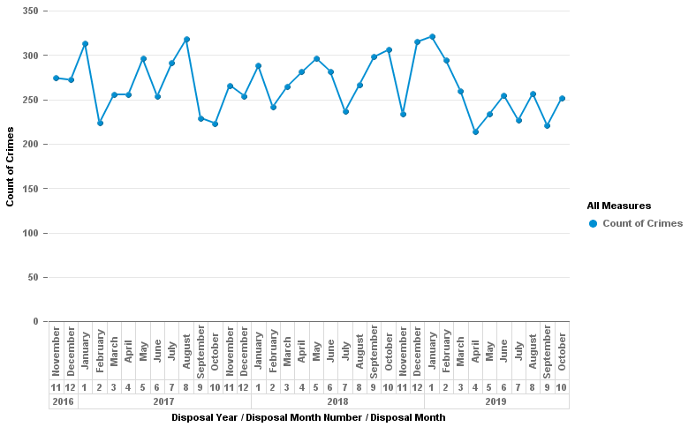

5.2 Gangs & Knife Crime:
- Operation Sceptre is the Essex Police serious violence and knife crime plan and links into the national operation with the same name. The overarching intention of the operation is the protection of and preservation of life by targeting the criminal supply, carriage & use of knives within Essex. The plan was launched on the 14th June 2019 and will run for 12 months. The Home Office have made £65million available for police surge activity to tackle knife crime and serious violence and we have been allocated £1.76m of this fund. The primary focus of the money is to reduce serious violence in public spaces with a focus on reducing knife crimes committed on young people.
- There have been 162 Operation Sceptre deployments since June, an average of 40 each month. These have resulting in over 800 arrests and 2121 stop and searches. Activity to challenge those who commit serious violence has become business as usual for Community Policing Teams (CPT`s) and the Operational Support Group (OSG), supported by an enhanced tactical coordination document which directs activity. The Home Office funding is also supporting equipment and technology and has been used to purchase forensic field test kits, knife arches and a training rig for officers to practise entering buildings.
- Operation Sceptre is funding an unlock solution in partnership with Kent Police, which provides enhanced ability to access locked electronic devices. Most significantly, there is £280k funding to support the uplift in Standard Taser Officers by 200.
- Essex CPT`s supported the national Operation Sceptre knife crime week of action in September. This included 73 weapons sweeps and surrender activity which saw 243 knives recovered. There were 27 arrests and 283 stop and searches. Essex Police undertook 89 engagement events and 22 test purchase operations. In October, the Serious Crime Directorate (SCD) with the OSG tackled a number of Gangs and County Lines causing harm across Essex. This intensification week led to 22 arrests, the safeguarding of three people and the recovery of drugs, cash and weapons.
- The Violence and Vulnerability Unit are key partners in this work. A co-ordinated county wide approach is addressing gang related crime including violent crime and drug related crime; and child criminal exploitation. The work of the Violence and Vulnerability partnership includes close collaboration with a range of partnerships working across Essex.

Knife Crime
(Burglary, Robbery and Violence against the person offences where a knife was used)
12m to end of Oct
LY | TY | Diff. | % Diff.
934 | 1188 | 254 | +27.2%

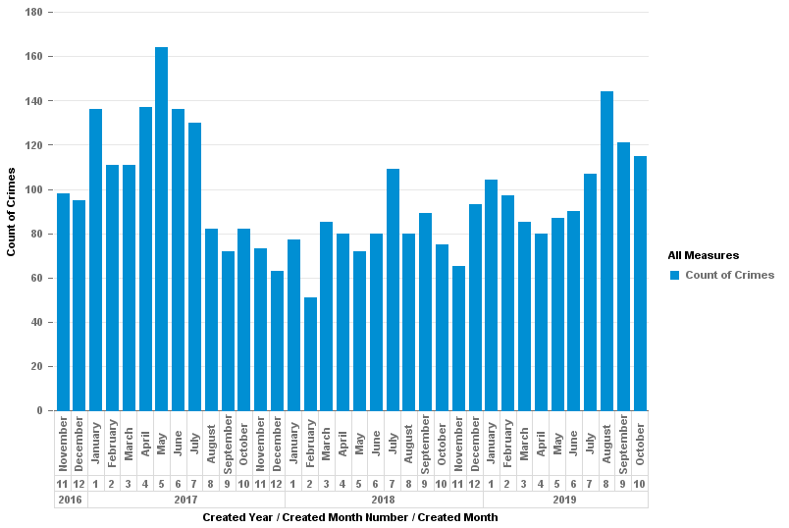

5.3 Night Time Economy:
- Operation Benison has been reinvigorated which will involve local districts producing bespoke NTE deployment plans, outlining key premises and identified flashpoints and patrol areas. The following are notable successes within Essex.
- Brentwood, Op Radio on Brentwood high street. A 3 month covert operation with undercover officers buying cocaine as it was believed that cocaine use was a significant cause of violent crime. It was low cost operation but had a big impact within the district as 24 persons after a 3 month deployment. Additionally a closure order was completed on one premises who were complicit in the use of the drugs on their premises. Licensing reviews were carried out within other Brentwood establishments. The High Street now has ID scanners at venues, new cameras and extra door staff.
- Colchester, The Town Centre team have run two separate nights where they have deployed multi agency operations in which they worked with Zone Wardens, Outreach workers, Military Police, Special Constables and ensured a visible engaging presence in the Town Centre, combining this with the use of ASB dispersal powers where appropriate. This led to a huge reduction in calls for service on those nights.
- Chelmsford, the Pubwatch scheme have taken on an information sharing system called DISC which is now used in 9 areas across the county. This assisted by sharing current news and information in order to keep trouble makers out of the licensed premises. Pubwatch are the gatekeepers for that banning process but in working with CPT’s to use CBW/CBN/CBO’s this has managed to largely keep known organised crime gang nominal’s away from the City centre.
5.4 Sexual Crime, Child Abuse & Exploitation:
- The Drink Aware project was implemented on 1st December 2019. The project works with Night Time Economy venues to deliver vulnerability awareness training to staff and places Drink Aware Crews into identified venues.
- Project Goldcrest is now live, an initiative designed collaboratively by Essex Police and partner agencies. This project enables young people, who have already been identified as being at risk of CSE, to take their own forensic samples at home, with someone with parental responsibility (or an appropriate adult) as a witness. Their information, along with their bagged exhibits, are provided to the Police and can be stored for up to 25 years. The young person remains anonymous to the Police, unless they later decide they want to formally report, however, the forensic samples enable Police to record valuable information, intelligence and evidence.
- The Catalyst Project, a collaboration with the University of Essex. Data extracted from Athena around CSE has been provided and the University are in the process of mapping where patterns and trends occur relating to teenage rape offences. The anonymised data is input into a secure online platform which provides useful mapping, charts, graphs and key findings from that data. Data from the platform will be analysed and made available to commands with plans to share at local children’s boards.
- A new CSE Team will launch in Jan 2020.

5.5 Extremism & Radicalisation:

LPSU have run a joint event with Eastern Regional Serious Organised Unit (ERSOU) - Action Counters Terrorism Training, this is a powerful new tool with the focus on the critical role the public can play to defeat terrorism. All SIAG/IAG and local community and Faith members were invited. It was a well-attended event with many from the Education sector attending, attendees have asked for another such event to be organised in 2020. As a result this is being planned. Within the Event the following subjects were covered:
- Introduction to Terrorism
- Current Threat
- How to Identify and Respond to Suspicious Behaviour
- How to Identify and Deal with a Suspicious Item
- What to do in the Event of a Bomb Threat
- How to Respond to a Firearms or Weapons attack
- Summary and Supporting Materials
S/IAGs had an input within the last quarter from the new Prevent and Protect Manager - Dave Gibbs. The S/IAGs discussed radicalisation and it became apparent that education seems to be an area where many young people are referred to PREVENT.

5.6 Hate Crime;
- CPD Events have now been delivered across the force to better equip CPT officers in tackling hate crime
- New hate crime procedure has been embedded with a risk management process for hate crime victims and the creation of a single referral form (HC5 for police and partners)
- Quality of investigations are improving for hate crime with strong evidence that Case Action Plans are being set and good levels of supervision.
- Partnership wide hate crime campaign in the process of being designed and launched to ensure a consistent approach to signposting and supporting victims of hate crime.
- Increases in reported hate crime linked to the EU Exit are being closely monitored to identify any patterns, trends or key threats.
- Volume of hate crime solved outcomes via prosecution or other intervention for 3m July 18: was 79 in comparison to 3m July: 19 which show an increase to 99.
- CPD Training being arranged for CPT officers from Guide Dogs for the Blind to help them better understand and tackle hate crime against blind victims
- Essex Police Internal hate crime investigative review due to be undertaken within the next two months

Hate Crime Solved
12m to end of Oct
LY | TY | Diff. | % Diff.
343 | 385 | 41 | +12.0%
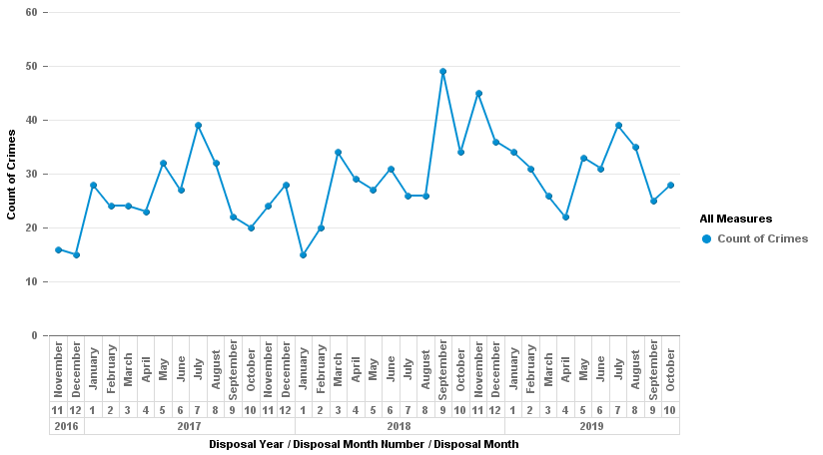

5.7 Fraud:
- Essex Police have recruited 3 x PREVENT Fraud Co-ordinators. Their role primarily focus on identification and visits to vulnerable persons at risk of being victims of fraud. They provide crime prevention advice and support to minimise the likelihood of them being victimised. This includes visiting those who have been identified through the ‘Banking Protocol’, to support banking organisations in ensuring their customers are not being made victims of fraud. All 3 Fraud Co-ordinators have now been recruited (1 per LPA area).
- Recruitment for the Business Crime Team starts December 2019. The team will be made up of 1 x Police Sergeant, 2 x Police Constable and analyst.
- Essex Police are working with UK Finance to extend the ‘Banking Protocol’. The protocol currently only covers incidents where vulnerable persons are taken into banks to withdraw money. A plan is being formulated to extend to on-line/telephone customers, seeking to withdraw unusual amounts. The plan being for police to interact with those customers, seeking to prevent them being victimised – This is ready for go live once the Fraud Co-ordinators have completed training.

5.8 Cyber:
- In line with the national model, the Essex Police Cyber Crime Unit (CCU) resources have been increased, with PSE investigators – CCU are near strength. The final Cyber Investigator (PSE) is going through the recruitment process currently, and it is hoped these will be in place by Feb 2020. Also, a business case has been made to SCD Command for an increase in Detective Inspector establishment, who will have direct responsibility for the CCU.
- DCI Truss has been invited to create a working group with the Essex Chambers of Commerce and other key partners in January 2020 in order to increase awareness of Cyber Crime.
5.9 House burglary and street robbery:
- Local Policing Support Unit are currently in the process of launching Op Meteor.
- Operation Meteor is the Essex Police 2018 – 2019 dwelling burglary reduction campaign. The operation aims to deliver an analytical and predictive tool as an enabler to drive down offending, reducing crime, and provide public engagement and improvements in our public confidence; whilst delivering a reduction in demand against residential dwelling.
- The property marking aspect of Operation Meteor was completed on 1st November 2019 – approx. 2 months earlier than expected. There were 5 separate property marking products that will be incorporated within the evaluation. In total there were 15 areas, (10 test and 5 control.) Each product was deployed in two separate ‘test’ areas, with a control area being used as a comparable measure.
- An academic evaluation of Operation Meteor will take place that focuses on evaluating the effectiveness of property marking tools. The evaluation will also examine the implementation of the project.
- The independent evaluation of the products impact on burglary will be carried out by Police Institute of Eastern Region.

Burglary (Dwelling) Offences
12m to end of Oct
LY | TY | Diff. | % Diff.
6371 | 5792 | -579 | -9.1%

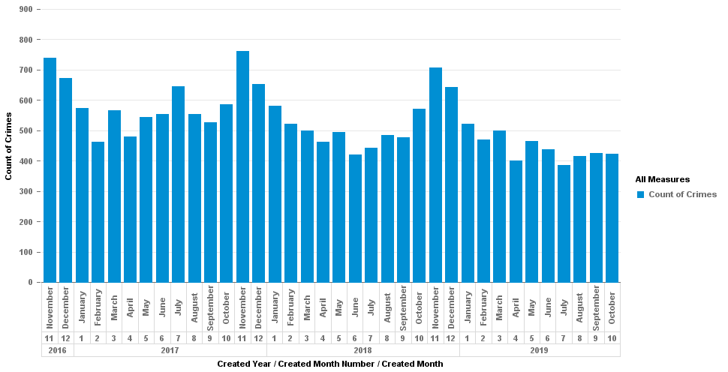

Burglary (Dwelling) Solved
12m to end of Oct
LY | TY | Diff. | % Diff.
399 | 432 | 33 | +8.3%
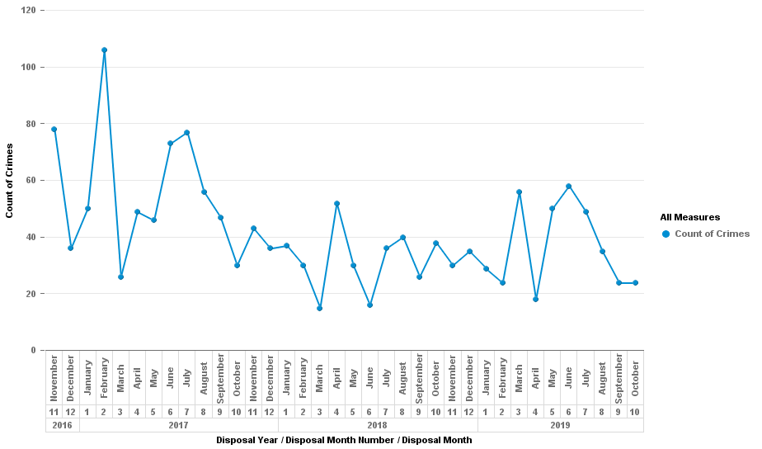

Robbery (Personal) Offences
12m to end of Oct
LY | TY | Diff. | % Diff.
1400 | 1643 | 243 | +17.4%

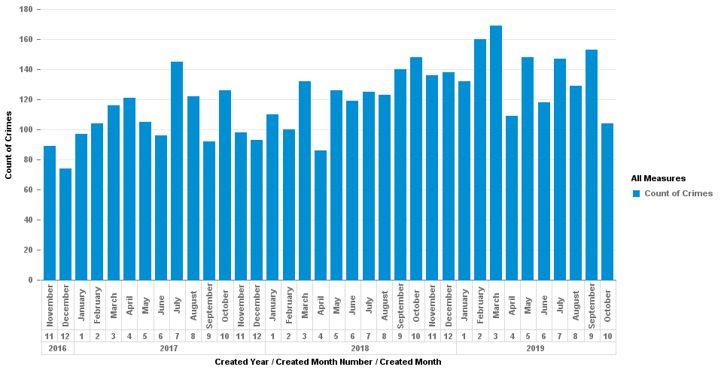

Robbery (Personal) Solved
12m to end of Oct
LY | TY | Diff. | % Diff.
180 | 156 | -24 | -13.3%
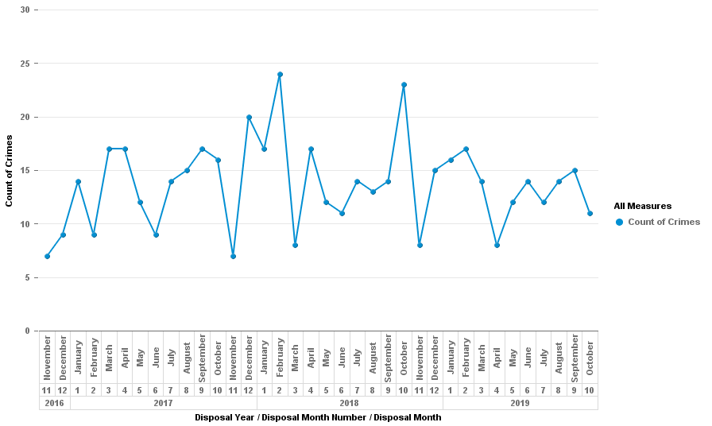

6.0 Implications (Issues)
None identified

6.1 Links to Police and Crime Plan Priorities
The creation and delivery of this strategy contributes to all areas of the PFCC Police and Crime Plan and should be considered an underlying theme throughout.
6.2 Demand
N/A
6.3 Risks/Mitigation
None identified
6.4 Equality and/or Human Rights Implications
None identified.
6.5 Health and Safety Implications
None identified.

7.0 Consultation/Engagement
- NPCC Crime Prevention Delivery Working Group
- NPCC Modernising Neighbourhood Policing Working Group
- NPCC Problem Solving Working Group
- Essex Chief Superintendents
- Key Community Safety Partners (via the Essex Community Safety Network and Safer Essex)
- LPSU & OPFCC stakeholders

8.0 Actions for Improvement
There are no outstanding HMICFRS improvement plans or Areas for Improvement (AFIs) relating to the Crime Prevention Strategy.

The depth and rigour of the performance data sets against the crime prevention priority strands,

9.0 Future Work/Development and Expected Outcome
The 9 Strategic Leads have reviewed their delivery plans to ensure they remain fit for purpose and reflect any relevant changes to legislation, national guidance and established good practice.
Work is still ongoing to standardise the reporting format for CSPs via the OPFCC requirement for CSPs to report progress against the stated CSP objectives to secure continued funding.

10.0 Decisions Required by the Police, Fire and Crime Commissioner

None

Appendix 1 – Crime Prevention Strategy

Appendix 2 – Updated Delivery Plans

1 | Domestic Abuse
2 | Gangs & Knife Crime
3 | Night Time Economy
4 | Sexual Crime, Child Abuse & Exploitation
5 | Digital Crime & Fraud
6 | Extremism & Radicalisation
7 | House Burglary and street robbery
8 | Hate Crime
9 | Serious and Organised Crime

The Home Office Modern Crime Prevention Strategy, the NPCC Crime Prevention Strategy and the Serious Violence Strategy

