**Performance and Resources Scrutiny Programme 2019/20**

**Report to: the Office of the Police, Fire and Crime Commissioner for Essex**

|  |  |
| --- | --- |
| **Title of Report:** | **Use of Force/Stop and Search – 2019/20 Quarter 2** |
| **Agenda Number** | **5.0** |
| **Chief Officer** | **T/ACC Paul Wells** |
| **Date Paper was Written** | **18/10/2019** |
| **Version Number** | **1.2** |
| **Report from:** | **Essex Police** |
| **Date of Meeting:** | **28/11/2019** |
| **Author on behalf of Chief Officer:** | **Dan Youngman 42078817** |
| **Date of Approval:** | **08/11/2019** |

1. **Purpose of Report**

To provide a quarterly update on Essex Police’s use of force and use of stop and search powers. This is a substantive agenda item for the PFCC Performance and Resources meeting.

1. **Recommendations**

There are no recommendations. This report is for the board to note.

1. **Executive Summary**

**Use of Force**

* There were 3,610 Use of Force forms submitted in this quarter. This is an increase of 282 (8.4%) additional forms completed, compared to the same quarter for the 2018/19, and a 2.3% decrease from the previous quarter.
* 61% (2,194) of tactics involved the handcuffing of the subject.
* There were 59% more Compliant Handcuffs than Non-Compliant.
* The number of forms with Firearms listed as a first tactic has fallen since last quarter, the number of incidents has also fallen.
* 51 uses of Taser that have been recorded in this quarter, these refer to 39 separate incidents.
* 79.5% of subjects on Use of Force records were male.
* For the first time, the number of blank genders was zero.
* 51.9% of subjects are in the 18-34 age range, with the average age being 31 years old.
* The proportion of BAME subjects continues to be higher than the proportion of BAME within the population of Essex as a whole. 8.8% of subjects were Black (or Black British) compared to 2% of the population (*BAME population data taken from 2011 Census*).
* 53.6% (5,817) of reasons for the use of force are to prevent harm to people or property. The most common reason for Use of Force is to effect an arrest. Alcohol and drugs continue to be high impact factors, but have now been joined by Size/Gender/Build.

**Stop and Search**

* There has been an average increase of 28.5% per quarter in Stop Searches since the beginning of 2018/19. 2.6% (131) of searches in the last quarter did not have reasonable grounds for that search. This is a rise from last quarter (*this has been identified as an issue with probationary constables on an operation which has been rectified).*
* 97% of searches (4,233 of 4,350) were carried out under PACE or the Misuse of Drugs Act (MDA). This proportion is usually over 99%, but has been affected by Sec.60[1] stops in the last quarter.
* The peak age range for those stopped is 18-25, equating to 1,694 stops in the last quarter (40.6% of subjects). 27.7% of persons searched in the last quarter are recorded as being under 18 with 88.2% of subjects being male. Where stated, 88.8% of subjects are from Essex.
* The proportion of BAME subjects that Essex Police stop to search (18.1%), is higher than the demographic proportion of the BAME population in the county (6.8%). The proportion of Black (or Black British) subjects was 10.8% compared to 2% of the population. For searches attributed to Op Raptor (including officers attached to Op Raptor), the proportion of BAME searches increases considerably to 41.4% BAME *(BAME population data taken from 2011 Census).*
* The rate of positive outcomes fluctuates but does not change significantly with the rise in report volume. This rate currently stands at 33.5%. There were 664 stops under Operation Sceptre, of these 49.5% had positive outcomes.

**4.0 Introduction/Background**

This report combines the Use of Force and Stop Search reports into one in order to have the two reports discussed at the Essex Police Use of Force board in one document for ease of reference. The report structure uses the PFCC template to avoid duplication of work.

This report discusses the use of force forms and stop searches submitted for incidents occurring between 1st April 2019 and 30th June 2019.

The use of force data analysed in this report contains duplicates, as one form should be submitted per officer for each use of force. Therefore, if three officers use force against one subject in relation to the same incident, three forms should be submitted, and the subject would appear three times in the data (for that one incident).

The data analysed in this report required substantial cleaning. Extraneous spaces, for example, needed to be removed from many fields, and there is a disparity in the way that certain fields have been inputted by officers, particularly the date, time and custody number.

**5.0 Current Work and Performance**

**Use of Force**

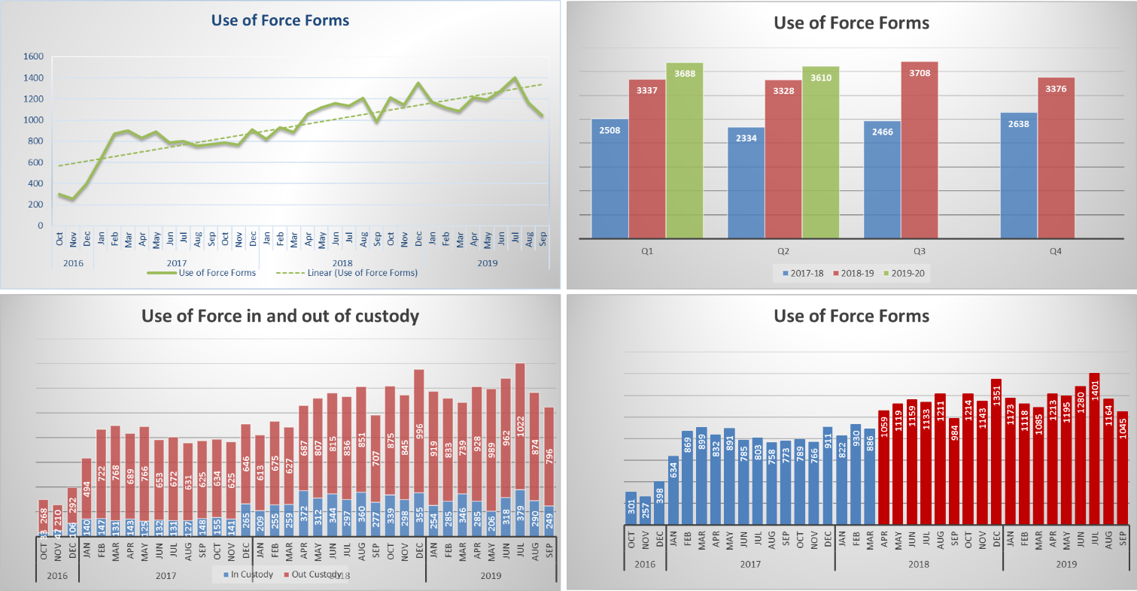

3,610 instances of Use of Force were recorded in Essex during quarter 2 of 2019/20. This is an increase of 282 (8.4%) additional forms completed, compared to the same quarter for the 2018/19, and a 2.3% decrease from the previous quarter. The volume of forms relating to force used in custody have levelled off and, despite some fluctuation, averages 26.5% of all Use of Force forms. The quarter 2 average was 25.3%.

Since the move to MobileFirst, the volume of forms submitted remains high – none of the past nine months, since MobileFirst was introduced, has recorded lower volumes than any month using the Limes Survey. September 2018 recorded the lowest volume of form submitted since the introduction of the MobileFirst app; September 2019 was also a low volume month, recording 10.6% fewer forms than average.

The below table details the tactics employed with each Use of Force in quarter 2 of 2019/20. It details the first eight tactics employed (not necessarily the most severe), and more than one will have been used in the majority of incidents. The MobileFirst app allows for the inputting of up to 20 Tactics for one incident.

Compliant Handcuffing was the most commonly used tactic both overall and in the first used tactic.

In 117 reports, Tactical Communications (Tac Comms) were the only method employed, suggesting further training on the app may be required, as a form is not required when Tac Comms are the only method. This is 23 reports more than the previous quarter.

71.7% of forms did not state that Tac Comms were used as a first tactic. It is unlikely that this is the case, it is inferred that officers simply did not enter Tac Comms as a tactic used.

2,194 forms (60.8%) involved the use of either compliant or non-compliant handcuffs.

27 forms showed Taser as a first tactic. All Taser use forms refer to a total of 39 separate incidents (four incidents more than the previous quarter).

30 forms involved a firearm as a first tactic; this is 17 lower than the previous quarter. This, however, related to only 12 individual incidents (eight fewer than the previous quarter).



Since Spit Guards were introduced in 2018/19, levels of use have steadily increased up to 77 forms including Spit Guard as a tactic in the last quarter.

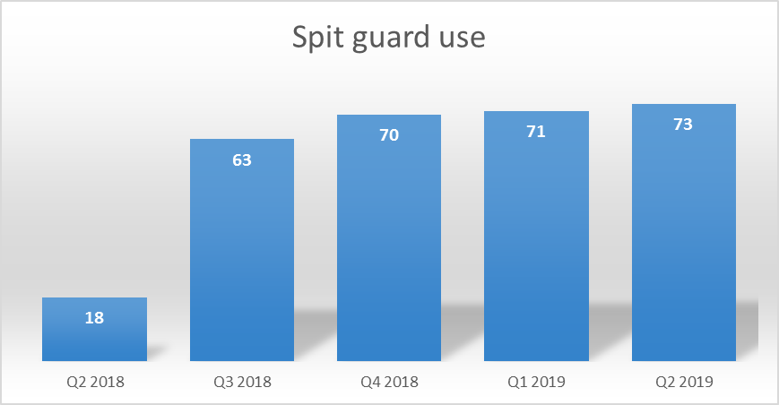

The demographic of subjects upon whom Spit Guards have been used is generally similar to the Use of Force profile as a whole, however the proportion of female subjects is higher than overall and the proportion of Black or British subjects is lower than overall.



Force was used most in Basildon, Colchester, Southend-on-Sea, Chelmsford and Thurrock Districts in quarter 2 of 2019/20 (data relates to the area in which force was used rather than the officer’s command); 65.9% of force was used in these five districts during this period, this proportion has remained steady since last quarter. Southend has seen a distinct drop in volume this quarter which has had an effect on the volume for South LPA.



81.5% of those subjected to use of force were identified by officers as male; 18.4% were identified as female; two subjects were identified as transgender.

The proportion of blank or Not Recorded was zero for the first time.



31 was the average age for subjects (where a date of birth was given/stated), and this is true for both male and female subjects. The mode (age most recorded) is 16 for female subjects[2] and 22 for males. Males with a perceived age between 18-34 years were the most common gender and age band in the review period.

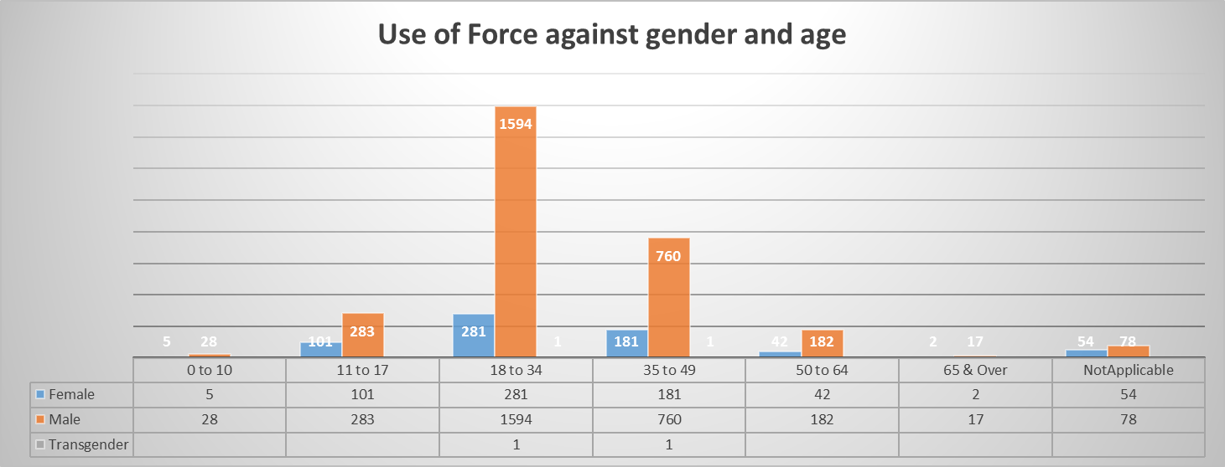

82.7% of subjects were White, this is 10.5 percentage points lower than the proportion of White residents of Essex. This disproportionality has grown by 2.3 percentage points since last quarter.

8.8% of subjects against whom force was used were Black. This is 6.8 percentage points higher than the 2.0% Black resident population proportion in Essex (2011 census data). This does not necessarily mean that the force used in these cases was inappropriate.



Effecting Arrest was the most commonly used reason entered for officers using force, followed by Preventing Harm, Preventing Escape and Protecting Oneself. Please note, that more than one reason can be entered when justifying a Use of Force.

Combining the reasons that encompass preventing harm as a whole, we can say that 53.7% of reasons are to prevent harm.





Each Use of Force form can have multiple impact factors, the table above shows the proportion of each impact factor in the total number of forms for the last quarter. Alcohol and drugs are the top three impact factors, however there has been a drop in Drugs as an Impact factor.

Mental Health is an impact factor in 16.6% of reports, whereas 9.5% of subjects are reported as having a Mental Disability.



In the last quarter, Staff have been injured in 4.3% of incidents and Subjects have been injured in 6.1% of incidents.

**Stop and Search**

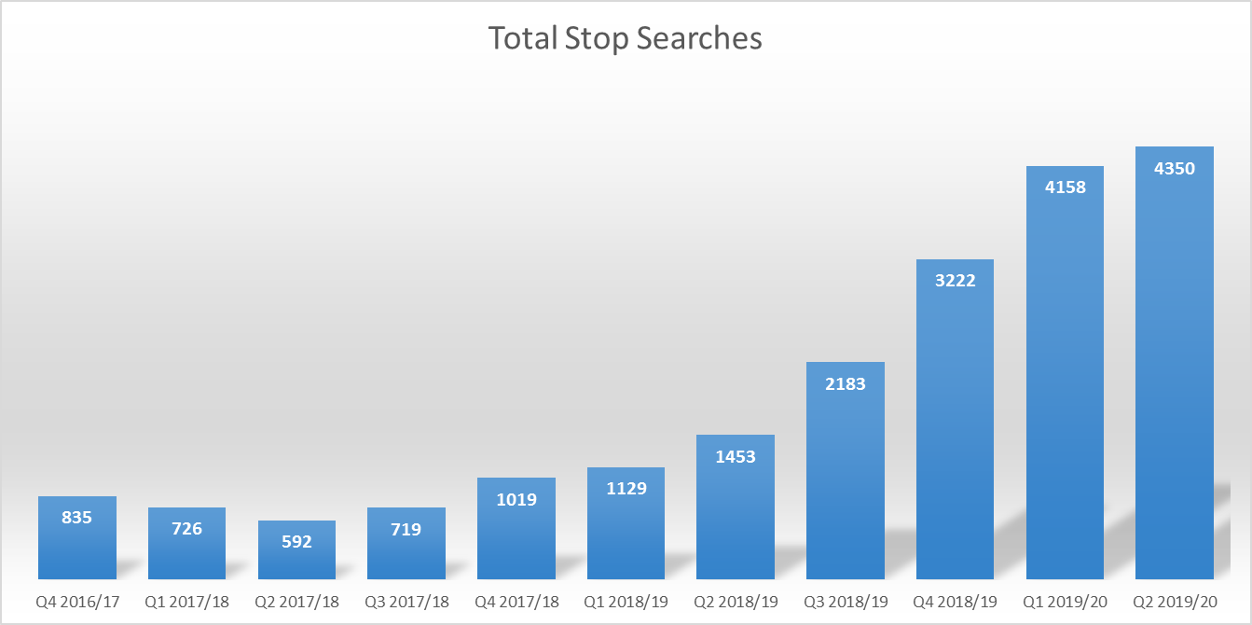

4,350 searches were recorded in the second quarter of 2019/20, this is 29% (192) higher than the previous quarter and 199% (2897) higher than the same quarter in 2018/19.



Just over 2.6% (131 records) did not have recorded reasonable grounds in the past quarter; this has risen since last quarter. The quarter average for the rolling year is 2.33% without reasonable grounds recorded. This is simply due to the records having poorly written search grounds. Whilst this is a subjective measure, it is based on the expertise of an experienced member of Police Staff.

When stops are filtered to show only those completed by Units with the word “Town” in their name, it is possible to see that the new Town Centre Teams have been involved in 13.4% (581) stops in this quarter.

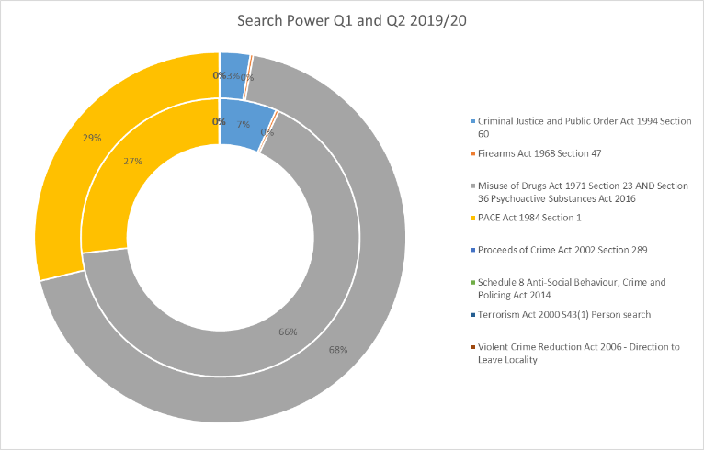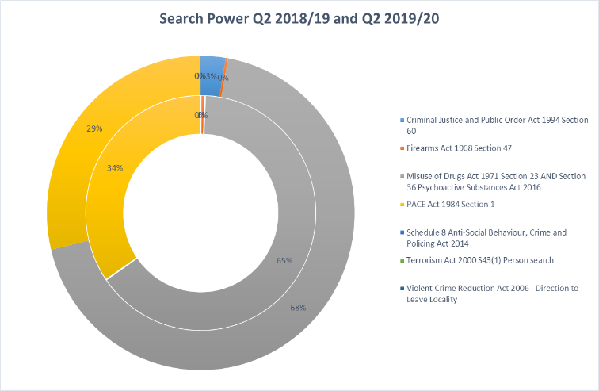

The majority of stops are under PACE and MDA, which comprise 97% of Stops in the last quarter. Most of the remaining three percent is comprised of Section 60 stops. The proportion of S.60 stops on the force is usually dependent on where the S.60 is put in place, Harlow conducted more S.60 stops in the previous quarter than Castle Point in this quarter.



With the volume changes over the past year, comparison of the number of Stop Searches recorded for each district often will not yield meaningful results, so the proportion is used instead. The drop in Harlow is explainable by the increased number of S.60 stops in quarter one, returning to a normal level in quarter two. The South LPA Districts received additional funding for the summer months, which explains the rise in proportion for each of these areas. Tendring has seen an as yet unexplained reduction in the most recent quarter.



In previous reports, it was reported that the proportion of female subjects being searched has been slowly rising over the last four years. This is due to larger numbers of female officers carrying out searches. Whilst the proportion of females searched since April 2017, remains fairly steady at around 10%, the latest quarter shows the highest proportion since the first quarter of 2018/19 (11.8%). A district breakdown of gender is also included above.



Over the last two financial years, the Average age of subjects remains steady. This is relevant to the Mean (average), Median (middle value) and Mode (value that occurs most often). The values of each of these differs as is detailed above.

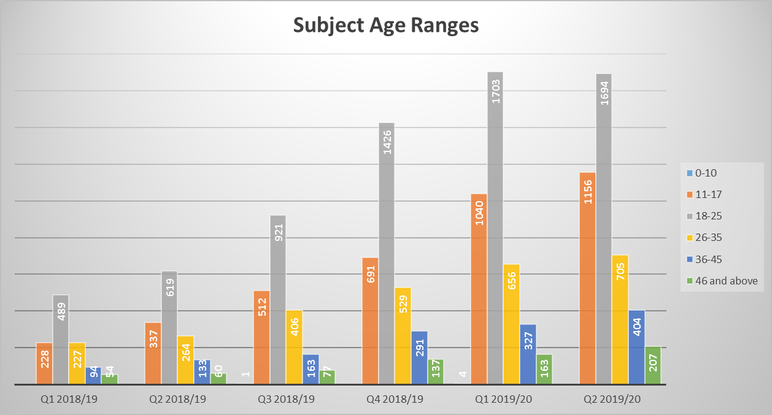

Across all quarters of the past two financial years, the age range 18-25 is the one with the largest volume.



The above table shows the proportion of stops carried out by ethnicity compared to the proportion of the population based on the 2011 Census[3]. Whilst figures fluctuate over time, over the past financial year, the proportion of BAME subjects stopped is 19% which is disproportionate to the population of BAME people in Essex (6.8%).



In relation to search powers used, the proportion of BAME stops is subtly different to the overall proportion. Generally, for drugs stops, the proportion of BAME subjects is higher than the overall, whereas for PACE stops the proportion is lower, however this position has reversed in the last quarter.

Stops by officers assigned to Op Raptor teams have a different ethnic makeup to their stops; the stops over the past financial year averages out to 41.1% BAME subjects. This is likely to be due to these stops being more targeted.

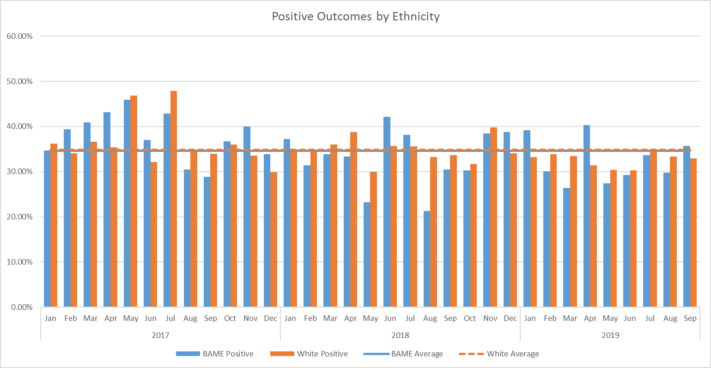

For the purposes of this report, Positive Outcomes **do not include** NFA, Intelligence Report Only and Other; all other outcomes are included. Over time, the proportion of positive outcomes remains steady at an average of 33.4% (32.5% for BAME subjects).

Outcomes for Operation Raptor officers do not differ significantly to the overall proportions. This is unexpected as it would be anticipated that as these stops are largely targeted the proportion of positive outcome would be higher.

The operation field for Stop Searches is free text and therefore the data needs extensive cleaning; however there were at least 664 Operation Sceptre stops in the last financial quarter (15.2% of all stops), the volume has increased by 19.6% (109). Of these stops, 329 (49.5%) had positive outcomes, this is a 16.7 percentage point increase since the previous quarter.



During the most recent quarter, there were 2,038 records in which the subject gave a home postcode, the above tables show the proportion of those subjects from within Essex or from an area covered by another force. The tables show all subjects and just BAME subjects.

32.2% of all subjects from outside Essex are BAME.

**6.0 Implications (Issues)**

Effective analysis is reliant both on the accuracy of the forms submitted, and the volume.

The data analysed in this report contains duplicates, as one form should be submitted per officer for each use of force. Therefore, if three officers use force against one subject in relation to the same incident, three forms should be submitted, and the subject would appear three times in the data (for that one incident).

**6.1 Links to Police and Crime Plan Priorities**

The use of force is a cross-cutting issue that impacts on many areas in the Police and Crime Plan.

**6.2 Demand**

Any increase/decrease in the use of force and Stop & Search by police is dependent on the number of subjects against whom this is necessary and proportionate.

**6.3 Risks/Mitigation**

Use of force is monitored by the Use of Force Oversight Board chaired by T/ACC Paul WELLS; these meetings are held on a quarterly basis. This group is a force-wide focus group facilitated and organised by the Operational Policing Command (OPC), and is intended to provide formal scrutiny and consultative feedback on the use of force and all its associated issues. The Use of Force Oversight Board focuses on enabling the force to examine and improve on statistical data-gathering and its analysis, and transparency with the public in order to improve confidence and trust in Essex Police.

Representation within the Use of Force Oversight Board comprises a number of disciplines, as detailed in the below structure:



**6.4 Equality and/or Human Rights Implications**

The above analysis indicated a potential disparity in the ethnic origins of those against whom force was used, when compared to the resident population in the county. 7.97% of those against whom force was used (where stated) had a self-defined ethnicity of black; 11% of those stopped were Black, compared to a 2.0% black population in the county. This does not necessarily mean that the force used, or the stop search, in these cases was inappropriate, however.

**6.5 Health and Safety Implications**

Use of force has a health and safety implication for the subject, the police, and the public.

**7.0 Consultation/Engagement**

Professional Standards at Essex Police provided data relating to the volume of complaints submitted by members of the public since April 2016 for a previous report; we have not received any further data.

**8.0 Actions for Improvement**

The new Mobile First app has assisted with the accessibility, ease and timeliness of completing Use of Force forms. The forms within the app contain more constrained and pre-completed fields, which has improved the accuracy of that which is submitted, and will enable more effective analysis to be conducted. However, cleaning and displaying this data is an ongoing process. The volume and accuracy of these forms will continue to be monitored by the Use of Force Oversight Board.

**9.0 Future Work/Development**

This report is a substantive agenda item.

Work is continuing on bringing Stop and Search to the Mobile First platform which may have an impact on the volume of records submitted.

**10.0 Decisions Required by the Police, Fire and Crime Commissioner**

This report is purely for the information of the Police, Fire and Crime Commissioner.

1. Section 60 Criminal Justice and Public Order Act 1994 (s.60) gives police the right to search people in a defined area during a specific time period when they believe, with good reason, that: serious violence will take place and it is necessary to use this power to prevent such violence; or that a person is carrying a dangerous object or offensive weapon; or that an incident involving serious violence has taken place and a dangerous instrument or offensive weapon used in the incident is being carried in the locality.
2. This figure is skewed by 36 forms relating to one subject.
3. It is acknowledged that the 2011 census is an increasingly inaccurate measure and cannot reflect the changing demographics of Essex.