**Performance and Resources Scrutiny Programme 2019/20**

**Report to: the Office of the Police, Fire and Crime Commissioner for Essex**

|  |  |
| --- | --- |
| **Title of Report:** | **2019/20 Month 8 Financial Monitoring Report** |
| **Agenda Number:** | **3.ii** |
| **Chief Officer** | **DCC Mills** |
| **Date Paper was Written** | **12th December 2019** |
| **Version Number** | **Version 1** |
| **Report from:** | **Essex Police: Corporate Finance** |
| **Date of Meeting:** | **20th December 2019** |
| **Author on behalf of Chief Officer:** | **Richard Jones, Head of Business Partnering and Management Accounting** |
| **Date of Approval:** |  |

1. **Purpose of Report**
   1. This report identifies the 2019/20 month 8 position for the Force.
2. **Recommendations**
   1. The report is for noting.
3. **Executive Summary**
   1. The latest forecast revenue overspend is **£0.519m**, which includes forecast expenditure of £2.180m for Op Melrose (£1.7m underspend excluding Op Melrose).
   2. The police officer strength forecast at end of November is **3,133 FTE** and at year end is **3,325 FTE**.
   3. The Capital Reserve is forecast to be **£2.801m** surplus at year end.
   4. The forecast capital expenditure is **£13.323m** and the forecast capital income from property disposals is **£8.800m**.
4. **Introduction/Background** 
   1. This reports sets out the November, month 8, financial position.
5. **Current Work and Performance**
   1. The month 8 financial position is shown at Annex 1.
6. **Implications (Issues)**
   1. The implications are reported in Annex 1.
7. **Links to Police and Crime Plan Priorities**
   1. The Force budget is used to help meet the priorities of the Police and Crime plan.
8. **Demand**
   1. The Force budget is reviewed and re-allocated within virement rules to match demand e.g. overtime funded by vacancies.
9. **Risks/Mitigation**
   1. Risk Register URN 452 - Short and Long Term Capital Finance.
10. **Equality and/or Human Rights Implications**

N/A

1. **Health and Safety Implications**

N/A

1. **Consultation/Engagement**
   1. The pay forecasts are based on information received from HR Organisational Management.
2. **Actions for Improvement**

N/A

1. **Future Work/Development and Expected Outcome**
   1. Reviews will continue with budget holders, working towards a balanced budget by year end.
2. **Decisions Required by the Police, Fire and Crime Commissioner**
   1. To approve the virements in Annex 1 (para 4.2).

# Executive Summary – 2019/20 – Month 8

# Revenue

## Revenue Summary – 2019/20 – Month 8

## Main Forecast Movements since Month 7



# Workforce Analysis

## Pay Summary



## Police Officer FTEs

### 



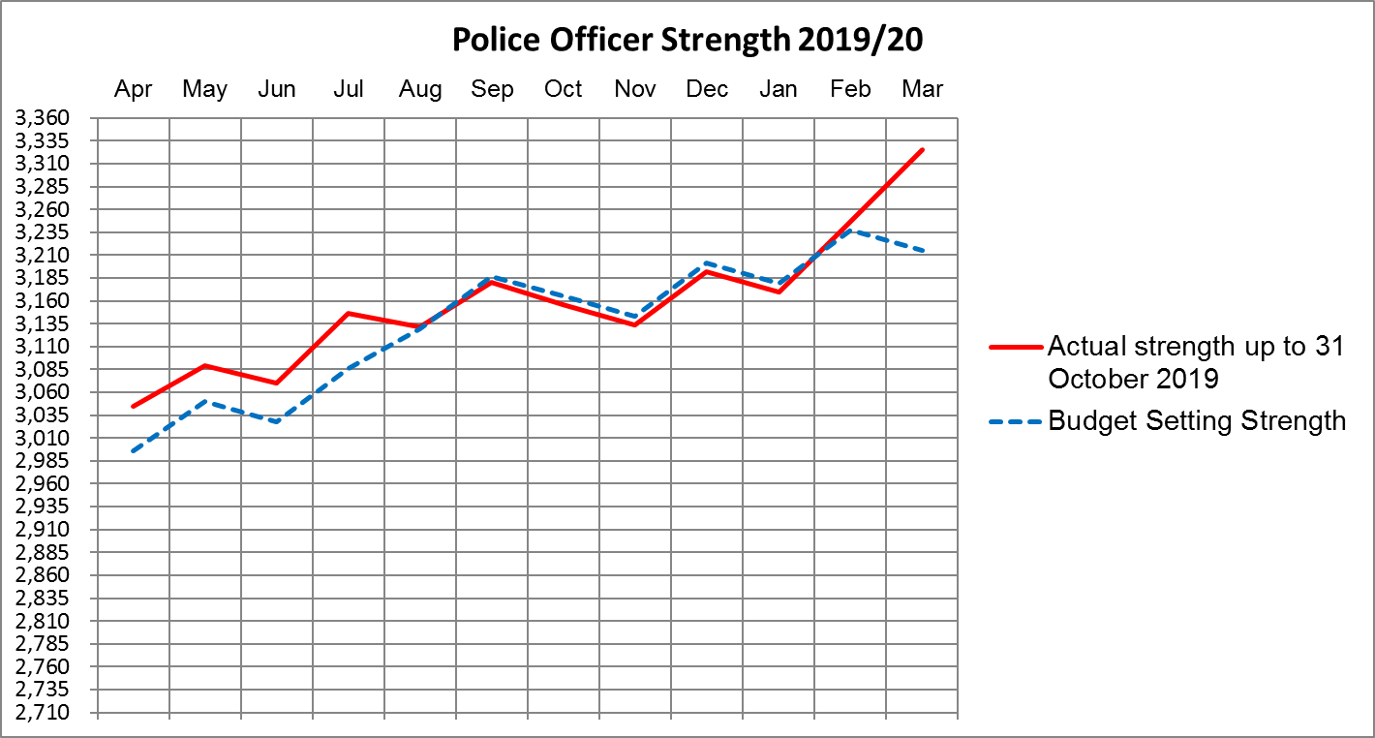

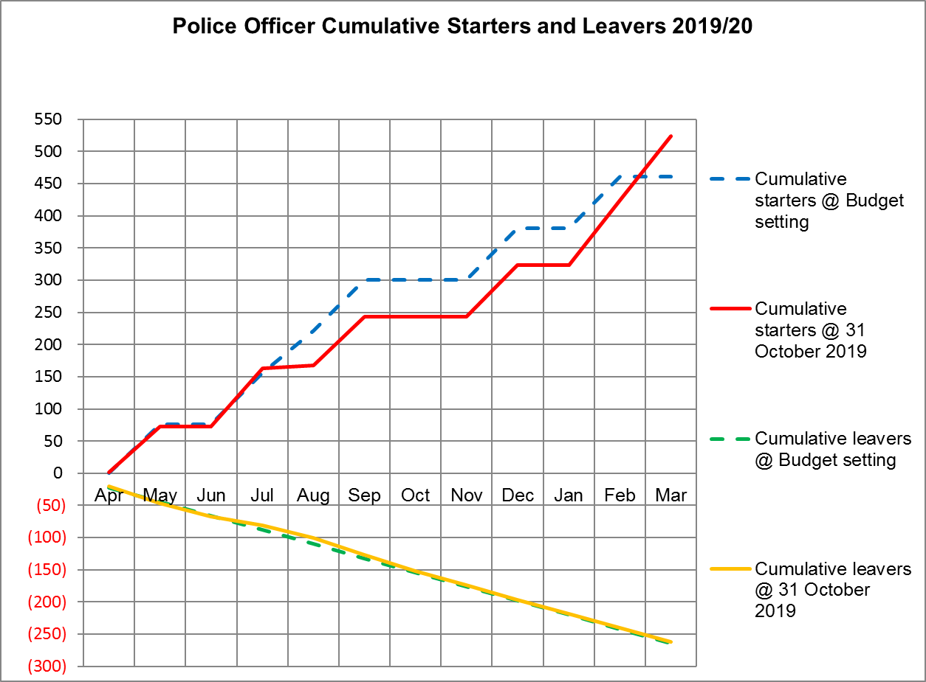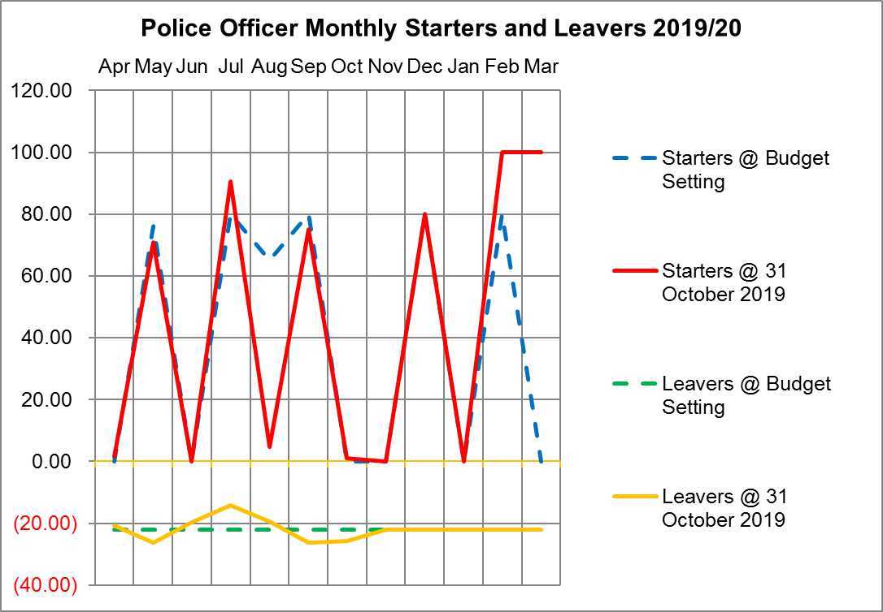

## Police Officers, Police Staff, PCSOs and Specials



# Virement Analysis – Month 8

## Virement Analysis – Summary



## Virement Analysis – Detail







# Reserves & Provisions

## Detail Reserve & Provision Analysis



## Transformation Reserve



## Op Sceptre Financial Summary

## Detail Reserve Analysis – Future Years





# Capital

## Movement in Capital Reserve Forecast



## Projection of Capital Reserves – Cashflow Profile

