**Performance and Resources Scrutiny Programme 2019/20**

**Report to: the Office of the Police, Fire and Crime Commissioner for Essex**

|  |  |
| --- | --- |
| **Title of Report:** | **2019/20 Month 7 Financial Monitoring Report** |
| **Agenda Number:** | **10ii)** |
| **Chief Officer** | **DCC Mills** |
| **Date Paper was Written** | **21st November 2019** |
| **Version Number** | **Version 1** |
| **Report from:** | **Essex Police: Corporate Finance** |
| **Date of Meeting:** | **28th November 2019** |
| **Author on behalf of Chief Officer:** | **Richard Jones, Head of Business Partnering and Management Accounting** |
| **Date of Approval:** |  |

1. **Purpose of Report**
   1. This report identifies the 2019/20 month 7 position for the Force.
2. **Recommendations**
   1. The report is for noting.
3. **Executive Summary**
   1. The latest forecast revenue underspend is **£0.708m**, an increase of £0.669m from

quarter 2.

* 1. The police officer strength forecast at end of October is **3,157 FTE** and at year end is **3,327 FTE**.
  2. The Capital Reserve is forecast to be **£2.706m** surplus at year end.
  3. The forecast capital expenditure is **£12.755m** and the forecast capital income from property disposals is **£8.137m**.

1. **Introduction/Background** 
   1. This reports sets out the October, month 7, financial position.
2. **Current Work and Performance**
   1. The month 7 financial position is shown at Annex 1.
3. **Implications (Issues)**
   1. The implications are reported in Annex 1.
4. **Links to Police and Crime Plan Priorities**
   1. The Force budget is used to help meet the priorities of the Police and Crime plan.
5. **Demand**
   1. The Force budget is reviewed and re-allocated within virement rules to match demand e.g. overtime funded by vacancies.
6. **Risks/Mitigation**
   1. Risk Register URN 452 - Short and Long Term Capital Finance.
7. **Equality and/or Human Rights Implications**

N/A

1. **Health and Safety Implications**

N/A

1. **Consultation/Engagement**
   1. The pay forecasts are based on information received from HR Organisational Management.
2. **Actions for Improvement**

N/A

1. **Future Work/Development and Expected Outcome**
   1. Reviews will continue with budget holders, working towards a balanced budget by year end.
2. **Decisions Required by the Police, Fire and Crime Commissioner**
   1. There are no virements required for approval.

# Executive Summary – 2019/20 – Month 7

# Revenue

## Revenue Summary – 2019/20 – Month 7

## Main Forecast Movements since Quarter 2



# Workforce Analysis

## Pay Summary



## Police Officer FTEs

### 



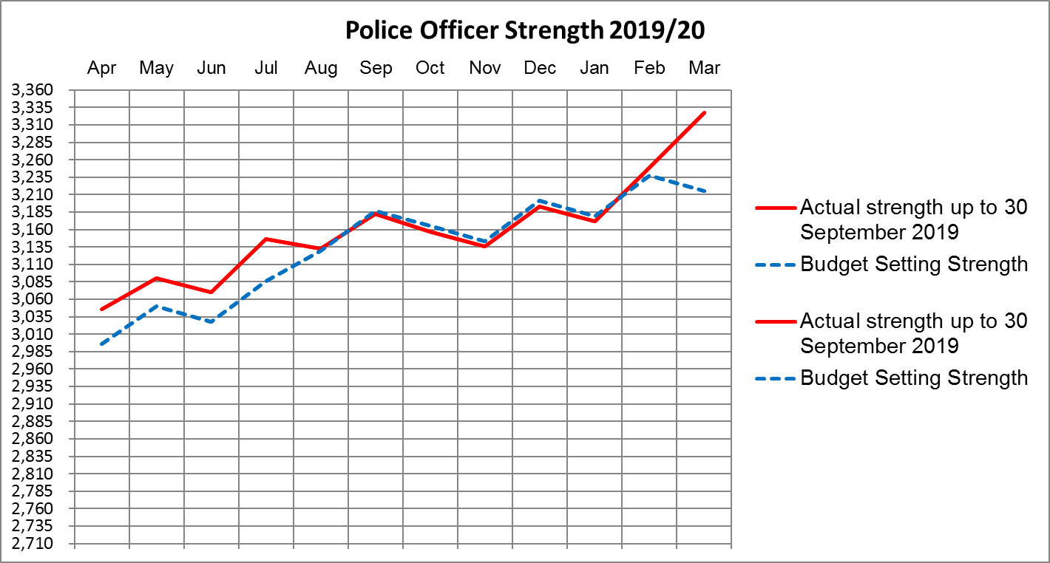

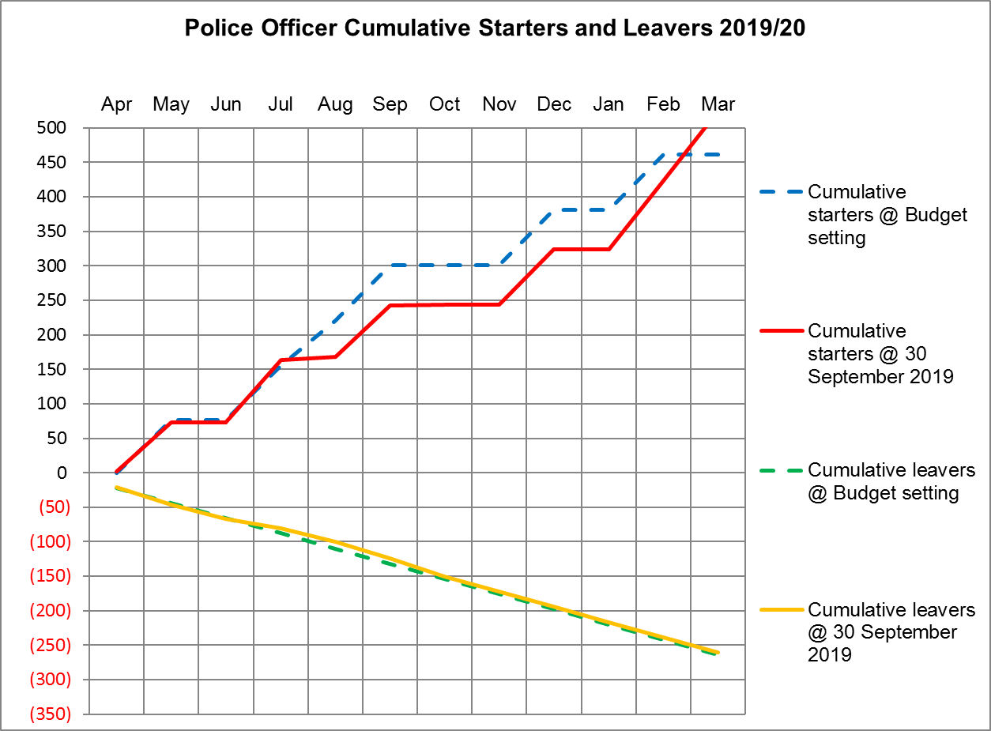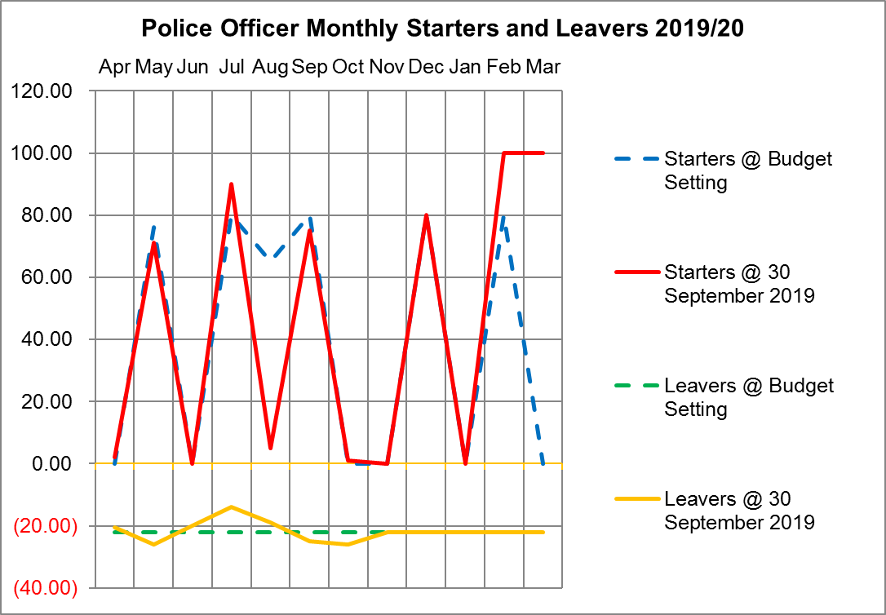

## Police Officers, Police Staff, PCSOs and Specials



# Virement Analysis – Month 7

## Virement Analysis – Summary



## Virement Analysis – Detail

# Reserves & Provisions

## Detail Reserve & Provision Analysis



## Transformation Reserve



## Op Sceptre Financial Summary



# Capital

## Movement in Capital Reserve Forecast



## Projection of Capital Reserves – Cashflow Profile

