**Performance and Resources Scrutiny Programme 2019**

**Report to: the Office of the Police, Fire and Crime Commissioner for Essex**

|  |  |
| --- | --- |
| **Title of Report:** | **Update on the Force Growth Programme 2018/19 and 2019/20** |
| **Agenda Number:** | **8.0** |
| **Chief Officer** | **Deputy Chief Constable Pippa Mills** |
| **Date Paper was Written** | **24th June 2019** |
| **Version Number** | **V 2.0** |
| **Report from:** | **Essex Police** |
| **Date of Meeting:** | **25th July 2019** |
| **Author on behalf of Chief Officer:** | **T/Supt Ed Wells** |
| **Date of Approval:** |  |

1. **Purpose of Report**

This report provides an update on the growth in police officer establishment following the precept increase for the financial year 2018/19. It outlines delivery against plans as set out in a paper to the PFCC on 22nd March 2018.

This report also details the 2019/20 Force Growth Programme and highlights the work underway to recruit police officers and police staff in line with the agreed investment.

1. **Recommendations**

That the progress is noted by the Office of the Police, Fire and Crime Commissioner.

1. **Executive Summary**

The 2018/19 precept increase was intended for specific investment into identified teams as outlined by the Chief Constable in March 2018. Progress on this investment was reported on 23rd May 2019 to the Performance and Resources Scrutiny Panel and to the Police, Fire and Crime Panel on the same day; and then to the Strategic Board on the 13th June 2019. In this report further progress is reported which demonstrates the Force’s commitment to achieving the planned investments.

The overwhelming majority of 2018/19 growth posts are now filled with further increases in the number of officers since the last position statement as of 26 April 2019. Essex Police’s officer strength is 3069.67 fte (as at 1st July 2019). This is the highest officer number since March 2015 and a significant achievement, demonstrating that the Force has not only met its 2018/19 growth plans but has also made significant progress towards the 2019/20 growth plans within just a couple of months.

The Chief Officer Group on 3rd July decided that the 2018/19 Growth Programme would be closed given the strong position the Force is now in. The small number of vacancies that remain will be routinely managed through the Resource Deployment Meeting. The current position provides a strong foundation for the continuing implementation of the 2019/20 Force Growth Programme.

The 2019/20 Force Growth Programme outlined specific plans to utilise the additional investment, which included recruiting 215 more frontline officers, 32 operational police staff and 18 support staff roles. This paper will outline progress against these recruitment plans including an update from the recent Force Growth Programme Board (24th May 2019) which recommended adjustments which have since been agreed by the Chief Officer Group.

1. **Information/Background**

**4.1 2018/19 Precept Increase**

The 2018/19 investment was allocated to frontline policing roles, as detailed below at Figure 1. The phasing of recruitment into the specialist roles has been timed to ensure that the increase of new recruits into core frontline teams is achieved before more experienced officers are moved into the identified specialist posts. Since the last update to the PFCC (as at 26th April 2019) the following progress has been made in filling these specialist posts:

**Figure 1: 2018/19 uplift: Establishment vs. Strength tracking**



As can be seen, all of the teams identified for investment have continued to grow since the last update, with the exception of the Cyber Crime Investigation team where the total strength has reduced by 1 fte (from five to four). This is due to a joint Essex and Kent role within that team becoming vacant which is now subject to the normal recruitment processes.

Local Policing Teams

Since the last report the Local Policing Teams (LPT) have benefitted from another intake of student officers becoming operationally deployable, which is reflected in the 18 fte officer increase shown in Figure 1. This has allowed, in line with Force priorities, a number of appropriately experienced officers to be released from LPT into other specialist roles including those identified within the 2018/19 growth programme.

Domestic Abuse Investigation Team

An additional 7.32 fte officers are now working in local Domestic Abuse Investigation Teams (DAIT); the remaining 10.41 fte vacancies continue to be managed in line with Force priorities through the Resource Deployment Meeting.

Community Policing Team

Since the last report (26th April 2019) a further 3.32 fte officers are now working in Community Policing Teams (CPT). This means 95.70% of CPT posts are now filled (Figure 2).

**Figure 2: 2018/19 uplift: CPT posts Establishment vs. Strength as at 20th June 2019**

|  |  |  |  |
| --- | --- | --- | --- |
| **Command / Department** | **Est** | **Str** | **% Resourced** |
| **Local Policing Area North** | **55.00** | **51.45** | **93.55** |
| Braintree and Uttlfrd LP Partnership Hub | 12.00 | 12.14 | 101.16 |
| Chelmsford and Maldon LP Partnership Hub | 16.00 | 13.87 | 86.71 |
| Clacton LP Partnership Hub | 12.00 | 11.96 | 99.66 |
| Colchester LP Partnership Hub | 15.00 | 13.48 | 89.87 |
| **Local Policing Area South** | **42.00** | **39.85** | **94.89** |
| Basildon LP Partnership Hub | 16.00 | 14.90 | 93.14 |
| Castle Pnt and Rchfrd LP Partnership Hub | 10.00 | 12.00 | 120.00 |
| Southend LP Partnership Hub | 16.00 | 12.95 | 80.94 |
| **Local Policing Area West** | **43.00** | **42.68** | **99.25** |
| Epp Brntwd and Lghtn LP Partnership Hub | 15.00 | 15.22 | 101.49 |
| Grays LP and Partnership Hub | 18.00 | 17.45 | 96.96 |
| Harlow LP and Partnership Hub | 10.00 | 10.00 | 100.00 |
| **Grand Total** | **140.00** | **133.98** | **95.70** |

Each Local Policing Area continues to carefully manage their vacancies across different teams in order to balance a number of competing priorities within the particular local context. The position for each District’s CPT can be influenced by a number of different factors which include, for example, officers performing acting or temporary duties within the CPT.

Figure 2 shows Southend CPT having 3.05 fte vacancies. However, two Police Now officers are currently working within this CPT as part of their development programme but will only be included in the strength figure when they are formally posted to the CPT on 22nd July.

Chelmsford CPT is now showing as having 2.13 fte vacancies (1 more vacancy than the last update on 26 April 2019). This follows an officer resigning from the Force in April. Recruitment to these vacancies has been paused to allow the Town Centre Teams to be formed. Once this is complete recruitment to the other CPT vacancies will continue through the Resource Deployment Meeting.

Colchester remain at 2.52 fte vacancies; one officer selected for CPT is awaiting a start date, one is currently covering a sergeant role and will revert to their PC post in July. The 0.52 FTE results from part time workers within the team.

Operational Support Group

In addition to the four officers who have joined the Operational Support Group (OSG) since April, three further officers are scheduled to join on 1st July and one further on the 22nd July. Since April 2018 this will then represent an uplift of more than 26 fte officers against a planned investment of 26. The remaining 3.32 fte vacancies will continue to be managed through the Force’s Resource Deployment Meeting.

2018/19 Growth Programme Summary

The overwhelming majority of 2018/19 growth posts are now filled with further increases in the number of officers since the last position statement as of 26 April 2019. The Chief Officer Group on 3rd July decided that the 2018/19 Growth Programme would be closed given the strong position the Force is now in. The small number of vacancies that remain will be routinely managed through the Resource Deployment Meeting. The current position provides a strong foundation for the continuing implementation of the 2019/20 Force Growth Programme.

**4.2 2019/20 Force Growth Programme**

The 2019/20 investment recommendations put forward by Essex Police were carefully calculated to ensure that the Force remains local, visible and accessible to communities, responding to the growth in high harm and emerging crimes as well as investing in long term infrastructure, technology and skills.

**Figure 3: 2019/20 uplift: Agreed allocation of new posts**

|  |  |  |  |
| --- | --- | --- | --- |
| **Investment for Additional Police Officers and Staff** | | | |
| **Investment Area** | | **Officers** | **Staff** |
| FTE | FTE |
| Town Centre Teams | | 68 | 0 |
| Information Management | | 0 | 11 |
| Gangs (Operation Raptor) | | 19 | 11 |
| Children/Young People | | 20 | 0 |
| Business Crime | | 3 | 1 |
| Roads Policing Unit | | 21 | 0 |
| Crime & Public Protection | | 20 | 3 |
| Local Policing Teams | | 50 | 0 |
| SCD – Modern Slavery | | 5 | 0 |
| SCD – Volume Fraud | | 1 | 0 |
| SCD – Op Signature (Fraud Prevention Coordinators) | | 0 | 3 |
| SCD – OCG Co-ordinators | | 0 | 3 |
| SCD - Violence & Vulnerability Unit | | 1 | 0 |
| Gypsy, Traveller and Rural Engagement Team (GTRET) | | 7 | 0 |
| **Total – Operational Policing** | **215** | **32** |
|  | |
| Support Functions (recruitment, standard training) | |  | 18 |

Essex Police has developed a detailed plan for the deployment of these additional officers and staff. As was the case for 2018/19 growth, the recruitment will be sequenced to ensure the effect of new officer recruitment has been realised within Local Policing Teams before experienced officers can be recruited to other specialist roles. The initial timeline for this sequencing was outlined in the paper to the PFCC in March 2019.

The Strategic Change team has worked with the various commands benefiting from the 2019/20 investment to develop detailed implementation plans. This has naturally identified some necessary adjustments to the planned investment. As outlined in the paper to the PFCC in March 2019 the governance process for this programme includes a Force Growth Programme Board chaired by the Deputy Chief Constable. This met for the first time on 24th May 2019 and considered the proposed adjustments. Those which were approved are outlined below.

**4.3 2019/20 Investment Adjustments**

Violence & Vulnerability Inspector

Two bids from separate Commands included the role of the Violence and Vulnerability Inspector for Gangs, as a result this post has been double counted towards the total of 215 officers. Therefore there is one police officer post within the 215 uplift which is no longer assigned to a specific role. The Force Growth Board will in due course recommend to the Chief Officer Group where this post should be utilised; considering any changes in demand and also some of the current non-established police officer roles in Force. The total Establishment uplift of 215 officers will be maintained.

Crime & Public Protection

The initial bid included two Legal Counsel, however more detailed consideration and planning has resulted in agreement at the Force Growth Board to adjust this specific growth to one post only. Therefore the overall operational staff growth is reduced by 1 fte post to 31 fte.

Information Management

The original bid for 11 fte police staff was adjusted at the Force Growth Board to include 2 fte additional posts; partly this is funded by removal of a superintendent post (a decision taken by COG in December 2018) which is repurposed as a constable post elsewhere (thereby maintaining the growth in police officers at 215). Therefore, the overall staff growth for Information Management is now 13.

**4.4 2019/20 Implementation Timeline**

Also considered at the Force Growth Programme Board was the overall resourcing picture for the Force (as managed through the Resource Deployment Meeting), along with the developing operational priorities for the Force. As a result of this up to date understanding some adjustments were made to the planned sequencing of police officer recruitment to specialist teams. Figure 4 shows the current timeline for posting police officers into growth posts throughout 2019/20.

The context to some of these decisions includes the need to progress some areas more quickly such as the Gangs bid to increase the Force’s operational capability to respond to gang related criminality. Therefore the implementation of the new Gangs team has been moved from February 2020 to December 2019; the Children and Young People Officer Posts are moved from a start date of December 2019 back to February 2020.

In addition, a more detailed understanding of the impact of some current ‘business as usual’ moves requires some future changes to be staggered. Following a recent move of officers into Crime and Public Protection to address existing vacancies, the new Crime and Public Protection Officer Posts have been moved from a start date of September 2019 back to January 2020. The LPT growth of 50 Officers scheduled for September will also now start in post on 1st October to coincide with the go-live of the Essex Flex shift pattern.

Outside of the Force Growth Board the resilience of the Gypsy, Traveller and Rural Engagement Team (GTRET) has been reviewed due to anticipated retirements in the medium-term. This has identified an opportunity to build confidence in our rural communities, and demonstrate the Force’s commitment to addressing concerns within that community through a modest adjustment in the timing of planned investment. Therefore Chief Officers have decided to implement four of the seven posts in September, and the remaining three in March.

**Figure 4: Revised Implementation plan for the 2019/20 Force Growth Programme**

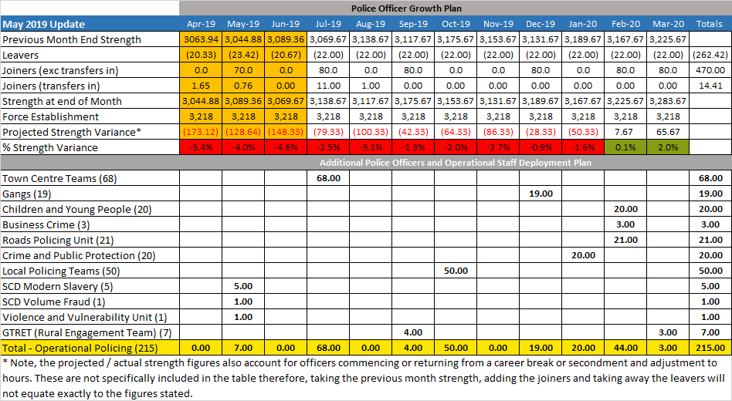

**5.0 Current Work and Performance**

The Force Growth Programme is now carefully tracking each officer and staff post, ensuring that each phase of the recruitment cycle is progressing in line with the planned implementation timeline. This is scrutinised at the Resource Deployment Meeting and then presented to the Force Growth Programme Board. The Force Growth Board next meets on 22nd July 2019.

Infrastructure Support Police Staff posts

These are being progressed early as key enablers to the overall growth programme, and at least five individuals are already in post across Vetting and Business Services. There are a number of other selection processes underway with some individuals already identified and simply awaiting release from elsewhere in the organisation.

Town Centre Teams

The first substantial investment of police officers (68) to be implemented will be the Town Centre Teams. **The recruitment to these teams is already underway and on track for implementation on 22 July.**

The Town Centre Teams will place additional police officers in town centres across Essex. This will enable greater targeting of crime and anti-social behaviour (ASB) in town centres and promote local confidence through visible policing interventions. There are clear links between town centre locations and community and partner priorities as well as street-based violence and vulnerability.

**Figure 5: Allocation of Town Centre Officers**

|  |  |  |  |
| --- | --- | --- | --- |
|  |  | **Constables** | **Sergeants** (One per Police District) |
| **South LPA** | Southend | 5 | 1 |
| Rochford | 2 | 1 |
| Rayleigh | 2 |
| Canvey | 2 |
| Basildon | 4 | 1 |
| Billericay | 2 |
| Wickford | 2 |
| **West LPA** | Grays | 3 | 1 |
| South Ockendon | 2 |
| Stanford le Hope | 2 |
| Brentwood | 2 | 1 |
| Loughton | 2 |
| Waltham Abbey | 2 |
| Harlow | 3 | 1 |
| **North LPA** | Chelmsford | 4 | 1 |
| Maldon | 2 |
| South Woodham Ferrers | 2 |
| Witham | 2 | 1 |
| Braintree | 2 |
| Saffron Walden | 2 |
| Colchester | 4 | 1 |
| Harwich | 2 | 1 |
| Clacton | 3 |
|  |  | **58** | **10** |

This investment into Town Centre Teams is a further increase in Community Policing Teams following the 2018/19 investment. Including the Children and Young Persons Officers expected to be implemented in February 2020, CPTs will have had a net investment of 127 Constables over two years. To support these teams, 10 additional sergeants will form part of the Town Centre Team uplift and be allocated to each of the 10 CPTs in the Force (Figure 5). The Sergeants will also commence from 22 July 2019.

**6.0 Implications (Issues)**

As a result of agreed changes as at 4.3, one police officer post which forms part of the overall investment is not yet allocated to a specific role. The Force Growth Board will in due course recommend to the Chief Officer Group where this post should be utilised; considering any changes in demand and also some of the current non-established police officer roles in Force. The total Establishment uplift of 215 officers will be maintained.

**6.1 Links to Police and Crime Plan Priorities**

The deployment decisions directly support the Police and Crime Plan as set out below

**Figure 6: 2019/20 Force Growth Programme links to Police & Crime Plan Priorities**

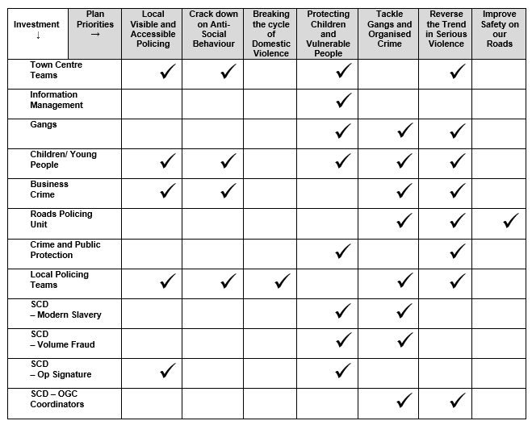

**6.2 Demand**

The investment areas identified align to our current analysis of demand; at LPT and Town Centre Team level, as well as more specifically teams tackling high harm issues such as Complex Child Abuse Investigation and Modern Slavery.

**6.3 Risks/Mitigation**

As risks are identified they will be reported into the Force Growth Board.

**6.4 Equality and/or Human Rights Implications**

Essex Police will continue positive action to maximise diversity within recruit intakes.

**6.5 Health and Safety Implications**

There are no Health and Safety Implications.

**7.0 Consultation/Engagement**

Internal consultation with staff associations continues through JNCC, the Force Growth Board and regularly between the project team and each relevant body as appropriate.

Public engagement on specific elements of the Force Growth Programme, for example the Town Centre Team launch, is led by the Media Department and co-ordinated through the Force Growth Board.

**8.0 Actions for Improvement**

There are no actions for improvement.

**9.0 Future Work/Development and Expected Outcome**

Work will continue to manage recruitment campaigns to recruit officers and staff to posts that are receiving investment.

Update reports on recruitment will continue to be provided to the OPFCC and will indicate progress in recruitment and deployment of additional police officers and police staff.