Performance and Resources Scrutiny Meeting Programme 2019

Police and Crime Plan Priority Deep Dive Reporting

Report to: the Office of the Police, Fire and Crime Commissioner for Essex

Deep Dive Title: | Police and Crime Plan Priority Deep Dive: Crack down on Anti-Social Behaviour
Classification of Paper:
Agenda Number: | 3.0
Chief Officer: | ACC 1883 Prophet
Date Paper was Written: | 18/6/19
Version Number: | 3
Report from: | Essex Police
Date of Meeting: | 25th July 2019
Author on behalf of Chief Officer: | Chief Inspector 1838 Gennery
Date of Approval: | 12th July 2019

- Purpose of Report
This paper is a deep-dive assessment of anti-social behaviour (ASB) and sets out long term trends, resource investment, partnership working, best practice and future challenges.
The paper includes analysis from the new ASB dashboard (Appendix 1) which includes ASB data from 2016 onwards.

- Recommendations
In addition to noting the content of this report the Board is asked to consider the need for Community Safety Partnerships to formally report activity, outputs and outcomes in relation to their activity aimed at reducing ASB as part of the annual process to secure funding from the OPFCC.

- Executive Summary

Headlines:

- Recorded ASB is falling in Essex and nationally. There are clear links between the reduced level recorded ASB and the drive to improve the quality and consistency of crime recording.
- ASB powers are increasingly used across the county. There is potential to make even greater and more consistent use of these powers.
- Between 40% and 50% of ASB incidents in Essex are attended by the police. Only About 8% of all ASB incidents are assessed as being high risk.
- Recent / imminent investments in Community Policing Teams, Town Centre Teams, Community Safety Hubs, the Rural Engagement Team and partnership working more broadly will all support the response to ASB.
- ASB and the effectiveness with which it is responded to by local agencies is a significant driver of public confidence.

Definition and volume:

ASB is defined as ‘any behaviour where the victim is suffering harassment, alarm, distress, nuisance or annoyance’.

Last year Essex Police recorded approximately 55,000 incidents of ASB. The level has reduced consistently since 2016.

Resources:
The primary responsibility for managing ASB in Essex Police sits with Community Policing Teams (CPTs). They are supported by 3 ASB Officers based on each Local Policing Area. They are managed by the Youth Justice and ASB Manager based in LPSU.

Powers and partnership:
The primary tools for managing ASB are provided by the provisions of the Anti-Social Behaviour, Crime and Policing Act 2014, particularly Community Protection Warnings and Notices (CPWs/CPNs), Civil Injunctions, Dispersal Powers and Criminal Behaviour Orders (CBOs).
It is recognised in national research that responding to ASB effectively requires collaborative working between the police, councils and other relevant agencies to determine the most appropriate response. The introduction of Community Safety Hubs and closer working practices between Essex Police and community safety partners is a key component of this work.

Policy and procedure:
Essex Police has a detailed ASB procedure which sets out the minimum standards expected when recording, attending and investigating incidents of ASB and identifies types of ASB that will always be responded to, including incidents involving;
- Vulnerability
- Repeat locations
- Identifiable offenders
- Repeat victims
Where risk and / or vulnerability are identified, officers will be always dispatched to attend the incident and the procedure requires officers to engage with the victim and complete an initial ASB risk assessment to identify what risk level is present, either Standard, Medium or High Risk.

Qualitative assessment:

The 2016, 2017 and 2019 HMICFRS PEEL inspections assessed Essex as GOOD with regards to preventing crime and tackling ASB, noting that: “the prevention of crime and ASB has become a routine part of neighbourhood policing activity”.

- Deep Dive

  - Resources

Police

The primary responsibility for managing ASB in Essex Police sits with the 10 district Community Policing Teams (CPTs). CPTs have seen an increase in resources. There are currently 134 PCs (compared to 93 in April 2018) in CPT teams with an additional 58 PCs and 10 Sgts in the newly formed Town Centre Teams.

Expert advice and support to CPTs is provided by 3 ASB Officers based within each Local Policing Area, managed by the Youth Justice and ASB Manager based at LPSU.
The ASB Officers role is to proactively manage serious and persistent ASB. They do this by providing tactical support and guidance to CPTs (and other relevant departments) on ASB tools & powers, training and briefing officers on changes to legislation and analysing data trends. This includes assisting with the preparation of Criminal Behaviour Order (CBOs) and ASB Injunctions for the force, chairing multi- agency meetings, liaising with the CPS, taking statements and providing expert witness testimony in court.

The expansion of the Police Support Volunteer, Active Citizen Scheme and Volunteer Police Cadets across Greater Essex has seen an increase in visible activity at district level, particularly following incidents of community tension or that require a degree of reassurance. There are now approximately 120 such volunteers working with CPTs across the county, administered by the Citizens in Policing Team within LPSU.
Community Safety Partnerships (CSPs)
All 10 CPTs work closely within their Community Safety Partnerships (CSPs), particularly where co-located within Community Safety Hubs. All 14 CSPs across Southend, Essex and Thurrock identify ASB as a priority with some highlighting specific hot spots and others having this area of business as a general priority.
The structure of CSP administration and management differs between authorities with a range of role profiles, remits and role titles, however each district has some form of Community Safety Manager who report via their local executive, CSP and Safer Essex.
The Community Safety managers form the core membership of the Essex Community Safety Network (ECSN) which has the remit of identifying community safety priorities, crime & ASB trends, sharing best practice, implementing shared solutions, problem solving and peer support.
Community Safety Hubs (CSHs)
Effective multi-agency working enhances the service agencies can deliver, particularly regarding dealing with ASB. The Community Safety Hubs (CSH) project has brought key partners together across the county with the intention of:
- Improving community safety
- Reducing crime and disorder
- Improving victim satisfaction and support
Even where partners are not yet co-located, there is a strong partnership working ethos. For example, there is, currently, no Hub in Harlow, however, there are strong partnership arrangements in place and daily and fortnightly tasking takes place against CSP Priorities (including ASB).
Co-located Community Safety Hubs can be found in the following districts;
  - Tendring
  - Colchester
  - Chelmsford & Maldon
  - Braintree & Uttlesford
  - Southend
  - Castle Point & Rochford
  - Epping Forest & Brentwood
with plans being developed for Thurrock and Basildon.
The Community Safety Accreditation Scheme (CSAS)
The Community Safety Accreditation Scheme (CSAS) was created under section 40 of the Police Reform Act 2002 and enables chief constables to accredit employed people already working in roles that contribute to maintaining and improving community safety with limited but targeted powers.
These roles include local authority neighbourhood wardens, hospital security guards, park wardens, shopping centre security etc.

The scheme creates a framework for public and private bodies to work in partnership with the Police, providing additional uniformed presence in communities and capitalising on the skills and information captured by those already engaged with the community.
Essex Police has the largest scheme in England and Wales with 53 Accredited Organisations and 540 Accredited Persons (with 94 more awaiting Vetting clearance). Of the 53 Accredited Organisations, 40 have been granted ASB powers, totalling 350 Accredited Persons with ASB powers.

All local and unitary authorities, and a number of housing providers, in Essex are members of the CSAS with specific accredited powers to deal with ASB.

Restorative Justice (RJ)
RJ is a process which gives victims, involved in a crime or conflict, the opportunity to meet or communicate with those who have offended against them in a safe way. Victims are given the chance to explain to a criminal the impact a crime has had on them, ask questions of the offender and seek an apology.

RJ enables offenders to be held to account for what they have done but also take responsibility for the harm they have caused. Restorative justice is widely used to resolve ASB.The Essex Restorative and Mediation Service was piloted in April 2014 and rolled out county-wide in 2015.The RJ Hub based within the Office of the Police, Fire and Crime Commissioner maintains close links with all police departments and provides a single point of contact for officers to seek advice and guidance on referrals made or referrals proposed.

4.2 Impact on Performance

Police Resources
The role of the 3 ASB Officers has been integral to introducing the changes in legislation brought about by the Anti-Social Behaviour, Crime and Policing Act 2014.

ASB performance data (detailed in Section 5) focuses on overall outcomes and activity at a district and force-wide level. It is not possible to accurately break down where CPT or ASB Officers have been the primary resource utilised in resolving ASB cases.
It could be argued that an increase in ASB Officers would assist in supporting CPTs and tackling ASB, however, the uplift in CPT numbers provided by the precept increase provides an opportunity for CPTs to become ASB experts which may actually negate the requirement for a separate ASB Officer role.
A careful review of capacity and functionality would be required to make an informed decision.

Partners
Relevant agencies within each CSP work together on the ASB priority and target shared hot spots and numerous examples are available to demonstrate this. Community Safety managers also oversee the implementation of Community Triggers introduced by the Anti-Social Behaviour, Crime and Policing Act 2014, where 3 or more reports of ASB can “trigger” a review by the local CSP. Community triggers are reported via the local authority’s own reporting channels and therefore not always reflected in police data.

The development of standardised Information Sharing Agreements and Memoranda of Understanding as part of the implementation of Community Safety Hubs has enabled this data to be shared with relevant partners in order to plan a collaborative approach.
Currently, the most successful response to ASB appears to be the use of the Community Protection Warning/ Notice (CPW/N) process created by the Anti-Social Behaviour, Crime and Policing Act 2014. The CPW/CPN process is used in all Essex policing districts with some leading to a full Criminal Behaviour Order being achieved in the courts.

Social Housing providers also have a duty to investigate ASB affecting their tenants either as victims or perpetrators. Where housing providers take the lead and manage the harm, CPT Officers support and use additional policing skills where appropriate. There are some excellent examples of this happening across Essex including;

- the co-located activity within the Southend CSH where the CPT work with a member of staff from Southend Borough Homes (SBH) who can access STORM incidents and manage investigations that fit better with her agency
- the fortnightly meetings held between Chelmsford Police, Chelmer Housing Partnership (CHP) and Chelmsford City Council that promote a proactive response instead of waiting for an urgent response.

Effective information sharing is key to effective problem solving, as is a multi-agency approach to tackling ASB. Under section 17(1) of the Crime and Disorder Act 1998, local authorities have a duty to exercise their functions with due regard to the need to prevent crime and disorder in their area.

There is no statutory requirement for Accredited Organisations to keep records on how often their powers are utilised, but the Citizens in Policing Manager in LPSU is working with the CSAS organisations county-wide on a method of providing such data voluntarily.
In September 2016 the RJ Hub recruited a full-time coordinator, which facilitated a 51% increase in referrals and a 55% increase in positive outcomes. The RJ Hub saw a 43% increase in referrals in 2018/19 on the previous year, with 426 referrals received and a 96% participant satisfaction rate, nearly half these referrals related to ASB;

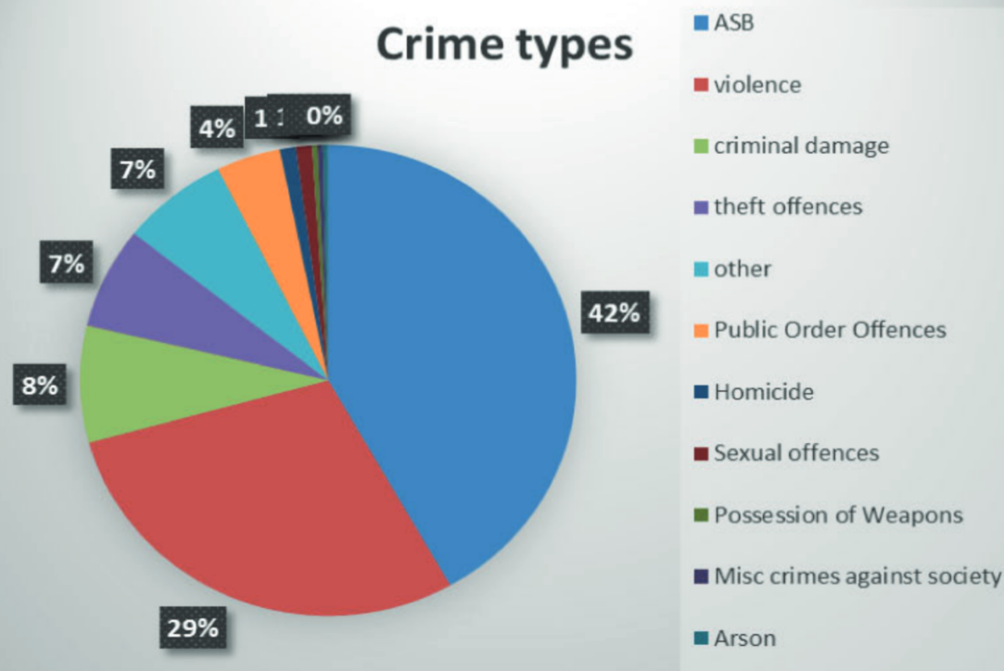
The Hub also saw an increase in referrals from sources such as Police (49%), Essex Youth Offending (46%) and councils (14%) as well as new referrals from Essex County Fire and Rescue Service and the Prison Service. In total, the RJ Hub dealt with 40 Conditional Cautions in 2018/19 which would otherwise have been dealt with by CPT/ LPTs.
    - Impact on Performance: Key initiatives, activities and What Works
Effective approaches to ASB, particularly those that focus on repeat or future offending will have a positive impact on demand by negating future behaviour.
The LPSU (ASB) staff and relevant partner agencies review good practice to identify what works practices that can be implemented at a local level. This is best illustrated by describing the three different types of approach that are used by Essex Police and its partners to target ASB, by addressing the behaviour of the perpetrator or focusing on the location where the harmful behaviour is occurring (this includes evaluation, where available):

- Early Interventions
- Coercive and Developmental Interventions
- Situational Interventions

Early Interventions:
This type of intervention is designed to prevent the onset of offending and is generally targeted at young people. Research indicates that future ASB can be prevented through interventions aimed at helping families overcome problems that may lead to the onset of these behaviours and early intervention to divert individuals from offending has been found to be one of the most effective types of intervention overall.
Examples of where early intervention is being utilised in Essex include;
- The Essex Police Youth Justice Team scheduled for launch in August 2019 which will divert minor criminal behaviour directly to an early help agency that can provide an intervention to address the behaviour that is causing the harm
- Essex Fire & Police Youth Engagement Officers presenting to a universal group of children in schools.
- Use of Acceptable Behaviour Contracts with adults and young people
- Referrals to the RJ Hub.
- CPT early engagement via engagement operations
- Working closely with partner agencies and supporting community safety programmes (including joint operations with Police and Community Safety Partners)
- Maximising the use of Verbal and Written Warnings
- Information sharing with housing and local authorities
- Encouraging young people into diversionary activities

Coercive and Developmental Interventions
Coercive Interventions;
This well recognised methodology aims to manage ASB by prohibiting and modifying certain behaviours and includes the use of positive enforcement tactics such as CPNs, CPWs and CBOs.

Examples of Essex Police using Coercive Interventions include;

- 110 Community Protection Warnings (April 2018 to March 2019)
- 61 Community Protection Notices (April 2018 to March 2019)
- 46 Criminal Behaviour Orders (April 2018 to March 2019)
- 24 uses of Dispersal Powers (April 2018 to March 2019)
- Licence conditions (with partners across all licensed premises)
- Gang injunctions (several high profile ones now established)
- Closure Orders (when serious violence occurs)
Developmental Interventions
These interventions utilise a partnership approach to address the harmful behaviour being committed. There is limited empirical evidence on their effectiveness but anecdotal evidence from a number of other force areas indicates that such educational interventions are more costly than many other approaches. Examples in Essex include;

- Referrals to the Restorative Justice (RJ) Hub (outlined above)
- Referrals to Youth Offending Service Multi-Systemic Therapy or referring to parenting support
- Acceptable Behaviour Contracts (ABCs)

Restorative Justice is a process whereby the parties with a stake in the particular offence come together to resolve collectively how to deal with the aftermath of the offence and its implications for the future.
Of all the interventions described in this report, only Restorative Justice involves not just the offender but the victim.
Research on the success of restorative justice indicates a high (70%) success rate. However, this relates to interventions that are carefully planned by experts and not a “Street RJ” which is often no more than a verbal warning and apology that is passed via a police officer.
Family based interventions have also seen success in preventing re-offending, including parenting programmes and Multi-Systemic Therapy (MST). There is some research abroad to find these programmes to reduce offending of young people as well as preventing offending by younger siblings.
Acceptable Behaviour Contracts (ABCs) are a voluntary agreement made between the individual and a local agency (police, housing, council, school) allowing an offender to acknowledge their ASB, recognise its negative impact on others and agree to either stop the behaviour outright or engage in positive activity such as a diversion scheme (sometimes referred to by housing providers as Good Neighbour Agreements). ABCs are used with adults and young people and relevant agencies can work in partnership to issue a contract. It is important that if issued, they are supervised over a period of time (6 months) and the supervising agency must encourage positive behaviour and engagement.

Situational Interventions

This methodology is designed to reduce the opportunities to offend and can be an effective means of reducing crime and ASB. Examples of situational interventions in Essex include;

- The Licensing Team working with the Night Time Economy to remove glasses or bottles from pubs, closing of problematic premises and ensuring taxis are readily available
- The designing Out Crime Team working with local authorities and developers to create safer environments via the national Secured By Design Accreditation Scheme
- Working in partnership with charities including drug & alcohol agencies and Street Pastors
- Issuing Fixed Penalty Notices in the early evening to reduce offences being committed later in the evening
- Dispersal Powers in town centres and ASB hot spots
- High visibility patrols by PCSOs alongside strong engagement tactics
- Working in partnership to achieve Public Spaces Protection Orders (PSPOs) and taking positive action where breaches of PSPOs occur
- The development of Neighbourhood and specialist Watch schemes county-wide

The Resolution Centre in the Contact Management Command became operational on 15th April 2019, initially focused on the South LPA. It aims to provide an improved service to the public at the point of first contact and also reduce demand on front line officers.

The Crime Bureau directs certain crime types to the Pathway Team that are assessed as less complex and without issues of vulnerability and suitable for Desk Based Investigation.

Although the Resolution Centre does not directly handle ASB the intention was to build a better culture of call handling and dispensation of advice to callers at the first point of contact. It is therefore logical that this change in record handling which is specific to the South LPA is likely to be the impetus for this recent drop.

- Performance

The key performance indicators for ASB are;

  - A reduction in the number of all anti-social behaviour incidents.
  - An increase in public confidence that policing responses to anti-social behaviour is improving (survey).

5.1 A reduction in the number of all ASB incidents
All police forces record incidents of ASB reported to them in accordance with the provisions of the National Standard for Incident Recording (NSIR).

ASB is split into 3 categories;

- Environmental
- Nuisance
- Personal
Overall levels of recorded ASB across the county have fallen appreciably since 2016. Essex receives a smaller proportion of Personal ASB calls compared to the national average (8.9% versus an average of 21.1%). In contrast, Environmental ASB is amongst the highest (18.9% versus an average of 6.5%, making it the second highest). This might be expected given the significant amount of the force area classified as rural and the focus on the rural crime agenda since late 2017. This is comparable with other large geographical counties with significant rural area (including Norfolk, Durham, Cambridgeshire and Suffolk)

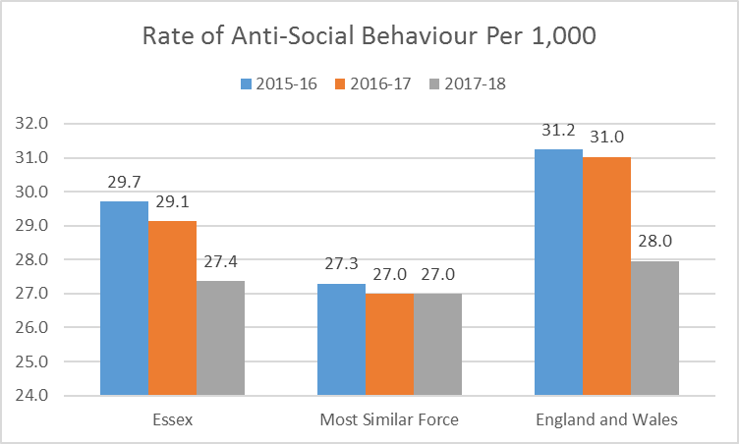

The decrease in recorded ASB is in part linked to improved crime data accuracy. Many incidents that would previously have been recorded as ASB are now more accurately recorded as crimes. The following graph highlights the overall decline across all categories of ASB:

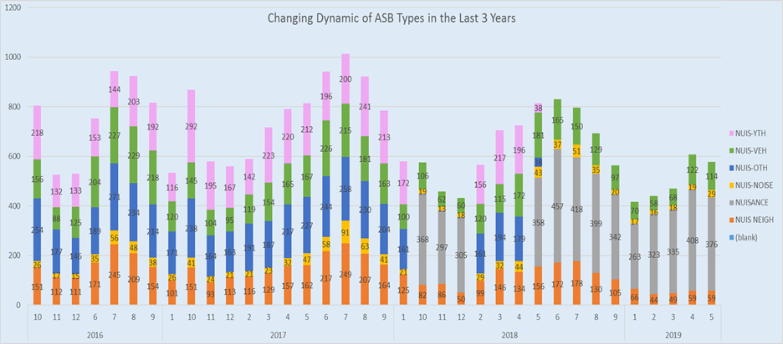
It is not possible to be precise about how much ASB is now recorded as crime but the decrease largely relates to the category of Personal ASB. A significant number of incidents that were previously recorded as personal ASB are now believed to be recorded as criminal harassment. From 2016/17 the level of recorded harassment have increased by 280% as summarises in the next table:

2016/17 | 7324
2017/18 | 10636
2018/19 | 21019

The Essex data reflects a wider national trend with Home Office data showing stalking and harassment since 2015.
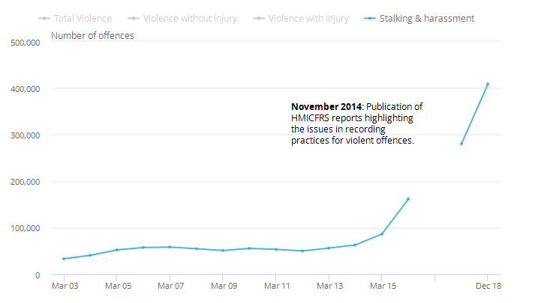

Environmental ASB is an area of investigation that is often led by local authorities and it may be that the increased use of Community Protection Warnings (CPWs) and Community Protection Notices (CPNs)are impacting on the reduction of reports received.
The use of enforcement measures has shown a steady increase in the more serious cases (obtaining a Criminal Behaviour Order) and a significant increase in “lower level” enforcement such as Community Protection Notices since 2016.

For example, in the rolling 12-months to March 2019, 47 Criminal Behaviour Orders (CBO) have been obtained, an increase from 31 in the previous corresponding period. Community Protection Warnings (CPN) have been used 308 times in the last financial year;

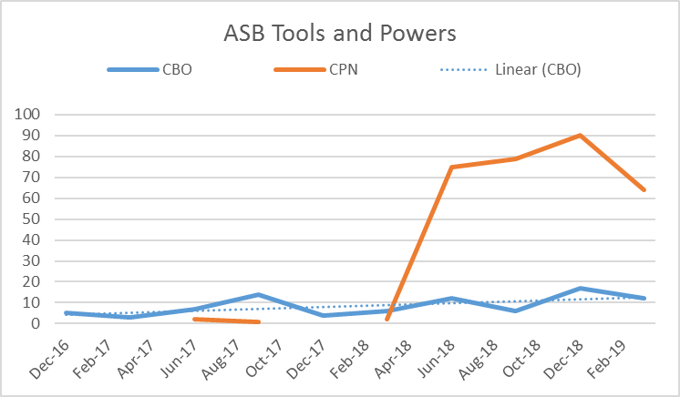
These figures are matched by marked decreases in reports of High Risk Victims and Repeat Victims across the force area.
Intelligence submissions relating to ASB have also increased significantly year on year between 2016 (1,555) and 2018 (2,800), and continue to increase in 2019. There were 2,929 in the rolling 12- months to the end of May 2019, an increase of 510 compared to the previous corresponding period.

Crack down on anti-social behaviour – summary of performance measures | 2016 | 2017 | 2018 | 2019 to date
CBO obtained | 5 | 24 | 28 | 29
CPN obtained | n/a | 3 | 156 | 154
High Risk victims | 54 | 66 | 29 | 7
Repeat victims | 113 | 128 | 62 | 24
ASB intel reports | 1,555 | 2,198 | 2,800 | 1,449

As indicated above, the increase in use of ASB legislative tools and powers corresponds with a declining volume of ASB victims on Athena, reducing from 538 to 287 from 2017 to 2018.

Proportionately the highest risk category has fallen consecutively between 2016 and 2018 (15%, 12% and 11%, with 2019 to date at just 8%). The number of repeat victims reduced from 128 in 2017 to 62 in 2018:

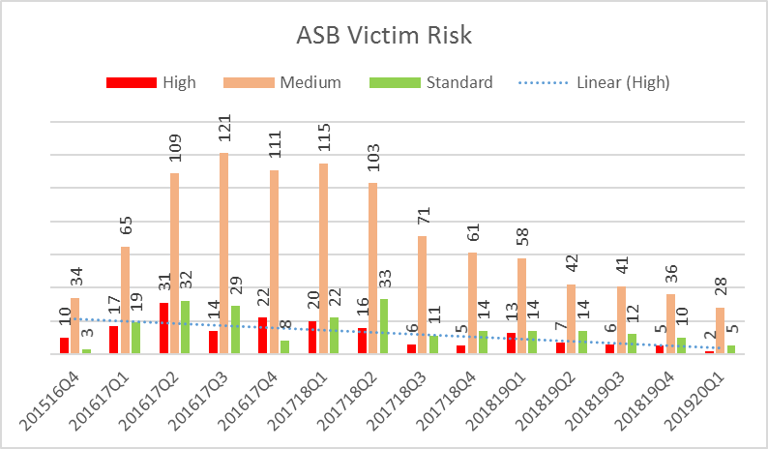

The continuing reduction in reports of ASB can obviously be seen as a positive, but more analytical work is required to understand further how much is linked to changes in crime recording methodology.

The ASB dashboard is a significant step forward and will enable a more accurate picture of the ASB situation in future. LPSU (ASB) is working with the Crime Data Team to understand how reports are being distinguished between Harassment ASB and Harassment Crime to ensure patterns of ASB are not being missed, with meaningful results anticipated in late Summer 2019.
This work will link to the review of Community Protection Notices and Warnings being undertaken by LPSU (ASB) which will result in an easy-read guidance document to the issue of Community Protection Warnings and Notices.

The ASB dashboard shows that ASB as a whole is in decline across the Force by roughly 30% year on year since 2016 with all 3 LPAs showing a similar rate of decrease:
- North: 28.99%
- South: 27.4%
- West: 33.06%

At a force-wide level there is a definite seasonal pattern to ASB with incidents peaking in volume during May-August. During November to February levels of ASB are typically 30-35% lower than in the previous summer period (2016-19). Although this patterning can be attributed to the weather, October has (2016-18) contained approximately 25% more Nuisance Youth category incidents each year.

During the peak period (July) attendance at ASB incidents has regularly fallen by as much as 15.8% force-wide compared to January/ February. This is linked to the increase in ASB demand in the summer period with more incidents requiring attendance by a relatively small pool of resources.

Allocation to ASB incidents is not always the answer and much of the lower tiered ASB can be handled well with professional advice, as demonstrated by the trial of using ASB Officers in the FCR in Autumn 2018.
There is some disparity between LPAs and attendance to ASB at district level. Over the last 3 years LPAs have given attendance to incidents in the following proportion:
LPA | Over 3 Years | 2018 | 2019
North | 43.2% | 44.2% | 43.8%
South | 45.8% | 47% | 44.9%
West | 48% | 47.4% | 50.1%

The introduction of the Resolution Centre which went live on April 15th 2019 could potentially be responsible for this drop in attendance in the South LPA. Although the Resolution Centre does not directly handle ASB, its introduction is designed to create a better culture of call handling and provision of advice at the first point of contact.

5.2 An increase in public confidence that policing responses to ASB is improving (survey)
Despite the increase in use of ASB powers and intelligence submissions, the public generally are no more likely to say they feel informed over the 12-month rolling periods (stable at 38%).

The quarterly data shows a consecutive marginal falls in how well informed respondents felt since March 2018 (40%) with the data for December 2018 being lowest (35%);
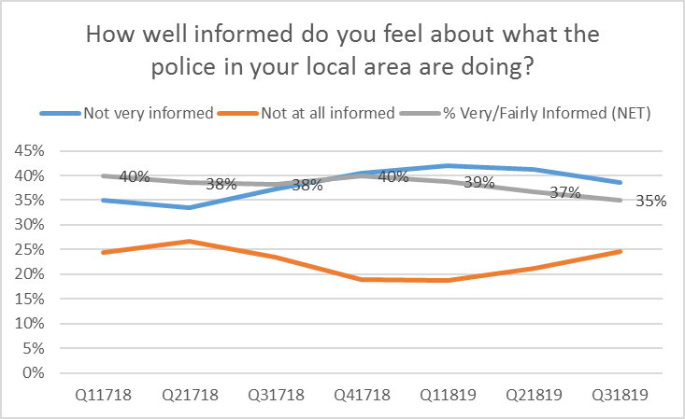
When asked, people in Essex are increasingly likely to agree that police understand issues that affect the community, however, are less likely to agree that police are dealing with crime and ASB that matter. In contrast to the increased activity and outputs outlined above, respondents were less likely to agree that police and partners are dealing with ASB:

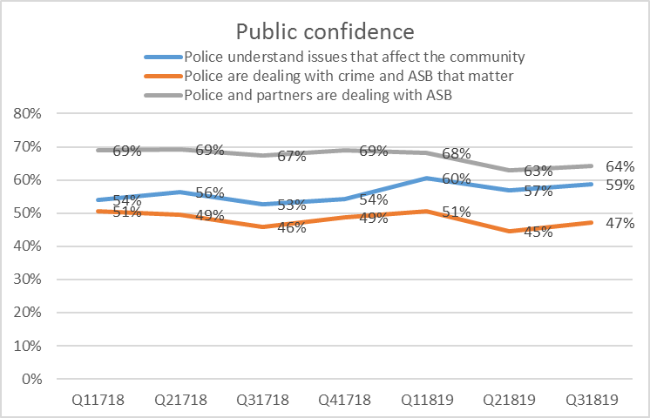

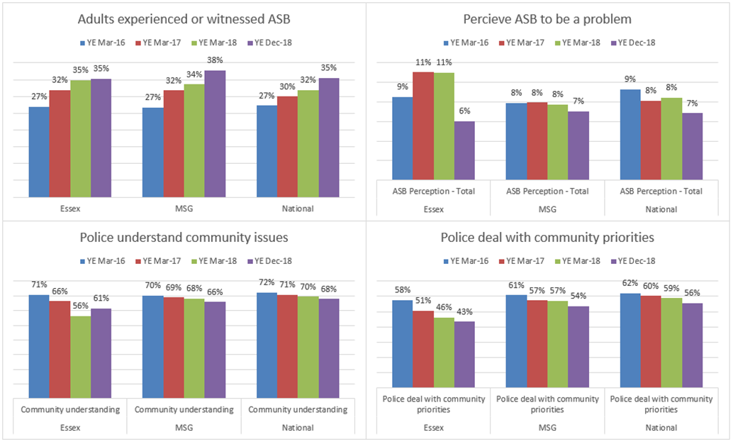

Essex performs relatively poorly with regards to perceptions of understanding of community issues and dealing with community priorities. For adults experiencing or witnessing ASB Essex performs in line with our MSF group and the national average. In relation to perception of ASB as a problem, Essex has made the most significant improvement in the most recent survey compared to year end March 2018.

These important measures are a continuing focus for the force / partners and will be supported by ongoing investment in CPTs, town centre teams, schools officers and the rural engagement team.

- Future Work/Development, Expected Outcome and Actions for Improvement

Analytical predictions indicate that the volume of ASB calls received by Essex Police will remain stable and that continued use of legislative powers to tackle ASB should contribute to maintaining lower levels of high risk and repeat victims. Continuing to capture and record intelligence on ASB is a key enabler to using tools and powers.

However, public perception and satisfaction data indicate that ASB remains one of the largest concerns for the communities of Essex. Some of this concern could be offset by information/ education campaigns that would see a proportion of reports of ASB being classified as other offences, but the general issue of “nuisance” in whatever form is still expected to feature heavily in public perception and satisfaction data.

It can be reasonably assumed therefore that the communities of Essex will expect to see the management of ASB remaining a priority for the Office of the Police, Fire and Crime Commissioner, Essex Police and relevant partner agencies beyond 2020.

National research and good practice clearly indicates that, when addressing ASB issues, authorities should;

- focus on the risk factors that increase the likelihood of offending behaviour
- relate the level of intervention to the seriousness of the offence
- target high and medium-risk offenders
- attend to the context in which criminal activities tend to take place
- remove opportunities to commit ASB where possible
There have been no recent national inspections into ASB, however, a review by HMIC in 2012 is still regarded as a valid research document and may be subject to review in the future, particularly with regard to updating the national public perception survey.
LPSU has signed up to the NPCC Problem Solving and Demand Reduction Programme and undergone an initial assessment of readiness, achieving a score of 20 out of a total 36, a relatively high level of compliance, with the main gaps being around performance management, some of which are now addressed by the ASB dashboard.

The ASB Manager based in LPSU has conducted random sampling of cases which indicates that, although the quality of ASB investigations is improving, there is still a need to provide training, particularly to Community Policing Teams. This training will also reflect the fact that PCSOs are often the first to respond to ASB incidents and have accordingly been granted enhanced powers to deal with ASB.

The LPSU ASB Manager has devised a training package will form part of the rolling programme of CPT/ Town Centre Team training sessions commencing on 5th July 2019.
The Youth Justice Team will work with the three Youth Offending Services and other key partners to explore the use of emerging intervention methodologies such as Cognitive Behaviour Approaches and other successful interventions focused on individual counselling, interpersonal skills training and behaviour programmes which have been shown to reduce recidivism by 40%.
Problem solving remains a feature in the development of ATHENA and work continues to achieve the Partnership Problem Solving Solution (PPSS) that will allow key partners to directly update and work together on joint problem solving responses to ASB. In the interim, the force problem solving database, Go2 is receiving promising localised examples of ‘what works’ in both Kent and Essex which may contribute to further reductions in reports of ASB as these tactics are adopted (and adapted) force-wide.

Research by the Restorative Justice Council: “concluded that Restorative Justice (RJ) works. The Essex Restorative and Mediation Service annual report 2017/2018 confirmed 426 referrals had been received across Essex which is a very small proportion of the number of reported crimes and ASB each year. However, 42% of these referrals were for incidents of ASB and over 95% of victims were “extremely satisfied” with the service. It is therefore important to understand why referrals are low. The RJ Hub acknowledge the need to raise awareness and knowledge of RJ across the organisation and the Restorative Justice Strategic Group is in the process of developing an action plan for increasing the number of RJ referrals.

7.0 Risks/Mitigation

None identified.

8.0 Equality and/or Human Rights Implications

There are no identified impacts on equality, diversity or human rights.

9.0 Health and Safety Implications
None

Appendix 1

ASB Dashboard

High risk investigations require a review every 7 days with medium risk requiring a 14 day review process
Linked to the NTE Delivery Plan under the Essex Police Crime Prevention Strategy
“A Step In The Right Direction: The Policing Of Anti-Social Behaviour”
Ipsos MORI: “Policing Anti-Social Behaviour- the Public Perspective: Wave 2”
Youth Justice Board, 2001
“Improving Victim Take-Up of Restorative Justice” (February 2017)

