**Performance and Resources Scrutiny Programme 2019/20**

**Report to: the Office of the Police, Fire and Crime Commissioner for Essex**

|  |  |
| --- | --- |
| **Title of Report:** | **2019/20 Quarter 1 Financial Monitoring Report** |
| **Agenda Number:** | **11.0 ii** |
| **Chief Officer** | **Mark Gilmartin, Director of Essex and Kent Support Services** |
| **Date Paper was Written** | **19th July 2019** |
| **Version Number** | **Version 1** |
| **Report from:** | **Essex Police: Corporate Finance** |
| **Date of Meeting:** | **25th July 2019** |
| **Author on behalf of Chief Officer:** | **Richard Jones, Head of Business Partnering and Management Accounting** |
| **Date of Approval:** |  |

1. **Purpose of Report**
   1. This report identifies the 2019/20 quarter 1 position for the Force.
2. **Recommendations**
   1. The report is for noting.
3. **Executive Summary**
   1. The latest forecast revenue underspend is **£0.695m**.
   2. The police officer strength forecast at end of June is **3,067 FTE** and at year end is **3,284 FTE**.
   3. The Capital Reserve is forecast to be **£3.708m** surplus at year end.
   4. The forecast capital expenditure is **£13.558m** and the forecast capital income from property disposals is **£9.942m**.
4. **Introduction/Background** 
   1. This reports sets out the June, quarter 1, financial position.
5. **Current Work and Performance**
   1. The quarter 1 financial position is shown at Annex 1.
6. **Implications (Issues)**
   1. The implications are reported in Annex 1.
7. **Links to Police and Crime Plan Priorities**
   1. The Force budget is used to help meet the priorities of the Police and Crime plan.
8. **Demand**
   1. The Force budget is reviewed and re-allocated within virement rules to match demand e.g. overtime funded by vacancies.
9. **Risks/Mitigation**
   1. Risk Register URN 452 - Short and Long Term Capital Finance.
10. **Equality and/or Human Rights Implications**

N/A

1. **Health and Safety Implications**

N/A

1. **Consultation/Engagement**
   1. The pay forecasts are based on information received from HR Organisational Management.
2. **Actions for Improvement**

N/A

1. **Future Work/Development and Expected Outcome**
   1. Reviews will continue with budget holders, working towards a balanced budget by year end.
2. **Decisions Required by the Police, Fire and Crime Commissioner**
   1. To approve the virements in Annex 1 (para 6.2).

# Executive Summary – 2019/20 – Quarter 1

# Revenue

## Revenue Summary – 2019/20 – Quarter 1



## Top Five Forecast Overspends *(Current budget)*

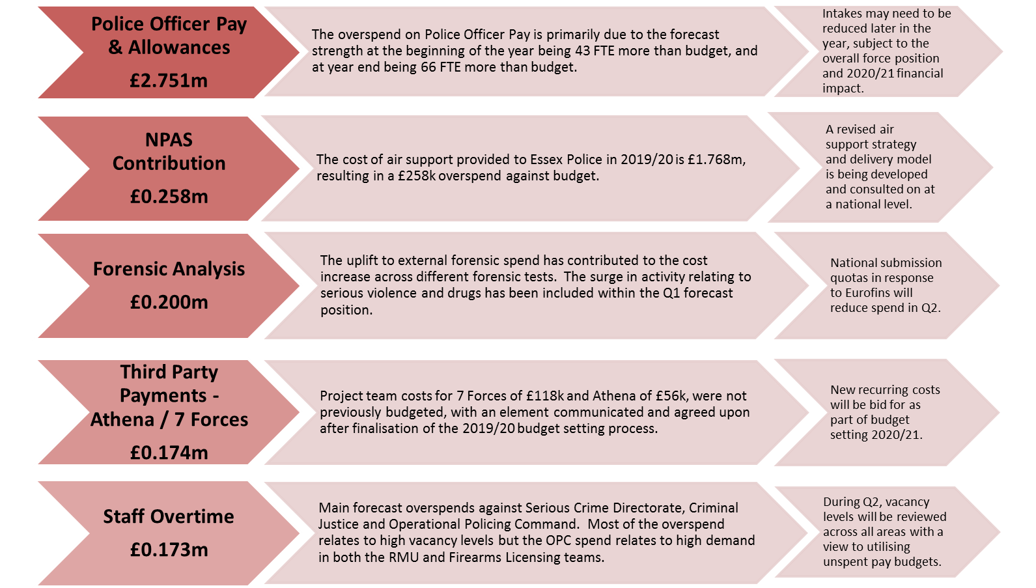

## Top Five Forecast Underspends *(Current budget)*

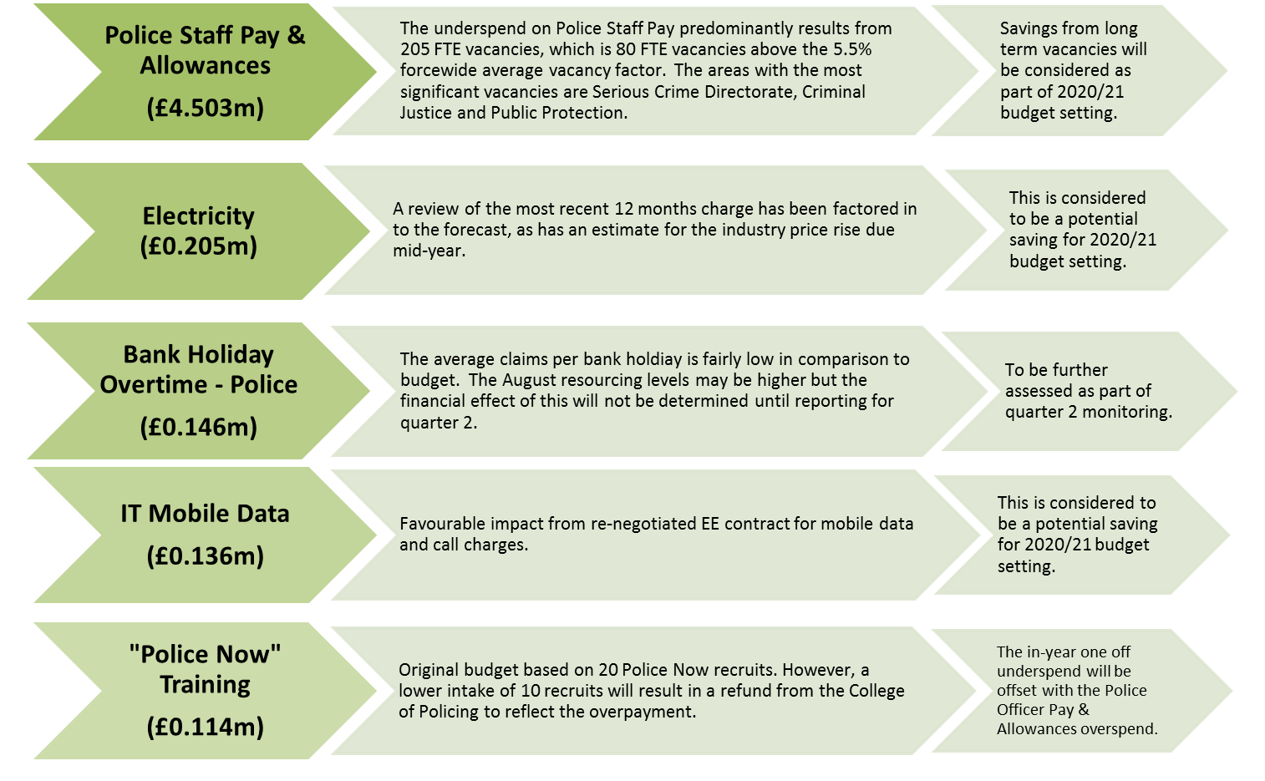

# Police Staff Overtime

## Summary



## Main overspends

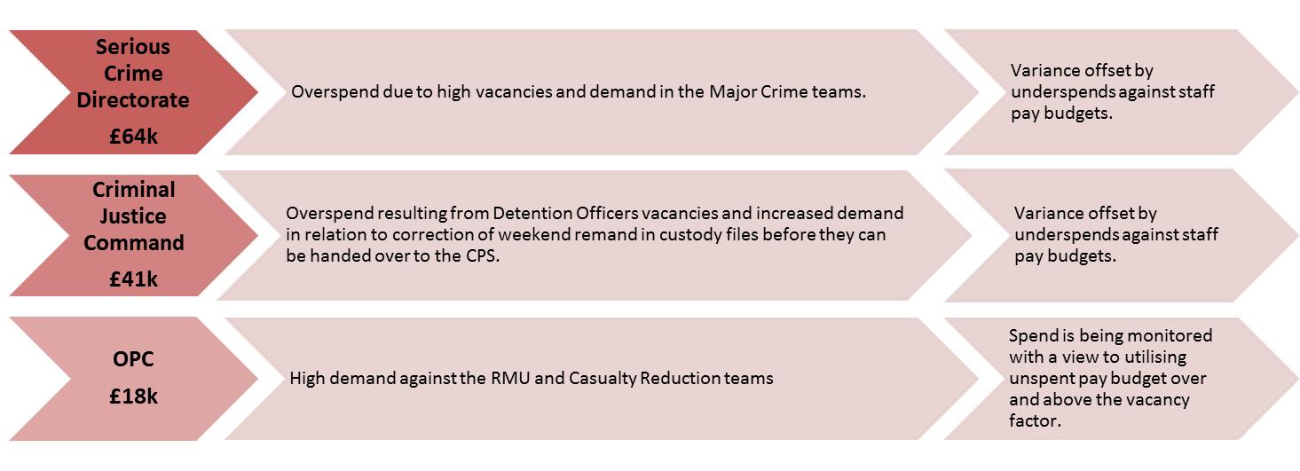

# Workforce Analysis

## Pay Summary



## Police Officer FTEs

### 



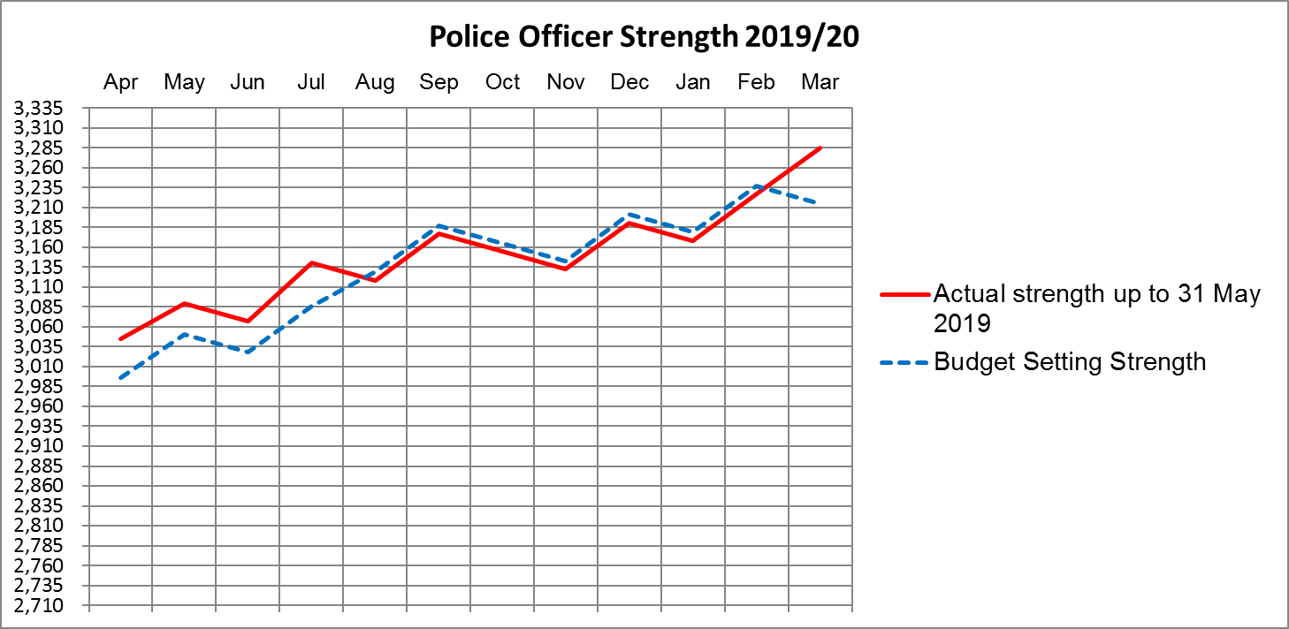

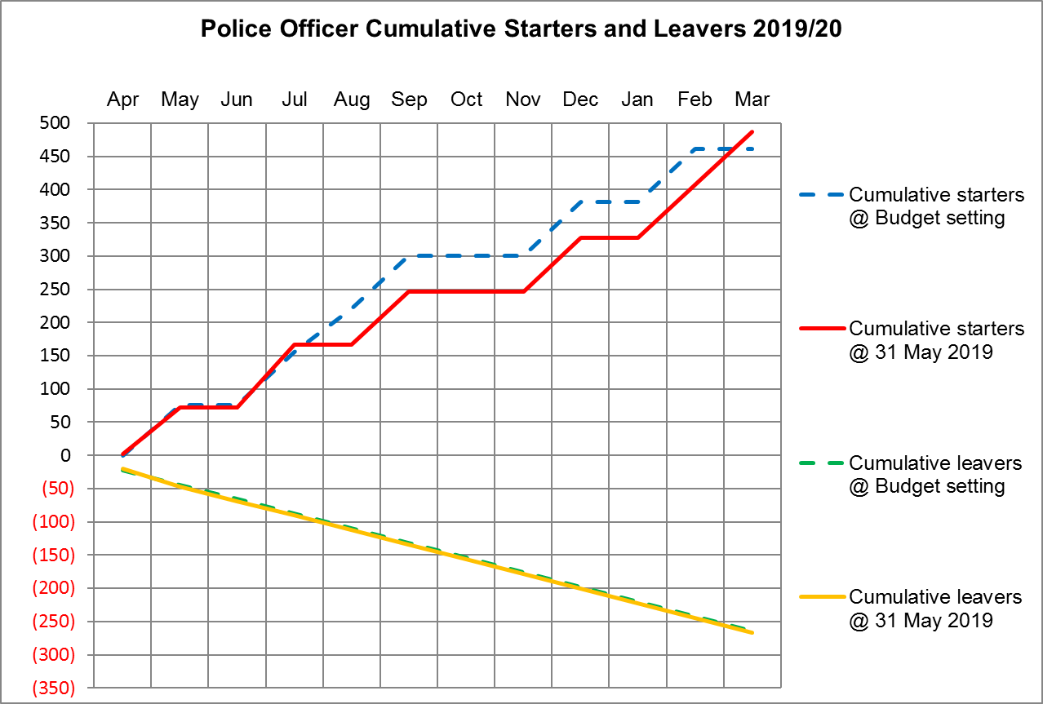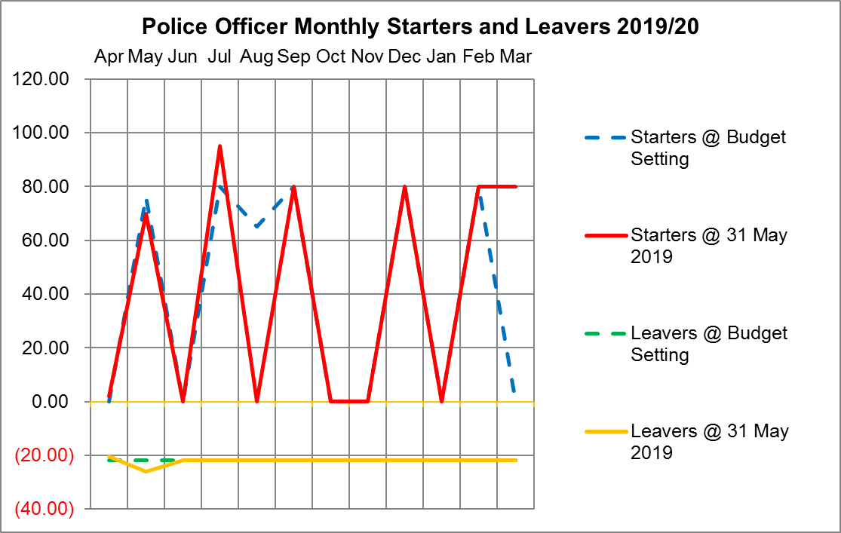

## Police Officers, Police Staff, PCSOs and Specials



# Police Objective Analysis – Level 1



# Virement Analysis – Quarter 1

## Virement Analysis – Summary



## Virement Analysis – Detail





# Reserves

## Detail Reserve Analysis



## Transformation Reserve



# Chief Officer Budgets

|  |  |  |  |
| --- | --- | --- | --- |
| **Budget** | **Budget** | **Net Allocations** | **Budget Remaining** |
|  | **£** | **£** | **£** |
| DCC Operational Contingency | 200,000 | (10,000) | 190,000 |
| ACC Territorial Policing / Crime & Public Protection / LPSU | 100,000 | (8,300) | 91,700 |
| ACC Criminal Justice Command / OPC / Contact Management | 50,000 | (1,544) | 48,456 |
| ACC Serious Crime Directorate | 50,000 | 0 | 50,000 |
| Director of Support Services | 20,000 | (925) | 19,075 |
| Director of Strategic Change & Performance | 20,000 | (1,500) | 18,500 |
| COG Policing Initiatives | 250,000 | (20,000) | 230,000 |
| Strategic Change Co-ordination Board | 160,000 | 0 | 160,000 |
| **Total** | **850,000** | **(42,269)** | **807,731** |

# Capital

## Capital Expenditure Forecast

## Movement in Capital Reserve Forecast



## Capital Income

## Projection of Capital Reserves – Cashflow Profile

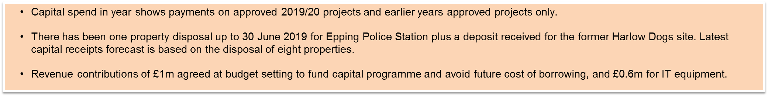

**Appendices to Revenue Report 2019/20 – Quarter 1**

10. APPENDIX A – Detail Revenue Report 24

11. APPENDIX B – Police Objective Analysis – Level 2 25

12. APPENDIX C – Virement Analysis – Other Virements 26

13. APPENDIX D – Revenue Summary by Chief Officer 28

14. APPENDIX E – Detail Reserves Analysis 29

# APPENDIX A – Detail Revenue Report



# APPENDIX B – Police Objective Analysis – Level 2



# APPENDIX C – Virement Analysis – Other Virements





# APPENDIX D – Revenue Summary by Chief Officer

# APPENDIX E – Detail Reserves Analysis