**Performance and Resources Scrutiny Programme 2019/20**

**Report to: the Office of the Police, Fire and Crime Commissioner for Essex**

|  |  |
| --- | --- |
| **Title of Report:** | **2019/20 Month 2 Financial Monitoring Report** |
| **Agenda Number:** | **8.0 iii** |
| **Chief Officer** | **Mark Gilmartin, Director of Essex and Kent Support Services** |
| **Date Paper was Written** | **20th June 2019** |
| **Version Number** | **Version 1** |
| **Report from:** | **Essex Police: Corporate Finance** |
| **Date of Meeting:** | **27th June 2019** |
| **Author on behalf of Chief Officer:** | **Denise Breckon, Chief Accountant** |
| **Date of Approval:** | **19th June 2019** |

1. **Purpose of Report**
   1. This report identifies the 2019/20 month 2 position for police officer, police staff and PCSO pay and allowances, in advance of a full reported position at quarter 1.
2. **Recommendations**
   1. The report is for noting.
3. **Executive Summary**
   1. The police officer forecast outturn is higher than the original budget by **£2.589m**.
   2. The police officer strength forecast at the beginning of April is **3,064 FTE** which is 43 FTE higher than budget setting and FTE’s are forecast as **3,274 FTE** at year end which is 56 FTEshigher than budget setting.
   3. The police staff forecast outturn is lower than the original budget by **£3.598m.**
   4. The police staff vacancy factor at the end of April were 82 FTEs above the vacancy factor of 125 FTEs. Total vacancies are 207 FTEs.
   5. The PCSO’s forecast outturn is higher than the original budget by **£0.521m.** The forecast outturn includes externally funded PCSO’s.
4. **Introduction/Background** 
   1. This reports sets out the May, month 2, financial position on the pay and allowances budgets for police officers, PCSO’s and police staff.
5. **Current Work and Performance**
   1. The month 2 financial position is shown at Annex 1.
6. **Implications (Issues)**
   1. The implications are reported in Annex 1.
7. **Links to Police and Crime Plan Priorities**
   1. The Force budget is used to help meet the priorities of the Police and Crime plan.
8. **Demand**
   1. The Force budget is reviewed and re-allocated within virement rules to match demand e.g. overtime funded by vacancies.
9. **Risks/Mitigation**
   1. N/A
10. **Equality and/or Human Rights Implications**

N/A

1. **Health and Safety Implications**

N/A

1. **Consultation/Engagement**
   1. The pay forecasts are based on information received from HR Organisational Management
2. **Actions for Improvement**

N/A.

1. **Future Work/Development and Expected Outcome**
   1. Reviews are continuing on the variances, external funding activities and updated information on investment and savings since budget setting for the main Quarter 1 financial report.
2. **Decisions Required by the Police, Fire and Crime Commissioner**
   1. None.

# Executive Summary – 2019/20 – Month 2

# Workforce Analysis

## Pay Summary



## Police Officer FTEs





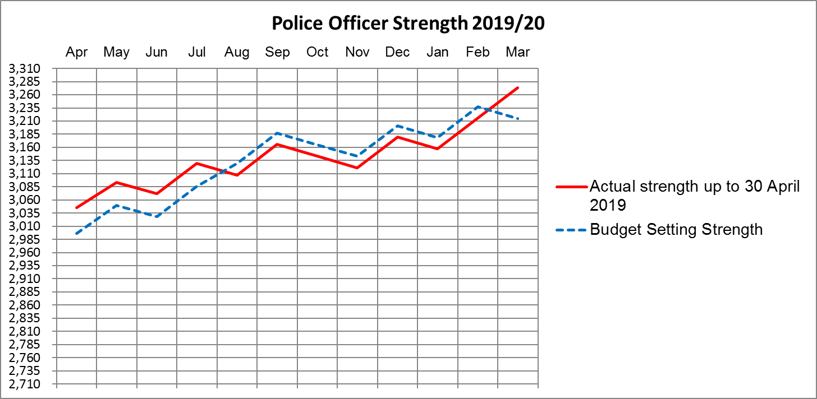

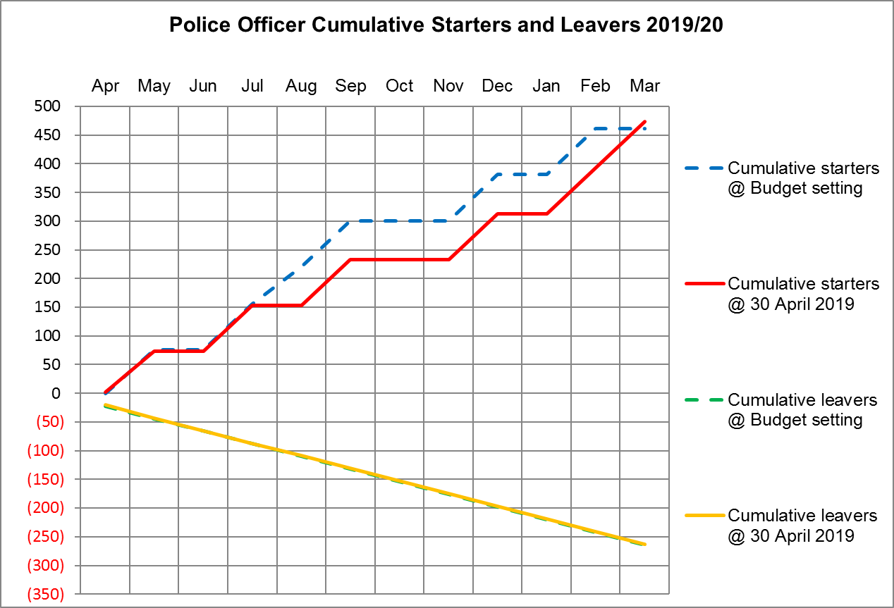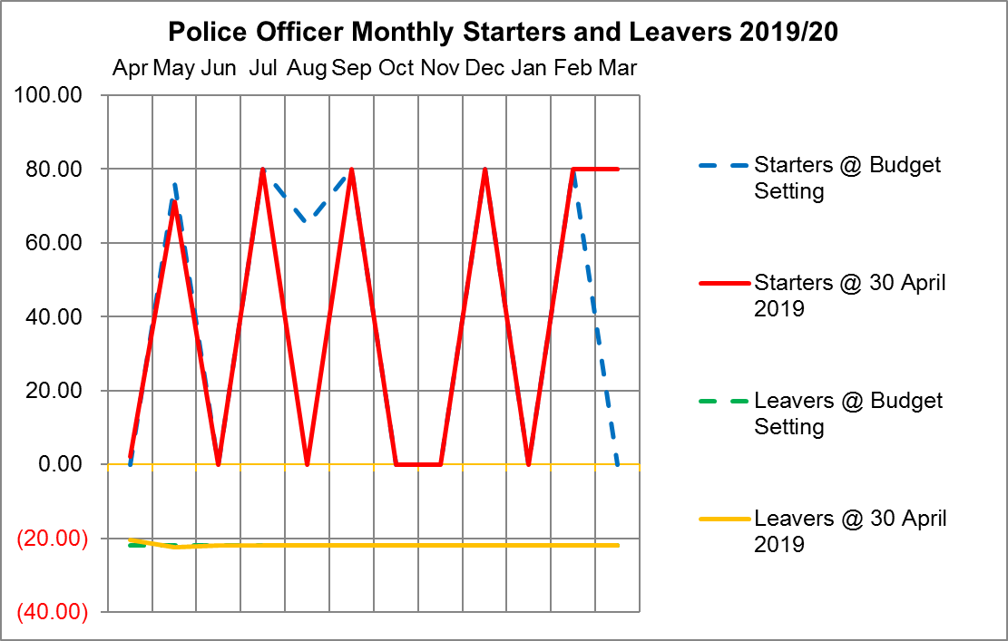

## Police Officers, Police Staff, PCSOs and Specials