**Performance and Resources Scrutiny Programme 2018/19**

**Report to: the Office of the Police, Fire and Crime Commissioner for Essex**

|  |  |
| --- | --- |
| **Title of Report:** | **Use of Force – 2018/19 Quarter 4** |
| **Chief Officer** | **T/ACC Paul Wells** |
| **Date Paper was Written** | **16 May 2019** |
| **Version Number** | **1.2.** |
| **Report from:** | **Essex Police** |
| **Date of Meeting:** | **23 May 2019** |
| **Author on behalf of Chief Officer:** | **Dan Youngman 42078817** |
| **Date of Approval:** | **20 May 2019** |

1. **Purpose of Report**

To provide a quarterly update on Essex Police’s use of force. This is a substantive agenda item for the PFCC Performance and Resources meeting.

1. **Recommendations**

There are no recommendations. This report is for the board to note.

1. **Executive Summary**

* 26.6% (703) more Use of Forms were submitted in this quarter compared to the same quarter last year (3,314 forms were submitted in this Quarter). March 2019 experienced the lowest number since the Mobile First app was introduced, however.
* Tactical Communications remain the most used tactic, accounting for over a fifth of all the tactics used in the last period.
* 53% (1823) of incidents involved handcuffing of the subject. There was nearly double the number of Compliant Handcuffs compared to the number of those that were Non-Compliant.
* The number of forms with Firearms listed as a first tactic has fallen since the last quarter.
* 52 uses of Taser were recorded in the period. These relate to 42 separate incidents.
* There has been an improvement in data quality: only one form submitted in the period did not detail the gender of the subject.
* The proportion of Black or Black British subjects continues to be higher than the proportion of the Essex population (8.7% of subjects compared to 2.0% population). The proportion of those against whom force was used who were Black or Black British also rose by almost 1% compared to the previous quarter.
* 15.7% of subjects reside outside of Essex (where the data is available).
* Alcohol and drugs are the highest Impact Factors for Use of Force.

**4.0 Introduction/Background**

This report discusses the Use of Force forms submitted for incidents occurring between 1st January 2019 and 31st March 2019. This is the fourth Quarter for which the Mobile First app has been used to record the use of force in Essex Police. The analysis conducted is reliant both on the accuracy of the forms submitted, and the volume. Use of the app will produce results that are more accurate than the previous Limes Survey forms.

The data analysed in this report contains duplicates, as one form should be submitted per officer for each use of force. Therefore, if three officers use force against one subject in relation to the same incident, three forms should be submitted, and the subject would appear three times in the data (for that one incident).

The data analysed in this report required substantial cleaning. Extraneous spaces, for example, needed to be removed from many fields, and there is a disparity in the way that certain fields have been inputted by officers, particularly the date, time and custody number.

**5.0 Current Work and Performance**

*Overview*

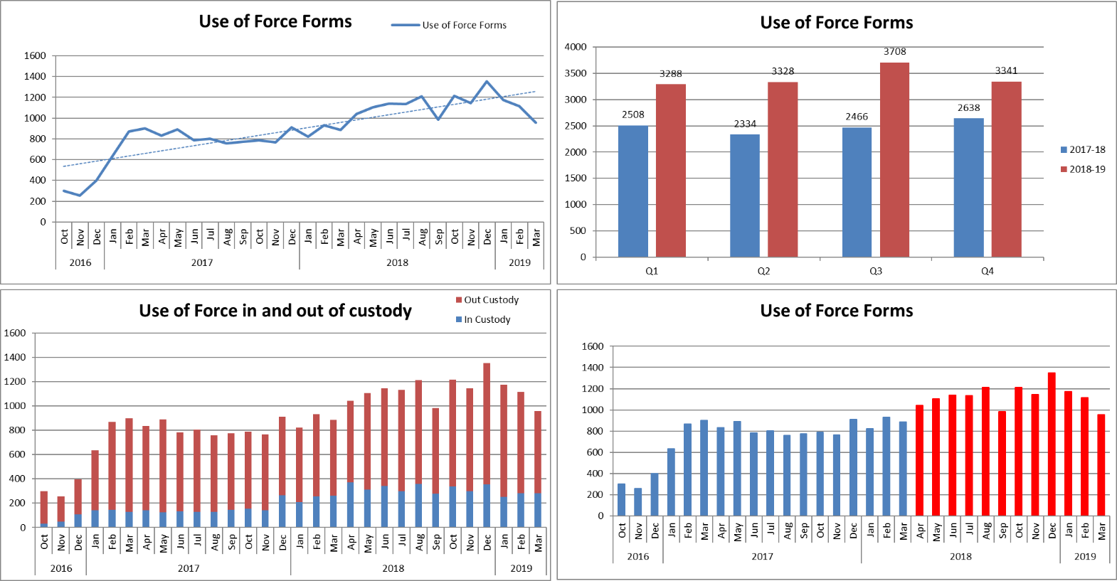

3,314 instances of Use of Force were recorded in Essex during Quarter 4 of this financial year. This is an increase of 703 (26.6%) additional forms completed, compared to the same quarter for the 2017/18 financial year, but a 9.9% drop from the previous quarter. The volume of forms relating to force used in custody have levelled off after an initial rise in April.

March 2019 experienced the lowest number of Use of Forms submitted since the Mobile First app was introduced.

*Tactics Employed*

The below table details the tactics employed with each use of force in Quarter 4 of 2018/19. It details the first eight tactics employed (not necessarily the most severe), and more than one will have been used in the majority of incidents. The Mobile First app allows for the inputting of up to 20 Tactics for one incident.

* Tactical communications (tac comms) were the most commonly used tactic. In 110 reports, tac comms were the only method employed, suggesting further training on the app may be required (a form is not required when tac comms are the only method). This is only five reports fewer than the previous quarter.
* 68.3% of incidents did not state that tac comms were used. It is unlikely that this is the case, however, and that officers simply did not enter tac comms as a tactic used.
* Handcuffing is the next most common tactic. There were 80% more compliant cuffs used than non-compliant. 1823 incidents (53.1%) involved the use of either compliant or non-complaint handcuffs.
* 26 forms showed Taser as a first tactic. All Taser use forms refer to a total of 42 separate incidents.
* 45 forms involved a firearm as a first tactic; this is 22 fewer than the previous quarter. This related to 27 individual incidents.



*Location*

Force was used most in Southend-on-Sea, Thurrock, Basildon, Chelmsford and Colchester in Quarter 4 of 2018/19 (data relates to the area in which force was used rather than the officer’s command); 65.9% of force was used in these five districts during this period.





*Subjects*

83.3% of those subjected to use of force were identified by officers as male; 16.6% were identified as female; three subjects were identified as transgender.

The proportion of Blank or Not Recorded genders has fallen to a negligible level in this quarter (one form submitted in the quarter did not detail the gender of the subject).



31 was the average age for subjects (where a date of birth was given/stated); this is true for both male and female subjects. The mode (age most recorded) is 28 for all both male and female. Males with a perceived age between 18-34 years were the most common gender and age band in the review period.

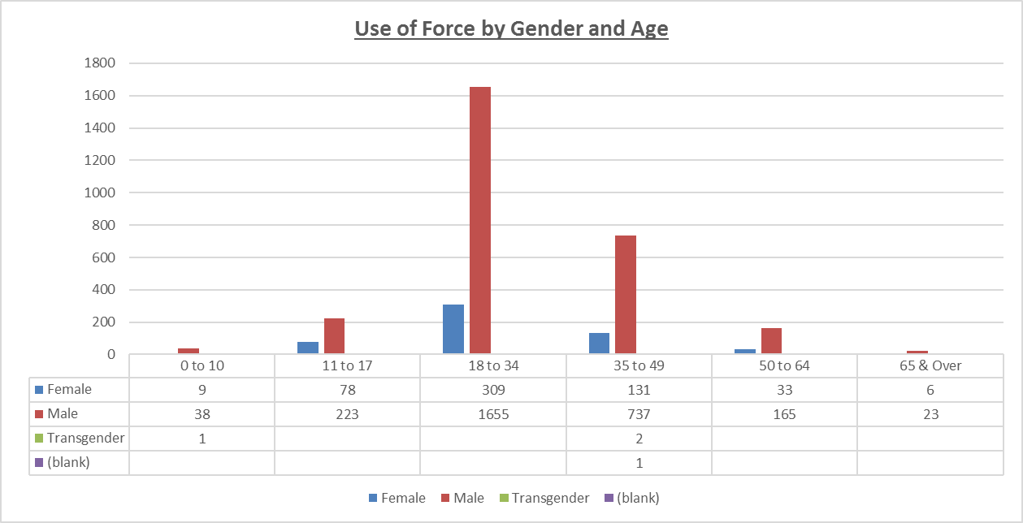

84.8% of subjects were white, this is 8.4% lower than the proportion of White residents of Essex. This disproportionality has increased decreased slightly.

8.7% of subjects against whom force was used were Black or Black British. This is 6.7% higher than the 2.0% Black or Black British resident population proportion in Essex (2011 census data). Furthermore, the proportion of Black or Black British subjects rose by almost 1% compared to the previous quarter. This does not necessarily mean that the force used in these cases was inappropriate.



*Reason for Use of Force*

Effecting Arrest was the most commonly used reason entered for officers using force, followed by Protecting oneself and Preventing Harm. Please note, that more than one reason can be entered when justifying a use of force.



*Essex and Non-Essex Residents[1]*

1,159 records correspond to a usable custody record in the same period. This equates to 35% of all use of force forms, an improvement on the last quarter by 7%. Of those usable numbers with a valid address:



* 15.7% (182 persons) had a home address outside of Essex. Of these, 34.1% (62 persons) were from a perceived BAME origin. This compares to 28% last quarter and 12.4% of Essex residents.
* 43 of the 62 persons with home addresses outside of Essex were perceived to be Black or Black British:

*Impact Factors*



Each Use of Force form can have multiple Impact Factors. The table above shows the proportion of each impact factor in the total number of forms for the last quarter. Alcohol and drugs are again the top factors.

Mental Health is an Impact Factor in 17.6% of reports, whereas 8.7% of subjects are reported as having a Mental Disability.

**6.0 Implications (Issues)**

Effective analysis is reliant both on the accuracy of the forms submitted, and the volume. The data analysed in this report contains duplicates, as one form should be submitted per officer for each use of force. Therefore, if three officers use force against one subject in relation to the same incident, three forms should be submitted, and the subject would appear three times in the data (for that one incident).

**6.1 Links to Police and Crime Plan Priorities**

The use of force is a cross-cutting issue that impacts on many areas in the Police and Crime Plan.

**6.2 Demand**

Any increase/decrease in the use of force by police is dependent on the number of subjects against whom this is necessary and proportionate.

**6.3 Risks/Mitigation**

Use of force is monitored by the Use of Force Oversight Board chaired by T/ACC Paul Wells; these meetings are held on a quarterly basis. This group is a force-wide focus group facilitated and organised by the Operational Policing Command (OPC), and is intended to provide formal scrutiny and consultative feedback on the use of force and all its associated issues. The Use of Force Oversight Board focuses on enabling the force to examine and improve on statistical data-gathering and its analysis, and transparency with the public in order to improve confidence and trust in Essex Police.

Representation within the Use of Force Oversight Board comprises a number of disciplines, as detailed in the below structure:



**6.4 Equality and/or Human Rights Implications**

The above analysis indicated a potential disparity in the ethnic origins of those against whom force was used, when compared to the resident population in the county. 8.7% of those against whom force was used (where stated) had a self-defined ethnicity of black, compared to a 2.0% black population in the county. This does not necessarily mean that the force used in these cases was inappropriate, however.

**6.5 Health and Safety Implications**

Use of force has a health and safety implication for the subject, the police, and the public.

**7.0 Consultation/Engagement**

Professional Standards at Essex Police provided data relating to the volume of complaints submitted by members of the public since April 2016 for previous reports.

**8.0 Actions for Improvement**

The new Mobile First app has assisted with the accessibility, ease and timeliness of completing Use of Force forms. The forms within the app contain more constrained and pre-completed fields, which has improved the accuracy of that which is submitted, and will enable more effective analysis to be conducted. However, cleaning and displaying this data is an ongoing process. The volume and accuracy of these forms will continue to be monitored by the Use of Force Oversight Board.

**9.0 Future Work/Development**

This report is a substantive agenda item. This report is the first to use data from the new Mobile First app. As the data from this app is continuing to be reviewed and analysed, more meaningful key findings should consequently be available in subsequent reports.

**10.0 Decisions Required by the Police, Fire and Crime Commissioner**

This report is purely for the information of the Police, Fire and Crime Commissioner.

1. For the purposes of this report, subjects’ home counties have been determined via their postcode (and whether this postcode is within Essex). However, address information (including postcodes) is not available for subjects on the Mobile First app (this could be addressed in subsequent versions). Custody record numbers have therefore been used to identify the home addresses of these subjects from the Athena Custody system. It is of note that there are issues with data accuracy with the custody number field on Mobile First, as it involves manual data entry (if an officer consequently fails to input the custody number correctly, the address information within the custody system will not be returned).