**Performance and Resources Scrutiny Programme 2018/2019**

**Report to: the Office of the Police, Fire and Crime Commissioner for Essex**

|  |  |
| --- | --- |
| **Title of Report:** | **Stop and Search Quarterly Report** |
| **Agenda Number:** | **9.0 ii** |
| **Chief Officer** | **ACC Wells** |
| **Date Paper was Written** | **26th April 2019** |
| **Version Number** | **1** |
| **Report from:** | **Essex Police** |
| **Date of Meeting:** | **23rd May 2019** |
| **Author on behalf of Chief Officer:** | **Dawn Woollcott**  **Communities & Engagement Coordinator**  **LPSU** |
| **Date of Approval:** | **2nd May 2019** |

1. **Purpose of Report**

To provide the quarterly update on the use of Stop & Search in Essex for the period January to March 2019.

1. **Recommendations**

There are no recommendations, this report is for the Board to note.

1. **Executive Summary**

The number of Stop & Searches continues to rise quarter on quarter compared to previous years.

Anecdotal evidence and routine dip-sampling of reports by the author indicates this increase is as a result of officers’ increased use of Mobile Data Terminals (MDTs) to complete a Stop & Search record after each encounter.

The proportion of women subject to Stop & Search remains steady at 10% whilst the proportion of Black, Asian and Minority Ethnic (BAME) subjects searched is 21.45% which is higher than the actual proportion of BAME population in the county as shown in the census data.

**4.0 Introduction/Background**

The Stop & Search report **(Appendix 1)** allows the organisation to monitor the potential disproportionality between White and BAME (Black, Asian, Minority, and Ethnic) groups.

The new Best Use of Stop & Search Scheme Version 2 (BUSSS2) shown as **Appendix 2** is still awaiting Home Office approval. Essex remains fully compliant with BUSSS1.

A review of Essex practice indicates that we will be compliant with BUSSS2 when launched.

**5.0 Current Work and Performance**

**Number of Stop Forms;**

There have been 3125 Stop & Search forms submitted in the fourth quarter of 2018/2019.

This is 45% (970) higher than the previous quarter.

This is an increase of 2118 compared to the same quarter for 2017/18.

This is the highest quarterly number of Stop & Searches recorded, to date, in Essex.

The chart below shows the increase in stops over the last two years;

**Overview of Reasonable Grounds Data;**

Of the 3125 Stop Searches that have been recorded during the fourth quarter of 2018/19, **96.92%** (3029) had reasonable grounds recorded compared to **98.29%** (2118) for the last quarter 2018/19.

This is where officers either record grounds that do not meet the BUSSS criteria or fail to record grounds for search.

Failure to record reasonable grounds is addressed by the Communities and Engagement Coordinator by means of escalating advice from officer to supervisor.

There has been a slight increase this quarter of insufficient reasonable grounds being logged. This is due to Operation Smuggler (North LPA only) which involved Probationers carrying out stops in Colchester town centre, unfortunately they recorded PACE legislation as reasonable grounds rather than the actual grounds for the search. Feedback has been given to the lead Officer to prevent recurrence.

The proportions of the total volume of Stop & Searches across policing districts remains fairly stable with the exception of Basildon where the number of searches has doubled since the first quarter 2017/2018.



**Gender;**

Of the 3125 people stopped in this quarter, 2785 identified themselves as male, compared to 871 in the same quarter the previous year.

340 identified themselves as female, compared to 99 in the same quarter the previous year.

Whilst there is no evidence that the rise in searches on female subjects is related to any particular search power, district or ethnicity, the proportion of searches conducted by female officers is rising, as is the proportion of searches on female subjects by female officers.

This could support the hypothesis that the rise in female subjects is due to there being more female officers carrying out searches that male officers might have been reticent to carry out.

**Age;**

Across all quarters of the past two financial years, the age range 18-25 is the one

with the highest number of searches.

**Outcomes;**

The proportion of positive outcomes remains steady at an average of 34.7% (35.2% for BAME subjects). For the purpose of this report the positive outcomes do not include NFA, Intelligence Report Only and Other; all other outcomes are included.

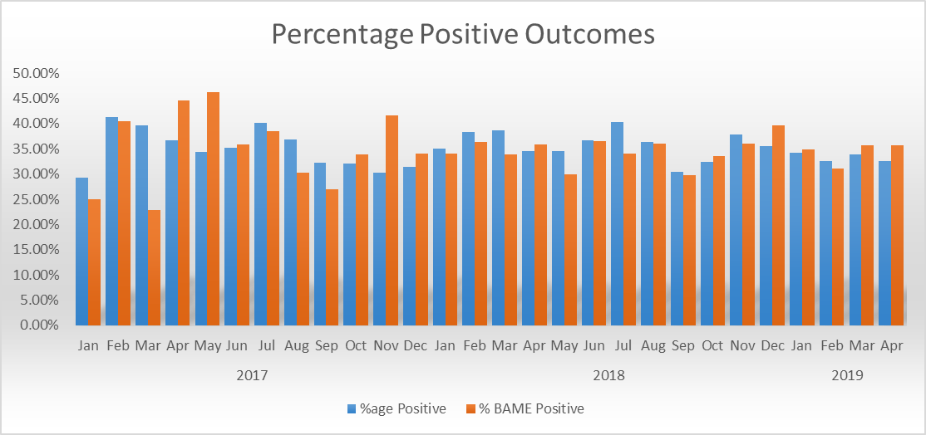

**Ethnicity;**

The below table shows the proportion of stops carried out by ethnicity compared to

the proportion of the population based on the 2011 Census.

|  |  |  |  |
| --- | --- | --- | --- |
| Ethnic Description Group | Jan-March 2017 | Jan-March 2018 | Change |
| White | 77.35% | 78.55% | 0.20% |
| Black or Black British | 11.89% | 13.45% | 1.56% |
| Asian or Asian British | 5.69% | 3.98% | -1.71% |
| Mixed | 4.65% | 3.61% | -1.04% |
| Chinese or Other Ethnic  Groups | 0.41% | 0.40% | -1.00% |

Stops by officers assigned to Op Raptor teams show a much different ethnicity to their stops, the stops over the past two financial years average out to 50.4% BAME subjects.

This is likely to be due to these stops being more targeted than those carried out by other officers.

. 

**Complaints;**

There have been 11 complaints related to Stop & Search since April 2016;

2016/17: 1

2017/18: 6

2018/19: 6

The Professional Standards Department have confirmed that, despite the marked increase in Stop & Search in the fourth quarter, only 2 complaints have been received in relation to Stop & Search for January, February or March 2019.

**6.0 Implications (Issues)**

It is recognisedat both local and national level that the use of Stop & Search can be

Controversial and attracts considerable political attention.

Overuse of the power can lead to the alienation of certain groups (BAME) whilst failing to utilise the power removes a valuable option to gain intelligence and suppress criminality.

The guidelines contained in the Best Use of Stop and Search Scheme (versions 1 and 2) aim to address such concerns, particularly in its emphasis on Stop & Search as an engagement tool rather than just a punitive measure.

The lack of accurate census data can indicate disproportionality.

The only data available is from the 2011 Census and it is known that the BAME population of the county has grown considerably, particularly in certain districts and amongst certain ethnic groups (i.e.; Thurrock, where the Local Authority conservatively estimate a 150% in residents of West African origin).

This must be considered when considering apparent disproportionality in the use of Stop & Search.

To illustrate;

13.45% of those stopped in this quarter were Black or Black British (where known or stated) this is 11.00% higher than the proportion of residents in Essex who defined themselves as Black or Black British in the 2011 Census.

78.55% of those stopped were White (where known or stated), which is 14.45% lower than the proportion of residents in Essex who defined themselves as White in the 2011 Census.

**6.1 Links to Police and Crime Plan Priorities**

The results from the Stop and Search report aim to inform against objectives in the Police and Crime Plan, particularly;

Priority 1; More Local, Visible and Accessible Policing

Priority 2; Crack down on Anti-Social Behaviour

Priority 4; Reverse the Trend in Serious Violence

Priority 5; Tackle Gangs and Organised Crime

**6.2 Demand**

There are no direct links to the Stop and Search report.

**6.3 Risks/Mitigation**

None identified

**6.4 Equality and/or Human Rights Implications**

The Local Policing Support Unit (LPSU) produces a simplified version of the Stop & Search report for use by the Strategic and local Independent Advisory Groups.

Stop and Search is one of 3 standing agenda items at these meetings (the others being Use of Force and Hate Crime).

Members of these groups scrutinise the data for any indication of disproportionality or potential impact on communities.

Members are also able to scrutinise Body Worn Video footage of Stop & Search encounters in addition to taking part in Ride-Along.

Any feedback is taken by the Communities and Engagement Coordinator as an action and all feedback is recorded for use in HMICFRS inspections.

To date, no concerns have been raised regarding disproportionality with the membership regularly citing the inaccuracy of the 2011 Census data as described above.

**6.5 Health and Safety Implications**

None identified

**7.0 Consultation/Engagement**

LPA Commands

S/IAGs

EPC

Mobile First Team

Performance Information Unit

**8.0 Actions for Improvement**

Just over 3% (107) of stop searches carried out in this period did not have reasonable grounds stated on the form this figure has risen since the last quarter. The increase is due to Operation Smuggler (North LPA only) which involved Probationers carrying out stops in Colchester town centre, unfortunately they recorded PACE legislation as reasonable grounds rather than the actual grounds for the search.

**9.0 Future Work/Development and Expected Outcome**

As part of the work outlined in 8.0 above, the Communities & Engagement Coordinator is working with Essex Police College to ensure Stop & Search training is relevant and meets the requirements of BUSSS1.

The improvement in the recording of reasonable grounds indicates that the recently introduced half day refresher training on Stop & Search is proving effective.

We looked at additional information for the fourth quarter report, specifically in relation to public confidence levels and how stop and search ties into a reduction in violence but there is no research base that would suggest a correlation between an increase in public confidence and an increase in the use of stop and search.

There could be a relationship but a lack of research/evidence stops us reporting.

**10.0 Decisions Required by the Police, Fire and Crime Commissioner**

None required, this report is for the information of the Police, Fire and Crime

Commissioner.

**Appendices**

**Appendix 1 Appendix 2**

 