**Stop and Search Report Q4 2018-19 DRAFT**

**Strategic Change Directorate**

**Date: 25/04/2019**

**Version No: 1.0**

**Unit: Performance Information Unit**

**Contact: Dan Youngman 42078817**

**Sensitivity: Official**

1. **Aim and Purpose**

This report examines the Stop Search reports for Essex Police during the financial years 2017 (April 2017 – March 2018) and 2018 (April 2018 – March 2019) in order to identify trends and issues associated with Stop and Search for the Use of Force Board.

It uses data relating to Stop Search that has been extracted via Business Objects and uses statistical methods to explore the data.

1. **Executive Summary**

The volume of searches has continued to rise throughout 2018 as officers make increased use of Mobile Data Terminals to record Stop and Search reports immediately after each event.

The proportion of female subjects searched is steady at around 10% and the proportion of BAME subjects is 21.45%

1. **Key Findings**

* There has been an increase in stop and searches since the beginning of 2018.

This is likely to be due to searches being input on Mobile Data Terminals in real time rather than later on a desktop computer.

* Less than 4% of searches in the last quarter did not have reasonable grounds for that search.
* Over 99.2% of searches (7,746 of 7,839) were carried out under PACE or the Misuse of Drugs Act (MDA), although the proportions of these powers has changed over time.

MDA Searches have increased and PACE Searches have reduced.

* The peak age range is 18-25 with 26.8% of those searched in the last quarter being under 18.
* The overwhelming majority of subjects searched are male.
* Essex Police searches a proportion of BAME subjects that is higher than the actual proportion of the BAME population in the county.
* For searches attributed to Op Raptor and for officers attached to Op Raptor, the proportion of BAME searches increases enormously to 50.4% BAME.
* The rate of positive outcomes fluctuates but does not change significantly with the rise in report volume.

1. **Analysis**

Chart 1 - Search Volume

We know from previous reports that there has been a marked increase in Stop/Searches throughout 2018, this may be attributable to data being input directly onto Mobile Data Terminals.

3125 searches were recorded in the final quarter of 2018/19, this is 45% (970) higher than the previous quarter and 210% (2118) higher than the same quarter in 2017/18



Table 1 - Reasonable grounds

Just over 3% (107 records) did not have recorded reasonable grounds in the past quarter; this has risen since last quarter.

This is simply due to the records having poorly written search grounds.

Whilst this is a subjective measure, it is based on the expertise of an experienced member of Police Staff.



Table 2 - Search Powers breakdown

Over the past two years, the vast majority of Stops (99.2%) have been under the Misuse of Drugs Act and Section 1 of PACE.

In 2018/19, there were 7,746 searches under these powers compared to 3,020 in 2017/18.



Table 3 - Search District Breakdown

With the dramatic volume changes over the past year, comparison of the number of Stop Searches recorded for each district does not yield meaningful results, the volume for each district rises in line with the force total.

When we look at the proportions of the total volume that each local command is responsible for, we can see that for the most part, they are fairly stable with the occasional notable exception.

The proportion of searches in Basildon has doubled since the first Quarter of 2017/18.



Table 4 - Searches by Town

When we look at the major towns in Essex over the past two financial years, not only are there no surprises in the top ten, the proportions remain fairly steady with the exception of Basildon which experienced a rise that mirrors its parent district.



In previous reports, we saw that the proportion of female subjects being searched has been slowly rising over the last four years. This is due to larger numbers of female officers carrying out searches. Whilst the proportion of females searched since April 2017, remains fairly steady at around 10%, the latest quarter shows the highest proportion of 10.9%. A district breakdown of gender is included as Appendix ?.



Over the last two financial years, the Average age of subjects remains steady. This is relevant to the Mean (average), Median (middle value) and Mode (value that occurs most often). The values of each of these differs as is detailed above.

Across all quarters of the past two financial years, the age range 18-25 is the one with the largest volume.



The above table shows the proportion of stops carried out by ethnicity compared to the proportion of the population based on the 2011 Census. Whilst figures fluctuate over time, over the past two financial years, the proportion of BAME subjects stopped is 20.7% which is disproportionate to the population of BAME people in Essex (6.8%).



When we look at the main search powers used, we can see that the proportion of BAME stops is subtly different to the overall proportion. For drugs stops, the proportion of BAME subjects is higher than the overall; whereas for PACE stops the proportion is lower.



Stops by officers assigned to Op Raptor teams have a much different ethnic makeup to their stops, the stops over the past two financial years average out to 50.4% BAME subjects. This is likely to be due to these stops being more targeted than those carried out by other officers.

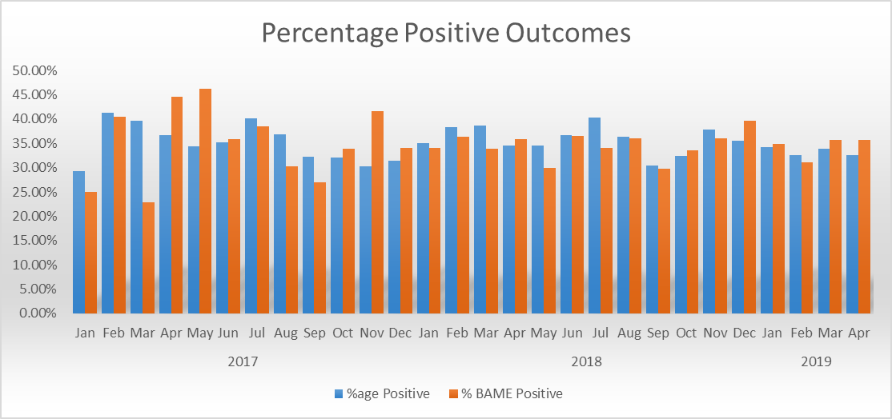

For the purposes of this report, Positive Outcomes **do not include** NFA, Intelligence Report Only and Other; all other outcomes are included. Over time, the proportion of positive outcomes remains steady at an average of 34.7% (35.2% for BAME subjects).



Outcomes for operation Raptor officers do not differ significantly to the overall proportions.

1. **Acknowledgements**

Thanks to Dawn Woollcott for the Reasonable Grounds data.