Performance and Resources Scrutiny Programme 2019

Report to: the Office of the Police, Fire and Crime Commissioner for Essex

Title of Report: | FCR Programme update
Agenda Number: | 9
Chief Officer | T/ACC Paul Wells
Date Paper was Written | 10th March 2019
Version Number | V1a
Report from: | Essex Police
Date of Meeting: | 28th March 2019
Author on behalf of Chief Officer: | C.Insp Sam Smith
Date of Approval: | 19/3/19

- Purpose of Report

This report provides an update on the progress of the Contact Management project against recommendations agreed by the PFCC on the 20th June 2018.

- Recommendations

- Note the progress made towards the target operating model.

- Executive Summary

KPMG were commissioned along with i-three analytics to provide consultancy support and recommendations which would identify a new target operating model. The final report by KPMG identified opportunities to improve the service delivery within the Contact Management Command.

- Create a Resolution Centre
- Create an Operations Support team.
- Implement a set of Performance Dashboards.
- Move away from the Omni-competency.
- Improve the operating efficiency of Switchboard.
- Carry out a review of flexible working arrangements.
- Increase the digital offer to the public

These proposed changes will create a structure and workforce which is more able to meet the current and future demands.

4.0 Introduction/Background

In June 2018 Chief Officers and the PFCC agreed to work towards a new target operating model as described throughout the KPMG report and identified the below opportunities to improve the service delivery within the Contact Management Command:

- Create a Resolution Centre, by utilising the experience of LDRM’s and the capacity created in Crime Bureau, to manage Grade 4 demand and low level investigations.

- Create an Operations Support Team to focus on driving performance improvement and increasing productivity.

- Implement a set of Performance Dashboards, which will include both measures of efficiency and effectiveness, in order to provide better MI to Supervisors, allowing them to drive improved productivity levels across the teams.

- Reduce dispatch channels and redeploy resources in to either a Resolution Centre or Operations Support Team.

- Move away from Omni-competency in order to free up funds to be re-invested in the implementation of an Operations Support Team and Resolution Centre.

- Improve the operating efficiency of Switchboard by making changes to current IVR routing.
- Carry out a review of flexible working arrangements to better align shift patterns with the demand profile, improving service levels across all functions.

- Increase the digital offer by pushing business crime to online crime reporting, providing training to drive its use.

5.0 Current Work and Performance

Below is a breakdown of each strand and how work is progressing within the project.

- Create a Resolution Centre

A Pathway is planned to commence on the 15th April 2019, this will test the concept of managing Grade 4 incidents within Contact Management. South LPA are the test bed for the Pathway.
This Pathway will be based within the Force Control Room. The aim is for the Full Resolution centre to be recruited and based within the current Crime Bureau building (Q Block) by November 2019.
A fresh review of 2018 demand is being undertaken by i-three analytics to ensure the proposals planned around a new shift pattern for the Resolution centre marry with the demand profile.
A consultation process with existing staff will then begin in May 2019.

- Create an Operations Support team.

A detailed paper showing the recommended design and function of the Operational Support team will be out for consultation by 15th March.
Interviews are currently underway for the Operational Support Manager, these conclude early March and the successful applicant will then be appointed to assist in the recruitment and implementation of this team.

- Implement a set of Performance Dashboards.

KPMG were commissioned to complete a set of Management Information (MI) dashboards which will assist in giving clear oversight of the commands performance, this will enable effective Management of staff and insight into individual and team performance. It will allow us to bench mark performance and analyse what good performance looks like. This in turn will drive the work of the Operational support team.

The dashboard is in the final test phase before anticipated sign off due 31st March 2019.Essex IT team have been a fundamental part in the delivery and have agreed to take over ongoing design and enhancements once signed off from KPMG.

This Dashboard breaks down all data from call demand, to call duration, time taken to allocate in each LPA. It will allow us to set specific KPI’s and benchmark performance. Once Athena data is also added this will also extend to the work of Crime Bureau and the Resolution centre. Allowing us to measure individual performance and drive quality and efficiency.

- Move away from the Omni-competency.

This work is ongoing, Since January 2019 we have recruited scale 3 Contact Handlers on new contracts in replacement of Scale 3-4 Communications Officers.

This work can continue as we commence channel shift in the South and then progress to the North LPA as recommended by KPMG.
Castle Point and Rochford channel shift is planned for 1st May 2019 implementation, allowing for a soak up period following the Resolution Centre Pathway commencement on 15th April 2019.

- Improve the operating efficiency of Switchboard.

A review of our Interactive Voice Response (IVR) has been completed and a new version designed. This will re-introduce Crime Bureau as an early option for the public. It is anticipated this will reduce the call volume on Switchboard as an average of 20% of daily calls are routed via Switchboard to the Crime Bureau. This new version is awaiting recording by IT and is anticipated by 31st March 2019.

- Carry out a review of flexible working arrangements.

This work is underway within the Crime Bureau in preparation for the Resolution Centre.
Early indications within the FCR suggest that a full review of the shift pattern may be required. Once the i-three data review for 2018 is received this will allow us a greater analysis of demand against our current shift pattern

- Increase the digital offer to the public

The digital hub work has progressed and a full report will be presented to the Performance and Resources Scrutiny Board in August 2019. This element has been moved outside the scope of the implementation team.

6.0 Implications (Issues)

6.01 Resolution Centre;

The Pathway will be staffed from officers within the LDRM as well as recruiting to vacancies in the establishment. A significant number of staff currently within the LDRM have adjusted duties and travel restrictions that may prevent them from taking up a post in the new Resolution centre based at HQ.
These issues are being progressed through HR and consultation with Legal services in relation to Equality.

The final location of the Resolution centre is subject to work being agreed and completed by estates on the current layout of the Crime Bureau building by November 2019.The Estates change of use request will be heard at the 15th April 2019 Estates board.

6.02 Implementing Performance dashboards;

The delay in delivery of this product is due to the significant amount of data that was required from 5 different data sources. This needed to be created into a ‘universe environment’ before the data could be drawn from the universe to produce the reports.
The FCR is currently changing from Call Vision to ICCS. This will mean a change in the universe will be required to ensure the data stream continues.

There has also been a significant delay in Athena data being accurate and available within the universe. The Dashboard is now designed to show the Athena data but Essex IT will add this function once the ‘universe’ has been furnished with Athena Data.

6.03 Moving away from “Omni-competence”;

Whilst this work is underway it is recognised that for FCR to maintain its resilience there is a need for the FCR to have its Police Officer vacancies filled. The Control room is currently 9 officer’s understrength from an establishment of 26. All officers should be trained to dispatch level for the reduction of Scale 4 dispatch trained Police Staff to continue.

The KPMG paper highlighted the ability to reduce our grade 4 dispatchers by 30 as we reduce our channels across the force by 3.Further analysis is required in relation to the 2018 demand picture. It must be recognised that a reduction in channels does mean an increase in volume of communication on the combined channels. This would therefore necessitate an increase in the time a backup operator is required on the channels that remain. Early calculations show that the viable reduction in dispatchers across the force is 23.7 however this is yet to take into account the 2018 demand profile from i-three.

This potential reduction presents a financial risk of £217K in 2020/2021 and future years and represents a potential increase in establishment. There is scope for other financial savings that could offset this e.g. reviewing the need for senior officer ranks within the Resolution Centre and reviewing the structure of the Operational Support team. This work is still ongoing and a full financial report will follow once this has been fully scoped.

6.1 Links to Police and Crime Plan Priorities

More local, visible and accessible policing

The proposed changes to the Contact Management Command will make the force more efficient at dealing with telephone, on-line and investigation demand; this will allow local officers to spend more time in public facing roles. The proposals to improve digital contact will also increase visibility and accessibility on-line.

6.2 Demand

The PA Consulting Demand Analysis Report highlighted the overall increase in 999 calls, and an increase in peak call volumes during late afternoon and early evening. This report recommended an increase in staff and/or flexible working review.

The work by i-three analytics has taken this assessment a stage further with comprehensive analysis of our current and future Demand; the output of this forms a test bed for the design of the target operating model. Out of this work a virtual control room has been built which remains available for the Force to test future workflow designs and assumptions.

Of particular note is the predicted ongoing increase in demand for 999 calls against a reducing 101 demand. It should be noted that this is in line with the analysis provided through the PA Consulting demand review.

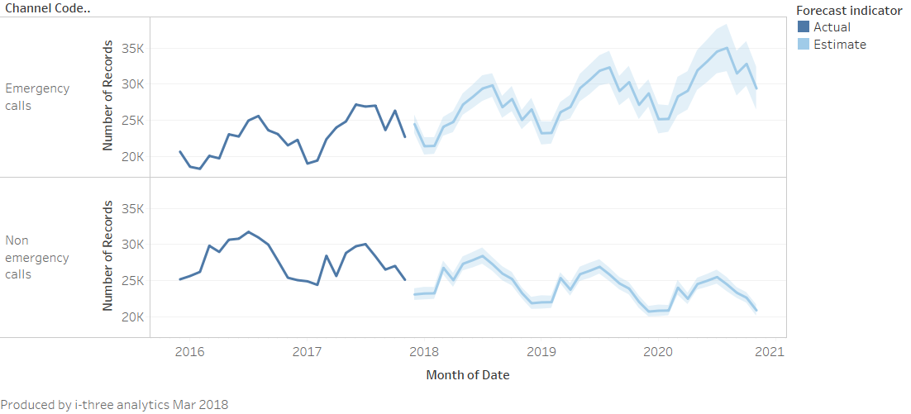

The Key Findings from the i3 work complement the overarching work from KPMG; specifically around the need for the Operations Support Team to drive up performance and consistency across the teams. In summary these Key Findings were:

Further to this the i-three work has provided a good level of confidence in the proposed high level workflows from KPMG, as the volumes of calls and activities have been tested against virtual design of the new structures such as the Resolution Centre.

The work completed by i-three analytics was based on 2017 data. A fresh review of the 2018 data is being completed to ensure that the target operating model being implemented is still viable taking into account the demand profile of last year.

6.3 Risks/Mitigation

The process and time line for implementation comes with some risks. The project team currently manage the response to these risks through the following governance structure.
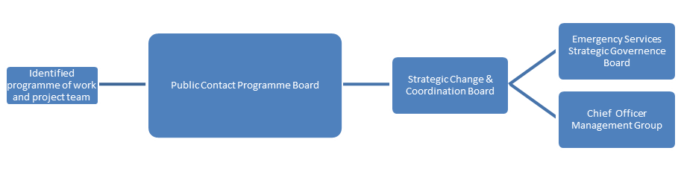

- Conflict with other Force change programmes

There are a number of other change projects underway, some directly impacting Contact Management, such as Oscar 1 and 2 implementation, the Digital hub and implementation of ICCS.

Mitigation

Project management support role performed by Strategic Change Department to maximise de-confliction.
Change and innovation board held within Contact Management Command to ensure all internal projects dovetail and issues are DE conflicted.

- Digital

Implementing new Contact Management processes in parallel with other Force work being undertaken. For example the forthcoming paper from Jules Donald concerning the Single On-Line Home. This presents risks of conflict in the implementation of new processes and training.

Mitigation

Careful sequencing through the project management meeting structure and other Contact Management governance processes.

6.4 Equality and/or Human Rights Implications

LDRM staff are being relocated to headquarters this has raised some concerns in relation to equality and disability, the Legal team and HR will be consulted in relation to this and potential implications of centralising staff who will be completing desk based investigations.

6.5 Health and Safety Implications

None identified

7.0 Consultation/Engagement

The implementation team will continue to consult with staff associations and staff directly throughout the anticipated timeline. Local Policing teams, HR and Finance continue to be engaged with the project.
As new methods of contact for the public are developed (such as web-chat), the Force will seek to engage with the public in a variety of ways around how the public would like to interact with these functions. There are a number of partners through the Essex Customer Service Group from whom lessons can be learnt; Claire Heath is the vice-chair of this group and able to provide access and support.

8.0 Actions for Improvement

The 2017 PEEL Efficiency inspection (Page 7) identified an Area for Improvement in the Force’s 101 Abandoned Rates; albeit some progress has been made in this performance there is still improvement the force wants to see.
The proposed restructure takes account of the range of success factors the command and the force seek – specifically to call handling, the introduction of an Operations Support Team is felt to be crucial in achieving and maintaining a good performance against a range of measures including call handling abandoned rates and grade of service.
The introduction of the Dashboard will also support the drive to improve performance.

9.0 Future Work/Development and Expected Outcome

The Project team are still working towards a delivery timeline of November 2019 for the Force wide implementation of the Resolution centre. Channel reduction will also progress inside this time frame.
The Operational Support Manager should be appointed and in post by May 2019, subject to vetting.
Procedural improvements within CB have seen the grade of service (percentage of calls answered within the target time) for calls transferred to CB increase from 19.7% in Sept 2018 to 52.5% in Jan 2019. Improvements include proactive use of live time performance information, use of mobile data capability to reduce officer calls and increase public contact, IVR providing call back option, revised workflow processes and specific performance objectives for each team.

In November 2018 a second Inspector (Oscar 2), was added to each team in FCR. Part of this officer’s duties is to monitor call handling performance in the room. Since being put in place our grade of service in respect of 101 calls ( those calls that are answered within the 60 second target) has risen from 40% in November to 57% in January and the percentage of 101 calls abandoned by the caller has decreased from a little over 19% to 11%.

During Summer 2019, along with 38 other forces nationally, Essex Police will be moving to the Single Online Home web page, this will introduce new ways that the public can interact with and report matters to the Police. One of the new functions with be the use of a ‘live chat’ function, which is an on-line tool where members of the public can communicate with a call taker by sending typed messages. This is an extremely popular means of communication and most big companies use this facility to reduce phone calls.

Grade 4 incidents are those assessed as requiring police attendance within 24 hours; i.e. non-urgent attendance. Many of these can in fact be resolved without attendance but do require police action.

