**Performance and Resources Scrutiny Programme 2018/2019**

**Report to: the Office of the Police, Fire and Crime Commissioner for Essex**

|  |  |
| --- | --- |
| **Title of Report:** | **Balanced Scorecard Gradings – 12th Cycle** |
| **Agenda Number:** | **8.0** |
| **Chief Officer** | **Dr. Victoria Harrington** |
| **Date Paper was Written** | **18 February 2019** |
| **Version Number** | **1.1.** |
| **Report from:** | **Essex Police** |
| **Date of Meeting:** | **28 March 2019** |
| **Author on behalf of Chief Officer:** | **Matt Robbins 42073495** |
| **Date of Approval:** | **7March 2019** |

1. **Purpose of Report**

To provide a quarterly update on the final Balanced Scorecard gradings, following the Essex Synergy and Performance Meeting, which was held on Friday 25th January 2019. This report discusses the 12th cycle.

1. **Recommendations**

There are no recommendations. This report is for the board to note.

1. **Executive Summary**

There were three changes in cycle 12 compared to cycle 11 (all a deterioration from Good to Requires Improvement):

* Keeping People Safe
* Gangs
* Digital Crime

The following areas are currently graded at Requires Improvement:

* Keeping People Safe
* Child Abuse/Child Sexual Exploitation
* Domestic Abuse
* Gangs
* Violence with Injury
* Modern Slavery
* Digital
* Community Focussed

One area graded as Outstanding (Innovation). All other areas are graded as Good.

**4.0 Introduction/Background**

Essex Police use the “Balanced Scorecard” strategic performance management framework to self-assess its performance. It also uses the grading names employed by Her Majesty's Inspectorate of Constabulary and Fire & Rescue Services (HMICFRS) in its assessments; the grades are ‘Outstanding’, ‘Good’, ‘Requires Improvement’, and ‘Inadequate’. Where possible, Essex Police benchmark its performance against other forces in its Most Similar Group (MSG); this enables Essex Police to derive minimum standards (and consequently assess what is ‘Good’).

This process is conducted on a quarterly basis. Individual commands first grade themselves, and provide quantitative and qualitative evidence in support of their self-assessment. These grades are then reviewed by the relevant Assistant Chief Constable/Director at Oversight Boards, and then by the Deputy Chief Constable in the Performance Board.

**5.0 Current Work and Performance**

The below table details the final gradings at command and force-level:



The “Tube Maps” showing the final force gradings can be found in the appendices of this report.

The rationale for these grades is provided in the following tables:





**6.0 Implications (Issues)**

Essex Police use the “Balanced Scorecard” strategic performance management framework to self-assess its performance. All areas of this framework – from the Plan-on-a-Page (which details the priorities for the force) to the “Redline Measures” (minimum standards that indicate when the Force cannot be graded at anything above Requires Improvement) and Key Performance Indicators – are currently under review. The aspiration is to reduce the number of areas reviewed in the process, involve all commands, and provide more rounded view of the force.

**6.1 Links to Police and Crime Plan Priorities**

The Essex Police Plan on a Page currently includes the Police and Crime Plan priorities. The Force therefore assesses itself against these priorities as part of the Balanced Scorecard process.

**6.2 Demand**

The Balanced Scorecard ensures that demand is managed appropriately by identifying both good practice and areas of concern at a strategic level.

**6.3 Risks/Mitigation**

Risk is discussed as part of the Balanced Scorecard process. Balanced Scorecard meetings are also attended by staff from Continuous Improvement, who ensure that the Force Risk Register is updated with any new risks identified.

**6.4 Equality and/or Human Rights Implications**

No equality or human rights implications were identified in the process of writing this report.

**6.5 Health and Safety Implications**

No health and safety implications were identified in the process of writing this report.

**7.0 Consultation/Engagement**

All commands involved in the Balanced Scorecard process were consulted in the last cycle, particularly with the identification of “Redline Measures” and the data required to support the effective completion of the Balanced Scorecard returns.

**8.0 Actions for Improvement**

The Balanced Scorecard identifies good practice, but also areas for improvement. Areas graded at “Requires Improvement” or below become the focus for the Chief Constable’s Essex Synergy and Performance meeting, and the next cycle of the Balanced Scorecard process.

**9.0 Future Work/Development and Expected Outcome**

The Performance Analysis Unit at Essex Police are currently working on a reboot of the Balanced Scorecard. This will involve the continued use of “Redline Measures” for all areas on the Balanced Scorecard, as well as evidence-based Key Performance Indicators (KPIs). Other commands within the Force – such as the Contact Management – are also in the process of being introduced to the Balanced Scorecard process.

**Appendix 1: Force-Level Balanced Scorecard Gradings “Tube Map”**

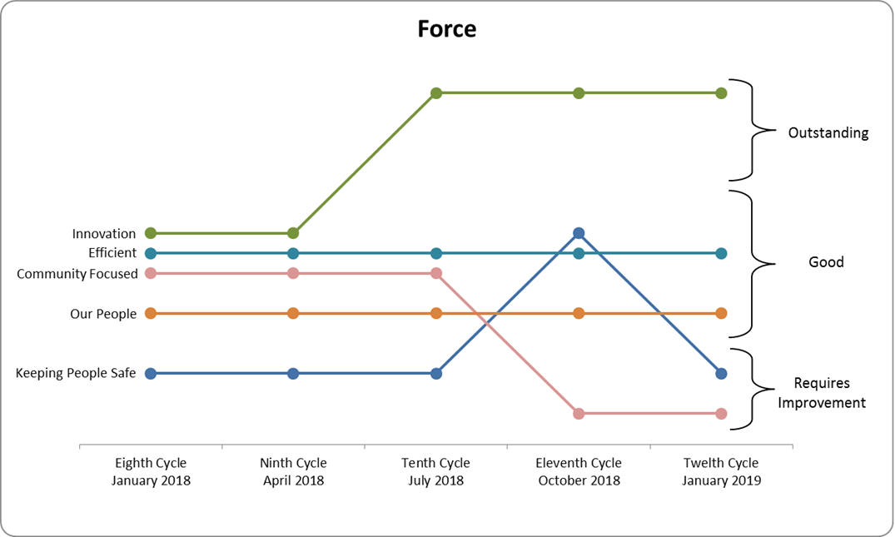

**Appendix 2: Force Additional Priorities Balanced Scorecard Gradings “Tube Map”**

