Performance and Resources Scrutiny Programme 2019

Report to: the Office of the Police, Fire and Crime Commissioner for Essex

Title of Report: | DA DRIVE PROJECT
Agenda Number: | 7.0
Chief Officer
Date Paper was Written | 07/05/2019
Version Number | V2
Report from: | Essex Police
Date of Meeting:
Author on behalf of Chief Officer: | ACC Andy Prophet
Date of Approval: | 13th May 2019

- Purpose of Report

Assessment of the DA DRIVE project (DA Perpetrator Programme).

- Recommendations

There are no specific recommendations within this report. The board are invited to note key areas of performance as well as the amendments that were made to the project on the 1st April 2019.

- Executive Summary

The Drive Project launched in April 2016 and concluded in March 2019. It was piloted in three areas across England and Wales (Essex, South Wales and West Sussex) with the aim to reduce the number of child and adult victims of domestic abuse by deterring perpetrator behaviour.

The Drive Project (DRIVE) targets the perpetrators of domestic abuse and improves outcomes for victims and children. The key objectives are to:

- reduce the number of serial perpetrators of domestic abuse;
- reduce the number of repeat and new victims;
- reduce the harm caused to victims and children; and
- intervene earlier to safeguard families living with high-harm domestic abuse.

There is evidence from the quantitative and qualitative data gathered in Year 2 of the pilot that Drive is reducing harm to victims and children, and doing so to a greater degree than in cases where only support to the victim is being provided. The data also shows a more sustainable impact on safety when Drive is present.

In Essex DRIVE operated in Colchester and Tendring only. Its governance was through the Essex DRIVE Steering Group, reporting to the Southend, Essex and Thurrock Domestic Abuse Board. This identified that the elements of the model that brought the most value was through the multi-agency perpetrator panel, where disruption and/or support options can be agreed and actioned with the provision of support workers to directly engage with perpetrators. This informed the development of the learning into a new project called, Project Columbus, which went live on the 1st April 2019. This proposal was approved by the SET DA strategic development group and Strategic Board.

Project Columbus will be able to use the most effective tactics from DRIVE to prevent offending across Essex and Southend (Thurrock declined the offer to be involved in favour of their own local arrangements), and will allow all DA perpetrator work streams to align. Whilst Thurrock are not participating directly in Project Columbus, they are adopted a perpetrator focus in their multi-agency work.

The perpetrator projects that are being funded via the Home Office VAWG Transformation Fund will all run until March 2020. Columbus funding has been agreed for the same timescales. A shared evaluation will be undertaken during 2019/20 to inform future commissioning of perpetrator work across Southend, Essex and Thurrock for 2020 onwards.

4.0 Introduction/Background

The DRIVE project was a three year pilot in Essex which operated in Colchester and Tendring and concluded at the end of March 2019. The project aimed to develop and evaluate a new approach to hold perpetrators of domestic abuse to account in order to keep victims and children safe.

As shown in the diagram below, the original DRIVE model saw high-risk perpetrators identified at random and allocated to a case manager who would seek to make contact and deploy a range of tactics ranging from supportive interventions to disruption activity. From June 2018, by local agreement and reflecting operational learnings, DRIVE cases were no longer randomly allocated to the project by Safe Lives. Under Project Columbus referrals in Southend and Essex are now made directly from MARAC; cases are considered and discussed at the multi-agency MARAC panel with the perpetrator case workers present who can inform the discussion and, where appropriate, take-on cases for further action and contact. Thurrock MARAC also operates in the same way but they have their own perpetrator worker in attendance rather than Project Columbus.

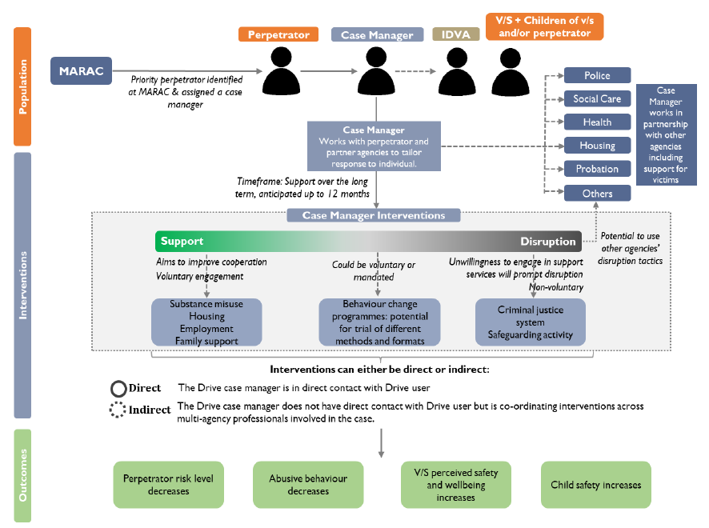

Under the original DRIVE model all cases remained open for 10 months regardless of the engagement of clients referred into the project or the length of disruption work undertaken. This time requirement will no longer be in place, allowing flexibility in dealing with individual cases. These changes have been made in response to practitioners’ experience of the Drive programme. This will allow an improved allocation of resources and better outcomes for victims.

5.0 DRIVE Work and Performance

Cost: £250,000. Area: Colchester and Tendring. Outcomes:

- Reduction of 55% in use of all physical abuse
- Reduction of 22% in use of all sexual abuse
- Reduction of 40% in use of all harassment and stalking
- Reduction of 42% in use of all jealous and controlling behaviour.

DRIVE was evaluated independently by the University of Bristol. Key findings from the year two evaluation were identified as;

- The number of DRIVE service users using each type of abusive behaviour reduced substantially: physical abuse reduced by two-thirds; sexual abuse reduced by over three quarters; controlling behaviour and harassment and stalking both reduced by over half.
- IDVA reporting on the victim/survivor experience of abusive behaviours indicated that victims/survivors in the control group, where DRIVE was not involved, were almost 3 times more likely to experience physical abuse at case closure than victim/survivors associated with DRIVE service users.
- IDVA reporting on the risk posed to victims/survivors also indicated that risk was permanently eliminated in twice as many cases for victims/survivors in the DRIVE associated group (13%) than for those in the control group (6%).
- Analysis of police data shows a 30% reduction in number of criminal DA incidents for Drive service users in the 6 months after the intervention compared to 6 months before. By comparison, there was no change for control group perpetrators over the same period.

6.0 Implications (Issues)

The Columbus project will run for one year at a cost of £237k. This has been funded by the PFCC, Essex County Council and Southend-on-Sea Borough Council.

Commissioners, operating through the governance structures of the SET domestic abuse board, will be required to make decisions within 2019-20 about activity post-March 2020 when national VAWG funding and the locally agreed Columbus funding will terminate. This will be informed by an ongoing evaluation project, commissioned by the PFCC into the VAWG Transformation Fund projects.

6.1 Links to Police and Crime Plan Priorities

Both DRIVE and Project Columbus directly impact on the following priorities set out in the Police and Crime Plan.

- Breaking the cycle of domestic abuse
- Reverse the trend in serious violence
- Protecting children and vulnerable people

6.2 Demand

Within the PA Consulting Demand Analysis Report it states demand is increasing across many areas of the Public Protection workload with particularly notable rises in domestic abuse, missing persons and adult safeguarding demand. Significant additional staff may be needed here to cope with increasing demand and to enable a shift back towards preventative policing.

The below chart shows the predicted demand for year 19/20. Project Columbus will be a key tool to enhance the ability of police and partners to prevent further harm being caused to victims and children.

Demand Drivers | Previous Volume | Current Volume | % Increase Based on Demand Analysis | % Change Based on Population Increase and External Research³ | Projected Volume
 |  |  |  |  | FY17/18 | FY18/19 | FY19/20
Unweighted crime / incident volumes¹ | 34,330 (FY15/16) | 43,595 (FY16/17) | 27.0% |  | 55,360 | 70,301 | 89,274
 |  |  |  | 10.7 % for DA | 15,173 | 16,796 | 18,593
 |  |  |  | 0.9% for others | 30,145 | 30,403 | 30,663
Crime Severity- weighted crime volume² | 13,118,212 (FY15/16) | 14,556,694 (FY16/17) | 11.0% |  | 16,152,913 | 17,924,166 | 19,889,646
 |  |  |  | 10.7 % for DA | 8,839,792 | 9,785,650 | 10,832,714
 |  |  |  | 0.9% for others | 6,627,544 | 6,684,234 | 6,741,408

6.3 Risks/Mitigation

The current risks relating to Columbus are detailed below and managed through SETDAB

The table over the page summarises the key risks identified for the DRIVE project.

Risk ID | Date Raised and by whom | Risk Title and Description | Probability | Impact | Proximity | Score | Proposed Countermeasures and Record of Actions Taken | Risk Owner(s)
1 | 02.04.19 | Considering perpetrator actions at MARAC impacts on timeliness target. | 1 | 2 | 3 | 6 | Monthly MARAC Steering Groups monitor risks. | Alison Gilmour
2 | 02.04.19 | Project Columbus (working in Southend and Essex) is funded for 12 months, funding beyond this is uncertain. | 3 | 2 | 1 | 6 | Perpetrator projects are being evaluated so that a report is available by Sept 2019 to inform future commissioning decisions. | Elliott Judge and Greg Myddelton
3 | 02.04.19 | Capacity for Essex Police to complete perpetrator actions set at MARAC (Central Referral Unit). | 2 | 3 | 3 | 18 | Essex Police have increased capacity and set up a new Tasking unit who will receive MARAC actions. Police will monitor task completion. | Elliott Judge

6.4 Equality and/or Human Rights Implications

There are no identified issues in relation to Equality or Human Rights.

6.5 Health and Safety Implications

There are no identified issues in relation to Health and Safety.

7.0 Consultation/Engagement

Greg Myddelton PFCC
Alison Gilmour Head of SET Domestic Abuse Partnerships.
DCS Worron

8.0 Actions for Improvement

Development of an inclusive model, supporting the work in other agencies where input regarding perpetrators is relevant.

9.0 Future Work/Development and Expected Outcome

The new model – ‘Columbus’.
Cost £237,000. Area: Essex & Southend.

The proposed team consists of a Senior Practitioner, 3 full time DVA Perpetrator Workers, a sessional budget to use for additional practitioner time and a part time Partner Support Worker.

The Process: DVA Perpetrator Workers (including the Senior Practitioner) will attend the 5 weekly MARAC meetings in Essex and Southend (Thurrock MARAC have chosen not to fully participate in this model). Each DVA Perpetrator Worker will have responsibility for 1 MARAC day and alternate attendance at the 5th MARAC day between the team. The bulk of cases will be allocated at MARAC but the project will also be open to direct referrals from Essex Police based on the RFG score.

General ambitions:
- Attendance at all MARACs in Essex and Southend
- 10% of cases presented at MARAC allocated to the DVA Perpetrator team

Severity of Abuse targets (measured during direct work with perpetrator)
- Reduction of 47% in use of all physical abuse
- Reduction of 30% in use of all sexual abuse
- Reduction of 31% in use of all harassment and stalking
- Reduction of 33% in use of all jealous and controlling behaviour.
These baseline targets have been set using the Drive experience.

In 2017/18 Essex and Southend MARACs received 2,220 referrals including 54 non-Police referrals. With disruption activity happening at MARAC we estimate that approximately 222 cases (10%) will be allocated to the DVA Perpetrator Worker.

The experience of DRIVE Essex is that there is an approximate contact success rate of 25%. The project will be flexible to referrals direct from agencies and we have estimated one per month. Whilst this number will be around 50, these are high risk perpetrators. The interventions will be intense and specialist so whilst the raw numbers may be low the opportunity to reduce harm and the potential impact of the project is considerable.

During the three years DRIVE operated in Essex 252 perpetrators were selected. 101 (40%) of which engaged with the project. The remainder were subject of disruption activity only. The below charts shows the abuse at intake vs closure for all 252 closed cases as well as the same measures for the 101 that did engage.
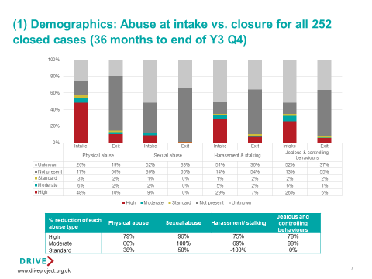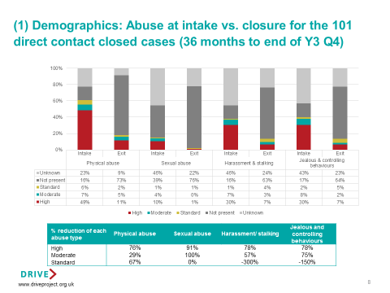

Project Columbus workers will attend all MARAC meetings in Essex and Southend and contribute to action planning for perpetrators in all cases heard. If successful we will re-evaluate and seek to increase the scale (if that is the ambition of the DA Board), this will however come at a financial cost.

The below chart details the number of domestic abuse perpetrators that have repeat offended by risk level and the number of times that they have reoffended over the last 12 months.
Risk level | No of repeat perps on two occasions | No of repeat perps 3 occasions | No of repeat perps 4+ occasions | Total
Standard | 2124 | 638 | 479 | 3241
Medium | 579 | 266 | 361 | 1206
High | 301 | 153 | 200 | 654
Total | 3004 | 1057 | 1040 | 5101

The number of repeat perpetrators is huge and it is the ambition of the Perpetrator Steering Group to make early recommendations to SETDAB as to how Columbus could be scaled up to tackle all repeat perpetrators for each level of risk. At this time it is too early to be able to predict costings.

