**Performance and Resources Scrutiny Programme 2019**

**Report to: the Office of the Police, Fire and Crime Commissioner for Essex**

|  |  |
| --- | --- |
| **Title of Report:** | **An evaluation of ‘what works’ in addressing ASB and consideration of any link between failing ASB levels and the focus on crime data accuracy** |
| **Agenda Number:** | **6.0** |
| **Chief Officer** | **ACC Andy Prophet** |
| **Date Paper was Written** | **April 2019** |
| **Version Number** | **0.2** |
| **Report from** | **Essex Police** |
| **Date of Meeting** | **30th April 2019** |
| **Author** | **Jan Bloomfield** |
| **Date of Approval** | **18/04/2019** |

1. **Purpose of Report**

This paper follows a report submitted for Performance and Resources scrutiny in October 2018. That report provided data (from the previous 12 months) identifying a 4% reduction in the levels of reported Anti-Social Behaviour (ASB). The Board requested more evaluation of ‘what works’ and an assessment of any link between the focus on crime data accuracy and the reduction in recorded ASB.

1. **Recommendations**

There are no specific recommendations but the Board is asked to note, and invited to comment upon, the content.

**3.0 Introduction/Background**

This paper has been requested to describe an evaluation of what works, in a national and local context, to combatting ASB and an assessment of any link between the focus on crime data accuracy and the reduction in recorded ASB.

**4.0 Current Work and Performance**

The most recent 12 months of ASB data (March 2018 to March 2019) highlight that levels continues to decrease across Essex.

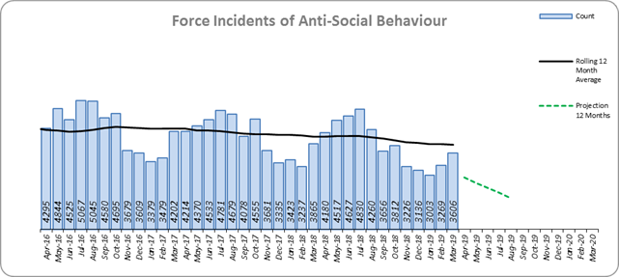

During the same period there has been a significant increase in reports of harassment many of which are believed to have been previously incorrectly recorded as ASB.

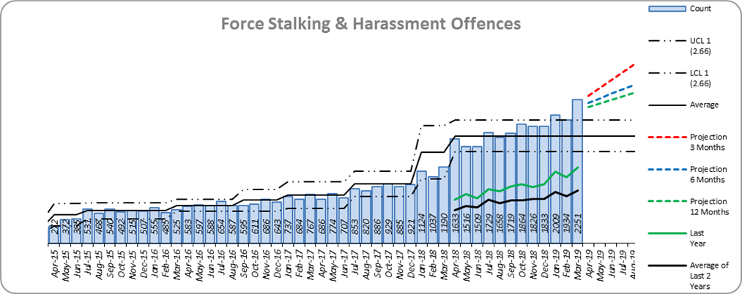

**What Works?**

Based on national research and college of policing best practice suggestions interventions broadly focus on 3 areas and these are widely used across Essex;

* **Early Interventions**
* **Coercive and Developmental Interventions**
* **Situational Interventions**

**Early Interventions** seek to prevent the onset of offending and are generally targeted at young people. Research indicates that future ASB can be prevented through interventions aimed at helping families overcome problems that may lead to the onset of these behaviours. Early intervention to divert individuals from offending has been found to be one of the most effective types of intervention overall, it is therefore imperative that the Police Service explores opportunities for early intervention.

Examples of where early intervention is being utilised in Essex include;

* The Essex Police Youth Justice Team scheduled for launch in June 2019 which will divert minor criminal behaviour directly to an early help agency that can provide an intervention to address the behaviour that is causing the harm
* Essex Fire & Police Youth Engagement Officers presenting to a universal group of children in schools.
* Use of Acceptable Behaviour Contracts with adults and young people
* Referral to RJ Hub.
* Referral to the Preventing Offending With Emotional Resilience (POWER) Team
* CPT early engagement via engagement operations
* Supporting community safety programmes
* Working closely with partner agencies
* Organising joint operations days with Police and Community Safety Partners
* Maximising the use of Verbal and Written Warnings
* Information sharing with housing and local authorities
* Encouraging young people into diversionary activities

**Coercive and Developmental Interventions** include the use of enforcement tactics such as a Community Protection Notice or Criminal Behaviour Order.These sanctions are useful as they seek to manage ASB by prohibiting and modifying certain behaviours. Unlike their predecessors (ASBOs), they are relatively quick to achieve in the courts and can be a very useful tool against adults and some young people (16+) who are causing the most harm.

There is no current research evaluating the effectiveness of these type of orders, but the available evidence indicates that coercive sanctions cannot be relied on to prevent, or even necessarily to reduce, re-offending, particularly among young people.

The most extensive meta-analyses of programme evaluations (Lipsey) concluded that ‘deterrent’ or coercive sanctions appear to have negative effects on recidivism, leading to an average increase in the incidence of re-offending. However, one research finding did suggest that individuals with low self-control and high impulsivity (criminal propensity) might in fact respond positively to the threat of punishment.

Examples of where Essex Police are using **Coercive Interventions** include;

* Community Protection Warnings
* Community Protection Notices
* Criminal Behaviour Orders
* Gang injunctions

Essex Police uses **developmental interventions** where there is a partnership approach to the harmful behaviour being committed. There is limited empirical evidence on their effectiveness but anecdotal evidence indicates that such educational interventions are more costly than many other approaches.

Examples in Essex include;

* Referrals to the Restorative Justice (RJ) Hub
* Partners in the Youth Offending Service Multi-Systemic Therapy or referring to parenting support
* Acceptable Behaviour Contracts

**Restorative Justice** is a process whereby the parties with a stake in the particular offence come together to resolve collectively how to deal with the aftermath of the offence and its implications for the future. Of all the interventions described in this report, only Restorative Justice involves not just the offender but the victim. Research on the success of restorative justice indicates a high (70%) success rate. However, this relates to interventions that are carefully planned by experts and not a “Street RJ” which is often no more than a verbal warning and apology that is passed via a police officer.

**Family based interventions** have also seen success in preventing re-offending, including parenting programmes and Multi-Systemic Therapy (MST). There is some research abroad to find these programmes to reduce offending of young people as well as preventing offending by younger siblings.

**Acceptable Behaviour Contracts** (ABCs) are sometimes referred to by housing providers as Good Neighbour Agreements and are a voluntary agreement made between the individual and a local agency (police, housing, council, school) allowing an offender to acknowledge their ASB, recognise its negative impact on others and agree to either stop the behaviour outright or engage in positive activity such as a diversion scheme. ABCs can be used with adults and young people and relevant agencies can work in partnership to issue a contract.It is important that if issued, they are supervised over a period of time (6 months) and the supervising agency must encourage positive behaviour and engagement.

**Situational Interventions** are designed to reduce the opportunities to offend and can be an effective means of reducing crime and ASB. Many situational interventions reflect the Broken Windows Theory (Wilson & Kelling 1982), for example there are evaluations that indicate improved street lighting leads to significant reductions in crime and ASB with an overall reduction in recorded crime of 20% across all the experimental areas (Farrington and Welsh, 2002). This is due to increased surveillance of potential offenders as well as signalling that the community is increasing investment in the area.

Examples of **situational interventions** in Essex include;

* The Licensing Team working with the Night Time Economy to remove glasses or bottles from pubs and the simultaneous closing of nightclubs
* The designing Out Crime Team working with local authorities and developers to create safer environments
* Working with councils to improve street lighting
* Working with town centres to ensure taxis are readily available
* Working in partnership with charities including drug & alcohol agencies and Street Pastors
* Working with partners to clear abandoned derelict areas/buildings to increase perception of public safety
* Issuing Fixed Penalty Notices in the early evening to reduce offences being committed later in the evening
* Dispersal Powers in town centres and ASB hot spots
* High visibility patrols by PCSOs alongside strong engagement tactics
* Working in partnership to achieve Public Spaces Protection Orders (PSPO)
* Working in partnership to take positive action where breach of PSPO occurs
* The increase in the various Watch schemes county-wide

**5.0 Implications (Issues)**

Community Protections Notices (coercive intervention) have been highly successful within Essex Police and across the partnerships where local authorities actively use them.

**5.1 Links to Police and Crime Plan Priorities**

**Building Block 1: Prevention**: improving the wellbeing of people across Essex, making sure that crime and anti- social behaviour do not happen in the first place and that children and vulnerable people are kept safe from harm.

**Priority 1 - More Local, Visible and Accessible Policing**; Particularly:

E: Expect every Community Safety Partnership to set local priorities for their local Community Policing Team to ensure community confidence in the police.

F: Working with our partners we will establish Community Safety Hubs in every policing district with police co-located with local community safety partners to deliver joined up responses to tackle locally defined priorities.

**Priority 2 - Crack down on Anti-Social Behaviour**; A –F

**5.2 Demand**

Effective approaches to ASB, particularly those that focus on repeat or future offending will have a positive impact on demand by negating future behaviour.

**5.3 Risks/Mitigation**

None identified.

**5.4 Equality and/or Human Rights Implications**

There are no identified impacts on equality, diversity or human rights.

**5.5 Health and Safety Implications**

None

**6.0 Consultation/Engagement**

* LPSU
* Performance Information Unit
* Head of Contact Management
* Information Management Team (re information sharing issue only)

**7.0 Actions for Improvement**

In dealing with ASB, officers must ensure they focus on the risk factors that increase the likelihood of offending behaviour, relate the level of intervention to the seriousness of the offence, target high and medium-risk offenders, attend to the context in which criminal activities tend to take place and remove opportunities where possible. Investigations need to demonstrate an action plan that has aims, methods, resources and evaluation that is integrated and consistent.

There are numerous examples of where this is already happening on a daily basis but dip-sampling indicates there is room for improvement. LPSU will therefore be providing training events throughout the summer for Community Policing Teams, including PCSOs (who have recently been issued with increased powers to respond to ASB).

Criminal Behaviour Order (CBO) applications have been highlighted in this report as a further area for improvement. LPSU has been working with the Crown Prosecution Service to create a 7 point aide- memoire for use by CPS to ensure their staff fully understand the process with the aim of achieving more successful applications.

**8.0 Future Work/Development and Expected Outcome**

The necessity to conduct strong problem solving using SARA model (Scanning, Analysis, Response, Assess) before is paramount to successful outcomes.

The Essex Police ASB Team will be attending the National ASB Conference (Problem Solving and Demand Reduction) hosted by South Yorkshire Police in April 2019. This will ensure Essex Police is briefed on the latest and best practice for maximising the use of problem solving approaches which will be cascaded to CPTs.

LPSU will be working with Contact Management to enhance our understanding of how we are recording Harassment (ASB) and Harassment (crime) to increase confidence in both crime recording and ASB investigations being managed by CPTs.

LPSU and Contact Management will also be working together to understand how the Resolution Centre will impact ASB investigations.

The continuing reduction in reports of ASB can be seen as a positive, but, as discussed above, more detailed analytical work would be required to understand further how much is linked to changes in crime recording methodology. This can only be achieved if resources are committed to manually review all reports of Harassment to identify whether this would previously have been recorded as ASB. LPSU is working with the Crime Data Team to understand how reports are being distinguished between Harassment ASB and Harassment Crime to ensure patterns of ASB are not being missed.

LPSU will conduct a Community Protection Notice review, including how ASB Officers can enhance every Notice issued to avoid appeals being lodged in addition to creating an internal force procedure and further guidance on issuing Community Protection Warnings and Notices to minimise the likelihood of an appeal.

LPSU will be conducting a series of training sessions across the Summer to ensure CPTs are empowered to utilise ASB legislation effectively.

LPSU will be working with Information Management on the development of Information Sharing Agreements with housing providers.

A necessary requirement in resolving ASB is to share information with partners so they can take the appropriate action to keep victims safe and use enforcement tactics against perpetrators. Essex Police currently shares information with Community Safety Partnerships and housing providers within Essex and additionally, social landlords based in the London Boroughs via the provisions of S115 of the Crime & Disorder Act 1998. LPSU will be exploring, via the Community Safety Hubs and the Information Management Team, whether our information sharing arrangements with these organisations meet the revised requirements of the Data Protection Act and the introduction of the EU General Data Protection Regulation (GDPR).

Additionally, the Youth Justice Team and core partners will be exploring other intervention methodology such as Cognitive Behaviour Approaches which aim to address the ways in which thoughts, feelings and behaviour are interrelated and which regard dysfunctional behaviour as a product of personal/ internal and situational/ external factors (Feilzer *et al*, 2004) and other successful interventions focused on individual counselling, interpersonal skills training and behaviour programmes which have been shown to reduce recidivism by 40% (Youth Justice Board, 2001).