**Crime Prevention Strategy Data**

**Date: 18th March 2019**

**Version No: 1.0**

**Unit: Performance Analysis Unit**

**Contact: Mark Shaw 42071402**

**Sensitivity: Official**

1. **Domestic Abuse**

Domestic Abuse has seen a year on year increase of 46.3% (8,023 additional offences) for the 12 months to February 2019.

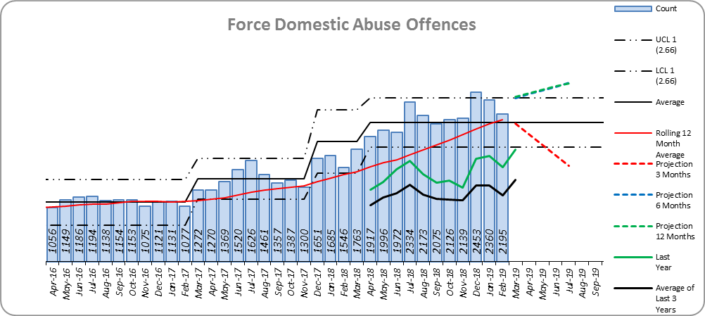

The latest quarter (Dec 2018 to Feb 2019) has seen a 79.2% increase when compared to the same quarter in the previous year, and a 10.5% (668 offences) increase when compared to the previous quarter (Sep 2018 to Nov 2018).



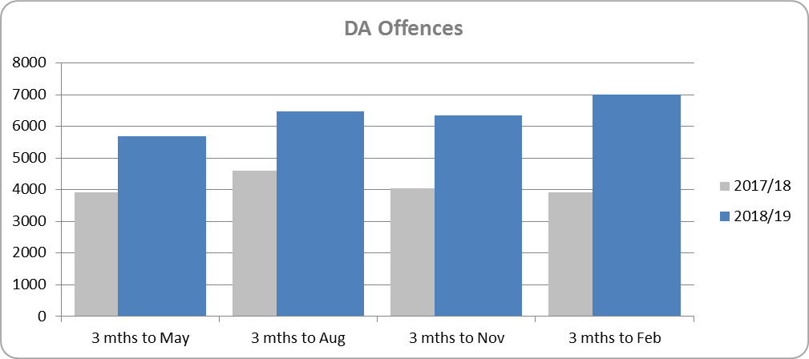

High Risk Domestic Abuse has seen a year on year increase of 21.0% (424 additional offences) for the 12 months to February 2019.

The latest quarter (Dec 2018 to Feb 2019) has seen an 11.3% increase when compared to the same quarter in the previous year, and a 4.6% (26 offences) increase when compared to the previous quarter (Sep 2018 to Nov 2018).



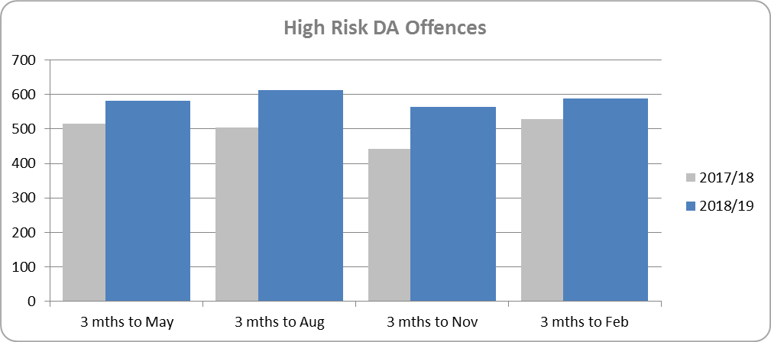

Medium Risk Domestic Abuse has seen a year on year increase of 7.4% (328 additional offences) for the 12 months to February 2019.

The latest quarter (Dec 2018 to Feb 2019) has seen an 8.0% increase when compared to the same quarter in the previous year, and a 2.8% (32 offences) increase when compared to the previous quarter (Sep 2018 to Nov 2018).



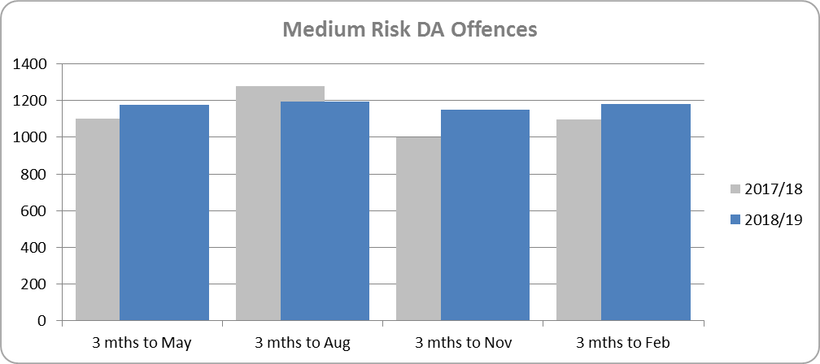

Standard Risk Domestic Abuse has seen a year on year increase of 59.7% (6,153 additional offences) for the 12 months to February 2019.

The latest quarter (Dec 2018 to Feb 2019) has seen a 57.2% increase when compared to the same quarter in the previous year, and a 15.1% (584 offences) increase when compared to the previous quarter (Sep 2018 to Nov 2018).



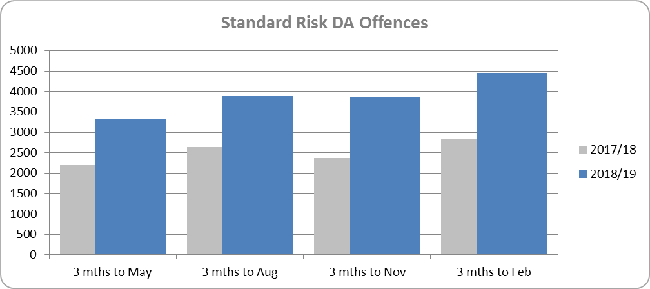

No Risk Domestic Abuse has seen a year on year increase of 183.6% (1,118 additional offences) for the 12 months to February 2019, from 609 last year to 1,727 this year.

1. **Gangs and Knife Crime**

**Knife Crime Offences**

Knife Crime has seen a year on year decrease of 16.0% (260 fewer offences) for the 12 months to February 2019.

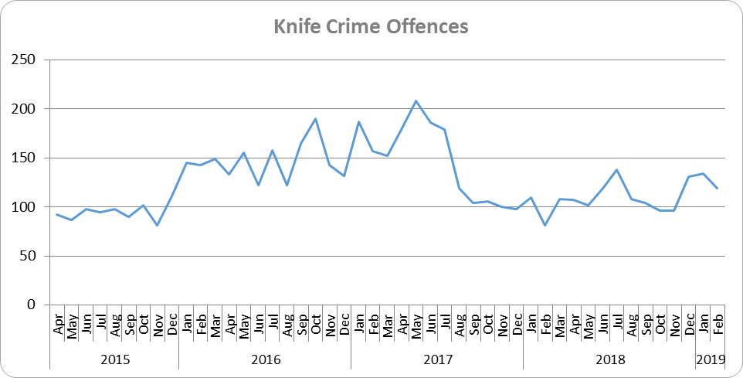

The latest quarter (Dec 2018 to Feb 2019) has seen a 32.9% increase when compared to the same quarter in the previous year, there has also been a 29.7% (88 offences) increase when compared to the previous quarter (Sep 2018 to Nov 2018).



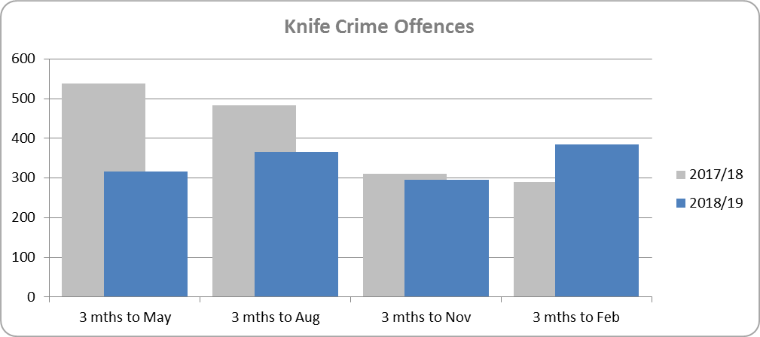

1. **Night-Time Economy**

The trend for NTE offences (Violence against the Person, Arson, Criminal Damage, Rape and Other Sexual Offences committed between 2100-0500 hours in designated NTE areas) is slowly declining. Offences have increased in the last quarter, however, particularly when compared to the same period (December to February included) the previous year.

The rise in offences committed in the last quarter has been driven by the rise in North LPA, particularly Chelmsford and Colchester.





1. **Sexual Crime, Child Abuse and Exploitation**

**Sexual Crime**

Sexual Crime has seen a year on year increase of 12.6% (465 additional offences) for the 12 months to February 2019.

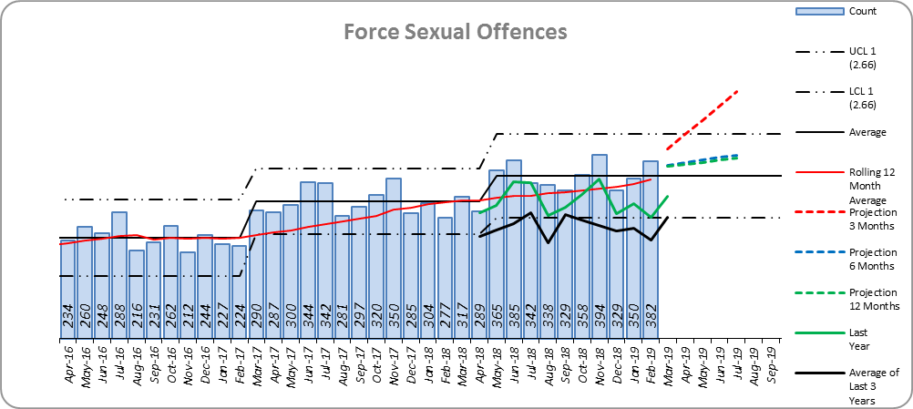

Essex is ranked 3rd in our MSG and 6th nationally for crimes per 1,000 of the population.

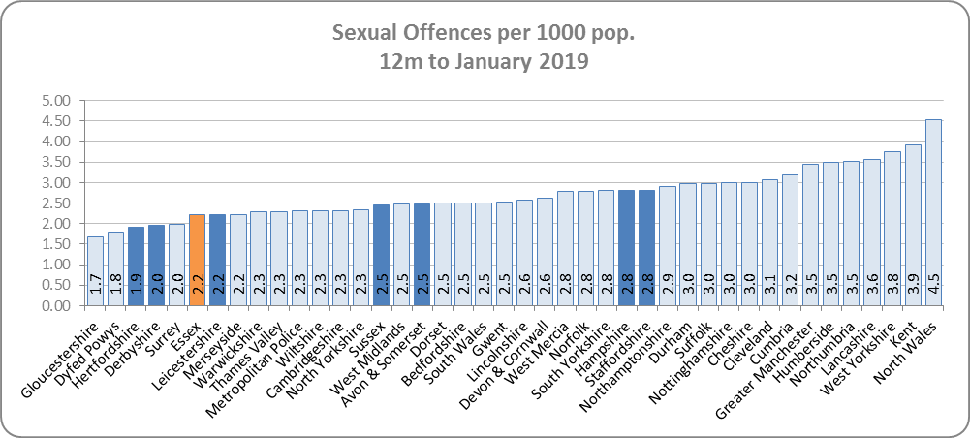

The latest quarter (Dec 2018 to Feb 2019) has seen a 22.5% increase when compared to the same quarter in the previous year, however there has been a 1.9% (20 offences) decrease when compared to the previous quarter (Sep 2018 to Nov 2018).



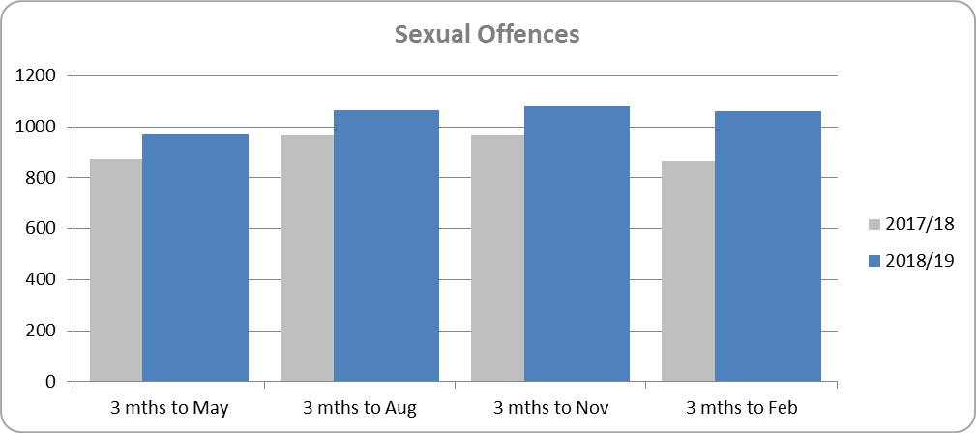

Rape has seen a year on year increase of 20.3% (273 additional offences) for the 12 months to February 2019.

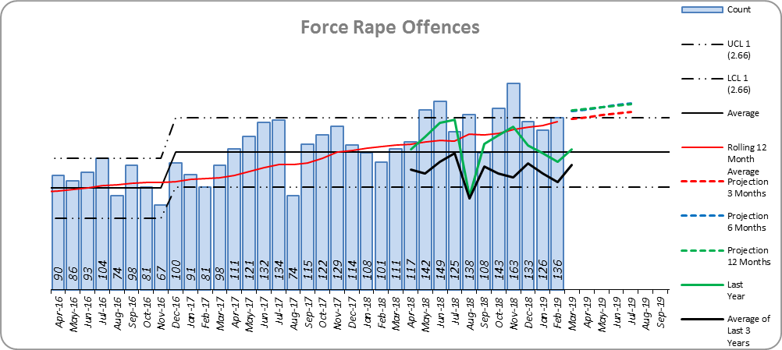

Essex is ranked 5th in our MSG and 14th nationally for crimes per 1,000 of the population.

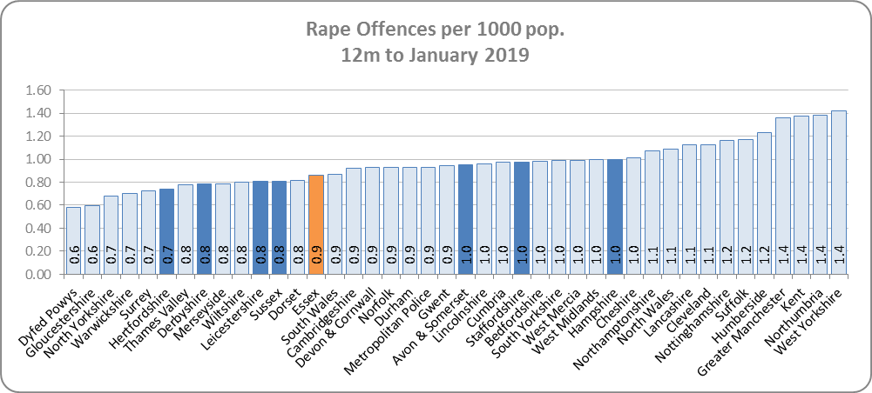

The latest quarter (Dec 2018 to Feb 2019) has seen a 22.3% increase when compared to the same quarter in the previous year, however there has been a 4.6% (19 offences) decrease when compared to the previous quarter (Sep 2018 to Nov 2018).



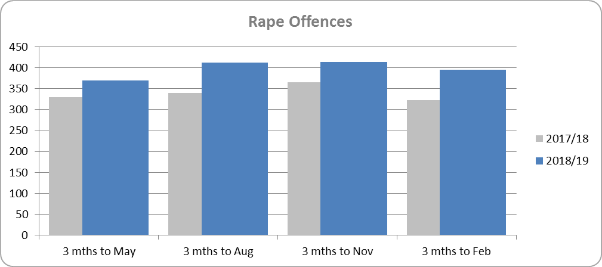

Other Sexual offences have seen a year on year increase of 8.2% (192 additional offences) for the 12 months to February 2019.

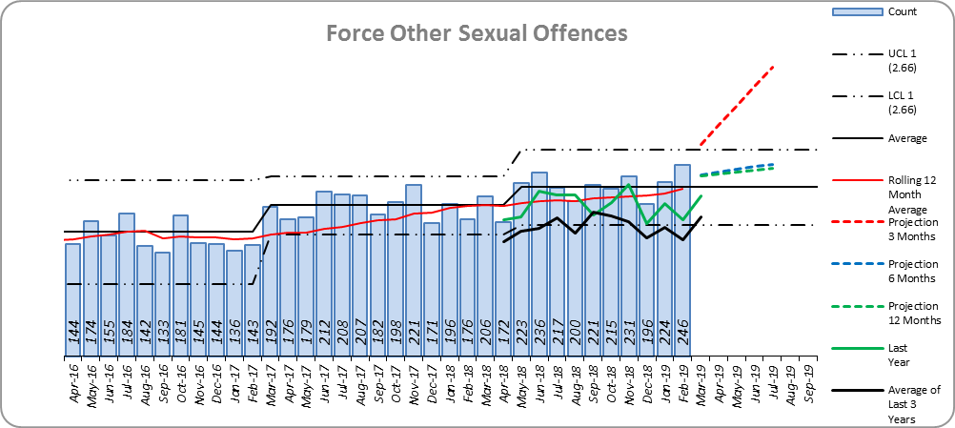

Essex is ranked 3rd in our MSG and 6th nationally for crimes per 1,000 of the population.

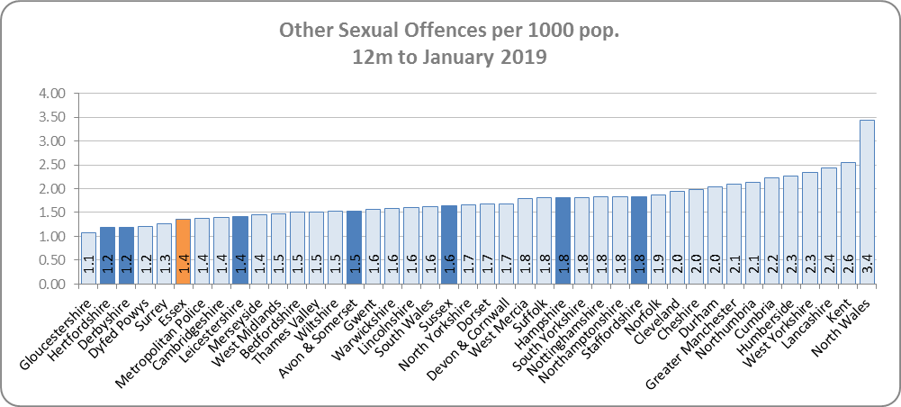

The latest quarter (Dec 2018 to Feb 2019) has seen a 22.7% increase when compared to the same quarter in the previous year, there has been a 0.1% (1 offence) decrease when compared to the previous quarter (Sep 2018 to Nov 2018).



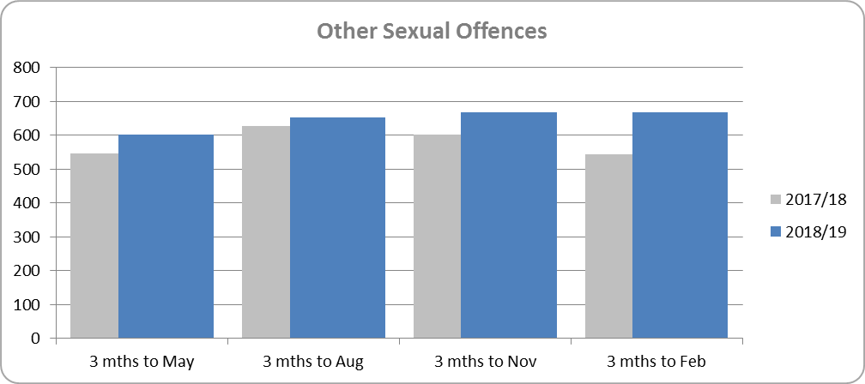

**Child Sexual Abuse & Sexual Exploitation Offences**

Child Sexual Abuse & Sexual Exploitation has seen a year on year increase of 7.1% (82 additional offences) for the 12 months to February 2019.

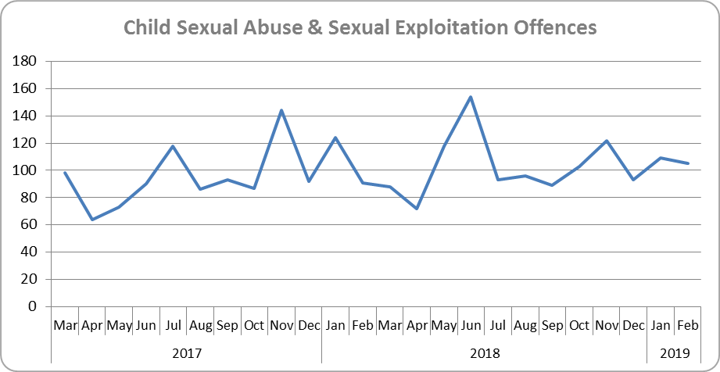

The latest quarter (Dec 2018 to Feb 2019) has seen no change when compared to the same quarter in the previous year, there has been a 2.2% (7 offences) decrease when compared to the previous quarter (Sep 2018 to Nov 2018).



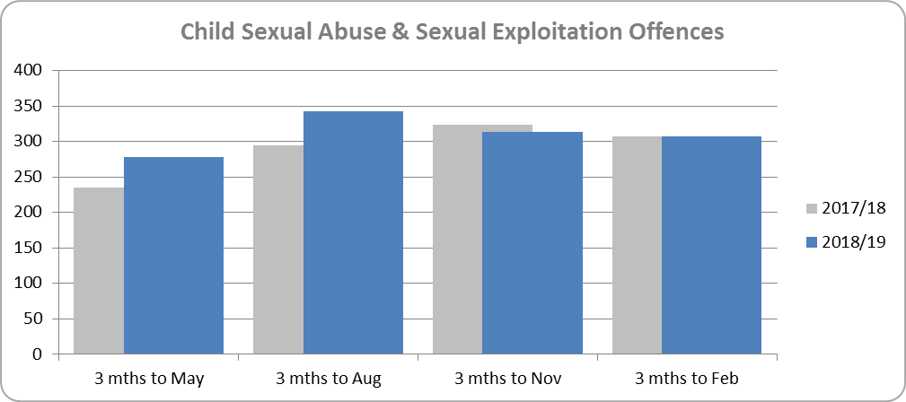

1. **Digital Crime and Fraud**

**Cyber & Online Crime Offences**

Cyber and Online Crime have seen a year on year increase of 17.0% (624 additional offences) for the 12 months to February 2019.

The latest quarter (Dec 2018 to Feb 2019) has seen a 45.5% increase when compared to the same quarter in the previous year, there has also been a 16.3% (171 offences) increase when compared to the previous quarter (Sep 2018 to Nov 2018).



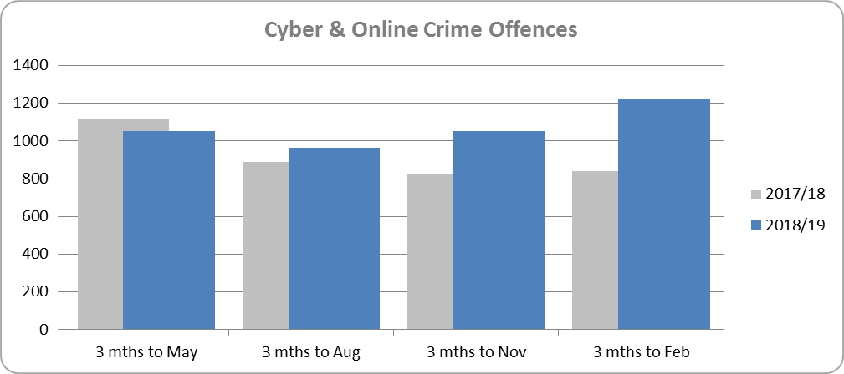

**Fraud Offences**

Fraud has seen a year on year decrease of 8.8% (218 fewer offences) for the 12 months to February 2019.

The latest quarter (Dec 2018 to Feb 2019) has seen a 46.9% decrease when compared to the same quarter in the previous year, there has also been a 12.3% (63 offences) decrease when compared to the previous quarter (Sep 2018 to Nov 2018).



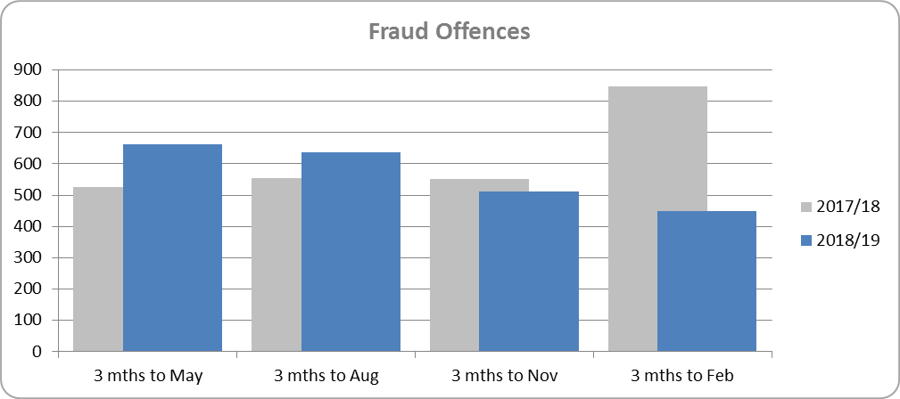

1. **Extremism and Radicalisation**

Data set being developed.

1. **Dwelling Burglary and Personal Robbery Offences**

**Burglary Dwelling Offences**

Dwelling Burglary has seen a year on year decrease of 11.3% (792 fewer offences) for the 12 months to February 2019.

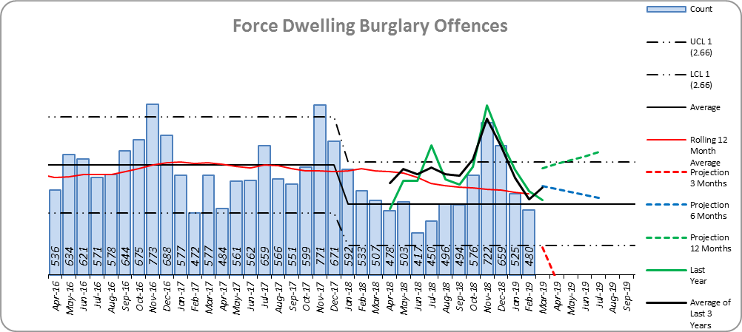

The latest quarter (Dec 2018 to Feb 2019) has seen a 7.3% decrease when compared to the same quarter in the previous year, there has also been a 7.1% (128 offences) decrease when compared to the previous quarter (Sep 2018 to Nov 2018).



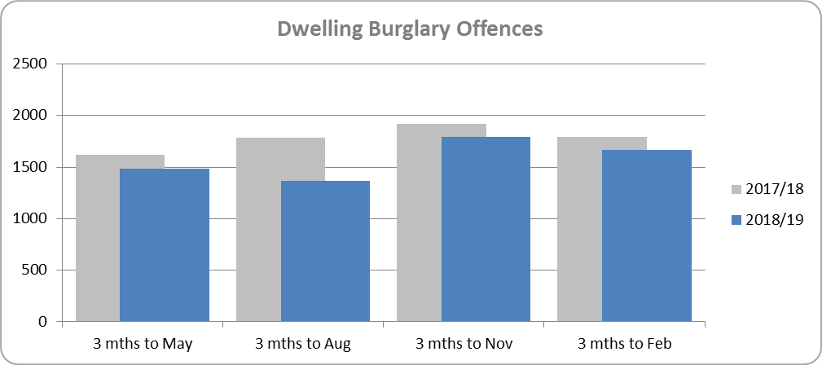

**Personal Robbery Offences**

Personal Robbery has seen a year on year increase of 18.2% (240 additional offences) for the 12 months to February 2019.

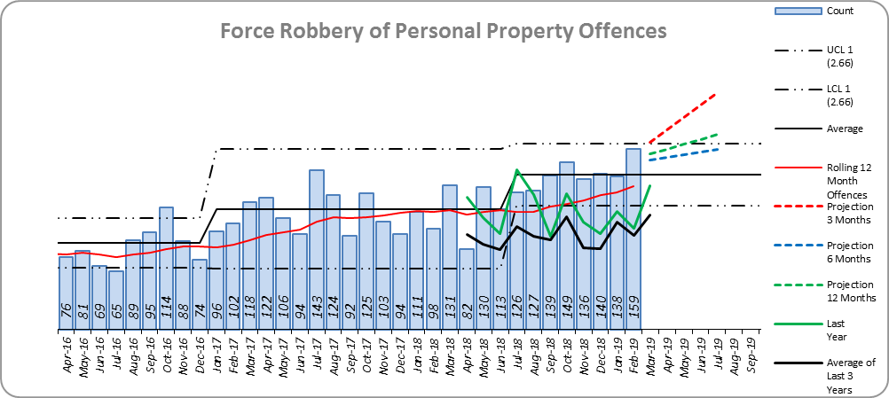

Essex is ranked 7th in our MSG and 28th nationally for crimes per 1,000 of the population.

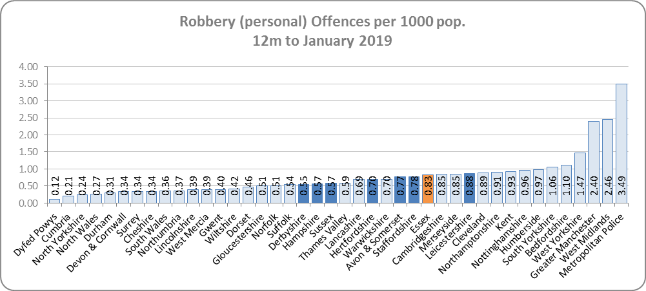

The latest quarter (Dec 2018 to Feb 2019) has seen a 44.2% increase when compared to the same quarter in the previous year, there has also been a 3.1% (13 offences) increase when compared to the previous quarter (Sep 2018 to Nov 2018).



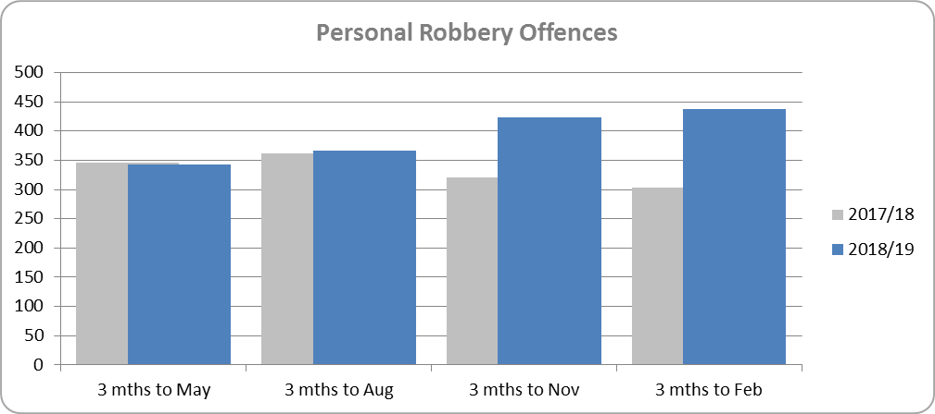

1. **Hate Crime Offences**

Hate Crime has seen a year on year increase of 23.8% (506 additional offences) for the 12 months to February 2019.

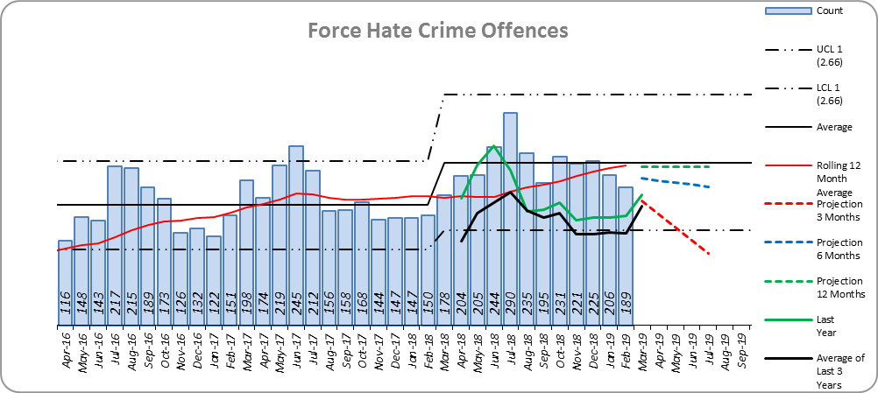

The latest quarter (Dec 2018 to Feb 2019) has seen a 39.6% increase when compared to the same quarter in the previous year, however there has been a 4.2% (27 offences) decrease when compared to the previous quarter (Sep 2018 to Nov 2018).



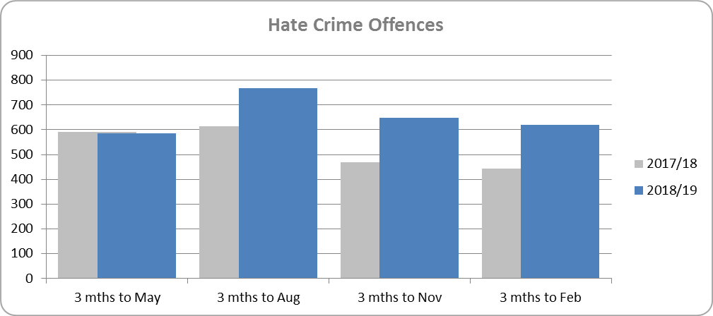

Racial/Religiously Aggravated Crime has seen a year on year increase of 15.8% (190 additional offences) for the 12 months to February 2019.

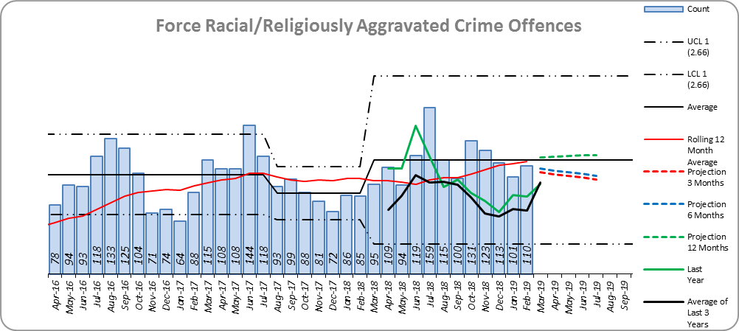

Essex is ranked 4th in our MSG and 23rd nationally for crimes per 1,000 of the population.

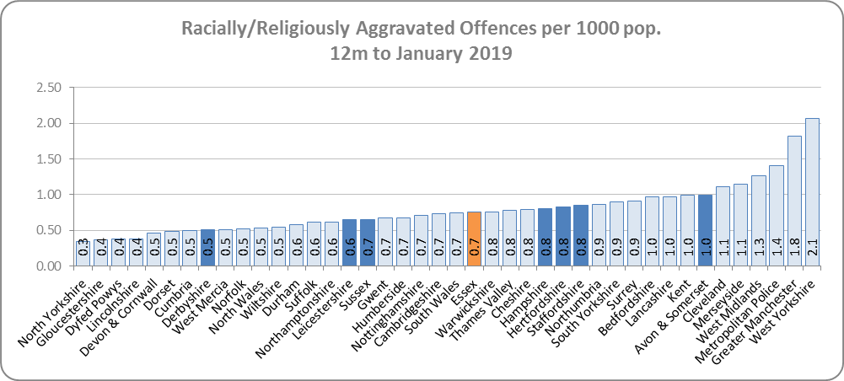

The latest quarter (Dec 2018 to Feb 2019) has seen a 33.3% increase when compared to the same quarter in the previous year, there has been an 8.5% (30 offences) decrease when compared to the previous quarter (Sep 2018 to Nov 2018).



