**Performance and Resources Scrutiny Programme 2018/2019**

**Report to: the Office of the Police, Fire and Crime Commissioner for Essex**

|  |  |
| --- | --- |
| **Title of Report:** | **2018/19 Provisional Revenue, Capital Outturn Report & Draft Unaudited** |
| **Agenda Number:** | **12. ii (a)** |
| **Chief Officer** | **Mark Gilmartin, Director of Essex and Kent Support Services** |
| **Date Paper was Written** | **17th May 2019** |
| **Version Number** | **Version 1** |
| **Report from:** | **Essex Police: Corporate Finance** |
| **Date of Meeting:** | **23rd May 2019** |
| **Author on behalf of Chief Officer:** | **Richard Jones, Head of Business Partnering and Management Accounting**  **Denise Breckon, Chief Accountant** |
| **Date of Approval:** |  |

1. **Purpose of Report**
   1. This report identifies the 2018/19 provisional outturn position for the Force and the draft Unaudited Statement of Accounts.
2. **Recommendations**
   1. To approve the level of earmarked reserves and the General Reserve balances (para 9).
   2. To review the 2018/19 draft unaudited Statement of Accounts.
3. **Executive Summary**
   1. The provisional revenue outturn underspend is **£0.373m**, a reduction of £0.546m from the month 11 overspend of £0.173m.
   2. The police officer strength was **3,064 FTE** at year end, 61 FTE above establishment of 3,003 FTE.
   3. The General Reserve balance is **£9.226m**, after the transfer of the underspend of **£0.373m**, an overall reduction of **£2.996m** during 2018/19.
   4. The provisional year-end balance on the Capital Reserve is **£7.324m** surplus.
   5. The provisional capital expenditure is **£8.178m** and the provisional capital income from property disposals is **£14.867m**.
4. **Introduction/Background** 
   1. This reports sets out the provisional outturn, highlighting the changes from February, month 11 and the draft Unaudited Statement of Accounts.
5. **Current Work and Performance**
   1. The provisional outturn financial position is shown at Annex 1.
   2. The draft Unaudited Statement of Accounts are shown at Part B. There are three Statement of Accounts within two documents. The Group & PFCC accounts are within one document and the Chief Constable’s accounts are in the second. The performance information within the Narrative Report is the same in the Group and Chief Constable’s Statement of Accounts.
6. **Implications (Issues)**
   1. The implications are reported in Annex 1.
7. **Links to Police and Crime Plan Priorities**
   1. The Force budget is used to help meet the priorities of the Police and Crime plan.
8. **Demand**
   1. The Force budget is reviewed and re-allocated within virement rules to match demand e.g. overtime funded by vacancies.
9. **Risks/Mitigation**
   1. Risk Register URN 452 - Short and Long Term Capital Finance.
10. **Equality and/or Human Rights Implications**

N/A

1. **Health and Safety Implications**

N/A

1. **Consultation/Engagement**
   1. N/A
2. **Actions for Improvement**

N/A

1. **Future Work/Development and Expected Outcome**
   1. The transfer of the £0.373m to the General Fund is a decision based upon the understanding that if there are cost pressures in year that require additional revenue, the Chief Constable will call upon the PFCC to authorise a draw down on reserves to meet this rather than put the additional money in an operational contingency fund.

* 1. The unaudited Statement of Accounts are timetabled to be signed by the two Chief Financial Officer’s on Friday 24th May and published on the external websites on Tuesday 28th May. The statutory deadline for signing the draft Statement of Accounts is 31st May.
  2. The on-site external audit inspection is due to commence on Monday 10th June and finish on 19th July. During this time, they will be on-site for four weeks.
  3. The unaudited Statements of Accounts are due to be presented to the Joint Audit Committee on Friday 21st June.
  4. A closure update is due to be presented to Performance and Resources Board on Thursday 27th June.
  5. The Joint Audit Committee followed by the signing of the audited Statement of Accounts is planned for Friday 26th July. The statutory deadline for the final audited Statement of Accounts is 31st July.

1. **Decisions Required by the Police, Fire and Crime Commissioner**
   1. To approve the level of earmarked marked reserves and General Reserve balances.
   2. To review the 2018/19 draft unaudited Statement of Accounts for sign off by the Chief Financial Officers on 24th May and publication on the external websites on Tuesday 28th May.

# Executive Summary – 2018/19 – Provisional Outturn

# Current Position

# Revenue

## Revenue Summary – Provisional Outturn 2018/19



## Main Forecast Movements since month 11



## Analysis of Main Variance Areas



## Top Five Forecast Overspends *(Current budget)*

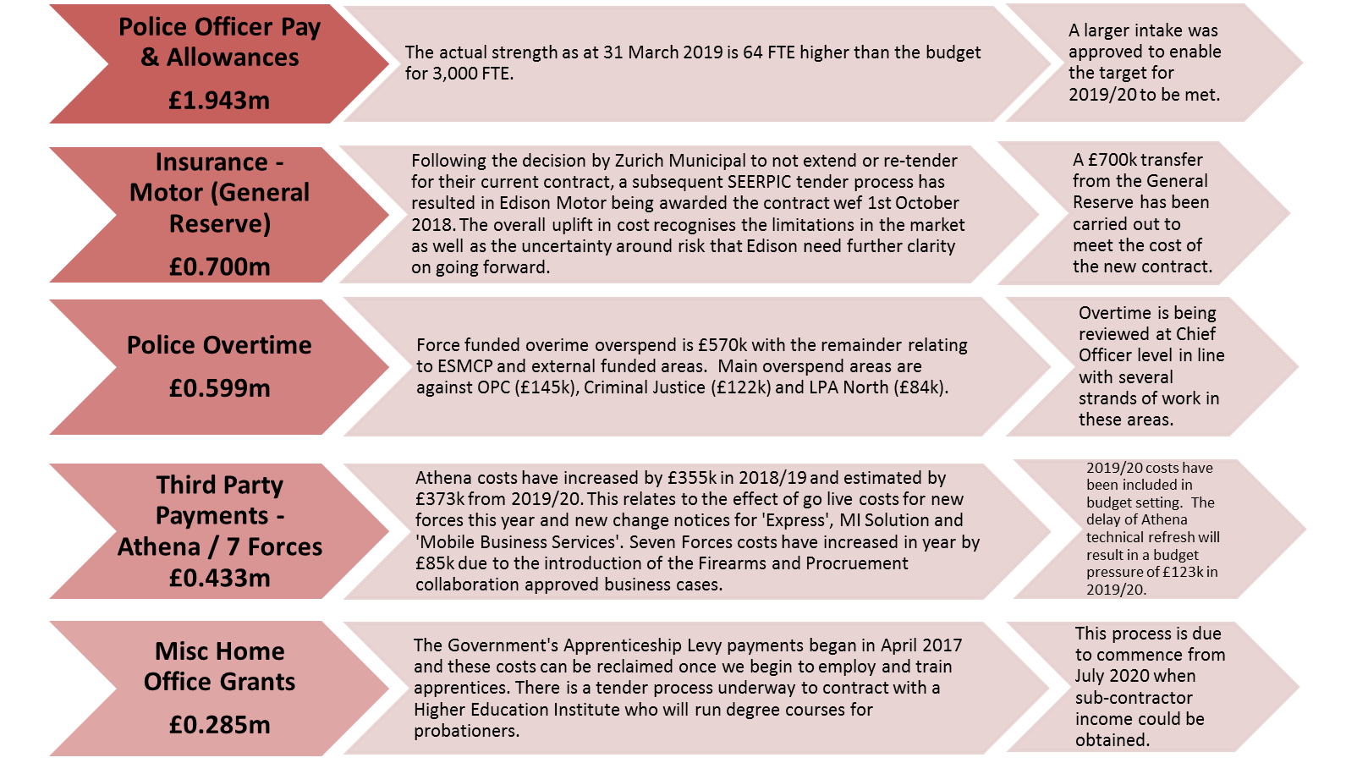

## Top Five Forecast Underspends *(Current budget)*

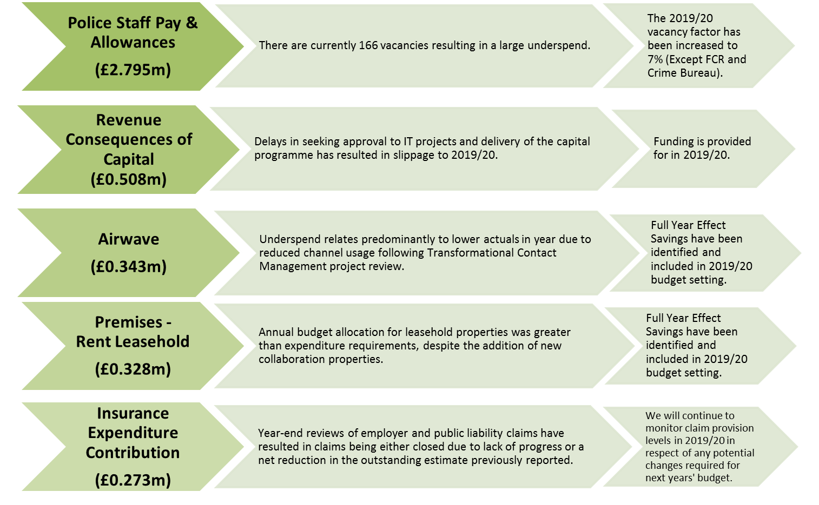

# Police Officer Overtime

## Summary



## Main overspends

# Police Staff Overtime

## Summary



## Main overspends

# Workforce Analysis

## Pay Summary



## Police Officer FTEs

### 



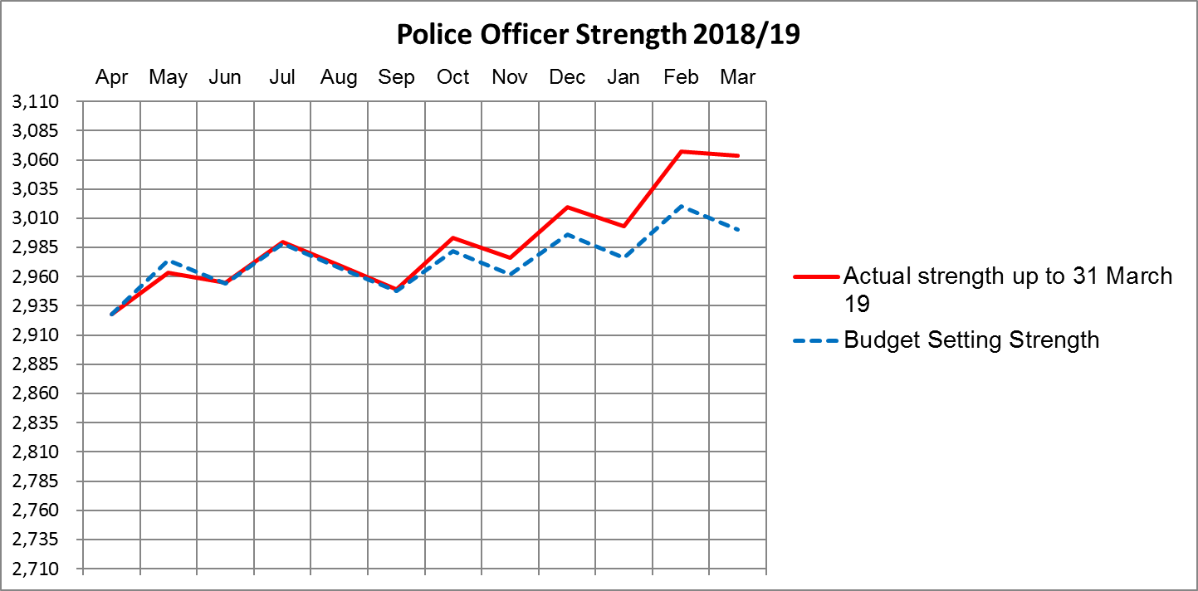

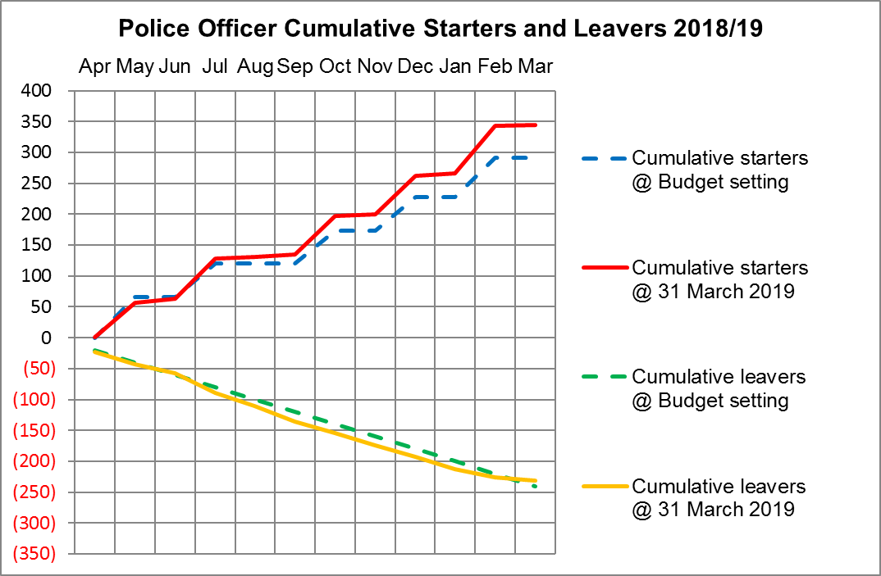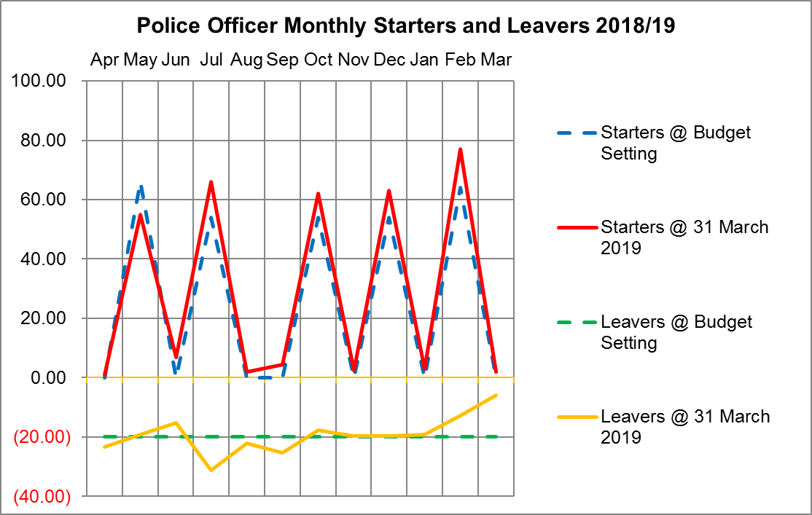

## Police Officers, Police Staff, PCSOs and Specials



# Police Objective Analysis – Level 1



# Virement Analysis

## Virement Analysis – Summary



## Virement Analysis – Detail





# Reserves

## Detail Reserve Analysis



## Transformation Reserve



# Capital

## Capital Expenditure Forecast

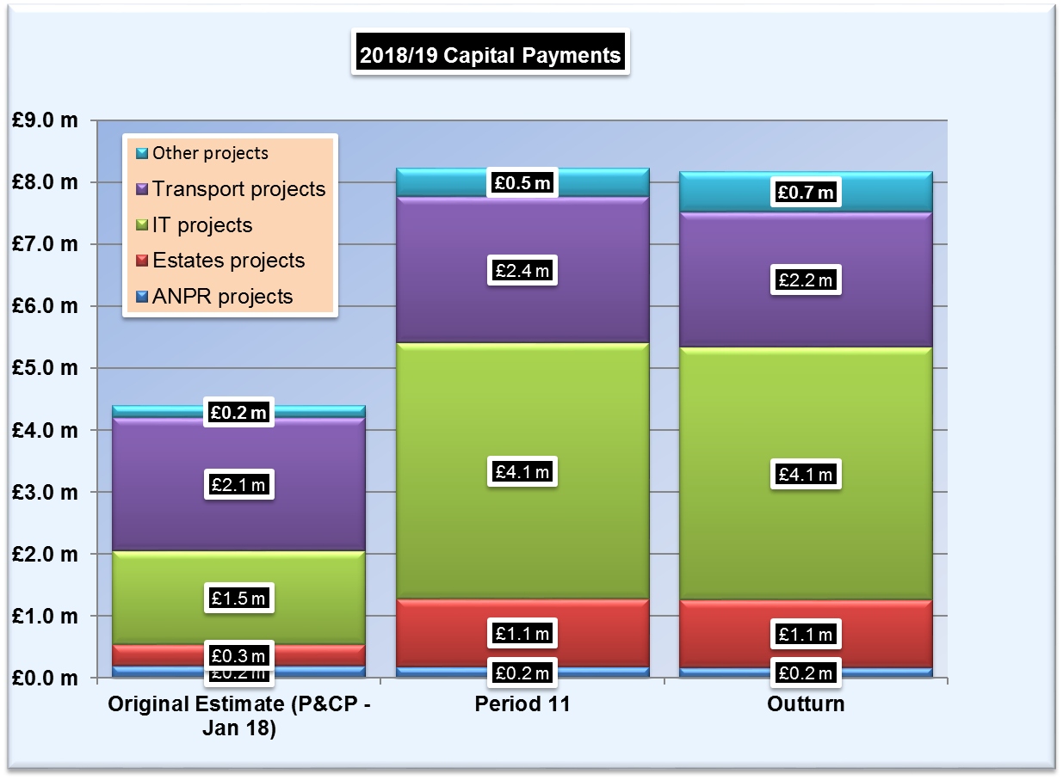

## Movement in Capital Reserve Forecast

## Capital Income

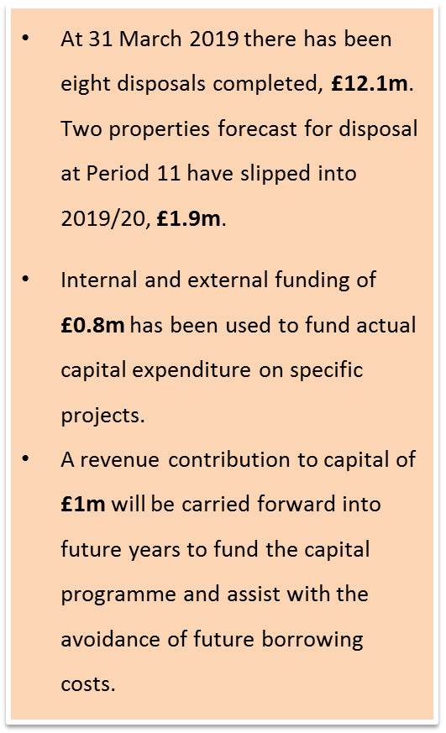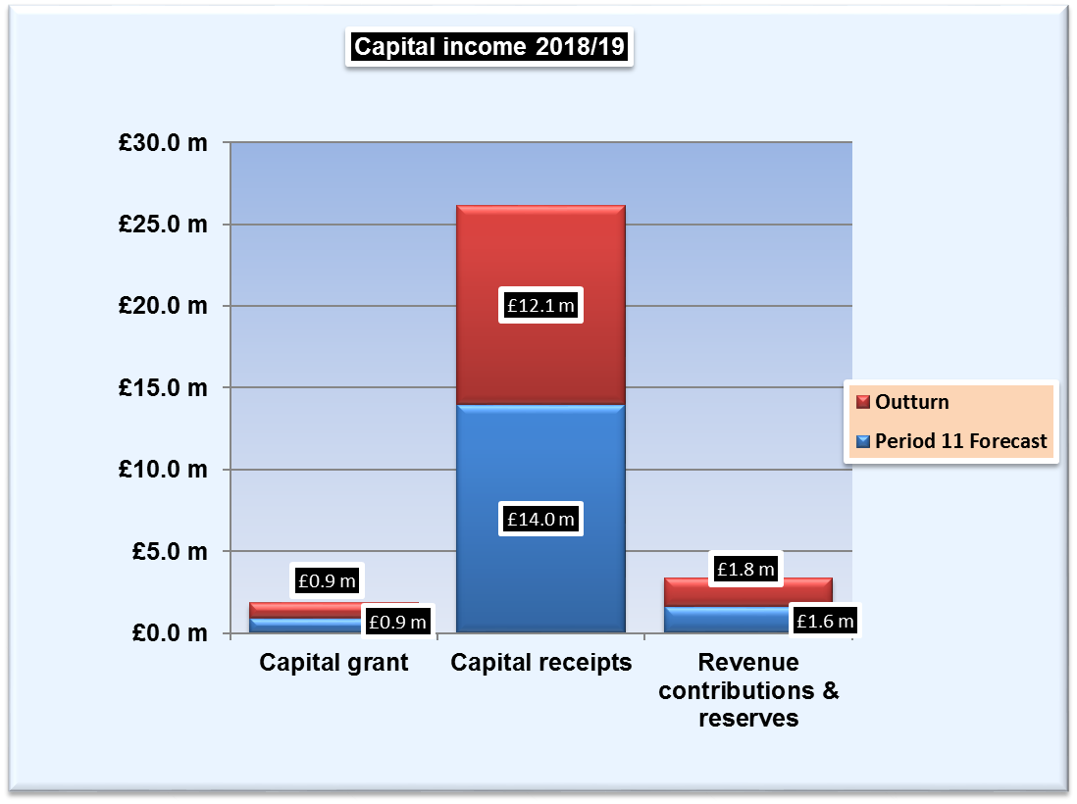

## Projection of Capital Reserves – Cashflow Profile

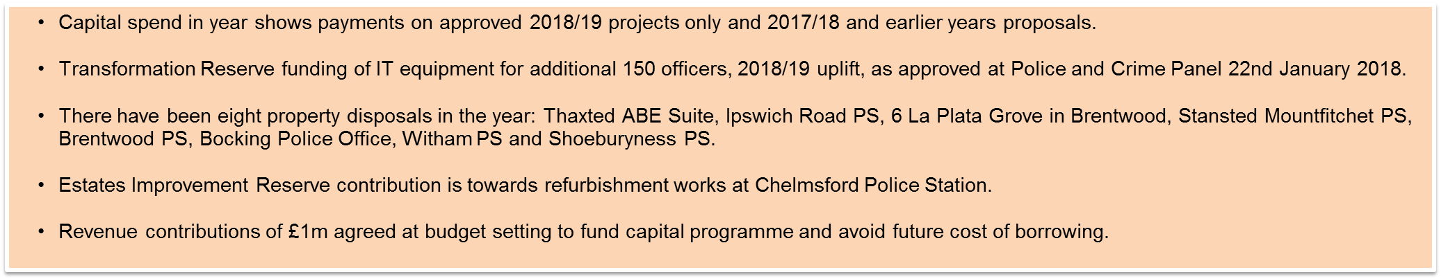

**Appendices to Revenue Report 2018/19 – Provisional Outturn**

11. APPENDIX A – Detail Revenue Report 28

12. APPENDIX B – Police Objective Analysis – Level 2 29

13. APPENDIX C – Virement Analysis – Other Virements 30

14. APPENDIX D – Detail Reserves Analysis 33

# APPENDIX A – Detail Revenue Report



# APPENDIX B – Police Objective Analysis – Level 2

# APPENDIX C – Virement Analysis – Other Virements







# APPENDIX D – Detail Reserves Analysis