**ESSEX POLICE, FIRE AND CRIME COMMISSIONER FIRE & RESCUE AUTHORITY**

Essex County Fire & Rescue Service



|  |  |  |  |
| --- | --- | --- | --- |
| Meeting | **Fire & Rescue - Performance and Resources Board** | Agenda Item |  |
| Meeting Date |  | Report Number |  |
| Report Author: | Jayesh Padania, Finance Manager | | |
| Presented By | Glenn McGuinness, Assistant Director of Finance | | |
| Subject | **Budget Review – April 2019** | | |
| Type of Report: | Information | | |

**SUMMARY**

This paper reports on expenditure against budget as at 30th April 2019 and identifies and comments on major budget variations. In addition the report includes key indicators that act as lead indicators for expenditure across the Authority.

**RECOMMENDATIONS**

The Service Leadership Team is asked to:

1. Note the position on the income and expenditure at 30th April 2019 compared to the budget.
2. Note the Capital Expenditure spend is as at 31st March 2019 (Financial Year 2018-19), as final Capital expenditure impact is being analysed and reviewed for the Annual Accounts for 2018-19.

**BACKGROUND**

This table below shows actual expenditure against budget to 30th April 2019.



More detailed figures are provided at appendix 1

**STAFFING**

**Overall employment costs are £191K (4.4%) under budget for the month to 30th April 2019.**

**Spend for whole time fire-fighters is £138K (4.9%) under budget:-**

* £3K underspend on Overtime of which ASW was £51K to 30th April 2019

**For On-Call firefighters, spend is £39K (15.6%) under budget**

**For Control staff, spend is £15K (12.1%) under budget:-**

* £ 7K underspend on Control Staff Pay
* £ 5K underspend on Control Staff Overtime
* £ 3K underspend on Control staff pay on-costs

**Support staff pay is £ 1K (0.1%) over budget for the 1 month to 30th April 2019.**

This is comprised of:-

* An underspend of £3K on Secondary Contract Staff
  + £ 2K underspent on Operations
  + £ 8K underspend on Community Safety
  + £ 7K overspent on Training
    - £2.8K Virement to move budget from secondary contracts to support staff pay
    - £4.7K actual costs for Driver Trainers in April 2019 – charged as Secondary Contracts staff costs
* The overspend of £4K for Support Staff (Excl. Secondary Contracts) is made up of:-
  + £ 86K overspend on Casual and Temporary
  + £ 82K underspend in Support Staff Pay

Appendix 3 – Table Summary of Support Staff FTE numbers

Whole-time fire-fighter numbers at 620.0 are 46.0 (6.9%) below phased budget at the end of April.

The staffing position at the end of April is summarised below (% figures rounded):



As at the end of April the number of whole-time fire-fighters aged over 50 with more than 25 years’ service was 81, of these 12 have more than 30 years’ service.

The graph below shows the numbers of whole-time fire-fighters compared to the budget for the year.

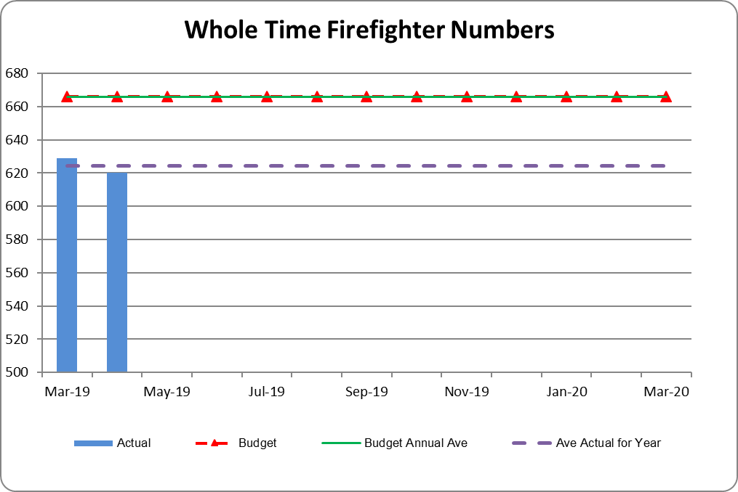

**WATCH BASED FIREFIGHTERS**

The numbers of Watch Based Fire-fighters compared to the target levels set by the Authority are shown

below.



**ON-CALL FIREFIGHTERS**

Appendix 2 -On Call Firefighter nos. by Station

The table (top of page 4) shows that the total FTE at 30th April 2019 was 398.25, a net increase of 0.75 FTE from 1st April 2019.

**NON-PAY RELATED EXPENDITURE**

Non-pay expenditure is £85K underspent for the 1 month to 30th April; in addition operational income is £83K less than budget.

**Support Costs are £ 22K (12.1%), underspent for the month to 30th April 2019**



* £15K underspend on Travel & Subsistence is due to budget phasing.
* £10K overspend on Employee Support Costs related to:-
  + Fitness Equipment costs of £11K included in 2018-19 Budget and received in April 2019

**Premises & Equipment are £91K (10.4%), underspent for the 1 month to 30th April 2019**



* Information Systems underspend of £77K
  + £39K underspend on IT Consumables relating to ICT project against budget to date
  + £38K underspend on IT Maintenance and Contracts
* Communications underspend of £31K relates to IT Communications.

**Other Costs & Services are £39K (13.8%), underspent for the 1 month to 30th April 2019**



* Professional Fees & Services underspend of £28K
  + £13K underspend on Legal Fees
  + £12K on Other Local Authority Services

**CAPITAL EXPENDITURE**

**Total capital spend and commitments to 31 March are in the process of being finalised as part of the year end process. The table below shows the figures to March, these may be subject to final year end accrual adjustments.**

Capital expenditure for the 12 months to 31st March 2019 is shown in the table below.

Total capital expenditure and commitments is £4.0m.

The largest item included is £1.8m for asset protection.

* £1,349K invoices received
* £467K commitments from various PO’s raised to date for anticipated spend throughout the year

Vehicle £1,386K:-

* £639K invoices paid and commitments related to Off Road Vehicles
* £293K invoices paid and commitments related to Light Vans
* £243K invoices paid and commitments related to Light Vehicles
* £ 75K invoices paid related to Appliances

The investment of £653K in information technology relates to:-

* £132K on HOBS/ Civica
* £199K for MDT replacement programme
* £232 on Devices for Appliances
* £ 81K on hardware replacement



**VIREMENTS**

* £3,517K Full Year virement reflecting the Additional Pension costs for Grey Book staff, which is offset by a Government Grant to be received.
  + The Government Grant covers majority of the total estimated additional pension costs £3,817K
  + £300K to be funded by the service and has been included in the 2019-20 Budget
* £34K Full Year virement for Driver Trainers moving to a Fixed Term Contract from Secondary Contract Staff

**BENEFITS AND RISK/ FINANCIAL IMPLICATIONS**

The review of expenditure against the profiled budget is part of the overall financial control process of the Authority. In exceptional circumstances it allows for budget virements to ensure that under spending against budget heads can be utilised to fund expenditure against other priorities. If virements are not made there is a risk that the Authority will miss out on opportunities to improve performance and meet key objectives during the year. The Authority’s reserves are at the upper end of their target range and the Authority is able to fund short term fluctuations in activity from them when necessary.

The review of the management accounts is one control measure to mitigate the risk of overspending the Authority’s budget for the year.

**EQUALITY AND DIVERSITY IMPLICATIONS**

There are no direct Equality or Diversity implications within this report

**LEGAL IMPLICATIONS**

There are no direct legal implications within this report.

**HEALTH & SAFETY IMPLICATIONS**

There are no direct Health and Safety implications within this report.

**ACTIONS / NEXT STEPS**

|  |  |
| --- | --- |
| LOCAL GOVERNMENT (ACCESS TO INFORMATION) ACT 1985 | |
| List of background documents – including appendices, hardcopy or electronic including any relevant link/s. | |
| Appendix 1 Management Accounts – April 2019  Appendix 2 On Call Firefighter Headcount Numbers  Appendix 3 Support Staff and Agency/Temp numbers | |
| Proper Officer: | Acting Finance Director to PFCC Fire & Rescue Authority |
| Contact Officer: | Glenn McGuinness  Essex County Fire & Rescue Service, Kelvedon Park, London Road,  Rivenhall, Witham CM8 3HB  Tel: 01376 576186  glenn.mcguinness@essex-fire.gov.uk |

**Appendix 1**

**MANAGEMENT ACCOUNTS – April 2019**



**Appendix 2**



Appendix 3

