**Performance and Resources Scrutiny Programme 2019**

**Report to: the Office of the Police, Fire and Crime Commissioner for Essex**

|  |  |
| --- | --- |
| **Title of Report:** | **Balanced Scorecard Gradings – 13th Cycle** |
| **Agenda Number:** | **11** |
| **Chief Officer** | **Dr. Victoria Harrington** |
| **Date Paper was Written** | **8 May 2019** |
| **Version Number** | **1.2** |
| **Report from:** | **Essex Police** |
| **Date of Meeting:** | **23 May 2019** |
| **Author on behalf of Chief Officer:** | **Matt Robbins**  **Corporate Performance Analyst** |
| **Date of Approval:** | **8 May 2019** |

1. **Purpose of Report**

This paper provides an overview of the final grades for the 13th cycle of the Balanced Scorecard. This paper will also provide the rationale for the Force-level grades, as determined in the Performance Board on Monday 15 April 2019.

1. **Recommendations**

There are no recommendations. This report is for the board to note.

1. **Executive Summary**

There were three changes since cycle 12 of the Balanced Scorecard (BSC) process: one improvement; two deteriorations.

* Digital Crime improved to Good from Requires Improvement
* Serious and Organised Crime deteriorated to Requires Improvement from Good
* Innovation deteriorated to Good from Outstanding.

No areas are now at Outstanding (since Innovation was downgraded).



Seven areas are currently graded at Good. Eight areas are graded at Requires Improvement.

This was the last cycle of the BSC in its current iteration. Essex Police will continue to use the BSC as its strategic performance management framework, but a new “Rebalanced Scorecard” will take effect in the next cycle. More detail as to this “Rebalanced Scorecard” can be found at 9.0.

**4.0 Introduction/Background**

Essex Police use the “Balanced Scorecard” (BSC) strategic performance management framework to self-assess its performance, and will continue to use this framework in the future. Essex Police also use the grading names employed by Her Majesty's Inspectorate of Constabulary and Fire & Rescue Services (HMICFRS) in its assessments; the grades are ‘Outstanding’, ‘Good’, ‘Requires Improvement’, and ‘Inadequate’. Where possible, Essex Police benchmark its performance against other forces in its Most Similar Group (MSG) of forces and national targets; this enables Essex Police to derive minimum standards (and consequently assess what is ‘Good’).

The BSC process is conducted on a quarterly basis. Individual commands first grade themselves, and provide quantitative and qualitative evidence in support of their self-assessment. These grades are then reviewed by the relevant Assistant Chief Constable/Director at Oversight Boards. Force-level grades are agreed at the Performance Board, which is chaired by the Deputy Chief Constable.

**5.0 Current Work and Performance**

The below table details the final gradings at command and force-level:



The “Tube Maps” showing the final force gradings can be found in the appendices of this report.

The rationale for these grades is provided in the following tables:







**6.0 Implications (Issues)**

The Balanced Scorecard (BSC) is used to identify and address command and force-level performance issues; the focus is on the areas that are graded at “Requires Improvement”. Many force-wide issues that are discussed at the Performance Board form the basis of “deep dives” at the subsequent Essex Synergy and Performance Meeting (Synergy).

**6.1 Links to Police and Crime Plan Priorities**

Both the former and “Rebalanced” BSC processes incorporate all of the seven priorities within the PFCC’s Police and Crime Plan. The Force therefore takes into account these priorities as part of the Balanced Scorecard process.

**6.2 Demand**

The Balanced Scorecard ensures that demand is managed appropriately by identifying both good practice and areas of concern at a strategic level.

**6.3 Risks/Mitigation**

Risk is discussed as part of the Balanced Scorecard (BSC) process. BSC meetings are also attended by staff from Continuous Improvement, who ensure that the Force Risk Register is updated with any new risks (or with the action that is being taken to mitigate existing risks).

As part of the new “Rebalanced Scorecard” (see 9.0 below), risks with a score over 75 (namely those with a probable or almost certain likelihood, with a catastrophic impact) constitute Redline Measures at both Force and Command-level.

**6.4 Equality and/or Human Rights Implications**

No equality or human rights implications were identified in the process of writing this report.

**6.5 Health and Safety Implications**

No health and safety implications were identified in the process of writing this report.

**7.0 Consultation/Engagement**

All commands involved in the Balanced Scorecard process were consulted in the last cycle, particularly with the identification of “Redline Measures” and the data required to support the effective completion of the Balanced Scorecard returns.

The Performance Analysis Unit (PAU) are currently working with commands to identify evidence-based metrics for every command, and for every area within the new “Rebalanced Scorecard” (discussed at 9.0).

**8.0 Actions for Improvement**

The Balanced Scorecard identifies good practice, but also areas for improvement. Areas graded at “Requires Improvement” or below become the focus for the Chief Constable’s Essex Synergy and Performance meeting. With regards the future of the BSC process, see section 9.0 below.

**9.0 Future Work/Development and Expected Outcome**

It was recognised that the Balanced Scorecard (BSC) process, as it had been conducted in Essex Police until this cycle, had too many priorities. It was also skewed toward operational priorities, did not give a holistic view of the business, and relied too heavily on qualitative information. Chief Officers consequently agreed to continue to use the BSC as the Force’s strategic performance management framework, but in a rebalanced format. This “Rebalanced Scorecard” comprises four areas:

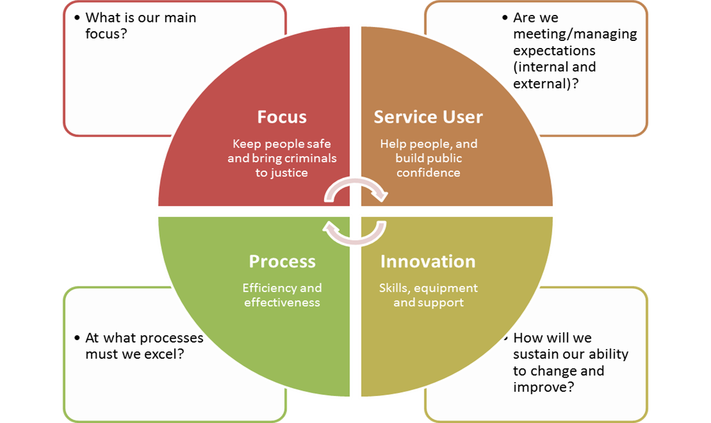

This new Rebalanced Scorecard will be:

* Broader, in order to provide a more holistic view of Essex Police’s performance
* Shorter than the current BSC process (four areas rather than the current 15)
* Supported by more streamlined data, including new Redline Measures, and evidence-based Key Performance Indicators (KPIs)

**Appendix 1: Force-Level Balanced Scorecard Gradings “Tube Map”**

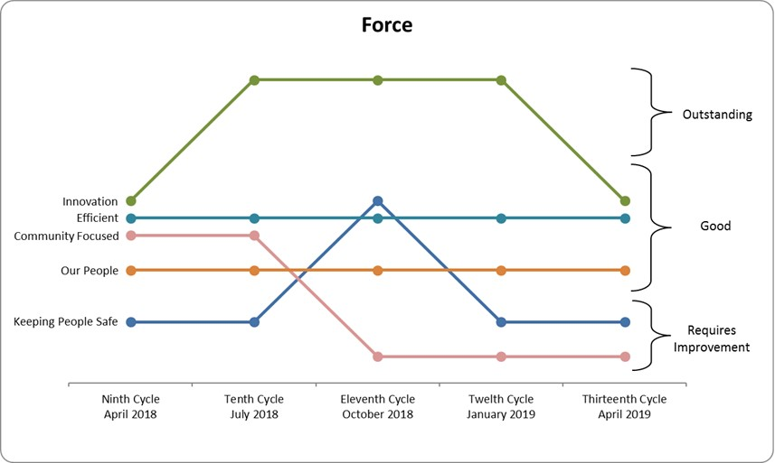

**Appendix 2: Force Additional Priorities Balanced Scorecard Gradings “Tube Map”**

