**Performance and Resources Scrutiny Programme 2018/2019**

**Report to: the Office of the Police, Fire and Crime Commissioner for Essex**

|  |  |
| --- | --- |
| **Title of Report:** | **2018/19 Month 11 Financial Monitoring Report** |
| **Agenda Number:** | **10. ii** |
| **Chief Officer** | **Mark Gilmartin, Director of Essex and Kent Support Services** |
| **Date Paper was Written** | **21st March 2019** |
| **Version Number** | **Version 1** |
| **Report from:** | **Essex Police: Corporate Finance** |
| **Date of Meeting:** | **28th March 2019** |
| **Author on behalf of Chief Officer:** | **Richard Jones, Head of Business Partnering and Management Accounting** |
| **Date of Approval:** | **21st March 2019** |

1. **Purpose of Report**
   1. This report identifies the 2018/19 month 11 position for the Force.
2. **Recommendations**
   1. The report is for noting.
3. **Executive Summary**
   1. The latest forecast revenue overspend is **£0.173m**.
   2. The police officer strength forecast at end of January is **3,065 FTE** and at year end is **3,046 FTE**.
   3. The Capital Reserve is forecast to be **£8.961m** surplus at year end.
   4. The forecast capital expenditure is **£8.227m** and the forecast capital income from property disposals is **£16.535m**.
4. **Introduction/Background** 
   1. This reports sets out the February, month 11, financial position, highlighting the changes from January, month 10.
5. **Current Work and Performance**
   1. The month 11 financial position is shown at Annex 1.
6. **Implications (Issues)**
   1. The implications are reported in Annex 1.
7. **Links to Police and Crime Plan Priorities**
   1. The Force budget is used to help meet the priorities of the Police and Crime plan.
8. **Demand**
   1. The Force budget is reviewed and re-allocated within virement rules to match demand e.g. overtime funded by vacancies.
9. **Risks/Mitigation**
   1. Risk Register URN 452 - Short and Long Term Capital Finance.
10. **Equality and/or Human Rights Implications**

N/A

1. **Health and Safety Implications**

N/A

1. **Consultation/Engagement**
   1. The pay forecasts are based on information received from HR Organisational Management
2. **Actions for Improvement**

N/A.

1. **Future Work/Development and Expected Outcome**
   1. Reviews will continue with budget holders, working towards a balanced budget by year end.
2. **Decisions Required by the Police, Fire and Crime Commissioner**
   1. None.

# Executive Summary – 2018/19 – Month 11

# Revenue

## Revenue Summary – 2018/19 – Month 11





## Main Forecast Movements since month 10



# Workforce Analysis

## Pay Summary



## Police Officer FTEs

### 

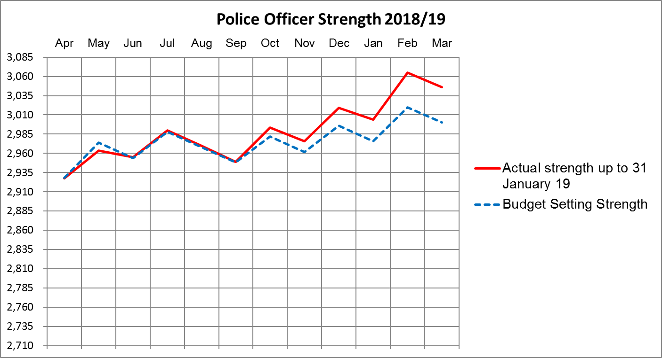

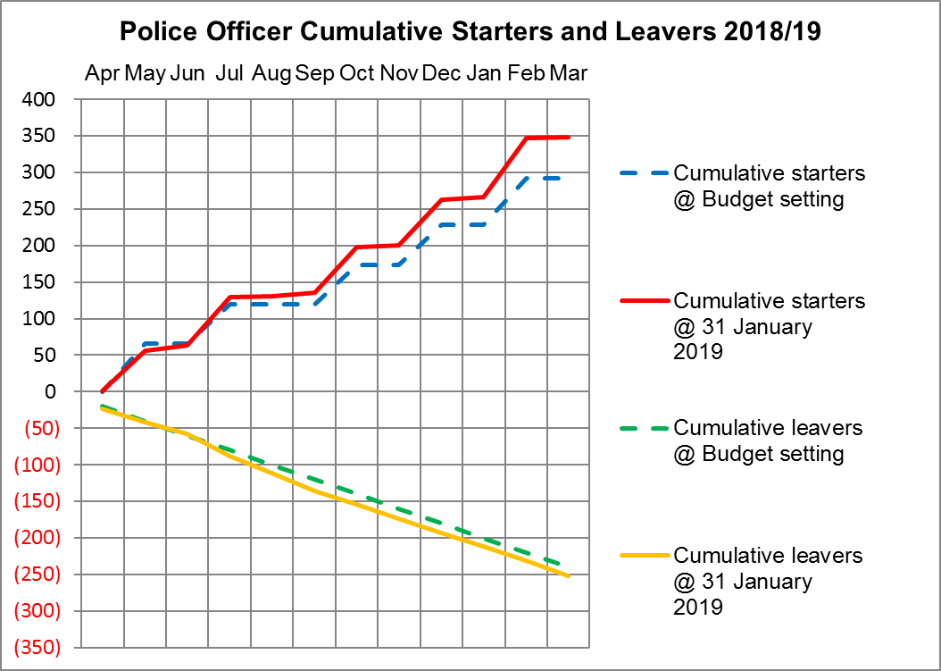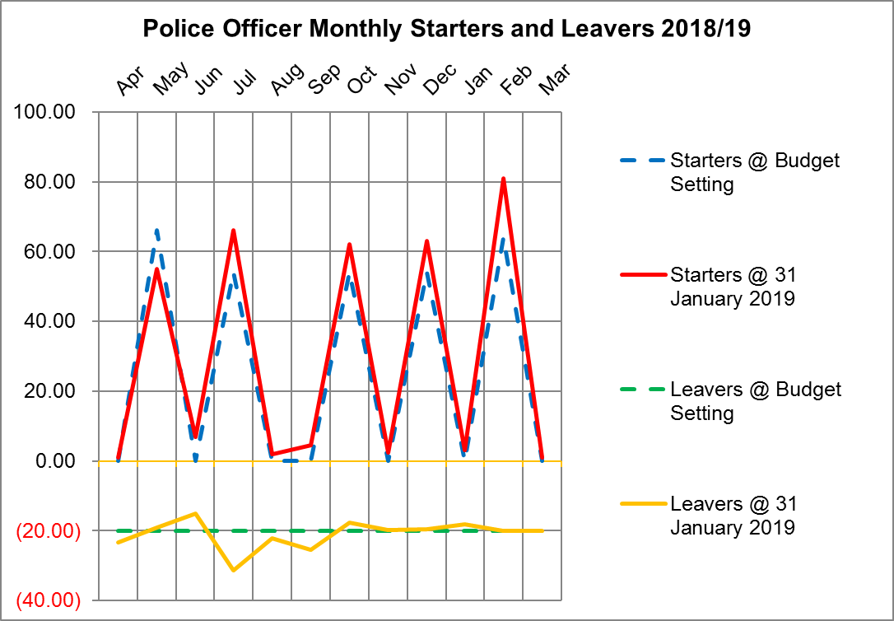

## Police Officers, Police Staff, PCSOs and Specials



# Police Objective Analysis

## Level 1 – All POA Categories



## Level 2 – All POA categories





## Level 2 – Local Policing



**1a – Neighbourhood Policing**

2018/19 original budget

* The pay budget for Police Officers allocated to Neighbourhood Policing decreased by £0.3m from the equivalent 17/18 position, including £0.1m of overtime element. There was also a £0.4m decrease in relation to supplies & services corporate growth allocated within the 17/18 budget, which has subsequently been reallocated elsewhere in 18/19.

2018/19 current budget

* The virements shown include £0.9m additional budget for Police Officer pay, reflecting the increase in officers. These include £0.3m of salary uplifts and £0.2m allocation of non-consolidated pay for Local Policing Officers. In addition, £0.2m additional overtime has been allocated for Operation Thistle and there has been a £0.2m increase for Bear Scotland adjustments. In addition to Police Officer spend, there has been a £0.4m increase in PCSO's which has been funded from additional matched funding income, as well as £0.2m of additional staffing costs.

2018/19 forecast outturn

* There is a minor forecast overspend variance of £0.198m, with additional costs on probationer cost centres (including Police Now) offset by corresponding underspends in Local Policing pay lines and reductions in the amount of centrally held budgets being allocated to Neighbourhood Policing.

**1c – Specialist Community Liaison**

2018/19 original budget

* The main movements from 17/18 include a £0.3m increase in Police Officers and £0.2m increase in staffing. These increases are within the children and young persons, crime reduction & licensing teams. In addition, £0.3m of centrally-held corporate budget has been allocated to Community Liaison for 18/19 (mainly in respect of Police Officers for youth offending teams).

2018/19 current budget

* The Police Officers budget has increased by £0.123m, funded by Epping Forest District Council for a CPT.
* It should also be noted that reallocations have been adjusted between the 1a and 1c lines which result in a decrease. The POA classifications are still being reviewed in this area.

2018/19 forecast outturn

* The forecast outturn variance of £0.488m comprises forecast overspends for Police Officers, dangerous dogs, stray horses and a shortfall in income in respect of firearms licences

**1d – Command Team**

2018/19 original budget

* The Police Officer budget has decreased by £1.4m comprising a £1m reduction in LPA Commands and £0.4m in Territorial Policing. In addition there has been a £0.3m reduction in Police Officer overtime and £0.5m reduction in staffing (all within LPA Commands). £0.2m of corporate growth held within central budgets has also been allocated to the Command Team for the purposes of the 18/19 budget POA allocations.

2018/19 current budget

* The main theme of the virements movement for the Local Policing Command Team budget in 18/19 has been an increase in overtime. Overall there has been a £0.372m increase for overtime costs which has reduced to an overspend of £0.247m, due to other underspends within the department, as well as additional income received.
* The £0.139m external funding received for the additional overtime includes £0.048m from the College of Policing for Superintendent direct entry training, £0.025m from Thurrock Council in respect of Operation Raptor and Operation Sacrifice, and £0.015m partnership funding for Operation Spider.
* The POA reclassifications have resulted in a decrease of £0.229m.

2018/19 forecast outturn

* The forecast outturn variance of £0.276m overspend is mainly comprised of Police Officer overtime as well as an increase in Police Officer pay in the LPA North Command team

## Level 2 – Support Services



**10a – Human Resources**

2018/19 current budget

* During the year £0.112m of additional staffing costs previously held centrally have been transferred to HR, as part of the £1m growth allocation. Also an additional £0.138m of excess travel costs have been added into the budget, funded from earmarked reserves. There has also been a £0.096m increase in the medical costs budget in respect of the Specials programme, funded by both recurring & one-off growth.
* Following the completion of the 2018/19 POA return an exercise was undertaken to tidy up the coding for staff located within Business Services. This lead to some reallocations for three principal areas, namely, Administration Support, Finance and HR. As part of this exercise £0.482m of staffing costs have been reallocated into the HR heading, offset by circa £0.600m of staffing costs already within the HR original budget which had previously been manually allocated anticipating the tidy-up exercise required. An additional £0.273m of central costs previously allocated to HR have been removed during 18/19. Going forward the force now has more accurate information to ensure that the coding for all three of these POA functions will be more accurate.

**10b - Finance**

2018/19 current budget

* An additional budget of £0.091m for forfeitures income has been created in year, with all of these monies being transferred into the forfeitures earmarked reserve at the point at which these monies are recognised as income in the force accounts.
* A net increase of £0.294m has been allocated to Finance as part of the Business Services review exercise referred to within ‘10a – Human Resources’.

**10c – Legal**

2018/19 current budget

* The budget has increased due to £0.045m of legal advice requirements for ICT as well as £0.090m for Procurement. In addition, significant legal work on the Allard claim has resulted in a £0.341m budget increase, all of which has been funded from earmarked reserves. In addition the Essex County Council SLA contract has increased by £0.060m.
* Additional external partnership funding of £0.060m has been received to pay for the increase in legal advice for ICT.

**10d – Fleet Services**

2018/19 current budget

* The main reason for the current budget increase is the additional £0.700m of motor insurance premium following the re-tender of this contract and subsequent award to Edison. This increase has been funded from the General Reserve. Offset against this increase has been £0.082m of additional recharged transport costs.
* Within the reclassifications column it should be noted that £0.494m has been adjusted in respect of the revenue consequences of capital budget. For the original budget position an assumption was made that the revenue consequences budget was pro-rated in accordance with areas of the approved capital programme spend. The Period 11 position now reflects the updated position that all of these costs actually relate to ICT for 18/19.

**10e – Estates**

2018/19 current budget

* There have been various increases to Estates budgets in the year, funded from various sources. Planned maintenance for Operation Dagenham has increased by £0.078m funded from additional income. In addition there has been £0.159m for extra security installation costs and £0.072m for security guards. The professional fees budget requirement has increased by £0.164m, with funding for this from the Transformation Reserve. Offset against these increases is a reduction of £0.168km in respect of leasehold rental costs.
* The net external funding received comprises £0.082m for Operation Dagenham as well as a £0.030m shortfall for rental income.
* Within the reclassifications column £0.393m has been adjusted in respect of the revenue consequences of capital budget. This is referred to within the commentary for ‘10d – Fleet Services’.

**10f – Information Communication Technology**

2018/19 original budget

* The main material movements from the 2017/18 budget include £0.5m of staffing increase, £0.8m additional supplies & services requirement as well as a £1.3m allocation for ICT’s element of corporate budgets held centrally. It should be noted that the process for mapping and allocating the centrally-held budgets has been more detailed in 2018/19, but is an area still under review.

2018/19 current budget

* During the year staffing has increased by £0.564m with £0.500m of this funded from extra income. There have been various other supplies & services increases, including £0.062m of agency costs, £0.093m of mobile phones rental costs, £0.098m relating to circuit networks and £0.076m relating to enabling software. Some of the larger budget increases comprise £2.127m of additional IT maintenance software, £0.615m of IT software, £0.342m of consultancy, £0.284m of mobile data costs and £0.204m relating to other shared services. £0.924m of additional contractors costs have been offset by £0.483m funded from extra income.
* The extra income received of £1.318m comprises partnership & other funding.
* It should also be noted that £1.452m of revenue consequences of capital funding has been allocated to finance the ICT virements referred to above e.g. covering projects such as Mobile First, ESMCP, SAP refresh, FIM, Athena and ACU insider threat. This funding is included within the reclassifications and reallocations column.

2018/19 forecast outturn

* The forecast outturn variance of £0.823m underspend relates to various budgets including Airwave and IT software, software maintenance and hardware, as well as an assumption that the remaining revenue consequences of capital budget will not be spent in 18/19.

**10g – Professional Standards**

2018/19 current budget

* The movement in year includes £0.016m of additional Police Officer pay, part of which has been funded from additional contractor vetting income. In addition, staff pay has increased by £0.297m with £0.128m of this funded by additional DBS grant.

**10h – Press and Media**

2018/19 current budget

* The Media budgets have increased by £0.029m for force marketing and £0.020m for social media costs. Both of these increases relate to the Specials programme and have been funded from both recurring & one-off growth pots.

**10i – Performance Review/Corporate Development**

2018/19 original budget

* The main material movements from the 2017/18 budget include £0.5m of additional staffing (ECFRS & Operational Change Project) as well as £0.3m of extra third party payments relating to the Essex share of the 7 Force collaboration. These increases were offset by a £0.1m reduction in supplies & services.

2018/19 current budget

* Police Officer pay has increased by £0.263m with £0.158m of this funded from additional income. Staffing has also increased by £0.708m with £0.273m of this also funded from additional income. The majority of these increases related to the ECFRS and 7 Force collaborations with other elements also related to the Strategic Change and the Operational Change Programme. Other increases include £0.050m in respect of agency and hospitality expenses, and £0.460m of consultancy.
* The external funding received comprises £0.110m of Police Innovation funding in respect of the ECFRS collaboration, £0.100m of One Public Estate Grant and £0.330m relating to the creation of a Seven Forces income budget (to pay for officers and staff)

**10j – Procurement**

2018/19 current budget

* The uniform budget has been increased by £0.071m for the increase in Police Officers (with funding reallocated from central budgets as part of the £1m growth). In addition £0.025km of budget has been transferred to Legal for specific advice in respect of Procurement work (see ‘10c – Legal Services’)

**10k – Training**

2018/19 original budget

* The main movements from the 17/18 budget include £0.2m relating to Police Officers within the EPC Strategic Management, Dogs & Weapons training teams, a £0.9m increase in relation to staffing, and additional income of £0.3m relating to apprenticeship government funding

2018/19 current budget

* During the year Police Officer pay has increased by £0.279m Police Officer Pay. External training has also increased by £0.198m as well as a £0.027m increase in training fees relating to the ECFRS collaboration, £0.020m of which has been funded from additional Police Innovation funding. Other net increases of £0.038m comprise mileage, public transport and subsistence costs.

2018/19 forecast outturn

* The in-year forecast variance of £0.575m overspend mainly comprise other employee costs including £0.141m of external training costs for Police Officers and £0.097m of training for staff. In addition, there is a forecast overspend on pay budgets of £0.2m and a net decrease of £0.090m income.

**10l – Administration Support**

2018/19 current budget

* The main increases within the current budget relate to £0.083m of agency staff costs, £0.052m of mileage & public transport costs, and £0.023m of additional office equipment/furniture. The remainder of the increase in year relates to staffing.
* A net decrease of £0.847m within reclassifications has been allocated out of Administration Services as part of the Business Services review exercise referred to within ‘10a – Human Resources’

2018/19 forecast outturn

* The in-year forecast outturn variance of £0.647m overspend comprises various supplies and services budgets held centrally with the force.

**10m – Force Command**

2018/19 current budget

* The main movements in year relate to £0.023m of additional Police Officer pay, and the creation of a Chief Officer contingency budget which is currently £0.088m.

|  |
| --- |
|  |

**10n – Support to Associations and Trade Unions**

2018/19 current budget

* The staffing budget has increased by £0.041m, funded from additional Federation staff recharges income.

**10o – Social Club**

2018/19 current budget

* The staffing budget has increased by £0.046m, funded from additional EPSA recharges income.

**10p – Insurance/Risk Management**

2018/19 current budget

* The original budget reflected an apportionment to Insurance of £0.043m of centrally-held corporate budgets, which have subsequently been reallocated during 2018/19.

**Note on commentary provided**

* An explanation of the key movements between the 2018/19 Original and Current Budget has been provided for all Level 2 headings within Support Services.
* Where the movement between the 2017/18 Original and 2018/19 Original Budget exceeds £0.5m for a Level 2 heading, an additional note has been provided.
* Where the movement between the 2018/19 Forecast Outturn and 2018/19 Current Budget exceeds £0.5m for a Level 2 heading, an additional note has been provided.

# Reserves

## Detail Reserve Analysis



## Transformation Reserve



# Capital

## Movement in Capital Reserve Forecast



## Projection of Capital Reserves – Cashflow Profile



