**ESSEX POLICE, FIRE AND CRIME COMMISSIONER FIRE & RESCUE AUTHORITY**

Essex County Fire & Rescue Service



|  |  |  |  |
| --- | --- | --- | --- |
| Meeting | **Fire & Rescue - Performance and Resources Board** | Agenda Item |  |
| Meeting Date |  | Report Number |  |
| Report Author: | Jayesh Padania, Finance Manager | | |
| Presented By | Glenn McGuinness, Assistant Director of Finance | | |
| Subject | **Budget Review – February 2019** | | |
| Type of Report: | Decision + Information | | |

**SUMMARY**

This paper reports on expenditure against budget as at 28th February 2019 and identifies and comments on major budget variations. In addition the report includes key indicators that act as lead indicators for expenditure across the Authority.

**RECOMMENDATIONS**

The Fire & Rescue - Performance and Resources Board is asked to:

1. Note the position on the income and expenditure at 28th February 2019 compared to the budget.
2. Note the Capital Expenditure spend against budget and forecast for period to 28th February 2019.
3. Note the latest Forecast including Virements.
4. Decision – to approve the request for a carry forward into the next financial year the underspent revenue budget of £85,000 for Consultancy Fees

**BACKGROUND**

This table below shows actual expenditure against budget to 28th February 2019.



More detailed figures are provided at appendix 1

**STAFFING**

**February continues to see some minor adjustments due to the change of the HR and Pay system to Civica, as staff and processes adapt to the new system.**

**Overall employment costs are £428K (0.9%) under budget for the 11 months to 28th February 2019.**

**Spend for whole time fire-fighters is £41K (0.1%) under budget:-**

* ASW was £10K underspend against the revised ASW budget to 28th February 2019

**For On-Call firefighters, spend is £648K (11.8%) under budget**

**For Control staff, spend is £48K (3.7%) under budget:-**

* £ 11K underspend on Control Staff Pay
* £ 24K underspend on Control Staff Overtime
* £ 13K underspend on Control staff pay on-costs

**Support staff pay is £309K (2.6%) over budget for the 11 months to 28th February 2019.**

This is comprised of:-

* An underspend of £108K on Secondary Contract Staff
* The overspend of £417K for Support Staff (Excl. Secondary Contracts) is made up of:-
  + £244K overspend on Casual and Temporary
  + £173K overspend in Support Staff Pay

Appendix 3 – Table Summary of Support Staff FTE numbers

**Please be aware that the staff FTE and headcount data for February 2019 was extracted from Civica.**

Whole-time fire-fighter numbers at 631.0 are 17.0 (2.6%) below phased budget at the end of February.

The staffing position at the end of February is summarised below (% figures rounded):



As at the end of February the number of whole-time fire-fighters aged over 50 with more than 25 years’ service was 88, of these 16 have more than 30 years’ service.

The graph below shows the numbers of whole-time fire-fighters compared to the budget for the year.

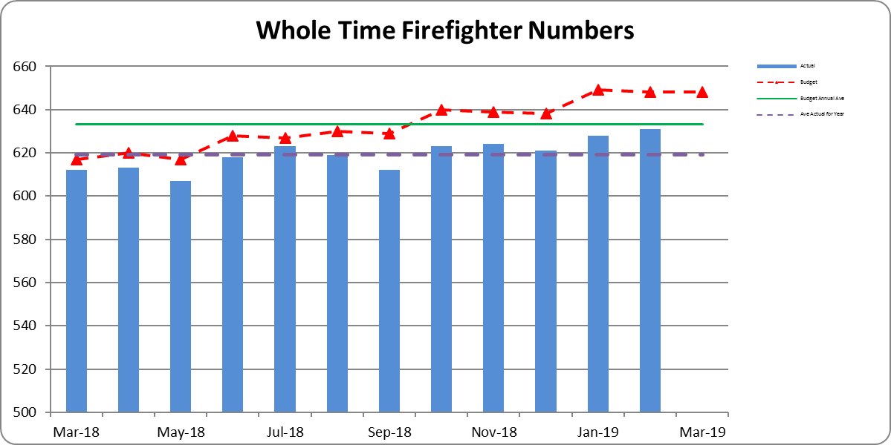

**WATCH BASED FIREFIGHTERS**

The numbers of Watch Based Fire-fighters compared to the target levels set by the Authority are shown

below.



**ON-CALL FIREFIGHTERS**

Appendix 2 -On Call Firefighter nos. by Station

The table (top of page 4) shows that the total FTE at 28th February 2019 was 385.75, a net decrease of 18.25 FTE from 1st April 2018. For February there with a net decrease of 0.25 FTE in the month.

**NON-PAY RELATED EXPENDITURE**

Non-pay expenditure is £407K underspent for the 11 month to 28th February; in addition operational income is £311K more than budget.

**Support Costs are £201K (12.2%), overspent for the 11 months to 28th February 2019**



* The overspend on Travel and Subsistence relates to mileage costs being £63K higher than budgeted and following a decision by a number of Officers to switch from service provided lease vehicles to using their own vehicles as a result of proposed taxation changes and the suspension of the lease scheme in force at the time. This has resulted in an underspend of £102K on Lease and Interest Changes for lease cars under Financing Items.
* £147K (28.1%) overspend on Training Costs:-



* + Overspend is in relation to training for operational staff and in particular the new whole time recruits
  + The increased costs for training were included and agreed as part of the mid-year forecast

**Premises & Equipment are £394K (4.0%), underspent for the 11 months to 28th February 2019**



* Information Systems underspend of £425K
  + £449K underspend on IT Consumables against budget to date
* Utilities underspend of £49K
  + £52K underspend for Gas charges against budget to date, mainly due to budget phasing assumptions
  + £14K overspend on Electricity and Fuel Oil against budget to date
  + £11K underspend on Water metered usage

**Other Costs & Services are £144K (4.5%), underspent for the 11 months to 28th February 2019**



* Establishment Costs overspend of £30K
  + £88K overspend on Home Safety, related to spend of £124K from Sprinkler fund. This cost is offset by contributions from reserves in February 2019
  + £53K underspend on Media Expenses
* Professional Fees & Services underspend of £117K



**FORECAST**

The forecast for the year has been prepared partly by finance and partly in conjunction with budget holders, this will be updated once all forecasts for 2018/19 have been reviewed with budget holders as part of the 2019/20 budget setting process.

This forecast shows a deficit for the year of £687K, and is before any planned release from reserves, as the budget included a planned release from the Capital Receipts Reserve of £2,569K we are £1,882K better than budget.

The main reasons for this positive initial forecast are:

* A reduction in capital financing charges (£692K) arising from the review in capital expenditure dealt with elsewhere in this report.
* A combination of both lower headcount and activity level for On-Call Firefighters (£589K)
* ICT projects are expected to be £500K underspent this year.

A summary of the current forecast against budget is given in the table below:



**VIREMENTS**

* £216K Full Year virement reflecting the post of CFO/CEO has been transferred from Grey Book to Green Book.
* £113K Full Year virement contribution of 1% inflation provision included in the budget for Support Staff annual pay increment
* £434K Full Year virement for Police Collaboration, virement of the projected income from PTF grant and Essex Police contribution towards the related projected costs to which this income relates
* £208K Full Year virement for pay award for Whole Time Fire Fighters including on-costs, due to be paid from November 2018 and backdated to July 2018
* £48K Full Year virement for pay award for Retained Fire Fighters including on-costs, due to be paid from November 2018 and backdated to July 2018
* £17K full Year Virement for Fitness Equipment requiring replacement, from savings on Retained Firefighter pay to date

**CAPITAL EXPENDITURE**

Please note - requests for Capital Budget carry forward from 2018-19 into 2019-20 have been received and are being reviewed by Finance with the Budget Holders.

Capital expenditure for the 11 months to 28th February 2019 is shown in the table below.

Total capital expenditure and commitments is £3.9m.

The largest item included is £1.8m for asset protection.

* £1,037K invoices received to February 2019
* £715K commitments from various PO’s raised to date for anticipated spend throughout the year

Vehicle £1,222K:-

* £656K invoices paid and commitments related to Off Road Vehicles
* £292K invoices paid and commitments related to Light Vans
* £ 75K invoices paid related to Appliances

The investment of £714K in information technology relates to:-

* £197K on HOBS/ Civica
* £195K for MDT replacement programme
* £232 on Devices for Appliances
* £ 81K on hardware replacement



**Capital Expenditure Forecast commentary**

An extensive review of all capital expenditure carried out by the Finance team in conjunction with budget holders in September and October 2018 resulted in a number of projects being rescheduled or cancelled.

The forecast for 2018-19 shows expenditure at £5.2m against a budget of £12m. The draft capital budget for 2019-20 shows expenditure at c.£5m.. Expenditure for both years has been reviewed to concentrate on essential expenditure over the next couple of years, this will be reconsidered when The Fire and Rescue plan and IRMP to 2024 are developed.

The reasons for the forecast spend for 2018/19 of £5.2m being £6.8m below budget are as follows:

* **Vehicles - £2.6m underspend.**
  + The budget included continued provision for the replacement of appliances, we are now planning to continue appliance replacement in 2020/2021.

This accounts for an underspend of £1.9m

* + Light vehicles a stores van, vehicle telematics account for an underspend of £605K, of this £200K for light vans has been deferred to 2019/20
* **Operational Equipment - £490K underspend**
  + Three items (c. £350K) deferred, these are Hose Reel Branch/Main Line (£136k), light portable pumps (£152K) and Foam £60)
  + Heavy Rescue Rumps equipment £97K underspent.
* **Information Technology - £880K underspend**
  + The main reason for this is deferral of ESMCP preparation work and ICCs/CAD replacement, the project is being rescheduled.
* **Property - £2.8m underspend.**
  + The budget included an initial £3m for Service Workshops replacement, we are forecasting nil spend this year, we are however forecasting an initial £200K on Shoebury although this would be subject to a business case and project approval.

**BENEFITS AND RISK/ FINANCIAL IMPLICATIONS**

The review of expenditure against the profiled budget is part of the overall financial control process of the Authority. In exceptional circumstances it allows for budget virements to ensure that under spending against budget heads can be utilised to fund expenditure against other priorities. If virements are not made there is a risk that the Authority will miss out on opportunities to improve performance and meet key objectives during the year. The Authority’s reserves are at the upper end of their target range and the Authority is able to fund short term fluctuations in activity from them when necessary.

The review of the management accounts is one control measure to mitigate the risk of overspending the Authority’s budget for the year.

**EQUALITY AND DIVERSITY IMPLICATIONS**

There are no direct Equality or Diversity implications within this report

**LEGAL IMPLICATIONS**

There are no direct legal implications within this report.

**HEALTH & SAFETY IMPLICATIONS**

There are no direct Health and Safety implications within this report.

**ACTIONS / NEXT STEPS**

1. Capital Budget carry forwards to be reviewed with Budget Holders
2. Finance Managers will be working with the Budget Holders on the Year End

|  |  |
| --- | --- |
| LOCAL GOVERNMENT (ACCESS TO INFORMATION) ACT 1985 | |
| List of background documents – including appendices, hardcopy or electronic including any relevant link/s. | |
| Appendix 1 Management Accounts – February 2019  Appendix 2 On Call Firefighter Headcount Numbers  Appendix 3 Support Staff and Agency/Temp numbers | |
| Proper Officer: | Acting Finance Director to PFCC Fire & Rescue Authority |
| Contact Officer: | Glenn McGuinness  Essex County Fire & Rescue Service, Kelvedon Park, London Road,  Rivenhall, Witham CM8 3HB  Tel: 01376 576186  glenn.mcguinness@essex-fire.gov.uk |



**Appendix 2**



