

**P&R Board**

**Action 98/2018: Explore what the actual percentage change in recorded crime has been, in order to inform future forecasting of crime**

**Date: 25 February 2019**

**Author: 42073495 Matt Robbins**

**Version: 2.4**

1. **Aim and Purpose**

P&R action 98/2018:

*Work on the Crime Data Tree back to May 2015 and explore what the actual percentage change in recorded crime has been, in order to inform future forecasting of crime. This piece of work once completed will be presented to the Board.*

This report identifies the rise in external levels of crime, i.e. offences that are unaffected by Crime Data Accuracy (CDA) and Home Office Counting Rules (HOCR). It compares this external increase in crime to the overall increase that has been driven by CDA and HOCR.

1. **Executive Summary**
   1. **10.9% genuine[1] increase in crime reporting**

As a proxy measure to determine the genuine increase in reported crime, STORM incidents with a crime-related initial category were analysed. These incidents are not subject to Crime Data Accuracy (CDA) or Home Office Counting Rules (HOCR). By applying proportion changes to the volume of these STORM incidents to All Crime numbers, a 10.9% genuine increase in crime reported between May 2015 to January 2019 was found (this equates to 900 additional offences per month). This can be compared to the 53.6% increase[2] in all crime recorded in the same time period.

* 1. **21.6% rise in crime due to better Crime Data Accuracy (CDA)**

Extending this methodology, the volume of the same STORM incidents (discussed above) that are closed as crimes can be used as a proxy measure to identify how effective a police force is at CDA. The number (and ratio) of STORM incidents that are closed as crimes indicate how proactive forces are at identifying offences; the more they identify, the better their CDA (this was identified as an Area for Improvement success measure by HMICFRS). By applying this methodology, 21.6% of the increase in crime recording since May 2015 is as a result of better CDA (this equates to around 1,800 additional offences per month).

Until Essex Police have reached an optimum incident to crime conversion rate (work currently being undertaken by the Strategic Force Crime and Incident Registrar), it is not possible at this time to indicate how much CDA will influence crime volumes, beyond what is currently being experienced (21.6%).

* 1. **21.1% rise in crime due to Home Office Counting Rules (HOCR)**

The remaining 21.1% rise in crime recording since May 2015 is due to changes in HOCR (this equates to around 1,800 additional offences per month in January 2019 compared to May 2015), most notably the recording of multiple offences in Stalking & Harassment, which came into effect in April 2018. Since April 2018, this offence category can no longer be forecasted with statistical accuracy due to a sudden spike in offences from this point. Once offence levels have stabilised, we will be able to more accurately forecast future crime levels.

* 1. **Essex Police would be experiencing over 3,500 fewer offences each month, had there been no CDA or HOCR changes**

Taking account of the 10.9% genuine increase in offences only, there has been a rise in reporting crime of 900 offences per month compared to May 2015. There has also been a rise of over 1,800 offences per month as a result of better CDA, and a similar rise as a result of HOCR. Put another way, Essex Police would be experiencing over 3,500 fewer offences (42.7%) each month if CDA and HOCR had not had an impact.

1. **Crime Table Changes - 12 Rolling months May 2015 vs. Dec 2018** (a further breakdown can be found in Appendix 1)



49.7% of the increase in crime compared to the 12 months to May 2015 is due to the rise in the Violence without Injury category (25,455 additional offences/198.3% rise). This has been driven by the changes to HOCR (Stalking & Harassment).

Domestic Abuse experienced a 113.6% increase (12,750 additional offences) compared to the 12 months to May 2015. While Essex Police encourages the reporting of Domestic Abuse, this type of offence has also been heavily affected by changes to HOCR.

Charts detailing the rise in All Crime, Stalking & Harassment and Domestic Abuse categories can be found in Appendix 2. The charts clearly show the effect of the increase in stalking and harassment on DA and all crime.

1. **STORM Incidents with a Crime-Related Category and Crime Data Accuracy (CDA)**
   1. **Genuine Crime Increase**

The Strategic Force Crime and Incident Registrar tracks and monitors:

* STORM incidents that contain a crime-related initial call type.
* The number (and rate) of the incidents described above that are closed off as Crime (i.e. those that have a ‘C’ closing code).

Working on the hypothesis that the genuine number of crimes being reported to Essex Police is more accurately reflected in the data relating to STORM incidents with crime-related categories, data was reviewed from May 2015 to the end of January 2019. There was a:

* 10.9% increase in the volume of STORM incidents with a crime-related initial classification.
* 53.6% increase in All Crime.

If this 10.9% increase is therefore applied to All Crime, and no changes had occurred with regards CDA or HOCR, there would have been (based purely on a linear trend):

* 42.7% less crime overall, and
* 3,677 fewer offences recorded each month.

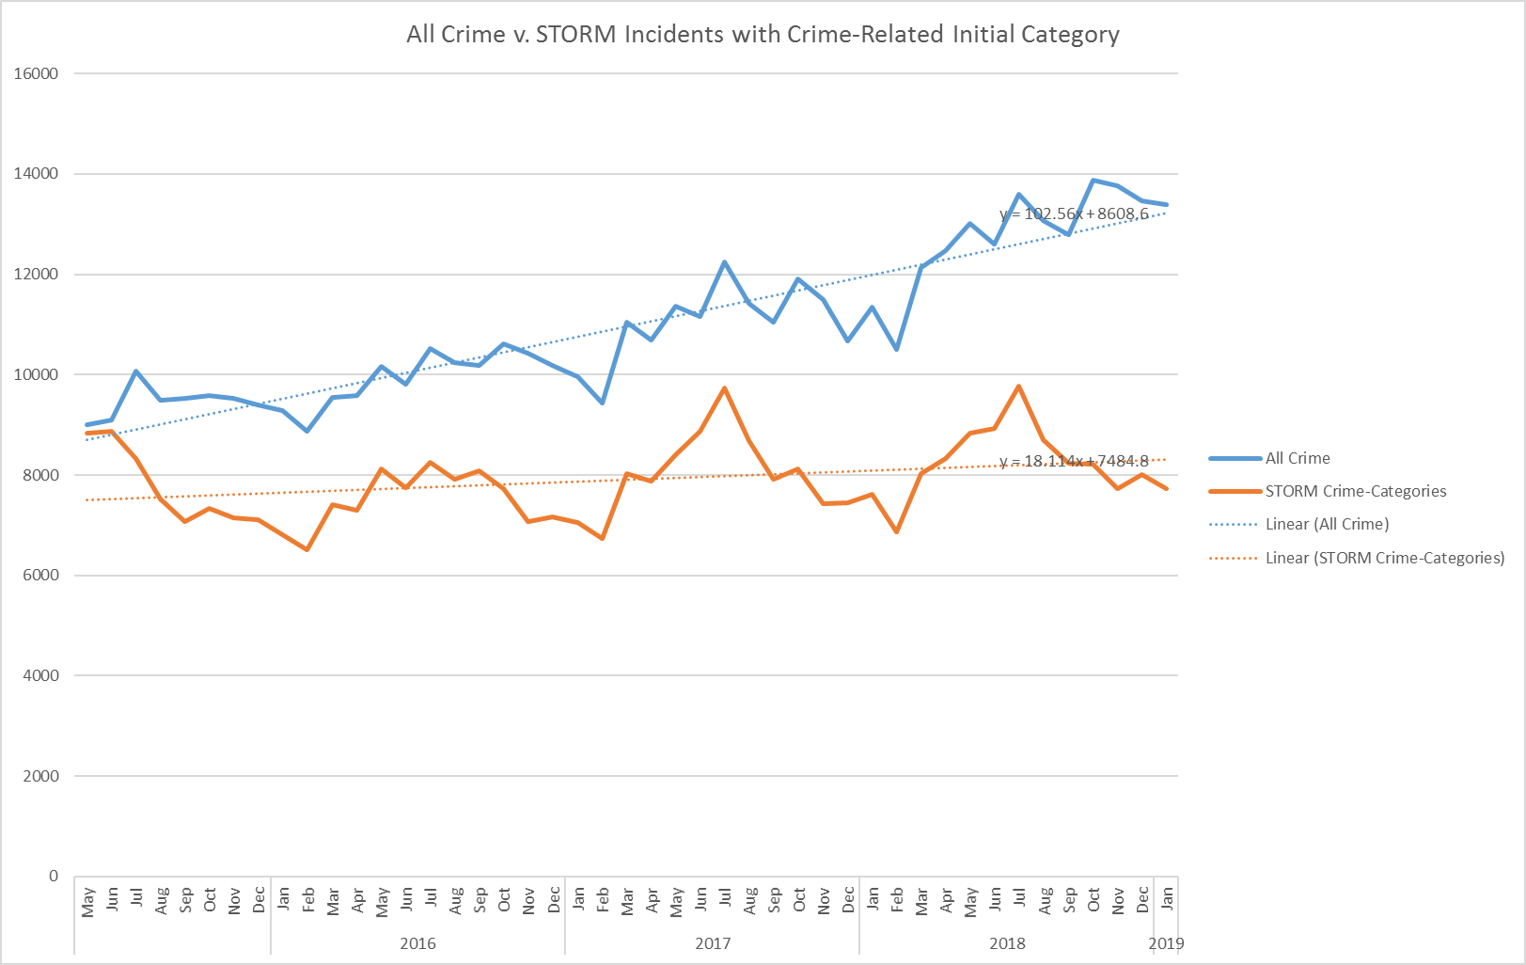

* 1. **Better Crime Data Accuracy (CDA)**

In order to gauge the extent to which better CDA has impacted on crime levels, the volume of incidents with crime-related initial classifications that have been closed as crimes have been identified. Better CDA will increase both the volume and ratio of these incidents:

* 32.5% increase in the volume of STORM incidents with a crime-related initial category that were closed as crimes. This is a steeper increase than the rise in all STORM incidents with a crime-related initial category (10.9%). This is due to better CDA. The chart below shows that the volume of incidents closed as crimes has risen in stark contrast to those with other closing codes since August 2017.

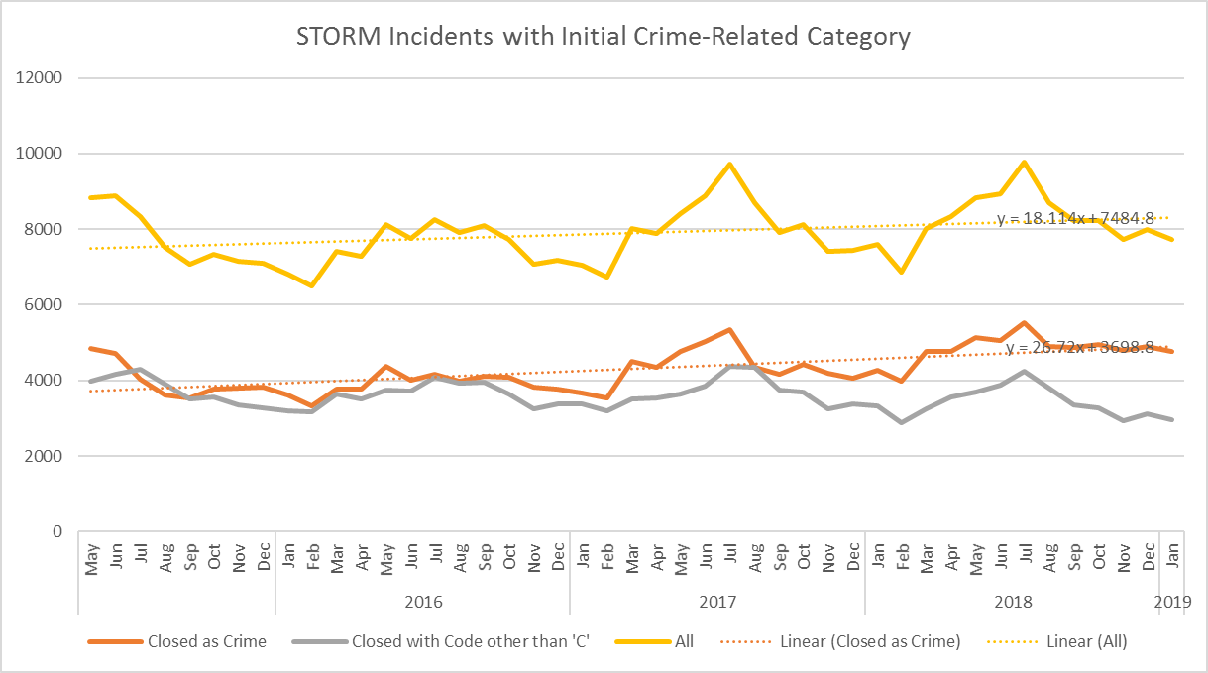

Based on this methodology, it is reasonable to hypothesise that, since May 2015:

* 10.9% as result of a genuine increase in crime reporting (all incidents with a crime-related initial classification).
* 21.6% of the increase in crime since May 2015 is as a result of better CDA (increase in incidents closed as crimes, minus the overall rise).
* 21.1% as a result in changes in HOCR (such as the recording of multiple offences in relation to Stalking & Harassment). Other internal and external influence are also likely to have affected this increase, however.



**Appendix 1: Crime Breakdown**





**Appendix 2: All Crime, and Stalking & Harassment/DA Offences Recorded by Month**

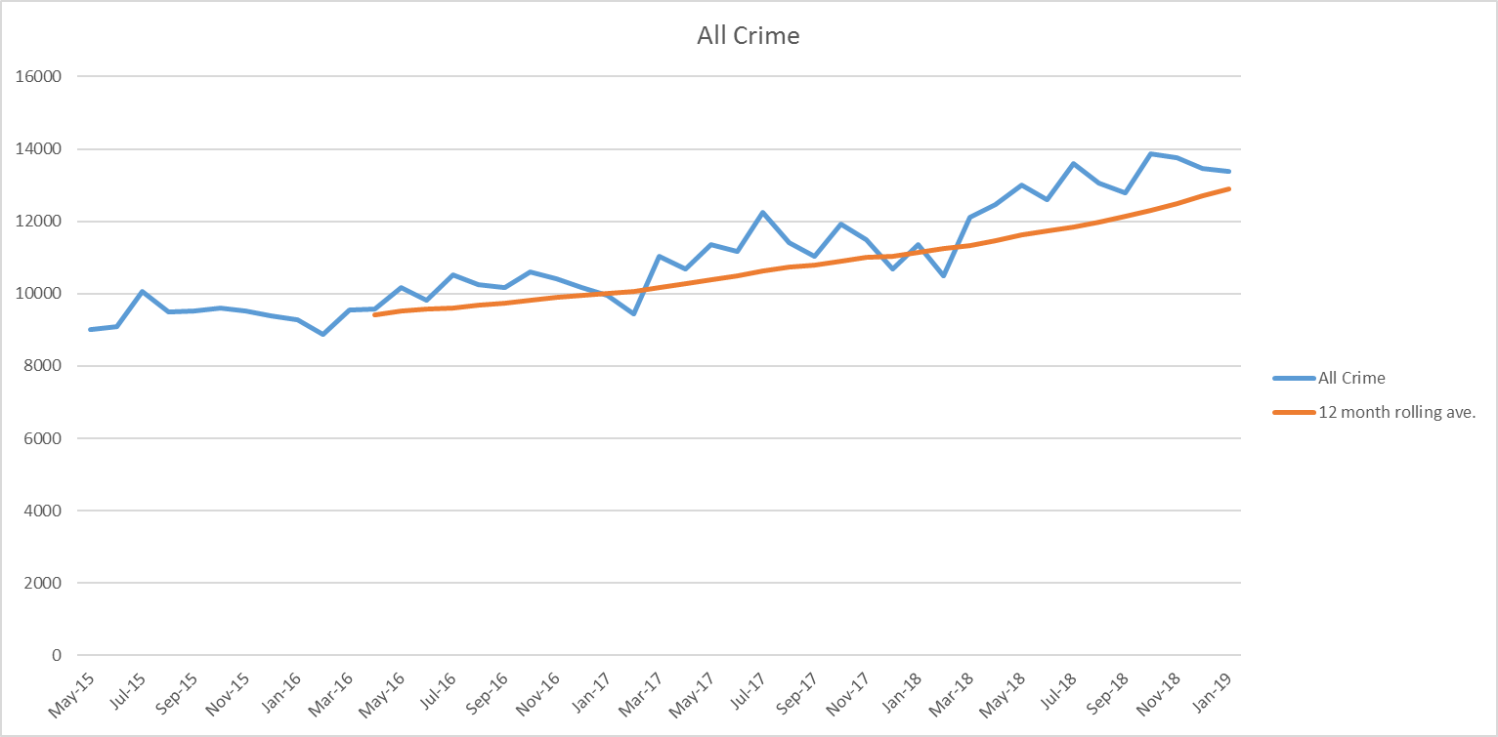

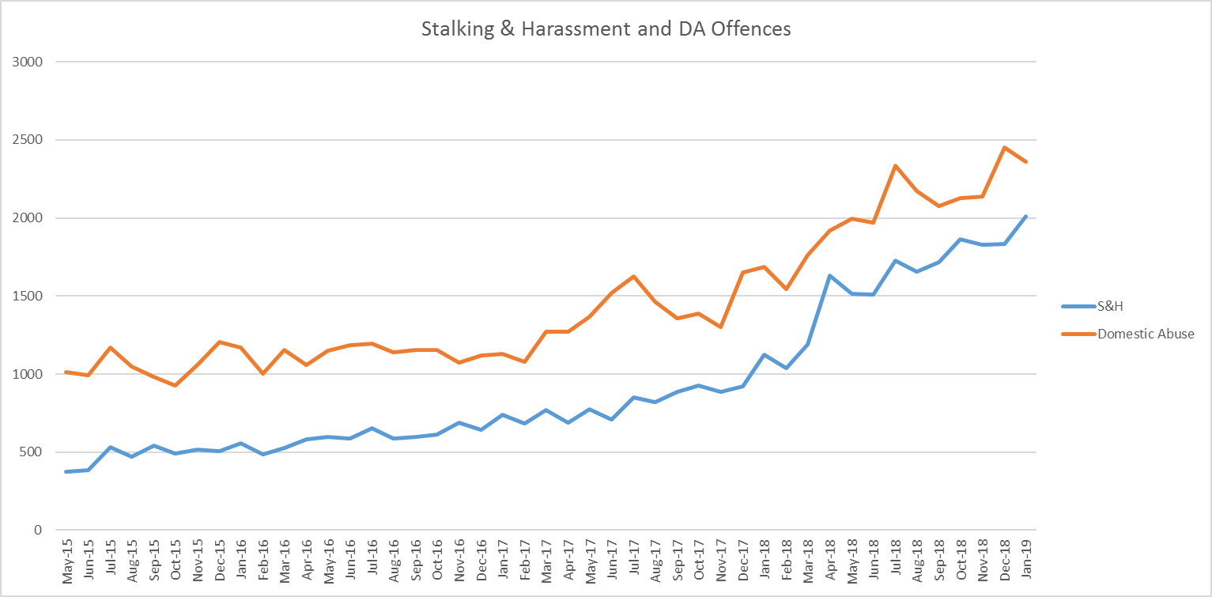

1. For the purposes of this report, a genuine increase refers to the level of crime that is unaffected by CDA and HOCR.
2. Note that this percentage change figure is different to the 12 month figure featured in the Crime Tree tables. Forecasts were based on the linear trend-line for May 2015 to January 2019 start point rather than the actual crime figure in May 2015.