**Performance and Resources Scrutiny Programme 2018/2019**

**Report to: the Office of the Police, Fire and Crime Commissioner for Essex**

|  |  |
| --- | --- |
| **Title of Report:** | **Stop and Search Quarterly Report** |
| **Agenda Number:** | **6.0 ii** |
| **Chief Officer** | **ACC Prophet** |
| **Date Paper was Written** | **15th November 2018** |
| **Version Number** |  |
| **Report from:** | **Essex Police** |
| **Date of Meeting:** | **29th November 2018** |
| **Author on behalf of Chief Officer:** | **Dawn Woollcott**  **Communities & Engagement Coordinator**  **LPSU** |
| **Date of Approval:** | **16/11/2018** |

1. **Purpose of Report**

To provide a quarterly update on Stop and Search for the period July to September 2018.

1. **Recommendations**

There are no recommendations, this report is for the Board to note.

1. **Executive Summary**

* 133.0% (914) more Stop and Search forms were submitted in the second quarter of 2018 compared with the same period last year. Volumes have increased since April 2018 when officers were able to input stop and search data directly using mobile devices. Consequently figures are more likely to represent the volume of stop and searches conducted in Essex.
* 1.6% (25) of Stop Searches carried out in this period did not have reasonable grounds stated on the form. For the previous year it was 12.4% (85).
* 11.9% of those stopped were Black or Black British, this is 9.9% higher than the proportion of residents in Essex who defined themselves as Black or Black British in the 2011 census, however the actual proportion of BAME in the county is estimated to be nearer to 12/15% so the stop and search rate is proportionate.
* The proportion of Black or Black British Stop Searches with a positive outcome is 31.4%, which is below the force level of 34.4%.
* Tendring had the highest increase in the number of stops with 137 additional stops. Colchester had the second highest with 117 additional stops. In Tendring 125 stops were carried out by Clacton officers, an increase of 115 stops. Thirty-eight stops were carried out by Harwich officers, an increase of 37 stops.
* The number of stops increased in all districts.

**4.0 Introduction/Background**

The Stop and Search report **(appendix 1)** allows the organisation to monitor the potential disproportionality between White and BAME (Black, Asian, Minority, and Ethnic) groups.

The new BUSSS v2 report **(appendix 2)** is still with the Home Office awaiting submission to Ministers, once approved Essex will introduce the changes.

**5.0 Current Work and Performance**

**Number of Stop Forms**

There was a 133.0% increase in stop and search forms submitted during the second quarter of 2018/19. This is an increase of 914 (total of 1601) forms compared to the same quarter for 2017/18. The chart below also shows a general increase in stops over the period. The total for this quarter is also the highest.

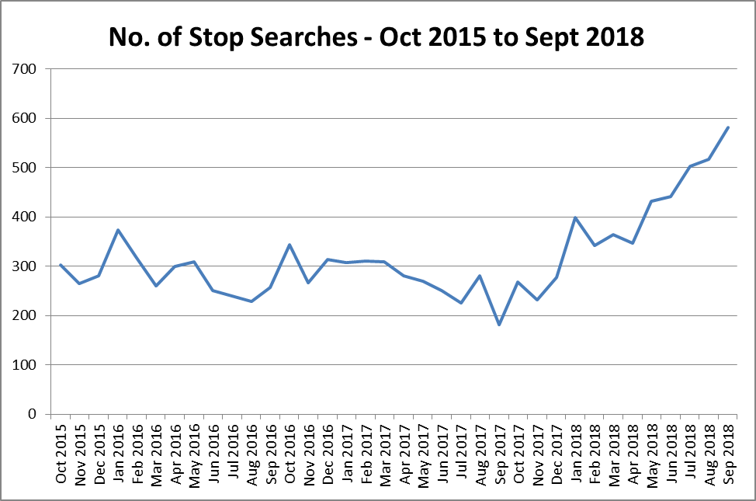

**Overview of Reasonable Grounds Data**

Of the 1601 Stop Searches that have been recorded during the 2nd quarter of

2018/19:

* 1576 (98.4%) had reasonable grounds recorded (87.6% for same quarter last year).
* 25 (1.6%) did not have reasonable grounds recorded (12.4% for same quarter last year).



**Gender**

* 86.3% of those stopped identified themselves as male (89.4% for the same quarter the previous year) and 10.6% female (8.0% previously).
* 25 was the average age for those stopped (where a date of birth was stated); 25 for men and 27 for women.



**Age**

* 56.0% of stop searches in the review period were males in the age band 18 to 34 years.
* 18.8% were males in the age band 11 to 17 years (where age was stated).

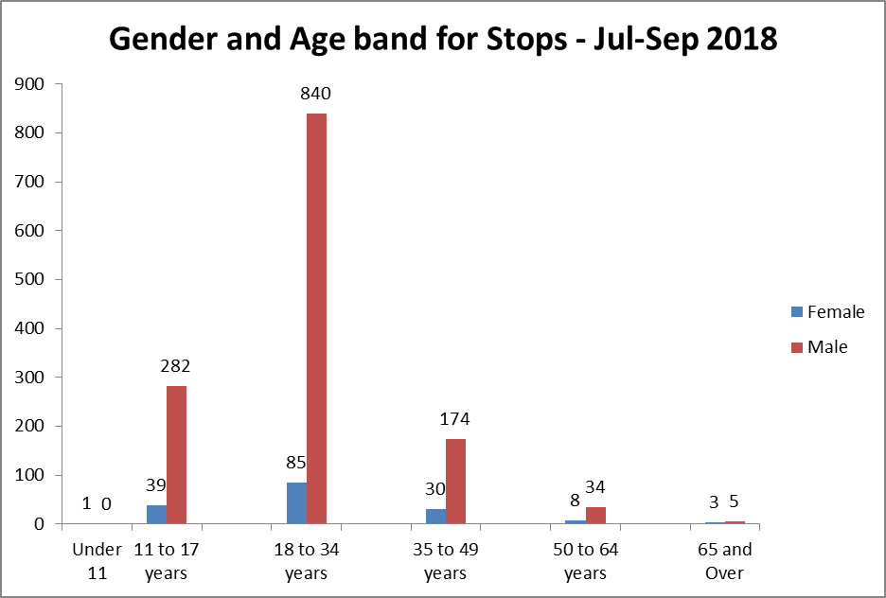

**Outcomes**

The proportion of positive outcomes for the Force is 34.4% (where known or stated),

and 31.4% for Black or Black British.



For those who defined themselves as BAME and those who defined themselves as white had a similar percentage of positive outcomes (33.0% and 34.7% respectively) although those that defined as BAME Increased by 3.0% and white decreased by 4.0%.



**Complaints**

Since Apr 2016 the have been a total of 11 complaints related to Stop and Searches,

one in 2016/17, 6 in 2017/18 and 4 in 2018/19.

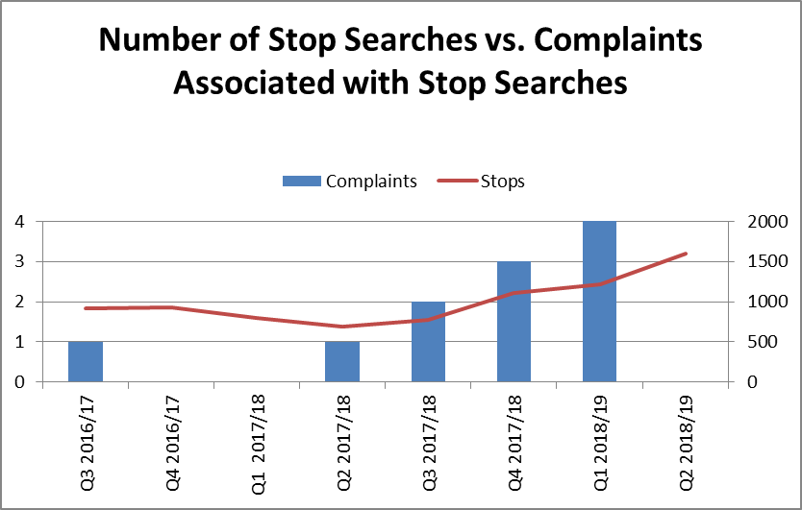

Although low numbers, complaints are increasing.

**6.0 Implications (Issues)**

A balance must be struck with over use of Stop and Search which can lead to

alienation of BAME groups, whilst under use can remove a valuable option to

supress criminal activity.

11.9% of those stopped were Black or Black British (where known or stated), this is 9.9% pts. higher than the proportion of residents in Essex who defined themselves as Black or Black British in the 2011 census.

81.7% of those stopped were white (where known or stated), which is 11.5% pts. lower than the proportion of residents in Essex who defined themselves as white in the 2011 census.



**6.1 Links to Police and Crime Plan Priorities**

The results from the Stop and Search report will help inform against objectives in the Police and Crime Plan; Crack down on anti-social behaviour, reverse the trend in serious violence and tackle gangs and organised crime.

**6.2 Demand**

There are no direct links to the Stop and Search report.

**6.3 Risks/Mitigation**

None identified

**6.4 Equality and/or Human Rights Implications**

LPSU now produce reports which are SIAG (Strategic Independent Advisory Group) specific. The Stop and Search report is scrutinised by attendees during the meeting, they give feedback which is recorded for HMIC Inspections, to date no concerns have been raised regarding disproportionality.

**6.5 Health and Safety Implications**

None identified

**7.0 Consultation/Engagement**

LPA Commands

S/IAGs

EPC

Mobile First Team

Performance Information Unit

Procurement Department

**8.0 Actions for Improvement**

1.6% (25) of stop searches carried out in this period did not have reasonable grounds stated on the form. For the previous year it was 12.4% (85). This is a good improvement year on year but the force continues to focus on this area.

The Stop and Search app has been developed and is currently undergoing rigorous testing to ensure success when released. The app will enable officers to complete Stop & Search records via their hand-held device.

Testing of the app has revealed several areas that need improvement, these are currently being investigated, once corrected the app will launch.

**9.0 Future Work/Development and Expected Outcome**

The Stop and Search coordinator was asked by The Community Policing Team to produce a Stop and Search PowerPoint “Know your Rights” **(appendix 3),** for young people. The PowerPoint is a resource available to schools and all youth services. This will ensure young people are aware of their rights should they be stopped. The Children, Young People and Anti-Social Behaviour Manager uses the PowerPoint as good practice.

The Stop and Search coordinator has reviewed the Section 60 form **(appendix 4)**

after concerns were raised by District Commanders regarding continuous duplication of information. The updated Section 60 is available on force forms, it has reduced from 21 pages to 16 and the Intelligence Log, Community Impact Assessment and Media Plan can now be embedded.

**10.0 Decisions Required by the Police, Fire and Crime Commissioner**

None required, this report is for the information of the Police, Fire and Crime

Commissioner.

**Appendices**

Appendix 1 Appendix 2

 

Appendix 3 Appendix 4

 