**Performance and Resources Scrutiny Programme 2018/19**

**Report to: the Office of the Police, Fire and Crime Commissioner for Essex**

|  |  |
| --- | --- |
| **Title of Report:** | **Use of Force – 2018/19 Quarter 2** |
| **Agenda Number** | **6.0 i** |
| **Chief Officer** | **ACC Pippa Mills** |
| **Date Paper was Written** | **15 November 2018** |
| **Version Number** | **1.1.** |
| **Report from:** | **Essex Police** |
| **Date of Meeting:** | **November 2018** |
| **Author on behalf of Chief Officer:** | **Dan Youngman 42078817** |
| **Date of Approval:** | **19/11/2018** |

1. **Purpose of Report**

To provide a quarterly update on Essex Police’s use of force. This is a substantive agenda item for the PFCC Performance and Resources meeting.

1. **Recommendations**

There are no recommendations. This report is for the board to note.

1. **Executive Summary**

* With continued use of the Mobile First app, the volume of Use of Force forms continues to be higher in 2018-19 than in previous years. The quarterly average for this Financial Year is currently 33% higher than 2017-18.
* 27% of incidents did not involve the use of Tactical Communications in the first instance. It is more likely, however, that officers simply did not input this tactic onto the system. The proportion of forms in which Tactical Communications were not used first has reduced significantly since last quarter.
* The highest five volume districts (Basildon, Chelmsford, Colchester, Southend and Thurrock) account for 70% of all use of force in this quarter.
* 8.7% of subjects were perceived to be Black or Black British (compared to a 2.0% resident Black or Black British population in Essex), this is a slight reduction from last quarter.
* 13.9% (192 persons) had a home address outside of Essex. Of these, 18.8% (36 persons) were from a perceived BAME origin.

On 1 April 2018, the Mobile First application (“app”) replaced the former system as the means to complete use of force forms. Via this app, officers can now submit forms on either a desktop or on their handheld devices (this can be performed remotely also.) This has so far resulted in a third more Use of Force forms being submitted per Quarter in 2018/19 than in the previous year.

**4.0 Introduction/Background**

The ‘Police Use of Force’ Annual Data Return (ADR) placed a requirement on police forces to collect data from October 2016. The use of force data was captured in Essex on the Limes Survey database until March 2018. On 1 April 2018, a new Mobile First Application (“app”) was introduced to replace Limes Survey; this app is available on desktop, on officers’ handheld devices and forms can be completed remotely. This report relates to data solely from the Mobile First app.

**5.0 Current Work and Performance**

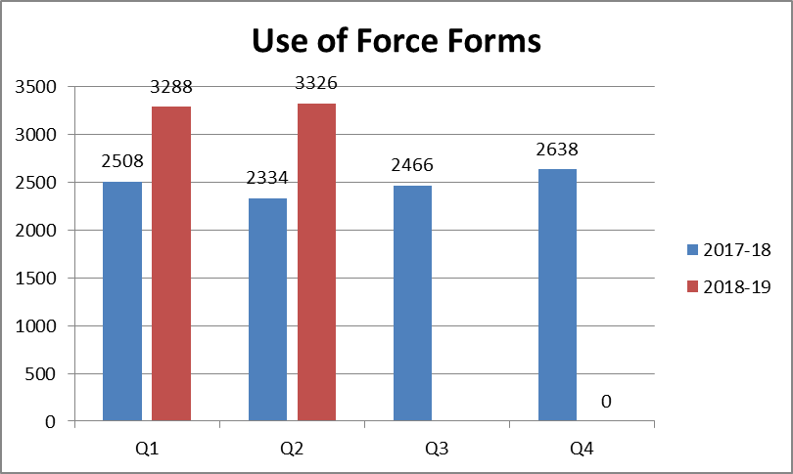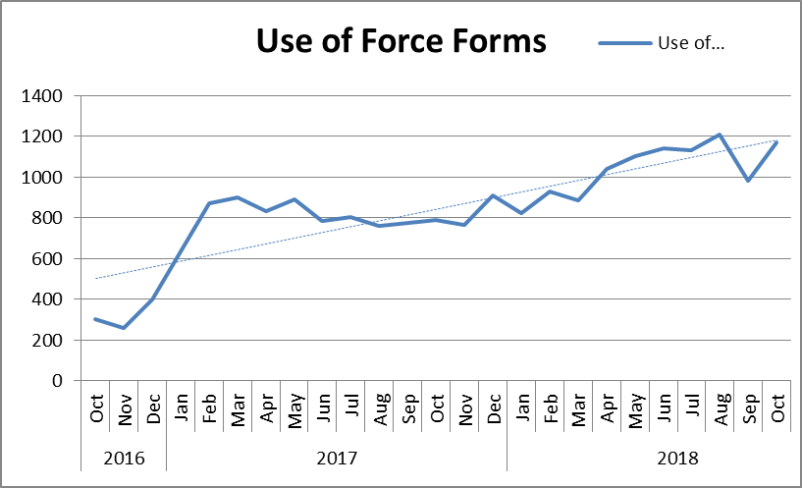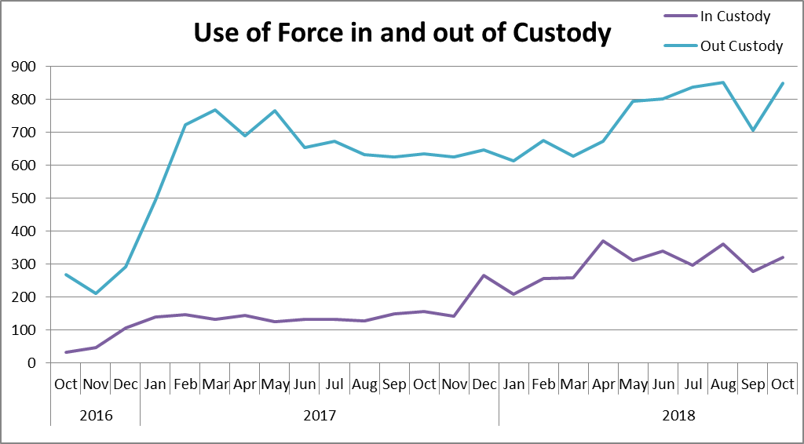

3,326 use of force forms were submitted in Essex during quarter 2. This is an increase of 992 (42.5%) additional forms completed, compared to the same quarter for the 2017/18 financial year and a 1.2% rise from the previous quarter. This quarter on quarter rise is despite a significant dip in volume in September 2018. A continuing increasing trend for form submissions is also shown.

Use of Force reports in Custody appear to have levelled off since April, but it will take several more data points to see whether this is a medium-long term trend. Significant work was undertaken from Nov 2017 to improve reporting of force in custody.

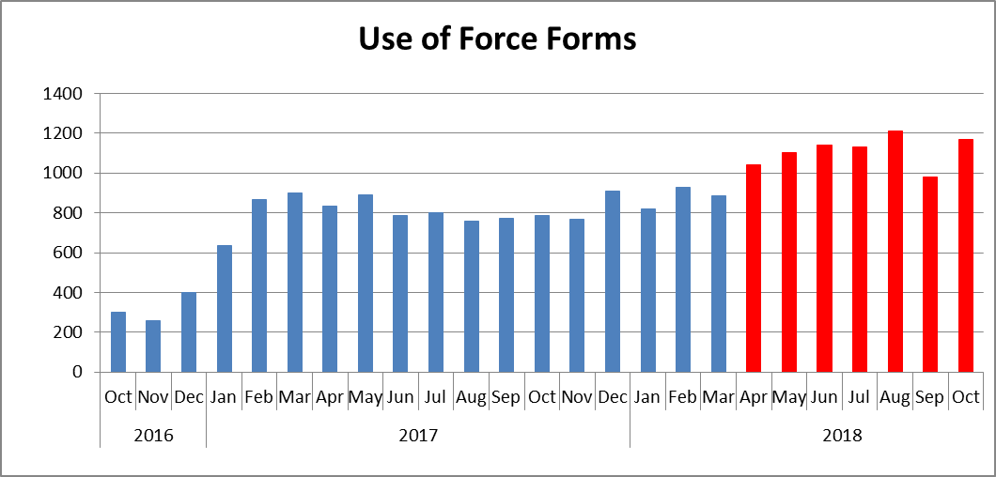

As illustrated in the above chart, all six months of 2018-19 are higher in volume than any of the months in the previous six quarters.

*Tactics Employed*

The below table details the tactics employed with each use of force in quarter 2 of 2018/19. It details all tactics employed (not necessarily the most severe), and more than one will have been used in the majority of incidents. The Mobile First app allows for the inputting of up to 20 Tactics for one incident.

* Tactical communications (tac comms) were the most commonly used tactic. In 83 reports, tac comms were the only method employed, suggesting further training on the app may be required (a form is not required when tac comms are the only method).
* 63.66% of incidents did not state that tac comms were used. It is unlikely that this is the case, however, and that officers simply did not enter tac comms as a tactic used.
* Handcuffing is the next most common tactic; there were 51% more compliant cuffs used than non-compliant. 2,021 use of force incidents (60.7%) involved the use of either compliant or non-complaint handcuffs.
* 21 incidents involved a Taser recorded as a first tactic.
* 24 incidents involved a firearm recorded as a first tactic.

*Location*

Force was used most in Southend, Basildon, Chelmsford and Colchester in Quarter 2 of 2018/19 (data relates to the area in which force was used rather than the officer’s command); 59.8% of force was used in these 4 districts during this period.

 

*Subjects*

78.5% of those subjected to use of force were identified by officers as male; 15.1% were identified as female; one subject was identified as transgender.

The proportion of Blank or Not Recorded genders rose since the inception of Mobile First and remains high. 189 of these Blank Gender records have a Subject name attached to them, suggesting that further care is required to input data accurately.



31 was the average age for subjects (where a date of birth was given/stated); 31 was the average age for men, and 30 the average age for women. Males with a perceived age between 18-34 years were the most common gender and age band in the review period.

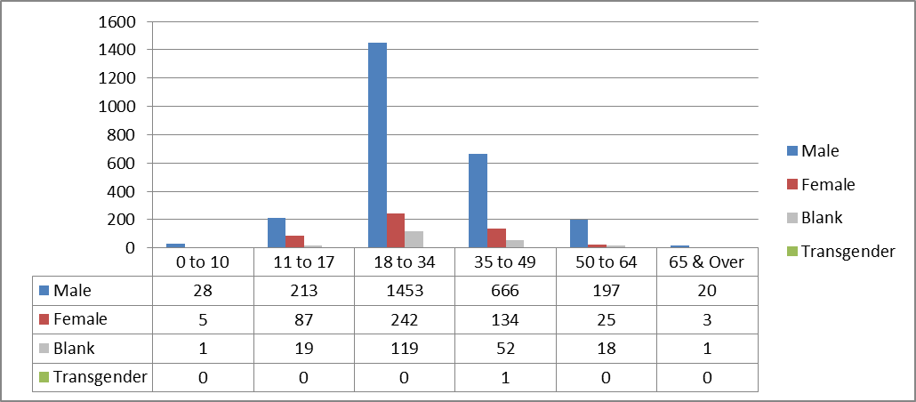

83.6% of subjects were white. This is 9.6% lower than the proportion of residents in Essex who identified themselves as being white (93.2% of Essex defined themselves as white in the 2011 census).

8.7% of subjects against whom force was used were black. This is 6.7% higher than the 2.0% black resident population proportion in Essex (2011 census data.)



*Reason for Use of Force*

Effecting Arrest was the most commonly used reason entered for officers using force, followed by Preventing Harm. Please note, that more than one reason can be entered when justifying a use of force.



*Arrest Reason for BAME*

The below table details the 11 most common arrest reasons when the subject of use of force is perceived to be of Black, Asian and Minority Ethnic (BAME). Please note, however, that the data has been extracted from custody, so those against whom force has been used may have been arrested for multiple offences this data is based entirely on the first offence listed for each custody record.

Assaults (ABH and common assault) are the most common arrest reasons. For Black or Black British subjects, supply of drugs was the next most common arrest reason.



**6.0 Implications (Issues)**

Effective analysis is reliant both on the accuracy of the forms submitted, and the volume.

The data analysed in this report contains duplicates, as one form should be submitted per officer for each use of force. Therefore, if three officers use force against one subject in relation to the same incident, three forms should be submitted, and the subject would appear three times in the data (for that one incident).

**6.1 Links to Police and Crime Plan Priorities**

The use of force is a cross-cutting issue that impacts on many areas in the Police and Crime Plan.

**6.2 Demand**

Any increase/decrease in the use of force by police is dependent on the number of subjects against whom this is necessary and proportionate.

**6.3 Risks/Mitigation**

Use of force is monitored by the Use of Force Oversight Board chaired by ACC Pippa MILLS; these meetings are held on a quarterly basis. This group is a force-wide focus group facilitated and organised by the Operational Policing Command (OPC), and is intended to provide formal scrutiny and consultative feedback on the use of force and all its associated issues. The Use of Force Oversight Board focuses on enabling the force to examine and improve on statistical data-gathering and its analysis, and transparency with the public in order to improve confidence and trust in Essex Police.

Representation within the Use of Force Oversight Board comprises a number of disciplines, as detailed in the below structure:



**6.4 Equality and/or Human Rights Implications**

The above analysis indicated a potential disparity in the ethnic origins of those against whom force was used, when compared to the resident population in the county. 9.47% of those against whom force was used (where stated) had a self-defined ethnicity of black, compared to a 2.0% black population in the county. This does not necessarily mean that the force used in these cases was inappropriate, however.

**6.5 Health and Safety Implications**

Use of force has a health and safety implication for the subject, the police, and the public.

**7.0 Consultation/Engagement**

Professional Standards at Essex Police provided data relating to the volume of complaints submitted by members of the public since April 2016 for the previous report.

**8.0 Actions for Improvement**

The new Mobile First app has assisted with the accessibility, ease and timeliness of completing Use of Force forms. The forms within the app contain more constrained and pre-completed fields, which has improved the accuracy of that which is submitted, and will enable more effective analysis to be conducted. However, cleaning and displaying this data is an ongoing process. The volume and accuracy of these forms will continue to be monitored by the Use of Force Oversight Board.

**9.0 Future Work/Development**

This report is a substantive agenda item. As the data from this app is continuing to be reviewed and analysed, more meaningful key findings are consequently becoming available.

**10.0 Decisions Required by the Police, Fire and Crime Commissioner**

This report is purely for the information of the Police, Fire and Crime Commissioner.