Meeting | ECFRS Strategic Board | Agenda Item | 6
Meeting Date | 7th March 2019 | Report Number
Report Author: | Amanda Johnson
Presented By | Pippa Brent-Isherwood
Subject | Essex Emergency Services Collaboration Programme update
Type of Report: | Information
Actions Required | Note content

Information Sharing

A joint (EP, ECFRS and EEAST) GDPR compliant Information Sharing Agreement with Data Impact Assessment and Joint Privacy Notice has been developed and agreed at strategic level. This is the first such agreement relating to collaboration in its broadest sense nationally and is a key enabler for a number of other projects.

This will be signed by each of the Chief Officers (or their nominees) once reviewed by SIROs.

In order to maintain an audit trail, all project documents will contain a specific section referencing ‘Information Sharing’ and the project leads will need to complete this and indicate what information will need to be shared within the project and that they have checked this sits within this protocol.

Risk Register

The current register was drawn up for the PFCC Business Case for governance of ECFRS in 2016. At EESCGB in January it was agreed to implement a thorough review of the Risk Register.

The revised format was approved at SCGB on 14th February, and the revised register will be presented to SCGB in March 2019. This will include a revision of the wording in order to reflect more accurately the real risks and the adoption of a 5x5 risk score matrix which has been adopted by Essex Police and the OPFCC.

Tactical 10 projects update

The Tactical 10 Projects (T10) are listed in the PFCC Business Case and have been in delivery since the end of 2017 when the Programme received the PTF Grant funding to deliver them.

The T10 have a monetarised benefits map against them agreed with Essex Police. The monetarised benefits are included in the Economic Dashboard tracker against the PFCC Business Case and all sit within the ‘Better Working Together’ business area. The monetarised benefits have also been included in the Essex Police Efficiency Plan.

It was agreed at EESSCGB (SCGB)on 14th February that most of the existing T10 projects can be closed but with the following provisos:
- When there is a recommendation to close, there will be a Closure Report , detailing the full evaluation which has led to the decision to close.
- There will be a benefits realisation plan and a quarterly update to EESSCGB on benefits realisation, if Board members are confident that the benefits are being realised then this could go out to six months, but an annual report is not acceptable at this point in time. The risk associated with efficiency in benefits achievement and their tracking with regards to the 10 Tactical projects that will now close, to be added to the Programme Risk Register.

Strategic Programme of Work Update

Programme of Work agreed by Chief Officers from Police, Fire and Ambulance on 5th January 2018. EEAST are engaged and invited to all workshops. Assurance is through quarterly STAR chambers (next ones on 4th and 6th March 2019) with CC and CFO; governance is through the monthly SCGB chaired by the PFCC.

Appendix 1 details the current monetarised benefits to-date against the PFCC Business Case. There is an urgent need to establish all monetarised benefits against the PFCC Business Case to determine the level of risk against meeting the stated targets, and this will a focus for accountable leads at STAR Chamaber

Appendix 2 also shows how the SPoW projects map to the Success Factors in the PFCC Business case, the Strategic Priorities of the Fire and Rescue Plan, the Police and Crime Plan and EEAST Strategic Objectives.

Project | Status
Joint Fleet Workshops | Full business case with options, costings and benefits (financial and non-financial) will be presented at the SGB in March 2019.
Shared use of ECFRS Estate (OPE Blue Light Access) | Scope for this phase of the project has now increased from 10 to 11 stations in adding Ingatestone. Forecast for completion is end of March 2019 - slippage in dates due to increase in scope and difficulty aligning required visits and inductions.  The second phase is to look at actual shared of fire stations – papers for shared use of Dovercourt and Frinton will go to ECFRS SLT in the by mid March.
Provision of Classroom Facilities for joint training in JESIP, supervision and leadership (OPE Blue Light Access) | Update paper submitted to Strategic Collaboration Board. Capacity of classrooms at Kelvedon Park has now been analysed showing the value of classrooms for either Essex Police and Collaborative training rooms to be to the value of £6.5k for the last 12 months.  Head of EP training contacted who confirmed that the KP is a fantastic facility but its size a capacity will only continue to act as an over flow facility. Further work now needs to take place to understand further the opportunities of any shared training course opportunities.
Joint provision of specialist capabilities between Fire and Police (OPE Blue Light Access) | An opportunities report was submitted to SGB on 14th February and agreement given to continue to develop opportunities. Next report to SCGB in April 2019.
Joint Incident Command Unit | Full business case with options, costings and benefits (financial and non-financial) will be presented at the SGB in March 2019.
IT Convergence Roadmap | Full Roadmap with options, costings and benefits (financial and non-financial) will be presented at the SGB in March 2019.
Joint Procurement Initiatives | CC & CFO continue to be provided with updates on the sharing of contracts between the two services at STAR Chambers, with a number of items awaiting the expiry date of the current arrangements
Shared Control Room Facility | An initial Project Initiation Document has now been completed to a 70% confidence level, based on the information available and design work carried out to date. This was submitted to the ECFRS Change Board on 18 December 2018, but was not approved, due to the significant costs and increase in timescales since the Project Brief was approved in June 2018. The Investment Appraisal and Operational Risk will now be subject to further review by the Essex PFCC, ECFRS and Essex & Kent Police senior management and ICT Management, in order to determine if the proposed option still supports the Essex PFCC local business case. An initial meeting took place on 4 January 2019 to discuss, followed by a meeting on 22 January between the PFCC and CFO. A meeting with the new Deputy CFO and the EP lead is scheduled for 7 March 2019,  In the meantime, ECFRS have had agreement to upgrade the Frequentis ICS to version 2.9
Increase resources in the Dengie Peninsula | Full business case with options, costings and benefits (financial and non-financial) will be presented at the SGB in March 2019.
Joint Community Safety Function | Community Safety collaboration to continue to ensure effective attendance at / operation of CSPs and effective attendance at / operation of the Community Safety Hubs. This work will provide greater detail on the identification and selection of the 8 x ECFRS staff, including a timeline for them to work as part of the CS hubs. It will consider how the current Community Builders also become integrated. At the Feb 2019 SCGB it was agreed that these staff will continue to be part of the shared space. This convergence work will also include a deep dive review of youth diversion / engagement work across police and fire and consider options for closer working; a report will go to SCGB in May 2019. This also links into LPSU-led wider Youth Justice Team development and its links to the Violence and Vulnerability Unit and the Home Office funding availability for diversion.

Finance Update

Phase 7 One Public Estate Bids:

The ESCP Project Manager for OPE related work is funded under Phase 6 monies until June 2019 and is working on the projects involving Estates – Drop-in Centres, co-use of estate, Joint classrooms, joint training and collaboration specialist capabilities.

The outcome of the Phase 7 bids for One Public Estate funding has been awarded. Planning will now commence. This relates to the Lexden (Colchester) site owned by ECC, EEAST and ECFRS. This will help inform ongoing collaborative projects exploring shared fleet and specialist training facilities.

Home Office PTF Grant

Budget update 2018/19

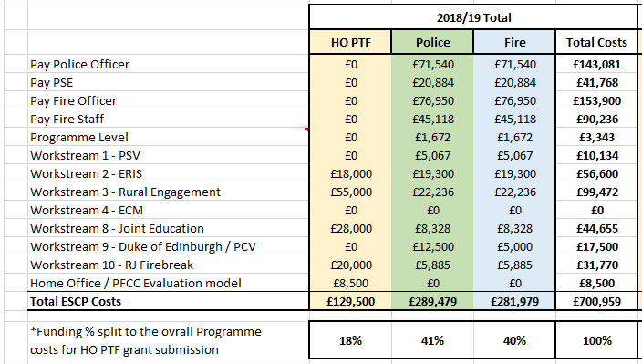

Budget for 2019/20

2019/20 budget templates have been completed to support the ESCP collaboration team’s funding 50/50 with Fire/Police.

 | Projected 2019/20 Total
 | HO PTF | Police | Fire | Total Costs
Workstream 3 - Rural Engagement | £0 | £42,500 | £42,500 | £85,000
Workstream 8 - Joint Education | £0 | £27,500 | £27,500 | £55,000
Workstream 10 - RJ Firebreak | £0 | £12,500 | £12,500 | £25,000
Home Office / PFCC Evaluation model | £10,000 | £0 | £0 | £10,000

Benefits Realisation

This is an on-going piece of work with the ESCP Team attending the national Benefits Realisation Practitioners Working Group (NPCC sponsored) and are fully engaged with the Home Office and senior Emergency Service Collaboration sector leads on Benefits development in a collaborative prevention arena.

Representative Body engagement

CFO Jo Turton has regular meetings with Rep Bodies and will be incorporating ‘collaboration’ in future meetings to ensure consistent messaging.

Communications and Engagement

The Collaboration Communications Plan has been agreed and is in active use by the joint communications teams.

- A press release regarding co-use of Corringham Fire Station went out to media early December and published on ECFRS daily news, Essex Police intranet news and PFCC website.
- Internal news story about Pc Lewis Jones was published on ECFRS daily news on the 12th December. PC Lewis Jones went on an ECFRS Firebreak course as a teenager in 2012 and ‘passed out’ as a police officer with Essex Police in December.
- Ch Insp Norris is discussing with ECFRS Comms to discuss how to ensure that consistent messaging is echoed across both services. It can been suggested that a review bi-monthly to amend any inconsistences is appropriate.

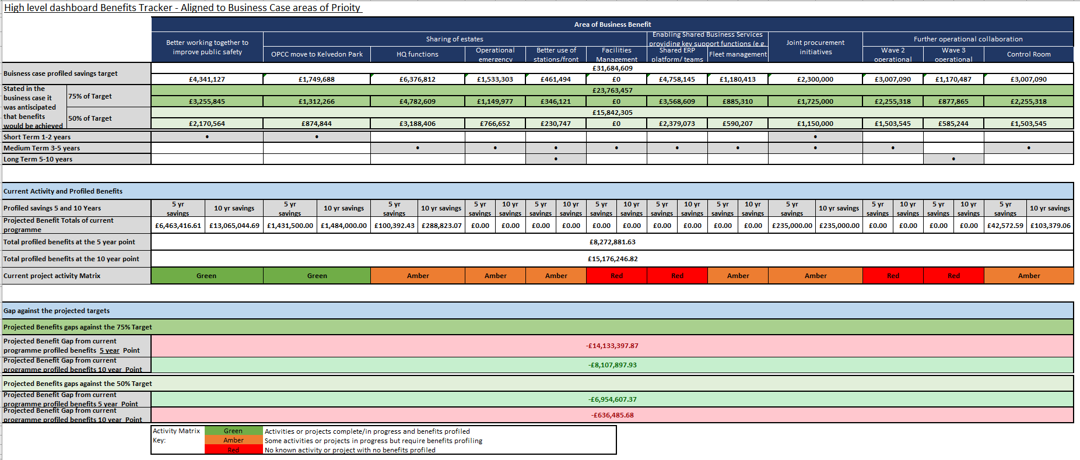
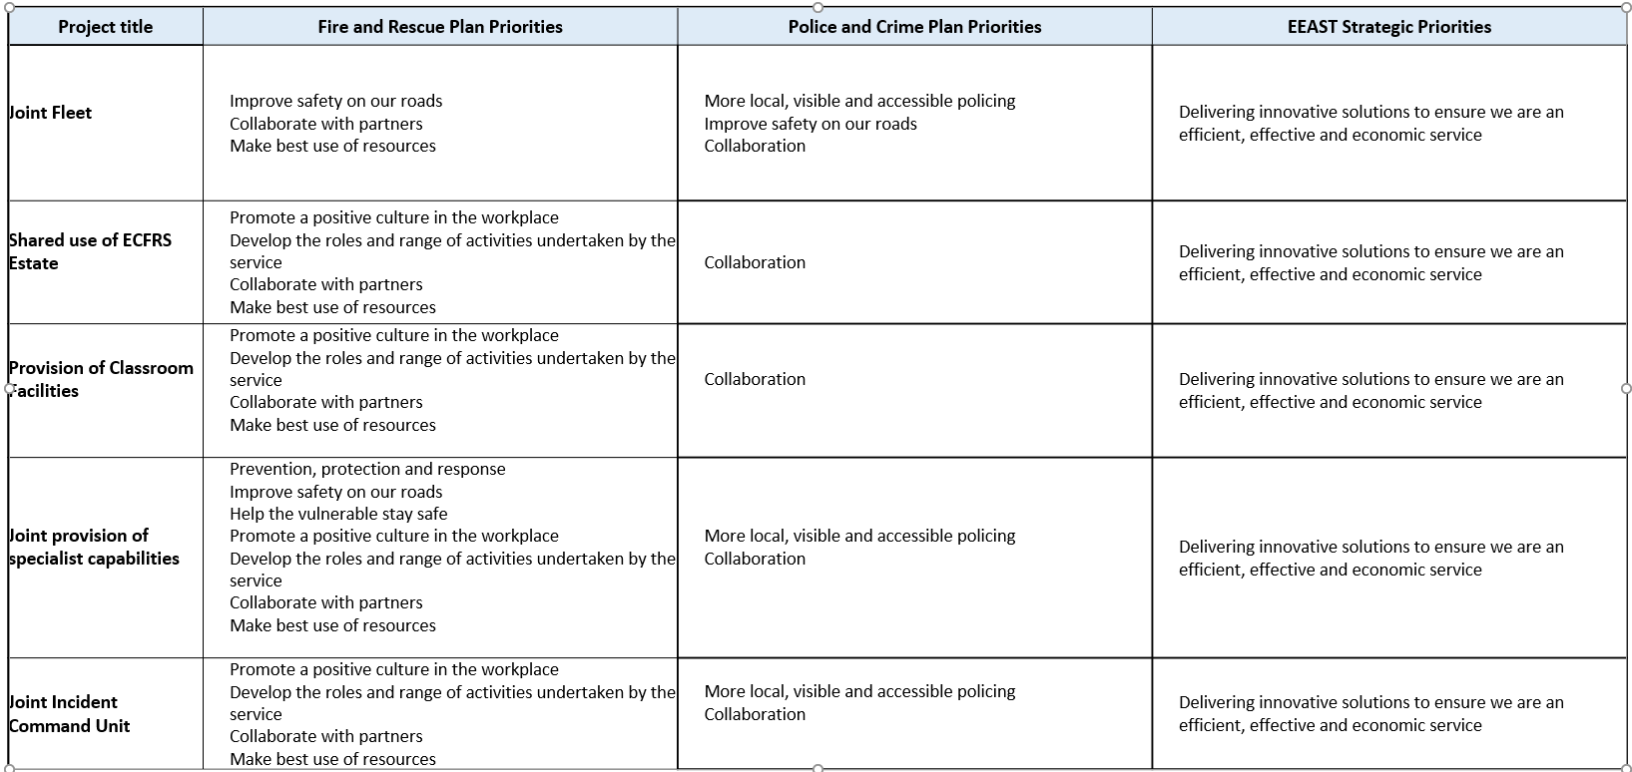

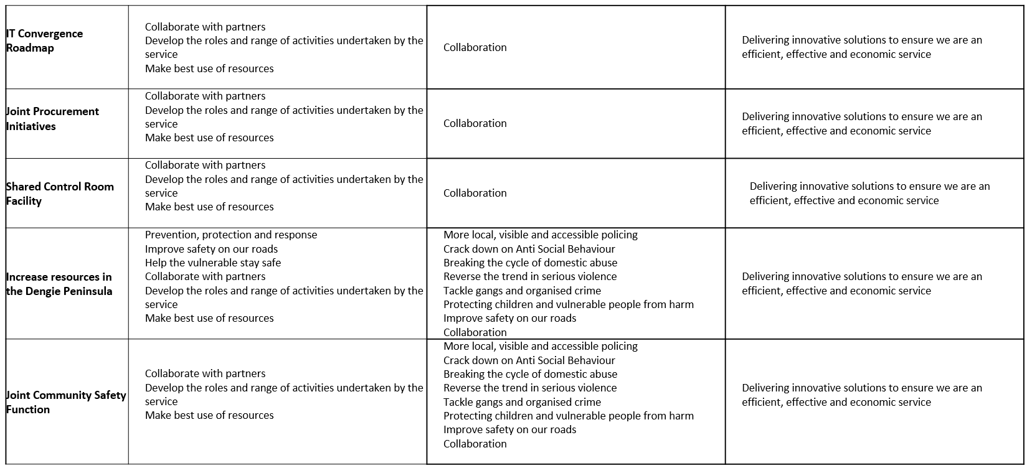

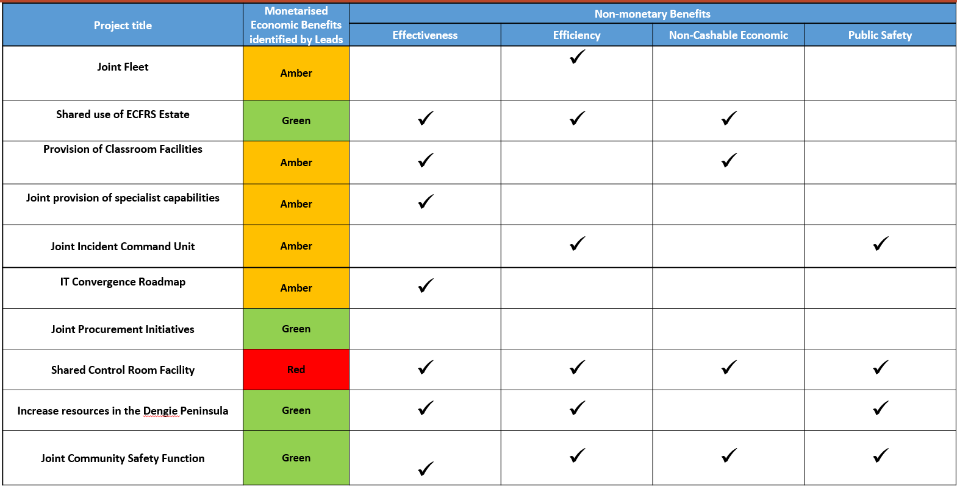
Alignment to PFCC Business Case success Factors

