**ESSEX POLICE, FIRE AND CRIME COMMISSIONER FIRE & RESCUE AUTHORITY**

Essex County Fire & Rescue Service



|  |  |  |  |
| --- | --- | --- | --- |
| Meeting | **Fire & Rescue - Performance and Resources Board** | Agenda Item | 6 |
| Meeting Date |  | Report Number |  |
| Report Author: | Jayesh Padania, Finance Manager | | |
| Presented By | Glenn McGuinness, Assistant Director of Finance | | |
| Subject | **Budget Review – January 2019** | | |
| Type of Report: | Information | | |

**SUMMARY**

This paper reports on expenditure against budget as at 31st January 2019 and identifies and comments on major budget variations. In addition the report includes key indicators that act as lead indicators for expenditure across the Authority.

**RECOMMENDATIONS**

The Fire & Rescue - Performance and Resources Board is asked to:

1. Note the position on the income and expenditure at 31st January 2019 compared to the budget.
2. Note the Capital Expenditure spend against budget and forecast for period to 31st January 2019.
3. Note the latest Forecast including Virements.

**BACKGROUND**

This table below shows actual expenditure against budget to 31st January 2019.



More detailed figures are provided at appendix 1

**STAFFING**

**January has seen some minor adjustments due to the change of the HR and Pay system to Civica, as staff and processes adapt to the new system.**

**Overall employment costs are £363K (0.9%) under budget for the 10 months to 31st January 2019.**

**Spend for whole time fire-fighters is £46K (0.2%) under budget:-**

* £98K overspend on Firefighter basic pay and overtime
  + ASW was £18K underspend against the revised ASW budget to 31st January 2019
* £144K underspend on salary related costs

**For on-call firefighters, spend is £538K (10.9%) under budget:-**

**For Control staff, spend is £45K (3.8%) under budget:-**

* £ 12K underspend on Control Staff Pay
* £ 21K underspend on Control Staff Overtime
* £ 12K underspend on Control staff pay on-costs

**Support staff pay is £267K (2.5%) over budget for the 10 months to 31st January 2019.**

This is comprised of:-

* An underspend of £96K on Secondary Contract Staff
* The overspend of £363K for Support Staff (Excl. Secondary Contracts) is made up of:-
  + £214K overspend on Casual and Temporary
    - Mainly in increase in Temp staff within the ICT and IT Projects, there has been a smaller reduction in support staff pay within the ICT and IT projects
  + £142K overspend in Support Staff Pay
  + £ 7K overspend on support staff on costs

Appendix 3 – Table Summary of Support Staff FTE numbers

**Please be aware that the staff FTE and headcount data for January 2019 has been extracted from Civica.**

Whole-time fire-fighter numbers at 628.0 are 27.0 (3.2 %) below phased budget at the end of January.

The staffing position at the end of January is summarised below (% figures rounded):



As at the end of January the number of whole-time fire-fighters aged over 50 with more than 25 years’ service was 86, of these 13 have more than 30 years’ service.

The graph below shows the numbers of whole-time fire-fighters compared to the budget for the year.

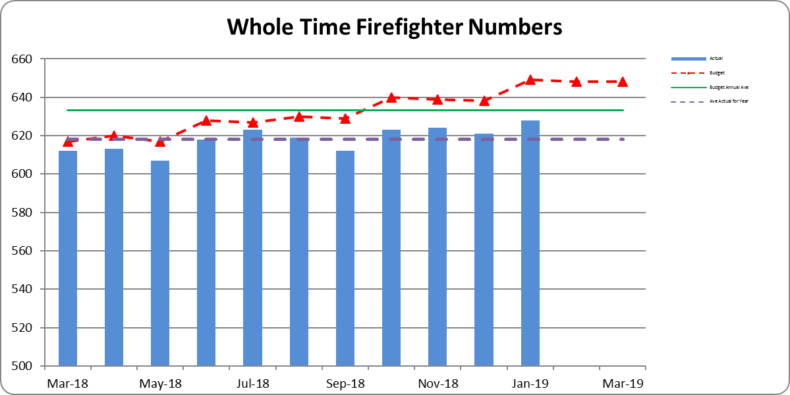

**WATCH BASED FIREFIGHTERS**

The numbers of Watch Based Fire-fighters compared to the target levels set by the Authority are shown

below.



Wholetime recruitment process is currently under way with a further 12 new recruits joining in January 2019.

**ON-CALL FIREFIGHTERS**

Appendix 2 -On Call Firefighter nos. by Station

The table shows that the total FTE at 31st January 2019 was 386.00, a net decrease of 18.00 FTE from 1st April 2018. For January there with a net decrease of 7.25 FTE in the month.

**NON-PAY RELATED EXPENDITURE**

Non-pay expenditure is £468K underspent for the 10 month to 31st January; in addition operational income is £237K more than budget.

**Support Costs are £95K (6.3%), overspent for the 10 months to 31st January 2019**



* The overspend on Travel and Subsistence relates to mileage costs being £61K higher than budgeted and following a decision by a number of Officers to switch from service provided lease vehicles to using their own vehicles as a result of proposed taxation changes and the suspension of the lease scheme in force at the time. This has resulted in an underspend of £92K on Lease and Interest Changes for lease cars under Financing Items.
* £70K (14.7%) overspend on Training Costs:-



* + Overspend is in relation to training for operational staff and in particular the new whole time recruits

**Premises & Equipment are £365K (4.1%), underspent for the 10 months to 31st January 2019**



* Information Systems underspend of £388K
  + £430K underspend on IT Consumables against budget to date
* Utilities underspend of £61K
  + £56K underspend for Gas charges against budget to date, mainly due to budget phasing assumptions
  + £ 4K overspend on Electricity against budget to date
  + £10K underspend on Water metered usage

**Other Costs & Services are £138K (4.7%), underspent for the 10 months to 31st January 2019**



* Establishment Costs underspend of £61K
  + £47K underspend on Media Expenses
  + £29K underspend on Events
* In January there was a correction to the Recruitment accrual reducing the overspend to January to £15K

**FORECAST**

The forecast for the year has been prepared partly by finance and partly in conjunction with budget holders, this will be updated once all forecasts for 2018/19 have been reviewed with budget holders as part of the 2019/20 budget setting process.

This forecast shows a deficit for the year of £687K, and is before any planned release from reserves, as the budget included a planned release from the Capital Receipts Reserve of £2,569K we are £1,882K better than budget.

The main reasons for this positive initial forecast are:

* A reduction in capital financing charges (£692K) arising from the review in capital expenditure dealt with elsewhere in this report.
* A combination of both lower headcount and activity level for On-Call Firefighters (£589K)
* ICT projects are expected to be £500K underspent this year.

A summary of the current forecast against budget is given in the table below:



**VIREMENTS**

* £216K Full Year virement reflecting the post of CFO/CEO has been transferred from Grey Book to Green Book.
* £113K Full Year virement contribution of 1% inflation provision included in the budget for Support Staff annual pay increment
* £434K Full Year virement for Police Collaboration, virement of the projected income from PTF grant and Essex Police contribution towards the related projected costs to which this income relates
* £208K Full Year virement for pay award for Whole Time Fire Fighters including on-costs, due to be paid from November 2018 and backdated to July 2018
* £48K Full Year virement for pay award for Retained Fire Fighters including on-costs, due to be paid from November 2018 and backdated to July 2018
* £17K full Year Virement for Fitness Equipment requiring replacement, from savings on Retained Firefighter pay to date

**CAPITAL EXPENDITURE**

Capital expenditure for the 10 months to 31st January 2019 is shown in the table below.

Total capital expenditure and commitments is £3.7m.

The largest item included is £1.6m for asset protection.

* £1,000K invoices received to January 2019
* £633K commitments from various PO’s raised to date for anticipated spend throughout the year

Vehicle £1,126K:-

* £656K invoices paid and commitments related to Off Road Vehicles
* £190K invoices paid and commitments related to Light Vans
* £ 79K invoices paid related to Appliances

The investment of £710K in information technology relates to:-

* £198K on HOBS/ Civica
* £198K for MDT replacement programme
* £225 on Devices for Appliances
* £ 81K on hardware replacement



**Capital Expenditure Forecast commentary**

An extensive review of all capital expenditure carried out by the Finance team in conjunction with budget holders in September and October 2018 resulted in a number of projects being rescheduled or cancelled.

The forecast for 2018-19 shows expenditure at £5.2m against a budget of £12m. The draft capital budget for 2019-20 shows expenditure at c.£5m.. Expenditure for both years has been reviewed to concentrate on essential expenditure over the next couple of years, this will be reconsidered when The Fire and Rescue plan and IRMP to 2024 are developed.

The reasons for the forecast spend for 2018/19 of £5.2m being £6.8m below budget are as follows:

* **Vehicles - £2.6m underspend.**
  + The budget included continued provision for the replacement of appliances, we are now planning to continue appliance replacement in 2020/2021.

This accounts for an underspend of £1.9m

* + Light vehicles a stores van, vehicle telematics account for an underspend of £605K, of this £200K for light vans has been deferred to 2019/20
* **Operational Equipment - £490K underspend**
  + Three items (c. £350K) deferred, these are Hose Reel Branch/Main Line (£136k), light portable pumps (£152K) and Foam £60)
  + Heavy Rescue Rumps equipment £97K underspent.
* **Information Technology - £880K underspend**
  + The main reason for this is deferral of ESMCP preparation work and ICCs/CAD replacement, the project is being rescheduled.
* **Property - £2.8m underspend.**
  + The budget included an initial £3m for Service Workshops replacement, we are forecasting nil spend this year, we are however forecasting an initial £200K on Shoebury although this would be subject to a business case and project approval.

**BENEFITS AND RISK/ FINANCIAL IMPLICATIONS**

The review of expenditure against the profiled budget is part of the overall financial control process of the Authority. In exceptional circumstances it allows for budget virements to ensure that under spending against budget heads can be utilised to fund expenditure against other priorities. If virements are not made there is a risk that the Authority will miss out on opportunities to improve performance and meet key objectives during the year. The Authority’s reserves are at the upper end of their target range and the Authority is able to fund short term fluctuations in activity from them when necessary.

The review of the management accounts is one control measure to mitigate the risk of overspending the Authority’s budget for the year.

**EQUALITY AND DIVERSITY IMPLICATIONS**

There are no direct Equality or Diversity implications within this report

**LEGAL IMPLICATIONS**

There are no direct legal implications within this report.

**HEALTH & SAFETY IMPLICATIONS**

There are no direct Health and Safety implications within this report.

**ACTIONS / NEXT STEPS**

1. Further reviews with budget holders on the Support Staff numbers

|  |  |
| --- | --- |
| LOCAL GOVERNMENT (ACCESS TO INFORMATION) ACT 1985 | |
| List of background documents – including appendices, hardcopy or electronic including any relevant link/s. | |
| Appendix 1 Management Accounts – January 2019  Appendix 2 On Call Firefighter Headcount Numbers  Appendix 3 Support Staff and Agency/Temp numbers | |
| Proper Officer: | Acting Finance Director to PFCC Fire & Rescue Authority |
| Contact Officer: | Glenn McGuinness  Essex County Fire & Rescue Service, Kelvedon Park, London Road,  Rivenhall, Witham CM8 3HB  Tel: 01376 576186  glenn.mcguinness@essex-fire.gov.uk |



**Appendix 2**



**Appendix 3**

**SUPPORT STAFF & TEMP/AGENCY NUMBERS**

