**Performance and Resources Scrutiny Programme 2018/2019**

**Report to: the Office of the Police, Fire and Crime Commissioner for Essex**

|  |  |
| --- | --- |
| **Title of Report:** | **2018/19 Month 9 Financial Monitoring Report** |
| **Agenda Number:** | **5** |
| **Chief Officer** | **Mark Gilmartin, Director of Essex and Kent Support Services** |
| **Date Paper was Written** | **22nd January 2019** |
| **Version Number** | **Version 1** |
| **Report from:** | **Essex Police: Corporate Finance** |
| **Date of Meeting:** | **31st January 2019** |
| **Author on behalf of Chief Officer:** | **Richard Jones, Head of Business Partnering and Management Accounting** |
| **Date of Approval:** | **22nd January 2019** |

1. **Purpose of Report**
   1. This report identifies the 2018/19 month 9 position for the Force.
2. **Recommendations**
   1. The report is for noting.
3. **Executive Summary**
   1. The latest forecast revenue overspend is **£0.780m**.
   2. The police officer strength forecast at end of December is **3,018 FTE** and at year end is **3,018 FTE**.
   3. The Capital Reserve is forecast to be **£8.808m** surplus at year end.
   4. The forecast capital expenditure is **£10.205m** and the forecast capital income from property disposals is **£18.360m**.
4. **Introduction/Background** 
   1. This reports sets out the December, month 9, financial position, highlighting the changes from November, month 8.
5. **Current Work and Performance**
   1. The month 9 financial position is shown at Annex 1.
6. **Implications (Issues)**
   1. The implications are reported in Annex 1.
7. **Links to Police and Crime Plan Priorities**
   1. The Force budget is used to help meet the priorities of the Police and Crime plan.
8. **Demand**
   1. The Force budget is reviewed and re-allocated within virement rules to match demand e.g. overtime funded by vacancies.
9. **Risks/Mitigation**
   1. Risk Register URN 452 - Short and Long Term Capital Finance.
10. **Equality and/or Human Rights Implications**

N/A

1. **Health and Safety Implications**

N/A

1. **Consultation/Engagement**
   1. The pay forecasts are based on information received from HR Organisational Management
2. **Actions for Improvement**

N/A.

1. **Future Work/Development and Expected Outcome**
   1. Reviews will continue with budget holders, working towards a balanced budget by year end.
2. **Decisions Required by the Police, Fire and Crime Commissioner**
   1. To agree a transfer from the general reserve of £700k to meet the renewal cost for the force motor insurance contract from 1 October 2018.

# Executive Summary – 2018/19 – Month 9

# Revenue

## Revenue Summary – 2018/19 – Month 9





## Main Forecast Movements since month 8



# Workforce Analysis

## Pay Summary



## Police Officer FTEs

### 

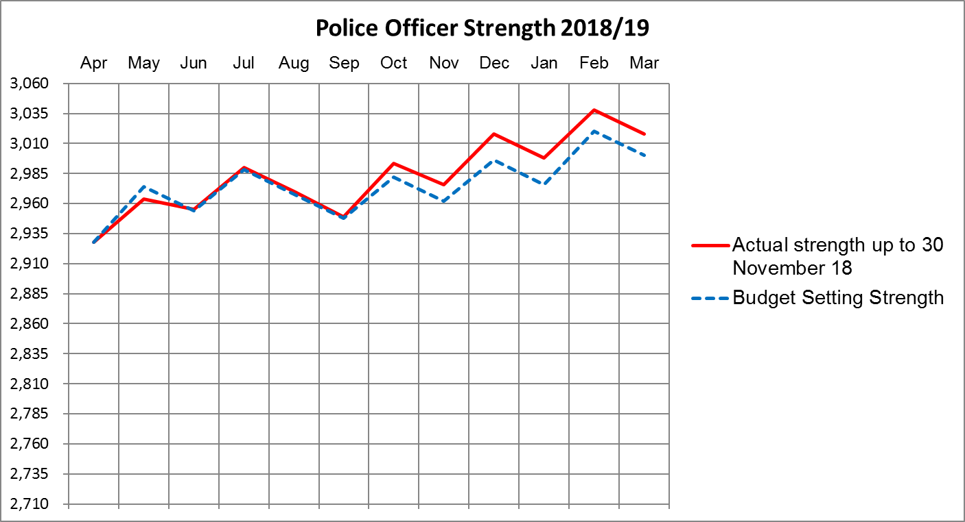

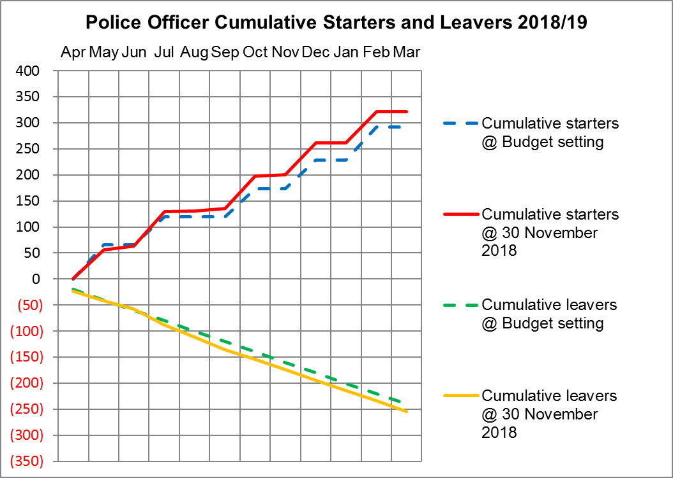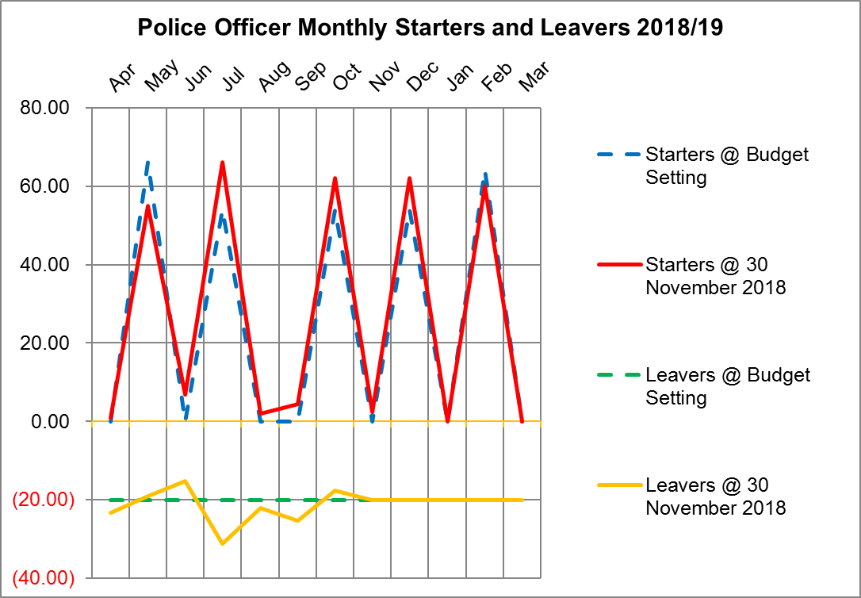

## Police Officers, Police Staff, PCSOs and Specials



# Virement Analysis – Month 9

## Virement Analysis – Summary



## Virement Analysis – Detail



# Reserves

## Detail Reserve Analysis

## Transformation Reserve



# Capital

## Movement in Capital Reserve Forecast



## Projection of Capital Reserves – Cashflow Profile



