Performance and Resources Scrutiny Programme 2018/2019

Report to: the Office of the Police, Fire and Crime Commissioner for Essex

Title of Report: | Stop and Search Quarterly Report
Agenda Number: | 4
Chief Officer | ACC Prophet
Date Paper was Written | 14th February 2019
Version Number | 2
Report from: | Essex Police
Date of Meeting: | 28th February 2019
Author on behalf of Chief Officer: | Dawn Woollcott  Communities & Engagement Coordinator  LPSU
Date of Approval: | 18th February 2019

- Purpose of Report

To provide the quarterly update on the use of Stop & Search in Essex for the period October to December 2018.

- Recommendations

There are no recommendations, this report is for the Board to note.

- Executive Summary

The number of Stop & Searches has continued to rise throughout 2018 compared to previous years.
Anecdotal evidence and routine dip-sampling of reports by the author indicates this increase is as a result of officers’ increased use of Mobile Data Terminals (MDTs) to complete a Stop & Search record after each encounter.
The proportion of women subject to Stop & Search has continued to rise whilst the proportion of Black, Asian and Minority Ethnic (BAME) subjects has fallen, becoming closer in parity to the BAME proportion of the overall Essex population as shown in census data.
The proportions of the total volume of Stop & Searches across policing districts remains fairly stable with the exception of Epping & Brentwood where the proportion of Stop & Searches have been dropping steadily since 2015.

4.0 Introduction/Background

The Stop & Search report (Appendix 1) allows the organisation to monitor the potential disproportionality between White and BAME (Black, Asian, Minority, and Ethnic) groups.
The new Best Use of Stop & Search Scheme Version 2 (BUSSS2) shown as Appendix 2 is still awaiting Home Office approval. Essex remains fully compliant with BUSSS1.
A review of Essex practice indicates that we will be compliant with BUSSS2 when launched.

5.0 Current Work and Performance

Number of Stop Forms;
There have been 2,415 Stop & Search forms submitted in the third quarter of 2018/2019.
This is an increase of 1,731 compared to the same quarter for 2017/18.
This is the highest quarterly number of Stop & Searches recorded, to date, in Essex.
The chart below shows the increase in stops over the period;
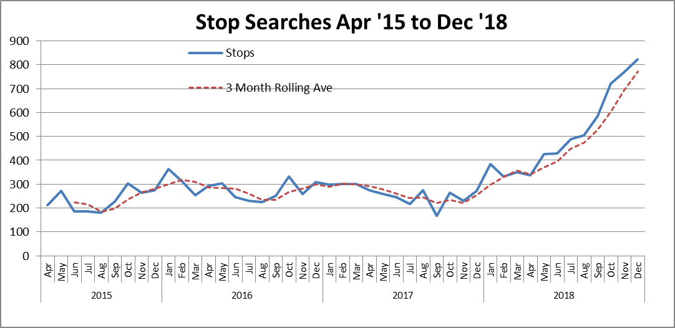

Overview of Reasonable Grounds Data;
Of the 2,415 Stop Searches that have been recorded during the third quarter of 2018/19, 98.09% (2371) had reasonable grounds recorded compared to 88.2% for the same quarter last year.
Only 1.91% (44) did not have reasonable grounds recorded, compared to 11.8% for the same quarter last year.
This is where officers either record grounds that do not meet the BUSSS criteria or fail to record grounds for search.
Failure to record reasonable grounds is addressed by the Communities and Engagement Coordinator by means of escalating advice from officer to supervisor.

Gender;
Of the 2,415 people stopped in this quarter, 1,978 identified themselves as male, compared to 678 in the same quarter the previous year.
220 identified themselves as female, compared to 72 in the same quarter the previous year.
Whilst there is no evidence that the rise in searches on female subjects is related to any particular search power, district or ethnicity, the proportion of searches conducted by female officers is rising, as is the proportion of searches on female subjects by female officers.
This could support the hypothesis that the rise in female subjects is due to there being more female officers carrying out searches that male officers might have been reticent to carry out.
The volume of searches on both genders has increased since the change in recording practice, however the gender split of searches has remained reasonably static.

The rise in proportion in White females searched is smaller than the rise in proportion of White males searched;
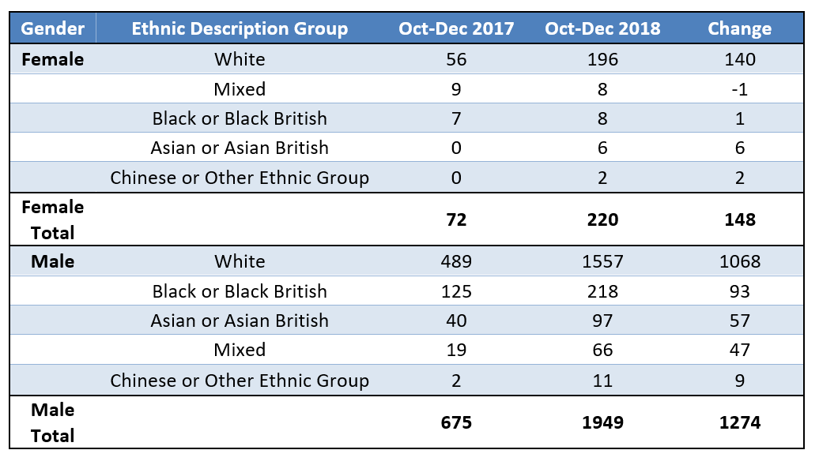
Age;
The average age searched has reduced slightly, but remains between 24 and 25 years of age.
The age that is searched the most has reduced from 18 to 17 years of age;

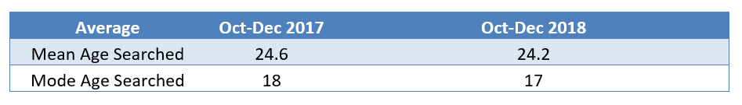
Outcomes;

Despite the increase in Stop & Searches overall, the proportion of positive outcomes has only risen by 1.19% (559 records);
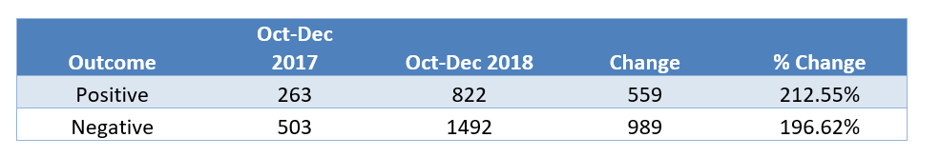
Where an Ethnic Description is given in the record, there has been an increase in the proportion of White subjects searched and a commensurate decrease in the proportion of Black/Black British subjects searched;

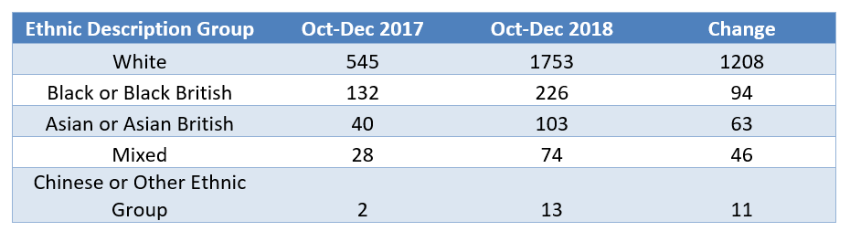

Complaints;
There have been 11 complaints related to Stop & Search since April 2016;
2016/17: 1
2017/18: 6
2018/19: 4
The Professional Standards Department have confirmed that, despite the marked increase in Stop & Search in the third quarter, no complaints have been received in relation to Stop & Search for October, November or December 2018.

6.0 Implications (Issues)
It is recognised at both local and national level that the use of Stop & Search can be
controversial, and attracts considerable political attention.
Overuse of the power can lead to the alienation of certain groups (BAME) whilst failing to utilise the power removes a valuable option to gain intelligence and suppress criminality.
The guidelines contained in the Best Use of Stop and Search Scheme (versions 1 and 2) aim to address such concerns, particularly in its emphasis on Stop & Search as an engagement tool rather than just a punitive measure.
The lack of accurate census data can indicate disproportionality.
The only data available is from the 2011 Census and it is known that the BAME population of the county has grown considerably, particularly in certain districts and amongst certain ethnic groups (i.e.; Thurrock, where the Local Authority conservatively estimate a 150% in residents of West African origin).
This must be considered when considering apparent disproportionality in the use of Stop & Search.
To illustrate;
15.17% of those stopped in this quarter were Black or Black British (where known or stated) this is 13.17% higher than the proportion of residents in Essex who defined themselves as Black or Black British in the 2011 Census.
80.82% of those stopped were White (where known or stated), which is 10.62% lower than the proportion of residents in Essex who defined themselves as White in the 2011 Census.

6.1 Links to Police and Crime Plan Priorities

The results from the Stop and Search report aim to inform against objectives in the Police and Crime Plan, particularly;
Priority 1; More Local, Visible and Accessible Policing
Priority 2; Crack down on Anti-Social Behaviour
Priority 4; Reverse the Trend in Serious Violence
Priority 5; Tackle Gangs and Organised Crime

6.2 Demand

There are no direct links to the Stop and Search report.

6.3 Risks/Mitigation

None identified

6.4 Equality and/or Human Rights Implications

The Local Policing Support Unit (LPSU) produces a simplified version of the Stop & Search report for use by the Strategic and local Independent Advisory Groups.
Stop and Search is one of 3 standing agenda items at these meetings (the others being Use of Force and Hate Crime).
Members of these groups scrutinise the data for any indication of disproportionality or potential impact on communities.
Members are also able to scrutinise Body Worn Video footage of Stop & Search encounters in addition to taking part in Ride-Along.
Any feedback is taken by the Communities and Engagement Coordinator as an action and all feedback is recorded for use in HMICFRS inspections.
To date, no concerns have been raised regarding disproportionality with the membership regularly citing the inaccuracy of the 2011 Census data as described above.

6.5 Health and Safety Implications

None identified

7.0 Consultation/Engagement

LPA Commands
S/IAGs
EPC
Mobile First Team
Performance Information Unit

8.0 Actions for Improvement

1.91% (44) of stop searches carried out in this period did not have reasonable grounds stated on the form compared to 11.8% (81) on the same period in the previous year. This is clearly an improvement but the Communities and Engagement Coordinator will continue to work with officers and supervisors with the aim of 100% compliance.

9.0 Future Work/Development and Expected Outcome

The Stop and Search App has now been developed and is currently undergoing rigorous testing to ensure success when released and the Communities and Engagement Coordinator is working with the Mobile First teams in Essex and Kent in preparation for the launch.
The App will enable officers to complete Stop & Search records via their hand-held devices.
The App has been demonstrated to members of the Strategic IAG.

As part of the work outlined in 8.0 above, the Communities & Engagement Coordinator is working with Essex Police College to ensure Stop & Search training is relevant and meets the requirements of BUSSS2.

The continuing improvement in the recording of reasonable grounds indicates that the recently introduced half day refresher training on Stop & Search is proving effective.

10.0 Decisions Required by the Police, Fire and Crime Commissioner

None required, this report is for the information of the Police, Fire and Crime
Commissioner.
Appendices

Appendix 1 Appendix 2

