**Use of Force – 2018/19 Quarter 3 Analysis**

**Strategic Change Directorate**

**Date: 15th February 2018**

**Version No: 1.2**

**Unit: Performance Analysis Unit**

**Contact: Dan Youngman**

**Sensitivity: Official**

1. **Aim and Purpose**

The aim of this report is to provide a quarterly update on Essex Police’s use of force. This is a substantive agenda item for the Use of Force Oversight Board, and the PFCC Performance and Resources meeting.

1. **Executive Summary**

The number of Use of Force forms continues to rise since the inception of the Mobile First app, but it will not be possible to provide an accurate quarter three 2018/19 against quarter three 2017/18 comparison until the app has been in use for five full quarters.

Tactical Communications and Handcuffings are the most common tactics used. This is likely to remain the case for the foreseeable future.

Force is used on BAME subjects in a greater proportion than the general population, although the disparity has fallen in this quarter.

1. **Key Findings**

* There were 3,699 Use of Force forms submitted in this Quarter. This is 11.2% (372 forms) up on the previous quarter and 50% (1,233 forms) up on the same quarter last year.
* Tactical Communications remain the most used tactic, accounting for almost a quarter of all the tactics used in the last period.
* 57% (1567) of incidents involved the handcuffing of the subject. There was more than double the number of Compliant Handcuffs than Non-Compliant.
* Whilst the number of forms with Firearms as a first tactic has more than doubled since last quarter (going from 26 to 63), this relates to only seventeen actual incidents by incident number.
* Whilst there has been a slight rise in the number of Taser use as a first and second tactic, all Taser use forms relate to 39 individual incidents.
* Thurrock has seen a quarter on quarter rise of 55% (185 forms) which brings it to a similar level as Southend-on-Sea, Chelmsford, Basildon and Colchester.
* When Tactical Communications is used as a first tactic, there is a 90% chance that a second tactic will be needed.
* 80.7% of subjects on Use of Force records were male. The proportion of subjects for whom the gender is blank has reduced considerably this quarter.
* 58.9% of subjects are in the 18-34 age range, with the average age being 30 years old.
* Whilst the proportion of BAME subjects is higher than the proportion of BAME people in the population of Essex as a whole, the disparity has reduced in the last quarter.
* The most common reason for the use of force is to effect an arrest. However, when the reasons Prevent Harm, Protect Self, Protect Other Officers and Protect Subject are combined, we see that 58.2% of reasons are to keep people safe.
* Where there is data, 16.2% of subjects reside outside of Essex.
* Alcohol and drugs are the highest Impact Factors for Use of Force.

1. **Methodology**

This report discusses the use of force forms submitted for incidents occurring between 1st October 2018 and 31st December 2018. This is the third Quarter for which the Mobile First app has been used to record the use of force in Essex Police. The analysis conducted is reliant both on the accuracy of the forms submitted, and the volume. Use of the app will produce results that are more accurate than the previous Limes Survey forms.

The data analysed in this report contains duplicates, as one form should be submitted per officer for each use of force. Therefore, if three officers use force against one subject in relation to the same incident, three forms should be submitted, and the subject would appear three times in the data (for that one incident).

The data analysed in this report required substantial cleaning. Extraneous spaces, for example, needed to be removed from many fields, and there is a disparity in the way that certain fields have been inputted by officers, particularly the date, time and custody number.

1. **Analysis**

*Overview*

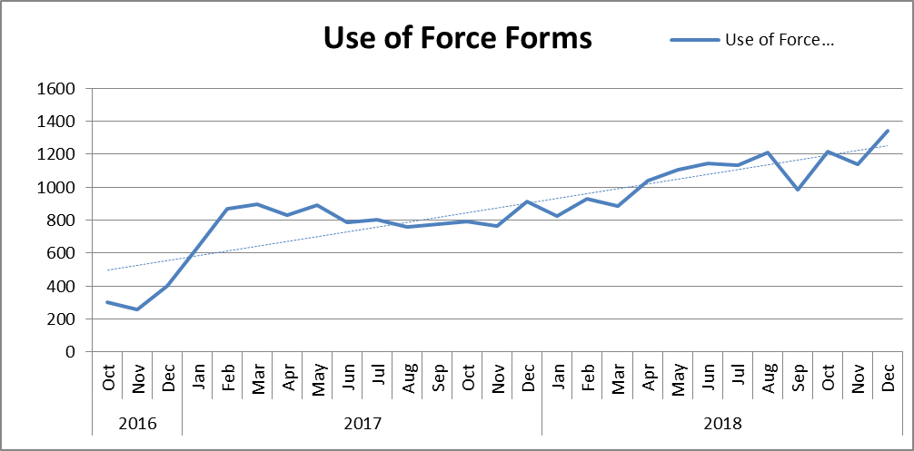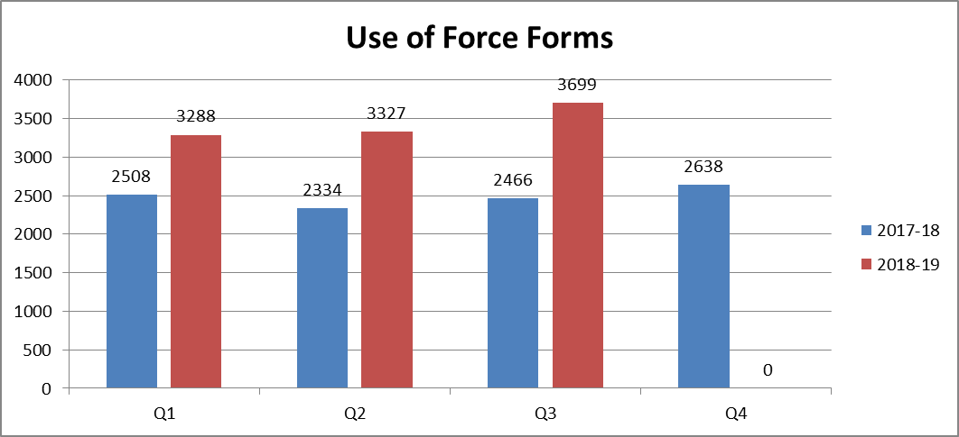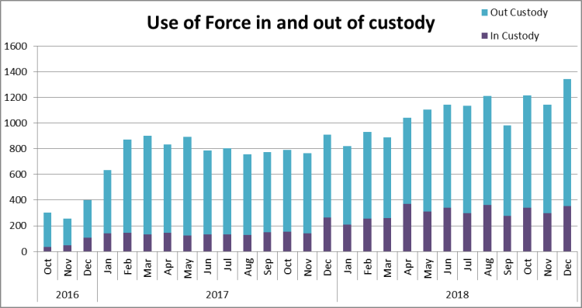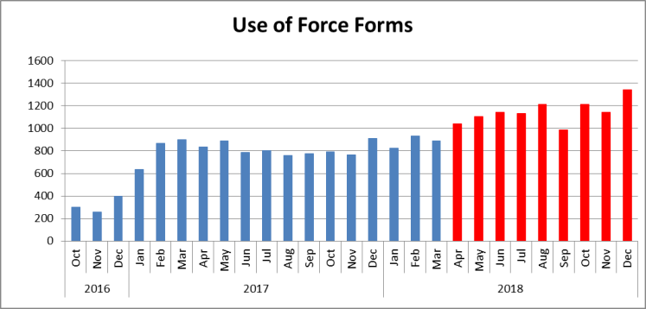

3,699 use of force forms were submitted in Essex during Quarter 3 of this financial year. This is an increase of 1233 (50%) additional forms completed, compared to the same quarter for the 2017/18 financial year and an 11.2% rise from the previous quarter. This large quarter on quarter rise is due to a significant dip in volume in September 2018. A continuing increasing trend for form submissions is also shown.

The volume of forms relating to force used in custody have levelled off after an initial rise in April.

Since the move to MobileFirst, none of the past nine months has had a level lower than the highest of the months under the Limes Survey.

*Tactics Employed*

The below table details the tactics employed with each use of force in Quarter 3 of 2018/19. It details the first eight tactics employed (not necessarily the most severe), and more than one will have been used in the majority of incidents. The Mobile First app allows for the inputting of up to 20 Tactics for one incident.

* Tactical communications (tac comms) were the most commonly used tactic. In 115 reports, tac comms were the only method employed, suggesting further training on the app may be required (a form is not required when tac comms are the only method).
* 64.2% of incidents did not state that tac comms were used. It is unlikely that this is the case, however, and that officers simply did not enter tac comms as a tactic used.
* Handcuffing is the next most common tactic; there were 57% more compliant cuffs used than non-compliant. 1567 incidents (57%) involved the use of either compliant or non-complaint handcuffs.
* 26 forms showed Taser as a first tactic. All Taser use forms refer to a total of 39 separate incidents.
* 67 forms involved a firearm as a first tactic; this is 43 more than the previous quarter. This, however, related to only seventeen individual incidents.



The table below is based on all Mobile First data from this financial year. It looks at the first tactic used and whether a second tactic is listed to establish the likelihood of a second tactic being needed for each first tactic.



*Location*

Force was used most in Southend-on-Sea, Thurrock, Basildon, Chelmsford and Colchester in Quarter 3 of 2018/19 (data relates to the area in which force was used rather than the officer’s command); 67% of force was used in these five districts during this period. The inclusion of Thurrock in these high volume districts is the result of a 55.2% rise in UoF forms for the last quarter.

Further analysis of the rise in Thurrock reveals a 59% rise in forms relating to custody (67 forms) and two exceptionally high volume weeks in October. 7th-13th October resulted in 67 UoF forms being submitted and 21st-27th October resulted in 53 forms being submitted. Cross referencing with Stop and Search data, there are no obvious operations that might have resulted in this.

236 of these Thurrock forms have no incident number attached, making it difficult to assign the rise to particular incidents.





*Subjects*

80.7% of those subjected to use of force were identified by officers as male; 15.6% were identified as female; one subject was identified as transgender.

The proportion of Blank or Not Recorded genders has fallen since the high point of last quarter (6.4%) to 3.6%. Use of Force Board will need to decide what an acceptable level of blank records should be acceptable.



30 was the average age for subjects (where a date of birth was given/stated), and this is true for both male and female subjects. The mode (age most recorded) is 27 for all subjects and female subjects but 29 for males. Males with a perceived age between 18-34 years were the most common gender and age band in the review period.

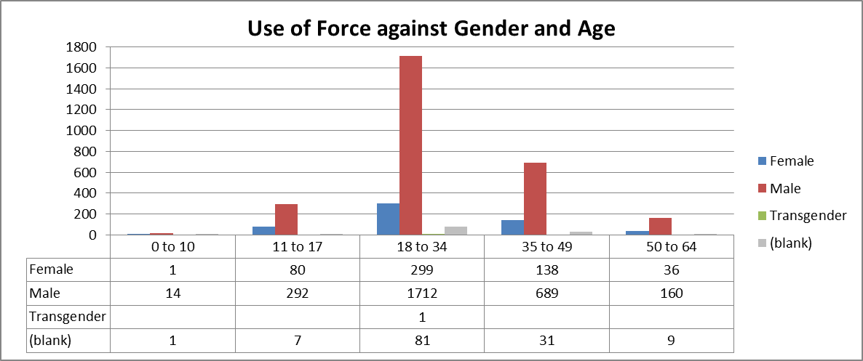

85.5% of subjects were white, and, whilst this is 7.7% lower than the proportion of residents in Essex who identified themselves as being white (93.2% of Essex defined themselves as white in the 2011 census), that proportion has grown slightly from the last quarter.

7.7% of subjects against whom force was used were black. This is 5.7% higher than the 2.0% black resident population proportion in Essex (2011 census data) and the proportion has fallen slightly since last quarter. This does not necessarily mean that the force used in these cases was inappropriate.



*Reason for Use of Force*

Effecting Arrest was the most commonly used reason entered for officers using force, followed by Preventing Harm. Please note, that more than one reason can be entered when justifying a use of force.



*Arrest Reason for BAME*

The below table details the 10 most common arrest reasons when the subject of use of force is perceived to be of Black, Asian and Minority Ethnic (BAME). Please note, however, that the data has been extracted from custody, so those against whom force has been used may have been arrested for multiple offences this data is based entirely on the first offence listed for each custody record.

Assaults (ABH and common assault) are the most common arrest reasons.



*Essex and Non-Essex Residents*

Address information (including postcodes) is not available for subjects on the MobileFirst app (this could be addressed in subsequent versions). Custody record numbers have therefore been used to identify the home addresses of these subjects from the Athena Custody system. There are issues with data accuracy with fields on Mobile First which involve the manual entry of data; custody number is one of these fields.

1,030 records correspond to a usable custody record in the same period, this equates to 28.6% of all use of force forms. A further 28.2% of forms showed N/A or similar. Therefore 43.1% of forms had a custody number which was unrecognizable to the Athena Custody system due to Out of Force custody or input error. Of those usable numbers with a valid address:

* 16.2% (167 persons) had a home address outside of Essex. Of these, 28.1% (47 persons) were from a perceived BAME origin. This compares to 18% last quarter and 11.3% of Essex residents.



* 28 of the 47 persons with home addresses outside of Essex were perceived to be Black or Black British:

*Impact Factors*



Each Use of Force form can have multiple Impact Factors, so the table above shows the proportion of each impact factor in the total number of forms for the last quarter. Unsurprisingly, alcohol and drugs are the top factors.

Mental Health is an Impact Factor in 17.7% of reports, whereas 8.2% of subjects are reported as having a Mental Disability.