

**ESSEX POLICE, FIRE AND CRIME COMMISSIONER FIRE & RESCUE AUTHORITY**

Essex County Fire & Rescue Service

|  |  |  |  |
| --- | --- | --- | --- |
| Meeting | **Fire & Rescue - Performance and Resources Board** | Agenda Item | 9.0 |
| Meeting Date | 30 November 2018 | Report Number |  |
| Report Author: | Jayesh Padania, Finance Manager | | |
| Presented By | Glenn McGuinness, Assistant Director of Finance | | |
| Subject | **Budget Review – October 2018** | | |
| Type of Report: | Information | | |

**SUMMARY**

This paper reports on expenditure against budget as at 31st October 2018 and identifies and comments on major budget variations. In addition the report includes key indicators that act as lead indicators for expenditure across the Authority.

**RECOMMENDATIONS**

The Fire & Rescue - Performance and Resources Board is asked to:

1. Note the position on the income and expenditure at 31st October 2018 compared to the budget.
2. Note the Capital Expenditure spend against budget and forecast for period to 31st October 2018.
3. Note the latest Forecast including Virements.

**BACKGROUND**

This table below shows actual expenditure against budget to 31st October 2018.



More detailed figures are provided at appendix 1

**STAFFING**

**Overall employment costs are £476K (1.6%) under budget for the 7 months to 31st October 2018.**

**Spend for whole time fire-fighters is £177K (1.0%) under budget:-**

* £80K underspend on Firefighter basic pay and overtime
  + £37K overspend on Additional Shift Work.
* £97K underspend on salary related costs

**For on-call firefighters, spend is £362K (10.9%) under budget:-**

* £212K underspend relates to actual average FTE at 397.9 is below budget at 471.75 this year
* £150K underspend due to activity levels being lower than budget

**For Control staff, spend is £39K (4.7%) under budget:-**

* £ 13K underspend on Control Staff Pay
* £ 14K underspend on Control Staff Overtime
* £ 12K underspend on Control staff pay on-costs

**Support staff pay is £102K (1.4%) over budget for the 7 months to 31st October 2018.**

This is comprised of:-

* An underspend of £54K on Secondary Contract Staff
  + £ 7K favourable variance for Training Dept.
  + £15K adverse variance for Control. Related to work on the Systems for Control.
  + £53K favourable variance for Operations
  + £ 9K favourable variance for Community Safety
* The overspend of £156K for Support Staff (Excl. Secondary Contracts) is made up of:-
  + £89K overspend on Casual and Temporary
  + £57K overspend in Support Staff Pay.
  + £10K overspend on support staff on costs.

Appendix 3 – Table Summary of Support Staff numbers

Whole-time fire-fighter numbers at 623.0 are 17.0 (2.7%) below phased budget at the end of October.

The staffing position at the end of October is summarised below (% figures rounded):



As at the end of October the number of whole-time fire-fighters aged over 50 with more than 25 years’ service was 73.

Of the 73 there are 12 who have more than 30 years’ service.

The graph below shows the numbers of whole-time fire-fighters compared to the budget for the year.

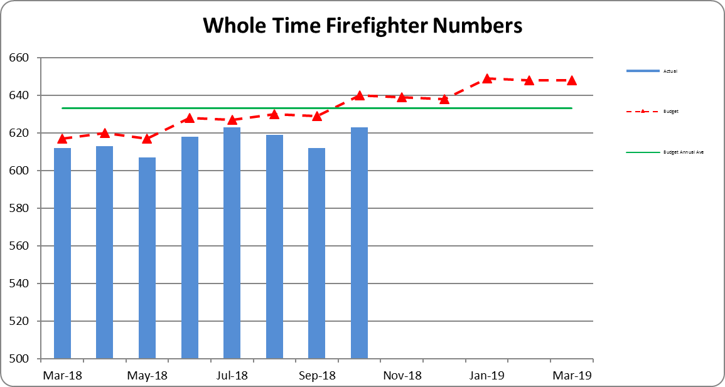

**WATCH BASED FIREFIGHTERS**

The numbers of Watch Based Fire-fighters compared to the target levels set by the Authority are shown below.



Wholetime recruitment process is currently under way in addition to the 12 new recruits joined in June, an additional 5 Firefighters (On-Call conversion) joined in July and 11 new recruits in October 2018. The whole time recruitment plan is for a further 12 new recruits in January 2019 and 12 new recruits in May 2019.

**ON-CALL FIREFIGHTERS**

Appendix 2 -On Call Firefighter nos. by Station

The table shows that we have a headcount of 487 firefighters at 31st October 2018 a net decrease of 21.0 from the 508.0 at 1st April 2017. In October there was a decrease of 5 in the total On-Call Firefighters headcount (8 leavers and 3 joiners).

Total FTE at 31st October was 386.75, a net decrease of 17.25 FTE from 1st April 2018. For the month of September there was a net decrease of 4.00 FTE.

**NON-PAY RELATED EXPENDITURE**

Non-pay expenditure is £447K underspent for the 7 month to 31st October 2018; in addition operational income is £268K more than budget.

**Support Costs are £106K (10.3%), overspent for the 7 months to 31st October 2018**



* The overspend on Travel and Subsistence relates to mileage costs being £64K higher than budgeted, following a decision by a number of Officers to switch from service provided lease vehicles to using their own vehicles as a result of proposed taxation changes and the suspension of the lease scheme in force at the time. This has resulted in an underspend of £65K on Lease and Interest Changes for lease cars under Financing Items.
* £87K (26.1%) overspend on Training Costs:-



* + Operational Training Contracts and In House Operational Training is being reviewed with L&D operational training team.

**Premises & Equipment are £421K (6.8%), underspent for the 7 months to 31st October 2018**



* Information Systems underspend of £302K
  + £333K underspend on IT Consumables against budget to date
* Property Maintenance underspend £27K
  + £8K underspend on Furniture and Fittings
  + £13K on Fuel Pump Maintenance
* Utilities underspend of £101K
  + £65K underspend for Gas charges against budget to date, mainly due to budget phasing assumptions
  + £26K underspend on Electricity against budget to date

**Other Costs & Services are £97K (4.7%), underspent for the 7 months to 31st October 2018**



Professional Fees and Services



**FORECAST**

The 1st forecast for the year has been prepared partly by finance and partly in conjunction with budget holders, this will be updated once all forecasts for 2018/19 have been reviewed with budget holders as part of the 2019/20 budget setting process.

This first forecast shows a deficit for the year of £987K, and is before any planned release from reserves, as the budget included a planned release from the Capital Receipts Reserve of £2,569K we are £1,582K better than budget.

The main reasons for this positive initial forecast are:

* A reduction in capital financing charges (£692K) arising from the review in capital expenditure dealt with elsewhere in this report.
* A combination of both lower headcount and activity level for On-Call Firefighters (£589K)
* ICT projects are expected to be £500K underspent this year.

A summary of the current forecast against budget is given in the table below:



**VIREMENTS**

* £216K Full Year virement reflecting the post of CFO/CEO has been transferred from Grey Book to Green Book.
* £113K Full Year virement contribution of 1% inflation provision included in the budget for Support Staff annual pay increment
* £434K Full Year virement for Police Collaboration, virement of the projected income from PTF grant and Essex Police contribution towards the related projected costs to which this income relates
* £208K Full Year virement for pay award for Whole Time Fire Fighters including on-costs, due to be paid from November 2018 and backdated to July 2018
* £48K Full Year virement for pay award for Retained Fire Fighters including on-costs, due to be paid from November 2018 and backdated to July 2018

**CAPITAL EXPENDITURE**

Capital expenditure for the 7 months to 31st October 2018 is shown in the table below.

Total capital expenditure and commitments is £2.9m.

The largest item included is £1.2m for asset protection.

* £880K invoices received to October 2018
* £276K commitments from various PO’s raised to date for anticipated spend throughout the year

Other Vehicle £881K:-

* £656K commitments/PO’s related to Off Road Vehicles

The investment of £787K in information technology relates to:-

* £187K on HOBS/Carval/Civica
* £116K for MDT replacement programme
* £355K on Devices for Appliances
* £ 122K on hardware replacement



**Capital Expenditure Forecast commentary**

Following the Capital Expenditure Review paper presented to the Performance a Resources Board on 30th July a review of capital expenditure has taken place in conjunction with budget holders.

The forecast for 2018-19 shows expenditure at £5.2m against a budget of £12m. The initial draft capital budget for 2019-20 shows expenditure at c£5m although this is subject to review. Expenditure for both years has been reviewed to concentrate on essential expenditure over the next couple of years, this

will be reconsidered when The Fire and Rescue plan and IRMP to 2024 are developed.

The reasons for the forecast spend for 2018/19 of £5.2m being £6.8m below budget are as follows:

* **Vehicles - £2.6m underspend.**
  + The budget included continued provision for the replacement of appliances, we are now planning to continue appliance replacement in 2020/2021.

This accounts for an underspend of £1.9m

* + Light vehicles a stores van, vehicle telematics account for an underspend of £605K, of this £200K for light vans has been deferred to 2019/20
* **Operational Equipment - £490K underspend**
  + Three items (c. £350K) deferred, these are Hose Reel Branch/Main Line (£136k), light portable pumps (£152K) and Foam £60)
  + Heavy Rescue Rumps equipment £97K underspent.
* **Information Technology - £880K underspend**
  + The main reason for this is deferral of ESMCP preparation work and ICCs/CAD replacement, the project is being rescheduled.
* **Property - £2.8m underspend.**
  + The budget included an initial £3m for Service Workshops replacement, we are forecasting nil spend this year, we are however forecasting an initial £200K on Shoebury although this would be subject to a business case and project approval.

**BENEFITS AND RISK/ FINANCIAL IMPLICATIONS**

The review of expenditure against the profiled budget is part of the overall financial control process of the Authority. In exceptional circumstances it allows for budget virements to ensure that under spending against budget heads can be utilised to fund expenditure against other priorities. If virements are not made there is a risk that the Authority will miss out on opportunities to improve performance and meet key objectives during the year. The Authority’s reserves are at the upper end of their target range and the Authority is able to fund short term fluctuations in activity from them when necessary.

The review of the management accounts is one control measure to mitigate the risk of overspending the Authority’s budget for the year.

**EQUALITY AND DIVERSITY IMPLICATIONS**

There are no direct Equality or Diversity implications within this report

**LEGAL IMPLICATIONS**

There are no direct legal implications within this report.

**HEALTH & SAFETY IMPLICATIONS**

There are no direct Health and Safety implications within this report.

**ACTIONS / NEXT STEPS**

1. Review and analysis of new grading pay scales, as costs not included in original budget for 2018-19
2. Monitor and analysis of the Training Budget spend, liaise with L&D Budget Holders to review the training requirements year and financial impact for remaining.
3. Continued review of Additional Shift Working, as greater proportion of budget was allocated to first half of the financial year for cover over the summer period.
4. Liaise with HR to continue with the review and monitoring of Casual And Temporary staff and costs

|  |  |
| --- | --- |
| LOCAL GOVERNMENT (ACCESS TO INFORMATION) ACT 1985 | |
| List of background documents – including appendices, hardcopy or electronic including any relevant link/s. | |
| Appendix 1 Management Accounts – October 2018  Appendix 2 On Call Firefighter Headcount Numbers  Appendix 3 Support Staff and Agency/Temp numbers | |
| Proper Officer: | Acting Finance Director to PFCC Fire & Rescue Authority |
| Contact Officer: | Glenn McGuinness  Essex County Fire & Rescue Service, Kelvedon Park, London Road,  Rivenhall, Witham CM8 3HB  Tel: 01376 576186  glenn.mcguinness@essex-fire.gov.uk |



**Appendix 2**



**Appendix 3**

**SUPPORT STAFF & TEMP/AGENCY NUMBERS**

