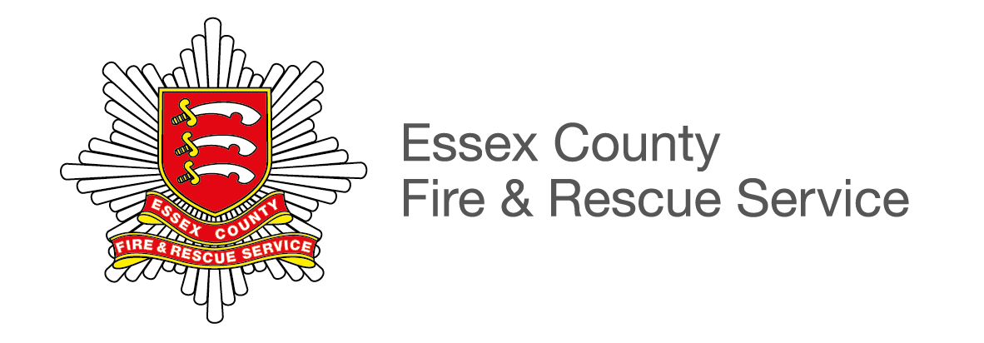

Castle Point District
Briefing Note

3 December 2018
PFCC – Castle Point Public Meeting
6.30pm – 8pm

The Paddocks
London Road
Canvey Island
Essex, SS8 0JA
ECFRS Structure and Resources
Operationally, Essex County and Fire Rescue Service (ECFRS) divides the county into four geographical working groups. Castle Point is situated in the South East group, which covers the coastal areas of Southend and Canvey Island and extends as far north as Chelmsford.
Group Manager Dave Barnard is responsible for the South East Group, which comprises of the following fire stations:
- Southend
- Leigh
- South Woodham Ferrers
- Great Baddow
- Chelmsford
- Rayleigh Weir
- Shoeburyness
- Hawkwell
- Rochford
- Canvey Island
Information: Canvey Island Fire Station
Canvey Island Fire Station is crewed by on-call firefighters. There are two fire engines based at the station and the station is currently recruiting.

Access to the island and traffic issues have historically made it difficult to find candidates who are within the five minute response time radius of the station.

As the only fire station in the Castle Point district, many residents believe the station should be crewed by wholetime firefighters. Despite that, the low number of incidents Canvey firefighters are called to attend annually and the agreement that is in place to have it as a key station mean that is unnecessary.

The key station agreement means that if ever on-call firefighters are unable to crew an appliance (or they are what’s known as ‘off the run’) crews from other nearby Fire Stations such as Basildon or Rayleigh Weir will standby to ensure there is always cover.

Of course, our fire engines are countywide resources, meaning they are regularly called to other areas of the county, particularly when larger or protracted incidents are ongoing.

Recent events
Last month, serving Crew Manager John Jenkins passed away at the age of 46, following a long battle with pancreatic cancer.
A funeral procession, which began at the Fire Station and involved many of our firefighters, made its way across the island. John was well known after serving at the station for many years. John’s brother Dave remains a firefighter at the station.

Recent notable incidents
Recently (in September and October) firefighters have attended two separate arson incidents in Thorney Bay Caravan Park, Canvey Island. The incidents were covered in the local press, who raised concerns about the regulations of the caravan park.
Several hundred people live at the caravan park but there are not thought to be any safety concerns.

Statistics

Incidents attended
Between 1 November 2017 and 31st October 2018 Essex County Fire and Rescue Service responded to a total of 15721 incidents.

Here are some statistics for the stations in and around the Castle Point district.

- Canvey Island fire crews attended 246 incidents in 2017/18. 90 of these were false alarms – while 98 were confirmed fires and 58 were special services – (for example road traffic collisions, animal rescues, flooding/water rescues, hazardous materials etc.)
- Basildon fire crews attended 1152 incidents in 2017/18. 485 of these were false
alarms – while 338 were confirmed fires and 329 were special services.
- Corringham fire crews attended 107 incidents in 2017/18. 41 of these were false alarms – while 40 were to confirmed fires and 26 were special services.
- Hawkwell fire crews attended 120 incidents in 2017/2018. 46 of these were to false alarms – while 46were to confirmed fires and 28 were to special service.
- Rayleigh Weir fire crews were called to 502 incidents – 183 false alarms, 151 fires and 168 special services.
- Rochford fire crews were mobilised to 164 incidents. 80 were false alarms, 53 were confirmed fires and 31 were special services.
- Southend fire crews were called to 1152 incidents – 555 false alarms, 234 fires and 363 special services.
- Wickford fire crews attended 218 incidents. 91 were false alarms, 72 were confirmed fires and 55 were special services.

Home Fire Safety / Safe and Well Visits
- Our Home Fire Safety Officers carried out a total of 1677 home safety visits in the Castle Point district and surrounding areas (including Rayleigh, Wickford and Southend) between 1 November 2017 and 31 October 2018.
- A total of 2114 smoke alarms and 127 sensory smoke alarms were also supplied and fitted during that period.
- Our Service completes around 9,500 visits across Essex every year.

