ESSEX POLICE, FIRE AND CRIME COMMISSIONER FIRE & RESCUE AUTHORITY
Essex County Fire & Rescue Service


Meeting | Fire & Rescue - Performance and Resources Board | Agenda Item | 10
Meeting Date | 24th September 2018 | Report Number
Report Author: | Jayesh Padania, Finance Manager
Presented By | Glenn McGuinness, Assistant Director of Finance
Subject | Budget Review – August 2018
Type of Report: | Information

SUMMARY
This paper reports on expenditure against budget as at 31st August 2018 and identifies and comments on major budget variations. In addition the report includes key indicators that act as lead indicators for expenditure across the Authority.
RECOMMENDATIONS
The Fire & Rescue - Performance and Resources Board is asked to:
- Note the position on the income and expenditure at 31st August 2018 compared to the budget.
- Note the Capital Expenditure spend against budget for period to 31st August 2018.

BACKGROUND
This table below shows actual expenditure against budget to 31st August 2018.

More detailed figures are provided at appendix 1
STAFFING
Overall employment costs are £394K (1.9%) under budget for the 5 months to 31st August 2018.
Spend for whole time fire-fighters is £111K (0.9%) under budget:-
- £41K underspend on Firefighter basic pay
- £45K underspend on salary related costs
- £25K underspend on overtime
  - £10K overspend on Additional Shift Work.
    - Working with the budget holder the rate of ASW spend is being brought in line with budget, resulting in an underspent against budget by £10 for ASW in August 2018
    - This will continue to be monitored against the phased budget
  - £35K underspend on normal budgeted overtime

For on-call firefighters, spend is £228K (10.0%) under budget:-
- £145K underspend relates to actual average FTE at 400.9 is below budget at 471.75 this year
  - Please note the change in reporting the On-call to FTE from headcount (previously on-call was reported as headcount)
- £83K underspend due to activity levels being lower than budget

For Control staff, spend is £27K (4.5%) under budget:-
- £ 8K underspend on Control Staff Pay
- £10K underspend on Control Staff Overtime
- £ 9K underspend on Control staff pay on-costs

Support staff pay is £29K (0.5%) under budget for the 5 months to 31st August 2018.

This is comprised of:-
- An underspend of £63K on Secondary Contract Staff
  - £ 8K favourable variance for Training Dept.
  - £ 8K adverse variance for Control. Related to work on the Systems for Control.
  - £44K favourable variance for Operations
  - £19K favourable variance for Community Safety

- The overspend of £34K for Support Staff (Excl. Secondary Contracts) is made up of:-
  - £42K overspend on Casual and Temporary

Appendix 3 – Table Summary of Support Staff numbers

Whole-time fire-fighter numbers at 619.0 are 11.0 (1.7%) below phased budget at the end of August.
The staffing position at the end of August is summarised below (% figures rounded):

As at the end of August the number of whole-time fire-fighters aged over 50 with more than 25 years’ service was 80.
Of the 80 there are 20 who have more than 30 years’ service.

The graph below shows the numbers of whole-time fire-fighters compared to the budget for the year.
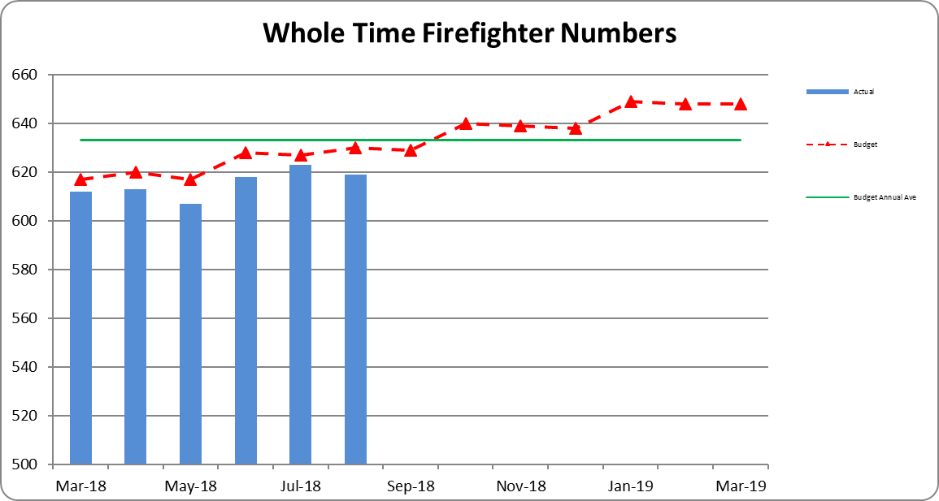
WATCH BASED FIREFIGHTERS
The numbers of Watch Based Fire-fighters compared to the target levels set by the Authority are shown below.
Wholetime recruitment process is currently under way in addition to the 12 new recruits joined in June and an additional 5 Firefighters (On-Call conversion) joined in July. The whole time recruitment plan is for a further 12 new recruits in October 2018, 12 new recruits in January 2019 and 12 new recruits in April 2019.

ON-CALL FIREFIGHTERS
Appendix 2 -On Call Firefighter nos. by Station
The table shows that we have a headcount of 499 firefighters at 31st August 2018 a net decrease of 9.0 from the 508.0 at 1st April 2017. In August there was a decrease of 4 in the total On-Call Firefighters headcount. The 4 leavers were at Canvey Island, Corringham, Tillingham and Wivenhoe.
Total FTE at 31st August was 397.00, a net decrease of 7.00 FTE from 1st April 2018. For the month of August there was a net decrease of 3.00 FTE.
NON-PAY RELATED EXPENDITURE
Non-pay expenditure is £392K underspent for the 5 month to 31st August 2018; in addition operational income is £159K more than budget.

Support Costs are £48K (6.5%), underspent for the 5 months to 31st August 2018
- The overspend on Travel and Subsistence relates to mileage costs being £54K higher than budgeted, following a decision by a number of Officers to switch from service provided lease vehicles to using their own vehicles as a result of proposed taxation changes and the suspension of the lease scheme in force at the time. This has resulted in an underspend of £46K on Lease and Interest Changes for lease cars under Financing Items.

- £38K (16.0%) overspend on Training Costs:-

  - Training spend is being reviewed with the Budget Holders.
  - Operational Training Contracts and In House Operational Training overspend has been highlighted and being reviewed with L&D operational training team.

Premises & Equipment are £330K (7.4%), underspent for the 5 months to 31st August 2018

- Information Systems underspend of £216K
  - £229K underspend on IT Consumables against budget to date
- Property Maintenance underspend £101K
  - Due to timing of actual spend against budget phasing
  - Actual spend based on Purchase Orders and Commitments due to increase in later part of the year
- Utilities underspend of £74K
  - £56K underspend for Gas charges against budget to date, mainly due to budget phasing assumptions

Other Costs & Services are £93K (6.3%), underspent for the 5 months to 31st August 2018

- Professional Fees and Services

  - Other Local Authority Services include
    - £44K Service Level Agreement paid to Essex Pension Fund
    - £38K match funding from Essex Fire for the Police Collaboration
    - £130K related to the reduction to the gross precept from Councils for Hardship Fund, Intended repayment and adjustments

VIREMENTS

- £216K Full Year virement reflecting the post of CFO/CEO has been transferred from Grey Book to Green Book.
- £113K Full Year virement contribution of 1% inflation provision included in the budget for Support Staff annual pay increment
- £434K Full Year virement for Police Collaboration, virement of the projected income from PTF grant and Essex Police contribution towards the related projected costs to which this income relates
CAPITAL EXPENDITURE
Capital expenditure for the 5 months to 31st August 2018 is shown in the table below.
Total capital expenditure and commitments is £2.4m.
The largest item included is £1.1m for asset protection.
- £655K invoices received to August 2018
- £476K commitments from various PO’s raised to date for anticipated spend throughout the year

Other Vehicle £844K:-
- £656K commitments/PO’s related to Off Road Vehicles

The investment of £327K in information technology relates to:-
- £132K on HOBS/Carval/Civica
- £106K for MDT replacement programme

BENEFITS AND RISK/ FINANCIAL IMPLICATIONS
The review of expenditure against the profiled budget is part of the overall financial control process of the Authority. In exceptional circumstances it allows for budget virements to ensure that under spending against budget heads can be utilised to fund expenditure against other priorities. If virements are not made there is a risk that the Authority will miss out on opportunities to improve performance and meet key objectives during the year. The Authority’s reserves are at the upper end of their target range and the Authority is able to fund short term fluctuations in activity from them when necessary.
The review of the management accounts is one control measure to mitigate the risk of overspending the Authority’s budget for the year.
EQUALITY AND DIVERSITY IMPLICATIONS
There are no direct Equality or Diversity implications within this report
LEGAL IMPLICATIONS
There are no direct legal implications within this report.
HEALTH & SAFETY IMPLICATIONS
There are no direct Health and Safety implications within this report.

ACTIONS / NEXT STEPS
- Monitor and analysis of the Training Budget spend, liaise with L&D Budget Holders to review the training requirements year and financial impact for remaining.
- Continued review of Additional Shift Working, as greater proportion of budget was allocated to first half of the financial year for cover over the summer period.
- Liaise with HR to continue with the review and monitoring of Casual And Temporary staff and costs

LOCAL GOVERNMENT (ACCESS TO INFORMATION) ACT 1985
List of background documents – including appendices, hardcopy or electronic including any relevant link/s.
Appendix 1 Management Accounts – August 2018
Appendix 2 On Call Firefighter Headcount Numbers
Appendix 3 Support Staff and Agency/Temp numbers
Proper Officer: | Acting Finance Director to PFCC Fire & Rescue Authority
Contact Officer: | Glenn McGuinness  Essex County Fire & Rescue Service, Kelvedon Park, London Road,  Rivenhall, Witham CM8 3HB  Tel: 01376 576186  glenn.mcguinness@essex-fire.gov.uk
Appendix 2

Note. We are approaching the crewing level required at Clacton for us switch the second pump to on-call shortly.

Appendix 3
SUPPORT STAFF & TEMP/AGENCY NUMBERS

