**Performance and Resources Scrutiny Programme 2018/19**

**Report to: the Office of the Police, Fire and Crime Commissioner for Essex**

|  |  |
| --- | --- |
| **Title of Report:** | **Stop and Search Quarterly Report 2018/19** |
| **Agenda Number** | **5.2** |
| **Chief Officer** | **ACC Prophet** |
| **Date Paper was Written** | **14th August 2018** |
| **Version Number** | **3.0** |
| **Report from:** | **Essex Police** |
| **Date of Meeting:** | **30th August 2018** |
| **Author on behalf of Chief Officer:** | **Dawn Woollcott**  **Communities & Engagement Coordinator**  **LPSU** |
| **Date of Approval:** | **17th August 2018** |

1. **Purpose of Report**

To present the quarterly performance information for Essex relating to the use of stop and search powers (April18-June18).

1. **Recommendations**

No recommendations have been made however, the Board are asked to note and consider the report content.

1. **Executive Summary**

This report highlights the continued increase in the use of stop and search across the County, an improvement in accurate recording of reasonable grounds, the demographic breakdown of those subject to stop and search as well areas for potential future development.

**4.0 Introduction/Background**

Local Policing Support Unit (LPSU) has worked with the Performance Information Unit to re-format the monthly stop and search report, which will now be produced quarterly to align with the *Use of force* report (3 months April18 - June18 (**Appendix 1**). This report will be presented and discussed at the quarterly Use of force oversight board (Terms of Reference **Appendix 2**).

The new quarterly stop and search report allows the organisation to monitor the proportionate use of stop and search powers.

The new *Best Use of Stop & Search Scheme Version 2* (BUSSS2) (**Appendix 3**) has not yet received Ministerial approval and therefore yet to be implemented across England and Wales. Once approved Essex will implement the required changes outlined in that report.

The stop and search app will launch in the next six months. It has been developed and is currently undergoing rigorous testing to ensure success when released. The app will enable officers to complete stop & search records via their hand-held device.

Stop and search is now a substantive agenda item at the Strategic Independent Advisory Group (IAG) and the 9 local IAGs.

The LPSU Stop and Search Coordinator meets monthly with Essex Police College (EPC) stop & search trainers to ensure that EPC include all relevant policy and legislative changes in lesson plans and discuss questions raised by officers.

The stop and search coordinator continues to provide officers with feedback on searches recorded on the stop and search database where reasonable grounds for the search have not been recorded.

**HMICFRS Inspection**

On the 5th July 2018 HMICFRS returned their findings on the stop and search documents supplied as part of the integrated PEEL assessment 2018.

Essex Police supplied 3200 stop and search records, of which HMICFRS dip sampled 320 records. Essex Police was assessed as having an 84% success rate, as detailed below;

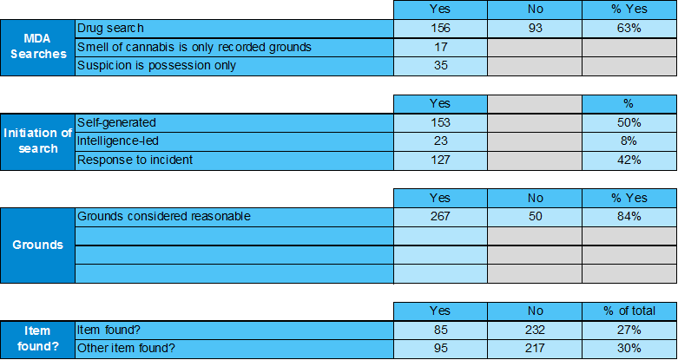

Of the 84%, HMICFRS cited a large number of “excellent” and “good” examples of the use of reasonable grounds for conducting a search. However, 16% were deemed to have insufficient grounds for search recorded, although the Essex searches were considered to be lawful. The LPSU Stop and Search Coordinator devised a series of remedial actions to address this “failure rate” which included;

* An intranet article explaining to officers why they must provide sufficient detail under reasonable grounds to justify the search and explaining to supervisors and managers the necessity to ensure the reasonable grounds have been completed before validating the search.
* The LPSU Stop and Search Coordinator will identify individual officers who have failed to provide sufficient reasonable grounds and each officer will be provided with a copy of SHACKS guidance to reasonable suspicion (**Appendix 4**) and a copy of legislative guidance.[1]
* The LPSU Stop and Search Coordinator will work with EPC to ensure that PCs/Specials and supervisors attend the stop and search upskill training day at EPC (training ongoing - 30 officers a week being trained).
* In cases of repeat failure, the LPSU stop and search coordinator approaches the officer direct and escalates to the supervisor.

**5.0 Current Work and Performance**

**Number of stop search forms**

There was a 53.0% increase in stop and search forms submitted during the first quarter of 2017/18. This is an increase of 424 (total of 1221) forms compared to the same quarter for 2017/18. The chart below also shows a general increase in stops over the period since December 2017. The total for this quarter is also the highest since July 2015.

**Overview of Reasonable Grounds Data;**

Of the 1221 Stop Searches that have been recorded during the 1st quarter of 2018/19:

* 1175 (96.2%) had reasonable grounds recorded (86.6% for same quarter last year).
* 46 (3.8%) did not have reasonable grounds recorded (13.4% for same quarter last year).



**Gender;**

84.9% of those stopped identified themselves as male (87.9% for the same quarter the previous year) and 11.8% female (9.9% previously) 25 was the average age for those stopped (where a date of birth was stated); 24 for men and 26 for women.



**Age;**

53.0% of stop searches in the review period were males in the age band 18 to 34 years, and 19.5% were males in the age band 11 to 17 years (where age was stated).

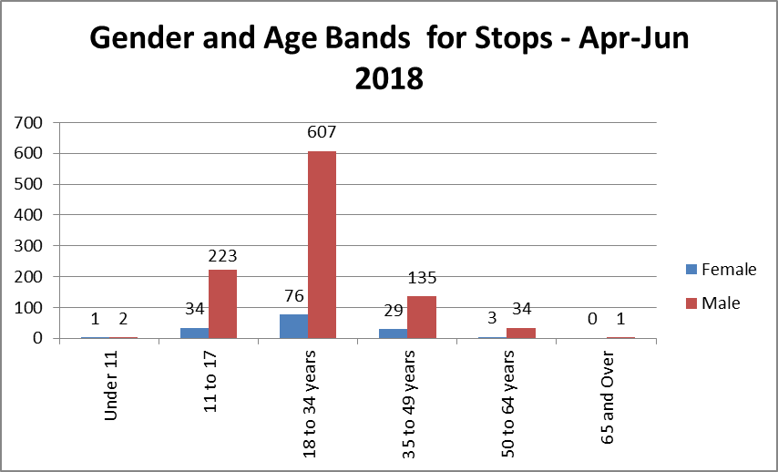

**Outcomes;**

The proportion of positive outcomes has increased by 3.5% (20) in those who were Black or Black British (where known or stated), but decreased in all other groups.



For those who defined themselves as BAME, 31% resulted in a positive outcome (31.8% for the precious year).



**Complaints;**

Since Apr 2016 the have been a total of 9 complaints related to stop and search;

* 2016/17 : 1
* 2017/18 : 6
* 2018/19 : 2

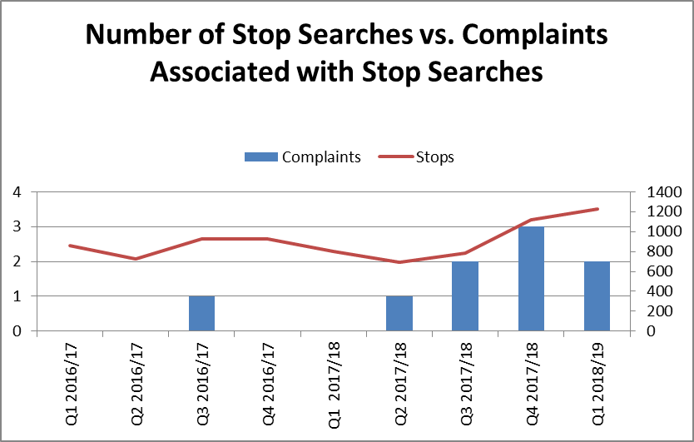

Clearly the number of complaints is extremely low relative to the number of stop and search conducted. This is being monitored however at this stage no pattern of complaints has been identified.

**6.0 Implications (Issues)**

A balance must be struck with over-use of Stop and Search, which can lead to the alienation of BAME groups, whilst under-use can remove a valuable option to supress criminal activity.

**Ethnicity**

14.2% of those stopped were Black or Black British (where known or stated), this is 12.2% higher than the proportion of residents in Essex who definedthemselves as Black or Black British in the 2011 census.78.2% of those stopped were white (where known or stated), which is 15% lower than the proportion of residents in Essex who defined themselves as white in the 2011 census.

The ethnic makeup of the county has changed significantly since the 2011 census.

Current estimates suggest a BAME population of 15-16% with certain areas (for

example Thurrock) with an even higher proportion. Therefore, the percentage of

BAME subject of stop and search is thought to be broadly in line with the overall

population of the county.



**6.1 Links to Police and Crime Plan Priorities**

The results from the stop and search report will help inform against objectives in the Police and Crime Plan;

* Crack down on anti-social behaviour.
* Reverse the trend in serious violence.
* Tackle gangs and organised crime.

**6.2 Demand**

None identified

**6.3 Risks/Mitigation**

None identified

**6.4 Equality and/or Human Rights Implications**

None identified

**6.5 Health and Safety Implications**

None identified

**7.0 Consultation/Engagement**

LPA Commands

S/IAGs

EPC

Mobile First Team

Performance Information Unit

Continuous Improvement Unit

**8.0 Actions for Improvement**

* To maintain the improved compliance with reasonable grounds
* To successfully launch the stop and search application on mobile devices

**9.0 Future Work/Development**

1. HMIC recommended the stop and search data is consistently scrutinised by the force. **(Appendix 5).**

* Stop and search is now included as a standing agenda item at the Use of force meeting.
* A scrutiny panel now meets every six months to review stop and search data. Attendees include both police officers and staff and those outside the organisation.
* Local Youth Councils and Youth IAGs have agreed to scrutinise searches and BWV footage. Communities and Engagement Coordinator to facilitate and scope possibility of Police and Fire Cadet Units scrutinising incidents/data.

1. Relaunch the stop and search page on the LPSU website which will include a link to the College of Policing website which covers a range of best practice (**Appendix 6**).
2. To investigate the benefits of a stop and search Jabber chat(s) with officers, trainers and staff.
3. To consider introducing stop and search SPOCs on each district.

**10.0 Decisions Required by the Police, Fire and Crime Commissioner**

None required, this report is for the Board to note the content.

**Appendices**

Appendix 1 Appendix 2

 

Appendix 3 Appendix 4

 

Appendix 5 Appendix 6

 

1. This acronym serves as a reminder to a police officer of the information they must provide when they perform a Stop & Search: G: Grounds for the search; O: Object the officer is searching for; W: Warrant, particularly if the officer is in plain clothes; I: Identification; S: Station to which the officer is attached; E: Entitlement to copies of all paperwork; L: Legislation, the legal power which gives the officer the right to stop and search; Y: “YOU are being detained for the search or for the purpose of…”