**Performance and Resources Scrutiny Programme 2017/18**

**Report to: the Office of the Police, Fire and Crime Commissioner for Essex**

|  |  |
| --- | --- |
| **Title of Report:** | **Use of Force – 2018/19 Quarter 1** |
| **Agenda Number** | **5.1** |
| **Chief Officer** | **ACC Pippa Mills** |
| **Date Paper was Written** | **21 August 2018** |
| **Version Number** | **1.1.** |
| **Report from:** | **Essex Police** |
| **Date of Meeting:** | **30 August 2018** |
| **Author on behalf of Chief Officer:** | **Dan Youngman 42078817** |
| **Date of Approval:** | **22 August 2018** |

1. **Purpose of Report**

To provide a quarterly update on Essex Police’s use of force. This is a substantive agenda item for the PFCC Performance and Resources meeting.

1. **Recommendations**

There are no recommendations. This report is for the board to note.

1. **Executive Summary**

* 24.8% more use of force forms were submitted in Essex during quarter 1 of 2018/19 compared to the same period the previous year. This suggests that the use of the Mobile First app can provide a more accurate picture of use of force in Essex.
* 37% of incidents did not involve the use of tactical communications in the first instance. It is more likely, however, that officers simply did not input this tactic onto the system.
* 58.9% of use of force was conducted in Basildon, Southend, Thurrock and Chelmsford combined.
* 9.5% of subjects were perceived to be Black or Black British (compared to a 2.0% resident Black or Black British population in Essex).
* 14.8% (263 persons) had a home address outside of Essex. Of these, 27.3% (72 persons) were from a perceived BAME origin.

On 1 April 2018, the Mobile First application (“app”) replaced the former system as the means to complete use of force forms. Via this app, officers can now submit forms on either a desktop or on their handheld devices (this can be performed remotely also). This new method led to 24.8% increase in the number of forms submitted in the first quarter of the new financial year compared to the same period in 2017.

This is the first analysis that has been undertaken with the new data.

**4.0 Introduction/Background**

The ‘Police Use of Force’ Annual Data Return (ADR) placed a requirement on police forces to collect data from October 2016. The use of force data was captured in Essex on the Limes Survey database until March 2018. On 1 April 2018, a new Mobile First Application (“app”) was introduced to replace Limes Survey; this app is available on desktop, on officers’ handheld devices and forms can be completed remotely. This report relates to data solely from the Mobile First app.

**5.0 Current Work and Performance**

*Overview*

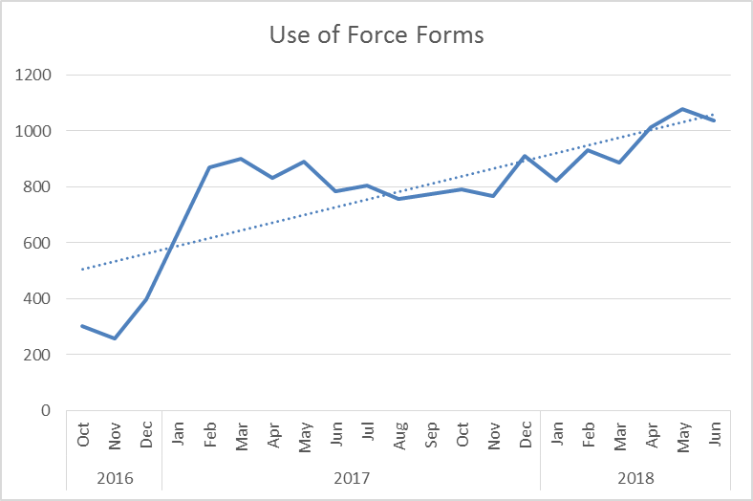3,130 use of force forms were submitted in Essex during quarter 1. This is an increase of 622 (24.8%) additional forms completed, compared to the same quarter for the 2017/18 financial year. A continuing increasing trend for form submissions is also shown.

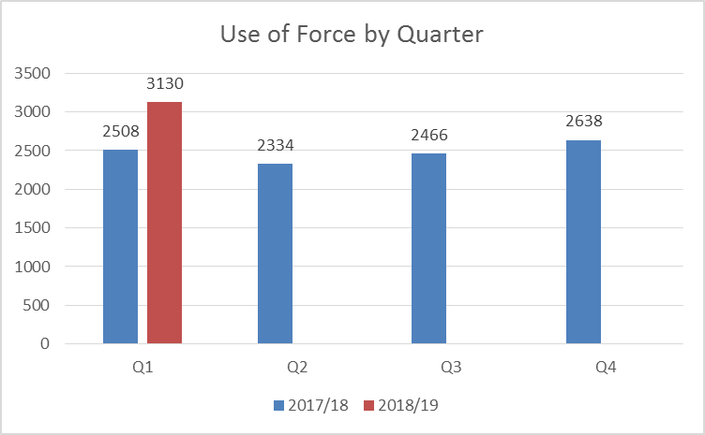Use of Force reports in Custody continued to rise in volume throughout the last quarter. This appears to be proportionate to the number of reports that were submitted out of custody.

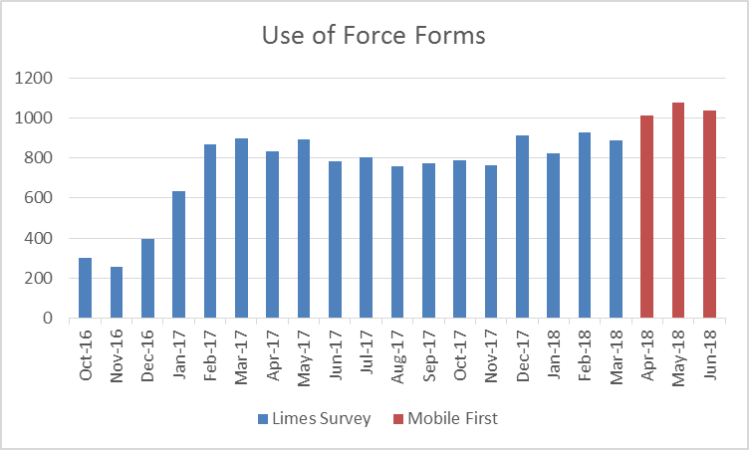

As illustrated in the above table, all three months of Q1 are higher in volume than any of the months in the previous six quarters.

*Tactics Employed*

The below table details the tactics employed with each use of force in quarter 1 of 2018/19. It details all tactics employed (not necessarily the most severe), and more than one will have been used in the majority of incidents. The Mobile First app allows for the inputting of up to 20 Tactics for one incident.

* Tactical communications (tac comms) were the most commonly used tactic. In 79 reports, tac comms were the only method employed, suggesting further training on the app may be required (a form is not required when tac comms are the only method).
* 62.96% of incidents did not state that tac comms were used. It is unlikely that this is the case, however, and that officers simply did not enter tac comms as a tactic used.
* Handcuffing is the next most common tactic; there were over one a half times more compliant cuffs used than non-compliant. 1,982 incidents (59.8%) involved the use of either compliant or non-complaint handcuffs.

*Location*

Force was used most in Basildon, Southend, Thurrock and Chelmsford in Quarter 1 of 2018/19 (data relates to the area in which force was used rather than the officer’s command); 58.9% of force was used in these 4 districts during this period.



 

*Subjects*

76.4% of those subjected to use of force were identified by officers as male; 16.3% were identified as female; two subjects were identified as transgender.

The proportion of Blank or Not Recorded genders rose since the inception of Mobile First; there were over 200 more blanks than in the last quarter. 144 of these Blank Gender records have a Subject name attached to them, suggesting that further care is required to input data accurately.



31 was the average age for subjects (where a date of birth was given/stated); 30 was the average age for men, and 32 the average age for women. Males with a perceived age between 18-34 years were the most common gender and age band in the review period.

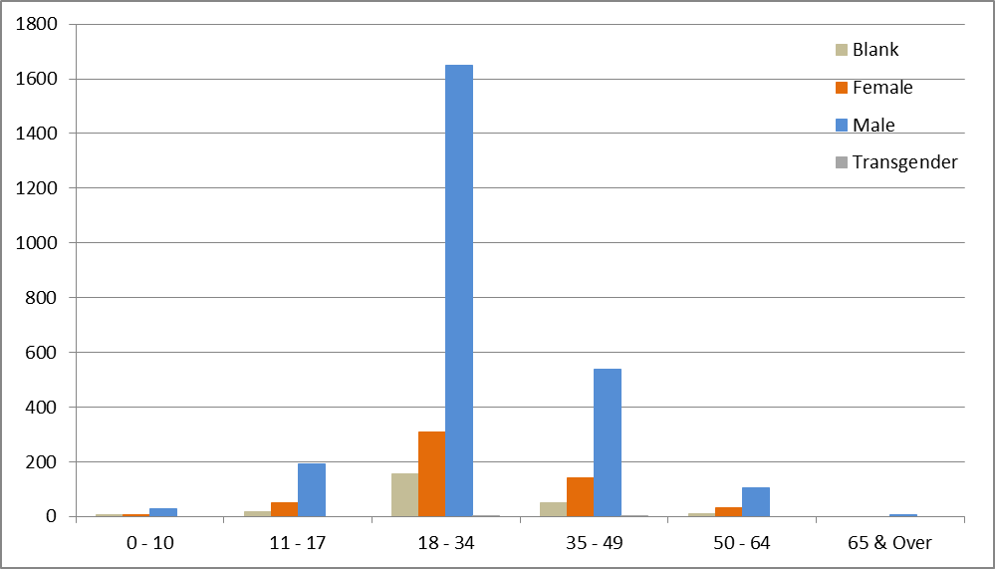



85% of subjects were white. However, this is 8.1% lower than the proportion of residents in Essex who identified themselves as being white (93.2% of Essex defined themselves as white in the 2011 census).

9.4% of subjects against whom force was used were black. This is 7.5% higher than the 2.0% black resident population proportion in Essex (2011 census data). This does not necessarily mean that the force used in these cases was inappropriate.



*Reason for Use of Force*

Effecting Arrest was the most commonly used reason entered for officers using force, followed by Preventing Harm. Please note, that more than one reason can be entered when justifying a use of force.



*Essex and Non-Essex Residents*

Address information (including postcodes) is not available for subjects on the MobileFirst app (this could be addressed in subsequent versions). Custody record numbers have therefore been used to identify the home addresses of these subjects from the Athena Custody system. It is of note that custody record numbers were entered into Limes Survey manually by officers; if there are any inaccuracies, the relevant custody record will not have been returned or included in the analysis.

1,776 records correspond to a custody record in the same period. This equates to 53.6% of all use of force forms. Of these with a valid address (or NFA stated):

* 14.8% (263 persons) had a home address outside of Essex. Of these, 27.3% (72 persons) were from a perceived BAME origin.



* 62 of the 72 persons with home addresses outside of Essex were perceived to be Black or Black British:



Those of BAME origin who gave home addresses outside of Essex were subjected to use of force most in Southend and Harlow districts:



*Other Data*

The below table forms the data return to the Home Office and contains further breakdowns. Please note that this is a work in progress.



**6.0 Implications (Issues)**

Effective analysis is reliant both on the accuracy of the forms submitted, and the volume.

The data analysed in this report contains duplicates, as one form should be submitted per officer for each use of force. Therefore, if three officers use force against one subject in relation to the same incident, three forms should be submitted, and the subject would appear three times in the data (for that one incident).

**6.1 Links to Police and Crime Plan Priorities**

The use of force is a cross-cutting issue that impacts on many areas in the Police and Crime Plan.

**6.2 Demand**

Any increase/decrease in the use of force by police is dependent on the number of subjects against whom this is necessary and proportionate.

**6.3 Risks/Mitigation**

Use of force is monitored by the Use of Force Oversight Board chaired by ACC Pippa MILLS; these meetings are held on a quarterly basis. This group is a force-wide focus group facilitated and organised by the Operational Policing Command (OPC), and is intended to provide formal scrutiny and consultative feedback on the use of force and all its associated issues. The Use of Force Oversight Board focuses on enabling the force to examine and improve on statistical data-gathering and its analysis, and transparency with the public in order to improve confidence and trust in Essex Police.

Representation within the Use of Force Oversight Board comprises a number of disciplines, as detailed in the below structure:



**6.4 Equality and/or Human Rights Implications**

The above analysis indicated a potential disparity in the ethnic origins of those against whom force was used, when compared to the resident population in the county. 9.47% of those against whom force was used (where stated) had a self-defined ethnicity of black, compared to a 2.0% black population in the county. This does not necessarily mean that the force used in these cases was inappropriate, however.

**6.5 Health and Safety Implications**

Use of force has a health and safety implication for the subject, the police, and the public.

**7.0 Consultation/Engagement**

Professional Standards at Essex Police provided data relating to the volume of complaints submitted by members of the public since April 2016 for the previous report; we are awaiting a refreshed version of this data in order that complaint levels can be compared to Q1 of 2018/19.

**8.0 Actions for Improvement**

The new Mobile First app has assisted with the accessibility, ease and timeliness of completing Use of Force forms. The forms within the app contain more constrained and pre-completed fields, which has improved the accuracy of that which is submitted, and will enable more effective analysis to be conducted. However, cleaning and displaying this data is an ongoing process. The volume and accuracy of these forms will continue to be monitored by the Use of Force Oversight Board.

**9.0 Future Work/Development**

This report is a substantive agenda item. This report is the first to use data from the new Mobile First app. As the data from this app is continuing to be reviewed and analysed, more meaningful key findings should consequently be available in subsequent reports.

**10.0 Decisions Required by the Police, Fire and Crime Commissioner**

This report is purely for the information of the Police, Fire and Crime Commissioner.