ESSEX POLICE, FIRE AND CRIME COMMISSIONER FIRE & RESCUE AUTHORITY
Essex County Fire & Rescue Service
Meeting | Performance & Resources Board | Agenda Item
Meeting Date | 24th September 2018 | Report Number
Report Author: | RTC & Motorcycle KSI Reduction Manager
Presented By | RTC & Motorcycle KSI Reduction Manager
Subject | Role of the RTC Reduction Team
Type of Report: | Information

Recommendations

  - This paper has been written to provide the reader with an introduction into the role of the ECFRS Road Safety/RTC Reduction team. The paper provides an overview of the role of ECFRS in relation to road safety and RTC Reduction. It sets out the relationship of ECFRS with the Safer Essex Roads Partnership and outlines the products, initiatives and activities ECFRS utilises to engage with and educate the public on the risks and potential consequences of using the roads.

BACKGROUND

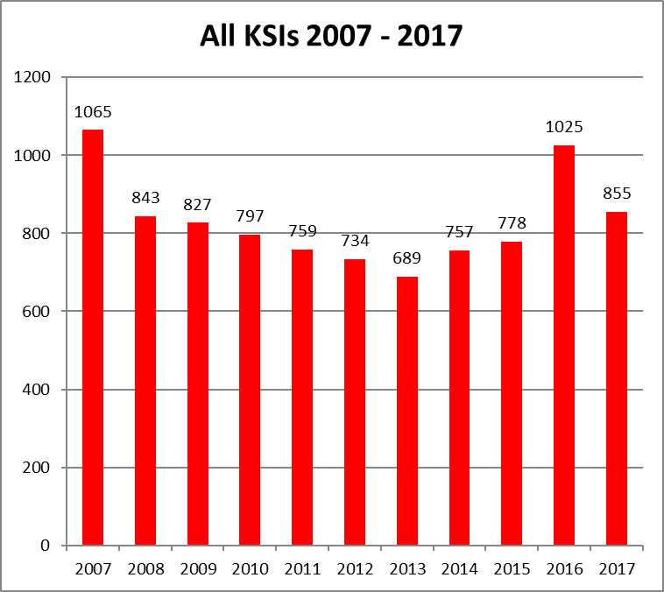
  - Road Traffic Collisions (RTCs) are a significant issue within Essex. Between January and December 2017, 855 people were killed or seriously injured (KSI) as a consequence of RTC’s (4,838 people since 2012 and 9,129 since 2007).

  - The number of casualties from RTC’s remains unacceptably high and addressing this represents a challenge for all those organisations and agencies involved in road safety. As well as the personal tragedies associated with RTC’s there are the wider social costs, with a single KSI being valued by the DfT at £1.6m.

  - ECFRS is an emergency response service and is regularly called upon to deal with the aftermath of RTCs with specialist equipment and our highly trained firefighters. However, a blue light emergency response is when things have gone wrong on the roads. We therefore actively seek to prevent Road Traffic Collisions from occurring in the first place through quality education and engagement activities; in nearly all cases cases, death and injury can be prevented through better education, awareness and responsibility amongst all road users.

  - RTC Reduction is a priority for ECFRS and is a key component in the Integrated Risk Management Plan. Keeping people safe on the roads is also a priority for the PFCC in the Police and Crime Plan 2016-2020 and is a priority in the emerging PFCC Fire Plan.

- THE SAFER ESSEX ROADS PARTNERSHIP

  - ECFRS does not act alone in its road safety activities and is a key and effective partner within the Safer Essex Roads Partnership (SERP) – a high level strategic partnership which oversees and co-ordinates collaborative road safety activities across Essex, Southend and Thurrock. ECFRS was one of the first signatories to the SERP Memorandum of Understanding along with Essex Police and Essex County Council.

  - Membership of SERP now includes the following:

- Essex County Fire and Rescue Service
- Essex Police
- Essex County Council
- Southend on Sea Council
- Thurrock Council
- Highways England
- East of England Ambulance Service Trust
- Essex and Herts Air Ambulance trust
- The Safer Roads Foundation

  - SERP’s purpose is to reduce death and serious injury on the road to zero (Vision Zero) and it will be appreciated that this is an ambitious vision. SERP has set a challenging interim target to reduce RTC KSIs by 40% by 2020 (from the 2005-2009 baseline average). This equates to 607 fewer deaths and serious injuries.

  - SERP is successful and effective at ensuring a co-ordinated collaborative approach to reducing RTC KSIs. All road safety activity within Essex across all partners is articulated in an annual Joint Road Safety Delivery Plan (JRSDP), built around key road user risk groups.

  - The work of SERP and the focus of the JRSDP ensures a targeted approach, removes duplication of effort, exploits the strengths of individual partners and ensures consistency.

  - In addition to funds devoted to road safety by individual partners, SERP also has its own income stream and is therefore in the beneficial position of being able to allocate funds to underpin the JRSDP. In 2017/18 SERP has allocated some £425,000 to road safety educational activity through the JRSDP.

- ECFRS RTC REDUCTION DEPARTMENT AND PRODUCTS

  - The RTC Reduction Department comprises the RTC Reduction Manager, the RTC Reduction Team Leader and a part time Business Support Assistant. The wide range of outreach work is supported by a team of RTC Reduction Secondary Contractors who assist with the deployment of our products and delivery of education in their own time.

  - Budget

Staff Costs 2017-18 | £93,625.34 (not including secondary contractors)
Non-Pay Costs 2017-18 | £40,176.02
Total | £133,801.36

Non-Pay Costs in 2017-18 included
Ford Car Simulator | £1894.40
Community Wheels | £7683.06
Fire Bike | £23,632.69
VR Goggles | £6965.87 one off payment 2017-18
Total | £40,176.02

  - The activities of the ECFRS RTC Reduction Department relate to all road users. However, on-going casualty data analysis particularly focuses activities on the highest risk groups –

- Motorcycles and other powered two wheelers;
- Young car drivers and their passengers;
- Children and young people; and
- Cyclists and pedestrians.

  - The RTC Reduction Department has a range of products, initiatives and activities designed specifically to engage with and educate road users as to the risks and potential consequences of using the roads. We seek to influence people’s driving/riding behaviour so as to reduce death and injury caused by road traffic related incidents.

  - To provide a measure of the extent of our road safety operations, in 2017 the RTc Reduction Team attended 372 events and engaged with 39,472 members of the public on road safety risk and consequence.

  - An outline of each of our products is given below:

FireBike

  - Motorcyclists remain the highest RTC KSI group in Essex, disproportionate to all other road users. Motorcycles account for just 0.8% of the traffic on the roads of Essex, yet they feature in 26% of all KSI collisions.

  - FireBike is ECFRS’s RTC Reduction product through which we promote motorcycle safety throughout Essex and seek to reduce the number of riders who are killed or seriously injured.

  - FireBike is a considered and pragmatic approach to reducing the number of motorcycle RTC KSI incidents. It provides an effective and respected means to directly engage with motorcyclists and promote safe riding, the use of protective equipment and the benefits of advanced rider training. The FireBike team delivers rider skills training through its established and popular FireBike Better Biking Courses and FireBike Advanced Machine Skills Courses.

  - Our 8 FireBike riders are all RoSPA Gold advanced motorcyclists and also hold the RoSPA National Diploma in Advanced Riding Instruction.

  - In 2017, FireBikes attended 54 events and engaged with over 1500 motorcyclists. 22 FireBike Better Biking Courses and 12 FireBike Advanced Machine Skills Courses were held, providing roadcraft and machine handling skills to 245 riders.

Fire Car

  - Significant problems with street racing and ‘drifting’ activities are experienced in several locations around Essex, which present a risk not only to the drivers involved but also to others who often gather in significant numbers to spectate.

  - Fire Car is used by ECFRS predominantly (though not exclusively) to engage with and educate these ‘modified performance car enthusiasts’ in Essex, and hopefully affect behaviours and RTC risk amongst that road user group. This is a very difficult group to engage with and they are not receptive to the Police (who are of course pro-active in enforcement activities for these behaviours).

  - The Fire Car is an Audi S3 performance car, generously donated by Essex Audi Group. The vehicle is appropriately ‘branded’ to identify it as being part of the Fire Service. The Car is used with the intention of achieving a genuine two-way dialogue with drivers, passengers and event spectators.

Community Wheels

  - Community Wheels is ECFRS’s bespoke multi-media vehicle used to deliver of road safety/RTC reduction messages to a wide audience. It is a stand-alone mobile classroom facility capable of being located anywhere, therefore enabling road safety engagements to be delivered to people in their own localities.

  - The product allows for flexibility in terms of the location in which Community Wheels can deliver road safety messages - it has full disabled access; a generator to enabling it to function without the need for a separate electrical supply.

  - As well as being used by ECFRS for its own RTC reduction activities, Community Wheels is well used as a SERP resource supporting multi agency road safety activities such as Surround a Town enforcement and engagement events.

  - Community Wheels is used to engage with all road users of all ages. However it is extensively used to engage with and educate young newly qualified and prospective drivers, given the high risks they face on the roads.

Ford Driving Simulator

  - Developed and donated to us by Fords at their R&D Centre Dunton, the Ford Driving Simulator is located at Waltham Abbey Fire Station.

  - The facility combines a Ford Fiesta car body with a state of the art (Transport Research Laboratory developed) driving simulator inside and full panoramic projection screens to create an immersive driving experience. Whilst there is no engine or any other road going functionality, there are real tyres, working windows and radio thus making the simulator as close to a real driving experience as possible.

  - The simulator was located at Waltham Abbey Fire Station in 2013 in light of the incidence of RTCs in that area, and particularly due to the number involving young people.

  - The simulator is used primarily for young newly qualified and prospective driver education, and we have worked particularly in partnership with Epping and Harlow Colleges to deliver road safety education to their students using the simulator facility.

  - This entails a structured programme involving a classroom lecture on driving risk and consequences, a session from Fire Station personnel on the front-line implications of responding to and RTC, and a session using the driving simulator itself.

Virtual Reality Road Safety

  - VR Road Safety is our newest RTC Reduction product and uses cutting-edge virtual reality technology to deliver an immersive and realistic road safety experience.

  - The product involves the use of virtual reality goggles (commonly used in computer gaming) linked to a smartphone through which a 360º film is shown. The user is a young front seat passenger in a car with 3 other people. The film depicts the ‘fatal 4’ causes of RTCs (speeding, not wearing a seatbelt, distraction and driving under the influence). The car is then in a serious collision and the passenger comes around to the aftermath of the collision involving the response of the emergency services.

  - VR is not used by itself, the interaction is part of a wider educational piece about risk and consequence which the VR product underlines and brings home the reality of the road safety message.

- CONCLUSION

  - It can be seen that ECFRS is extremely proactive in relation to road safety, not only in its own right, but as a fundamental and influential partner within SERP.

  - Given its experience as an emergency response service and the high public regard in which it is held, ECFRS is extremely well placed to engage with road users on road safety risk and consequence.

  - It is hoped that this report gives a good outline of the important educational work the service is involved with in seeking to reduce road deaths and serious injuries.

Financial Implications

There are no financial implications attached to this paper.

Equality and Diversity Implications

There are no equality and diversity implications attached to this paper.

Workforce Engagement

There is no requirement for workforce engagement requirements attached to this paper.

Legal ImplicationS

There are no legal implications attached to this paper.

HEALTH AND SAFETY IMPLICATIONS

There are no health and safety implications attached to this paper.

