Meeting | ECFRS Strategic Board | Agenda Item
Meeting Date | 18th September 2018 | Report Number
Report Author: | Amanda Johnson
Presented By
Subject | Essex Emergency Services Collaboration Programme update
Type of Report: | Information
Actions Required | Note content

Tactical 10 projects update

Project | Status
Expansion and roll-out of Parish Safety Volunteers model into the Safe & Well and Secure Visits | In BAU Crime Prevention Messaging delivered to technicians and community builders, and evaluation strategy confirmed. Benefits Mapping in place. confirmed
Development of an Essex Risk Intervention Service (ERIS) | Engaged with District Councils in Pilot area, as is scoping work with Essex Vision. Integration with Safe, Well and Secure so visits are intelligence led.
Development of a Joint Rural Engagement programme with Essex Police | Working with new District Commander to increase number of referrals from CPT, LPT and GTRET. Working with SERP to engage horse-riders around Essex Eyes. Working on Arson prevention for stables.
Development of web-based portal for the public to request a Safe, Well and Secure visit | Being developed with Hitachi – delayed until CRM work completed
Collapsed Behind Closed Doors | In BAU – Closure Report to be written.
ECFRS to take over the Development of Community Speed Watch | In BAU – Closure report to be written. Co-ordinator finalist in Essex Police Community Awards
Strategic Road Network- ECFRS supporting Essex Police in keeping the Essex Strategic Road Network open | Outline Business Case presented to SGB on 7th September
Expansion of ECFRS Education Team with officers funded by Essex Police | Evaluation strategy to be improved with academic support from Nottingham Trent University and a utilisation report around Police time saved
Duke of Edinburgh Provision for Essex Police Cadets | Moving to BAU. Also incorporates the Police Fire Cadet Challenge games
Restorative Justice Firebreaks | Additional course scheduled for 2018/19 - Evaluation strategy to be improved with academic support

Other tactical/operational work in progress:

- Leadership Training – Two programmes for first line managers running in 2018 with nominations from the three Blue Light Services.

- Student Police Officers Familiarisation Days have started. Nine have run already with 20+ students attending monthly days at KP.

Strategic Programme of Work Update

This is the Programme of Work agreed by the Chief Officers from Police, Fire and Ambulance on 5th January. EEAST engaged and invited to all workshops.

Project | Status
Joint Fleet Workshops | An Strategic Business Case will be taken to Strategic Governance Board in Oct with all reasonable options (not just the development of two workshop buildings, one at Boreham and one at Kelvedon Park supporting a single service for fleet) presented and those which cannot be made to work or are cost prohibitive ruled out. Any assumptions will be evidenced on cost and benefits terms. At this time the option to commission consultants to carry out the OBC development are not considered appropriate as sufficient expertise within Fire/Police to outline strategic case to enable move to OBC is available.
Shared use of ECFRS Estate (OPE Blue Light Access) | - Manningtree and Corringham Fire Stations are now open for use by Essex Police as drop-in centres for Police personnel. Evidence based roll-out programme being developed based on the evaluation of the pilots;  - The ECFRS IRMP is still being drafted and together with the emerging ECFRS Estates Strategy, these will shape the future direction of the service in respect of the shared use of estates. The extension of the use of buildings to a more substantial co-use is not yet supported by EP as the existing work needs to be more thoroughly evaluated and ensure any decision to extend operational deployment from ECFRS estate meets police operational needs & does not impinge on ECFRS operational use. E.g. Dovercourt, Rayleigh Weir etc. This is under discussion amongst EP Chief Officers.
Provision of Classroom Facilities for joint training in JESIP, supervision and leadership (OPE Blue Light Access) | A catalogue of internal and external training courses had been created for ECFRS and mapped across to the equivalent within EP. Focus is on:  - The development of a centralised system for booking all training facilities across the ECFRS estate;  - Development of a national MAGIC course in-house  - Explore opportunities for courses to be shared between the services
Joint provision of specialist capabilities between Fire and Police (OPE Blue Light Access) | On hold, but this could be re-scoped due plans for Boreham

Joint Incident Command Unit | A business case is being developed for the end of Sept to set out the options for the purchase or adaptation of a vehicle. The purchase of a bespoke high cost command vehicle has been ruled out for reasons of budget and currently favoured is a Transit sized ICU already owned by ECFRS, but there may also be an option to buy one of the HART vehicles which is potentially being sold.
IT Convergence Roadmap | ECFRS has offered resource from 1st September to explore convergence based on the agreed Terms of Reference developed from the last workshop. Once this is in place a three month scoping exercise would take place to present the opportunities for ICT convergence. Mobile devices and telephony were definitely fruitful areas for convergence.
Joint Procurement Initiatives | A matrix has been develop to assess the viability of a joint procurement based on a number of factors and 10 areas of potential joint procurement are being explored.
Shared Control Room Facility | The agreed approach adopted is to focus first on implementing a shared IT platform within the control rooms and then once the IT had been “bedded in” to assess the efficacy of moving to a single location.
Increase resources in the Dengie Peninsula | Closure report rejected, by Fire and Police as it has been agreed that although the level of demand in that area is low, that this nonetheless did generate a disproportionate level of complaints and anxiety with the public, as they felt isolated and sometimes poorly served by the Police and ECFRS response. Focus is on:  - Work to progress a joint recruitment event, including with the 3rd sector response services.  - A paper to provide a rationale as to why PCSOs cannot be recruited as On Call FFs in the Dengie;  - The potential and willingness for Fire/Police to look at Special Constable option amongst retained FF, Town Parish Council etc;  - Special constables/OC/First responder recruitment.
Joint Community Safety Function | Existing police / local authority community hubs in place across the County will be resourced with an ECFRS presence by Jan 2019 via dedicated community safety staff on stations. In April 2019 work will commence to align physical structures within the currently centralised areas of community safety. A number of risks to the project have been highlighted by the ECFRS strand lead to the scrutiny panel. ECFRS can sign into individual hub data sharing agreements; Jo and BJ have commissioned the start of a ECFRS/EP data sharing agreement.
Collaborative approach to repeat callers | This has been concluded as this was not a significant shared problem. The large number of calls from ECFRS Control to FCR has been managed effectively by creating a non-urgent e-mail link which is now being used.

OPE funded projects (part of the Estates work)

- Jon Wilson is funded by OPE Grant and is project managing the three Blue Light Access projects.
- Whilst the extension of the use of buildings to a more substantial co-use is not yet on the table, there is an opportunity to explore further concepts and develop feasibility studies using OPE funding. Agreement to progress these concepts would be needed before the end of September to enable an application to be made in October for the Phase 7 funding. The two concepts which could be explored are:
  - Four locations identified by the Essex Police strategy for possible disposal where shared use of ECFRS estate nearby would mitigate the disposal from a public perception. At the Essex Police Estates Board 1st February 2018, attended by ECFRS Head of Property, agreement to progress discussions was made.
  - An expansion of the current project to co-locate USAR and OPC with a new concept to explore a more strategic partner opportunity which would enable wider Essex outcomes.

Finance Update

Home Office PTF Grant

- Q2 report submitted on schedule and on target.

Budget update 2018/19

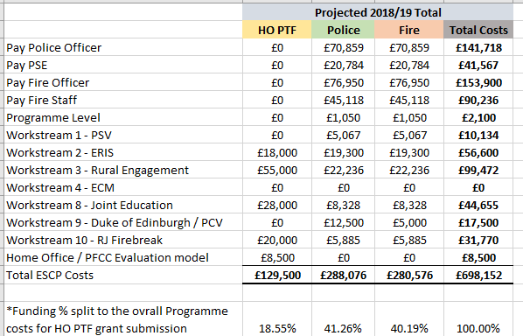

Budget for 2019/20

- Essex Police business planning competes on 10th September which is ahead of the ECFRS process. In agreement with Glenn McGuinness at Programme Board on 30th August, provision has been put into the budget.
- Changes to 2018/19 provision:
  - The PTF Grant funding finishes at the end of March 2019 except for £10,000 allocated for final write-up of the evaluation models developed with our academic partners. So all future spend will be 50:50 split with Essex Police.
  - Programme Manager (C/Supt) will no longer be 50% funded by Athena, so assumption is that the ESCP will pick up the full cost in 2019/20 – (£124,500 with on-costs). This will exceed the £200,000 set aside by Essex Police to fund the team at 50:50 (2018/19 contribution was £213,711 per service; 2019/20 contribution projected at £224,750 (includes 2% for Fire Grey Book).
  - Essex Fire are not providing a second Project Manager;
  - There is some Police Transformation funding to continue with a number of the key tactical projects – Joint Education, Rural Community Builders and Restorative Justice Firebreaks which impact multiple outcomes across Police and Fire.

 | Projected 2019/20 Total
 | HO PTF | Police | Fire | Total Costs
Pay Police Officer (C/Supt + C/Insp) | £0 | £104,250 | £104,250 | £208,500
Pay PSE (Project Analyst) | £0 | £20,750 | £20,750 | £41,500
Pay Fire Officer (Area Manager) | £0 | £54,500 | £54,500 | £109,000
Pay Fire Staff (Snr PM and Project Support) | £0 | £45,250 | £45,250 | £90,500
Sub-Total at Programme level | £0 | £224,750 | £224,750 | £449,500
Workstream 3 - Rural Engagement | £0 | £40,000 | £40,000 | £80,000
Workstream 8 - Joint Education | £0 | £12,500 | £12,500 | £25,000
Workstream 10 - RJ Firebreak | £0 | £12,500 | £12,500 | £25,000
Home Office / PFCC Evaluation model | £10,000 | £0 | £0 | £10,000
Sub-total at tactical level | £10,000 | £65,000 | £65,000 | £140,000
Total ESCP Costs | £10,000 | £289,750 | £289,750 | £589,500
*Funding % split to the overall Programme costs for HO PTF grant submission | 1.50% | 49.50% | 49.50% | 100.00%

Benefits Realisation

In developing the Benefits methodology, tracker and dashboard a number of key resources have been used including the “Guide for Effective Benefits Management in Major Projects” from the Infrastructure and Projects Authority (IPA) (October 2017) and “Benefits Mapping and Reporting, a practical guide for PTF Projects” from the Home Office (March 2018).

From these a set of principles have been developed and used when defining the Benefits for the Tactical Ten projects (see Appendix 1).

There are four levels of Benefits reporting, with Level 1 being reported to the Essex Emergency Services Strategic Collaboration Governance Board on a monthly basis Examples in Appendix 2):

- Level 1 – Benefits dash board against the overall business case
- Level 2 – Benefits tracker – Projects and programme level
- Level 3 – Benefits profiling - programme level
- Level 4 – Benefits methodology - how the benefits are calculated at the local level

Tactical Ten Projects

Amanda Johnson presented to the Association of Police and Crime Commissioners in July on the progress against the deliverables for the PTF Grant funding which includes five of the ten tactical projects. Part of this update focussed on Benefits Realisation and the challenges faced on doing this for Prevention and in a collaborative arena.

The benefit development methodology used for the Tactical Ten Projects has made a number of assumptions, which will be reviewed throughout the delivery phase of each project and tested at the end to see what was actually achieved.

The benefits methodology for the Tactical Ten is being reviewed regularly with Paul Nagle from Essex Police. During the development of the methodology, a number of key challenges and questions have evolved. Amanda is meeting with Adrian Wight and one of the economists from the Home Office Law Enforcement Transformation Unit on 13th September to discuss the application of their models at a local level and lessons we are learning. Views and comments are also being sought from Dr Rowena Hill (NTU); Cranfield University (via Mark Gilmartin); Alasdair Robertson (Shared Service Architects) and Rebecca Gill (Emergency Services Collaboration Working Group) to discuss the issues raised and determine if there is a methodology that can be agreed to resolve. The key issues on benefits development are:

- Benefits Attribution for prevention projects – how to determine what benefit can be attributed to a prevention activity where something may not have happened as a result of the intervention e.g reduction in ADFs or opportunist burglary as a result of implementing Safe, Well and Secure visits;
- Benefits Apportionment in a collaborative arena where resource, costs and benefits may not be equal across all partners;
- Benefits around Public Safety and Effectiveness activities are rarely cashable:
  - Benefits for behaviour changes, making communities safer, reducing the risk of harm in communities cannot be easily defined at the start of a project;
  - Benefits for prevention work can only be estimated based on a range of scenario’s and measured at the end of the activity;
- Potential Efficiency financial benefits tend to be translated into non-cashable capacity benefits which are often re-invested or based on a cost avoidance scenario where something was prevented from happening e.g. KSI’s were reduced at an estimated cost of £260,000 per KSI.

Strategic programme of work

The ESCP Team will be supporting and advising the accountable leads in developing their benefits using the principles developed for the Tactical Ten projects and mapping to the projections in the PFCC Business Case 10 year plan.

Glenn McGuiness has raised a query at Programme Board on 30th September, as he is expecting to budget for a £540,000 cashable saving from collaboration activity each year. This was a figure presented by Mike Clayton with the expectation that collaboration on ITC, Property, Fleet and procurement would yield this each year. The work on-going with benefits realisation for both the Tactical Ten Projects and the Strategic Programme of Work, will help inform whether this can be achieved.

Representative Body engagement

Engagement is continuing, however, the regular meeting schedule has not been maintained due to diary challenges between the Programme Manager and the CFO.

Communications and Engagement

The Collaboration Communications Plan has been agreed and is in active use by the joint communications teams.

Appendix 1 – Principles for Benefits development

- The Home Office model will be used as the basis for categorising benefits;
- Assumptions will be explained as to why they are reasonable for the project;
- Benefits realisation should cover the following (not just Police and Fire):
  - Police
  - Fire
  - Health
  - PFCC
  - Wider public
- Measures need to focus on the following:
  - What can be measured?
  - How easy is it to measure?
  - How easy is it to get the baseline data?
- Benefits development activities should be appropriate, scalable and proportionate to the size of the project;
- Benefits development should be an evidence based activity driven by actual and real information as much as possible;
- If it is data that would be useful to have in the future and is not currently held anywhere, recommendations should be made as to how this could best be carried out e.g. using Most Similar Family data;
- Any year-on-year benefit revenue saving will be calculated over the period of the PFCCs business case (10 years from October 2017);
- Where Essex data is not available, the New Economy Model will be used to calculate an indicative cost and uplifted by 3% year-on-year to get a current value. (Advised by Paul Nagle, Essex Police);

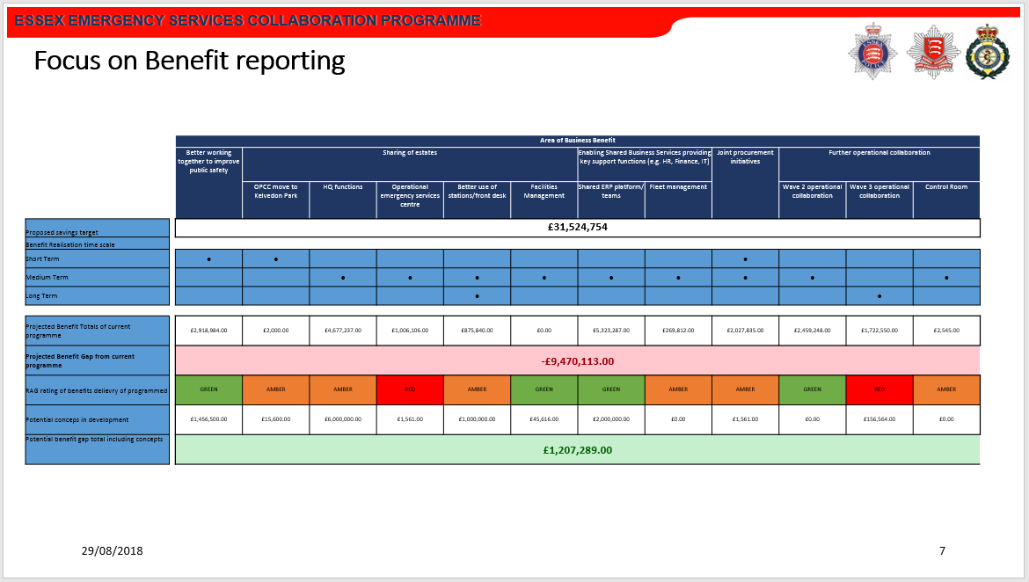
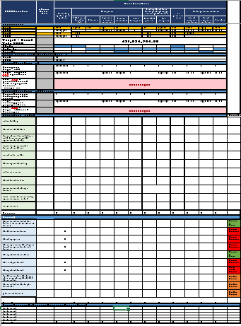
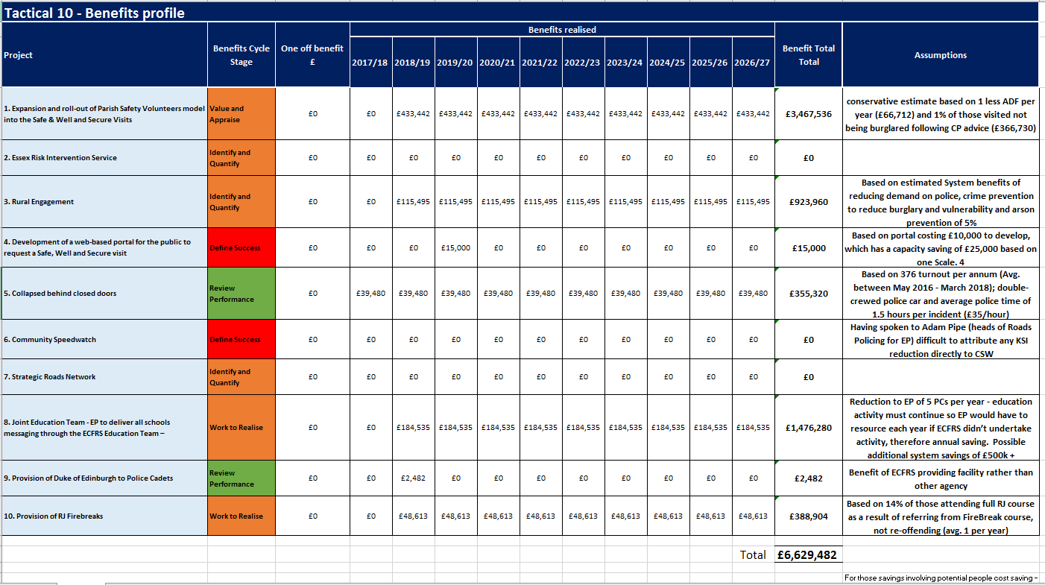
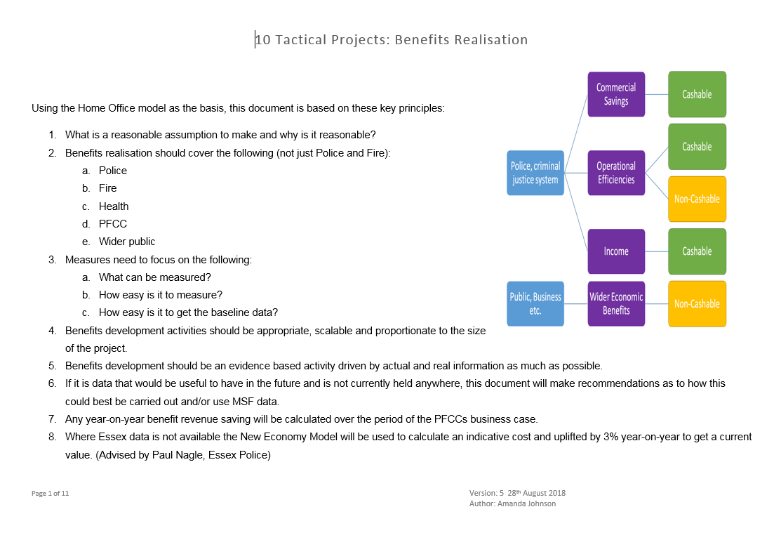

Level 1 –
SCGB Benefits dash board against the overall business case
Level 3 – Benefits profiling - programme Level
Level 4 – Benefits methodology - how the benefits are calculated

Level 2 –
Benefits tracker – Projects and programme level

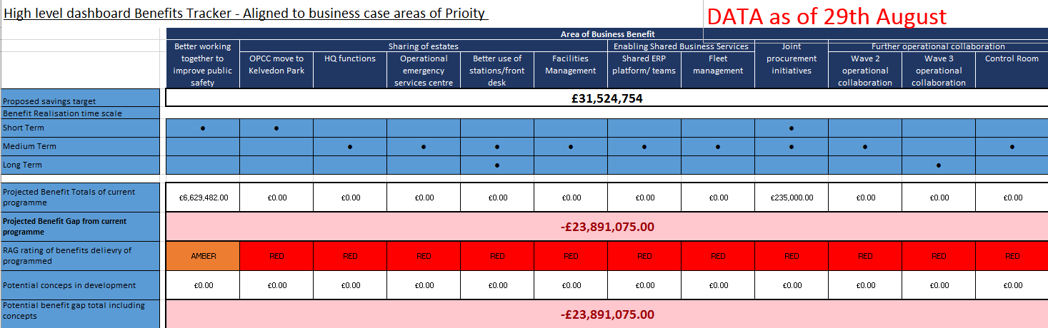
Level 1

Level 2
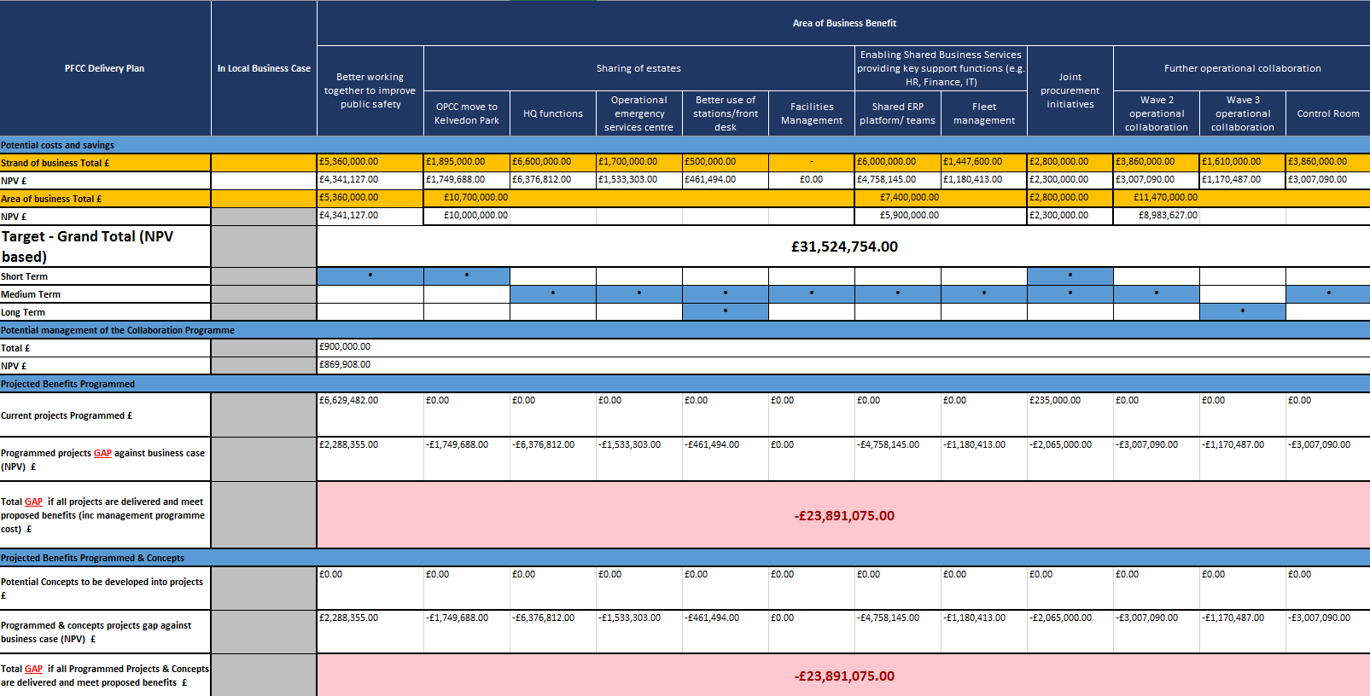

Level 3 – example for tactical 10

Tactical 10 - Benefits profile
Project | Benefits Cycle Stage | One off benefit  £ | Benefits realised |  |  |  |  |  |  |  |  |  | Benefit Total  Total | Assumptions
 |  |  | 2017/18 | 2018/19 | 2019/20 | 2020/21 | 2021/22 | 2022/23 | 2023/24 | 2024/25 | 2025/26 | 2026/27
1. Expansion and roll-out of Parish Safety Volunteers model into the Safe & Well and Secure Visits | Value and Appraise | £0 | £0 | £433,442 | £433,442 | £433,442 | £433,442 | £433,442 | £433,442 | £433,442 | £433,442 | £433,442 | £3,467,536 | conservative estimate based on 1 less ADF per year (£66,712) and 1% of those visited not being burglared following CP advice (£366,730)
2. Essex Risk Intervention Service | Identify and Quantify | £0 | £0 | £0 | £0 | £0 | £0 | £0 | £0 | £0 | £0 | £0 | £0
3. Rural Engagement | Identify and Quantify | £0 | £0 | £115,495 | £115,495 | £115,495 | £115,495 | £115,495 | £115,495 | £115,495 | £115,495 | £115,495 | £923,960 | Based on estimated System benefits of reducing demand on police, crime prevention to reduce burglary and vulnerability and arson prevention of 5%
4. Development of a web-based portal for the public to request a Safe, Well and Secure visit | Define Success | £0 | £0 | £0 | £15,000 | £0 | £0 | £0 | £0 | £0 | £0 | £0 | £15,000 | Based on portal costing £10,000 to develop, which has a capacity saving of £25,000 based on one Scale. 4
5. Collapsed behind closed doors | Review Performance | £0 | £39,480 | £39,480 | £39,480 | £39,480 | £39,480 | £39,480 | £39,480 | £39,480 | £39,480 | £39,480 | £355,320 | Based on 376 turnout per annum (Avg. between May 2016 - March 2018); double-crewed police car and average police time of 1.5 hours per incident (£35/hour)
6. Community Speedwatch | Review Performance | £0 | £0 | £0 | £0 | £0 | £0 | £0 | £0 | £0 | £0 | £0 | £0 | Having spoken to Adam Pipe (heads of Roads Policing for EP) difficult to attribute any KSI reduction directly to CSW
7. Strategic Roads Network | Identify and Quantify | £0 | £0 | £0 | £0 | £0 | £0 | £0 | £0 | £0 | £0 | £0 | £0
8. Joint Education Team - EP to deliver all schools messaging through the ECFRS Education Team – | Work to Realise | £0 | £0 | £184,535 | £184,535 | £184,535 | £184,535 | £184,535 | £184,535 | £184,535 | £184,535 | £184,535 | £1,476,280 | Reduction to EP of 5 PCs per year - education activity must continue so EP would have to resource each year if ECFRS didn’t undertake activity, therefore annual saving. Possible additional system savings of £500k +
9. Provision of Duke of Edinburgh to Police Cadets | Review Performance | £0 | £0 | £2,482 | £0 | £0 | £0 | £0 | £0 | £0 | £0 | £0 | £2,482 | Benefit of ECFRS providing facility rather than other agency
10. Provision of RJ Firebreaks | Work to Realise | £0 | £0 | £48,613 | £48,613 | £48,613 | £48,613 | £48,613 | £48,613 | £48,613 | £48,613 | £48,613 | £388,904 | Based on 14% of those attending full RJ course as a result of referring from FireBreak course, not re-offending (avg. 1 per year)
 |  |  |  |  |  |  |  |  |  |  |  | Total | £6,629,482
 |  |  |  |  |  |  |  |  |  |  |  |  |  | For those savings involving potential people cost saving - can this be annualised if activity would continue if not provided through this project

Level 4 - example

