ESSEX POLICE, FIRE AND CRIME COMMISSIONER FIRE & RESCUE AUTHORITY
Essex County Fire & Rescue Service
Meeting | ECFRS Strategic Board | Agenda Item | 10
Meeting Date | 8th June 2018 | Report Number | 5
Report Author: | Amanda Johnson – Senior Projects Manager
Presented By | Chief Superintendent Carl O’Malley – Programme Manager
Subject | Essex Emergency Services Collaboration Programme Update
Type of Report: | For information

Recommendations
- Members of the ECFRS Strategic Board are to note progress on the Essex Emergency Services Collaboration Programme.

BACKGROUND

- The vision for the Collaboration Programme is: Safe and secure communities to enable people to thrive. The principles by which it operates are:

- Collaboration as a first option -We will work together first, widely and with purpose
- We will value existing collaborations and build on new ones.
- We will be honest and open in all of our work together
- Our work will draw on evidence and be intelligence led.
- We will value the contribution of all partners

THE TEN TACTICAL PROJECTS

Tactical 10 projects update

Project | Status
Expansion and roll-out of Parish Safety Volunteers model into the Safe and Well and Secure Visits | Moving to delivery once Crime Prevention Messaging delivered to technicians and community builders, and evaluation strategy confirmed  and evaluation strategy confirmed
Development of an Essex Risk Intervention Service (ERIS) | 12 month pilot – April 2018 to April 2019
Development of a Joint Rural Engagement programme with Essex Police | 12 month pilot underway – April 2018 to April 2019  With Rural Community Builders
Development of web-based portal for the public to request a Safe, Well and Secure visit | Being developed with Hitachi – specification being scoped
Collapsed Behind Closed Doors | In delivery – Closure Report in preparation
ECFRS to take over the Development of Community Speed Watch | In delivery – Closure report in preparation
Strategic Road Network- ECFRS supporting Essex Police in keeping the Essex Strategic Road Network open | Options being explored and engagement with Representative Bodies underway
Expansion of ECFRS Education Team with officers funded by Essex Police | In delivery. Evaluation strategy to be underpinned with support from Nottingham Trent University.
Duke of Edinburgh Provision for Essex Police Cadets | In delivery. Also incorporates the Police Fire Cadet Challenge games
Restorative Justice Firebreaks | In delivery additional courses scheduled for 2018/19. Evaluation strategy to be underpinned with support from Nottingham Trent University.

- Other tactical/operational work in progress:

- Leadership Training – Two joint programmes for first line managers running in 2018 with nominations from the three Blue Light Services.

- Student Police Officers Familiarisation Days with Essex Fire and Rescue Service have commenced on a monthly basis. Three have run already with 20+ students attending each course at KP.

Strategic Programme of Work Update

- This is the Programme of Work agreed by the Chief Officers from Police, Fire and Ambulance on 5th January 2018.

Project | Status
Joint Fleet Workshops | Leads – ACFO Dave Bill and Mark Gilmartin (Director Shared Services Kent/Essex Police); Workshop being arranged to determine the service need. Research being undertaken to assess notable practice nationally – Staffordshire initial Business case shared
Shared use of ECFRS Estate (One Public Estate (OPE) Blue Light Access) | Project Brief agreed. Manningtree live, Corringham in progress as pilots. Learning needed to feed wider roll-out model. OPE Project Manager starts June to develop rollout model.
Provision of Classroom Facilities for joint training in JESIP, supervision and leadership (OPE Blue Light Access) | Scoping workshop (Chief Officer level) 16th May. OPE Project Manager will start beginning of June to develop Business Case
Joint provision of specialist capabilities between Fire and Police (OPE Blue Light Access) | Agreed to be on-hold until other OPE Blue Light Access projects delivered
Joint Incident Command Unit | Practitioner Workshop help 16th May. Action plan in place to scope requirements and options
IT Convergence Roadmap | Lead – Mark Gilmartin. Chief Officer workshop to be convened
Joint Procurement Initiatives | Procurement leads for ECFRS and Kent/Essex Police progressing to find synergies and savings
Shared Control Room Facility | Decision sheet signed by PFCC for ECFRS to use the Kent/ Essex contract for software procurement
Increase resources in the Dengie Peninsula | Practitioners’ development workshop held 14th May. Action Plan in place with leads to progress
Joint Community Safety Function | Chief Officer scoping workshop 14th June
Collaborative approach to repeat callers | Confirmation provided that no issue for ECFRS. Further discussions to be held on whether there are any other opportunities with ECFRS to support Essex Police and EEAST

- OPE Funding

- OPE funding has been secured of £100,000 to fund Project Management for the three Blue Light Access projects.

Finance Update

- Home Office Police Transformation Fund Grant

- End-of-Year report submitted on schedule.

Budget

- 2017/18 End-of-year status. Agreed with Essex Police and ECFRS Finance teams and approved by Strategic Collaboration Governance Board.

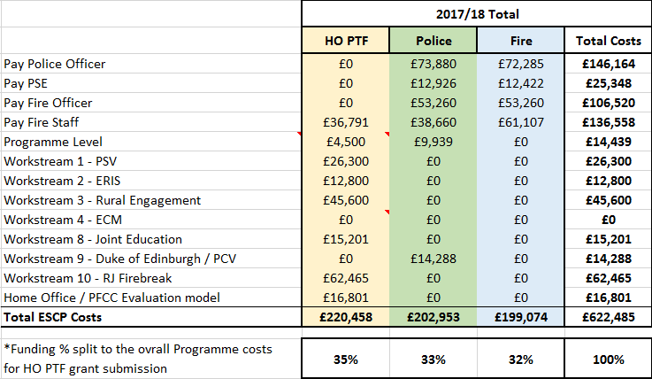

Budget for 2018/19
- Total Forecast spend, with the three pilot programmes, to April 2019 is: £730,578
- We have a PTF Grant of £129,500, which means Police/Fire match fund: £601,078
- On a 50:50 split this means each organisation contributions (including Programme Team salaries) is:
  - Fire: £296,789
  - Police: £304,289 (includes the DofE costs just picked by Police)
- Without Programme Team salaries, the contribution is:
  - Fire: £83,056
  - Police: £90,556
Budget | Funding | Variance | Source
£287,000 | £304,289 | -£17,289 | Police
£129,500 | £129,500 | £0 | PTF Grant
TBC | £296,789 |  | Fire
 | £730,578

This means a £17,289 overspend for the Police and this will be monitored throughout the year.
Representative Body engagement

- Engagement is on-going with regular meetings scheduled for all Representative Bodies:

Communications and Engagement

- The Collaboration Communications Plan has been agreed and is in active use by the joint communications teams.

