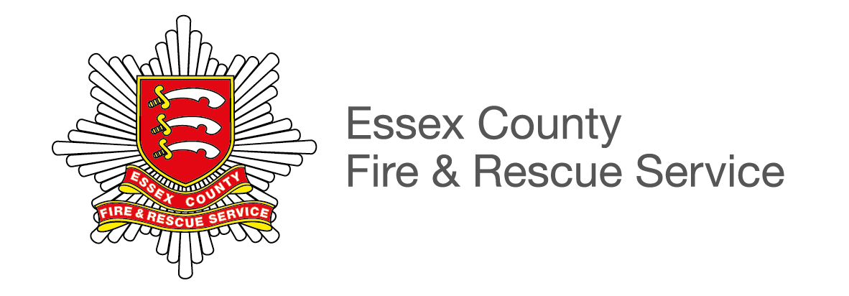

North West Group
Briefing Note

6 November 2018
PFCC – Braintree Public Meeting
Market Place
Braintree
CM7 3YG
6.30 – 8pm

ECFRS Structure and Resources
Operationally, Essex County and Fire Rescue Service divides the county into four geographical working groups. Braintree is part of the North West group, which extends to the borders of both Cambridgeshire and Suffolk.
In the Braintree area there is a Fire Station in the town itself, which is crewed by on-call firefighters, along with on-call stations at Coggeshall, Great Dunmow, Halstead, Wethersfield and Witham.

Braintree is one of our busiest on-call stations and houses two fire engines alongside its special appliance, the Hazmat Unit.

The Hazmat unit is deployed to incidents involving unidentified gases, powders or substances which may be hazardous to consume. Firefighters are trained to handle these materials and take the necessary precautions, wearing full body suits to prevent injury or any affect to their wellbeing.

Also in the Braintree area is one of our Service training centres, at Wethersfield. Located on the Ministry of Defence’s Wethersfield airbase, the site offers firefighters the opportunity to get hands on experience of how fires develop and spread, as well as how to contain them.

The facility is also used as a source of commercial income for the Service’s trading arm (Essex Fire Authority Trading) – who offer courses to Fire and Rescue Services from across the region as well as private companies.

There is a team of 19 on-call firefighters based at Braintree Fire Station in Railway Street. 19 on-call firefighters are based at Halstead, 15 at Dunmow, 11 at Coggeshall and 11 more at Wivenhoe.

Statistics
Between 1 August 2017 and 31 July 2018:

- ECFRS responded to 15,340 incidents across the county. 7367 of these incidents were deemed potentially life-threatening. 50% of these were responded to in under 10 minutes.
- Firefighters at Braintree Fire Station attended 404 incidents. Of these 109 were fires and 112 were to provide a specialist service such as assisting at a road traffic collision, dealing with hazardous materials, water rescue and making an unsafe building stable.
- Firefighters at Coggeshall Fire Station attended 69 incidents. Of these 18 were fires, while 21 were to provide a special service.
- Dunmow firefighters attended 190 incidents. 50 of those were fires, while 55 were special services.
- Halstead firefighters attended 230 incidents. Fires made up 79 of these, while special services were provided at 65 incidents.
- Wethersfield firefighters were called to 39 incidents. 19 were confirmed fires and five were special services.
- Our Home Safety Officers carried out 591 home safety visits in the Braintree area. This includes, 286 in Braintree, 110 in Halstead, 85 in Dunmow, 75 in Coggeshall and 35 in Wethersfield. During these visits, 239 regular smoke alarms and 34 smoke alarms for residents with hearing impairments were installed.

Recent notable incidents
On 11 October, firefighters from Braintree, Witham and Dunmow were called to a warehouse fire. Crews worked hard to contain the fire to the compartment it originated in, despite heavy smoke logging.

Prior to that, on 26 September, Braintree firefighters were part of a joint operation alongside the police, ambulance and our Urban Search and Rescue crews to locate and rescue a woman who had become trapped in thick mud deep in wooded area.

Police used a helicopter to support the efforts to locate the woman, but firefighters were able to find her quickly and free her using water rescue equipment.

